

LOCATION: Swansea | LLEOLIAD: abertawe
LEVEL 5 | LEFEL 5
EXAMINATION PERIOD | CYFNOD ARHOLIADAU
January 2019 | IONAWR 2019

MODULE CODE: M5X02068 / M5X00406
Thermofluid Mechanics 1 / Thermofluid Mechanics

TIME: 2 HOURS

answer all questions

Equipment or materials required
– Calculator
– Formulae booklets (General + Convection + Thermodynamics)
– Thermodynamics tables A-4 through A-6

- Question One: Heat Transfer Conduction (25 marks)

Water flows through a cast steel pipe with an outer diameter of 104 mm and 3 mm wall thickness. The pipe is lagged with insulation having a wall thickness of 15 cm, and thermal conductivity of k_{l} = 0.07 W/mK. The heat loss through the pipe Q is 4.5 W/m. Knowing that the steel inner pipe wall temperature T₁ is $25℃$, determine the outside lagging layer temperature T₃ and the inside lagging layer temperature T₂.

Schematic:
$$r_{1}$$
$$T_{1}$$
$$T_{3}$$
$$T_{2}$$
$$r_{2}$$
$$r_{3}$$
Steel
Lagging
$Q=$ 4.5 W/m

Assumptions:
- Steady-state conditions
- Properties of steel to be considered: k_{s} = 50.5 W/m.K

- Question Two: Heat Transfer Convection + Radiation (25 marks)

A household oven door of 0.5 m height and 0.7 m width reaches an average surface temperature of 32°C during operations. If the door has an emissivity of 1 and the surroundings ambient air is at 22°C, calculate the total heat loss to the room through free convection and radiation.
T_{s} = 32°C
Schematic:
Air temperature
T_{f} = 22°C
W = 0.7 m
H = 0.5 m

Q_{Total} = Q_{Convection} + Q_{Radiation}

Assumptions:
- Ambient air is quiescent
- Surface radiation effects are negligible
- Oven door thickness is negligible
- Significant length to be considered is the height of the oven door
- Properties of air at 27°C: ρ = 1.17 kg/m³, ν = 15.89×10⁻⁶ m²/s, k = 0.0263 W/mK, c_{p} = 1.005 kJ/kg.K

- Question Three: Fluid Flow (25 marks)

The outlet pipe from an open reservoir serving a hydroelectric power station is 20 m below the surface of the water. The tapered pipe is 250 m long and is inclined at 50° to the horizontal. At the turbine, the outlet nozzle discharges water in the atmosphere. Its diameter is 500 mm at the point of discharge. Taking frictional losses as equivalent to 3% of the potential head, determine:

- The velocity of the water issuing from the nozzle.

- The velocity in the pipe when its diameter is 75 cm.

Schematic:
h₁ =20 m
50°
250 m
h₂

- Question Four: Thermodynamics, Open system (25 marks)

In large steam power plants, the feedwater is frequently heated in closed feedwater heaters, which are basically heat exchangers, by steam extracted from the turbine at some stage. Steam enters the feedwater heater at 1 MPa and 200°C as superheated water and leaves as saturated liquid water at the same pressure. Feedwater enters the heater at 323 K and leaves 10°C below the exit temperature of the steam. Feedwater at both inlet and exit should be considered as saturated liquid water. If the heat losses from the outer surfaces of the heater are 455 W, determine,

- The temperature at the feedwater outlet 2, and the mass flow rates of the extracted steam ${\dot{m}}_{s}$ and the feedwater heater ${\dot{m}}_{fw}$ if their ratio is ${{\dot{m}}_{s}}/{{\dot{m}}_{fw}}=0.248$

- The heat transfer rate from the steam to the feedwater.

Schematic:
P₁ = 1 MPa
T₁ = 200°C
Superheated water

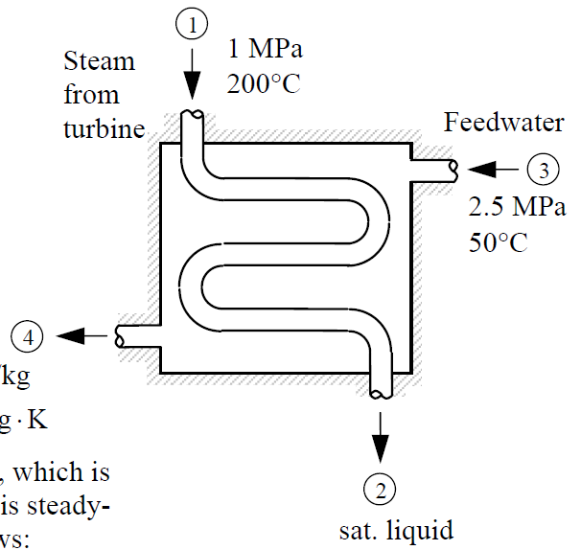
Sat. liquid water
T₄ = T₂ − 10°C

P₂ = P₁
Sat. liquid water
455 W
T₃ = 323 K
Sat. liquid water

Assumptions:
- Steady-flow process
- Kinetic and potential energy changes are negligible
- There are no work interactions
- The properties of steam and feedwater can be found in Tables A-4 through A-6
- It will be acceptable to round T₄ to the nearest whole number

Diwedd/End

