
Skills for the Workplace
Module Assignment Submission
Student Name: | Anamaria Bock
Student Number: | 2114314
Module No: | BMSK4002
Module Title: | Effective team working and communication

Statement of Confirmation of Authenticity
By the act of making this submission, the student declares that this is the work of the student named above. The work has not, in whole or in part, been knowingly presented elsewhere for assessment, or where assessment has been built on a previous assessment, this has been identified. Where materials have been used from other sources it has been properly acknowledged. If this statement is untrue, the student acknowledges that an assessment offence has been committed.
Attention is drawn to the plagiarism and unfair practice policies of both the University and of ILM.

Contents
Introduction 3
Definition 4
Forms of communication 4
Elements of communication 4
Verbal and Non-Verbal communication 5
Models of communication 5
Paralinguistic behaviour 7
Effective communication 7
Barriers to communication 8
References 9

Introduction
This assignment is about communication, starting with the definition and then explaining the types of communication, why is verbal and non-verbal communication important, how important it is that communication is effective in a team, in the workplace, barriers to communicate and how to overcome them.

Definition
Communication is the process of sending and receiving information It is very important in any type of relationship, but it is the key to success in any team.
“Most relationships, whether at work or elsewhere, are based on talking and listening. If you are really to learn, rather than accumulating book knowledges, you need to discuss ideas with others. Other people can give you feedback on different aspects of your behaviour: you need to be able to listen to this and absorb it. You may need to find out more about a situation by talking to the people involved. To convince someone to take action, you may need to talk them through the arguments. You may need to negotiate to people to get what you want.” (Cameron,2009)

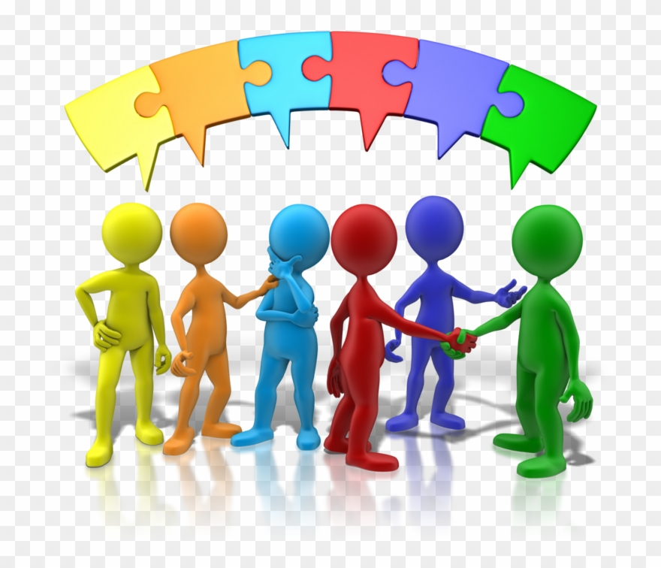

Forms of communication
Verbal communication – when the information is transmitted by speech.
Non-verbal communication – can be body language or symbols, facial expression.
Written communication /electronic – text message or email, letter or fax.

Elements of communication
When transmitting an information by verbal communication it is very important to make sure that the elements of communication are correlating so they will help us send the correct information.
VOCAL – the tone of the voice, the speed.
VISUAL – body language, facial expression, eye contact, gestures.
VERBAL – the actual content of the message, what is being said.
Albert Mehrabian says that the actual content of the message (verbal) it is only 7% of what people actually receive, but the most important part is the visual, body language, tone, facial expression, so will be 38% for voice and tone, then gestures will be 55%.
For example, if a manager has some bad news for the team and he is telling them the news laughing, the members will for sure think that he is joking.

Verbal and Non-Verbal communication
Verbal communication is the things we say, the message sent via speech and the non-verbal communication is whatever we don’t say but the others can see. These two forms of communication are both very important as it matters what you don’t say as much as the actual message.
For example, during a presentation the group is asked if the subject is interesting and the lady from the following picture says that she finds it very interesting: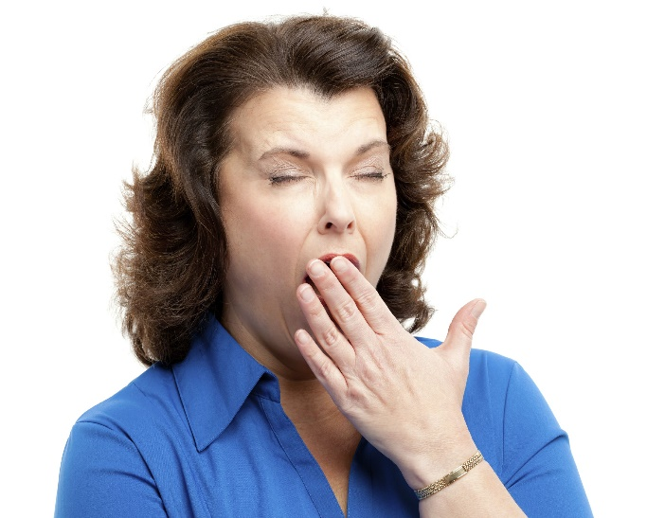
Another component of communication is the paralinguistic cue which is the speed of the speech, the tone, the intonation, and it can make such a big difference in a presentation.

Models of communication
When we try to communicate with our team or just one member, we have to make sure that all the details are correct, and nothing can make the message sound or look different that whatever we want it to be. So, let’s have a closer look to some communication models.
- Shannon-Weaver Mathematical model of communication
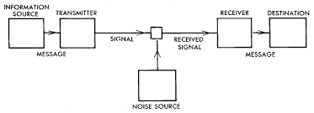
The sender incodes the message in his own noise and then he is sending it to the receiver to be decoded in a different noise which can make the message different.
- Berlo’s model of communication
For this model, the noise is not present but we can notice that Berlo described exactly what can actually influence the message.
- Schramm’s model of communication
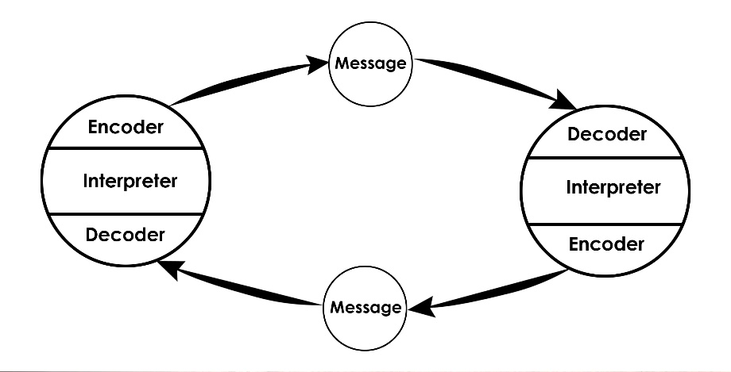
Schramm designed the model of communication as a circle because the communication should be cyclical, so the encoder is a decoder as well because when we communicate with someone we should get an answer.
- Aristotle’s model of communication
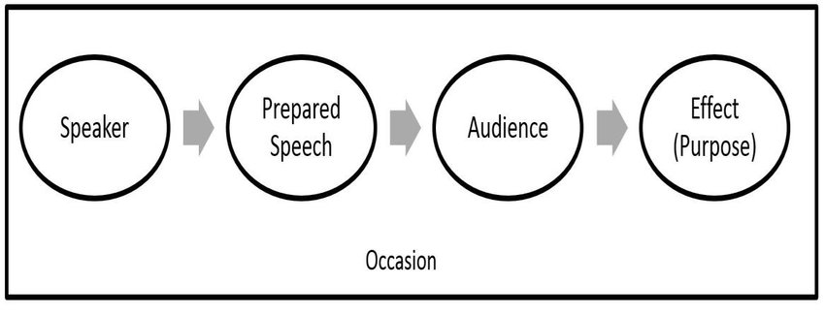
Aristotle designed this model where the speaker, the encoder is the most important as he is trying to send a clear message to a certain audience , so the encoder doesn’t wait for an answer but wants to see the effect of the communication made.
Seeing these four models of communication, we can notice that only Schramm’s is cyclical which is my favourite as any type of communication, being between friends or work colleagues or any type of team should be a two way communication, this is what makes communication effective, having the chance of asking questions to make sure the message was clear, they understood the purpose of the message, this is the was the conflicts can be managed by communicating, complaining about a subject and trying to find the right solution for it.

Paralinguistic behaviour
The paralinguistic behaviour and non-verbal communication can change the meaning of the message, that’s why we should always be careful how to behave when we are trying to communicate effectively.
So, if we want to have a particular impact on a subject when transmitting the message we should be aware of the four areas of paralinguistic cues:
- Speed of speech – some people will speak faster than others, they might be anxious, they might want to finish earlier or is just the way they are transmitting the message. On the other hand, the people who speak more slowly they might need more time to think about what they want to say next.
- Volume of speech – sometimes speaking loud could mean that the room is very big so the speaker wants everyone to hear him.
- Pitch and intonation – with the pitch of our voice we can indicate sarcasm and humour, but if our voice is very monotone than nobody will be interested in hearing that message.
- Change and modulation – if any of the above will be the same during the speech than we might lose the audience interest, but if we are having ups and down, like speaking louder when we want to highlight a certain part of the communication than we keep everyone awake.

Effective communication
As Neil Thompson wrote in his book “Effective communication – a guide for the people” to reach a high level of skills regarding communication it takes years of experience “by developing our knowledge about how communication works, by building up a more sophisticated understanding of the intricacies of how people interact, we can reach a more advanced level of skill and practice sooner and without making so many mistakes in the process. Of course, having the theoretical understanding will not of itself make us into better communicators. There is none the less much to be gained from the combination of: a better understanding of the theory base that casts light on communication; some guidance on how to draw on such theory in practice and actual practice experience.”
If the communication is not effective, you can lose time and money and waste resources.
That’s why it is very important to make the message clear, to speak in plain English so everybody can understand, to ask questions just to make sure everyone understood.
So, a two-way communication is what we need to make the communication effective and it should include: asking questions, listening, treating people as people, keep tuned in, speak the same language.
As for listening, there are five levels:
- Ignore – when the person is not interested in the subject and has something better to do.
- Pretend – the person is thinking about something else but pretends to pay attention.
- Selective – on and off, the person is hearing whatever he wants.
- Active – the person is there listening actively and interacting.
- Empathetic – more then listening, this person gets emotional and supporting.
So due to McPheat(2010) “communication skills are the tools that we use to remove the barriers to effective communication.”

Barriers to communication
It is very important to be aware of the barriers to communication so we can find a way to overcome them.
Here are some examples of barriers that can seriously affect the effectiveness of communication:
- Physiological factors
- Emotions
- Linguistic
- Lisps
- Perceptual
- Content
- Personal
Also, the feedback is very important because it helps you to realise what you are doing wrong and what you can improve. As a short example, I have done a PowerPoint presentation with recorded explanation on it so than I designed a short questionnaire to analyse the feedback so I can improve my communication skills for the future presentations. Examining the answers of the participants I have created a personal development plan with what I am doing wrong and how can I improve.
The questionnaire
- Was the message clear?
- Is my spoken English good?
- Was I loud enough?
- Was my posture and gestures, right?
- Is there anything I can do to make it sound better?
Personal Development plan
Objective | To communicate effectively
Action | Gaining more experience with time, learning more about effective communication skills and improve my skills with every experience.
Criteria | Based on my questionnaire, the participants suggested me to speak louder and focus more on the audience, do more eye contact.
Resources | The university is helping me a lot to develop new communication skills, the books about communication are really helpful as well and the feedback from the audience will help me improve my communication skills.

References
Cameron S., 2009, The business student’s handbook , Skills for study and employment, 5th edition, Pearson Prentice Hall.
Juneja P., Aristotle model of communication, http://www.managementstudyguide.com/aristotle-model-of-communication.htm.
Maund A., Schriek M., Tinkler P.K,2017, Certificate in Higher Education: Skills for the Workplace, Student Yearbook, Sage Publications Ltd
McPheat S., 2010, Effective communication skills, MTD Training and Ventus Publishing Aps
Morgan P., 2017, The business student’s guide to study and employability, Sage Publications Ltd
Thomas N., 2018, Effective communication: a guide for the people, Palgrave Macmillan.

