Effective Team Work and Communication

Student name: Rotaru Mihaela
Student ID: 1917114
Name of module: Effective team working and communication
Name of University:University of Wales Trinity Saint David
Name of Lecturer: Shao-Lan Yuen

Table of Contents
Introduction 3
Significance of communication Skills 3
Models of communication 4
Analysing communication in the workplace 5
Recommendations 9
Conclusion 10
Reference list 11
Appendices 12

Introduction
Communication Skill is one of the vital aspects in a business. Communication skill can be verbal, visual, non-verbal written. In order to establish an efficient teamwork, good communication skill has an utmost importance. In this report, various modes of communications are discussed. After that, there is a detail analysis of the ways of communication at Eyva Turkish Restaurant, in Ilford. The issues of communication are identified. In order to overcome those issues, some suggestions are made so that the issues are overcome and the organisation can make further improvement.

Significance of communication Skills
In the contemporary business world, the management uses various types’ of communication skill to communicate with their employees in an organisation. These various types of communication skills are as follows
Face-to-face meeting
One of the most efficient ways of communication is the face-to-face meeting. The importance of this means of communication lies in the fact that it helps to understand the body language of the peoples. According to the point of view of Schegloff (2007), face-to-face conversation helps the communicators to understand the exact meaning of what the person is trying to say. The researcher stated that it enhances the mutual understanding of the communicators
E-mail
It is one of the most important types of written communication. Most of the communications in any business organisation are done via email today. One of the usefulness of this means of communication is that this is private and confidential (Mahomedet al., 2017). It is the most reliable and the cheapest mode of communication. It helps the user to send various attachments that is advantageous. Mano and Mahesh (2010) stated that e-mail could be useful in increasing the efficiency and productivity of the employees. They pointed out that more than 2.6 billion people uses email worldwide. The primary reason behind the popularity of this mode of communication is its authenticity and security.

Business letters
Another important means of communication is the business letters. It is a type of formal mode of communication. This type of letter helps in selling of the product as well as to enquire about a customer or the price of the product. It also helps in seeking advice or maintaining good public relation. According to Davies and Birbili (2009), Writing is one of the most crucial aspects of today’s work and writing a good business letter is effective for the success of any organisation (Ranaut, 2018). The researchers stated that the way of writing in a business affects the decision-making of the customers.
Case Study Analysis
This is another non-verbal form of communication. The efficiency of this mode lies in the fact that it gives a chance of demonstration of the service by providing real-life examples. It helps to improve the communication skill of an individual by giving practical examples of any situation (Calarco et al., 2016). This is beneficial as it helps the individual to have a clear understanding of the context and that helps to improve his/her communication skill as the person becomes aware of the situation from the analysis of the case study. .

Models of communication
There are various models of communication. In order to explain effective teamwork and communication, Shannon and Weaver, Schramm, and Berlo theories are used. Shannon and Weaver model of communication is known as ‘mother of all models’. Claude Shannon and Warren Weaver jointly made this model of communication. Schramm model of communication explains how meaning is transferred among the individuals. Berlo model of communication (SMCR) presents simplest form of communication process.

Analysing communication in the workplace
Communication
On the construction site, is very important to communicate clearly. If we do not communicate then people might get hurt. In my work field, communication is the most important factor. Effective communication is necessary to handle customers as well as other staffs.
According to Shannon and Weaver model of communication, communication can be differentiated into 6 key concepts. They are such as sender, encoder, channel, noise, decoder and receiver. An extended version of Warren Weaver has added another step, which is feedback (Mishra, 2017).
Sender – A sender starts the process of communication by selecting information to send (Mishra, 2017). A sender sends message in various ways such as verbally, in writing and through body language.
Encoder – An encoder can be a machine or a person that transforms the ideas into signals that sends from a sender to a receiver. The model describes various transmitters or encoders such as telephone and computers. These systems encode the words by using binary digits and waves.
Channel – The communication channel is the infrastructure that receives information from sender and transmitted to the receiver (Mishra, 2017). It is also known as ‘medium’. People are sending emails through internet and talk to each other by landline phones. Therefore, the internet and electrical wires are mediums. When people are talking face-to-face then the sound waves are medium.
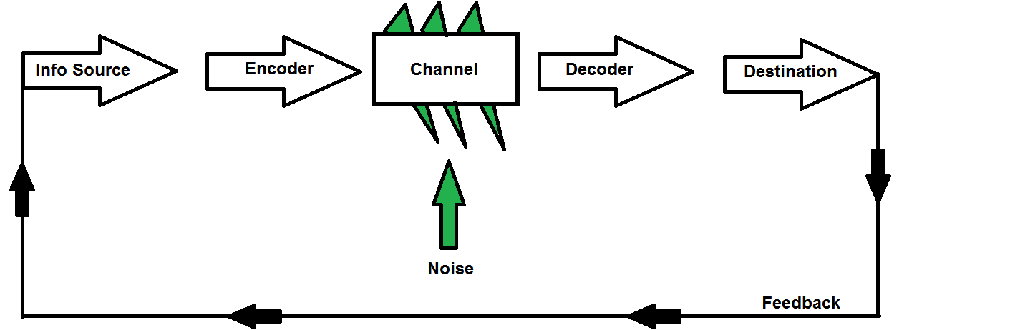
Figure 1: Shannon and Weaver model
(Source: Mishra, 2017)
Noise – It interrupts the message while transferring from the sender to the receiver. There are two types of noise, such as internal and external. Internal noise interrupts when the sender does a mistake regarding encoding or the receiver does a mistake regarding decoding. For example, internal noise raise when a sender misspelled a word or receiver misinterprets a sentence while reading (Mishra, 2017). External noise when a sender or a receiver is talking in a crowded area or noisy area. Internet issues and device issues are also considered as external noise.
Decoder – It is the opposite one of encoding. People need telephones or other communication devices, which help the receiver to decode the message. When a message decoded then it becomes understandable for the receiver.
Receiver – A receiver is the end point of the communication process. In this stage a person finally get the message.
Feedback – This stage is done when the receiver responses to the message comes from sender (Mishra, 2017). If receiver does not reply of the message then the communication process is not completed.
In our restaurant we have to talk face-to-face mostly with the customers. The receptionist has to attain phone call. Therefore, these are the communication processes done in my restaurant. However, I mostly communicate face-to-face with customers.
Group dynamics
I have noticed in my workplace that due to ineffective communication there are some problem raised between leaders and staffs. Sometimes we cannot understand what our leader tries to say. That is the reason we have some problem regarding understandings between us.
According to Schramm model, communication is a two-way street such as a sender and a receiver. There are four essential components of communication that help to assess the structure of this model (McQuail and Windahl, 2015). The components are such sender, message, receiver and semantic barriers.
Sender – A sender is a person who encodes or converts the message and sends to the receiver.
Message – It is the content that a sender wanted to share with somebody (McQuail and Windahl, 2015).
Receiver – A receiver is the person who decodes or interprets the message that came from the sender.
Semantic barriers – The background, emotion, experiences beliefs and values that influences the convince strength of the message and how the receiver gets it.
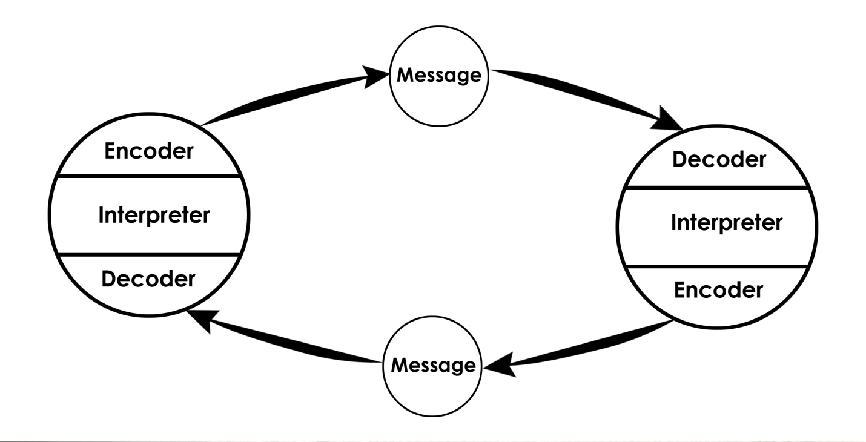
Figure2: Schramm model
(Source: McQuail and Windahl, 2015)
The Schramm model of communication has some merits and demerits. This model of communication provides an easy and effective approach to communication between sender and receiver. It allows both the parties to share their feedback equally. It acts as a confirmation of the message that has been received or decoded by the receive (McQuail and Windahl, 2015)r. The model also has a negative side. The model gets impaired sometimes by semantic noise, differences and misunderstandings. These are the causes of wrong interruption than it was intended to. There are many things that interrupt the communication between people. Feelings, misunderstandings and semantic noise affect the communication between people. In groups, people have to understand each other’s feelings and the tone of their communication. If they do not understand their thoughts, emotions and feelings then the communication between them will be interrupted.
In this case, I will definitely try to understand other people’s feelings and their emotion. I think it will help me to have effective communication with customers as well as other staff in my workplace.

Team working
In my workplace, team work is more important than individual conversation. We have to work as a team because our duty is divided to each other. Therefore we have to communicate well in order to work efficiently. However, many staffs have lack of skills that is the reason sometimes effective communication is not possible.
Berlo’s communication model is a simplest form of communication based on SMCR (Turaga, 2016). It stands for sender, message, channel and receiver. According to Berlo, these are the essential components of communication.
Sender – A sender is the source of transferring a message to the receiver. The sender starts the communication and encodes the message. As per SMCR structure, there are some factors that affect the source. They are such as communication skills, attitude, knowledge, social systems and culture. Communication is included with reading, listening and speaking skills. Attitude is included with the relationship between audience and the receiver. Knowledge is included with familiarity with the subject of the content or message. Social systems included with values, beliefs, rules and religion. Cultural differences also interpret the message.

Figure3: Berlo’s communication model
(Source: Turaga, 2016)
Message – Message is the compilation of information that is sent by the sender to the receiver. A message can be sent in different forms such as audio, video, speech and text. A sender required to send the message clearly so that receiver can interpret it correctly. The message can be influenced by some factors. They are such as content, elements, treatments, structure and code.
Channel – It works as a medium of the communication process Turaga, 2016). Through the channel a receiver can get the message from the sender. It includes hearing, seeing, touching, smelling and tasting senses.
Receiver – A receiver is the person who receives the message from the sender and interprets it. This model assumes that the thought process of the sender and the receiver must be similar. Therefore it will influence the communication and interpretation.
Therefore, I will make better coordination with my team-mates so that the thought will be cleared and similar to us. When we all think according to each other then it will be easy to understand other person’s though. Hence, the communication between our workers will be more effective and clear.

Recommendations
Communication
It has been found that some of the employees of Eyva Turkish restaurant have a problem in their behaviour. In order to overcome the rude behaviour of the employees, the company must take some necessary steps. The management must identify the employees who possess this rude behaviour and must adopt zero tolerance protocol on the ground of unethical behaviour (Liaw et al., 2018). The company should take necessary steps on them and they should enhance their way of communication with the employees so that their behaviour can be improved.
Teamwork
It has been found that there is a lack of skills on some of the employees of Eyva Turkish Restaurant. In order to overcome the issue, the company should think of giving necessary training to those employees so that their skills can enhance. This will be beneficial as the quality of the teamwork will be enhanced and that will result in the increase of the productivity of the company (Chaubey et al., 2016).

Conclusion
Communication Skill is one of the crucial aspects in a business. In this report, various modes of communications have been discussed. After that, a detail analysis has been done on the ways of communication at Eyva Turkish Restaurant, in Ilford. The issues of communication have been identified. In order to overcome those issues, some suggestions have been recommended so that the issues can overcome and the organisation can make further improvement.

Reference list
Calarco, P., Shearer, K., Schmidt, B. and Tate, D., 2016. Librarians’ competencies profile for scholarly communication and open access. Joint Task Force on Librarian’s Competencies in Support of E-research and Scholarly Communication.
Chaubey, D.S., Kothari, H.C. and Kapoor, S., 2016. Employees perception towards training outcome in some selected manufacturing organisations of Dehradun. Editorial Board, 5(6), p.225.
Liaw, J.O.H., Wong, W.L., Mardzuki, K., Mohaiyadin, N.M. and Abdul, M., 2018. Applying Effective Communication in Quality Management for Military Organisation. Journal of Social Science and Humanities. 1(6), pp.1-6.
MAHOMED, A.S.B., MCGRATH, M.G. and YUH, B.Z., 2017. The Role of National Culture on Email Usage among Non-Academic Staff in Malaysian Public Universities. International Journal of Economics & Management. 11(1).
McQuail, D. and Windahl, S., 2015. Communication models for the study of mass communications. Routledge.
Mishra, S., 2017. Shannon and Weaver model of communication.
Ranaut, B. 2018. Importance of Good Business Writing Skills. International Journal of Language & Linguistics. 5(2).
Turaga, R., 2016. Organizational models of effective communication. IUP Journal of Soft Skills, 10(2), p.56.

Appendices


