GRAJ Construction
Fabian Way (A438)
Method Statement (Replacement of Lock Gates)
Document 2/2
Revision | Prepared By | Role | Approved By
A | Matthew Macpherson  Richard Askham  Gareth Ingram  Josh Benger  Ashley John  Jennifer Sargisson | Site Engineers | Site Agent

Contents
- Summary………………………………………………………………………………………………3
- Resources……………………………………………………………………………………………..3
- Permit Requirements…………………………………………………………………………….4
- Emergency Procedures…………………………………………………………………………..5
- Welfare Arrangements…………………………………………………………………………..5
- Contact Numbers………………………………………………………………………………….6
- Interface with Members of the Public……………………………………………………6
- Methodology…………………………………………………………………………………………6
- Activity Specific Health and Safety Requirements………………………………….10
- Activity Specific Environmental Requirements……………………………………….11
- Review and Monitoring………………………………………………………………………….11
- Method Statement Briefing Log……………………………………………………………..12
- Appendix……………………………………………………………………………………………….13

- Summary
This Method Statement outlines proposals for the replacement of the lock gates in the following locations:
- SA1 Marina (Location below)
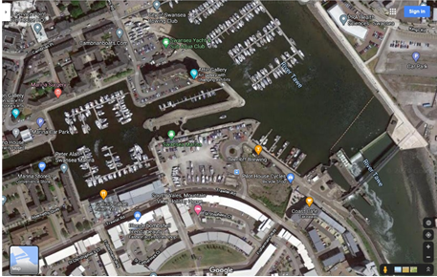



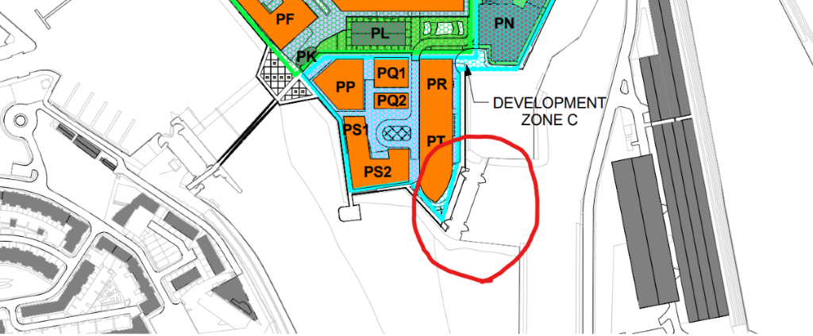
As per site drawing below, full drawing available at request in the site office.

Where it is identified that there is a need to change the method of work due to unforeseen circumstances for example, then revision, authorisation and issue will follow the same procedure as the original. Any subcontractors will adhere to all current legislation and site guidelines, following any relevant standards to complete this task in the best manor.

The scope of works for this project are as follows:
- Road Construction between Wern Terrace and Roberts Road
- Construction of a new lock gate in the SA1 dock area
The Road construction will be covered in a separate method statement.

- Resources
Materials
- Concrete
- Steel
- Scaffolding
- Timber
(Further Materials may be used and to be suggested by the site engineer)
Plant and Equipment
- 10t 360º Excavator with various buckets and breaker attachment
- Rubber Duck
- Crane
- GPS Guided D6 Dozer
- 135 Roller
- 13.5T Vibrating Roller
- 5t Dump Truck
- Plate Compactor
- Various Hand tools
- Testing apparatus
- CAT4+ and Genny or equivalent/superior
- Pipe Laser
- Rotating laser
- Air test kit
- Pedestrian Barriers
- Disc cutter
- Trench and manhole support system
All plant and equipment will be tested, tagged and registered prior to being used on site including accompanying lifting gear, e.g. chains, forklift attachment, shackles, etc Copies of Certification will be issued to the Works Manager so that a record is kept in the site office.
- No idling policy to be enforced – vehicles and plant to be switched off and secured when not in use.
- NRMM - Non-road mobile machinery must use ultra-low-sulphur diesel.
- NRMM- non-road mobile machinery - of engine power between 37kW - 560kW must conform to Tier IIIB European emission standard and be pre-notified to Fusion on the NRMM register.
- NRMM register must be provided prior to plant arriving on site.
- Stationary plant will be used with secondary containment measures such as plant nappies to retain any leakage of oil or fuel, which will be emptied at regular intervals to prevent overflow.
- Mobile spill kit to be kept on plant
- Daily plant inspections and pre-use checks will be carried out prior to work commencement and returned to the BGCL Works Manager on a weekly basis, these check sheets will be retained in the site files.
- Excavation inspection will also be carried out before each shift.
- Relevant Permit to load or recorded inspection of Temporary works to be carried out.
- Lifting permit will be issued to lift Manhole rings, Pipes and Trench/Manhole Boxes.

Personnel

- Manager - SMSTS - Minimum
- Supervisor - SSSTS - Minimum
- Excavator Operatives - CPCS
- General Operatives - CSCS

Mandatory PPE for all persons on site
- Hard Hat,
- High Visibility Vest or Coat (Orange – Full Sleeves)
- High Visibility Trousers (Orange)
- Lace up Boots with midsole and ankle protection (No Rigger Boots)
- Cut 5 gloves
- Light Eye Protection (LEP)

- Permit Requirements

- Permit to Dig
- Permit to work/accessing beneath existing overhead services)
- EAP – Ecological Arboriculture Permit
- Confined Space Permit for classification (NC1, NC2) for generic standard method of safe working
- Lifting Permit
All relevant Permits to work will be issued by GRAJ Construction prior to works commencing. A copy will be held in GRAJ Construction Site File.

- Emergency Procedure

- In the event of an emergency the work teams will follow the directions of the GRAJ Works Manager. Training on the correct emergency procedures will be briefed to operatives at GRAJ site Induction.
- Ensure no tools or equipment are left unattended. Pedestrian and emergency areas are to be kept clear for safe passage
- There will always be a member of the workforce with 3 Day First Aid at Work certification on site.
- In the event of a site wide emergency the team shall make safe the works area and proceed to the nearest assembly point.
- For specific incident information see the GRAJ Construction incident plan.
Directions to the nearest hospital will be found in the appendix.

- Welfare Arrangements

- Welfare will be provided in the main compound at SA1 and will consist of the following;
- Hot and Cold running water
- Fresh Water (Drinking)
- Toilets
- Canteen
- Drying facilities
- Means to heat food

This is not an exhaustive list and other facilities may be available.
Note that the following Welfare Requirements will comply with the water Resources technical standard
Facility | Measure
Toilet | 6 and 4 litres dual flush or;  4.5 litres single flush
Shower | 8 litres/minute
Hand basin | 5 litres/minute and a self-closing mechanism
Kitchen taps | flow rate of 5 litres/minute or less and trigger control is fitted to any pre-rinsing  facilities
Urinals | a flow rate of 3 litres/bowl/hour or less, or  hydraulic valves fitted to each urinal, or
Dishwasher | 1.25 litres/place setting
Washing machine | 8.17 litres/kilogram

- Contact Information
All relevant site personnel’s contact information will be available in the site office and on request.

- Interface with members of the public
Majority of the work on the A438 is wholly contained within the site boundary fencing and away from local residents and members of the public.
Should you have any interface with a member of the public or any person that you do not recognise be polite and direct them to GRAJ Construction management team.
Do not engage with any person or persons you do not recognise or any member of the public.
Be polite at all time when dealing with any member if the public regardless of their attitude to you.
In the case of a security breach, STOP all works and ensure the area is made safe. Do not commence works again until instructed to do so by the Works Manager.

- Methodology
All traffic management shall be managed and installed by TMS on behalf of GRAJ Construction. The traffic management provider will erect barriers around each defined works area, ensure both vehicles and pedestrians pass the works safely. At no point shall GRAJ alter the traffic management in any way; any alterations to TM shall be requested and approved in advance.

General Sequence
- All site operatives must have received a GRAJ Construction site induction prior to starting work.
- Operatives will report to the site compound at the SA1 Site for a Daily Briefing prior to commencing works. As a minimum the daily briefing will include Traffic Management arrangements for the shift, access, egress and segregation measures for plant and pedestrians, daily risks, site operations and safety points.
- Access to site will be gained via the existing site compound on the A438 at Fabian Way and via the existing haul routes. Deliveries will report to the site compound, receive a driver briefing and be escorted to the delivery point by GRAJ operatives. All deliveries are to report to the main compound before being escorted to the satellite site locations.
- All plant operators will complete a daily inspection of the equipment, this inspection will be recorded daily and will be filed with the Works Manager every Friday.
- The Site Registers will be updated every Tuesday morning by the GRAJ Works Manager.
- All mobile plant, and the equipment will not be left unattended with the key in the ignition.
- All power tools will be PAT tested on a 3-monthly basis.
- All excavated material to be reused as backfill for constructed carrier drainage.
- If ground conditions allow all excavations to be stepped back or battered. Temporary Works design to be completed prior works commencement.
- For all excavation support systems Temporary Works design to be completed prior works commencement.
- Assembly and dismantle of support equipment to be done to manufacturers instruction and approved design. Manufacturers training to be provided for assembly, maintenance and dismantle of the systems. Temporary Works Co-ordinator/Supervisor to make sure compliance and design followed.
- Inspection of excavations by competent persons at the beginning of each shift and the end of each break to determine ground conditions and to ensure that the excavation remains safe. Excavation inspections to be recorded.
- Excavation edges to be protected with pedestrian barriers and appropriate signage to exclude unnecessary personnel from the area.
- For all Low Risk Confined Spaces (NC1, NC2), Confined Space trained personnel to be only allowed to enter such spaces. Rescue and emergency procedure to be followed in the event of emergency.

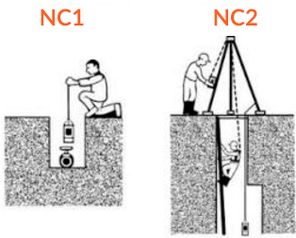

- Rescue procedure for Confined Space works will be developed at later date prior works commencement.
- Excavator will form 2:1 slope access area at the end of the trench for the access/extraction in case if an emergency and requirement of rescue procedure to be implemented.
- Interface between personnel and site vehicles/plant to be set up around works area by means of pedestrian/crowd barriers and maintained throughout the works. Accessing the work site with piece of machine will be done machine operator and banksman acknowledgement.

Identification of services prior to breaking ground
- Prior commencement of any intrusive works on site a Permit to Dig will be requested with Vision.
- Vision Utilities specialist will review the locations and complete the initial scanning using CAT4+ and Genny or equivalent/superior scan in all three modes (power, radio and generator) then issue the Permit to Dig.
- All known services to be positively located and marked on ground with exclusion zones for each service.
- The Works Manager will brief the content of the permit to all personnel affected by the works. They will sign to confirm understanding of the conditions within.
- No mechanical means of excavation within exclusion zone unless dispensation and permission from service owner is in place. Always refer and adhere to methodology agreed with service owner.
- Overhead power cables have been identified on site in various locations. Permit to work near OHL will be required (issued on monthly basis) and GS6 guidance to be followed.
- If possible, avoid working near OHL, if that is not feasible communicate with service provider to isolate service during works near it.
- All works near OHL should be done safely, if they cannot be done safely, it should be not be done at all.
- Exclusion zone for working near OHL will be required to avoid arcing:
7m – 400kV-275kV
6m – 132kV
3m – 33kV-11kV (identified on site)
1m – LV
- Size and reach of machinery and plant to be taken to consideration and whether working near, under or just travelling under OHL should be well-thought-out.
- Refer to GS6 guidance for appropriate control measures.
- Goal posts (made from nonconductive material) will be installed at crossing points to appropriate design and distance (6m away) from OHL along with fencing to protect overhead services from machine interface and possible damage. It will be restricted to single vehicle width.
- Warning signs of danger and maximum safe working height will be displayed on the goal posts. Additionally, blue cones will be placed either side of goal post.
- Machines travelling underneath services to have alarms warning the driver that the boom/jib/body is not stowed correctly.
- Machines working underneath or adjacent to OHL but capable of exceeding the maximum height or slew clearances to have electronic/mechanical restrictions on jibs/booms.
- Specific attention musts be paid when working in the hours of darkness (especially in winter time when limited hours of light are available) to ensure that overhead services are adequately identified.

Trench Excavation & Pipe Laying
- Engineer to set out and mark drainage position, also control line and level during works
- Trench excavation will be completed by 360 degree excavator specifically selected for the task/area constraint.
- Consult GRAJ Construction to provide Permit to Dig.
- Vision to CAT scan the area to be excavated and verify location of services – mark additional services as required.
- Trenches shall be supported by the use of proprietary trench boxes as ground condition dictate (i.e. battering or stepping not possible). Where trench depths exceed 3.0m deep, additional top boxes shall be used. Trenches shall be dug to a depth of approximately 1.5m prior to the boxes being installed. All further digging shall be undertaken within the trench box, with the box being ‘pushed’ into the excavation at a rate commensurate with the excavation. Trench boxes (and manhole boxes) shall be lifted by means of dedicated lifting chains supplied with the boxes using 360 degree excavator. Lift Plan to be prepared and adhered to at all times. Temporary Works design to be completed prior works commencement.
- Where hard ground is being encountered (i.e. rock, concrete) during excavation process. Excavator equipped with breaker attachment will be used to remove the obstruction.
- Vision Service Locator to scan the area to make sure no services less than a 1m away from the obstruction and is to be scan every 300mm during the excavation.
- When breaker is detached from excavator, it will be placed on plant nappy to make sure ground is protected from any potential hydraulics leaks.
- Noise exclusion zone to be established around breaking out area by physically erecting crowd barriers and to be maintained throughout the duration of works.
- All personnel working or visiting in the vicinity of exclusion zone will wear hearing protection.
- No person shall enter the trench prior to the installation of the trench boxes.
- Where, by the presence of services and other obstructions, it is not practical to use trench boxes, trench sides shall be supported by the use of traditional sheets and walers. Temporary Works design to be followed and manufacturer’s instructions.
- Trench boxes and trench sheets shall be sized such that they protrude sufficiently to form an edge barrier to the trench.

- Sufficient edge protection should be set up and maintained throughout the duration of works either by means of pedestrian barriers or proprietary system.
- Pipe bedding shall be placed within the trench by use of the excavator. Personnel shall then enter the trench by the use of the secured and tied ladder or proprietary access system and shall spread and level the bedding to receive the pipe.
- In the event of ground water being encountered in the excavation a temporary sump will be positioned to one side of the excavation to a depth just below the pipe bedding. A suitable sized pump depending on the volume encountered will then be positioned at ground level to one side of the excavation with the suction hose feed into the sump. The pump will sit in a fuel drip tray to avoid any fuel contamination. The ground water will be pumped via a delivery hose into either of the following;
- Pump the water in the field
- Pump the water to the holding pond.
- Pump the water into a tanker.

Lock Gate Design

- The design of the gates is a Pound lock. The gates are a quadrant shape which are in pairs. The gate opens by returning into a void in the lock wall to open. The gates fixed to the lock wall with the use a horizonal A frame which attaches to a bracket. The gates open with the use of hydraulics. The lock gates are guided on a track located on the lock floor.

Lock Gate Removal and Installation Process

- Dewater the working area required for the removal and replacement of the lock gates. An agreement will be made during the planning stage as to where the water will be pumped to, for us to provide a dry working zone.
- A cofferdam will be constructed at either end of the lock barrel, thereby providing a temporary enclosure around the two sets of lock gates, to keep water out and permit dewatering for the construction works to be carried out in dry conditions.
  - The cofferdam will be achieved through sheet piling, with its design issued by structural engineers.
  - Once the cofferdam has been installed, a rescue of fish and other species will be required to be undertaken by specialists before the dewatering process may commence. This will prevent species from being trapped once the water within the lock barrel has been removed.
- Once the dewatering process has been completed, works can begin on the removal of the existing lock gates. A scaffolding firm will be instructed to install scaffold access from the top walkway down to the floor of the dry lock barrel.
  - tower scaffolds will be used to provide access to the full height of the existing and new gates, providing safe access to the key components of the lock gates for their removal.
  - The walkways above the lock gates will be removed first, with the crane supporting the load whilst operatives dismantle the bolts from the lock gates.
  - The condition of the lock gates will first be assessed before deciding on a method of removal, but we hope to be able to remove the lock gates together with their frames in one single lift, so that they can be dismantled in a safer manner on the ground once offloaded.
- The removed lock gates will be removed from site by HGV’s immediately after their removal, loaded using the crane.
- Once the existing lock gates have been removed from site, HGV’s may deliver the new gates to be installed in place immediately.
- Once all three pairs of lock gates have been installed, and following acceptance by the engineer commissioning the works, all access equipment may be removed prior to the removal of the cofferdam.
- The removal of the cofferdam will be planned and executed with the same degree of care as its installation, on a stage to stage basis. Structural Engineers will also be required to assess the potential effects of the cofferdam removal on the permanent structures in place, and work together with the construction team to plan a safe way of removing the cofferdam.

- Activity Specific Health and Safety requirements
(In Addition to the mandatory PPE explained in the site induction)
- Additional PPE requirements
  - Hearing Protection whist using saw cutter and when using a breaker
  - High impact eye protection and FFP3 dusk mask when using saw cutter and within proximity of breaking.
- The following additional training may be required
  - CAT4+ and Genny or equivalent/superior scan in all three modes (power, radio and generator)
  - Abrasive wheels training to use disc cutter

- Activity Specific Environmental requirements

The following environmental monitoring is required:

- There will be spill kits made available at strategic points around the site, within the site vehicles and with each excavator.
- All Oil spills must be contained and cleaned up immediately and reported to the Site Manager, The Environmental Manager, and relevant authorities as appropriate. Fusion needs to be notified as soon as reasonably practicable.
- All materials shall be controlled and managed following the Site Waste Management Plan (SWMP). Waste must be adequately segregated and collected in designated skips. Minimise waste where possible. Tool box talks.
- Any used spill kits or contaminated waste will be double bagged and marked with the location, source of contaminant and type of contaminant if known. The contaminated material will be stored in a quarantine area within the site compound until it can be removed by a specialist removal company.
- Skips on site will be colour coded properly and appropriately signed. Skips will be covered from top by either a lid or sheet. It will be placed least 10m away from any watercourse or live drain.
- Daily briefing will identify of any potentially dust-emitting activities on site. A daily visual inspection will be made, and a record will be kept site file of whether there is a risk of dust emissions that day. Where required, dust will be dampened down with means of water where necessary to limit dust.
- Material stockpiles likely to generate dust will be enclosed if possible or kept watered as appropriate.
- Site speed limit will be briefed and asked to adhered to all operatives to limit noise and dust.
- Noise and nuisance will be controlled by making sure any plant emitting noise to be turned off when not in use.
- Spill kit to be kept with diesel bowser and on mobile plant.
- Any excavations left overnight will be covered to stop any wildlife entering the excavation.
- All materials and wastes shall be controlled and managed in line with the Resource management Plan and SWMP.
- Any timber and wood products (incl. plywood) will be certified as from a sustainable source (FSC/PEFC) with full chain custody.
- Fencing to be placed to ensure the protection of retained trees/hedgerows or other ecological features. (Retained trees to be protected in line with BS5738).
- EAP must be in place prior to any works.
- Any excavations left overnight must be covered or with access/egress ramps for any wildlife that may enter
- Areas of soil around features to be protected from construction activities including retained trees, and archaeology shall be clearly marked out by barrier tape and exclusion signs. To be confirmed with HERDS team where this is required for archaeology.

- Review and Monitoring
The method statement will be consistently reviewed and updated so that it is entirely up to date throughout the project duration.

- Method Statement Briefing Log
I/We* the undersigned have been given, and fully understood, the briefing of the contents of this method statement.
NAME | POSITION | DATE | SIGNATURE | REVISION NUMBER

BRIEFING BY
SIGNATURE |  |  | ROLE |  |  | DATE

- Appendix – Nearest Hospital
Singleton Hospital
Telephone Number: 01792 205666
Address: Sketty Lane, Sketty SA2 8QA

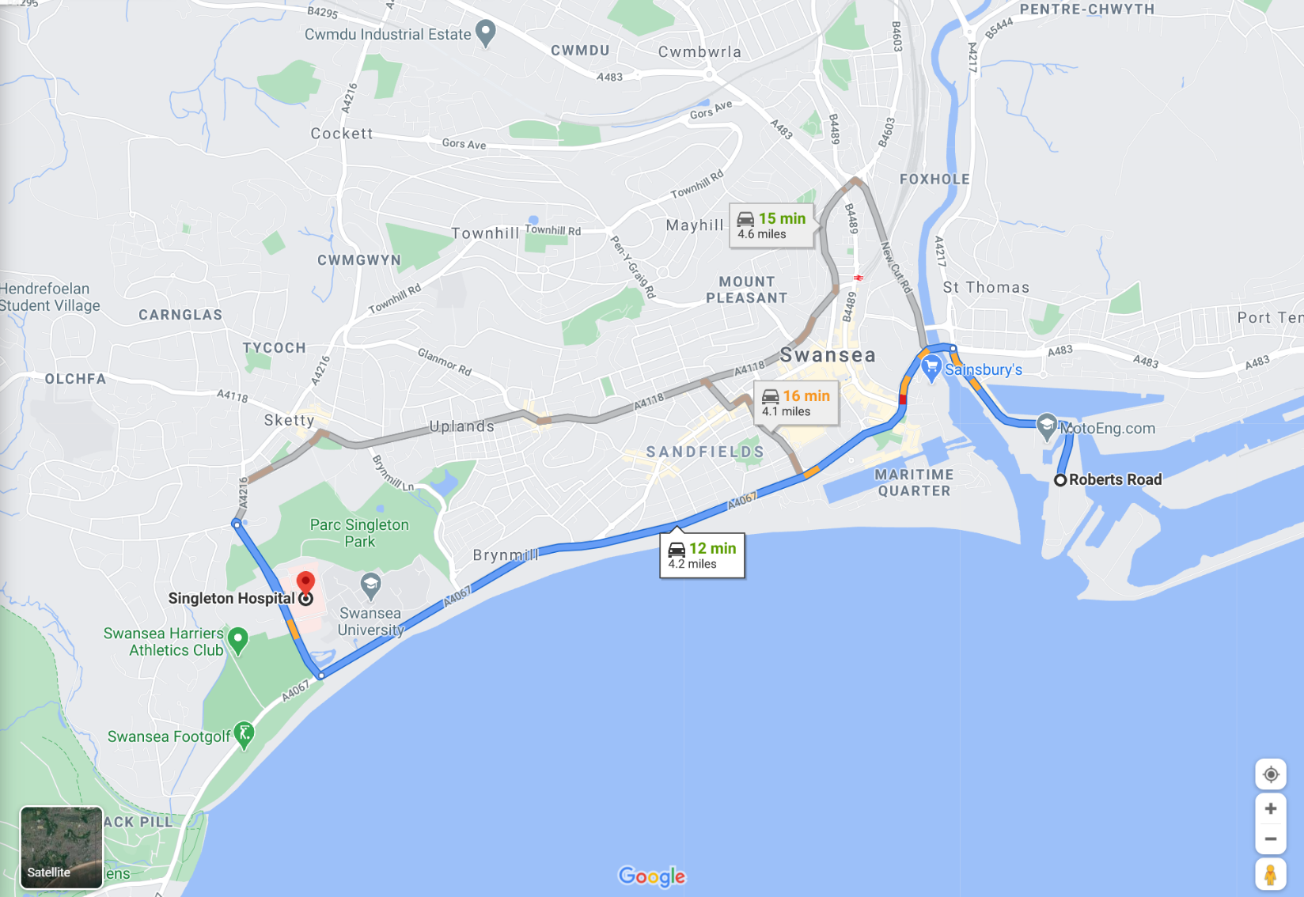

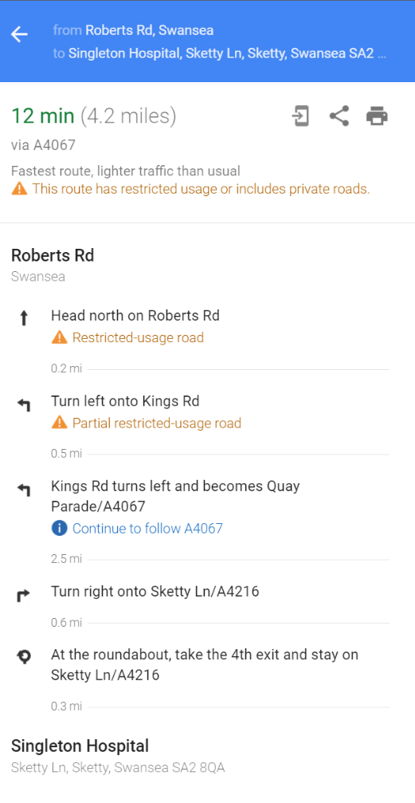

Appendix B – Lock Gate Information

