University of Wales Trinity Saint David
Wales Institute of Science & Art



Assessment 1 - Report
Engineering Projects (ACHA4034)

Group C

January 2026
Contents
1. Introduction 1
2. Design iterations and rationale 2
2.1. Initial Design Ideas 3
2.2. Final Design 4
3. Materials and methods used 5
3.1. Main design Overview 6
4. Testing and results 7
4.1. Results 7
5. Conclusion 8
References 9

- Introduction
Through this building, development, and testing assessment. As a team, we built a rubber band car. The primary objective was to research designs, expand and develop these into our own engineering drawings and the construction of the final design. As a team, we researched existing rubber band designs to take ideas and prompts from. This approach gave us the greatest opportunity to succeed in the upcoming competition against our current classmates. The following sections outline the process of researching, designing, and building our rubber-band car. Along with what worked well during building and testing. This shows how we adjusted the car throughout the process to simplify and improve its capabilities.

- Design iterations and rationale
During the initial stage of planning, we found out that there were many different types and designs of rubber band cars already in existence. While most designs had a four-wheel design, as shown in Figure 1. Some varied in the number of wheels used. We also found during research that the length of the vehicle used varied depending on the purpose of the test they were researching. 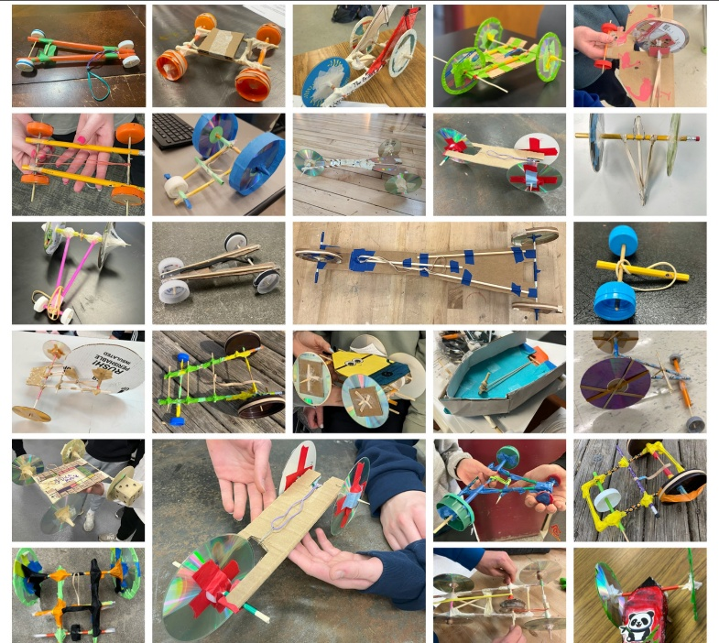
Figure 1
Early research into the rubber band cars showed that traction and torque transfer would be critical in the performance of our car. Particularly as our build station was a hard plastic material, and our testing surface was carpet. Critically, design decisions throughout the build process allowed us to modify the wheels to have more grip and reduce unwanted energy losses through the axles.

Initial Design Ideas
Our initial design started with a basic square frame made from popsicle sticks. Then, attaching an axle to the rear end of the square frame and having CDs attached to the axle to create the rear wheels. We were undecided on how we were going to attach the rubber bands to the axle. Whether we were going to have a releasing mechanism or a fixed mechanism.
Throughout the building process, the basic square frame went through a few iterations. Starting with a basic square frame that then extended to make the axle longer. We then realised that to attach the axles to the front and rear of the vehicle, we would have to double up the popsicle sticks to allow the axles to sit on the frame.

We also debated whether we would use CDs for the front wheels or wooden wheels, as the wooden wheels would provide a bigger contact area with a smaller rotation in comparison to the CDs, that will have a smaller contact area and a bigger rotation.

We also came up with an idea to have a bigger axle on the rear for the row bands to sit around, but we weren't sure if it was going to work due to the tension within the bands. This was due to not knowing the full amount of stress and strain we could put on the popsicle sticks without breaking.

Final Design
In the end, we decided on having wooden wheels on the front with rubber bands around the wheels to provide more traction on the carpet floor surface. We also decided to put two CDs together with hot glue to make the rear wheels thicker and make two of these for each side of the vehicle.
There was a long debate on how we were going to attach the series to the axle to allow them to spin. This was because if we connected directly to the axle, it may not spin and make the vehicle inert. So, we decided to attach the axle with paper straws to allow it to spin and fix the series to the axle using hot glue. We had to use metal washers to secure the CD to the axle due to the CD’s being too big. This allowed for a more precise attachment to the rear axle.

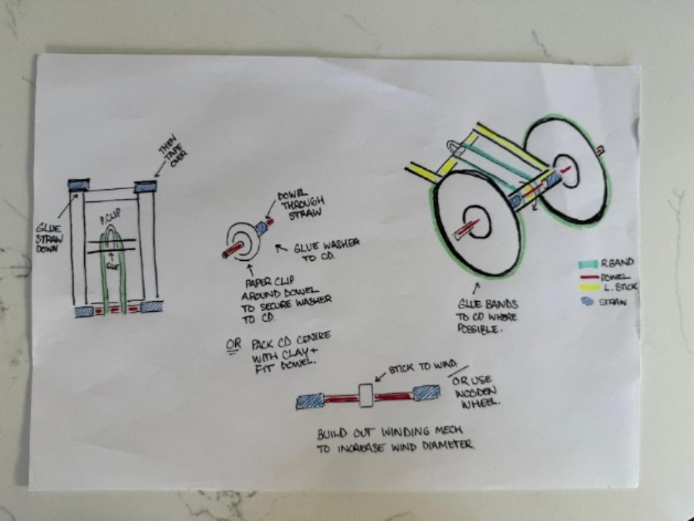
We decided on making a fixed axle for the rear that had a larger diameter piece attached in the middle for the bands to rotate around to create the required tension through the bands to provide directional movement. We did this as in our minds this would create the most torque and speed when released. As shown in Figure 2.

Figure 2

- Materials and methods used
During the construction of our rubber band car, we had to follow some rules and regulations. The main rules we had to follow were the materials we could use to construct with. These were as follows:
- Lollipop sticks (20)
- CDs (4)
- Rubber bands
- Wooden dowels (5)
- Straws
- Washers (10)
- Paper clips
- Cello-tape
- Modelling clay
- Wooden wheels (4)
- Glue gun
Due to these restrictions, we had to limit the number of materials we used so as not to exceed the limit.

Main design Overview
- The final vehicle utilises a four-wheeled layout with a slightly lower front end, which allows for a slight enhancement in stability. This configuration of a larger rear wheel and smaller front wheel equally distributes the weight more efficiently and reduces the chance that the front axle lifts during rapid acceleration. During the release process, this design can be seen in figures 3 and 4 and illustrates the complete design and key structural features mentioned throughout this report.
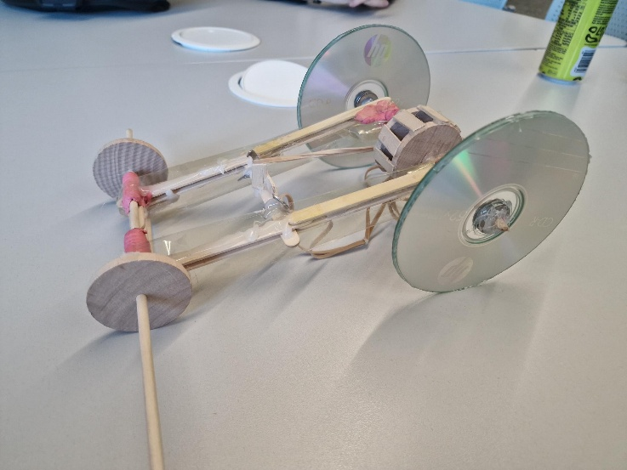
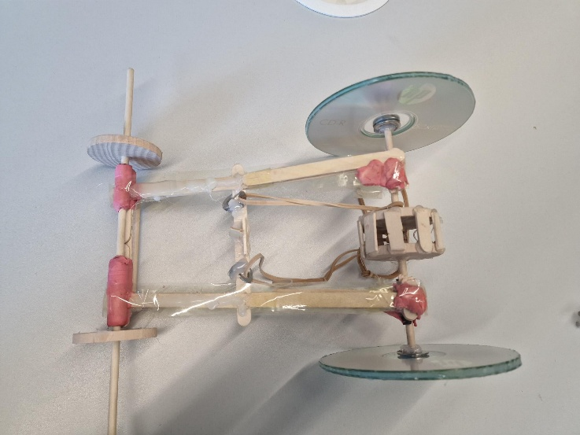
Figure 4
Figure 3

- Testing and results
During the testing portion of this assignment, we verified that the car successfully traversed 2 meters. Despite identifying several design flaws during the testing phase, including the vehicle's rollback at the conclusion of the rubber band's elasticity, which impacted the overall distance travelled, our team remained confident that the total distance achieved would yield a favorable outcome in the forthcoming competition.
The team was satisfied enough with the information gathered from the 2-meter runs to proceed with the design, even if no top speed was obtained during the testing phase. With a little change for the maximum speed run, a larger rubber band would be added for additional torque off the line.

4.1. Results
Our results show that our vehicle had higher acceleration but was unable to keep a constant speed due to the amount of torque created in the rear wheels. We found that the vehicle was consistently hitting the two metre mark, but was inconsistent with extending the distance further. We found that the maximum distance we could reach was 3.1 metres with an average speed of 2.3 m/s.
Our fastest speed over the two-metre gap was 1.1 metres per second with a time of 1.81 seconds. This was calculated using the equation:
$$s=d/t$$
$$s=2/1.81$$
$$s=1.10$$
Due to our vehicle not having a consistent distance measurement, we have averaged our speed over the two-metre gap with an average time of 1.90 seconds.

- Conclusion
The major purpose of this project was to design and build a rubber band-powered vehicle that could meet performance standards while staying within strict material constraints. This goal was successfully met. Using an iterative engineering design process, a working and competitive four-wheeled vehicle was made that always went farther than the required minimum of two meters and reached a maximum distance of 3.1 meters.

The final design did a good job of turning elastic potential energy into kinetic energy, which gave it a lot of early acceleration thanks to a fixed back axle and a bigger torque mechanism. Testing, on the other hand, showed that there were several big problems, like too much torque, making the speed uneven, and the car rolling back after the rubber band had let go of all its stored energy. These experiments show how vital it is to find the right balance between torque, traction, and efficiency in tiny vehicle systems.

References

Feinberg, L. (2011). Rubber band car hands-on challenge: explore force and energy with PBS’s Design Squad Nation. Technology and Engineering Teacher, 71(4), 21.

Feinberg, L. (2012). Rubber Band Car Hands-On Challenge. Technology and Engineering Teacher, 71(4), 21.

