ACBA4003: Construction phase plan
  - By Ben Kneeshaw – 1902457

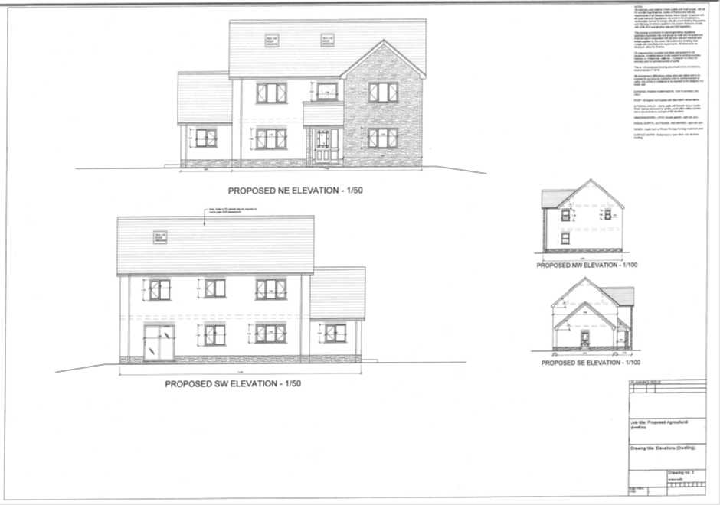

Table of contents

- Introduction………………………………………………………. Page 3
- Client/contractor duties…………………………………………. Page 3
- Construction phase plan………………………………………... Pages 3-5
- Method statements……………………………………………….Pages 5-6
  - Foundations………………………………………………………Page 5
  - Concrete floor slab……………………………………………….Pages 5-6
  - Scaffolding………………………………………………………..Page 6
- List of references…………………………………………………Page 7
- Appendix A – Excavations………………………………………Page 8
- Appendix B – Hazardous substance control………………......Page 9
- Appendix C – Working at height………………………………..Page 10

Introduction

This report will act as a construction phase plan file for the proposed domestic new-build, adjacent to the new UWTSD student accommodation in SA1 Swansea. It includes: a construction phase plan, method statements and risk assessments. References will be made to all applicable ‘health & safety’ legislation.

Client and contractor duties

The client for this project is commercial; due to this there are duties of which the client is responsible. This essentially means any ignorance towards health and safety procedures on the part of the client will result in them being legally responsible for the outcome (Summerhayes, 2016 p.30).
Another stipulation the client should be aware of is the provision of welfare facilities. Due to the small nature of the site it may be unfeasible to install welfare facilities. As the client is constructing in the adjacent site it may be feasible for workers to use the facilities already in place there, if this is not the case a portable toilet along with adequate seating and washing facilities must be provided (HSE, 2010 p.4).
As this project falls under the category of ‘constructing a structure’ all construction works must be in compliance with the CDM regulations of 2015 (Summerhayes, 2016, p.14). As such there are measures the contractor must put in place before or upon commencement of works.
Gov.uk (1974) states as part of the health and safety at work act: ‘It shall be the duty of every employer to ensure, so far as is reasonably practicable, the health, safety and welfare at work of all his employees’. A similar duty applies towards non-employees affected by the employer’s undertakings (Summerhayes, 2016, p.16). As such it is important the site is properly secured at all times, avoiding the risk of trespass and injury to a member of the public as this may result in a prosecutable offence.

Construction phase plan

This project is likely to take 4-6 months to complete, starting on the 6th of May and aiming to finish on the 6th of September. This is an ideal figure and extensions may be required due to unforeseen circumstances. Welfare facilities will either be in the adjacent site or on-site if the adjacent site is unavailable, at the discretion of the client. The site is positioned so as to be easily accessible from Kings Road east of the site. This access is for construction specific machinery and materials only and those working on site will be required to park elsewhere due to space limitations.
As the groundwork for the site has already been conducted the first phase for this project shall be the foundations. These will be of strip construction with a base depth of one metre. A trench will be required for this; it will be present underneath the footprint of all external and load-bearing walls. This is not a major depth but a cubic metre of soil can weigh 1.5 tonnes under certain conditions and so precautions must be taken, a risk assessment for this has been completed in appendix A. HSE (2015) state all steps must be taken to ensure worker safety in excavations and as such a number of precautions will be taken. Firstly supports will be used to prevent the edges of the trench from collapse. Secondly the trenches will be clearly marked with barriers so as to prevent any persons from falling into them; this will be clearly explained to all workers during induction. Thirdly precautions will be taken to prevent any accumulation of materials or machinery near to or around said trenches. Finally HSE (2015) state any battens or supports will require inspection by a competent person at the beginning of the working day, additional inspections will be required after ‘any event likely to compromise the strength or stability of an excavation’ and ‘after any material unintentionally falls or is dislodged’. All these precautions will be taken and workers will be required to wear appropriate PPE so as to mitigate any remaining risk.
The next phase for this project will be the superstructure, this is crucial as completion will result in a moisture resistant structure capable of withstanding unforeseen adverse weather conditions with minimal issues, thus reducing the likelihood of any setbacks. This will begin with the building of the external and load-bearing walls up from the foundations. Once the walls are above ground level and the trench has been filled, the inner ground will be compacted and covered using a damp proof membrane, this will allow for the concrete floor slabs to be poured. Concrete can be a hazardous substance, a risk assessment has been carried out in appendix B. Once the concrete has dried the suspended floors can be installed, this will be the best time for this as they are heavy and can be easier put in place at this point. Once this has been completed the walls will continue to be built upwards, special care must be taken when the first floor is reached as joists or joist hangers will need to be built into the load bearing walls for the suspended timber upper floors, the joists will need to be fitted at this stage as it will be easier to do whilst the roof is still open. The particleboard flooring can also be fitted at this stage to allow workers to use the inner floors as a safe level surface. Once the walls are complete the next part will be the roof, due to the roof size trusses will be needed, heavy machinery will be required on-site in order to lift the various components into place. There are a number of risks involved with this phase, namely working at height for which a risk assessment has been completed in appendix C. Scaffolding will be required for this project up to the eaves level. HSE (2005) state that in order for scaffolding to be safe, there are a number of precautions that must be taken. For this project guard rails and toe bars will be sufficient to prevent people falling. In order to comply with regulations the guard rails must be 950mm above the toe bar with an intermediate rail between the guard rail and toe bar with a gap no larger than 470mm. This will also help to protect against falling objects but not fully, as such waste chutes will also be provided to ensure any waste can be transitioned to ground level safely. Hard hats will be required as part of each worker’s PPE so as to protect the workers in the case of any accidents involving falling objects.
The third and final stage of this project will be the fitting out of the structure. The walls will have been built at this point with sufficiently strong lintels in place for all openings. As such the openings will now be fitted with windows and doors. Once this has been completed the smooth render can be applied to the exterior walls. This is the last exterior component for the project and as such the scaffolding can now be dismantled and removed from the site. The next stage will be to fit out the interior of the building with stairs and partition walls, thus completing the overall structure. Qualified professionals will be required on-site at this point to fit out the structure with electricity, gas and water, and all necessary internal fittings related to these commodities: such as heating, bathrooms etc.

Method statements

Foundations

The first stage of the foundations shall be excavating a trench one metre deep at the footprint of all load bearing walls for the proposed project. HSE (2015) state supports and barriers will be required, due to this these measures will be installed as and when the trenches have been excavated. A competent person will inspect these precautions at the start of any working day whilst they are in place.
Once the trenches are all in place concrete will be delivered in mixer vehicles and pumped into the trenches using a lorry pump. These will be positioned on site so sufficient space must be made and areas must be kept as clear as possible. The trenches will be filled up to a minimum of 150mm. Once this is complete the foundation will be built up using foundation blocks up to ‘just under’ ground level. At this point cavity wall construction will be used up to ‘just over ground’ level when the remaining space in the trench will be filled.

Concrete floor slab

The first stage of this phase will be to compact the inner ground to at least 100mm below normal ground level, some excavation may be required. A damp proof membrane will then be laid on top of the compacted ground and layered into the load-bearing walls. At this point concrete mixer vehicles and a lorry pump will be required on site once more. The concrete will be poured via the lorry pump into the internal areas to a minimum depth of 100mm and allowed to set.

Scaffolding

Scaffolding will be required on site for the building up of the project’s superstructure. The ideal time for this will be after the pouring of the floor slabs as concrete pump and mixer vehicles will no longer be required on site, thus allowing more space to be used. In order to comply with regulations all platforms comprising part of the scaffolding will: be solid with zero holes, have toe bars and have guard rails spaced as per the dimensions set out in the construction phase plan (HSE, 2005). Waste chutes will also be included as part of the scaffolding so as to mitigate the risk of falling objects. The scaffolding will be set up and inspected regularly by a competent person so as to ensure safety for all workers using it. Once the superstructure is complete, all openings are filled and the exterior render has been applied the scaffolding will be dismantled by a competent person or persons so as to mitigate any risks involved.

List of references

- Gov.uk (1974) Health and safety at work act 1974. Accessed at: http://www.legislation.gov.uk/ukpga/1974/37/contents (Accessed on: 24.04.20)
- HSE (2005) The work at height regulations 2005. Accessed at: http://www.legislation.gov.uk/uksi/2005/735/contents/made (Accessed on: 24.04.20)
- HSE (2010) Provision of welfare facilities during construction work. Accessed at: https://moodle.uwtsd.ac.uk/pluginfile.php/340785/mod_resource/content/0/Welfare%20Facilities.pdf (Accessed on 24.04.20)
- HSE (2015) The construction (design & management) regulations 2015. Accessed at: http://www.legislation.gov.uk/uksi/2015/51/contents/made (Accessed on: 24.04.20)
- S D Summerhayes (2016) CDM regulations 2015 procedures manual. Fourth edition. John Wiley & sons: Chichester.

Appendix A – Excavations

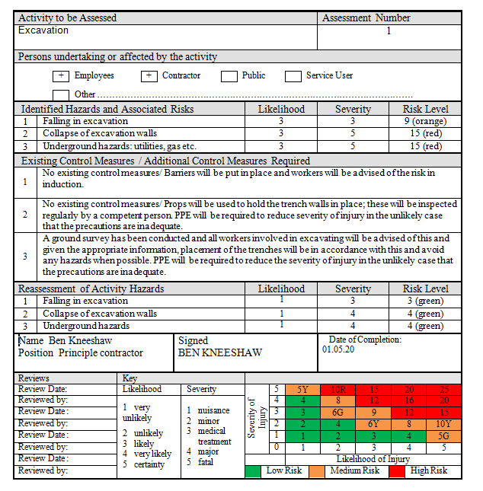

Appendix B – Working at height

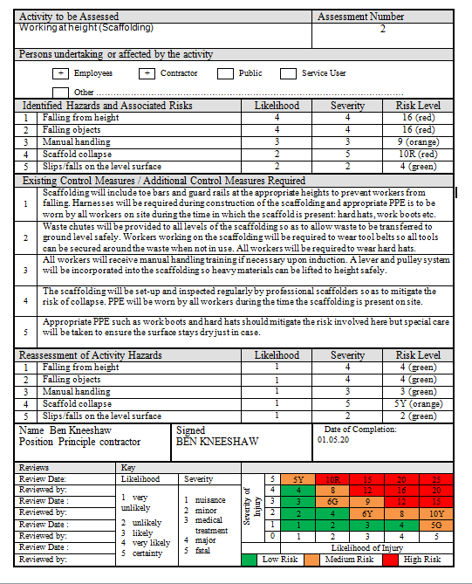

Appendix C – Control of hazardous substances



