

Programme: MSc Engineering Project Management

Module: Sustainable Operations Management Module code: ACHA7031

Title: Sustainable Inventory and Waste Management at Brocksweir Engineering Ltd
Lecturer: Andrew Thorn

Student Name: Md Jahid Hasan

Student ID: 2512612

Word Count: 2685

Executive Summary

The inventory issue with Brocksweir Engineering Ltd can be put into a better perspective when it is thought of as an organisation's ineffective control system. The company is using an all-equals treatment to restock very different materials when the foundry sand could be much more stable, while the new materials- phenolic, furan, etc. are far more costly and are far more hazard prone, not to mention their expiration dates. Consequently, as shown above, the report argues that there is a need to adopt a hybrid inventory management system in Brocksweir. Sand should be closely controlled using min-max and EOQ-based materials management techniques, and at the same time, resin should be managed by using FEFO discipline, batching visibility, reduction of order quantity and better coordination of the suppliers (Slack, Brandon- Jones and Burgess, 2024; Asghari et al., 2026; Salas-Navarro et al., 2026). It also highlights the need for a structurally careful series of quarantine, verification, authorised recovery screening and authorised disposal (where there is a clear-cut safe alternative) of the current stock of obsolete resin stock in an "unique" category (Department for Environment, Food & Rural Affairs, 2011; Environment Agency, 2024). Lastly, Brocksweir will require all the lead-time information they could ever want about their suppliers, their stores, how stock flows into production and back again, so that they are made aware of the ageing risk before the stock becomes a waste. Stabilising batch control for resin and triaging obsolete batches while waiting for updated rules governing batch replenishment based on verified shelf-life and lead- time data should be the top priority for resin (Teriete et al., 2026; Kalla, Scavarda and Hellingrath, 2025).

Table of Contents
Executive Summary 2
- Introduction 4
- Managing Sand and Resin Inventory Better 5
  - Diagnose why the current inventory approach is failing 5
  - Evaluate the candidate control tools 5
  - Recommended inventory architecture for Brocksweir 7
- Options for Dealing with the Obsolete Stock 9
  - Define the obsolete-stock decision problem 9
  - Critically analyse the available options 9
  - Recommended option hierarchy 12
- Understanding Lead Time Across the Business and Extended Enterprise 13
  - Identify the blind spots in current lead-time understanding 13
  - Evaluate the measures Brocksweir should take 13
  - Recommended governance model 17
- Integrated Recommendations and Conclusion 18
References 19

Introduction

Brocksweir Engineering Ltd faces a significant operational problem. They've seen poor inventory discipline, more than £20,000 of resin has passed its shelf life and rising on the disposal costs when the demand for sand has increased. In that context, buying can only be made based on the total economic impact. In that context, there is only one way to buy judgment: the total impact of the economy. They also need to be evaluated in terms of their impact on wastefulness, working capital, service reliability, compliance risk and environmental impact (Slack, Brandon-Jones and Burgess, 2024; Department for Environment, Food & Rural Affairs, 2011).
This report looks at Brocksweir's issue from an operations sustainability perspective, applying inventory-control theory, waste-tracking principles and end-to-end lead time analysis to compare choices on sustainability factors such as cost, compliance, service reliability, and environmental considerations. It starts with looking at controlling inventory of sand and resin, then explores the tools which are available for dealing with obsolete stock, and finally considers how lead time should be understood throughout the business and extended enterprise.

Managing Sand and Resin Inventory Better

Diagnose why the current inventory approach is failing

The initial failure mode is thinking in one-size-fits-all policies. Demand has increased from the foundry market, while resin has expired in stock, implying that there is a lack of alignment between purchase, stock maintenance, issuance discipline and review frequency. The authors of this paper argue the importance based on deteriorating inventory research. While sand, known as an inert material, can be managed similarly to a non-deteriorating inventory, the replenishment logic for stability-sensitive chemicals must be different, since the deterioration of the inventory itself reduces value (Asghari et al., 2026). A similar finding is offered by the multi-criteria classification research, which demonstrates that, in addition to annual usage value, lead time, durability, ordering cost, and criticality have to be considered (Soylu and Akyol, 2014). Purchase price is not the only factor for Brocksweir to consider when deciding on stocks.

Evaluate the candidate control tools

The most appropriate techniques to use for inventory can be determined as being the following for Brocksweir: EOQ and Min/Max Control, but this is to be used differently depending on the material type. EOQ can be beneficial in reducing emergency purchasing when demand is relatively stable, when the material has high volume, and when the shelf-life is low, as in the case of sand. These costs must be factored into the holding cost calculation, which should include storage, drying, handling and disposal environmental costs of the unused material. When these costs associated with sustainability are not considered, the EOQ model may fail to identify the actual cost of carrying excess sand inventory (Slack, Brandon-Jones and Burgess, 2024; Asghari et al., 2026).
Resin is a hazardous material that needs to be managed differently as it is perishable. Perishable inventory studies stress that the issue of stocks with "use by" dates directly results in financial loss and risk of disposing of the stocks (Boxma, Perry and Stadje, 2024). Hence, resin should be managed with smaller and more frequent ordering,

inflexible reorder points, FEFO (first-expiry-first-out) storage controls and controlled safety stocks. However, the (classical) EOQ models can recommend a high ordering quantity for orders that seems cost-effective but may pose practical challenges when combined with expiry, hazardous-disposal, and other factors (Asghari et al., 2026; Schuitemaker and Xu, 2020). In general, a segmented inventory policy that takes the different operational risks of the materials into account is recommended for Brocksweir.
Selected lines of resin can be a possibility, if data are reliable, due to the selective supplier collaboration. While being able to help reduce waste and increase synchronisation, VMI requires information sharing and digital and realistic routine (Salas-Navarro et al., 2026). Therefore, a planning cycle is considered to be more suitable than supplier-led replenishment (SLP) across a larger time horizon, for Brocksweir this monthly cross-functional planning cycle is more suited than replenishment from suppliers (SLP) (Kreuter et al., 2022; Kalla, Scavarda and Hellingrath, 2025). This logic is realised as the matrix of Brocksweir in Table 1.
Table 1: Brocksweir inventory-control matrix by material type, demand pattern, shelf- life risk, recommended rule, owner, and KPI

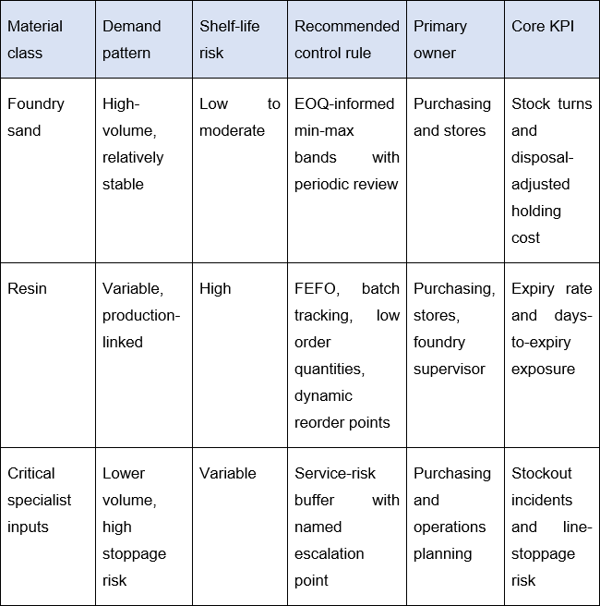

Recommended inventory architecture for Brocksweir

- Another important point is differentiating the inputs, critical specialist from sand and resin, into separate policy classes as their deterioration and service risks are different from each other (Asghari et al., 2026; Soylu and Akyol, 2014).
- Implement FEFO, batch coding and ageing alerts for all resin stock to ensure issue discipline by expiry risk and not based on “convenience in the issues” (Schuitemaker and Xu, 2020; Boxma, Perry and Stadje, 2024).

- Implementing reorder points and min-max bands that are dynamic, rather than static, that are shortened with actual demand and extended with shelf life to prevent out-of-stocks (Slack, Brandon-Jones and Burgess, 2024; Asghari et al., 2026).
- Incorporate the use of cycle counts for resin critical inputs, as per the Monthly discrepancy review, which should result in FEFO and reorder points based on accurate batch information (Schuitemaker and Xu, 2020; Kreuter et al., 2022).
- Improves the accuracy of stocks and considers trial supplier collaboration or VMI only for selected lines of resin, through the Monthly Forum, reviewing discrepancies. (Kalla, Scavarda and Hellingrath, 2025; Salas-Navarro et al., 2026).

Options for Dealing with the Obsolete Stock

Define the obsolete-stock decision problem

Ought expired resin is a mixed quality, Compliance, cash-flow and environmental concern. Guidance by the Environment Agency indicates that more likely materials will be treated as waste when unwanted, when inappropriate, when in excess supply, when treated in harmful ways, and when so reused under the legal claim of reuse, there must be certainty of use, fitness of purpose and no increased risk of health or the environment (Environment Agency, 2024). Brocksweir cannot thus presuppose that resin that has passed its expiry date is still a viable input due to the fact that they have not opened the bottles. Some of its decision criteria should be legal status, technical usability, disposal liability, recovery value, reputational risk and that of speedy resolution.

Critically analyse the available options

Quarantine is the initial and proper action for the disposal of surplus resin. Unless recovery or disposal can be determined, all expired or potentially unstable resin batches should be isolated, clearly marked and subject to careful handling and storage along with periodic container checks for potential damage. Advice from the Environment Agency emphasises the need to separate, store and ensure competent management of hazardous waste. The Health and Safety Executive (HSE) advises on the significant risk associated with unstable and incompatible chemical materials (Environment Agency, 2020; Health and Safety Executive, 2023). As such, it is important for obsolete resin to be treated as a controlled hazard and not as a normal ingredient in a stockroom.
The next step should be information-based screening. Before deciding whether to re- use or recover, Brocksweir should consult the most up-to-date SDS, supplier advice, Expiry evidence and Batch history. In accordance with the guidance provided by DEFRA, waste prevention and lawful recovery are encouraged wherever safe and practically possible (Department for Environment, Food & Rural Affairs, 2011). Re-use is a valid option. The Environment Agency reminds that only when it can be

demonstrated that the material is safe, technically appropriate and legally permitted (Environment Agency, 2024). Thus, controlled testing or limited use may only be appropriate for those batches of components that are found to meet supplier requirements and operational needs.
Recycling and particularly supplier take-back schemes and specialist treatment options should be considered to reduce the amount of items going for disposal, where this is not possible. However, environmental assessments show that there are concerns to be raised about the release of contaminants and leaching risks of phenolic and furan resin systems (Cioli et al., 2022; Holtzer et al., 2020). Even if part of the stock of GBP20,000 is lost, there is really no other safe or legal way to dispose of the hazardous waste than using licensed hazardous-waste services (Environment Agency, 2024; Health and Safety Executive, 2023).
Table 2: Decision matrix for obsolete-stock options

Option | Cost effect | Compliance risk | Environmental effect | Speed | Suitability for Brocksweir
Quarantine | Low | Low if | Positive | Fast | Essential
and identify | immediate | handled | because it |  | first step
 | cost, | correctly | prevents
 | prevents |  | accidental
 | escalation |  | release
Technical | May | Medium to | Mixed; | Moderate | Only for
revalidation | recover | high unless | depends on |  | clearly
or | value on | strongly | lawful safe use |  | defensible
controlled | limited | evidenced |  |  | batches
use | batches
Supplier | Can | Medium; | Better than | Moderate | Worth
return or | reduce | depends on | direct disposal |  | pursuing
take-back | disposal | contractual | if approved |  | selectively
 | costs | and legal
 |  | route
Specialist | May | Medium | Potentially | Moderate | Case-by-
recovery or | reduce |  | positive if | to slow | case only
treatment | landfill |  | legitimate
 | burden,
 | but needs
 | approval
Licensed | Highest | Lowest if | Negative | High | Final fallback
hazardous | direct cost | properly | relative to | certainty | for
or special- |  | managed | recovery, but | once | irrecoverable
 |  |  | safer than | arranged | stock

waste disposal |  |  | weak reuse claims

Recommended option hierarchy

- Immediately quarantine, label and trace all obsolete batches of resin, as the company will not be treating stock that they are unsure of as normal stock (Environment Agency, 2020; Health and Safety Executive, 2023).
- Based on the safety data sheets, expiry date evidence, storage requirements and suppliers' advice, consider and review whether any further option should be pursued (Environment Agency, 2024 and Department for Environment, Food & Rural Affairs, 2011).
- Only test or re-validate when performance and compliance can be justified based on evidence, but not because of sunk costs (Cioli et al., 2022; Holtzer et al., 2020).
- Employ supplier returns, suitable recovery and specialist treatment routes provided that they are legal and feasible (Department for Environment, Food & Rural Affairs, 2011; Environment Agency, 2024).
- Consider irrecoverable stock as your last resort and pass back any lessons learnt to the suggested preventive controls listed in section 2 (Health and Safety Executive, 2023; Department for Environment, Food & Rural Affairs, 2011).

Understanding Lead Time Across the Business and Extended Enterprise

Identify the blind spots in current lead-time understanding

It is probably the limits of measurement that are the key blind spot. All lead times must be added together in this instance and should encompass suppliers' manufacturing time, inbound transport lead time, book-in delay, stores handling delay, release to production delay, any delay whilst the product is in production, and the reverse flow time when the material becomes out of stock. The concepts through value stream mapping and process mining have revealed that the manual maps don't capture variability and the hidden waiting time, and the S&OP studies have demonstrated that the failures of internal coordination are as significant as suppliers' failures (Teriete et al., 2026; Kreuter et al., 2022). It will continue to tweak orders until someone in the supply chain, such as Brocksweir, can measure the whole chain.

Evaluate the measures Brocksweir should take

To achieve this, an end-to-end lead-time map for sand, resin and other important inputs is required. A conventional value-stream map is a good first step as it will make the company think about every touch point for the material and information from the supplier to the company's goods, in foundry preparation, use in production and, if applicable, backflow. However, the literature cautions that static mapping alone is limited, as it only provides a snapshot in time and is unable to capture the time scale (Teriete et al., 2026). Therefore, Brocksweir should not use mapping as the last line of visibility, but the first.

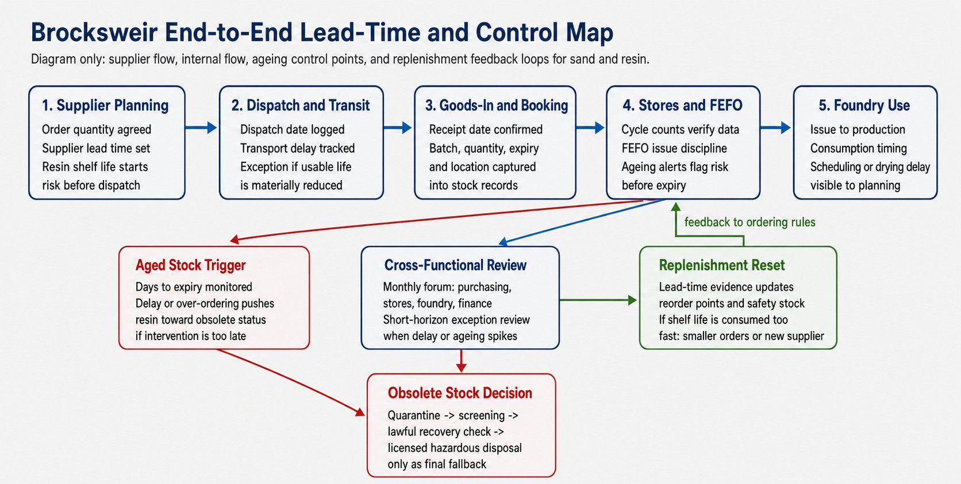

Figure 1: Brocksweir lead-time map

The second is time-stamped data capture at the material/batch level. From product- traceability research, it can be concluded that if organisations establish identifiable records between their receipts, storage status, movement through processes and decisions of usage, visibility improves (Schuitemaker and Xu, 2020). In the case of Brocksweir, that equates to structured date of receipt, batch number, shelf-life date, location, date off the shelves and the reason for the delay. This is particularly relevant to resin, as batch-level ageing information will form the link between Inventory Control and Obsolescence Prevention. It is essential to make FEFO more than just an aspiration.
Third, Brocksweir's governance of the data supplier-facing and cross-functional needs to be in place. Visibilities of lead-time should be broken up by material class. Extensive delivery service ranges can be justified for sand, but close service levels need to be set for resin, since delay can erode service time. According to the VMI literature, close collaboration with suppliers can provide an additional boost of alignment, provided the information basis is reliable and can be shared with suppliers (Salas-Navarro et al., 2026). S&OP research also found that for uncertain conditions, the need to forecast both products and forecasts frequently requires a more frequent planning cycle as well as a shorter-horizon risk review closer to actual execution (Kalla, Scavarda and Hellingrath, 2025). That translates for Brocksweir into a cross-functional review of

stock, lead time and ageing exposure every month, with exception escalation when deliveries are late or if there are material changes to the production schedules.
The ultimate one is ownership. Transparency and mapping are low if no one takes action based on the signals (Schafer, 2023; Kreuter et al., 2022). Ownership of supplier metrics should be in purchasing. Store data capture accuracy should be in the stores. Discipline in consumption should be in foundry operations, and challenging the slow-moving ageing stock costs should be in finance. Here, people-process-IT dominates over software alone – a matrix is turned into a dashboard of ownership and cadence, as seen in Table 3.
Table 3: Lead-time dashboard for Brocksweir

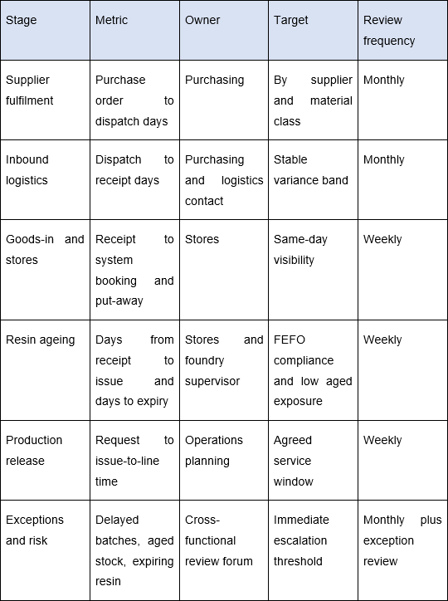

Recommended governance model

- First, create a baseline lead-time map of all of the critical material flows, as well as supplier lead, stores lead, production lead, and reverse-flow lead. That is, measure lead time, rather than guess (Teriete et al., 2026 and Schafer, 2023).
- Specify Responsibility for Data Capturing, Supplier Communication and Exception Escalation as responsibility without visibility will not lead to change of decisions (Schuitemaker and Xu, 2020; Kreuter et al., 2022).
- Monitor lead-time, ageing/expiry risk KPIs monthly in a purchasing-stores-foundry- finance forum, with interim escalation when a risk tolerance level exceeds defined limits (Kalla, Scavarda and Hellingrath, 2025; Kreuter et al., 2022).
- Based on measured changes in leadtime, update reorder points, adjust levels of safety stock, change supplier conditions, and, when necessary due to the consumption of the resin life, redesignation of smaller orders and/or a new supplier (Salas-Navarro et al., 2026; Schuitemaker and Xu, 2020).

Integrated Recommendations and Conclusion

The questions are singular, weak inventory classification encouraged the bulk buying, resin ageing and late intervention of Brocksweir's problem. The control architecture, therefore, must be re-designed for a sustainable response, optimising just one single rule is not enough (Asghari et al., 2026; Department for Environment, Food & Rural Affairs, 2011; Kalla, Scavarda and Hellingrath, 2025).
The containment redesign governance sequence. Immediate term next steps for Brocksweir involve stock audit, stock segregation of obsolete resin, implementation of FEFO for live resin and set-up of supplier dialogue about the possible routes for returns/resin treatment (Environment Agency, 2020; Environment Agency, 2024). In the medium term, it should selectively divide sand and resin into different control classes and use the dynamic min-max rule, reorder rule instead of Sand and Resin blind purchases, and install batch-level data capture, which is related to receipts, ageing, issue, and expiry risk (Soylu and Akyol, 2014; Schuitemaker and Xu, 2020). In the longer-term, the company should formalise a monthly cross-functional stock, lead time and ageing exposure review with greater supplier expectations and exposure escalation when there is a short shelf life or delay (Salas-Navarro et al., 2026; Kreuter et al., 2022).
The best response to this is therefore a blended operating model that combines stable sand under economic control, hazardous resin under conservative control, obsolete material through a lawful decision hierarchy, and that focuses the lead-time information on triggers for a change of behaviour before waste occurs at Brocksweir. That's commercially viable, more sustainable and the best way to prevent them from happening again.

References

Asghari, M., Jaber, M.Y., Afshari, H. and Searcy, C. (2026) 'Deteriorating inventory models: a comprehensive review', Computers & Industrial Engineering. doi:10.1016/j.cie.2026.111993.
Boxma, O., Perry, D. and Stadje, W. (2024) 'Perishable inventories with random input: a unifying survey with extensions', Annals of Operations Research. doi:10.1007/s10479-023-05317-2.
Brandon-Jones, A., Slack, N. and Burgess, N. (2024) Operations Management. 10th edn. Pearson. Available at: https://www.pearson.com/en-gb/subject-catalog/p/Slack- Slack-Operations-Management-10th-edition-10th- Edition/P200000005430/9781292473635 (Accessed: 4 May 2026).
Cioli, F., Abba, A., Alias, C. and Sorlini, S. (2022) 'Reuse or Disposal of Waste Foundry Sand: An Insight into Environmental Aspects', Applied Sciences. doi:10.3390/app12136420.
Department for Environment, Food & Rural Affairs (2011) Guidance on applying the waste hierarchy to hazardous waste. Available at: https://www.gov.uk/government/publications/guidance-on-applying-the-waste- hierarchy-to-hazardous-waste (Accessed: 4 May 2026).
Environment Agency (2020) Chemical waste: appropriate measures for permitted facilities - 4. Waste storage, segregation and handling appropriate measures. Available at: https://www.gov.uk/guidance/chemical-waste-appropriate-measures-for- permitted-facilities/4-waste-storage-segregation-and-handling-appropriate-measures (Accessed: 4 May 2026).
Environment Agency (2024) Check if your material is waste. Available at: https://www.gov.uk/guidance/check-if-your-material-is-waste (Accessed: 4 May 2026).
Health and Safety Executive (2023) Chemical waste treatment. Available at: https://www.hse.gov.uk/chemicals/chemical-waste.htm (Accessed: 4 May 2026).

Holtzer, M., Danko, R., Kmita, A., Drozyński, D., Kubecki, M., Skrzynski, M. and Roczniak, A. (2020) 'Environmental Impact of the Reclaimed Sand Addition to Molding Sand with Furan and Phenol-Formaldehyde Resin-A Comparison', Materials. doi:10.3390/ma13194395.
Kalla, C., Scavarda, L.F. and Hellingrath, B. (2025) 'Integrating supply chain risk management activities into sales and operations planning', Review of Managerial Science. doi:10.1007/s11846-024-00756-y.
Kreuter, T., Scavarda, L.F., Thome, A.M.T., Hellingrath, B. and Seeling, M.X. (2022) 'Empirical and theoretical perspectives in sales and operations planning', Review of Managerial Science. doi:10.1007/s11846-021-00455-y.
Salas-Navarro, K., Rojano-Flores, M., Salcedo-Villanueva, V. and Cardenas-Barron,
L.E. (2026) 'An analytical review of vendor-managed inventory models in sustainable supply chains', Supply Chain Analytics. doi:10.1016/j.sca.2025.100189.
Schafer, N. (2023) 'Making transparency transparent: a systematic literature review to define and frame supply chain transparency in the context of sustainability', Management Review Quarterly. doi:10.1007/s11301-021-00252-7.
Schuitemaker, R. and Xu, X. (2020) 'Product traceability in manufacturing: A technical review', Procedia CIRP. doi:10.1016/j.procir.2020.04.078.
Soylu, B. and Akyol, B. (2014) 'Multi-criteria inventory classification with reference items', Computers & Industrial Engineering. doi:10.1016/j.cie.2013.12.011.
Teriete, T., Erlach, K., Bauernhansl, T. and van der Aalst, W.M.P. (2026) 'Combining value stream mapping and process mining in production: a systematic literature review', Discover Applied Sciences. doi:10.1007/s42452-026-08446-y.

