Leadership Theories:
Theory X, Theory Y, and Theory Z

Kamil Kazimierz Lenczowski
Student ID: 2120445
Emergent Leadership Skills for the Workplace (BMSW6101_BIRM)
BA Leadership and Management Skills for the Workplace
University of Wales Trinity Saint David

Contents

Introduction 3
Difference theoretical approaches to leadership 4
Trait Theory 4
Behavioural Theory 4
Situational Theory 5
Transformational theory 5
Task oriented leadership style vs relationship-oriented style 6
Task-oriented approach 6
Relationship-oriented approach 7
Management and leadership 8
Explanation of Theory X, Y, Z 9
Theory X 9
Theory Y 9
Theory Z 11
Similarities and Differences of Theory X, Y, Z 12
Advantages and Disadvantages of Theory X, Y, Z 14
Role of Culture and Personal Differences 15
Situational or contingency leadership 16
Contingency leadership 16
Situational leadership 18
Implications for Florette Salad Company and Leadership Style 21
Conclusion 23
Appendix 24
References 26

Introduction
This report provides an in-depth analysis of three leadership theories: Theories X, Y, and Z. Leadership theories are designed to define how best leadership can be exercised and applied in managing teams and organisations. Theory X, Theory Y, and Theory Z are well-known frameworks that offer different viewpoints on how leaders view and engage their employees.
Theory X proposes that employees do not like to work hard and missing ambition, therefore need close supervision and external rewards in order to successfully complete tasks.
Theory Y challenges the assumption that employees need to be directed, this approach suggests that employees are self-motivated. On the other hand, they will still need support from management to succeed.
Theory Z compromises between the other two leadership perspectives by considering the cultural context and taking into account the employees’ personal preferences and values to achieve employee happiness and loyalty.
While these theories provide meaningful views of reality, their usage depends on situational factors.
Additionally, this report will explore various theoretical approaches including trait, behavioural, situational, and transformational theories. Furthermore, the report will discuss the distinction between task-oriented and relationship-oriented leadership styles in leadership field. Task-oriented leadership prioritises achieving specific objectives and performance outcomes, while relationship-oriented leadership focuses on fostering positive interpersonal relationships and team cohesion.
Furthermore, this work will focus on the Florette Salad Company, as detailed in the appendix, where not only this example is provided but also some of the approaches in leadership are explained in steps more deeply. The challenges of the damage to their infrastructure and transportation network caused by Storm Noa will be examined. Managers had to adopt an authoritative leadership style with certain employees and the business responsible for carrying out the facility repair work. This highlights that leadership styles can be applied selectively. Effective leaders are aware of the changes in their organisation's circumstances and adjust their strategies based on their team's strengths. Wise leaders comprehend the various leadership styles and deploy them accordingly depending on their organisation's situation.

Difference theoretical approaches to leadership

Trait Theory
The trait approach has been considered as having deep roots in leadership theory, focusing on the notion that people were born with specific traits that made them influential leaders and that one’s ability to lead is an inheritable characteristic. (Fisher, M. L. 2023).
This approach focuses on identifying specific personality traits that leaders possess. It can be contrasted with the process called socialisation, as we grow, we learn to follow from our parents. This suggests that there are two entities: leaders and followers. Traits such as charisma, intelligence, or determination are considered crucial for effective leadership. However, opinions regarding leaders can differ from time to time and from one culture to another. However, the main pillars will remain the same.
Initially, this theory was known as the Great Man theory, suggesting that leaders possess innate leadership qualities from birth. This theory often referenced historical figures like Julius Caesar, Mahatma Gandhi, Abraham Lincoln, and Napoleon Bonaparte, seen as naturally born leaders who shaped history. (Benmira, S. et al. 2021)
However, over time, this theory evolved into trait theories, which focused on identifying specific personality, mental, and social traits that would indicate a potential great leader. However, history shows that research on leadership went deeper, and those interested in the subject began to delve further to gain more understanding in this field.

Behavioural Theory
In contrast to leaders, over the time behavioural theory evolved. Instead of focusing on leader traits, this approach is different and focuses on specific behaviours and actions that leaders take in various situations. It focuses on what leaders do rather than who they are. Relying on the fact that leaders are primarily made rather than born opens a different view. Behavioural theory suggests that specific behaviours can be learned to ensure effective leadership, rather than relying solely on innate traits. This approach focuses on the actual behaviours exhibited by leaders, rather than their certain inherent characteristics that destines them to lead, although it tends to overlook the influence of situational factors. (Benmira, S. et al. 2021)
The mentioned theory recommends that effective leaders display a variety of behaviours, known as "behavioural complexity." It focuses on understanding how leaders behave and act, which is crucial for understanding what makes a good leader. (Denison R, et al. 1995)
The trait approach believes leaders have natural qualities from the birth, while the behavioural theory argues that effective leadership can be learned through acquired behaviours, highlighting different views on leadership development.

Situational Theory
According to this approach, the effectiveness of leadership depends on the context or situation in which it occurs. Leaders must adapt their approach to changing circumstances to achieve success. The theory can be found under different name as Adaptive leadership strategic.
The approach used by organisations is meant to navigate through uncertain and evolving conditions. It involves gathering individuals within the organisation to address problems that do not have clear or easily available solutions. These challenges, known as adaptive challenges, require not only individual but also organisational learning and change.
According to the article Adaptive Leadership by Dr. Heifetz, published by Nabaraj K, C., the core principles of adaptive leadership include adjusting actions to address specific interpretations of adaptive challenges, aligning actions with organisational objectives, and embracing experimentation and unpredictability in problem-solving approaches. Additionally, adaptive leadership emphasises maintaining a clear sense of purpose, managing conflicts effectively, inspiring others to embrace change, and prioritising self-care to sustain personal well-being while leading organisational transformation.
To be more clear, adaptive leadership is like a roadmap for organisations to handle new situations. It involves everyone in tackling difficult problems and encourages a culture where learning and adjusting are always happening.

Transformational theory
Transformational leadership is a style where leaders pay special attention to employees’ needs for achievement and development, inspire and motivate their team to go beyond what is expected, promoting an environment of growth and innovation. (Kelloway E. K. et al. 2010) It relays on encouraging individuals to take responsibility for designing and implementing a plan of correction that would lead to Growth and Change. (Bishop C, T. et al. 2023).
This approach has been extensively studied and shown to have a positive effect on various aspects like employee performance, satisfaction, commitment, creativity, and well-being. Despite the rise of newer leadership models, transformational leadership remains highly effective and relevant, offering a solid foundation for leadership development efforts in organisations.

Task oriented leadership style vs relationship-oriented style
According to Khan, Z. A. et al. (2016) Leadership Theories and Styles: A Literature Review article, leadership theories change over time, and different situations need different approaches. Before, people thought a strong leader could run an organisation alone, but now we see it differently. Being a leader is not just about personality traits. Different leadership styles, like making decisions alone, letting others decide, or deciding together, work in different situations. Iti s important for a leader to think about their relationships with their team and how ready they are to act, adjusting their behaviour depending on what is happening.
Leaders have been forced to shift their approaches to become more effective. There is widely seen an increasing need for improved methods to evaluate their effectiveness, and some leaders adopt a task-oriented approach as the demands of task achievements require this approach to be applied. (Hersh, W. et al. 1996).

Task-oriented approach
According to the article of A Task-Oriented Non-Interactive Evaluation Methodology for Information Retrieval Systems published by Reid, J. (2000), the task-oriented approach, which focuses on efficiently performing specific tasks, is also utilised in the field of Information Retrieval (IR), where the effectiveness of systems is evaluated not only by their ability to find documents but also by their usefulness in meeting specific user needs.
Similarly, the task-oriented approach is applied in leadership. Leaders who follow this approach concentrate on achieving goals and task accomplishment, adjusting their actions to current needs and situations, reflecting a similar approach in management.
Louis Carter in their article 7 Key Strengths of Task-Oriented Leadership (2024) describes the task-oriented approach as a management strategy that focuses on accomplishing specific tasks to achieve organisational goals. The author points 7 key strengths of this approach:
Clarify objectives: Task-oriented leadership clearly defines goals and providing explicit instructions and deadlines.
Precise task framework: The author emphasises the need for accurately outlining tasks and processes to ensure effectiveness in execution.
Issue exact deadlines: Establishing specific deadlines is crucial for motivating the team and providing a sense of goal achievement.
Offer guidance: The author highlights the importance of providing clear guidance and support to avoid mistakes and obstacles in task execution.
The best source of human source: Top performers understand their team dynamics well, which helps them assign tasks effectively to the right people. By recognising and using their team members' strengths, they boost productivity significantly.
Reward system: After achieving key results, the author recommends implementing reward systems to sustain motivation and increase productivity.
Achieving positive results: By following this leadership style, the best outcomes can be achieved by utilising the team's strengths and developing effective strategies. These skills and strategies help to focus on achieving results and outcomes, often prioritising task completion over constantly addressing emotional needs.

The task-oriented approach works well for specific tasks because it allows to focus on goal achievement and setting clear directions, which is crucial, especially in dynamic work environments.

Relationship-oriented approach
According to Gosling, J. et al. (2012) article of Individualistic and Relationship-Oriented Leadership, Key Concepts in Leadership, in a relationship-oriented approach to leadership, leaders see their employees as partners in collaboration rather than just people who follow orders.
It means they try to be involved in all areas of the company and work together with others instead giving orders and telling everyone what to do. This approach values cooperation and maintaining good relationships with people because those relationships help the company grow. It is a completely different approach from task-oriented leadership, where leaders often see employees only as tools to achieve goals, regardless of their feelings or thoughts. This approach emphasises respect for others and working together towards common success.
Leaders who focus on people tend to possess excellent communication skills and can forge strong relationships with their team members. Additionally, they strive to motivate and inspire their employees to perform at their best. By achieving employee motivation, the leaders reach the success and prosperity of business in such a dynamic and fierce market competition. (Khuong N, M. et al. 2015)
In relation-oriented leadership, leaders demonstrate attention, respect, and support for their followers, which can have a strong influence on employee motivation. This leadership style focuses on behaviours such as team building, consulting, supporting, developing, and recognising employees. Studies suggest that relation-oriented leadership reduces employee turnover and contributes to higher levels of motivation among employees, compared to task-oriented leadership.
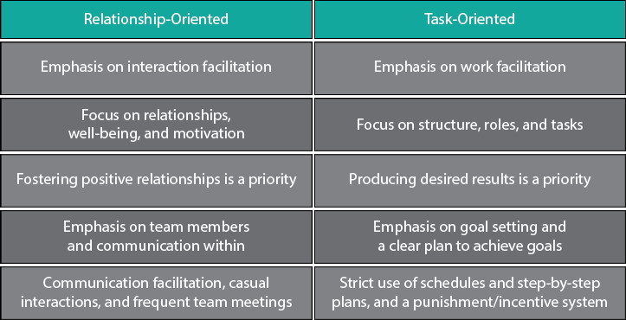
Table 1. task-oriented and relationship-oriented leadership styles compered in table format, source https://www.linkedin.com/pulse/achieving-results-through-people-dan-harrison
Management and leadership
Management is the process that involves organising, planning, controlling, and coordinating resources to accomplish specific goals. Managers focus on efficiently utilising resources, while leaders motivate and inspire others towards common goals.
According to the article The Differences Between Management And Leadership (Wajdi, M. B. N, 2017), leadership involves influencing others, motivating action, and creating passion around a shared vision. Leaders possess characteristic traits and skills such as integrity, vision, determination, and communication ability.
Human resource management handles essential tasks such as hiring, orientation, and maintaining a safe workplace to ensure staff satisfaction and productivity. It involves screening and selecting qualified candidates, helping employees adapt, and fostering positive relationships. Additionally, HR facilitates training and development programs to enhance employee skills and knowledge. Empower employees to make decisions and suggest improvements in their areas of expertise. (Yarberry, S. et al. 2021).
To be more specific, management involves administrative tasks like organising resources, interpersonal skills for effective communication, and conceptual understanding for planning.
Leadership, on the other hand, inspires and motivates through a shared vision. Human resource management combines these elements to hire, train, and maintain a productive workforce. Both management and leadership play crucial roles, as seen in theories like Theory X and Theory Y, which explore different perspectives on work and behaviour. To illustrate the importance of possessing all elements and become a docent leader we can look at the picture below (University of Wales Trinity Saint David).
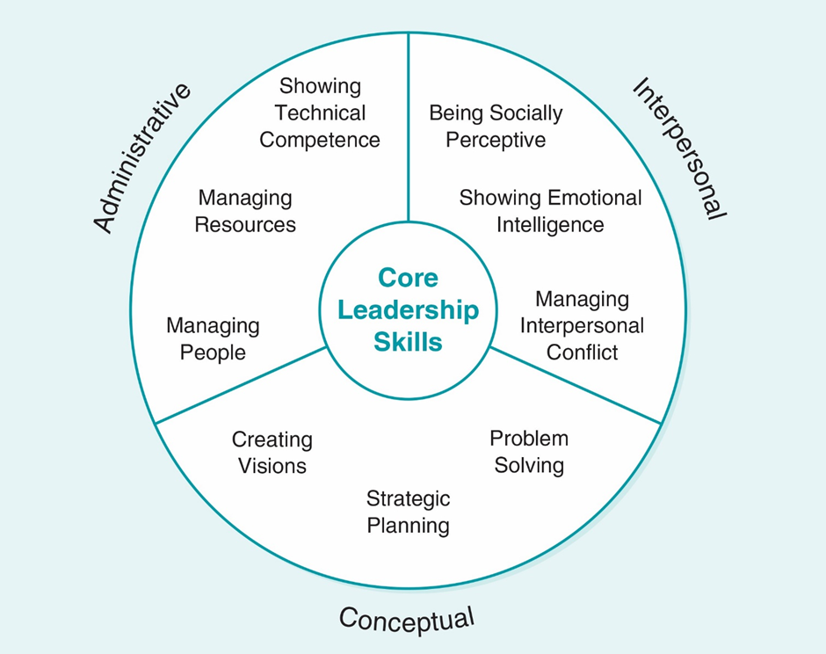
Table 3. Model of Primary Leadership Skills

Explanation of Theory X, Y, Z
Douglas McGregor suggested Theory X and Theory Y in the 1960s, while Theory Z, as an expansion of McGregor's theories, was proposed by William Ouchi in 1981. According to these theories, managers and workers have different perceptions of work and employee behaviour.
According to the University of Wales Trinity Saint David (UWTSD), leadership is the process of influencing an organisation or group within an organisation, in its effort towards achieving an aim or goal. Despite the importance of leadership training is crucial, lots of companies find it hard to create good programs. (University of Wales Trinity Saint David).
According to Michael Boyles who analysed Zippia’s statistics, the reports bring that even though 83 percent of businesses know it is important to grow leaders at all levels, only five percent do it well. Therefore to become a good leader, it is crucial to learn the basics of leading a group, understand why it matters and put effort into getting better at leading thus making a real difference in the company.

Theory X
Theory X originates from a belief in a pessimistic approach to human nature and work ethics. Theory X superiors may assume that if they stop monitoring their subordinates’ work activities, their subordinates will take advantage of the situation by reducing the rate at which they work or by stopping their work altogether. Theory X superiors, therefore, may distrust their subordinates, and, as a consequence, exhibit an anxious watchfulness or hypervigilance around them. (Sager K. L. 2008).
This view holds that workers would choose security and certainty over responsibility. Thus, they prefer to be under the guidance of their managers. Theory X in leadership is the controlling approach that drives productivity and ensures compliance with company policies and procedures.
Managers who follow Theory X, view themselves as authority figures who identify bad performance and lack of motivation in the employees. They set measurements that are clear through close supervision and give rewards or punishments based on the condition if the targets and efficiency are achieved or not.
This form of autocratic rule might bring a quick effect on employees’ performance and efficiency, however, it may make the work environment tense, making leaders and employees losing trust in each other. Employees can feel less freedom in carrying out their work tasks, which can result in losing their job satisfaction and affect their mental health in a long term. Overall, Theory X outlines a centralised and compliance-based leadership that does not take into account the active employee's skills and abilities.

Theory Y
In contrast to Theory X, Theory Y is based on the optimistic view of human nature as it values the quality of the work environment. This theory assumes that employees are motivated to work hard and the source of motivation is not the pay check at the end of the month. At the foundation of McGregor's Theory Y are the assumptions that employees are not inherently lazy, capable of self-direction and self-control, and capable of providing important ideas/suggestions that will improve organizational effectiveness. (Kopelman, R. E. et al. 2008)

Their motivation is coming from having a chance to grow their skills and creativity at work. This theory is based on the viewpoint of workers who already feel connected to the organisation's goals are keen to develop new ideas to solve problems.
Instead of oppression, Theory Y promotes democratic leadership where managers act as facilitators to achieve maximum involvement of employees and encourage employee self-motivation without limits. This involves engaging employees on taking part of decision making, maintaining open communication, and allocating tasks based on the employees’ skills and abilities. Workers are viewed as partners who are shaping the operation and future of the business.
Organisation theory studies reveal that the autonomy of employees, the unique professional skills, and the highest contribution of specialists can be designated as the key features of Theory Y. When well executed, this humanist ideology significantly improves the organisation's work culture to ensure staff satisfaction, idea generation, and commitment to top performance. The end result is improved creativity, productivity, and adaptation because of the employees being motivated.
Theory Y is certainly connected to Maslow's hierarchy which suggests that people have basic needs like food and safety, but also higher needs like personal growth. Psychologist Abraham Maslow (1943, 1954) stated that human motivation is based on people seeking fulfilment and change through personal growth. Self-actualized people are those who are fulfilled and doing all they are capable of. (Mcleod, S. 2024) Life events can cause people to move up and down this hierarchy. This idea connects with Theory Y directly which says employees are motivated by more than just money—they want opportunities to grow and develop at work. Both theories highlight the importance of meeting workers higher needs for motivation and fulfilment.
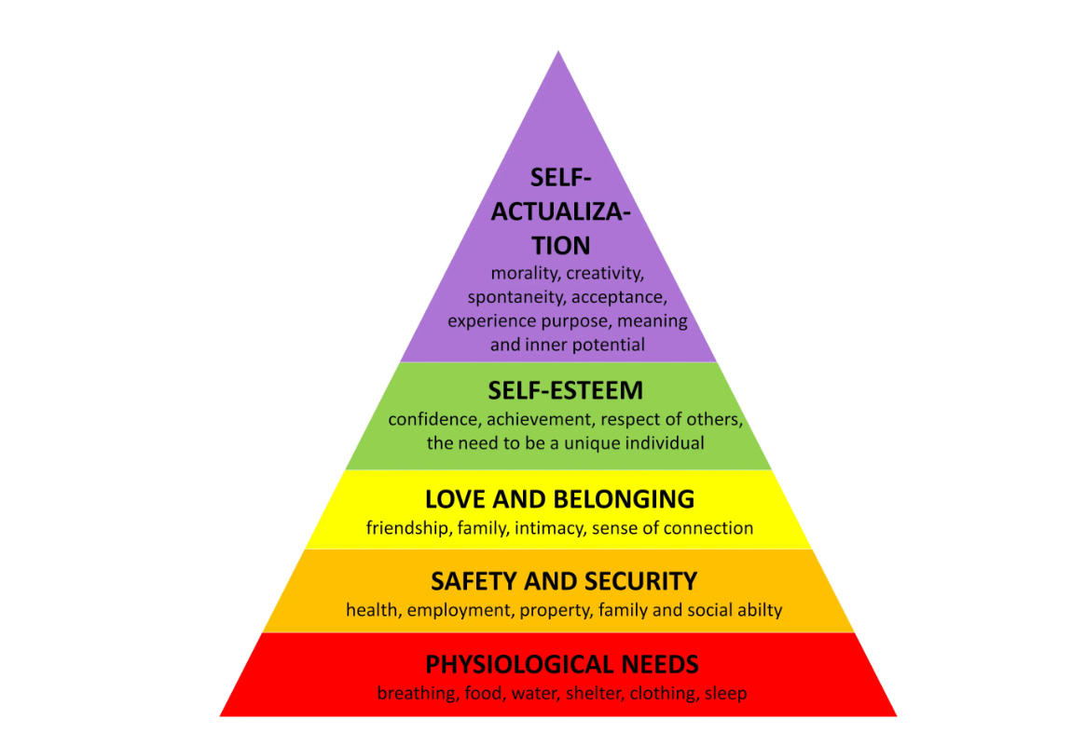
Table1, Maslow’s Hierarchy Of Needs Simply psychology https://www.simplypsychology.org/maslow.html

Theory Z
According to the article of Comparative Analysis of Theory X, Theory Y, Theory Z, and Theory A for Managing People and Performance published by Aithal, S., Kumar, S. P. M. (2016), theory Z combines the supportive leadership approach of Theory Y with a greater awareness of cultural differences. Theory Z was initially created by an analysis of successful Japanese companies during the 1970s and 1980s. Theory Z shows that when businesses apply certain norms and structures, it encourages greater employee commitment resulting in higher organisational achievement.
This structure recognises that people are self-motivated by internal aspirations, which they believe offer meaning to the shared mission of the organisation. Consequently, Theory Z promotes formal processes for consensus-based decision-making in major tasks while allowing the employees to have their own intuition over minor decisions. Managers can act as coordinators who create an environment that supports accessible communication, offers proper developmental support to all team members, and ensures that all the participants are heard before setting the agenda. It also encourages the team to take pride and ownership of organisational results.

Similarities and Differences of Theory X, Y, Z
Even though the theories X, Y, and Z push the leaders to different management styles, they all have the same goal of optimising employee productivity and discouraging ineffective leadership techniques. The fundamental divergence of these theories lies in the way they perceive the factors that motivate performance. Superiors with a Theory X orientation assume that the typical subordinate finds work to be aversive, must be forced to work, seeks direction from other organizational members, and avoids taking responsibility for his work (Sager, K. L. 2008, McGregor, D. 1960). Theory Y has the opposite position as it considers employees to be motivated and willing to work as it views with respect to what employees are willing and able to contribute to the organization, but admits that employees need assistance to be self-directed. (Kopelman R. E. et al. 2008). Combining these two theories, Theory Z emphasises the importance of intrinsic motivation, which involves finding personal satisfaction in tasks, and cultural cohesion within organizations, ensuring a sense of unity among employees. Intrinsic motivation means doing things because they are enjoyable or meaningful, rather than just for external rewards. By changing the focus to the internal rewards of a task, such as satisfaction and enjoyment, you can better motivate yourself and others. (Legg, J. T. et al. 2019) Cultural cohesion focuses on creating a strong sense of belonging and teamwork within the organisation. So, in Theory Z, it is about both enjoying what you do and feeling connected to the team. Despite these existing differences, these theories acknowledge that strategic leadership is crucial for organisational success.
The different ways of managing come from the basic beliefs of each theory. Theory X sees managers as strict rule-makers who closely watch over work and use forceful control to make sure everyone follows the rules. On the other hand, Theory Y promotes a management approach that decentralises decision-making and encourages employee autonomy. It aims to cultivate intrinsic motivation among employees while offering developmental support through facilitative leadership. In contrast, Theory Z promotes collective action and ownership while still maintaining formal hierarchy through the involvement of the employees in agenda-setting and task tracking. Despite the various views, all three theories agree on that leaders have the responsibility of creating suitable working conditions to recognise the potential of their teams.
These theories also differ in their explanation of employee behaviour. In Theory X, the employees are considered to be motivated by their self-interest. Therefore, they focus on the rewards upfront which results in a need of strict control by the managers, extrinsic rewards, and punishments for their work performance.
On the other hand, Theory Y combines individual fulfilment with the organisational success, therefore relying on intrinsic motivation and autonomy. Theory Z highlights the importance of peer support and cultural alignment to promote belonging and shared values within the company.
However, the effectiveness of the leadership differs depending on whether the employees are driven by personal gain or group success. On the other hand, the leader’s and their effective leadership skills plays a significant role. For instance, it involves several factors, such as the leader's intelligence, their self-awareness, and how they relate to their team. Additionally, factors like the organisation's culture and the leader's style can impact how successful they are perceived to be by their team. By assessing and understanding motivational orientations and aligning them with suitable strategies, managers can choose between directing activities or deepening engagement.
Although the theories are related to each other, their differences lie in the prioritisation between tasks and relationships. Theory X emphasises output and obedience, deeming authoritative controls as needed for directing employees. Theory Y requires people to be trusted, flexible, and collaborative to achieve a positive workplace environment. As subordinates perceived empowering leadership, rather than directive leadership, to be more strongly associated with leadership effectiveness, leaders, in general, should pursue an empowering style. (Solomon, A. et al. 2017).
Theory Z combines both task accomplishment and social cohesion to promote intrinsic motivation and aligns organisational resources with cultural content. While all the theories consider the same goal of organisational optimisation, they direct leaders towards different areas where they put the emphasis on either the measurable results or interpersonal connections and team cohesion to achieve and maintain high performance.
These three theories commonly initiate from the idea that people are driven by something inside them when they are at work. Motivation examines and tries to explain goal-directed behaviour in people, why do we act in a certain way and why do we choose different modes of actions, especially when in a number of situations several possibilities of conduct are available. (Kispál-Vitai, Zs. 2016).
However, when leaders do not consider differences, they might judge employees unfairly. So, these ideas help leaders understand motivation at work and adjust how they lead. By using these theories, they can handle problems better and lead their team more effectively. By regularly checking with these theories, leaders can react faster to changes and even guess what might happen next.

Advantages and Disadvantages of Theory X, Y, Z
Theory X can be valuable in times of crisis when a sudden situation leaves little or no time for discussion. In emergencies such as corporate scandals and natural disasters, a leader must take quick action by looking at the threat and taking direct command-and-control. According to McGregor, D., most managers tend in daily practice to rely less and less on the exercise of personal authority except in the crisis situation when other methods fail. This becomes more evident the higher one goes in the organization. The use of commands and orders within the higher levels of management is relatively rare. (McGregor, D. 2006).
By executing clear orders, applying penalties to those responsible and eliminating obstacles with executive decrees, leaders can bring back stability in crisis. Strict and quick command like this can contribute significantly to stabilising disordered situations. However, it is important to understand that this approach compromises employees’ autonomy which can easily damage the relationship between worker and company and therefore it is something not sustainable in long term.
Theory Y encourages internal motivation via autonomy, the development of employees' potential, and employee involvement in decision-making. Empowering employees with the power to make decisions over work processes and promoting themselves for career advancement. This is a way of showing confidence in them to perform great in their area of choice within the company. The average human being learns, under proper conditions, not only to accept but to seek responsibility. (McGregor, D. 2006). This provides workers with a sense of fulfilment and purpose, which further engages them with the company. However, allowing employees to choose their own path within company leads to more downtime. Without control or directives from the top-level leadership, those seeking guidance may disengage while groups discuss direction. Therefore, situations such as financial crises that require cooperation need to be addressed quickly. Despite the increased operational challenge, providing employees with more autonomy is crucial for their long-term creativity and satisfaction. The benefits outweigh the potential losses of centralised command and efficiency.
Theory Z leadership involves both managers and employees working together to set overall goals. Managers track goals, while involving workers in creating a shared vision boosts accountability and team unity.
This also gives the teams a strong sense of cultural alignment which helps them resist many external challenges. Shared values amongst various workers within company are essential for organisations facing various forms of uncertainties. Organisational culture, rather than factors such as structure, policy or politics, is seen as essential to organisational performance. As a consequence, focus turned away from national cultures and concentrated more on the culture of organisation. (Bamidele, R. 2022, Brown, 1998)
It is important to use the right motivators to engage employees. Management should avoid boredom and ineffective forms of recognition, considering individual differences. Ignoring these issues leads to lower engagement.

Role of Culture and Personal Differences
According to McCauley, C. D., Palus, C. J. (2021) in their Developing the theory and practice of leadership development: A relational view article, leadership originates from deep cultural forces. Specific approaches are compatible with the existing world views and logic. Therefore, leadership requires cultural code-switching because culture shapes both what the followers expect and what they respond to. Adaptive leaders know that strong responses, which are subconscious values, are crucial for gaining acceptance.
Cultural intelligence is very important to avoid clashes of values in a global organisation where people of many backgrounds can work together to achieve the same goal. Situational leadership is a grounded approach that considers both practical and symbolic alignment. As the article describes, practical alignment involves making sure actions match organisational goals, while symbolic alignment focuses on communicating shared values to build unity among followers.
The best leaders can understand, respect and follow the cultural values of their workplace rather than just rules.
Apart from cultural forces, Sethuraman, K., Suresh, J. (2014) claim that personal differences in values, ways of thinking, and personality traits also have an effect on how well workers respond to leadership. Some leaders may prefer Theory X or Theory Y’s suggestions, making it difficult to use a uniform approach. Some leaders like to control everything because it is convenient and certain. Others prefer more freedom to be creative. For introverted individuals, a high level of openness and collaboration at work can be exhausting and unpleasant.
On the other hand, friendly individuals may feel lonely without close social bonds. Experienced leaders should be flexible and adapt to different situations instead of sticking to one approach. However, a flexible approach to accountability might suit different people depending on their motivation or experience, and the task at hand. Overall, leaders should be flexible and adapt to the needs and challenges of the company.
Theory X provides strict control. Theory Y involves empowerment and autonomy, and Theory Z is group centred.

Situational or contingency leadership
While a leader can fulfil the role of a manager, not every manager possesses the qualities of a leader. The reason is the nature of the authority granted to managers and leaders. (Prevodnik, M.,Biloslavo, B. 2009)
In this part of the report latest theories of leadership will be discussed. The aim is to understand which of these theories are most helpful in real-world business settings. This part will focus particularly on the contingency decision-making models by Vroom, Yetton, and Jago, to see how they can assist leaders in their day-to-day work.

Contingency leadership
The theory of contingency (Fiedler’s contingency) in leadership suggests that a leader's effectiveness depends on the situation they are in, not just their personal traits or behaviours. (Sayed, H. 2013, Fiedler, 1967)
Instead of thinking of leadership as something you either have or do not have, it is more about getting people to work together towards the same goals. Organisational effectiveness is influenced by factors beyond the leader's actions, like the structure of the organisation. (Vroom, V.H., Jago, A.G. 2007).
Additionally, leader behaviours can change depending on the situation. According to the research at Ohio State University and the University of Michigan, leaders adapt their behaviours to different situations.
However, Vroom’s arguments are more about getting people to work together towards the same goals. This notion is backed by the understanding that the success of an organisation is influenced not only by the actions of its leader, but also by the organisation's structure and external factors affecting its operations.
To be more specific, according to the publication of Leadership in organizations by Yukl, G. (2013), the contingency theory is defined as the concept that leadership effectiveness relies on various contextual factors, such as the situation in which the leader operates, as well as the characteristics of the group or organisation.
In other words, the contingency theory suggests that there is not a general approach to leadership that would be effective in all situations. Instead, the effectiveness of leadership depends on its alignment with a specific situation or context.
This report will delve into the essence of contingency approach in leadership. Focusing on why certain leaders succeed in specific situations while others do not, it will also outline the key implications of this approach. This issue is significant as it underscores that the effectiveness of a leader depends not only on their personal traits but also on the context in which they operate. Furthermore, the report will analyse the main concepts, factors and insights related to this topic throughout the paper.
Any leader who understands contingency theory can also utilise path-goal model and the LPC approach to better understand and manage in different business situations, that way will allow any leading to be more effective.
Many leaders can adopt and use approaches either patch-goal or LPC approach.
Path-Goal Theory:
According to House J. R. (1971), the goal-oriented model suggests that leaders can influence subordinate behaviour and performance by clarifying paths to goals, removing obstacles, and providing rewards along the way. This can be achieved through various leader behaviors, such as initiating structure (providing support and direction) and consideration (creating a supportive environment). (House J. R. 1971).
The leader can use this model to adjust their behavior to the specific needs and circumstances of their employees. They can set goals and create a path that helps employees achieve those goals. For example, if employees need more clarity on goals, the leader can provide additional information and support them to achieve these goals.
The Path-Goal Theory tells us that the effectiveness of a leader depends on how well they can support their subordinates and remove obstacles that may make it harder for the team to achieve their goals. This means that a leader should provide appropriate support and assistance to enable employees to act effectively towards the set objectives. Applying different leadership styles, such as autocratic (where the leader makes decisions independently), democratic (where decisions are made in a participatory manner), and transformational (where the leader inspires and motivates subordinates to achieve higher goals), can have different effects on leadership effectiveness according to this theory.

LPC Approach:
In contrast, Fiedler's Leadership Theory delves into how leaders navigate situations, while the LPC Scale helps pinpoint their focus on tasks or relationships. High scores indicate a relational focus, contrasting with low scores reflecting a task-oriented approach. By grasping these preferences, leadership effectiveness can be enhanced across varied scenarios. Fiedler uses the distinction between task-oriented leadership style and relationship-oriented leadership style, relating these leadership styles with different types of situation, in order to determine the contingencies that make either style effective. (Nunes, A. J. S. et al. 2011).
The leader can also use the LPC (Least Preferred Coworker) measurement to understand their leadership preferences and match their leadership style to the specific needs and preferences of employees as well as situational requirements.
For instance, if a leader has a high LPC, indicating a preference for focusing on interpersonal relationships, they can adjust their leadership style to build strong relationships with employees, which may contribute to increased engagement and productivity.
Combining these approaches allows the leader to manage more flexibly and effectively depending on the specific business circumstances and team needs.

Transformational:
Transformational leadership originates in the personal values and beliefs of leaders, not in an exchange of commodities between leaders and followers. Their actions aim to inspire followers to embrace higher ideals and achieve performance levels beyond conventional expectations. (Kuhnert K. W., Lewis, P. 1987).
According to the article Transactional and Transformational Leadership: A Constructive/Developmental Analysis written by Karl W. Kuhnert and Philip Lewis, transformational leaders exhibit distinct personal characteristics such as confidence, authority, and a strong commitment to their moral principles. They establish clear objectives, promote an inspiring vision, give out confidence and spark motivation among their followers. In contrast to transactional leaders, who prioritise making deals, transformational leaders motivate their followers by imparting their own values and convictions. This contributes to the change of the mindset and aspirations of followers in both their personal and professional lives.

Conclusion
In conclusion, the theories of leadership, such as Theory X, Theory Y, and Theory Z, offer ways for understanding leadership in different environments. These approaches recognise employees' diverse nature. By assessing the advantages and disadvantages of each, leaders can identify the one that suits their circumstances the best.
Cultural and personal differences significantly affect leadership styles, as well as whether or not they are effective. Cultural values determine the manner and standards of both leaders and followers, which makes some leadership theories more appropriate to some situations. Leaders should be mindful of cultural norms and align their styles to maintain unity and effectiveness.
Besides, personal differences among leaders, which may include but are not limited to values, beliefs, and preferences, play a role in their leadership styles. Some leaders might lean on their individual preferences to use either of the theories in their leadership. Influential leaders, however, are adaptable and recognise that the situational nature of leadership requires flexibility. They are in a position to evaluate the current followers' needs, the cultural context, and the unique problematic characterisation to determine the style of leadership that will fit the situation.
Given the scenario of the Florette Salad Company in Storm Noa, Theory X's authoritarian leadership style was the most suited for decision-making and control. However, leaders should use this approach with good communication and empathy. Communication channels must be preserved to deal with any problems or issues and also to suggest solutions from the affected employees. After the crisis, the leader should switch back to the democratic style presented by Theory Y so as to rely on principles of trust, morale, and engagement.

Appendix

Implications for Florette Salad Company and Leadership Style
This work aims to prove the type of leadership theory and based on the details provided on their website, it seems that the company operates under a Theory Y approach. This can be deduced from their emphasis on empowering employees, fostering creativity, and promoting innovation in supply chain management.
Suddenly the situation was changed in the perception of leadership style when unexpected extreme weather conditions occurred. That fact played crucial role in a quick change in their approach.
During Storm Noa, Florette’s leadership faced sudden challenges demanding decisive action. Strong winds blocked the company’s essential distribution channels, thereby stopping scheduled lorry deliveries of fresh produce orders across regional supermarkets just as demand massively increased thanks to people wanting to stockpile on food ahead of the gathering storm (Whelan, L. 2023). In the same way, farmers rushed to pick crops at the peak of ripeness before the pre-scheduled floods and mudslides, as they feared the crops may not be able to be properly transported. Meanwhile, the number of phone calls from worried vendors was also skyrocketing, adding more stress to the matter. Furthermore, technological failures due to the heavy load on the power grid made communication difficult. The company could not properly synchronise its operations. This situation, related to a ’’perfect storm’’, presented leaders with challenging, unexpected, and complex circumstances, impacting all areas of operation. From supply chain operations to customer relationships to employee safety.
According to Paraskevas, A. (2006), "Crisis management or crisis response system? A complexity science approach to organizational crises" but also to Professor Waldemar Karwowski's research Podstawy zarzadzania kryzysowego (2011), their theories are highly relevant in understanding and addressing the challenges faced by companies like Florette Salad Company during crises. Professor Karwowski emphasises the significance of rapid responses to unforeseen circumstances and the necessity of decisive actions to ensure both employee safety and business continuity.
Florette leaders needed to understand that involving more people in the decision making would slow down reactions to the situation. Following the usual path of operation in which middle managers consult their local teams before making decisions could cause delays and pose a problem with coordination (McCauley, C. D., Palus, C. J. 2021). The situation at Florette Salad Company rapidly deteriorated, leading to significant losses and damages. In response, the executive team had to act swiftly and implement a centralised system of command and control. (The Blake and Mouton Managerial Grid model 1985)
Directors with experience in managing previous interruptions were required to quickly organise emergency protocols designed to account for the high-risk factors prioritised in the organisation. This meant that lorry dispatchers were to be commanded to suspend their movement given unfavourable road conditions, distribution personnel needed to stay safe and seek shelter within storage facilities, battery-backed power to be directed towards fuelling, and non-essential components to be suspended to preserve resources and prevent fire. These strategies under authoritative leaders could save the situation.
The employees were disoriented and stressed due to the disturbing effect of the lack of communication and uncertainty about both the safety of their workplace and their families. Strict leadership during a period where workers can be unsure of their own safety needs to be done in an understanding and reassuring manner.
Showing empathy during this time and calmly answering questions even when in a rush is also very important. (Tannenbaum, R., Schmidt, W. H. 1973).
Authoritative leadership requires leaders to preserve the dignity and mental safety of employees. (Tannenbaum, R., Schmidt, W. H. 1973, Peprah, P., Peprah, W. K. 2023)
During Storm Noa, Florette Salad Company faced a crisis that demanded swift changes in leadership style. Initially, they operated under a Theory Y approach, empowering employees. However, the storm required authoritative decision-making, akin to aspects of Theory X.
The executive team swiftly implemented a centralised command system to manage the crisis. However, they realised the importance of engaging employees in recovery efforts, leading to a shift towards democratic leadership.
Middle managers also needed to adapt, initially suspending standard protocols but later requiring a more collaborative approach. Tailored strategies and ethical leadership were crucial for effective recovery and preparation.

Situational leadership
Situational leadership, developed by Paul Hersey and Kenneth H. Blanchard, underscores the need for managers to adapt their approach based on changing circumstances and employee needs, emphasising flexibility and active communication. (Szymczyk J.2023).
Situational leadership theory, as presented by Hersey and Blanchard (1969), emphasizes the adaptation of a leader's behaviours to specific situations and the maturity level of subordinates. Within this theory, the effectiveness of leadership depends on a leader's ability to adjust their actions, such as initiating structure and consideration, to the task-relevant and psychological maturity levels of subordinates. (Graeff C. L. 2024, Hersey, P., Blanchard K. H. 1969)
According to Blanchard. K (1983) in his book The one minute manager and Justyna Szymczyk in an article Understanding and Implementing Situational Leadership in Practice? (2023), situational leadership is crucial in effective team management. The author believes that in the initial stages of a company's operation or an employee's tenure, employees expect clear guidance and direction from their leaders. They are in a learning phase, don not know everything, and need support in the form of specific instructions regarding their work.
However, when a manager gives more responsibility to employees, using a trust-based management model, it may turn out that employees feel overwhelmed or uncertain. This can lead to stress, which negatively impacts their concentration, productivity, and performance.
Therefore, the situational approach to management highlights the need for flexibility and adapting to changing needs and skills of employees. Depending on the specific situation and stage of employee development, managers should adjust their management style, offering appropriate support, guidance, or autonomy.
In later stages, employees often seek more autonomy, responsibility, and focus on motivation and productivity enhancement.
Paul Hersey and Kenneth H. Blanchard formulated the concept of situational leadership, advocating for managers to adapt their leadership style to fit each situation. They emphasise the importance of flexibility, stating that managers cannot rely on a single approach and must adjust their management method based on the circumstances. Blanchard highlights the significance of regular communication between the leader and employees, where the leader recognises individual needs and adjusts to the employee's stage of work.
This approach can be ideal when it comes to adaptation with a new situation or help with interpersonal contact with employees.

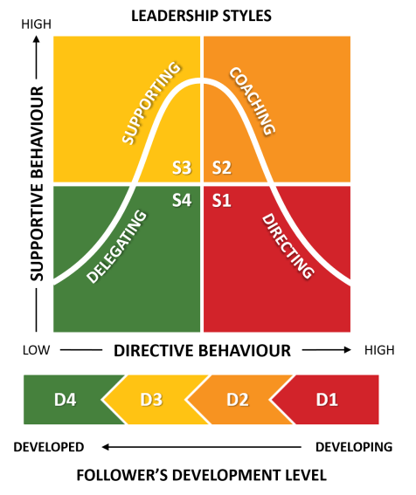
Figure 4: Hersey and Blanchard Situational Leadership Styles source: https://www.business-to-you.com/hersey-blanchard-situational-leadership-model/

This work will close examine a stage, components of the Harsey’s and Blanchard’s idea.

- Determine Your Employee's Stage:
To apply the model effectively, first assess your employees' readiness levels. This involves understanding their competencies and engagement. Assign them to one of four readiness levels:
R1: Enthusiastic or Cautious Beginner
R2: Disillusioned or Disillusioned Novice
R3: Competent but Cautious or Bored Practitioner
R4: Self-Reliant Expert
- Choose the Management Style:
Once you know the readiness levels, select the appropriate management style:
S1: Directive
S2: Coaching
S3: Supporting
S4: Delegating

- Exceptions to the Rules:
There are exceptions where different styles may be necessary temporarily:
S1: Use Directive Style in crises or with employees facing tight deadlines.
S2: Apply Coaching Style additionally in situations of employee demotivation or limited information.
S3: Use Supporting Style when employees need encouragement or face personal issues.
S4: Apply Delegating Style when employees show high competence and motivation.
(Szymczyk J.2023)

The situational leadership approach's strength lies in its flexibility, as it allows leaders to align their style to fit individual employees' needs. However, it can be challenging to implement and may demand considerable time and effort from the leader.

Appendix

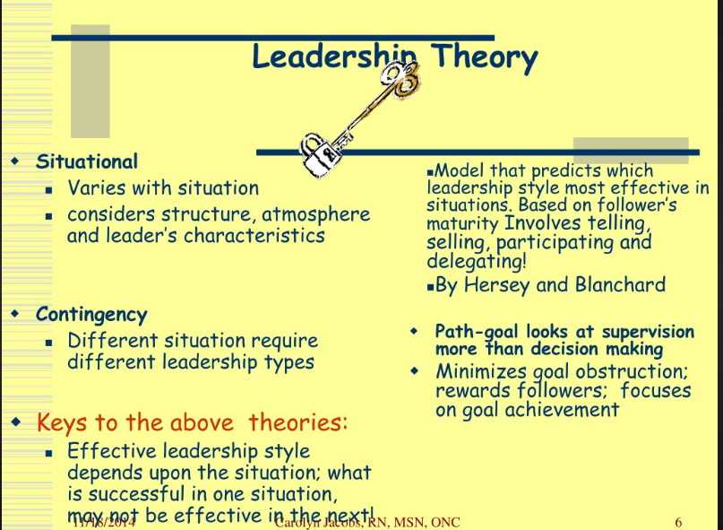
Komentar, T. (2021) Behavioral Theories Of Leadership : POM Course: Learnings: Understanding Taylorism and Early ... - Behavioral theories of leadership behavioral theory promotes the value of leadership styles with an emphasis on concern for people and collaboration, available at: https://paxtonkur.blogspot.com/2021/05/behavioral-theories-of-leadership-pom.html

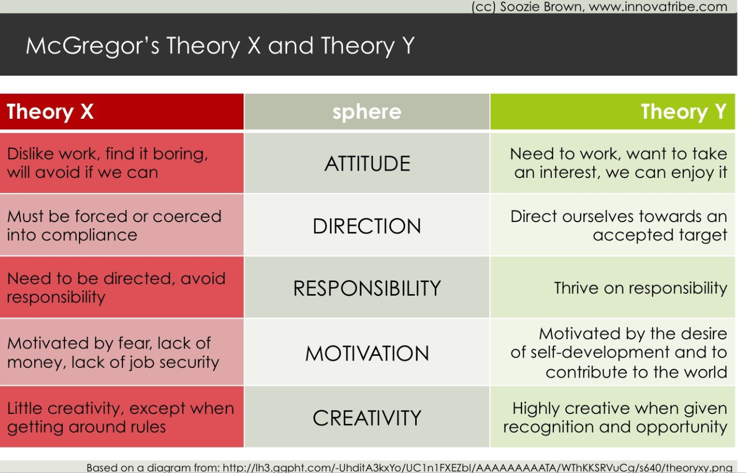
Anonymous n.d., available at: https://i.pinimg.com/originals/19/a0/3b/19a03bc31bd349af4b99dea495cca544.jpg
Anonymous (2019) Motivation Theories, Maslow's hierarchy, Herzberg two factor theory and McGregor theory X and Y, Management Adda, available at: https://www.youtube.com/watch?v=pjgdvp2f_cs

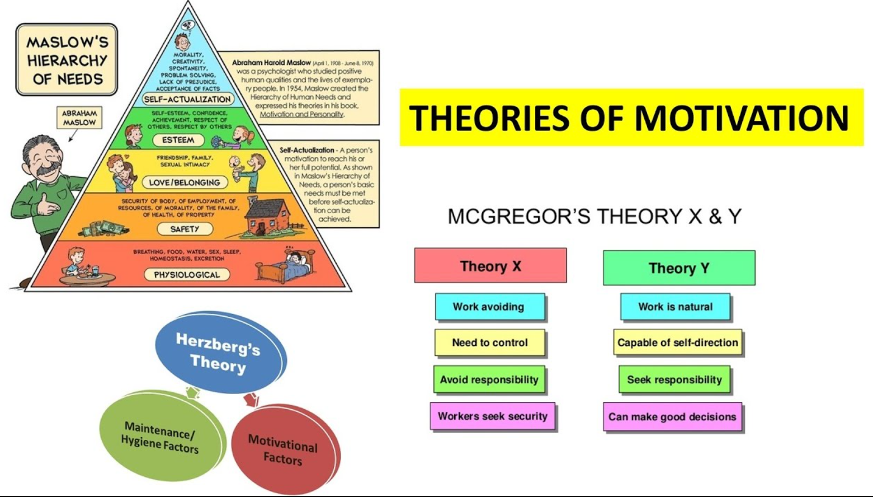
Anonymous n.d., available at: https://i.ytimg.com/vi/pjgdvp2f_cs/maxresdefault.jpg
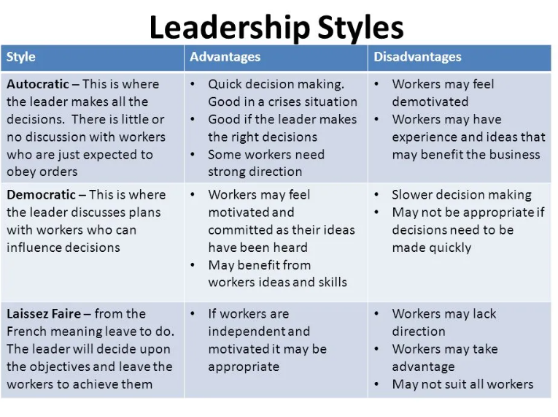Anonymous n.d. Advantages And Disadvantages Of Leadership Theories, Pinsoftek, available at: http://pinsoftek.com/wp-content/custom/sociological-imagination-essay/advantages-and-disadvantages-of-leadership-theories.php
Anonymous (2023) Storm Noa, Met Office, available at: https://www.metoffice.gov.uk/binaries/content/assets/metofficegovuk/pdf/weather/learn-about/uk-past-events/interesting/2023/2023_02_storm_noa.pdf
Anonymous (2023) Task-Oriented Leadership: Definition and Examples, Indeed, available at: https://www.indeed.com/career-advice/career-development/task-oriented-leadership
Anonymous (2024) Fiedler’s Contingency Theory: Why leadership isn’t uniform, Asana, available at: https://asana.com/resources/fiedlers-contingency-theory
Bus, B. n.d. Poziomy gotowości pracownika według modelu Herseya-Blancharda, HCM Deck Blog, available at: https://hcmdeck.com/blog/poziomy-gotowosci-pracownika-wedlug-modelu-herseya-blancharda/?_adin=11734293023
Czartoryski, A. (2020) 4 STYLE ZARZĄDZANIA SYTUACYJNEGO, KTÓRE MUSISZ ZNAĆ, Kuznia Leaderow, available at: https://kuznialeaderow.pl/4-style-zarzadzania-sytuacyjnego-ktore-musisz-znac/

References

Ackah. D. PhD (2019) Models of Leadership and Teamwork: Adairs Action-Centred Leadership Model, Worldwide Journal of Multi-disciplinary Studies, Akamia University, available at: https://www.academia.edu/39246094/Models_of_Leadership_and_Teamwork_Adairs_Action_Centred_Leadership_Model_1973
Aithal, S., Kumar, S. P. M. (2016) Comparative Analysis of Theory X, Theory Y, Theory Z, and Theory A for Managing People and Performance, DOI: 10.5281/zenodo.154600, available at: https://www.researchgate.net/publication/306031634_Comparative_Analysis_of_Theory_X_Theory_Y_Theory_Z_and_Theory_A_for_Managing_People_and_Performance
Al-Rabie, M. K. A. (2021). Leadership and its importance in sustainable development. Ovidius University Annals, Series Economic Sciences, 21(2), 33-37. Available at: https://stec.univ-ovidius.ro/html/anale/RO/2021-2/Section%201%20and%202/5.pdf
Anonymous n.d. Difference Between Theory X and Theory Y, Key Differences, available at: https://keydifferences.com/difference-between-theory-x-and-theory-y.html
Bamidele, Rasak. (2022). ORGANIZATIONAL CULTURE, ISBN: 978-978-8554-05-9, available at: https://www.researchgate.net/publication/357605292_ORGANIZATIONAL_CULTURE
Bass, B. M., Bass, R. (2009) The Bass Handbook of Leadership: Theory, Research, and Managerial Applications, Simon and Schuster, 2009, ISBN 1416545786, 9781416545781, available at: https://books.google.co.uk/books?hl=en&lr=&id=dMMEnn-OJQMC&oi=fnd&pg=PT16&dq=SEE+BASS+2008+BENIS+AND+NANNUS+2007&ots=EuVCwCsPjI&sig=s3t2vmMPWjrddkEaaJByCE1REGE#v=onepage&q&f=false
Benmira, S., Agboola, M. (2021) The Learning Zone, Evolution of leadership theory, BMJ Journal, BMJ Leader 2021;5:3-5., available at: https://bmjleader.bmj.com/content/5/1/3
Benson, S. A. PhD (2022) THE ROLE OF THEORY Y LEADERSHIP STYLE AND ITS IMPACT ON AN ORGANIZATION IN AN EMERGING ECONOMY – LITERATURE REVIEW, International Journal of Economics, Commerce and Management, ISSN 2348 0386 Vol. X, Issue 1, Jan 2022, available at: https://ijecm.co.uk/wp-content/uploads/2022/01/10117.pdf
Bishop, C.T., Esaki, N., Taub, M. E. (2023) Learning to Be a Leader Worth Following, Human Service Organizations: Management, Leadership & Governance, Volume 47, 2023 - Issue 5, available at: https://www.tandfonline.com/doi/abs/10.1080/23303131.2023.2228853
Blake, R., Mouton, J. (1985). Managerial grid III: The key to leadership excellence. Houston: Gulf Publishing Co. Available at: http://wiki.doing-projects.org/index.php/Blake-Mouton_Managerial_Grid
Blanchard, K. and Johnson, S. (1983). The One Minute Manager. New York: Berkley Books, available at : https://ia904703.us.archive.org/22/items/mastery-by-robert-greene-urdukutabkhanapk/23%20To%2026%20Oct-2021%20-Misc%20English%20Books/The-One-Minute-Manager-Biography-%20By%20Ken%20Blanchard%20and%20Spencer%20Johnson_urdukutabkhanapk.pdf
Boyles, M. (2023) ORGANIZATIONAL LEADERSHIP: WHAT IT IS & WHY IT'S IMPORTANT, Harvard Business School, available at: https://online.hbs.edu/blog/post/what-is-organizational-leadership
Carter, L. n.d. 7 Key Strengths of Task-Oriented Leadership, Louis Carter Blog, available at: https://louiscarter.com/task-oriented/
Challa, S. K., Vamsi, B. (2021) Management and Organizational Behavior, IMMORTAL PUBLICATIONSISBN: 978-93-5473-918-7, available at: https://www.researchgate.net/publication/352505954_Management_and_Organizational_Behavior
Chima, A., Gutman, R. (2020). What it takes to lead through an era of exponential change. Harvard Business Review. Available at: https://www.lifeforward.co.uk/wp-content/uploads/2021/02/What-It-Takes-to-Lead-Through-an-Era-of-Exponential-Change.pdf
Douglas McGregor (2006) The Human Side of Enterprise, Annotated Edition (PB). New York: McGraw Hill. Available at https://search-ebscohost-com.ezproxy.uwtsd.ac.uk/login.aspx?direct=true&db=nlebk&AN=2687857&site=ehost-live (Accessed: 15 March 2024).
Elsaid, A. M., Mostafa, B. N. (2016). Transformational leadership in hierarchical context: A study of gender differences in the mobile communication sector in Egypt. Journal of Applied Business Research (JABR), 32(1), 355-366. Available at: https://clutejournals.com/index.php/JABR/article/download/9543/9666/36010
Fisher, M. L. (2023) Motivation to Break Through Occupational Barriers: A Case Study of Female City Manager’s Career Progression, California Baptist University ProQuest Dissertations Publishing, 2023. 30486683., available at: https://www.proquest.com/docview/2811850761?sourcetype=Dissertations%20&%20Theses
Gosling, J., Jones, S. and Sutherland, I. (2012) Individualistic and Relationship-Oriented Leadership, Key Concepts in Leadership, SAGE Key Concepts Series. London: SAGE Publications Ltd. pp. 120-125 Available at: https://doi.org/10.4135/9781473914759
Graeff, C. L. (1983) The Situational Leadership Theory: A Critical View, The Academy of Management Review, Vol. 8, No. 2 (Apr., 1983), pp. 285-291, available at: https://www-jstor-org.ezproxy.uwtsd.ac.uk/stable/257756?searchText=&searchUri=&ab_segments=&searchKey=&refreqid=fastly-default%3A57da1ba5fbbf757e33edd14afe3b343a
Harrison, D. (2017) Achieving Results Through People, Linked In, available at: https://www.linkedin.com/pulse/achieving-results-through-people-dan-harrison
Hersey, P., Blanchard, K. H. (2016) Managing Research and Development Personnel: An Application of Leadership Theory, pages: 331-338, available at: https://www.tandfonline.com/doi/pdf/10.1080/00345334.1969.11755973
Hersh, W., Pentecost, J., Hickam, D. (1996) A task-oriented approach to information retrieval evaluation, Volume47, Issue1, Special Issue: Evaluation of Information Retrieval Systems, Pages 50-56, available at: https://asistdl.onlinelibrary.wiley.com/doi/abs/10.1002/(SICI)1097-4571(199601)47:1%3C50::AID-ASI5%3E3.0.CO;2-1
Hofstede, G. (2011) Dimensionalizing Cultures: The Hofstede Model in Context, Universities of Maastricht and Tilburg, The Netherlands, Readings in Psychology and Culture, 2(1), ISBN 978-0-9845627-0-1, available at: https://scholarworks.gvsu.edu/cgi/viewcontent.cgi?article=1014&context=orpc
House, R. J. (1971) A Path Goal Theory of Leader Effectiveness, Administrative Science Quarterly, Vol. 16, No. 3 (Sep., 1971), pp. 321-339, available at: https://www-jstor-org.ezproxy.uwtsd.ac.uk/stable/2391905?seq=1
https://www.business-to-you.com/hersey-blanchard-situational-leadership-model/
Jie-Hui, X. (2017) Leadership theory in clinical practice, Chinese Nursing Research, Volume 4, Issue 4, 2017, Pages 155-157, ISSN 2095-7718, available at: https://www.sciencedirect.com/science/article/pii/S2095771817300944#bib4
Kelloway, E. K., Barling, J. (2010). Leadership development as an intervention in occupational health psychology. Work & Stress, 24(3), 260–279. https://doi.org/10.1080/02678373.2010.518441
Khan, Z. A., Nawaz, A., Khan, I. U. (2016) Leadership Theories and Styles: A Literature Review, Department of Public Administration, Gomal University, Dera Ismail Khan, available at: https://www.researchgate.net/publication/293885908_Leadership_Theories_and_Styles_A_Literature_Review
Khan, Z. A., Nawaz. A., Khan, I. U. (2016) Leadership Theories and Styles: A Literature Review, Department of Public Administration, Gomal University, Dera Ismail Khan, available at: https://www.researchgate.net/publication/293885908_Leadership_Theories_and_Styles_A_Literature_Review
Khuong, M.N., Hoang, D. T. (2015) The Effects of Leadership Styles on Employee Motivation in Auditing Companies in Ho Chi Minh City, Vietnam, DOI:10.7763/IJTEF.2015.V6.471, available at: https://www.researchgate.net/publication/282421220_The_Effects_of_Leadership_Styles_on_Employee_Motivation_in_Auditing_Companies_in_Ho_Chi_Minh_City_Vietnam
Kispál-Vitai, Zs. (2016) Comparative analysis of motivation theories, International Journal of Mathematical Engineering and Management Sciences 1(1):1-13, DOI:10.21791/IJEMS.2016.1.25., available at: https://www.researchgate.net/publication/306041772_Comparative_analysis_of_motivation_theories
Kopelman R. E., Prottas, D. J., Davis, A. L. (2008) Douglas McGregor's Theory X and Y: Toward a Construct-Valid Measure, Journal of Managerial Issues 20(2):2008, available at: https://www.researchgate.net/publication/280114317_Douglas_McGregor%27s_Theory_X_and_Y_Toward_a_Construct-Valid_Measure
Kuhnert, K. W., Lewis, P. (1987) Transactional and Transformational Leadership: A Constructive/Developmental Analysis, The Academy of Management Review, Vol. 12, No. 4 (Oct., 1987), pp. 648-657, available at: https://www.jstor.org/stable/258070?origin=crossref
Malik, M., Mahmood, F., Sarwar, N., Obaid, A., Memon, M. A., & Khaskheli, A. (2023). Ethical leadership: Exploring bottom-line mentality and trust perceptions of employees on middle-level managers. Current Psychology, 42(20), 16602-16617. Available at: https://link.springer.com/article/10.1007/s12144-022-02925-2
McCauley, C. D., Palus, C. J. (2021). Developing the theory and practice of leadership development: A relational view. The Leadership Quarterly, 32(5), 101456. Available at: https://www.sciencedirect.com/science/article/abs/pii/S1048984320300837
McGregor, D. (1960) The Human Side of Enterprise, McGraw-Hill, available at: https://books.google.co.uk/books/about/The_Human_Side_of_Enterprise.html?id=9fA0AAAAMAAJ&redir_esc=y
Mcleod S. PhD (2024) Maslow’s Hierarchy Of Needs, Simply Psychology, available at: https://www.simplypsychology.org/maslow.html
Nabaraj, K. C. (2009) Adaptive Leadership by Dr. Heifetz, vol.2.5, available at: https://www.academia.edu/1493720/Adaptive_Leadership_by_Dr_Heifetz
Nemr, M. A. A., Liu, Y. (2021). The impact of ethical leadership on organizational citizenship behaviors: Moderating role of organizational cynicism. Cogent Business & Management, 8(1), 1865860. Available at: https://www.researchgate.net/publication/348589960_The_impact_of_ethical_leadership_on_organizational_citizenship_behaviors_Moderating_role_of_organizational_cynicism/citation/download
Northouse, P. G. (2021) Leadership: Theory and Practice, SAGE Publications, 2021, ISBN 1071834479, 9781071834473, available at: https://books.google.co.uk/books?hl=en&lr=&id=6qYLEAAAQBAJ&oi=fnd&pg=PA1&dq=Northouse,+P.+G.+(2016).+Leadership:+Theory+and+practice+(7th+ed.).+Thousand+Oaks,+CA:+Sage&ots=QQ6dsdXb3q&sig=QsHoGzQ7OrKuaHeKLMSiDjZGVDs#v=onepage&q&f=false
Nunes, A. J. S., Cruz, M. R. P., Pinheiro, P. G. (2011) Fiedler’s Contingency Theory: Practical Application of the Least Preferred Coworker (LPC) Scale, The IUP Journal of Organizational Behavior, Vol. X, No. 4, October 2011, pp. 7-26, available at: https://www.researchgate.net/publication/258974230_Fiedler's_Contingency_Theory_Practical_Application_of_the_Least_Preferred_Coworker_LPC_Scale
Paraskevas, A. (2006). Crisis management or crisis response system? A complexity science approach to organizational crises. Management Decision, available at: https://www.emerald.com/insight/content/doi/10.1108/00251740610680587/full/html
Pastor, J. C., Mayo, M. (2008). Transformational leadership among Spanish upper echelons: the role of managerial values and goal orientation. Leadership & Organization Development Journal, 29(4), 340-358. Available at: https://www.emerald.com/insight/content/doi/10.1108/01437730810876140/full/html
Peprah, P., Peprah, W. K. (2023). Leadership and its Impact on Supervision in the Hospitality Industry. Archives of Business Research, 11(1). Available at: https://digitalcommons.andrews.edu/cgi/viewcontent.cgi?article=5755&context=pubs
Pratt, M. K. (2023) Managerial grid model (The Blake and Mouton Managerial Grid model), Tech Target, available at: https://www.techtarget.com/searchcio/definition/managerial-grid-model-The-Blake-and-Mouton-Managerial-Grid-model
Prevodnik, M., Biloslavo, R. (2009) Managers and Leaders in Organizations of a Post-transition Economy, University of Primorska, Koper Faculty of Management, DOI: 10.2478/v10051-009-0006-1, available at: https://intapi.sciendo.com/pdf/10.2478/v10051-009-0006-1
Reid, J. (2000) A Task-Oriented Non-Interactive Evaluation Methodology for Information Retrieval Systems, Dordrecht: Springer Nature B.V; Information retrieval (Boston), 2000-02, Vol.2 (1), p.115-129, available at: https://librarysearch.uwtsd.ac.uk/discovery/fulldisplay?docid=cdi_proquest_journals_2908959270&context=PC&vid=44WHELF_UWTSD:44WHELF_UWTSD_VU1&lang=en
Richard, J., Moniz, Jr (2010) History of managerial thought: a brief overview, Contingency Theory, Practical and Effective Management of Libraries, ISBN 978-1-84334-578-7, available at: https://www.sciencedirect.com/topics/economics-econometrics-and-finance/contingency-theory
Sager, K. L. (2008) An Exploratory Study of the Relationships Between Theory X/Y Assumptions and Superior Communicator Style, Management Communication Quarterly, 22(2), 288-312., available at: https://journals.sagepub.com/doi/abs/10.1177/0893318908323148
Santos-Longhurst, A. (2019) Intrinsic Motivation: How to Pick Up Healthy Motivation Techniques, Healthline, available at: https://www.healthline.com/health/intrinsic-motivation
Sayed, H. (2013) The Influence of Principal Leadership on School Performance: A Case Study in Selected Gauteng Schools, University of South Africa, available at: https://uir.unisa.ac.za/bitstream/handle/10500/10494/dissertation_sayed_h.pdf?isAllowed=y&sequence=1
Schriesheim, C., Von Glinow, M. A. (1977) The Path-Goal Theory of Leadership: A Theoretical and Empirical Analysis, The Academy of Management Journal, Vol. 20, No. 3 (Sep., 1977), pp. 398-405, available at: https://www-jstor-org.ezproxy.uwtsd.ac.uk/stable/255413?searchText=&searchUri=&ab_segments=&searchKey=&refreqid=fastly-default%3Aebd6af572d793765c27c610fbe1c9409
Sethuraman, K., Suresh, J. (2014). Effective leadership styles. International Business Research, 7(9), 165. Available at: https://www.researchgate.net/publication/272727215_Effective_Leadership_Styles
Solinger, O. N., Jansen, P. G., Cornelissen, J. P. (2020). The emergence of moral leadership. Academy of Management Review, 45(3), 504-527. Available at: https://research.vu.nl/ws/portalfiles/portal/106346421/Final_published_version_AMR.pdf
Solomon, A., Steyn, R. (2017) Leadership style and leadership effectiveness: Does cultural intelligence moderate the relationship?, Acta Commercii 17(1), DOI: 10.4102/ac.v17i1.453, available at: https://www.researchgate.net/publication/318043517_Leadership_style_and_leadership_effectiveness_Does_cultural_intelligence_moderate_the_relationship
Tannenbaum, R., Schmidt, W. H. (1973). How to choose a leadership pattern. Harvard business review. Available at: https://hbr.org/1973/05/how-to-choose-a-leadership-pattern
Wajdi, M. B. N. (2017) The Differences Between Management And Leadership, Sinergi Jurnal Ilmiah Ilmu Manajemen, DOI: 10.25139/sng.v7i1.31, available at: https://www.researchgate.net/publication/318597967_The_Differences_Between_Management_And_Leadership
Walas-Trebacz, J., Ziarko, J. (2011) Podstawy zarządzania kryzysowego, Część 2 Zarządzanie kryzysowe w przedsiębiorstwie, Krakowska Akademia, im. Andrzeja Frycza Modrzewskiego, available at: https://repozytorium.ka.edu.pl/server/api/core/bitstreams/fcf8ddb9-eda2-4228-a7f5-6321ecc05cec/content
Whelan L. (2023) Horror moment HGV is blown over by ferocious 40mph winds as Storm Noa smashes into UK, Express, available at: https://www.express.co.uk/news/uk/1757365/M62-Lorry-wind-video-blown-over
Yang, Q. I., Wei, H. (2018). The impact of ethical leadership on organizational citizenship behavior: The moderating role of workplace ostracism. Leadership & Organization Development Journal, 39(1), 100-113. Available at: https://iranarze.ir/wp-content/uploads/2018/02/E5993-IranArze.pdf
Yarberry, S., Sims, C. (2021). The Impact of COVID-19-Prompted Virtual/Remote Work Environments on Employees’ Career Development: Social Learning Theory, Belongingness, and Self-Empowerment, Advances in Developing Human Resources, 23(3), 237-252., available at: https://journals.sagepub.com/doi/abs/10.1177/15234223211017850
Yücel, C., Karataş, E., Aydın, Y. (2013). The relationship between the level of principals’ leadership roles and organizational culture. Procedia-Social and Behavioral Sciences, 93, 415-419. https://www.sciencedirect.com/science/article/pii/S1877042813033168
Yukl, G. (2013) Leadership in organizations, 8th ed.; c2013; Pearson Education, available at: https://librarysearch.uwtsd.ac.uk/discovery/fulldisplay?context=L&vid=44WHELF_UWTSD:44WHELF_UWTSD_VU1&search_scope=MyInst_and_CI&isFrbr=true&tab=Everything&docid=alma99121750402421

