Student name: Fahima akthar Muhith
Student ID: (2211611)
Module code: LCSH 4002 Digital skills and research methods
Assignment section: Task 2
Lecture name: Zeno

Research report
Contents page
- Introduction
- Research design
- Research questions
- Ethical consideration
- Results
- Discussion
- Conclusion
- Hypothesis
- Reference list

Introduction (1)

In this research report I will be talking about the data that has been collected from other students in which digital tool is most used by students at UWTSD To collaborate. I will also be talking about the research designs, the research question methods, ethical considerations, the results that we have gained, discussion of what the results tells and conclusion.

Research design(2)

The research design that we are planning to show to collect data is a pie chart. The way that data is collected is by questionnaire and there are five questions for the students to answer on each of the five questions you can either choose strongly agree, agree, neutral, disagree on strongly disagree. This will give the students a wider range a more choices of what they want answer with the pie chart method you will give the research an easier way to see old data got it together I'm giving an overview of the results and will be easier to see if more people agree or if more people disagree.

Research questions (3)

Will be using questionnaire method to ask other students at the you UWTSD campus answer the questions.
The five questions that we have asked.
- Is Moodle effective in improving students access an attentiveness towards learning?
- Is Moodle practical to gain knowledge and skills?
- Is Moodle easy to use easy to navigate?
- Do participants prefer to use Moodle than other platforms?
- How easy is it to access Moodle from different devices and different locations?

Ethical considerations (4)

Research participants should not be subjected to harm in any ways whatsoever. Respect for the dignity of research participants should be prioritized. Full consent should be obtained from the participants prior to the study.

Should always keep confidentiality and consider someone else’s Perspective And you should make sure you respect their dignity and participants should always be prioritised. Full consensual always be received from the person before you start ask to fill out your questionnaire.

Any type of communication but the person should be done with honesty and there should not be any type of misleading information presented to them.

The use of offensive discriminatory or unacceptable language should not be used at anytime.

Think about the five w's you must ask who why what when and how when answering any questions or when discussing the results.

Results (5)

As you can see on the results below strongly agree and agree Have the most vote while neutral, disagree and strongly disagree a lot of people do not think that is right.

This tells the research at that more people Agree with that Moodle easy to use a navigate that they prefer to use Moodle than any other platforms.
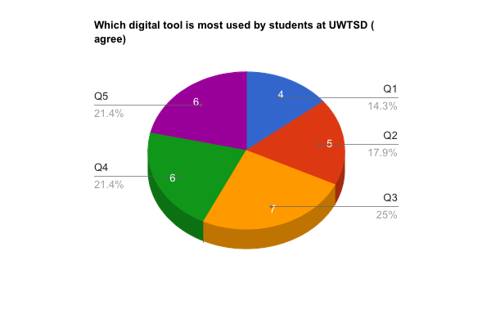
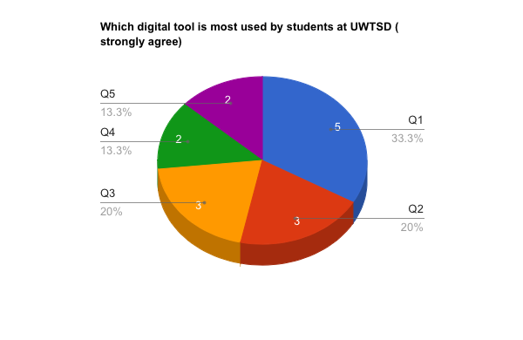

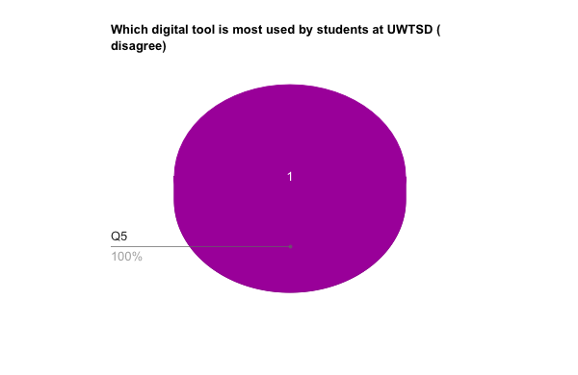
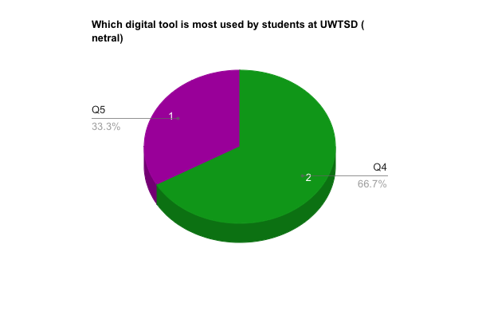

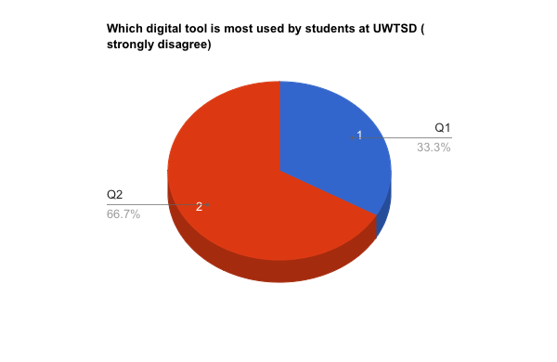

Discussion (6)

Is Moodle effective and improving students access and attentiveness towards learning?

This question was asked to 10 different students on campus embossed students either strongly agreed or agreed of those only one student that strongly disagreed. Five out of the 10 students strongly agreed that it helps then to learn, four out the ten students agreed that it helps but weren't 100% sure And there one person out of the 10 who said that they strongly disagree Moodle is not effective and helping them study.

Is Moodle practical to gain knowledge and skills?

For this question most people strongly agreed that mule is helpful to gain knowledge and new skills 8 out of 10 people had a positive on take about Moodle and its ability to help you gain knowledge and skill well two out of 10 strongly disagreed with this question and thought that Moodle is complicated and not useful and gaining new knowledge and skills.

It Moodle easy to use and navigate?

This question has 0 negative responses as everyone who would answer that either strongly agreed or agreed there were three out of 10 that strongly agreed on seven out of 10 that agreed. This tiles are debt collector that Moodle is really easy to use and navigate through And that even with some people that find using this technology hard still are able to you understand how to navigate through it.

Do participants prefer to use Moodle over other platforms?

The results show the eight out of the 10 people prefer to use Moodle then go into a different platform as it is much easier simpler and faster while there are two out of 10 add neutral as they neither think it is better nor worse.

How easy is it to access Moodle from different devices and different locations?

This is the one this is the one question that got a wide range of results as some agree some don't agree on some on neutral. This question relies on the person themselves some have the means to access Moodle from anywhere and others could not.

Conclusion (7)

Majority of the students that were asked on the campus agree that Moodle is easy to use And that they prefer it over other digital platforms. The same people that just don't like it some different method don't like it because they are not show how to use it well they have not been taught yet and they are struggling. It would have been better if we got data back from more students and had more questions that they could answer so our results could be more accurate.

It could be better to have a small box at the end of the questionnaire so students could leave that own feedback about what they thought and how they felt.

Hypnotise (8)

I hypothesise that students will think Moodle is easy, helpful and more convenient Because they have been told how to use moodle by the teachers and have a good base understanding of it.

Reference list (9)

https://research-methodology.net/research-methodology/ethical-considerations/

Connelly, L.M. (2014) 'Ethical considerations in research studies', MedSurg Nursing, 23(1), 54+, available: https://link.gale.com/apps/doc/A360608990/AONE?u=anon~fc7c5d28&sid=googleScholar&xid=f6a5ed90 [accessed 13 Oct 2022].

Barnes. (2016). 5 skills for the global learner : what everyone needs to navigate the digital world. Corwin A SAGE Company.

Moersch. (2013). Improving achievement with digital age best practices. Corwin.

https://www.simplypsychology.org/what-is-a-hypotheses.html

