

General Robotic Surgery in the Health and Care Professions (BMHP6026)

Component 1: Written Report
Student name: Abosede Dehinbo
Student number: 2313077
Lecturer’s name: Dr Laila Surani

Table of contents

Contents
Introduction……………………………………………………………………………………………………..3
Impact on workforce 5
Impact on service delivery 6
Impact on patients 7
Impact on community 8
Conclusion 9
References 10

Introduction
This report will highlight technological innovation. This has increasingly transformed healthcare systems worldwide, particularly through the integration of robotics and artificial intelligence. In the United Kingdom, robotics is becoming an important component of health and social care, particularly in surgical procedures and in assisting vulnerable populations. Robotic systems are designed to support healthcare professionals in performing complex tasks with greater accuracy, efficiency, and consistency. In surgical environments, robotic technologies enable surgeons to perform minimally invasive procedures with improved visualisation and precision. In social care settings, robotic devices are being explored as tools to support quality of life and person-centred care for people with disabilities in managing everyday activities and maintaining independence (Leineweber et al., 2026).
The adoption of robotics in the UK has expanded significantly in recent years. The number of robotic surgical systems in NHS hospitals increased from approximately 36 to more than 90 between 2019 and 2025 (Donald, Sebastian, and Preziosi, 2026). National plans also indicate that robotic surgery could increase from around 70,000 operations per year to approximately 500,000 annually by 2035 as part of broader efforts to reduce NHS waiting lists and modernise healthcare services (NHS England, 2025). These developments demonstrate the growing importance of robotics in healthcare delivery.
Despite these potential benefits, the integration of robotics raises several challenges related to workforce transformation, financial cost, patient safety, and ethical considerations. This essay critically analyses the use of robotics in surgical procedures and care assistance within the UK. It evaluates the impact of robotic technologies on the healthcare workforce, service delivery, patient outcomes, and the wider community. The discussion also compares robotic systems with traditional approaches to healthcare delivery.
Robotics in Healthcare
Robotic technologies in healthcare are primarily used to assist clinicians in performing tasks that require high levels of precision and consistency. Surgical robots operate through computer-controlled systems that translate a surgeon’s hand movements into smaller and more precise movements of robotic instruments. These systems typically include high-definition cameras, articulated robotic arms, and digital consoles. Together, these features allow surgeons to perform procedures with enhanced visibility, stability, and control (Russell H. Taylor et al., 2022).
Robotic surgery has significantly influenced the development of modern surgical practice. Initially, robotic systems were used mainly for specialised procedures such as prostate cancer surgery. However, as the technology has advanced and clinicians have gained experience with robotic systems, their use has expanded into other surgical areas, including colorectal surgery, gynaecology and cardiothoracic procedures. Evidence from several hospitals in the United Kingdom indicates that robotic surgery is increasingly used for complex procedures because of its potential to improve surgical precision and reduce complications and empower patients’ quality of life (Fuller et al., 2025).
Research from multiple UK surgical centres suggests that robotic colorectal surgery can produce favourable outcomes, including low conversion rates to open surgery and shorter hospital stays for patients undergoing complex procedures (Koc et al., 2024). These findings indicate growing confidence in robotic technologies among healthcare professionals.

Beyond surgical applications, robotics is also emerging within social care services. Care robots are designed to assist individuals with daily activities such as mobility support, medication reminders, and health monitoring. Research suggests that these technologies may help older adults maintain independence while reducing the workload of healthcare staff (Jinhui Xie, 2024).
Interest in care robotics is closely linked to demographic changes in the UK. The ageing population continues to increase, placing greater pressure on health and social care services. As a result, policymakers are exploring technological solutions that may complement traditional caregiving roles.
However, the introduction of robotics within the NHS remains uneven. Some hospitals have invested significantly in robotic technologies, while others lack the financial resources required to adopt these systems. This variation raises concerns about unequal access to healthcare innovations.

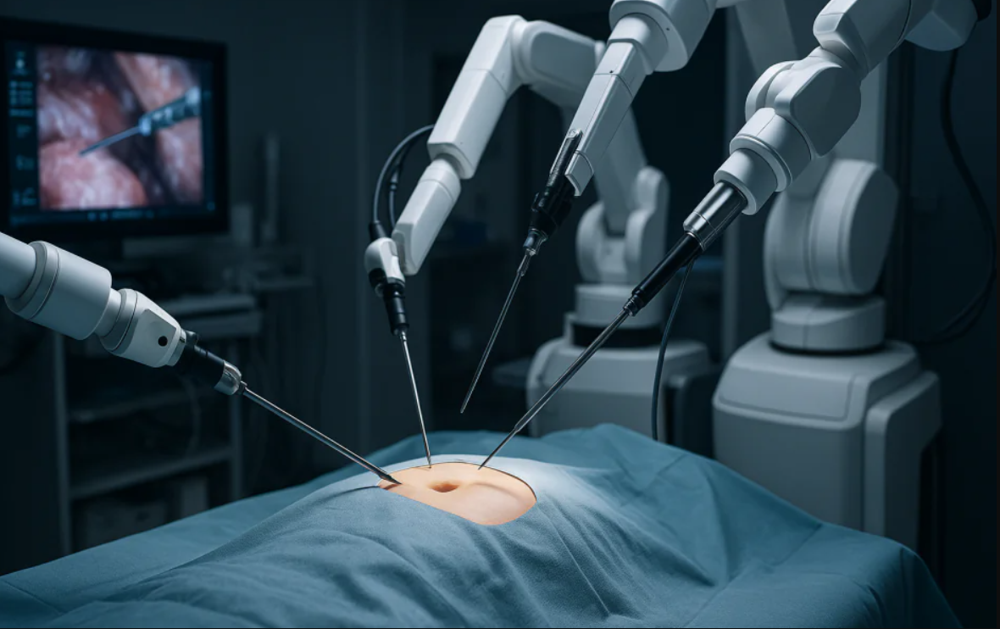 Figure 1.1

Impact on the healthcare workforce
The introduction of robotics has important implications for the healthcare workforce. One major benefit is the potential improvement in surgical precision and performance. Robotic systems reduce natural hand tremors and provide surgeons with magnified three-dimensional views of the surgical field, which can improve accuracy during complex procedures (Liu and Hayton, 2025).
Robotic surgery may also improve working conditions for surgeons. Traditional surgical procedures often involve prolonged standing and physically demanding movements. Robotic systems allow surgeons to operate from a seated console, which may reduce fatigue and physical strain.
Despite these advantages, the integration of robotics also presents challenges for healthcare professionals. One key issue is the need for specialised training. Operating robotic surgical systems requires advanced technical skills and familiarity with digital interfaces. Training programmes and simulation-based learning are therefore essential to ensure safe and effective use of these technologies.
Workforce capacity remains another important limitation. Research examining the adoption of robotic surgery in UK hospitals found that staff shortages and limited training opportunities can restrict the number of procedures performed using robotic systems (NHS England and GIRFT, 2025). Without sufficient trained personnel, hospitals may struggle to maximise the benefits of robotic technology.
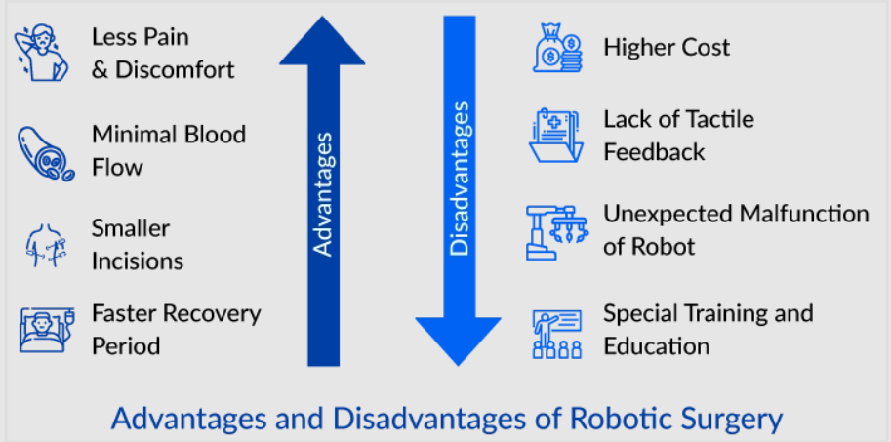 Figure 1.2
Robotics may also alter professional roles within healthcare teams. Some tasks traditionally performed by healthcare staff could become partially automated. For example, assistive robots may support rehabilitation exercises or monitor patients’ conditions in care settings. While this may reduce the physical workload of staff, it may also raise concerns about job security or changes in professional responsibilities.
Nevertheless, robotics should not be viewed as a replacement for healthcare professionals. Clinical judgement, ethical decision-making, and compassionate communication remain essential aspects of healthcare practice that cannot be replicated by machines. Robotics should therefore be considered a tool that supports healthcare professionals rather than replacing them.

Impact on service delivery
Robotic technologies also influence healthcare service delivery. One of the main advantages of robotic surgery is its ability to support minimally invasive procedures. These procedures involve smaller incisions compared with traditional open surgery, which can reduce tissue damage and accelerate patient recovery.
Research analysing robotic surgery across several NHS hospitals indicates that robotic procedures may lead to shorter hospital stays compared with traditional open surgery (Smith and Okocha, 2025). Faster recovery times may allow hospitals to treat more patients with the same resources, which could contribute to reducing waiting lists.
Robotic surgery has also been associated with reduced blood loss and lower complication rates in certain procedures, including colorectal and prostate surgeries. However, it is important to evaluate whether these improvements justify the substantial financial investment required.
Robotic surgical systems can cost more than £1 million per unit, in addition to ongoing maintenance, training, and equipment costs. In a publicly funded healthcare system such as the NHS, these expenses raise important questions about cost-effectiveness and resource allocation.
Another concern is the potential underutilisation of robotic systems. Reports suggest that some NHS hospitals do not use robotic equipment at full capacity due to workforce shortages or limited training opportunities (The Times, 2024). When expensive technologies are underused, their value for money becomes questionable.
Furthermore, robotic surgery is not always significantly superior to existing minimally invasive techniques such as laparoscopic surgery. In some procedures, laparoscopic methods can achieve similar clinical outcomes with lower costs and shorter preparation times. Therefore, the cost-effectiveness of robotic surgery remains an ongoing debate within healthcare policy.

Impact on patients

From a patient perspective, robotic technologies offer several potential advantages. Robotic systems allow surgeons to perform highly precise movements, which may reduce tissue damage during surgery.

Patients undergoing robotic surgery often experience reduced postoperative pain, smaller scars, and faster recovery compared with those undergoing open surgery. These improvements may lead to shorter hospital stays and quicker returns to normal daily activities.

Clinical evidence also suggests that robotic surgery can reduce complication rates in certain procedures. Studies comparing robotic and open colorectal surgery have reported favourable recovery outcomes and lower conversion rates to open procedures (Miskovic, 2024).

However, robotic surgery also presents potential risks. Technical malfunctions can occur during procedures, requiring surgeons to switch to conventional surgical techniques. Studies examining robotic surgical systems have identified occasional device-related errors or equipment failures during operations (Chen et al., 2021).

Another issue relates to patient understanding of robotic technologies. Some patients mistakenly believe that robots perform surgical procedures independently. In reality, robotic systems are fully controlled by trained surgeons. Clear communication is therefore essential to ensure informed consent and maintain patient trust.

In addition, while robotic surgery may improve short-term recovery outcomes, long-term clinical results, such as survival rates, are not always significantly different from those achieved through traditional surgical techniques. This further highlights the need to critically evaluate the overall benefits of robotic surgery.

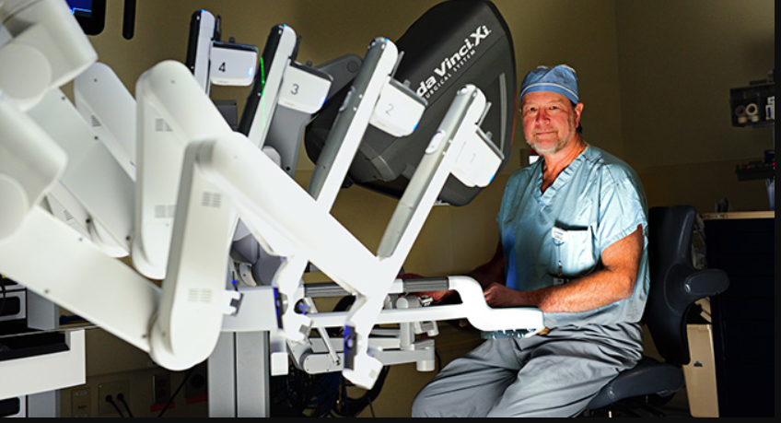 Figure 1.3. Clinic for individualized therapies for prostate cancer | VITUS Privatklinik

Impact on the community

The use of robotics in healthcare also has wider implications for communities and society. One potential benefit is improved access to specialised treatments. As robotic technologies become more widely available, patients in different regions may gain access to advanced surgical procedures that were previously limited to specialist centres.

Robotics may also help address the challenges associated with the ageing population in the UK. Care robots designed to assist older adults with daily activities may enable individuals to maintain independence for longer. Some studies suggest that care robots can support emotional well-being and reduce feelings of loneliness among older adults (Handa, Gaidhane, and Choudhari, 2024).

However, the use of care robots also raises important ethical concerns. Critics argue that replacing human caregivers with machines may reduce meaningful social interaction for vulnerable individuals. Research on social robotics emphasises that robots should complement human care rather than replace personal relationships (Yuan et al., 2023).

Digital inequality is another important concern. Hospitals and communities with greater financial resources may be more likely to adopt robotic technologies, while less resourced areas may struggle to access such innovations. This could contribute to widening inequalities in healthcare provision.

In addition, robotic systems rely heavily on digital data and network connectivity. Protecting sensitive patient information is therefore essential to prevent privacy breaches and maintain public trust in healthcare technologies.

Overall, robotics represents a significant technological advancement in healthcare. Evidence suggests that robotic surgery can improve surgical precision, reduce recovery times, and enhance patient experiences. However, these benefits must be carefully balanced against financial costs, workforce requirements, and ethical considerations.

Conclusion
Robotic technologies are becoming an increasingly important component of health and social care in the United Kingdom. Their use in surgical procedures and care assistance has expanded significantly in recent years, offering potential improvements in clinical outcomes, efficiency, and patient experiences.
Robotic surgery can enhance surgical precision and support minimally invasive procedures, while care robots may help address growing demand within social care services. However, the adoption of robotics also raises challenges related to financial costs, workforce training, patient safety, and inequalities in access.
Importantly, current evidence suggests that robotic systems are not consistently superior to existing surgical techniques, such as laparoscopic surgery. The cost-effectiveness of robotic technologies, therefore, remains a critical issue for the NHS.
Furthermore, while care robots may support independence for older adults, they should not replace human interaction within care environments. Compassionate communication and personal relationships remain essential components of effective care.
Ultimately, robotics should be viewed as a supportive technology that enhances the capabilities of healthcare professionals rather than replacing them. Responsible implementation, combined with appropriate training, ethical oversight, and careful evaluation of costs and outcomes, will be essential for ensuring that robotic technologies contribute positively to the future of health and social care in the United Kingdom.

References
Chen et al. (2021). Evolving robotic surgery training and improving patient safety with the integration of novel technologies. World Journal of Urology, 39(8), pp.2883–2893. Available at: https://doi.org/10.1007/s00345-020-03467-7 (Accessed: 12 March 2026).
Donald, N., Sebastian, J., and Preziosi, G. (2026) ‘Adoption and expansion of robotic surgery across general surgery in the United Kingdom: a 10-year procedure-specific analysis (2015–2024)’, Journal of Robotic Surgery, 20, p. 205. https://doi.org/10.1007/s11701-025-03073- (Accessed: 16 March 2026).
Eric Topol (2019). Deep medicine: How artificial intelligence can make healthcare human again. London: Basic Books. (Accessed: 15 March 26).
Fuller et al. (2025). Understanding the challenges of robotic-assisted surgery adoption: Perspectives from stakeholders and the general population on human-interaction, built environment, and training. Applied Ergonomics, 122, p.104403. Available at: https://doi.org/10.1016/j.apergo.2024.104403 (Accessed: 12 March 2026).
Handa, Gaidhane, and Choudhari (2024). Role of robotic-assisted surgery in public health: Its advantages and challenges. Cureus, 16(6), e62958. Available at: https://doi.org/10.7759/cureus.62958. (Accessed: 12 March 2026).
Jinhui Xie, (2024). The application of social robots in healthcare: Enhancing care quality and addressing ethics challenges. Applied and Computational Engineering, 114, pp. 128–132. Available at: https://doi.org/10.54254/2755-2721/114/2024.18226 (Accessed: 15 Mar. 2026).
Koc et al,. (2024). Structured training pathway for robotic colorectal surgery: Short-term outcomes from five UK centres. Colorectal Disease, 26(11), pp.1965–1970. Available at: https://doi.org/10.1111/codi.17179 (Accessed: 12 March 2026).
Leineweber et al., (2026). ‘Ethical aspects of the use of social robots in caring for older people – a systematic qualitative review,’ Medicine, Health Care and Philosophy, 29, pp. 209–224. https://doi.org/10.1007/s11019-025-10313-3 (Accessed: 16 Mar. 2026).
Liu, H.Y. and Hayton, J. (2025) ‘Expectation vs reality: A case study of the impact of the da Vinci surgical robot on healthcare professionals’ work experiences’, Social Science & Medicine, 383, p. 118437. https://doi.org/10.1016/j.socscimed.2025.118437 (Accessed: 16 March 2026).
Miskovic, D. (2024). ‘The advantages of robotic surgery for patient outcomes. Available at: https://www.topdoctors.co.uk/medical-articles/the-advantages-of-robotic-surgery-for-patient-outcomes/ (Accessed: 16 March 2026).
NHS England (2025). Expansion of robotic surgery in the NHS. Available at: https://www.england.nhs.uk (Accessed: 16 March 2026)
NHS England and GIRFT (2025). Implementation of robotically assisted surgery in England. Available at: https://gettingitrightfirsttime.co.uk/wp-content/uploads/2025/07/FINAL_NHS-England-and-GIRFT-implementation-of-robotically-assisted-surgery-in-England_17-07-2025.pdf (Accessed: 16 March 2026).
Russell H. Taylor, Simaan, N., Menciassi, A., and Yang, G.-Z. (2022) ‘Surgical robotics and computer-integrated interventional medicine’, Proceedings of the IEEE, 110(7), pp. 823–834. Available at: https://doi.org/10.1109/JPROC.2022.3177693. (Accessed: 16 March 2026).
Smith and Okocha (2025). Surgery. In: B. Siciliano and O. Khatib, eds., Springer Handbook of Robotics. 2nd ed. Cham: Springer International Publishing, pp. 1657–1683. Available at: https://doi.org/10.1007/978-3-319-32552-1_63 (Accessed: 14 March 2026).
The Times (2024). ‘NHS robots and scanners must be used more intensively.’ The Times. Available at: https://www.thetimes.co.uk/ (Accessed: 16 March 2026).

Yuan et al., (2023). Ethical design of social robots in aged care: A literature review using an ethics of care perspective. International Journal of Social Robotics, 15, pp. 1637–1654. Available at: https://doi.org/10.1007/s12369-023-01053-6 (Accessed: 15 Mar. 2026)

