“Module: Financial Management for the Hotel Industry”

“Module code: BMIH5007”

“Assignment 2”

Student name: Daniel Ranga

Student number:2118951

Lecture name:Christopher Wilkin

Table of Contents
Introduction 3
Discussions 3
Comparison of Insourced Housekeeping Team Vs Outsourcing Housekeeping 3
Abilities of Business Employees in IHG 4
Cost implications related to IHG 5
Performance results related to employees of IHG 7
Sustainability related to IHG 7
Employee Consistency in IHG 8
Guest Experience in IHG 9
Conclusions 10
References 11

Introduction
A positive and structural internal working culture in a business brings the operating development including the strategic objective completion support systematically. With managing the operating potentiality of the managerial department overall performance growth is mainly managed and formulated that ultimately initiates the standardised operating and cultural development support on a systematic basis (Atril and McLaney, 2015). According to the basic operating function, the management of Intercontinental Hotels Group (IHG) provides a significant volume of significance towards the employee management function and other non-financial attributes that ultimately formulates the operating development support on a fruitful basis.
This report mainly provides a focused supportive argument regarding the outsourcing Housekeeping department in the present position with operational accountability in IHG.

Discussions
According to the present operational structure of IHG, in the present position, the operational engagement of this business is spread over more than 20 additional countries including the United Kingdom and formulates a total of 6164 hotels out of which 962 hotels are owned, leased and managed by the IHG. Around 5202 franchised hotels are noticed in this business and based on the operational structure the engagement of outsourcing employee engagement is initiated associated with housekeeping and other purposes.

Comparison of Insourced Housekeeping Team Vs Outsourcing Housekeeping
As per the primary identification regarding human resource management in an organisation, while the recruitment processing of employees is initiated with the involvement of the human resource department is called insourced employee engagement. On the other hand, the engagement of such recruitment is initiated with the involvement of third-party engagement associated with the adequacy support is called outsourcing employee engagement support in general (Jia et al., 2019). Through the concept of employee engagement, the overall operating development including the strategic formulation of business has been managed which ultimately initiates to establish the operational growth securely. However, compared to internally, the presence of outsourcing is expensive and complex due to the involvement of third-party recruiters (Kim and Kim, 2021). However, it also initiated the declining support of employee recruitment burden for the HR department with a sustainable operational growth basis. In the present position, after the pandemic and Russia-Ukraine war, the overall labour charges and availability in the hospitality sector significantly declined, imposing a certain burden on the employee management in IHG. Under this approach, the management of this business fundamentally focuses on the recruitment and engagement of outsourcing employee engagement related to different aspects including housekeeping purposes as well that ultimately initiate the stability and operation growth approach (Statista, 2023). The present attribute of this type of engagement provides a proper volume of low-cost employee formulation support and also a proper volume of employee retention approach also that brings the ultimate results of business feasibility.
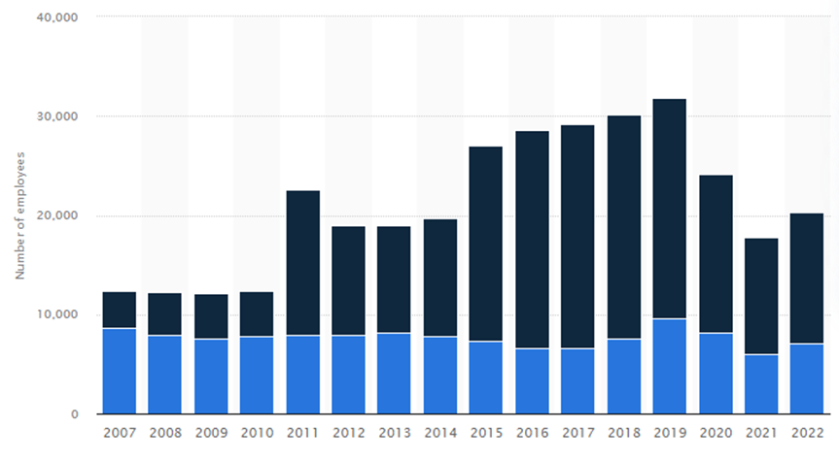
Figure 1: IHG employee volume
(Source: Statista, 2023)
In the present situation, more than 350,000 employee engagement is initiated in IHG along with proper employee-centric support that ultimately initiates the stability progress on a sustainable basis.

Abilities of Business Employees in IHG
According to the primary code of conduct related to the business, IHG initiates optimised engagement support of potential employees that brings operational growth and other associated performance progress on a proper basis. Through the involvement of third-party recruiters a positive and optimised level of employees’ ability processing is initiated that manages accountability support on a progressive basis. The present operational engagement and including the global workforce engagement in IHG initiates the employee formulation including a diverse operational background engagement in general that ultimately initiates an inclusive internal working environmental presence. Associated with the basic operating support, as per the primary strategy of this business “the management of IHG fundamentally intended to drive gender equality at group leadership levels, as well as doubling other minority representation, plus cultivating a culture of inclusion, particularly for ethnic minorities and disabled employees (UNLEASH 2022).”
Even in the present position the management of IHG also initiated a new conscious inclusion training program associated with talent management processing which initiates a proper volume of employee engagement and retention support on an effective basis. Additionally, the primary involvement of IHG’s employee resource groups (ERGs) also initiates a major role in the recruitment of employees including the maintenance support of employee potentiality support that brings the ultimate growth of operating stability and abilities for individual employees. Even the current initiative of IHG’s “Skills Academy programme and new virtual learning platform” manages a positive employee recruitment process with outsourcing support mainly for operational growth and for managing the quality and compatibility approach for individual employees associated with the business requisition (IHG, 2023).
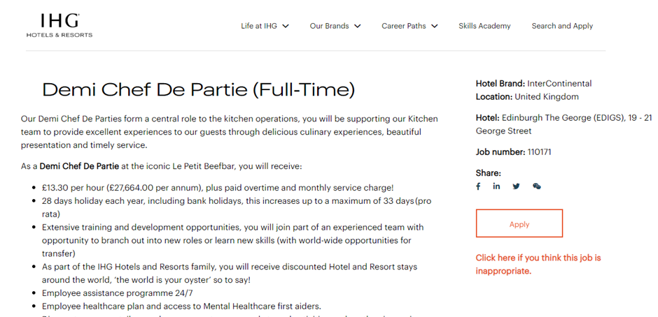
Figure 2: IHG employee recruitment notice
(Source: IHG, 2023)

Cost implications related to IHG
The associated charges which are levied over the business related to the reason for employee engagement is representing the volume of cost implications related to employee operations in business. Fundamentally, the engagement of the equality act in the business initiates a proper volume of remuneration support to individual employees depending on their responsibility which initiates progressive structural development and optimises internal cultural engagement in business (Drury, 2015).
According to the basic identifications the general volume of wages and salaries related to this particular business group is around $1604 million, which was $1315 million in 2021 respectively. Including the general identifications of the general operating processing, the primary Costs borne by IHG related to individual employees in the present period is $646 million, which is comparatively higher differentiated from the previous financial position of $569 million in 2021 respectively (IHG, 2022). In the present situation after the pandemic for initiating a proper volume of employee retention support the primary engagement of “Staff costs are represented net of government supportive income of $5 million in the present period relates principally to employee costs at certain of the Group’s leased hotels”. The involvement of this type of engagement generally provides a systematic opportunity including an employee retention approach that includes stability of progressive positions on a simultaneous basis. Associated with the general approach of this processing it can be recognised that Outsourcing employee engagement in the business initiates a proper volume of stability including the cost maintenance approach in proper order with the elimination of certain difficulties which is initiated as the impact of the Russia-Ukraine war.
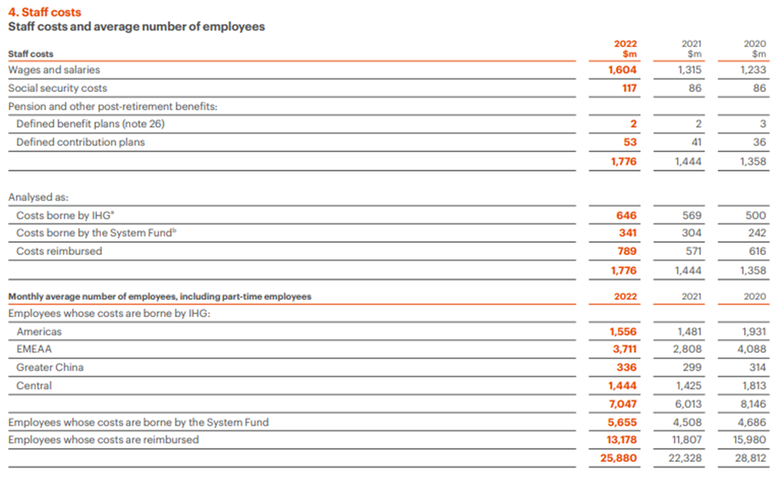
Figure 3: IHG’s three years employee cost
(Source: IHG, 2022)

Performance results related to employees of IHG
According to the primary operational progress, the involvement of 1300 different employee existence associated with diversified cultural support initiates and optimises the volume of working engagement in IHG. As per the basic identification, at the current movement around 86% of overall employee engagement expansions are initiated in this business with the 57000 hours of employee processing support that ultimately initiates the optimised development and cultural formulation (IHG, 2022). Throughout 2020, the primary involvement of the Creative approach related to employee engagement along with a proper and increasing number of meetings initiated in this business, which provide a proper volume of guidance and support to employee formulations on a supportive basis. The primary involvement of outsourcing employee engagement initiates a systematic opportunity related to labour maintenance and employee retention in this business which ultimately provides a proper volume of cultural development and internal operating progressive support (ihgplc.com, 2023). In the present situation for initiating a systematic development related to employee performances, management of IHG enables infrastructure and technology formulation, a continued focus on rapid and high-quality decision making, plus ensuring that inclusion remains a key focus for the business structural formulation.

Sustainability related to IHG
Fundamentally, the importance of the processing of employees' sustainability is one of the primary attributes in individual businesses which are initiated to maintain the internal working cultural development support. The presence of maintaining a proper sustainability level among the employees along with managing a proper volume of quality formulations related to Individual business brings the ultimate support of strategic objective completion properly (Guilding, 2013). The primary involvement of proper training and development and program by the managerial department brings the optimised growth including a systematic approach of Cultural formulation in business which ultimately initiates the stability and compatibility benefit on a progressive basis. A supportive engagement of the sustainability approach related to the business measures the greater investment with a longer pay-back period approach that initiates the stability formulation including internal working cultural growth support.
In IHG, the primary involvement of proper employee retention support and employee remuneration processing is generally initiated for standardisation support related to the employee structure and cultural attributes mainly which ultimately initiates the sustainability progress on an effective basis. Additionally, in the present situation, “the primary engagement of “high-performing suppliers in sustainability and the circular economy that provide carpeting, showers, furniture, bedding, mattresses, flooring, and air travel to hotels and also engaged in other associated corporate functions enables the sustainability support regarding business sustainability. Through the processing of such the business can gain valuable insights into the sustainability journey of suppliers, discuss opportunities for collaboration, and build stronger relationships with top-performing suppliers” in a proper basis that ultimately initiates the progressive development support of business standardised approach.

Employee Consistency in IHG
In association with the general code of conduct the primary operating approach including the operating development of the business initiates a sustainable development including the financial commitments and expenditures mainly. The general engagement related to the approach of ethics and compliances of this business brings the competencies and standardised growth support including the value maintenance support with the structural growth support on a proper basis (Our Code of Conduct, 2023).
The primary involvement of diversified cultural engagement regarding employee engagement brings the structural formulation approach on a progressive basis. Associated with the present operating structure the management of IHG initiates the strategic approach of 2030 that brings economic drive support including training and skills innovation programmes for individual employee engagement. Additionally, to provide a proper volume of community development the organisation also initiates the supportive cultural attribute and some of the collaborative engagement approaches for avoiding the poverty level as well which ultimately provide the systematic growth of business employed development formulations appropriately (InterContinental Hotels Group PLC, 2023).
In the present situation, for initiating a smooth transition support related to the working formulations the management of the business initiated the hybrid working approach along with the engagement of a three-day employee Hackathon approach that brings the working cultural development including an operating progressive approach in a systematic manner (IHG, 2022). According to the primary identifications, the involvement of the internal channel including the hybrid working model of the business initiates a proper volume of culturally attributable support related to the employee retention program in this business which ultimately initiates the stability and accountability progress properly.

Guest Experience in IHG
For every individual hospitality business, the experiences of individual guests or customers matter a lot which ultimately provides a supportive appearance to establish goodwill. The primary presence of operation activity and strategic approach of IHG provides focus on the cultural development system medical and the present global market campaign related to the “Guest How You Guest” approach brings the formulation and operating stability progress on an effective basis (Hospitality Net, 2023). A proper volume of staff management including the structural development initiative manages the loyalty program of the business in a proper order that ultimately initiates a positive opportunity for the next generation traveller.
Proper importance to the employee structure development and training and formulation initiative allows the business to express a proper volume of structural progress which ultimately standardised the experience of individual guests towards sovereignty (IHG, 2022). Even in the present situation, the primary environment of digitisation engagement is related to 58% digital booking facilities with a 20% digital marketing approach that brings structural growth support on a systematic basis (Ihg.com, 2023). The present involvement of a customer-centric approach by the business initiates a proper and sustainable internal working structural development including the revenue progressive support in IHG, which ultimately brings comparative formulations on a proper basis.
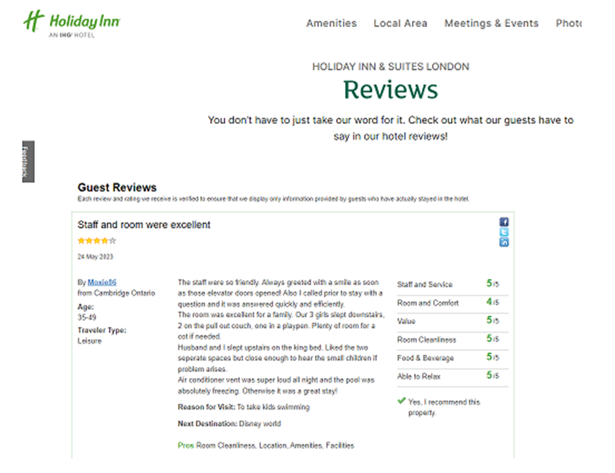
Figure 4: Review by customers on IHG services
(Source: Ihg.com, 2023)

Conclusions
In summary, the current Outsourcing employee engagement in IHG brings operational growth including the progressive cultural attribute that ultimately initiates the stability position related to internal operating growth. The current strategic initiative related to the Journey to Tomorrow approach by the IHG brings proper employee engagement and formulation support including the cultural sovereignty support that ultimately initiates the operating progress including the internal operational growth support in IHG. The presence of engagement initiates a proper volume of marketing development initiatives in this business including proper financial formulation support that ultimately brings the competencies of market capitalisation.

References
Atrill P and McLaney E (2015) Management Accounting for Decision Makers, FT Prentice Hall
Drury C (2015) (9th Ed) Management and Cost Accounting, London, Prentice Hall
Guilding,C.(2013) Accounting Essentials for Hospitality Managers, London, Taylor and Francis.
Hospitality Net. (2023). IHG Hotels & Resorts debuts trailblazing new global campaign, Guest How You Guest, inviting all travelers to be their authentic selves. [online] Available at: https://www.hospitalitynet.org/news/4111824.html [Accessed 9 Jun. 2023].
IHG (2022). Annual Report. [online] InterContinental Hotels Group PLC. Available at: https://www.ihgplc.com/en/investors/annual-report [Accessed 9 Jun. 2023].
IHG. (2023). Home. [online] Available at: https://careers.ihg.com/en/ [Accessed 9 Jun. 2023].
Ihg.com. (2023). IHG Customers review. [online] Available at: https://www.ihg.com/holidayinn/hotels/gb/en/london/yxulo/hoteldetail/hotel-reviews [Accessed 9 Jun. 2023].
ihgplc.com. (2023). employee performance. [online] Available at: https://www.ihgplc.com/en/news-and-media/news-releases/2018/ihg-awarded-top-employer-in-the-uk-for-the-fourth-year-running [Accessed 9 Jun. 2023].
InterContinental Hotels Group PLC. (2023). Journey to Tomorrow: IHG Hotels & Resorts publishes series of ambitious commitments to drive change for people, communities and the planet. [online] Available at: https://www.ihgplc.com/en/news-and-media/news-releases/2021/journey-to-tomorrow-ihg-hotels-resorts-publishes-series-of-ambitious-commitments [Accessed 9 Jun. 2023].
Jia, Y., Yan, J., Liu, T. and Huang, J., 2019. How does internal and external CSR affect employees’ work engagement? Exploring multiple mediation mechanisms and boundary conditions. International journal of environmental research and public health, 16(14), p.2476.
Kim, M. and Kim, J., 2021. Corporate social responsibility, employee engagement, well-being and the task performance of frontline employees. Management Decision, 59(8), pp.2040-2056.
Our Code of Conduct. (2023). Available at: https://www.ihgplc.com/en/-/media/ihg/files/pdf/corporate-governance/march-2022/ihg-final-code-of-conduct-pdf-english---external-document.pdf?la=en&hash=C0B600EEA20532FC15A3298E6CECAAD7 [Accessed 9 Jun. 2023].
Statista. (2023). IHG: number of employees 2019. [online] Available at: https://www.statista.com/statistics/223422/intercontinental-hotels-group-number-of-employees/ [Accessed 9 Jun. 2023].
UNLEASH. (2022). IHG: Employee listening is key to inclusion. [online] Available at: https://www.unleash.ai/diversity-equity-inclusion/ihg-employee-listening-is-key-to-inclusion/ [Accessed 9 Jun. 2023].

