Tahseen Akhtar (1907552)

TAHSEEN AKHTAR
(1907552)
BMHP5003_BIRM
LECTURER: MUMTAZ GOOLAM

Introduction to Physiology
BSc Health and Social Carei

Mouth: serves as the first point of the digestive system. It consists of the lips, tongue, palate and teeth. The tongue enables digestion by pressing food against palates and the teeth grind the food, this enables it to be travel through to the Oesophagus (Kamrani and Sadiq, 2020).
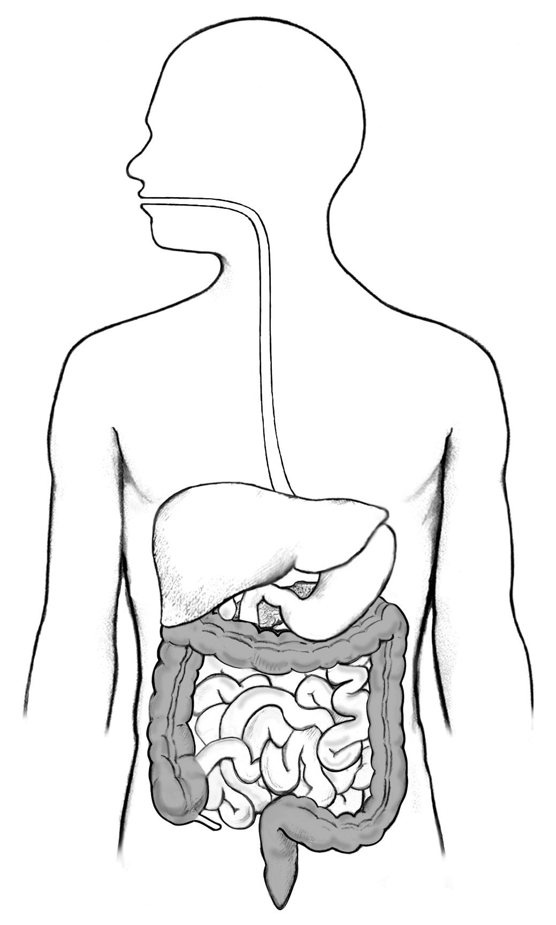
Small Intestine: The small intestine is made up of the duodenum, jejunum, and ileum. (Small Intestine Function, Anatomy& Diagram body Maps, 2021). Food that has already broken down further degraded by enzymes and the digestion of all the nutrients is completed

Duodenum: secretions from the gall bladder and the pancreas merge and enter here.
Pancreas: it is located behind the stomach and produces Exocrine cells that produce enzymes that aide digestion. (What is the Pancreas? -Pancreatic Cancer Action Network, 2021).

Digestive image: (Library, Details, labelled and Health, 2021)

Liver and gall bladder: the liver regulates chemical levels in the blood and produces bile to remove waste from the liver. The gallbladder is used to store and release bile (Wilson, Waugh and Ross, 2010)).
Oesophagus: this consists of a tube that connects the throat to the stomach. It is about 8 inches long and is lined with moist mucus. It has muscles that can control food and secretion from going down the windpipe and can prevent acid from the stomach going backwards. The muscle movement that moves the food from the throat to the stomach is called Peristalsis. (Woods and Carey, 2020).
Stomach:
The main function of the stomach is to aide digestion. The four key parts of gastric stomach are related to its capacity as a reservoir, acid secretion, enzyme secretion and its role in gastrointestinal motility. The stomach receives food from the oesophagus and the stomach then produces acid and enzymes that digest the food (O’Connor and O’Morain,2014).

Diaphragm: before entering the stomach, the oesophagus passes through the diaphragm.
The Colon: This organ has 3 main functions, engrossing water and electrolytes, delivering and retaining nutrients, and shaping and moving defecation toward the rectum for disposal (McConnell and Hull 2020).

DIGESTIVE SYSTEM
The digestive system consists of organs that are responsible in preparing food that has been eaten to be absorbed correctly in the body. The process begins at the mouth through the thorax the stomach and lastly passing through the anus. The process of absorption changes at each different organ in order for absorption to be properly digested and broken down (Waugh and Grant, 2014).

Descending Colon: Stores faceas which will be emptied into the rectum.

Ascending Colon: To retain the leftover water and other key nutrients from the inedible material, setting it to form stool.

Anus: This is the final organ in the digestive system. Once the rectum is ready to release the faeces it stimulates movement, and the faeces are released out of the body (Muller, 2018).
Rectum: is where the stool is received from the colon and holds the stool until it is ready to be released.
Sigmoid Colon: Contracts to increase the pressure inside the colon to move into the rectum.

Rectum: part of the large intestine that stores faeces.

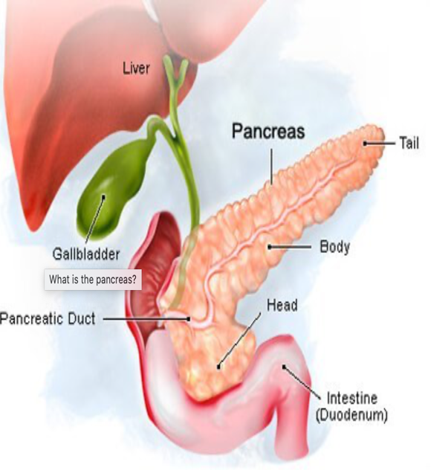Image: (Medicinenet.com2021).

DIABETES is a result of when the body does not properly process food as energy. At the point when you have diabetes, your body either doesn't react to insulin or doesn't create any insulin whatsoever. Insulin is a chemical that gets glucose (sugar that is utilized as energy) to the cells in your body. This makes sugars develop in your blood, which can result in further complication.

If left untreated diabetes can damage the nerves, eyes, kidneys and other major organs. DIABETES TYPES
Type 1: autoimmune disease. The immune systems attacks and the cells in the pancreas are destroyed. Type 2: the sugar in your blood builds up and the body is resistant to the insulin. Prediabetes: blood sugar is high but can still be managed with a diet change. Gestational diabetes: high blood sugar in pregnancy. This is caused by the insulin blocking hormones produced by the placenta. (Facts About Diabetes, 2021)

PANCREAS FUNCTION.

The functions that are performed by the pancreas are significantly important for the function of the human body. Endocrine purpose: it produces chemicals, including insulin and glucagon, and deliveries them into the blood. These chemicals direct sugar (glucose) transport into the body's cells, where it is utilized for energy and to assist with keeping up with normal glucose levels. Exocrine purpose: It delivers enzymes to digest and process food sources, fats, proteins, and sugars in our small intestine. The enzymes ordinarily are delivered and conveyed in an inert structure to the small digestive system, where the chemicals are initiated when they are required. It makes and passes bicarbonate that neutralizes stomach acids and takes into account the initiation of pancreatic enzymes.

HOW CAN YOU DIAGNOSE DIABETES?

-Increased hunger and thirst
-Weight loss
-The need to urinate more
-Blurry vision
-Fatigue
-Wounds that are delayed in healing.
RECOMMENDATIONS

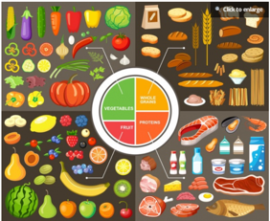
(Lyons and Susan McQuillan MS, 2021)

-Cut saturated, trans and refined carbohydrates from your diet to prevent type 2 and prediabetes.
-add more fruit and veg and wholegrains
-reduce your portion sizes
-lose weight if you are overweight or obese.

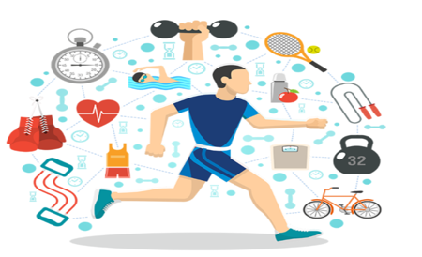
Increase physical activity gradually. Regular exercise can help prevent type 2 diabetes

(Exercise in Diabetes Management, 2021).
Try drinking only water instead of other sugared drinks as this will help control blood sugar and insulin levels and may help reduce the risk of developing diabetes.
Eat plenty of fibre foods to improve gut health.
Reduce the amount of processed food you are eating. Enjoy more whole foods to help reduce the risk of diabetes.
REFERENCES

Facts About Diabetes (2021) [online] Available at: https://www.hopkinsmedicine.org/health/conditions-and-diseases/diabetes (Accessed 3 July 2021).

Healthline. (2021). Small Intestine Function, Anatomy & Diagram | Body Maps. [online] Available at: https://www.healthline.com/human-body-maps/small-intestine (Accessed 25 June 2021).

Kamrani, P. and Sadiq, N.M., (2020). Anatomy, Head and Neck, Oral Cavity (Mouth). Stat Pearls [online] (Accessed 25 June 2021).

Library, M., Details, M., labelled, I. and Health, N., (2021). Illustration of the digestive system labelled. [online] National Institute of Diabetes and Digestive and Kidney Diseases. Available at: https://www.niddk.nih.gov/news/media-library/8894 (Accessed 25 June 2021).

Lyons, G. and Susan McQuillan MS, C., (2021). Diabetic Diet: The Best Way to Eat for Type 2 Diabetes. [online] Endocrine Web. Available at: https://www.endocrineweb.com/conditions/diabetes/diabetes-diet-best-way-eat-type-2-diabetes (Accessed 3 July 2021).

Medicinenet.com. 2021. [online] Available at: https://www.medicinenet.com/symptoms_of_your_pancreas_not_working_properly/article.htm (Accessed 3 July 2021).

McConnell, T.H. and Hull, K.L., (2020). Human Form, Human Function: Essentials of Anatomy & Physiology. Jones & Bartlett Publishers.pp536-582

Muller, A., (2018). Ross and Wilson Pocket Reference Guide to Anatomy and Physiology,. Elsevier Health Sciences., pp 266-328.

Novonordisk.co.in. (2021). Exercise in Diabetes Management. [online] Available at: https://www.novonordisk.co.in/patient-education/diabetes/4-pillars-of-diabetes-care/exercise-in-diabetes-management.html (Accessed 3 July 2021).

O'Connor, A. and O'Moráin, C., (2014). Digestive Function of the Stomach. Digestive Diseases, 32(3)., pp.186-191.

Pancreatic Cancer Action Network (2021). What is the Pancreas? - Pancreatic Cancer Action Network. [online] Available at: https://www.pancan.org/facing-pancreatic-cancer/about-pancreatic-cancer/what-is-the-pancreas (Accessed 3 July 2021).

Saladin, K.S., McFarland, R. and Sullivan, S.J., (2014). Essentials of Anatomy & Physiology. McGraw-Hill Education., pp558-595

Waugh, A., Grant, A, and Ross, J., (2010), Ross and Wilson anatomy and physiology in health and illness. Edinburgh, Churchill Livingstone

Waugh, A. and Grant, A., (2014). Ross & Wilson Anatomy and physiology in health and illness .12th ed. Elsevier Health Sciences., pp.285-357.

WebMD. 2021. Pancreatitis. [online] Available at: https://www.webmd.com/digestive-disorders/digestive-diseases-pancreatitis (Accessed 3 July 2021).

Woods, Y.L. and Carey, F.A., (2020). Pathology of the oesophagus and stomach. Surgery (Oxford).

.

