Kara Hughes - 2200061 Module 6007 - Who am I Teaching?

A critical evaluation and the identification of next teaching and learning steps focusing on a case study of an individual learner or a group of learners, based on an observed critical incident.

Word Count = 3688

Contents

Introduction ……………………………………………………………………………………………………………………………………... Page 3

The Role of Critical Reflection …………………………………………………………………………………………………………… Page 4

Observation - School & Class Context …………………………………………………………………………………………… Page 5 - 6

Critical Incident linked to Donaldson’s Four Purposes ………………………………………………………………………. Page 7

Literature Review ……………………………………………………………………………………………………………….…….. Page 8 - 12

Reflection / Evaluation & Next Step’s ……………………………………………………………………………….……… Page 13 - 14

Conclusion ……………………………………………………………………………………………………………..………………………. Page 15

References …………………………………………………………………………………………………….………………………… Page 16 - 17

Introduction

Behaviour in the classroom can be one of the most daunting things teachers have to face in the classroom. Controlling certain behaviours in the classroom is extremely important, hence why I’ll be focussing on one specific critical incident which happened during my observations. This essay aims to discuss a critical incident I observed during my time at ‘School X’, by analysing and reflecting on this critical incident, I also aim to discuss how this critical incident will impact my future teaching career, linking it to relevant literature. I’ll be examining various behaviour theories, mainly classical and operant conditioning, and discussing how they affect the learning environment and whether they are suitable for the classroom setting or not, using examples of conditioning within the classroom.

The Role of Critical Reflection

Critical incidents are a result of how we view a situation; the interpretation of the incident will determine its relevance (Tripp, 2011., p.8). Tripp (2011) believes that in order to develop our professional judgement, we are required to reflect on what we do. According to Tripp (2011), reflective teaching is essential because it allows the teacher to assess the choices they have made during an incident and allows them to think about how to advance in their professional growth. He also says that critical incidents are a great way to create a realistic agenda because they give teachers time to address their own issues. They can adapt their teaching methods in the classroom through action research to make them more consistent with their evolving perspectives (Tripp, 2011). Teachers need to find out what happened and what caused it when something goes wrong in the classroom or outside of it. I believe it’s important for me to reflect on the observation I made during my time at ‘School X’ as it’s important for me to learn from the incident and consider the reflections for my future teaching.

This essay will discuss the observations seen during one of the lessons observed at ‘School X’, Donaldson’s four purposes, key literature related to and surrounding the critical incident that happened in that observation, and reflections on that critical incident. I’ll also be discussing how I’ll implement what I’ve learnt in my future teaching. I will be focussing on one singular critical incident. Different aspects of behaviour theories and theorists will be researched; theories such as Ivan Pavlov’s theory of classical conditioning (Yampolsky. D, 2005) and B.F. Skinner’s theory of operant conditioning and his concept of positive punishment (McLeod. S, 2007).

Observation - School & Class Context

Following BERA guidelines, the school, staff, and pupils will all stay entirely anonymous and confidential, and during the entirety of this essay. Participants rights to secrecy and anonymity as well as their schools and individual’s entitlement to privacy will be respected throughout this essay (BERA, 2018).

The observation took place in a mixed comprehensive school based in West Wales, under Pembrokeshire’s local authority. There are currently 534 pupils attending the school between the ages of 11 and 16. The school is categorised as English medium with some significant Welsh, with 27% of pupils fluent in Welsh, 68% of pupils can speak Welsh to some degree with also 1% of pupils speaking English as an additional language (Estyn, 2019). The school currently has 26.6% of pupils on the special educational needs register, which is a little higher than Wales national average of 22.5% for secondary schools (Estyn, 2019). There’s also 15.2% of pupils attending the school who are eligible for free school meals, lower than the Welsh national average of 16.4% for secondary schools (Estyn, 2019). The school was rated good on all inspection categories from the most recent Estyn report, those being ‘standards’, ‘wellbeing and attitudes to learning’, ‘teaching and learning experiences’, ‘care, support and guidance’ and ‘leadership and management’ (Estyn, 2019).

I was provided with the school’s behaviour and safeguarding policies before even attending the school, which gave me a sense of how the school operated and functioned, allowing me to pick up on those concepts from those policies within the classroom. I was given a tour of the school when I initially arrived and was informed of the schedule that I would be following that day. I observed some of the steps taken by some teachers in accordance with the behaviour policy at the school, which made me aware of how seriously they took their policies in that school. This essay will focus on a particular observation that I saw during an I.T lesson for year 7 pupils, a class with a total of 32 pupils of mixed ability. I noted right away that there was no seating plan, so the pupils sat anywhere they pleased next to their friends during the lesson, which resulted in quite a bit of noise from the start; evidently affecting the behaviour and dynamic of the classroom. The main objective of this lesson was to have the pupils design a leaflet emphasising the importance of limiting their time online. This essay will explore the behaviour management techniques I observed being utilised in the classroom and how different behaviours were handled.

The main observation I made of my critical incident was how the teacher used different behaviour strategies and approaches to manage behaviour within the classroom. A tally was made on the board when pupils weren’t following directions or were being too noisy, so a minute was taken from their break time for each line that was added to the tally chart. By behaving appropriately, the pupils could gain time back by taking a tally off the board. This approach was frequently used within the classroom to deal with disruptive behaviour; particularly with one pupil (identified as ‘Pupil A’) who appeared to be off task most of the lesson. A similar method was used with ‘Pupil A’, where they were told that if they stayed on task, their work would be displayed on the class whiteboard. Another time they got told they would be shown how to change the name of specific things on websites using coding if they were to complete the writing on the leaflet. The teacher did go back and forth to check on what the pupil was doing, using different behaviour managing strategies to get the pupil to complete his work and stay on task. The pupil eventually started to complete the task, with the help of the teacher. The teacher also gave him positive feedback about the work he’d already completed, encouraging the pupil to stay engaged within the lesson and complete the task.

Critical Incident linked to Donaldson’s Four Purposes

The Welsh government asked Professor Graham Donaldson to review the curriculum and assessment arrangements for schools in Wales in March 2014 (Donaldson, 2015). According to Donaldson (2015), there are four main purposes that pupils should have when they leave school. This is based on his analysis and review of data collected from more than 700 people in Wales (300 of whom were children and young people). The new curriculum is currently being implemented in schools all over Wales. Those four main purposes are as follows:

- Ambitious, capable learners ready to learn throughout their lives.
- Ethical, informed citizens ready to be citizens of Wales and the world.
- Enterprising, creative contributors ready to play a full part in life and work.
- Healthy, confident individual’s ready to lead fulfilling lives as valued members of society.

I believe ‘ethical, informed citizens’ is the primary purpose associated with my critical incident. I can identify aspects of this main purpose that could be improved by linking them to my critical incident. Donaldson (2015) states that within this purpose pupils should be able to ‘understand and consider the impact of their actions when making choices and acting’ and ‘respect the needs and rights of others, as a member of a diverse society’. These aspects, I believe, weren’t particularly good during the lesson I observed as the lesson was noisy and chaotic. Pupils have a right to an education and a space to learn, however certain pupils interfered with other pupil’s education therefore making it difficult for others to listen and learn.

Literature Review

According to Dr. Barry S. Parasonson (2012), behavioural issues in the classroom increase stress levels in both pupils and teachers. Additionally, behaviour problems interfere with the lessons learning objectives as well as the learning processes. Distracting behaviours present in alters the dynamics of the classroom. Strategies are implemented within the classroom to control behaviour. Managing pupil’s behaviour in the classroom is crucial as it influences the learning environment. Ivan Pavlov’s theory of ‘classical conditioning’ and B.F. Skinner’s theory of ‘operant conditioning’ will be the main focus of this section, by exploring key literature.

Ivan Pavlov, a Russian psychologist, discovered classical conditioning: learning through association. Pavlov believed that when two stimuli are combined, a person (or animal) learns a new response (McLeod.S, 2021). The majority of Ivan Pavlov’s research involving animals, specifically dogs, are what makes him famous. This was done to demonstrate how repetition can condition behaviour over time. He effectively programmed their brains so that they would follow his instructions exactly (Yampolsky. D, 2005). Pavlov’s most famous example was his experiment with dogs and bells. He managed to prove that when a bell was rung, and the dog was presented with food, it learned to associate the sound of the bell with the presentation of food (Bitterman, M. E. 2006).

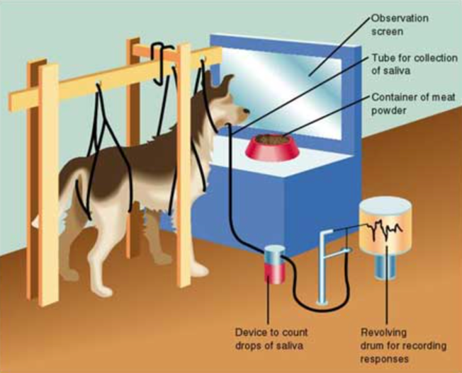
Figure 1 - Pavlov's Dog Experiment (McLeod. S, 2021)

Firstly, he presented the dog with the sound of the bell. The fact that the dog did not salivate indicated that this was a neutral stimulus. The food was an unconditional stimulus, and the salvation was an unconditional response. Following this, Pavlov repeatedly rung the bell before giving the dog the food. After repeating this procedure a few times, the dog began to salivate. The salivation was now a conditioned response to the conditioned stimulus; the sound of the bell (McLeod. S, 2021).

Similarly, was Pavlov’s command experiment. Pavlov was interested in how the dog would respond to the command sit. Putting the dog in the ‘sit’ position, he began by firmly saying the word ‘sit’. A treat would be given as a reward each time. The dog soon understood the command, and from that point forward whenever he performed the command ‘sit’, he salivated in. anticipation of a treat (Yampolsky. D, 2005). Despite learning the command, the dog is still susceptible to confusion. For instance, if a new person were to substitute another word for the command ‘sit’, such as ‘down’ or ‘lay’, the dog may get confused easily because it can’t understand the English language and simply responds to how the command sounds (Yampolsky. D, 2005).

Pavlov’s dog experiment was indeed a success, although there were a few minor issues. As Pavlov would condition the dogs to salivate once the bell was rung, the dogs would come to associate it with food. Then, he proceeded to ring the bell but did not follow that up by rewarding the dog with food. The dogs’ salivation decreased as Pavlov continued to ring the bell without offering them food as a reward. This indicated that experimental extinction of the conditioning had begun. This indicated that the dogs were starting to break their association between the sound of the bell and the reward of food. According to Pavlov’s research, following experimental extinction, the conditioning remains but is not active. By giving the dog the food in the same form as it was given to it as a reward during the initial conditioning, the conditioning can be reactivated (Psychologist World, No Date). In Pavlov’s experiments, the bell must be rung before the dog is given food as a reward in order for the conditioning to remain. The dogs may not form a conditioning. Association between the bell and the food if the bell is rung after they have been given the food (Psychologist World, No Date).

Operant conditioning is a term given by B.F. Skinner who believed that classical conditioning was too simplistic to explain complex human behaviour. His theory was based on Thorndike’s research (1905). According to Skinner, it is necessary to examine both the reasons behind the cause of an action and its consequences in order to understand behaviour (McLeod. S, 2015). Operant conditioning is the process of altering behaviour by utilising rewards that are provided, after the desired response (McLeod. S, 2015). Experiments using animals were done by Skinner to study operant conditioning, and most of these experiments were conducted on rats or pigeons. He placed those animals into ‘Skinner’s box’ and conducted these experiments using reinforcement inside the box.

There are a few minor features for the animals to interact with inside the box. For instance, if the box was designed with rats in mind, it would have a bar inside that the rats could press. This is crucial because “operant behaviour operates on the environment” (O’Donohue, W & Ferguson, K. E, 2001) therefore the apparatus must contain a component that the animals can interact with.
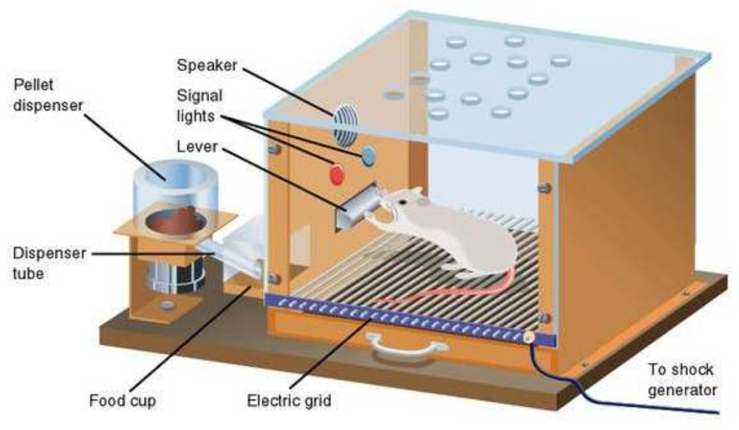

Figure 2 - 'Skinner's Box' (McLeod. S, 2015)

Positive punishment, positive reinforcement, negative punishment, and negative reinforcement are the four elements that Skinner says influences behaviour. Positive punishment is where you try and influence behaviour by adding something unpleasant making the behaviour less likely to occur. To deter bad behaviour, a negative consequence is introduced to the behaviour. Positive reinforcement on the other hand, involves influencing behaviour by adding something pleasant, increasing the likelihood that the behaviour will occur, hence encouraging the behaviour. Negative punishment, on the other hand, occurs when something is taken away from the individual, decreasing the likelihood that the behaviour will occur and discourages the behaviour. However, when something unpleasant is removed from the setting, negative reinforcement occurs, which encourages the behaviour and increases the likelihood that it will occur again (Ackerman, C. E., 2018).

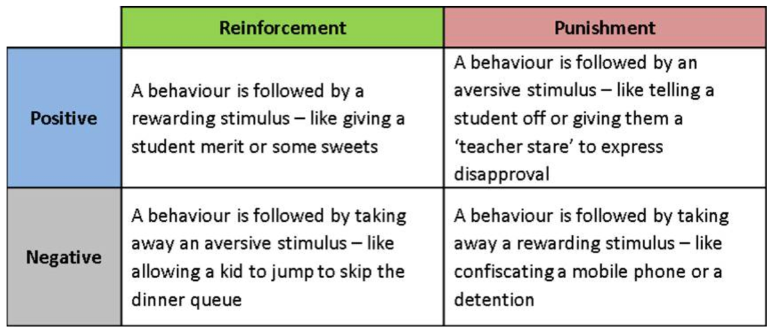
Figure 3 - Positive Punishment Diagram (The Psychology of Behaviour Management, 2016)

Skinner's box experiment demonstrated both positive and negative reinforcement. He demonstrated the effectiveness of positive reinforcement by putting a hungry rat into his box. As previously mentioned, a lever was included in the box designed for a rat, and as the rat moved around the box the lever would inadvertently be knocked. A food pellet would then drop into the container next to the lever as soon as this was done. After being placed into the box a few times, the rats started to learn to instantly approach the lever in order to acquire food, m much like Pavlov’s dog experiment, where the dogs would salivate as soon as a bell was sounded in anticipation of a reward. In terms of Skinners box, the consequence of the rat receiving food would therefore ensure that the rat would repeatedly press the lever (McLeod. S., 2015). In terms of negative reinforcement, Skinner demonstrated how it worked by putting a rat into his box and exposing it to an unpleasant electric current, which made the rat uncomfortable. In contrast to positive reinforcement, as the rat walked about the box, it would unintentionally press the lever, cutting off the electrical current. The rats quickly picked up the habit of going straight to the lever after being placed in the box, just like they had with positive reinforcement. The rats would repeatedly do this to try to avoid the electric current. Skinner even conditioned the rats to avoid the electric current by exposing them to a light before the electric current was put on, much like Pavlov and his ringing the bell. The rats quickly picked up on pressing the lever as soon as the light turned on to prevent the electric current from turning on (McLeod. S., 2015). These can be implemented within the classroom to manage behaviour.

Of the four elements which influence behaviour, positive punishment is by far the most common strategy in the classroom. In order to discourage unwanted behaviour, positive punishment involves introducing something unpleasant to the environment. For instance, if a pupil shouts out during class, the teacher may use positive punishment by making the pupil stay for lunchtime detention. As an alternative, using positive reinforcement to manage behaviour in the classroom can be just as effective. Giving stickers to pupils as a reward for finishing their schoolwork is one example of positive reinforcement. Similar to this, when a pupil achieves their goals, they can add stickers to a rewards chart. Positive punishment is still a favourite method among teachers for managing behaviour in the classroom, despite this. If used consistently, positive punishment is effective because it typically results in instantaneous behaviour change (Splash learn, 2022).

Whether a behaviour is voluntary or involuntary is the primary distinction between classical conditioning and operant conditioning. While operant conditioning focuses on voluntary behaviour involving reinforcement or punishment following a behaviour, classical conditioning focuses on involuntary behaviour. Operant conditioning also entails providing rewards for the individual, whereas classical conditioning does not. While the learner participates passively in. classical conditioning, active participation is necessary for operant conditioning in order for the learner to receive rewards or punishment. In order for classical conditioning to be effective, a connection must be made with a naturally occurring event. In contrast, for operant conditioning to work, an individual must first exhibit a behaviour that can either be rewarded or punished. In today’s world, both classical and operant conditioning are used. Animal training often employs classical conditioning, which involves repeatedly associating the sound of a training clicker with food as a reward. Eventually, the clickers sound alone would elicit the same reaction that food would. In a classroom situation, teachers frequently apply operant conditioning. Rewarding good behaviour may be an example of operant conditioning in the classroom, as was previously mentioned. Both classical conditioning and operant conditioning aim to influence and have a change on behaviour in some way (Cherry. K., 2022).

Reflection / Evaluation & Next Step’s

I’ve developed my own ideas of what to do in my future lessons by thinking back to the observations I made whilst attending ‘School X’. Looking back at the I.T lesson I observed, I think the objectives were stated clearly at the beginning, defining exactly what was expected of the pupils throughout the lesson and the desired outcome at the end of the lesson. Since pupils were allowed to sit next to their friends, it was clear right away that there were no established seating arrangements because the pupils were quite noisy. This undoubtedly had a negative impact on the dynamics in the classroom and the behaviour of some pupils, also effecting how the pupil’s completed the tasks given. I believe behaviour strategies must be put into place in situations like this as pupil’s are less likely to complete their work, even to a good standard if they are susceptible to distractions. Since the pupils were allowed to choose where they sat, I also noticed how those pupils who required extra support sat nearer to the back of the classroom. This, in my opinion, had a significant impact on the pupil’s ability to focus and behave during the lesson. I observed that Skinner’s operant conditioning theory was employed throughout the lesson. For instance, a tally was written on the whiteboard whenever pupils were being disruptive or overly loud, which resulted in a minute being taken away from their break time. This is an illustration of positive punishment because you are introducing something negative into the environment (the tally on the board) in order to correct the inappropriate behaviour. Throughout the lesson, this strategy was regularly used, especially with ‘Pupil A’. A tally was put on the board a few times when ‘Pupil A’ was found doing things he shouldn’t be doing. He appeared to be off task the majority of the lesson. If the pupils had been assigned seats, perhaps this could have been prevented especially if ‘Pupil A’ had been seated near the front of the room. The tally chart was used throughout the lesson for both negative reinforcement and positive punishment. This was done because pupils could earn back time for their break if they completed set tasks and weren’t being disruptive in the lesson, therefore removing a tally from the board and giving the pupils back time for their break. Given that the pupils behaviour did really change and get better from using the tally chart, I believe operant conditioning is extremely beneficial in the classroom. I aim to use operant conditioning to tackle behaviour in my future lessons. I believe using stickers as a reward for completing homework will work well, especially for the younger year groups. This strategy, especially when using the tally chart method, will be very beneficial for lessons right before morning and lunch breaks because pupils will be more likely to behave because they don’t want their break time taken away. I believe that using this behaviour management method will help me to control classroom behaviour and recognise pupils for their efforts and appropriate behaviour.

Whilst using Skinner’s theory of operant conditioning, I’ll also apply this whilst using Gibbs (1988) reflective cycle, to help me reflect on my thoughts and feeling throughout an incident. Developed by Graham Gibbs in 1988, this reflective cycle is split into 6 stages:
- Description of the experience
- Feelings and thoughts about the experience
- Evaluation of the experience, both good and bad
- Analysis to make sense of the situation
- Conclusion about what you learned and what you could have done differently
- Action plan for how you would deal with similar situations in the future, or general changes you might find appropriate. (The university of Edinburgh, 2020)
In addition to looking at how I might use my findings in future teaching, I think this will help me effectively use operant conditioning tactics to manage behaviour within the classroom, choosing specific methods carefully depending on the pupils within the classroom, the topic of the lesson and the practicality of the lesson.

Conclusion

In conclusion, the critical incident observed clearly demonstrates the beneficial influence operant conditioning has on pupils’ classroom behaviour. Given that classical conditioning focuses on involuntary behaviour, it wouldn’t really be appropriate in a classroom setting. After observing this lesson, I believe that it will greatly impact my teaching in the future as by using operant conditioning in the classroom, it will positively affect the learners in the classroom. After observing the lesson, I came to the conclusion that I was crucial to have clear behaviour management measures in place because the absence of a seating plan clearly effected pupil’s behaviour. However, just because there was no seating plan does not mean that the classroom behaviour could not be controlled, and for this reason, operant conditioning strategies played a significant part in controlling the classroom behaviour. Additionally, I will use operant conditioning in my future lessons coinciding with Donaldson’s (2015) four purposes, particularly ‘ethically, informed citizens’. This, in my opinion, is related to my critical incident because operant conditioning can be used to teach pupils how their behaviour affects others in the classroom and how they should respect other’s rights to learn. I’ll also be using Gibbs (1998) reflective model to help me learn from my experiences, and aid in my future behaviour management in my teaching. This is important to take into account when managing behaviour in the classroom because everyone has the right to a place where they can learn effectively.

References

Ackerman, C. E (2018) 12 Examples of Positive Punishment & Negative Reinforcement. Available at: https://positivepsychology.com/positive-punishment/ (Accessed: 28th October 2022).

Bitterman, M. E. (2006). Classical Conditioning since Pavlov. Review of General Psychology, 10(4), 365–376. SAGE Publications, Inc., https://doi-org.ezproxy.uwtsd.ac.uk/10.1037/1089-2680.10.4.365 (Accessed: 12th October 2022)

British Educational Research Association (2018) Ethical guidelines for educational research. 4th edition. Available at: https://www.bera.ac.uk/researchers-resources/publications/ethical-guidelines-for-educational-research-2018 (Accessed: 16th October 2022).

Cherry, K. (2022) Operant vs. Classical Conditioning. Available at: https://www.verywellmind.com/classical-vs-operant-conditioning-2794861#:~:text=Classical%20conditioning%20involves%20associating%20an,conditioning%20involves%20no%20such%20enticements. (Accessed: 31st October 2022).

Donaldson, G. (2015) Successful Futures - Looking at the Curriculum and Assessment Arrangements in Wales A summary of Professor Donaldson’s Report. Available at: https://gov.wales/sites/default/files/publications/2018-03/succesful-futures-a-summary-of-professor-graham-donaldsons-report.pdf (Accessed: 16th October 2022)
McLeod, S. (2021) Classical Conditioning: How it works with Examples. Available at: https://www.simplypsychology.org/classical-conditioning.html#:~:text=The%20most%20famous%20example%20of,the%20presentation%20of%20the%20food. (Accessed: 18th October 2022).

Estyn (2019) Ysgol Bro Gwaun school report. Available at: https://ysgolbrogwaun.com/media/1665/ysgol-bro-gwaun.pdf (Accessed 15th October 2022)

Gibbs G (1988). Learning by Doing: A guide to teaching and learning methods Available at: https://thoughtsmostlyaboutlearning.files.wordpress.com/2015/12/learning-by-doing-graham-gibbs.pdf (Accessed: 1st November 2022)

McLeod, S. (2015) Skinner - Operant Conditioning. Academia. Available at: https://d1wqtxts1xzle7.cloudfront.net/44186702/Skinner-with-cover-page-v2.pdf?Expires=1666546767&Signature=SsPg47cfwnZ1V95KbGR64~H8A3v~E-J1MDEpD7jkQOQiN2gAQHpTkYIS6Joki2r6fWqAORr8Lfhb2Cj~6kKeJtpuS4REnBuutR7oMiVHDmrda~XjROkxkn5609OzC~fqNioU5PSwXSOmYLNtwNqj4VOA-A6EEpYJXgmHuhrGsR-HMtkdJ0Vm8EBVJFPWK-T7sM16X-niyXKC8x46seBYMSeLFxIDKuvhP-tM2MyJGHZmfKzLcXqOzfSHLXDxze-0H7brPiqupg9QrkEm5Yq9BRB~A47gUpnJI8BiHyEd7nm2DqNVb~buG6CYb-QkgNAcXHMvnYxnrjR-pNYw~Qlbgw__&Key-Pair-Id=APKAJLOHF5GGSLRBV4ZA (Accessed: 23rd October 2022).

O'Donohue, W., & Ferguson, K. E. (2001). Operant conditioning and the experimental analysis of behavior. In The psychology of B. F. Skinner (pp. 73-100). SAGE Publications, Inc., https://dx.doi.org/10.4135/9781452229409.n5

Pavlov's Dog and Classical Conditioning (No Date) Available at: https://www.psychologistworld.com/behavior/pavlov-dogs-classical-conditioning#references(Accessed: 23rd October 2022).

The Psychology of Behaviour Management (2016) Available at: https://evidenceintopractice.wordpress.com/2016/01/10/the-psychology-of-behaviour-management-part-1/ (Accessed: 28th October 2022).

Splash Learn, 10 Positive Punishment Examples (2022) Available at: https://www.splashlearn.com/blog/practical-positive-punishment-examples-how-to-discipline-students-in-an-uplifting-way/#:~:text=Positive%20punishment%20means%20something%20is,by%20adding%20detention%20after%20school. (Accessed: 31st October 2022).

Tripp, D. (2011) Critical Incidents in Teaching (Classic Edition) Developing Professional Judgement. Taylor & Francis Group.

The University of Edinburgh (2020) Gibbs’ Reflective Cycle. Available at: https://www.ed.ac.uk/reflection/reflectors-toolkit/reflecting-on-experience/gibbs-reflective-cycle (Accessed 1st November 2022).

Yampolsky, D. (2005) Pavlovian Conditioning. Volume 27, Issue 2. Available at: https://www.proquest.com/docview/216517141?accountid=130472&parentSessionId=Zo5gmUymnjHwd8dWf7T4xQpASYhE5EHlD3dpux0V2MY%3D&pq-origsite=primo (Accessed: 19th October 2022).

