
Design, Development and Manufacturing – 3-Jaw Cobot End- Effector

Course Code: ACMA5002
Course Title: Manufacturing, Design & Technology
Submitted by:
Ieuan Wyn Morgan
ID: 2014408
Department of Engineering
Submitted to:
Richard Morgan
Submitted on:
21/06/2021

Contents Page

Design, Development and Manufacturing – 3-Jaw Cobot End- Effector 1
Contents Page 2
Introduction 3
Concept Design Appraisal 3
Quality Function Deployment 5
Product Design Specification 6
Manufacturing Process Proposal 7
Manufacturing Process 8
Design and Development 12
Design For ‘X’ 14
Design efficiency 15
FMEA 18
Manufacturing Process Design 19
Conclusion 20
References 20

Introduction

In this assignment, I will be carrying out a design project looking at a mechanical gripper. First, I will conduct a concept design appraisal to look at customers' needs and what is expected by a customer. As well as a Quality Function Deployment and Product Design Specification. Then I will be talking about my manufacturing design proposal, where I'll look into the business' needs and talk about my manufacturing process' for each component. Design for X, where I will look at four main aspects, manufacturing, maintainability, environment, and assembly. I'll look into the initial design of the gripper and talk about what design changes I will make before carrying out and FMEA and final manufacturing process.

Concept Design Appraisal

Customers’ needs and wants, what is expected by the customer?

Bonfanti, A. (2016, p.887) Customers are generally very satisfied when the manufacturer offers them feelings of physical safety, economic security, emotional security, and privacy. The customer is looking for a solid service experience in sensorial, psychological, and social terms. (Bonfanti, A., 2016).
For this project, the customer will be looking for a well-built, smooth functioning 3-jaw gripper, this gripper will cater to the customers work needs. The customer will expect a sound design with a solid assembly. As well as a good design the customer will want an adequate manufacturing process that is low cost and efficient. The design will also need to take into account aesthetics, meaning the customer will want a part that looks good. A product design specification will also need to be carried out to ensure all the customers’ needs are met.
David, A. & Glore, P. (2010, p.1556) writes that ‘Research has demonstrated that aesthetics plays an important role in shaping user responses to products and websites’ this is telling us that a lot of the customers expectation and response to the product is based on aesthetics, if a product doesn’t look particularly pleasing the response may not be a successful one regardless of the functionality.
According to Helen Marshall, et al.,(2007, p.3) research there is a ‘lack of awareness and understanding about engineering and engineers as well as a degree of confusion and uncertainty’ the public having this perception on what engineering is can result in a negative outcome for us by the customer as they might bypass important steps in the planning stages. Marshall, et al.,(2007, p.20) reiterates here is a perception that a design engineer is considered to be, ‘Cool looking’ and have a ‘big office with piles of paperwork’ if the customer was to have this perception and didn’t see what they had envisioned it could result in the customer losing confidence in our ability. We can mould this perception by showing the customer past works that have been designed and manufactured.
Kevin N. Otto (2021, p.2) states a design specification consists of a list of features that define performance targets for a product. A design specification is put into place to ensure that the customers needs are met. To start, the customers needs, their importance’s are taken into account for the product. Once the design specification has been finalised between the customer and manufacturer, the design stage can start.

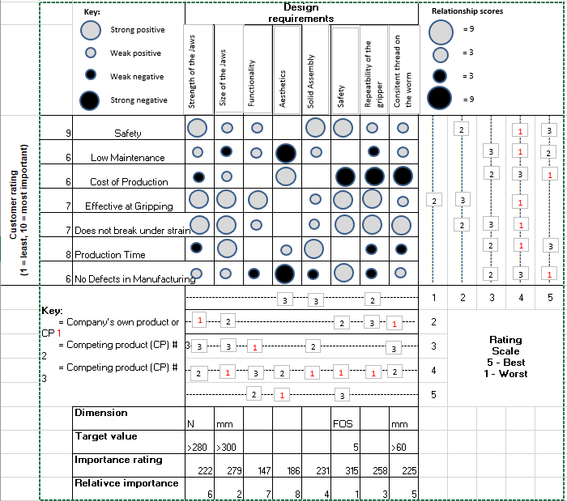
Quality Function Deployment

Product Design Specification

Performance
- The gripper must not drop what it intends to pick up.
- It must not damage the parts it picks up.
- There must not be too much pressure on the part while the gripper is operating.
- The gripper must place the parts in the intended place every time it is in use.

Working Environment
- The three-jaw gripper must be able to withstand working in temperatures ranging from 9˚C to 28˚C.
- The gripper will be coolant-resistant.
- Must be able to withstand up to 100 decibels.
- Will be able to withstand constant workflow.

Life in Service
- The product must have a lifespan of 10 years in a working environment.
- Will not require major maintenance within the first 5 years.
- Product will have a durable finish.

Maintenance
- Spare pare must be easily obtainable and easily installed.
- Planned maintenance schedule must written and implemented.
- No special tools required when carrying out maintenance tasks.

Shipping and Transportation
- The gripper must be shipped in an appropriate box that has been designed specifically for this product.
- The product must be able to withstand temperatures brought on by transportation i.e., air cargo.

Quantity
- Between 1000 and 2000 units a week will be produced.

Weight
- The final product must not weigh more than 10 kg.

Aesthetics, appearance, and finish.
- The product must be aesthetically pleasing.
- The finish must be robust and withstand day to day use.
- The gripper will be painted in the Renishaw colours of orange and black.
- Any aluminium parts will be anodised either orange or black.
- The final assembly will be both tidy and professional.

Standards
- The final assembly will be CE tested before being sold to customers.

Quality and Reliability
- The product will be made from high-quality materials.
- The gripper will go through several tests to ensure the final product is solid.
- Each gripper will be inspected by an inspection team.

Safety
- Weight limits will be clearly visible and displayed on the product.
- The product will comply with the health and safety at work act 1974.
- Only trained operators will be able to operate the gripper.
- Extensive testing will be carried out on the product to ensure it is safe before being delivered to customers.

Testing
- Tensile strength tests
- Plastic deformation tests
- Software tests
- Accuracy tests
- Hardware tests, Tahera, K., Wynn, D.C., Earl, C. et al (2019, p.291-316)

Environment
- Gripper must be made from British steel.
- Plastic free packaging.
- Some elements of the gripper must be recyclable.

Manufacturing Process Proposal

Business Needs and Cost Drivers
Kupe Kupersmith, Paul Mulvey, Kate McGoey (1995) says, Throughout the design process the business will set goals and objectives that the business will aim to reach. The goals and objectives set by the business are known as the business needs. Often these need to be met so the business can successfully run and be profitable.
To successfully identify what the business needs are we must look at these key factors,
- What objectives are attempted.
- What the ideal outcome is.
- What problems are facing us.
- What solutions are we implementing.
Our primary objective that we are trying reach is to successfully design a competent three jaw gripper along with a manufacturing process that will allow us to create 1000 – 2000 units per week. As well as looking at the design and manufacture side, we also need to take into account the customers’ needs.
The ideal outcome will be to meet all points presented by the product design specification. As well as meeting the PDS, an ideal outcome is to have a sound manufacturing process which will allow us to meet the target of 1000 – 2000 units a week.
Looking at the initial design, there are many problems facing it—for example, the cylinder. The design of the cylinder makes it impossible to secure the jaws to the cylinder safely.

Cost Drivers
The strategic CFO (2021) says, a cost driver is most commonly used to assign an overhead cost to the number of produced units. Cost drivers are also used in activity based costing analysis which determine the causes of the overheads, this is used to minimize overhead costs. Cost drivers are used to allocate variable and indirect costs to production.
Below are several examples of cost drivers we will face,
- Employee Labour Hours.
- Design process and change orders.
- Machine hours used.
- Maintenance carried out on the machines used.
- Number of products returned by customers for defects.
The cost drivers above have both a direct and indirect impact on the cost of production.
Each employee will be paid a certain amount each hour to work towards manufacturing the gripper, as well as paying the employee’s we must take into account the machine hours used and the maintenance. Each machine will have cost the business money for each hour it is used as well as needing maintenance from a planned and breakdown perspective. The design of the product will take up 80% of the total costs and changes to the design will also add to the amount. Angela Locascio (2000, p.208). Products that have been returned by the customers due to having defects will directly impact the profits as the manufacturing cost will have already been spent.

Manufacturing Process
Presented below is my proposed plan of manufacture of the three-jaw gripper. I have listed each component followed by the intended manufacturing process. As well as talking about each component, I will highlight some of the manufacturing processes’ I will be using.

RAMTIC
In this section, I will talk a little about the RAMTIC process. Mark Albert (2007) states that RAMTIC, or Renishaw automated milling turning inspection centre, is a process that is unique to Renishaw and comprises modifying Renishaw’s chosen machining platform (MAZAK FJV 250, Fig.1 ) to meet Renishaw’s needs. RAMTIC uses portable carrousels for palletized workpieces and cutting tools along with using its probes so that the machine tool can check its dimensional calibration. There are currently 43 machines running the RAMTIC Process in Renishaw.
The carousels (Fig.2) serve each machine tool with numerous kits; each kit includes all of the tools and billets needed to machine the component. The carousels get kitted by a “kitter” who will then place the carousel onto a machine tool. Once the carousel has been placed, the operator will then start the machine. Each wing will be pulled into the machine one by one, first the tooling wings. The machine tool will automatically unload the tools and calibrate them. Once this is completed, the machine will bring each wing of billets into the machine one by one and machine the components. Once the part has been machined, the Renishaw probe will validate the components, then the machine will remove the wing and bring the next in. This process repeats until all components have been machined, Albert, (2007) states that RAMTIC has been in use since the 1990s and, to this day, is still meeting Renishaw’s needs.
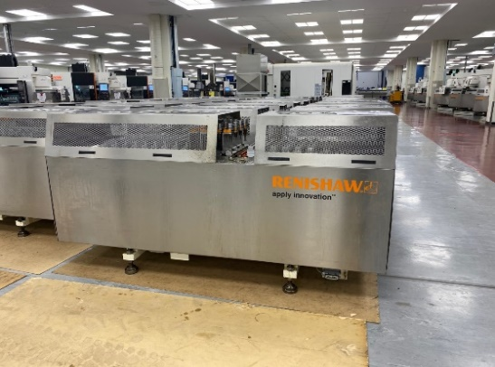
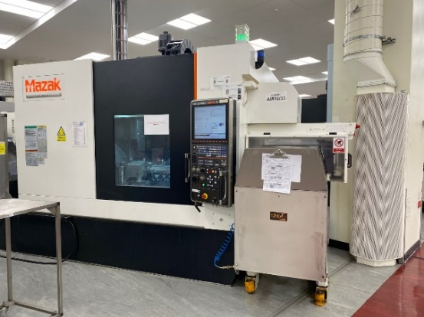

(MAZAK FJV 250, Fig.1) (Carousel, Fig.2)

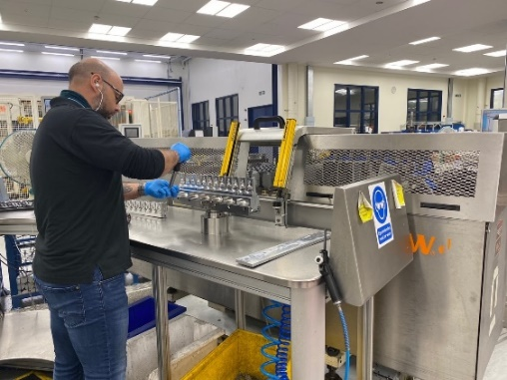

(Kitter, Fig.3)

The Jaw
The jaw is a crucial part of the whole assembly as it is the part that comes in contact with the items the gripper will be moving. For this reason, the jaw needs to have accurate measurements and a smooth surface finish. For this reason, I have chosen the RAMTIC process, and this is justified as it is an accurate yet fast process that can machine multiple wings of jaws in a short time.
Each jaw will start as a billet of 303 non-magnetic steel, kitted by a kitter onto a wing, then placed into a carousel. As well as the billets, the tools will also be kitted. After the kitting process, the operator will place the carousel onto a MAZAK FJV 250, and the machining process will start. The RAMTIC process is fully automated and will both confirm measurements and machine the jaws. Using the RAMTIC process can easily handle making 1000 – 2000 full units a week.

Cylinder
As well as the jaw, I would elect the cylinder to be manufactured using the RAMTIC process. Again, this is justifiable with the RAMTIC operation being able to machine multiple components in a short time. The MAZAK FJV 250 has a 5-axis machining capability, meaning it will easily handle the tricky shapes of this part. Again, the kitter will kit both billets and tools before placing the carousel onto a machine.

Drive Plate
The drive plate will also be manufactured using the RAMTIC process. The deciding factor was the amount of time it would take to machine. Billets will be bought with the same diameter as the drive plate, meaning only the top half will need to be machined. Shortening the machine process time.

Motor
The motor will be a complicated piece of equipment to manufacture, with accordance to design for manufacture, buying in a standard off the shelf motor will work well with this design. The motor I have chosen is the Sanyo Denki Stepper Motor (RS Components, 2021, Fig.4),. this motor consists of an 86mm shaft, runs on 100v and has plenty of torque to run the gripper.
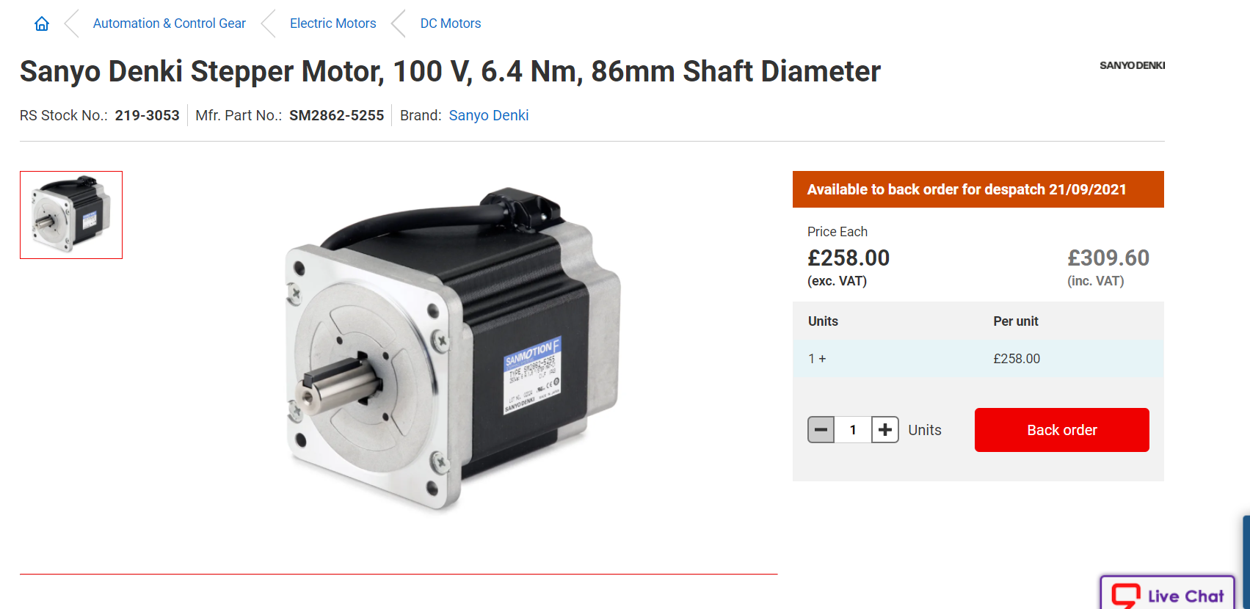 (RS Components, 2021, Fig.4)

Joint
When manufacturing the joint, I have chosen to use a MAZAK X44 (Fig.5), which is a laser cutter. I have chosen this method due to time. The laser cutter will easily be able to cope with manufacturing 1000 – 2000 units a week. A simple programme will need to be written and the appropriate sheets of steel bought. Multiple components can be made on one sheet of steel; this decreases process time and the cost of materials.
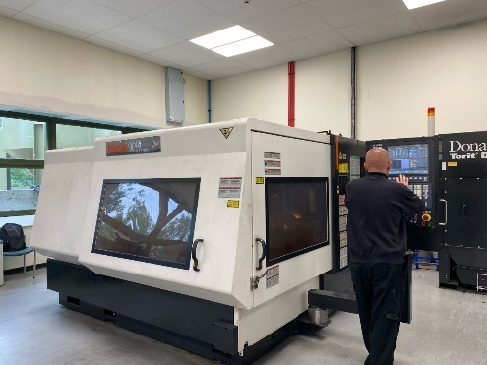

(MAZAK X44, Fig.5)

Shaft
The shaft will be cut to length on an automatic saw. The correct diameter bar will be bought. The diameter of bar will be 86mm to accommodate the motor. Each shaft will be cut to size using the KATSOwin A 4.6 (Fig.6). This process is exceptionally efficient as there is only one cutting operation needed.
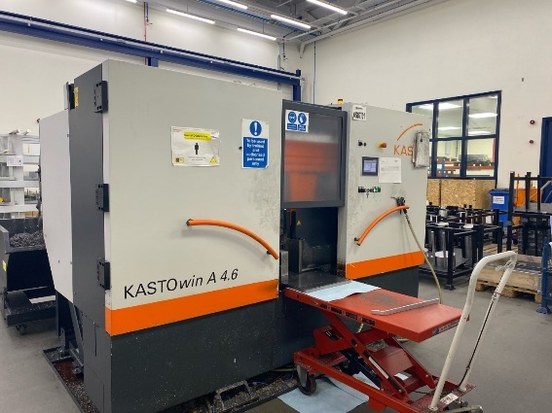

(KATSOwin A 4.6 Fig. 6)

The Worm
The worm will be manufactured using one of our MAZAK Integrex i-300’s (Fig. 7). The integrex i-300 is an incredibly diverse machine that can perform both milling and turning operations as well as run two separate programmes at the same time. MAZAK USA (2021). The machine will feed bar into the machine where the first operation will be carried out, machining the shaft to the right diameter before placing a thread onto the bar. The OSP will then meet with the MSP and transfer the component. The second operation will then be machined in the OSP. Renishaw currently have seven Integrex i-300’s, with this volume of machines 1000 – 2000 units per week is possible.
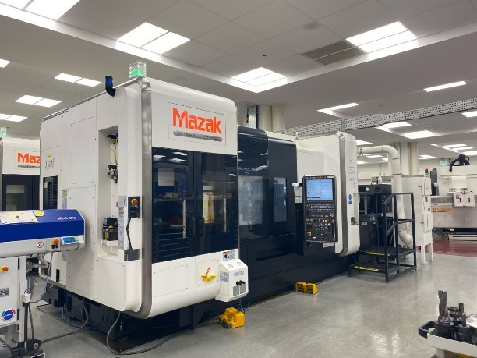

(MAZAK Integrex i-300, Fig. 7)

Process finishing
After each component has been manufactured, they will need to be placed in a deburring machine and a component cleaner. The deburring machine that will be used is the Rosler AD05-03 (Fig. 8). For parts requiring to be anodised, they will be cleaned and prepared before the process.

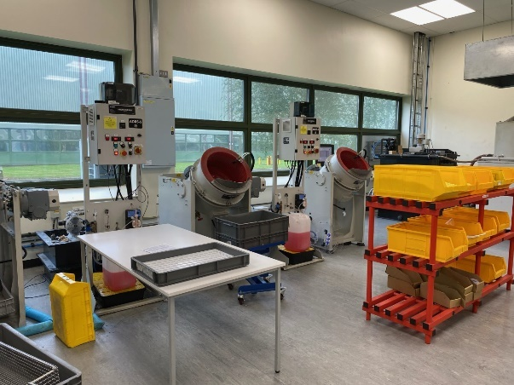

(Rosler AD05-03, Fig. 8)

Design and Development

This section will talk about what design changes I have decided upon and my reasons why. To ensure that all grounds are covered, I will be using the SCAMPER technique. Ozyaprak, M. (2016) says the SCAMPER technique is used to aid creative thinking. SCAMPER is an acronym that stands for Substitute, Combine, Adapt, Modify, put to another use, Eliminate and Reverse turn.

Substitute
For substitute, I will replace the jaw component. I will replace the jaws with a design that further curls the tips of the jaws inwards. By substituting the new component, will aid the gripper when gripping different parts. This design change makes the gripper more versatile in the types of objects it can lift. As well I will introduce a tolerance of 0.15mm to ensure the jaws do not interfere with the cylinder. The new jaw design will complement the aesthetics of the gripper, referring to what David, A. & Glore, P. (2010) said, Aesthetics rapidly changes the customers perspective of the final product.

Combine
With combing, I will combine all parts to meet a 0.25mm tolerance, excluding the jaws. By introducing a tolerance of 0.25mm, I will ensure that all components meet the customers' expectations by delivering an accurate gripper.

Adapt
Looking at the gripper's initial design, I noticed that there is nothing securing the jaw to the cylinder apart from a loose pin. I would adapt this idea by creating a through-hole through both supporting blocks on each side of the cylinder. I will place a pin through these two holes which will secure the jaw to the cylinder. The pin will have two grooves machine into either side. These grooves will accommodate a C-clip to prevent the pin from slipping out. By adding a C-clip, the design is maintenance-friendly as the jaws will be easily removed. As well as using a C-clip, I will add a bearing surrounding the pin to aid the movement in the gripper when picking up objects.

Modify
Modifying the design, I will add rubber grommets that will sit between the jaws and the joints. Adding the rubber grommets means I’m eliminating the friction between the jaws and the joints, this will eliminate the wear on the jaw. I will also add a second supporting joint to each side of the jaw. Aiding with stability and lift capacity. I will modify the worm to fit a spider coupling as the worm without modification is impossible to fasten to the motor.

Put to another use.
The one part I will modify to fit another use is the drive plate. I will add rubber to the top of the drive plate to protect any object that may encounter the top when the gripper is in operation. By adding this rubber, I can use the drive plate as a part of the lifting equipment by allowing the drive plate to encounter objects the gripper is lifting. Adding more stability to the design.

Eliminate
I will eliminate the chance of damaging objects that the gripper will pick up by placing rubber tips on the end of each jaw. These rubber tips will protect the object from the hard material of the jaw. One of the most important aspects of the gripper is not to scratch objects it is lifting, by implementing this idea we are eliminating the possibility.

Reverse
With the new design of the jaws, it will be possible to lift objects that do not fit into the gripper. This can be done by expanding the gripper. For example, a part that has a large bore. Rubber will be added to the outside of each jaw, protecting the part it is lifting. The gripper will be placed inside the bore of the part, expand, and use the outside of the jaws to lift the part.

Conclusion
In conclusion, the design changes I have made to the gripper will benefit its functionality. As well as making the gripper maintenance friendly. I am also expanding it’s capabilities by implementing the reverse pick up feature.

Design For ‘X’
In my design for ‘X’ evaluation, I will be focusing on four main aspects—design for manufacturing, maintainability, environment, and assembly.

Design for Manufacturing
Richard Morgan (2021) states that, Design for manufacturing is to design a product in such a way that it is easy to manufacture. This can be apparent in many ways, such as buying standard components. For example, the motor on the gripper. Purchasing this standard component eases the manufacturing process due to not having to manufacture complicated parts such as a motor. When designing for manufacture, it is essential to employ strict tolerances to ensure standardisation and ease of assembly. For example, on the gripper, a tolerance of 0.25mm has been applied, apart from the jaws, which have a tolerance of 0.15mm.
Maximum thickness of the jaw = 5.075mm
Minimum thickness of the jaw = 4.925mm
Tolerance of the jaw = 5.075mm – 4.925mm = 0.15mm

Design for Maintainability
Morgan (2021) argues, when designing for maintainability, the designer is looking for a product to perform at a satisfactory level throughout its lifespan. Design for maintainability will minimise downtime, maintenance teams time, and cost due to maintainability issues. When designing the gripper, I added aspects such as rubber between the joint and jaw to minimise wear. As well as adding preventative measures, I have added C-clip to the pin holding the jaw onto the cylinder; C-clips are easily removable, making the process easy for the maintenance teams.

Design for Environment
Morgan (2021) informs, Design for the environment is where designers will reduce the overall impact that the product will have on the environment. Designers look at different aspects such as energy efficiency, environmentally friendly packaging, and Design for reuse. When the gripper is in final assembly and at the packing stage, it is essential that environmentally friendly packaging is used, for example, paper packaging instead of plastic. As well as the packaging, it is essential that some of the materials in the motor can be recycled, such as the copper wire. I also will build the product from British steel to reduce the amount of miles the steel has travelled. As well as reducing air pollution, this supports the British steel industry. By carrying out these steps, it will lower the impact on the environment from the product.

Design for Assembly
Morgan (2021) writes, to design for assembly, you are looking to make the component easy to assemble. By doing this, you are minimising time spent in assembly, minimising the chances of the assembler creating a mistake. To maximise ease of assembly, the part should be self-aligned, does not require orientation when assembling, requires no tools to assemble, etc. For ease of assembly, I have introduced a poka-yoke system to the worm and motor. By adding the spider coupling, there is one way the motor can be connected to the worm, minimising potential mistakes and minimising time in assembly.

Design efficiency

Design efficiency before
Component | Essential | Non-essential
JAW | 1
Shaft |  | 1
Joints |  | 1
Motor |  | 1
Drive Plate |  | 1
Worm |  | 1
Cylinder | 1
Total | 2 | 5

Efficiency = 2/7 * 100 = 29%
The initial design poses an overall design efficiency of 29%.

Design efficiency after
Component | Essential | Non-essential
JAW | 1
Shaft |  | 1
Joints | 1
Motor |  | 1
Drive Plate | 1
Worm | 1
Cylinder | 1
Total | 5 | 2

Efficiency = 5/7 * 100 = 71%
The design efficiency of the new design is 71%, meaning that the re-designed gripper is showing a maximum output from the design. An example of improving the efficiency is the drive plate, by adding the rubber top I am adding another support to the design without adding any non-essential parts.

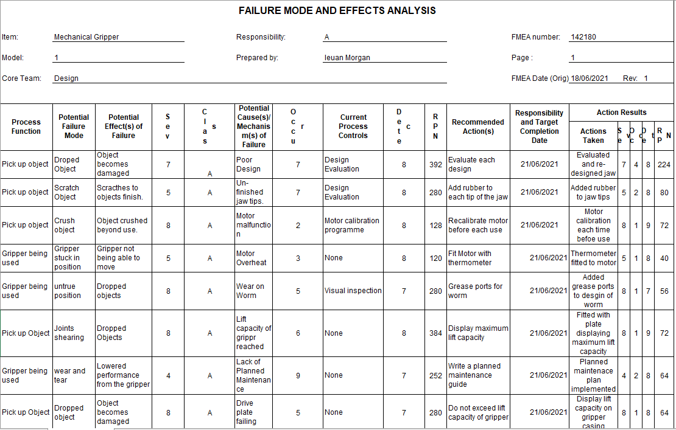
FMEA

Manufacturing Process Design
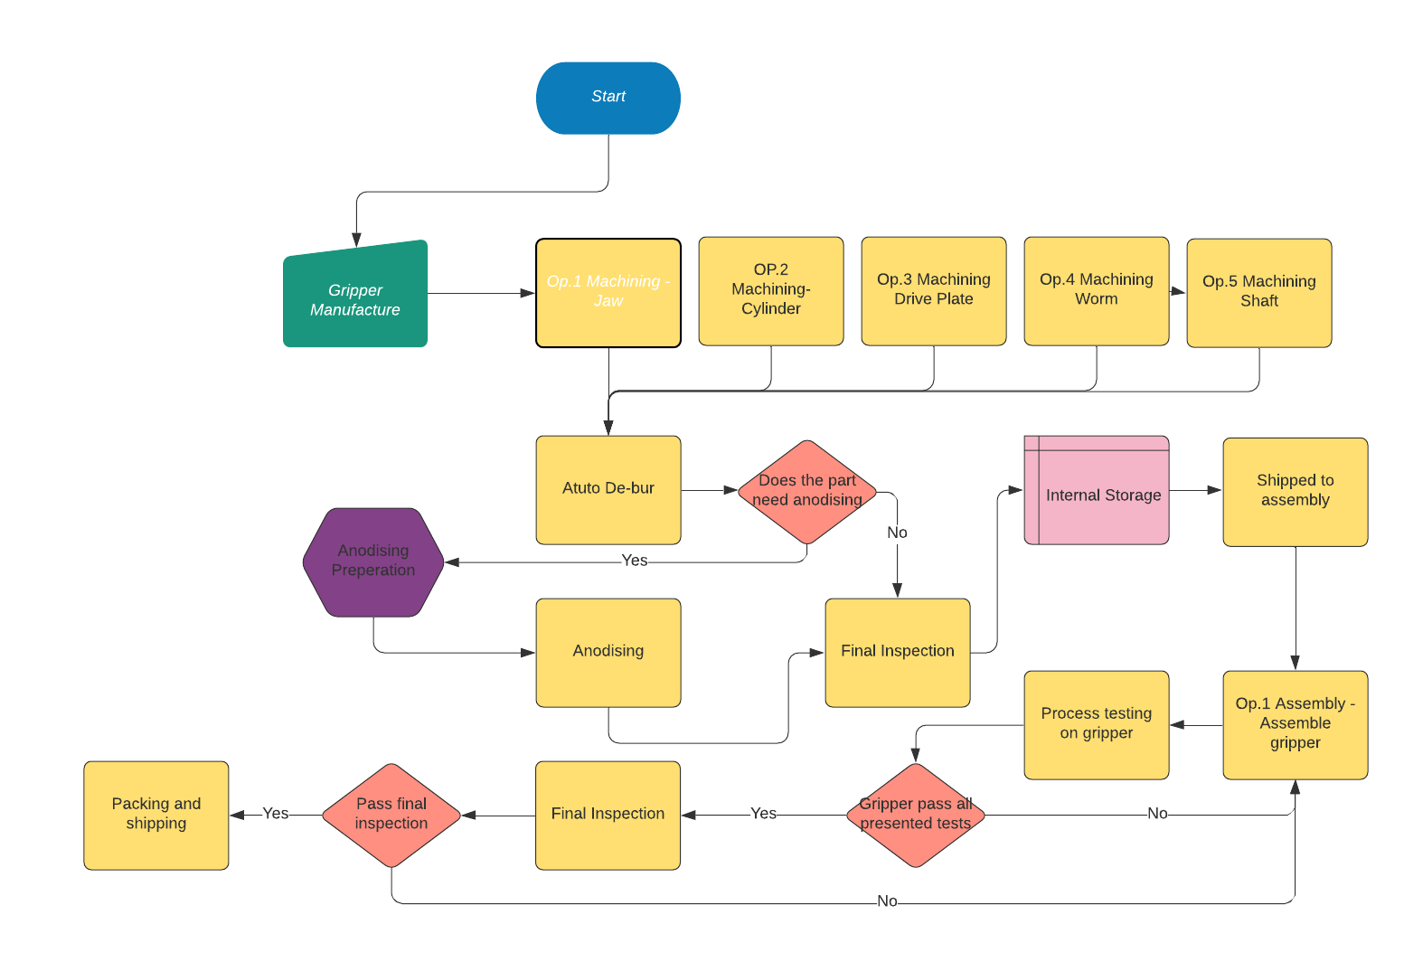
Below lies a flow chart that shows my planned design of the manufacturing process from start to end.

End

Conclusion

To conclude, the gripper design is now sufficient and can operate to meet the customers' needs. Looking into the initial design, I found many flaws and imperfections, such as the design and functionality of the jaws. Firstly I looked into what the customer needs are from a manufacturer, and performed a QFD. This QFD gave me an insight into what I was looking for when redesigning the gripper. Upon redesigning the gripper, I needed to consider the design for manufacture, maintainability, environment, and assembly. With this in mind, I pushed forward and redesigned many aspects of the gripper. I created a flow chart to document the process to take the design from start to finish.
Overall I am content that the design of the gripper is the best it can be and that my main objective of safety has been taken into consideration, for example, adding two joints to each jaw to add strength.

References
Albert, Mark (2007), ‘RAMTIC system still ticking’, MMS Online, October 2007, pp.84-89. Retrieved June 3, 2021 https://resources.renishaw.com/en/details/renishaws-machine-shop-mms-magazine-10-2007--15532
Angela Locascio. (2000) “Manufacturing cost modelling for product design”, International Journal of Flexible Manufacturing Systems Vol.12, No.2, pp. 207-217. Retrieved June 2, 2021. https://www.researchgate.net/publication/226088532_Manufacturing_Cost_Modeling_for_Product_Design
Bonfanti, A. (2016), "Customers’ needs and expectations on servicescape surveillance management", The TQM Journal, Vol. 28 No. 6, pp. 887-906. Retrieved June 1, 2021 https://doi.org/10.1108/TQM-05-2015-0067
David, A. & Glore, P. (2010). “The Impact of Design and Aesthetics on Usability, Credibility, and Learning in an Online Environment.” Online Journal of Distance Learning Administration, Vol.13 No.4,. pp.1557-3847. Retrieved June 1, 2021 https://www.learntechlib.org/p/52608/.
Helen Marshall, Lynne McClymont & Lucy Joyce. (2007), “Public Attitudes to and Perceptions of Engineering and Engineers 2007”, The Royal Academy of Engineering & the Engineering and Technology Board. Retrieved June 1, 2021 https://www.raeng.org.uk/publications/other/public-attitude-perceptions-engineering-engineers
Integrex i-300. (2021), MAZAK USA, Retrieved June 3rd, 2021 https://www.mazakusa.com/machines/integrex-i-300/
Kupe Kupersmith, Paul Mulvey, Kate McGoey. (1995), “How to define business needs through business analysis”, Dummies a Wiley brand. Retrieved June 2, 2021 https://www.dummies.com/business/business-strategy/how-to-define-business-needs-through-business-analysis/
Kwvin N. Otto. (1996). “Forming Product Design Specification”, Proceedings of the ASME 1996 Design Engineering Technical Conferences and Computers in Engineering Conference. Vol. 4 No. 8. pp. 96-108. Retrieved June 2, 2021 https://doi.org/10.1115/96-DETC/DTM-1517
Ozyaprak, M. (2016). “The effectiveness of SCAMPER technique on creative thinking skills”, Journal for the Education of Gifted Young Scientists, Vol. 4 No.1, pp. 31-40. Retrieved June 5, 2021 https://dergipark.org.tr/en/download/article-file/483637
Morgan, R. (2021). “Design for X”. Depart of Engineering, University of Wales Trinity Saint David.

