NAME: Tania Miranda
STUDENT NUMBER: 2435112
MODULE CODE/TITLE: LCHS4003 Introduction to health and social care
LECTURERS NAME: Helen Parsons
ASSIGNMENT TITLE Portfolio-Two tasks

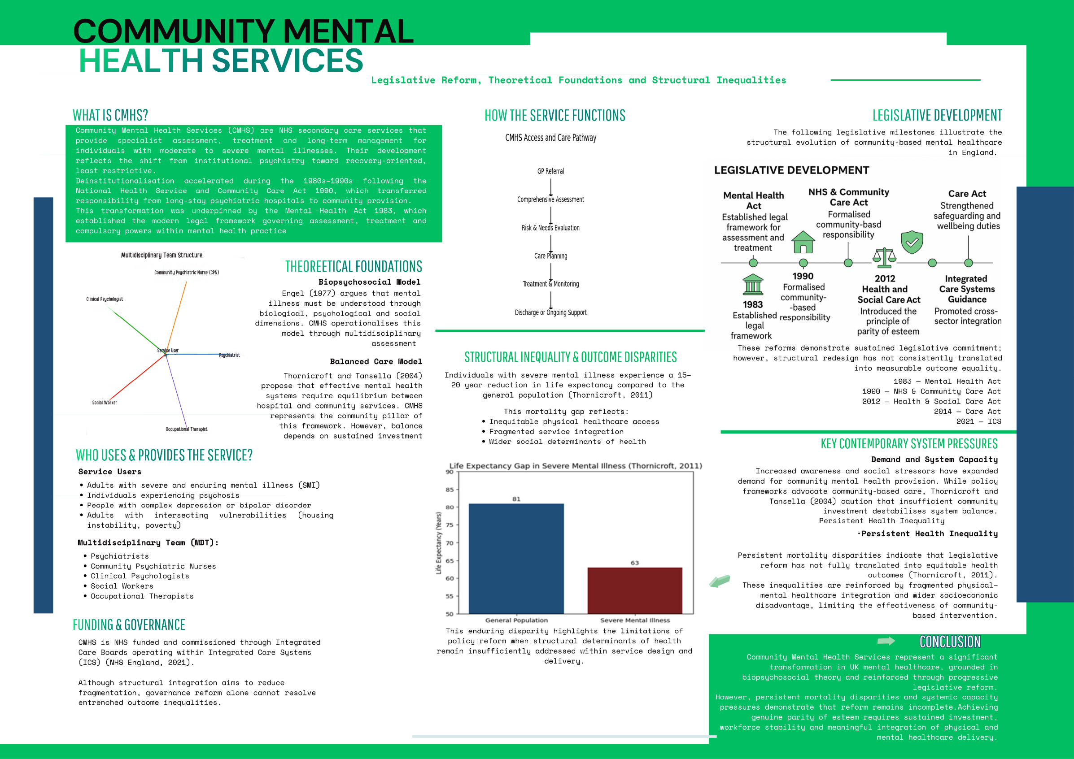

Pharmacy Services

Historical Development and Professional Evolution
Pharmacy services in England, particularly within the community pharmacy sector, originated in the nineteenth-century apothecary and chemist tradition, when medicines were compounded and supplied with limited regulation. The establishment of the Royal Pharmaceutical Society in 1841 formalised professional standards, while the Pharmacy Act 1868 regulated the sale of poisons and restricted certain medicines to qualified practitioners. This legislative framework strengthened pharmacy’s professional identity and contributed to its separation from medicine as an autonomous discipline, laying foundations for later integration into the National Health Service (NHS).
Although pharmacy practice predates the NHS, its modern structure was shaped by the NHS’s establishment in 1948, which formalised contractual arrangements between independent contractors and the state (Noyce, 2007). For much of the twentieth century, remuneration based on prescription volume reinforced a product-oriented model focused on medicine supply rather than direct patient care. Policy reform in the early 2000s initiated a shift toward patient-centred services, reflecting recognition of pharmacists’ clinical potential (Noyce, 2007). Integration efforts through Local Pharmaceutical Services aimed to embed pharmacists within multidisciplinary teams, though professional boundary tensions persisted (Bradley et al., 2008).
More recently, the NHS Long Term Plan (NHS England, 2019) positioned community pharmacy as a key component of primary care reform, expanding roles in minor illness management, vaccination and medicines optimisation. Evidence supports this transformation: Elliott et al. (2016) found that the New Medicine Service significantly improved medication adherence in patients with long-term conditions. Community pharmacies also contribute to public health through smoking cessation and vaccination programmes (Anderson, Blenkinsopp and Armstrong, 2009). These developments demonstrate a sustained transition from supply-based practice toward a clinically focused and accessible healthcare role.

Contemporary Challenges
Despite expanded expectations, funding pressures since 2016 present a significant challenge. Todd et al. (2018) warn of an “inverse pharmacy care law,” whereby pharmacies in deprived areas are most vulnerable to closure. Given that these communities often rely heavily on local pharmacies, reduced provision risks widening health inequalities. Furthermore, community pharmacies operate within a hybrid commercial–public model, meaning financial viability directly affects service continuity (Baird and Beech, 2020). The contradiction between policy ambitions and constrained funding therefore raises concerns regarding long-term sustainability and equitable access.
Workforce pressures further complicate reform. While the NHS Long Term Plan (2019) expands pharmacists’ clinical responsibilities, workforce growth and structural support have not consistently matched these expectations. The Additional Roles Reimbursement Scheme (ARRS), which funds pharmacists within GP practices, reflects efforts to strengthen multidisciplinary care. However, qualitative evidence suggests this has generated uncertainty and concerns regarding workforce redistribution (Paloumpi et al., 2023). By incentivising movement into general practice, ARRS may inadvertently destabilise community pharmacy staffing, particularly in deprived areas. Expanding clinical roles without aligning workforce capacity and funding risks undermining service sustainability.

Significance for Quality of Life
Nevertheless, community pharmacy remains integral to improving quality of life. Its accessibility often without appointments and with extended opening hours, supports early intervention and ongoing management of long-term conditions. Todd et al. (2018) highlight that pharmacies are disproportionately located in socioeconomically deprived areas, positioning them as important contributors to reducing health inequalities. Improved adherence through services such as the New Medicine Service (Elliott et al., 2016), alongside preventative interventions (Anderson, Blenkinsopp and Armstrong, 2009), aligns with the NHS commitment to prevention and population health. However, the sector’s ability to sustain this impact depends on resolving funding and workforce tensions.
Conclusion
In conclusion, community pharmacy in England has evolved from a loosely regulated trade into a clinically significant component of primary care. Legislative reform and NHS integration have strengthened its professional and public health role. Yet funding constraints and workforce pressures threaten the sustainability of this expanded function. While evidence demonstrates clear benefits for medication adherence, prevention and health equity, realising the full potential of community pharmacy requires alignment between policy ambition, financial investment and workforce capacity.
REFERENCES
Anderson, C., Blenkinsopp, A. and Armstrong, M., 2009. The contribution of community pharmacy to improving the public’s health: summary report of the literature review 1990–2007’, International Journal of Pharmacy Practice, 17(1), pp. 3–11.
Baird, B. and Beech, J. (2020). Community Pharmacy Explained. [online] The King’s Fund. Available at: https://www.kingsfund.org.uk/insight-and-analysis/long-reads/community-pharmacy-explained.
Bradley, F., Elvey, R., Ashcroft, D.M., Hassell, K., Kendall, J., Sibbald, B. and Noyce, P., 2008. The challenge of integrating community pharmacists into the primary health care team: a case study of local pharmaceutical services (LPS) pilots and interprofessional collaboration. Journal of Interprofessional Care, 22(4), pp.387-398.
Care Act (2014). Care Act 2014. [online] Legislation.gov.uk. Available at: https://www.legislation.gov.uk/ukpga/2014/23/contents
Elliott, R.A., Boyd, M.J., Salema, N.E., Davies, J., Barber, N., Mehta, R.L., Tanajewski, L., Waring, J., Latif, A., Gkountouras, G. and Avery, A.J., 2016. Supporting adherence for people starting a new medication for a long-term condition through community pharmacies: a pragmatic randomised controlled trial of the New Medicine Service. BMJ Quality & Safety, 25(10), pp.747-758.
Engel, G.L., 1977. The need for a new medical model: a challenge for biomedicine. Science, 196(4286), pp.129-136.
Health and Social Care Act 2012. (2012) Health and Social Care Act 2012. Available at: https://www.legislation.gov.uk/ukpga/2012/7/contents
Mental Health Act (1983). Mental Health Act 1983. [online] Legislation.gov.uk. Available at: https://www.legislation.gov.uk/ukpga/1983/20/contents.
NHS England (2021). Integrated Care Systems: Guidance. [online] Available at: https://www.england.nhs.uk/publication/integrated-care-systems-guidance/
NHS Long Term Plan (2019). UK Government Web Archive. [online] Available at: https://webarchive.nationalarchives.gov.uk/ukgwa/20230418155402/https:/www.longtermplan.nhs.uk/publication/nhs-long-term-plan/
Noyce, P.R., 2007. Providing patient care through community pharmacies in the UK: policy, practice, and research. Annals of Pharmacotherapy, 41(5), pp.861-868.
Paloumpi, E., Ozieranski, P., Watson, M.C. and Jones, M.D., 2023. Professional stakeholders’ expectations for the future of community pharmacy practice in England: a qualitative study. BMJ Open, 13(10), p.e075069.
Thornicroft, G., 2011. Physical health disparities and mental illness: the scandal of premature mortality. The British Journal of Psychiatry, 199(6), pp.441-442.
Thornicroft, G. and Tansella, M., 2004. Components of a modern mental health service: a pragmatic balance of community and hospital care: overview of systematic evidence. The British Journal of Psychiatry, 185(4), pp.283-290.
Todd, A., Thomson, K., Kasim, A. and Bambra, C., 2018. Cutting care clusters: the creation of an inverse pharmacy care law? An area-level analysis exploring the clustering of community pharmacies in England. BMJ Open, 8(7), p.e022109.

