Report on Being an Effective and Efficient HR Professional
Student Name: Iavor Nikiforov Stanimirov
Student ID: 1921573

Table of Contents
Task 1 3
Being an Effective and Efficient HR Professional 3
The CIPD Map 3
Task 2 5
Introduction 5
The Objectives of Companies towards Resources Planning and Resources Recruitment and Selection 5
Resource Planning 5
Dynamic Capabilities among Employees 6
Strategic Planning For Recruitment of Best Candidates 7
Attracting Talent 7
Diversity in Workforce during Recruitment 8
Recruitment system of Unilever 8
Selection Process at Unilever 8
Conclusion 9
References 10

Task 1

Being an Effective and Efficient HR Professional
HR professionals are the one who deals with business, strategies, planning, and development of the company apart from these roles they are also responsible for value creation for the company (Hurst, 2021). Being an effective and efficient HR professional, there are some skills required. These skills are effective timekeeping skills, project management skills, critical thinking skills, analytical skills, practical communication skills, managing and building relationship skills are also necessary. The HR professional must look at the outside trends which the competitors are following. Being aware of the trends helps use latest and most effective practices in a company. HR managers should keep in mind the company's priorities, which will help them provide good services to their customers. HR has to look at both the individual capabilities and capabilities of the organisation to make the best from their outputs (Greenberg, 2021).
The HR department is the important department of any company. It helps in generating value for the company. This department has many responsibilities and can be considered a critical asset when it comes to hiring employees, managing the staff, and solving disputes within a company. The HR professional is the person who guides other employees, provide help and support, and offers advice. To become an effective and efficient HR professional, one must have communication skills, team working, decision making, critical thinking skills, advising skills, budgeting skills, training, and development skills (General HR, 2021).
For further understanding the skills that are necessary for the professional to develop in order to be effective and efficient, the CIPD model was created.

The CIPD Map
Behind every successful company, there is a significant role of HR manager. As the business world is constantly changing so there is a need for talented HR professionals. HR managers and professionals are responsible for hiring efficient employees that will create value for the company and result in improving the efficiency of the entire workforce. The Chartered Institute of Personnel and Development is an association that is committed to professional HR managers. There are no such rules for HR professionals, and the field is changing continuously. There is no benchmark on which the managers can compare their skills. The CIPD professional map provides global standards on which the skills can be compared with, and the HR professional can work to meet these skills that the CIPD globally sets.
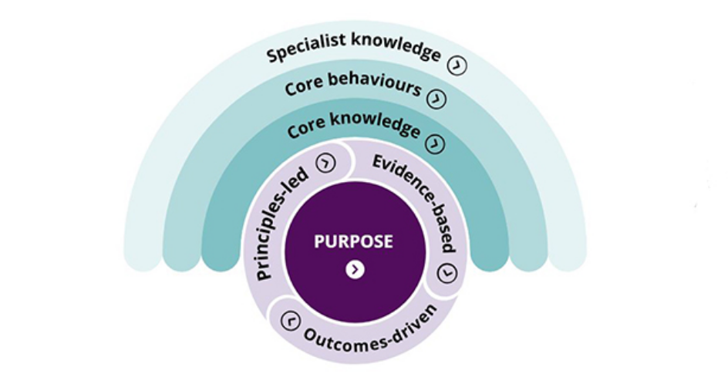
Figure 1: CIPD HR Professional Map (Faragher & Webber, 2018)

The CIPD map helps identify the level of the role of professional after this. The second step is to identify the standard of the level of the HR professional, and the last step is to relate the key standard with the level of the role identified. This is also called the future fit as it helps in understanding the future role or managers that are constantly changing (Mason, 2019).

Task 2

Introduction
Human resource department allows a company to meet its objectives related to resourcing activities. For instance, an organisation might need ten new employees to manage the workload. In this case, the human resource step would be required to hire ten new employees to meet the resourcing needs of employees. The HR department thus plays a crucial role in a company. This report explains the organisational objectives within resourcing activities that the HR function is responsible for delivering. It also discusses how these are evolving in Unilever.

The Objectives of Companies towards Resources Planning and Resources Recruitment and Selection
The purpose of the human resources plan is to have an accurate estimate of the number of employees that are needed in a company and the number of employees needed to complete any tasks having the best suitable skills that are needed to complete organizational task. Through this plan, companies can identify the number of human resources that will be needed in the future. The HR plan can help companies in improving the organisation abilities to attain its objectives by developing strategies. The human resource department of any organisation signifies a collection of knowledge, skills, abilities, and talents available for the organisation. Human resource planning is the process that evaluates the current position or state of an organisation's human resources and helps predict and meet the future human resource requirement of the company. It includes estimating the human resources required to achieve the company's objectives. Companies use different strategies and take different steps which can help fulfil the objectives of human resources planning.

Resource Planning
Recruitment and selection are an important part of human resources. When a company needs new or more employees, they start the hiring process. Recruitment is the process of identifying that a vacancy needs to be filled and selecting, interviewing, and hiring a candidate. The purpose of recruitment is to attract a large number of people to apply for the job. The objective of the selection process is to select the most suitable candidate. The selection process can be done by reviewing resumes, scheduling and conducting interviews by the selected candidates, conducting and performing tests, and finally choosing the best candidate after all the processes (Harness, 2019).
Human resources planning is considered the most important building block of the business as it helps in the success of the company. It must be considered the first priority for any organisation (Goddard, 2020). Unilever is the fourth largest consumer goods company in the world. The company is operating in almost 190 countries of the world and provides goods at a reasonable price. In most parts of the world everyday people use products of Unilever. There are also various sub-brands of Unilever. Unilever focuses on financial gain but also supports its employees and customer. The human resource planning of Unilever makes them successful.

Dynamic Capabilities among Employees
It is necessary for companies to adopt change and move through the rapidly evolving environment. Because of the rapid changes, companies need to have skilled staff that can adopt to change quickly. Dynamic capabilities are the abilities that can be integrated into the environment system to quickly adopt change (Wohlgemuth, et al., 2019). HR of the Unilever focuses on hiring skilled employees who have dynamic capabilities, which help improve the organisation. Unilever emphasises on integrating and adapting, external and internal skills of organisations, and resources and competencies to meet the basic needs of the organizational environment. Unilever also takes care of the training and development of employees. The company follows strategic capabilities to find if there is any need for training required in any department of Unilever. It also identifies if more employees are required in any department.
Unilever is considered as a role culture organisation. This type of organisation is split into different departments and each individual department is supervised by a particular role. In this type of organisation, employees and supervisors have more flexible working conditions as they have to focus on a specific project or work that is assigned. This increases the productivity among employees. In case of challenges and weaknesses, the company focuses only on that area as the department splits accordingly (Azeez, 2018).
The objective of resource selection and recruitment include:
- Creating and developing a large pool of talented individuals from where the company can choose the best employee to hire.
- Finding the best candidates that can fit in the company's culture and contribute to the goals and objectives of the organisation.
- Hiring the candidate
Recruitment and selection process helps in selecting employees that meet the organization's diversity and commitment. These aspects should clearly be based on the merit and skills of the individual.
Another objective of this activity is to improve the company's image by doing fair, impartial, unbiased, and effective hiring practices (People Process, 2020).

Strategic Planning For Recruitment of Best Candidates
Unilever is a big organisation, and it has a strong HR department. The company cares about each of its employees and also individual departments. The process of strategic planning of Unilever HR includes providing the data and ideas. After that, create a strategic vision for future planning and prediction. The company's HR is effective when it comes to managing the development and training of employees (Odak, 2020). Unilever focuses on the development and provision of training to the employees and makes development plans for the employees. It also creates a performance management plan and a strategy to improve employee motivation. The company also focuses on bonuses, rewards, and incentives to improve retention. The company has experienced improvement and growth because of the implementation of these activities (Haynes, 2021).
Recruitment and selection are the policies that need to be followed by each company. Companies should set recruitment and selection policies. These policies have a direct impact on organisational strategies. By implementing and following these strategies most effective selection can be made through which the goals and objectives of the organisation can be achieved. Different tools should be used for the best selection and recruitment of employees (Schafir, 2021).

Attracting Talent
When it comes to recruiting, attracting talent is the most important part of hiring. Hiring an employee who is not the best for the company can have costly consequences. To hire the best employee for the position without wasting time and resources, companies needed to take the recruitment process seriously. Attracting talent is the best approach to hire the most suitable employee for the position. It means implementing strategies that drive most qualified candidates to apply for the job. This offers businesses an opportunity to hire the most qualified candidate for the desired role (Kappel, 2020). Unilever also implements strategies for attracting talent. It advertises new job openings on its own website and features the ads on different websites to attract top talent to the firm.

Diversity in Workforce during Recruitment
Unilever ensures that the people in the company are representative of cultural and ethnic diversity. To attract the talent of UK, the company is focusing on building awareness in universities as universities produce effective graduates who can be suitable for the jobs at Unilever. There are several benefits that are given to the employees, which include the competitively high salary and development and training of employees.

Recruitment system of Unilever
As mentioned above, Unilever has adopted and implemented different strategies. Unilever's recruitment system is a very attractive strategy for the candidates applying for the job. The system is efficient because it speeds up the candidates' applications for the company and for the candidates. The company also gives chances to students and provides internships for fresh graduates across UK. Unilever promotes and advertises their vacancies and opportunities through a range of media including magazines, newspapers, online blogs and websites etc.

Selection Process at Unilever
There are several selection criteria and strategies available that companies use for the selection of candidates. In the selection process, the suitable candidates are selected from a pool of applications of candidates. These are conducted by the hiring company and are conducted onsite (Wilkinson, 2020). Interviews are a great and effective source of measuring several skills among the employees or candidates. The selection process of Unilever includes identifying the best suitable candidates for the right position. The HR managers in the HR department of Unilever often use standard documentation that helps them measure and match job roles with personal qualities and skills, including identifying job descriptions and specifications of a person. During the selection process of the candidate, the candidate has a face-to-face interview with the HR or recruitment manager. After selecting any employee or candidate, the candidate is responsible for creating and delivering multiple training and development programs that help them improve the performance of the employee.
The culture of the Unilever plays an important role for the organisation. The company makes strong communication with the employees because it can help in great success and growth. Unilever follows a corporate culture that benefits the company in making critical decisions at any time. When it comes to decision-making, employees also help the organization for their success. Unilever being a big name believes in healthy culture and for this purpose the company follows all the element of healthy culture (Becker, 2017).
The external recruitment resources of the company include the walk-ins and write-ins, referral of employees, advertisement, international recruitment, private placement agencies, and educational institutes etc.

Conclusion
This report discusses the different HR strategies and activities that the companies follow to be successful. Human resource department is the most effective and important department of any company which helps managing and planning the human resource of the company. Human resource management includes managing hiring, taking care of training and development of employees, managing the benefits, salary and incentives of employees.

References
Azeez, F. O., 2018. Impact of selection process on organisational performance: A case study of Unilever PLC, Malete: School of Business and Governance, College of Humanities, Management and Social Sciences, Kwara State University, .
Becker, E. G., 2017. 9 Indicators of a Healthy Company Culture. [Online]
Available at: https://medium.com/@elizabethgracebecker/9-indicators-of-a-healthy-company-culture-1c690bc43026
[Accessed 21 August 2021].
Faragher, J. & Webber, A., 2018. CIPD unveils new HR profession map at annual conference. [Online]
Available at: https://www.personneltoday.com/hr/cipd-unveils-new-hr-profession-map-at-annual-conference/
[Accessed 20 August 2021].
General HR, 2021. The 12 HR Skills Every HR Generalist Needs. [Online]
Available at: https://www.aihr.com/blog/hr-skills/
[Accessed 20 August 2021].
Goddard, W., 2020. Why Is Human Resource Planning Important?. [Online]
Available at: https://itchronicles.com/human-resources/why-is-human-resource-planning-important/
[Accessed 21 August 2021].
Greenberg, A., 2021. What Are the Duties and Responsibilities of HR Professionals?. [Online]
Available at: https://www.contractrecruiter.com/duties-responsibilities-hr-pros/
[Accessed 20 August 2021].
Harness, J., 2019. Recruitment & Selection Objectives. [Online]
Available at: https://bizfluent.com/list-6706885-recruitment-selection-objectives.html
[Accessed 20 August 2021].
Haynes, S., 2021. How Leena Nair, Unilever’s Head of HR, Sees the Future of Work in a Post-Pandemic World. [Online]
Available at: https://time.com/6049936/leena-nair-unilever-interview/
[Accessed 21 August 2021].
Hurst, J., 2021. What it means to be a HR professional. [Online]
Available at: https://realbusiness.co.uk/what-it-means-to-be-an-hr-professional
[Accessed 20 August 2021].
Kappel, M., 2020. Don’t Neglect the Importance of Attracting Top Talent—Here’s How to Do It. [Online]
Available at: https://www.allbusiness.com/dont-neglect-importance-attracting-top-talent-heres-115121-1.html
[Accessed 21 August 2021].
Mason, 2019. CIPD Profession Map: A concise guide to implementation and self-assessment. [Online]
Available at: https://cipdassignments.com/blog/how-to-reference-cipd-profession-map/
[Accessed 20 August 2021].
Odak, P., 2020. HR strategy for business growth: 7 ways HR can contribute to business development. [Online]
Available at: https://blog.recruitee.com/hr-contributes-business-development/
[Accessed 21 August 2021].
People Process, 2020. The strategic importance of the Recruitment and Selection Process in a Company. [Online]
Available at: https://peopleprocess.com.ar/en/blog/2020/01/24/the-strategic-importance-of-the-recruitment-and-selection-process-in-a-company/
[Accessed 20 August 2021].
Schafir, H., 2021. What Are Some Examples of Recruitment Strategies. [Online]
Available at: https://www.exacthire.com/recruiting/what-are-examples-of-recruitment-strategies/
[Accessed 21 August 2021].
Wilkinson, M., 2020. The 6 Different Types Of Interviews (And The Pros And Cons of Each). [Online]
Available at: https://www.coburgbanks.co.uk/blog/assessing-applicants/6-different-types-of-interview/
[Accessed 21 August 2021].
Wohlgemuth, V., Wenzel, M., Berger, E. S. & Eisend, M., 2019. Dynamic capabilities and employee participation: The role of trust and informal control. European Management Journal, 37(6), pp. 760-771.

