

UWTSD
Ordnance Munitions & Explosives

BEng

Academic Year 2024 - 2025

James Cawte

Electromagnetic Radiation

© UWTSD 2025. All rights reserved. No part of this publication may be reproduced without the written permission of the copyright owner.

Academic integrity declaration
I declare that:
- the thesis submitted has been written by me alone.
- the thesis submitted has not been previously submitted to this university or any other.
- that all content, including primary and/or secondary data, is true to the best of my knowledge.
- that all quotations and references have been duly acknowledged according to the requirements of academic research.
I understand that to knowingly submit work in violation of the above statement will be considered by examiners as academic misconduct.

Contents
Academic integrity declaration 2
Table of Figures 5
Table of Equations 7
Abstract 8
Introduction 9
Background 9
Section 1 – Waveguide 9
1.1 – Method 9
1.2 – Results 10
1.3 – Calculations 23
1.4 – Conclusions 23
1.5 – Teflon Method 24
1.6 – Teflon Results 24
1.7 – Teflon Calculations 36
1.8 Teflon Conclusions 37
Section 2 – Dipole Antenna 38
2.1 – Method 38
2.2 – Results 38
2.3 – Calculations 40
2.4 – Conclusions 41
References 42

Table of Figures
Figure 1 - Waveguide Simulated Cutoff Frequency 10
Figure 2 - Port 1, Mode 1 (m=1 n=0) 11
Figure 3 - Port 1, Mode 2 (m=2 n=0) 12
Figure 4 - Port 1, Mode 2 (m=3 n=0) 13
Figure 5 - Vacuum, Mode 1 E-Field Heat Map 13
Figure 6 - Vacuum, Mode 1 E-Field Direction 14
Figure 7 - Vacuum, Mode 1 H-Field Heat Map 15
Figure 8 - Vacuum, Mode 1 H-Field Direction 16
Figure 9 - Vacuum, Mode 2 E-Field Heat Map 17
Figure 10 - Vacuum, Mode 2 E-Field Direction 18
Figure 11 - Vacuum, Mode 2 H-Field Heat Map 19
Figure 12 - Vacuum, Mode 2 H-Field Direction 20
Figure 13 - Vacuum, Mode 3 E-Field Heat Map 20
Figure 14 - Vacuum, Mode 3 E-Field Direction 21
Figure 15 - Vacuum, Mode 3 H-Field Heat Map 22
Figure 16 - Vacuum, Mode 3 H-Field Direction 22
Figure 17 - Teflon Gamma Plot 24
Figure 18 - Teflon, Mode 1, E-Field 25
Figure 19 - Teflon, Mode 1, E-Field Direction 26
Figure 20 - Teflon, Mode 1, H-Field 27
Figure 21 - Teflon, Mode 1, H-Field Direction 28
Figure 22 - Teflon, Mode 2, E-Field 29
Figure 23 - Teflon, Mode 2, E-Field Direction 30
Figure 24 - Teflon, Mode 2, H-Field 31
Figure 25 - Teflon, Mode 2, H-Field Direction 32
Figure 26 - Teflon, Mode 3, E-Field 33
Figure 27 - Teflon, Mode 3, E-Field Direction 34
Figure 28 - Teflon, Mode 3, H-Field 35
Figure 29 - Teflon, Mode 3, H-Field Direction 36
Figure 30 - Dipole Antenna being Constructed 38
Figure 31 – Excitation being added 39
Figure 32 - Scope of the simulation 39
Figure 33 - S Parameter Plot 40
Figure 34 - Graphical representation of emission 40

Table of Equations
Equation 1 - Cutoff Frequency 23
Equation 2 - Length of a Dipole 38
Equation 3 - Frequency, Speed, Wavelength 40

Abstract
A rectangular waveguide was constructed in a simulation program and then 3 modes were simulated passing through it. These were then visualized providing evidence that some instances of simulation the wave guide functioned and clearly transported the wave along its length. The cutoff frequencies were theoretically calculated and then generated from the simulation to get very similar values for all 3 modes. Once this had been completed the waveguide was altered to contain a Teflon fill instead of vacuum to investigate how this would alter the cutoff frequencies. The result of this was significantly reduced cutoff frequencies due to the slower speed of light through the medium. However, there were larger discrepancies between the theoretical values and simulated values for cutoff frequencies.
A dipole antenna was constructed in the same software and set to emit in a controlled region of the simulation. This provided a visual aid to the emission pattern of a dipole antenna. Using data extracted from the simulation the operating frequency was compared to the theoretically calculated one but there was significant difference between the values. Reasons for this could include the simulation not being accurate to real world scenarios.

Introduction
Section 1 of this document will cover the process and results of creating a virtual rectangular waveguide with perfect electric conductor walls and a vacuum fill. This was simulated to produce results used to visualize cutoff frequencies. This was then repeated with a Teflon fill to compare against. Section 2 covers the design of a dipole antenna simulation used to obtain a radiation pattern.

Background
Waveguides are pieces of hardware designed to guide waves into a specific place and direction [1]. These come in many forms such as rectangular or cylindrical which act similarly to pipes for signals. There are optical waveguides which rely on reflecting signals along line of sight to where they need to be. Similarly, fiber optic cables are a type of waveguide relying on total internal reflection.
Antennae receive and transmit signals. There are a wide range of antennae such as dipoles which are discussed in this document, Yagi-Uda arrays, parabolic dishes and helical antenna which are used in satellites [2].
Antennae and waveguides both interact with waves on the electromagnetic spectrum and utilize them as a means of communication. Most common use in communication are radio and microwaves although most other types of EM waves can be used for specific communication purposes [3].

Section 1 – Waveguide

1.1 – Method
The first task was to create a rectangular waveguide in Ansys Electronics with measurments 23mm by 6.5mm by 50mm. The 4 long faces were then assigned as perfect electric conductors as per the assignment breif. The solution type was edited to High Frequency Structure Simulator to allow for a high frequency wave to be simulated along the waveguide. The transparency of the model was increased to allow for easier viewing of the internals. The 2 end faces were then asigned exitations with 3 modes. This allowed for 3 modes of vibration to be tested simulatniously. The fullport impedance was set to 50 ohms. These exitations were then verified visually on the model. Next, a solution was set up to run the simulation and gather results. A suitable number of passes for the simulation were selected and the frequency band it would sweep was set from 2 GHz to 30 GHz to ensure the cutoff frequency would be included. The solution was validated and run to produce results.

1.2 – Results
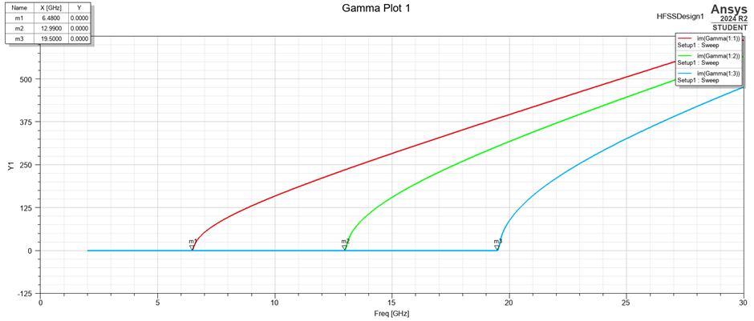
Figure 1 - Waveguide Simulated Cutoff Frequency
This graph shows the exact values for the cutoff frequency f_{c}. According to the simulation data, mode 1 has a cut of frequency of 6.48 GHz. Mode 2 has a cutoff frequency of 12.99 GHz. Mode 3 has a cutoff frequency of 19.50 GHz.

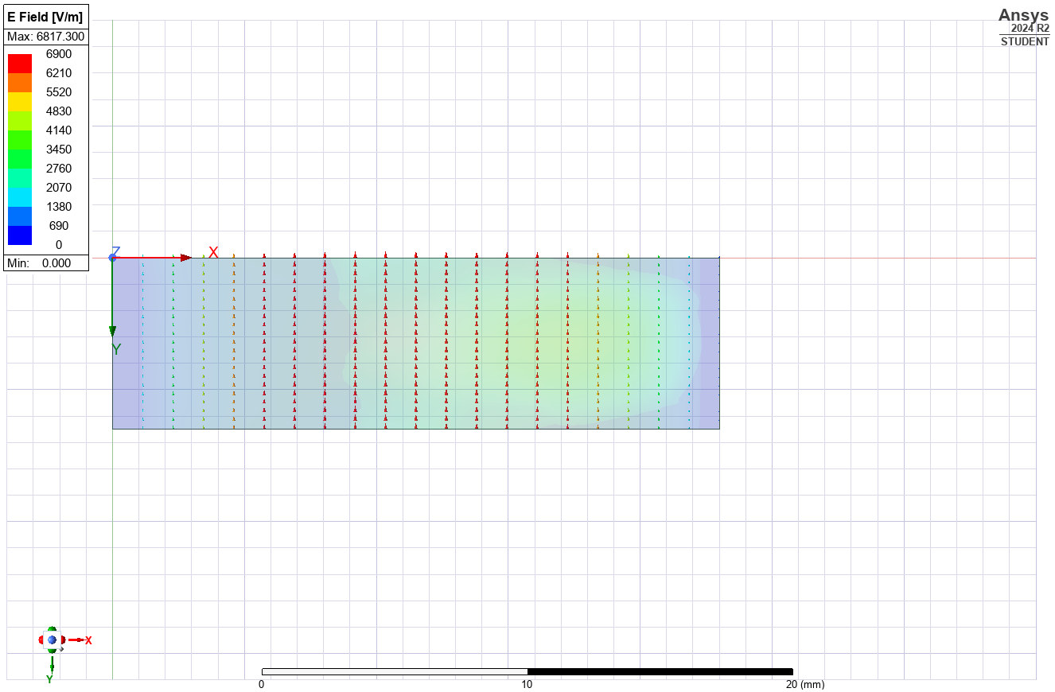
Figure 2 - Port 1, Mode 1 (m=1 n=0)
This figure shows mode 1 for the vacuum filled waveguide with half a wavelength horizontally and no wavelength vertically. This means that for later use in equations m=1 and n=0.
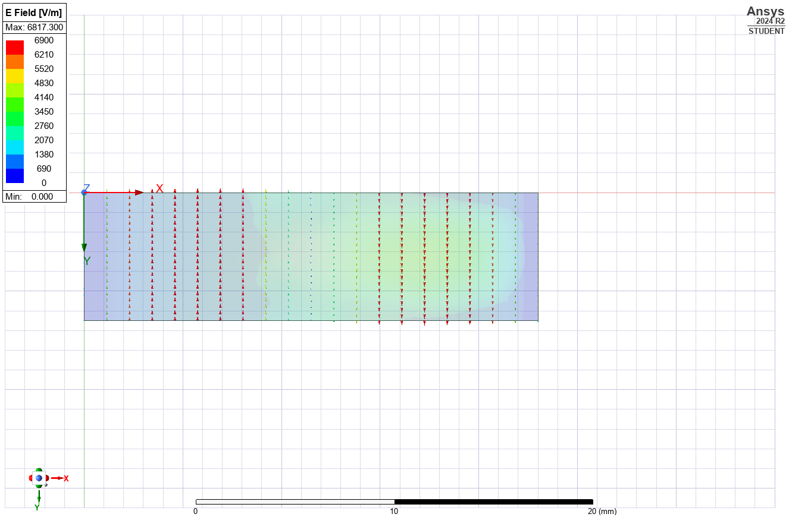
Figure 3 - Port 1, Mode 2 (m=2 n=0)
This figure shows mode 2 for the vacuum filled waveguide. There is one full wavelength visible due to the directional arrows meaning that m=2 and n=0 as there are no wavelengths vertically.
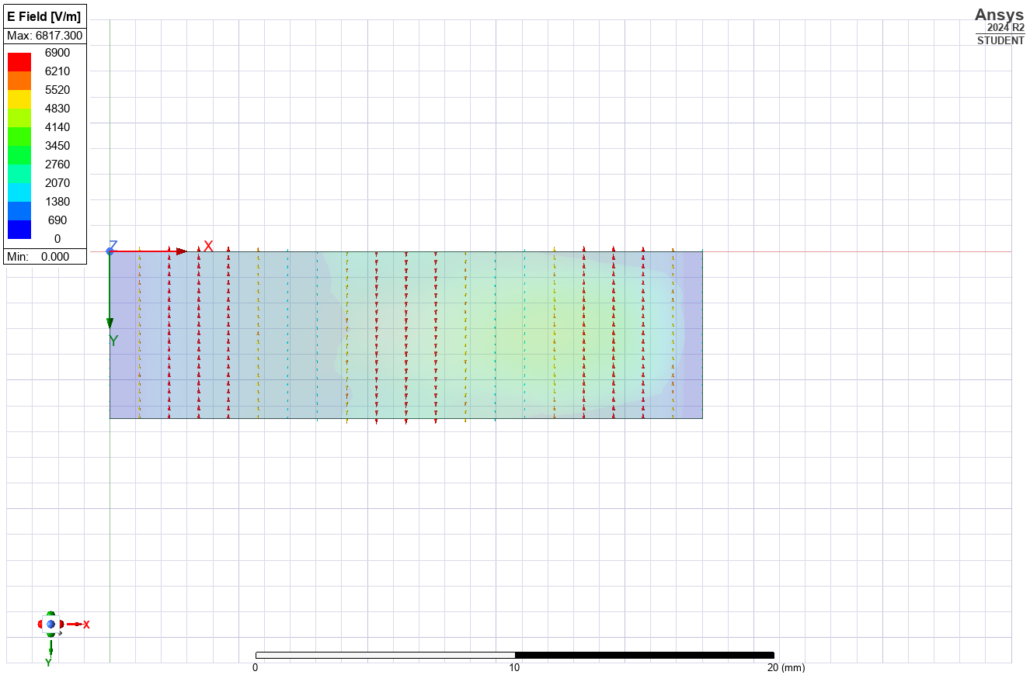
Figure 4 - Port 1, Mode 2 (m=3 n=0)
This figure shows mode 3 for the waveguide. Visible horizontally are three half wavelengths and no vertical wavelengths meaning m=3 and n=0 for the calculations.

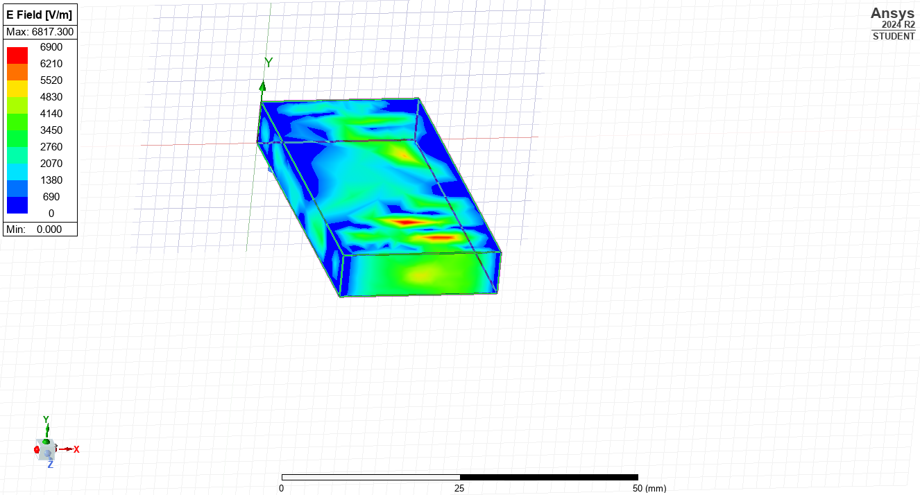
Figure 5 - Vacuum, Mode 1 E-Field Heat Map
Figure 5 shows the electric field strength along the waveguide. The areas of higher electric field strength will be points of major energy transfer due to the geometry of the waveguide. If this was a real-world waveguide and not a simulation then these points could be expected to heat up. At the end of the waveguide there is the approximate shape of the mode being propagated through the waveguide showing it functions to some degree.
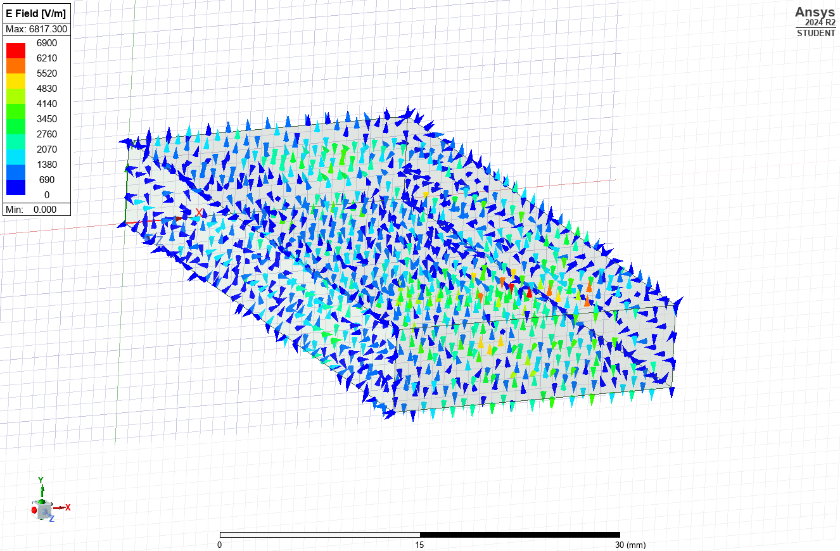
Figure 6 - Vacuum, Mode 1 E-Field Direction
This visualization shows the directions of the electric field strength throughout the waveguide.
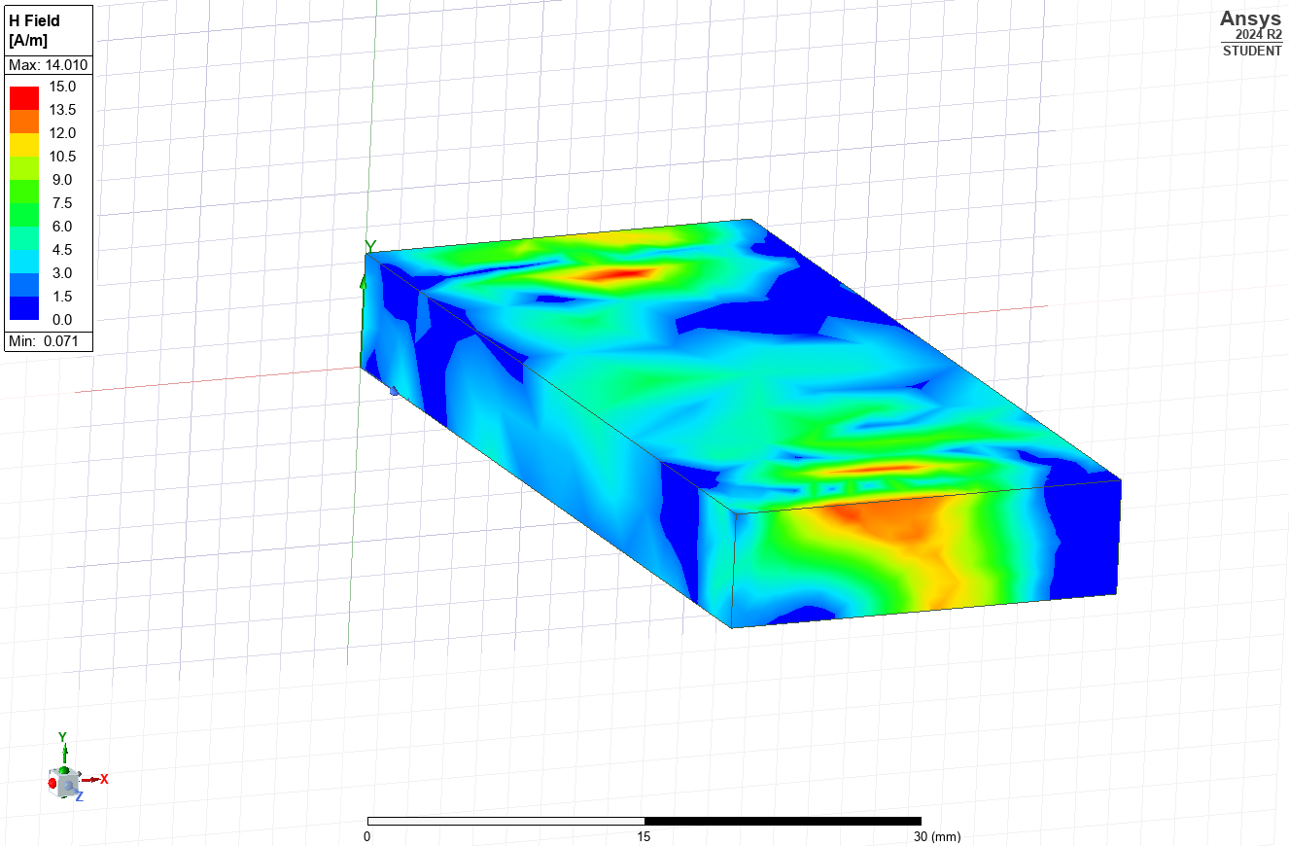
Figure 7 - Vacuum, Mode 1 H-Field Heat Map
This figure shows the waveguide with mode 1 being passed through it. This is a visual representation of the magnetic field intensity. An increased magnetic field intensity would induce larger current due to faradays law [4]. This needs considering in real world applications where unknown induction of current could cause issues for equipment.

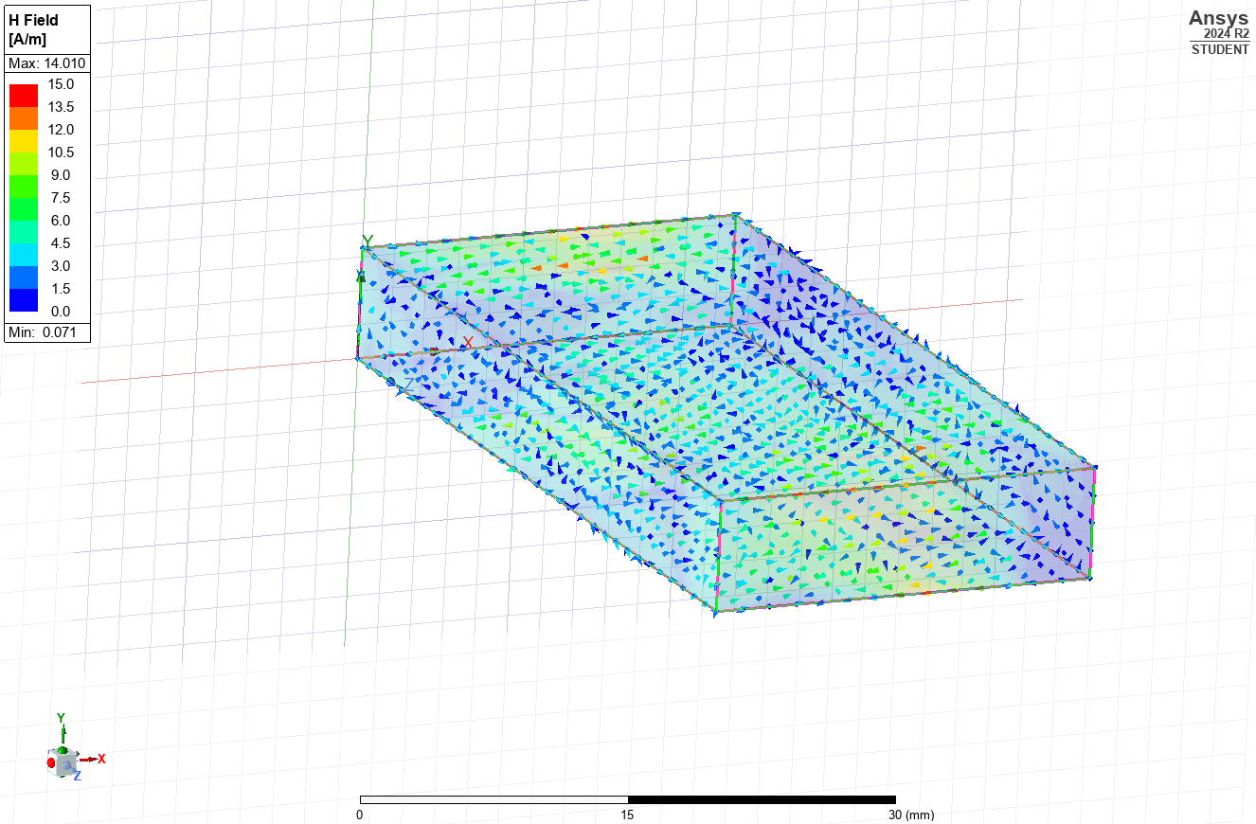
Figure 8 - Vacuum, Mode 1 H-Field Direction
This figure represents the direction of the magnetic field at all points along the waveguide.

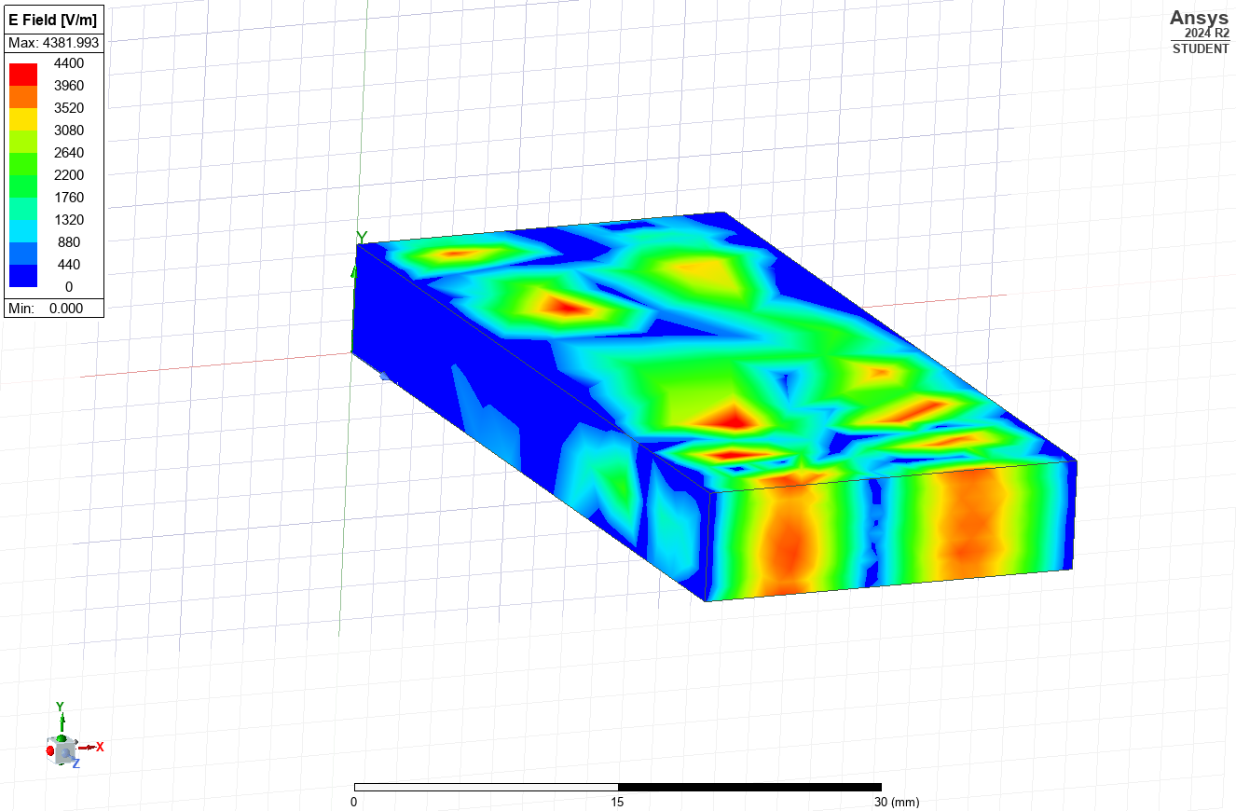
Figure 9 - Vacuum, Mode 2 E-Field Heat Map
This image show the electric field strength for the waveguide being simulated for mode 2. This mode is clearly visible at the port of the waveguide with the areas of high field strength corresponding to the areas of maximum amplitude in Figure 3. This is a more typical waveguide field however there are still unexpected areas of low electric field strength. These are likely due to the dimensions of the waveguide.

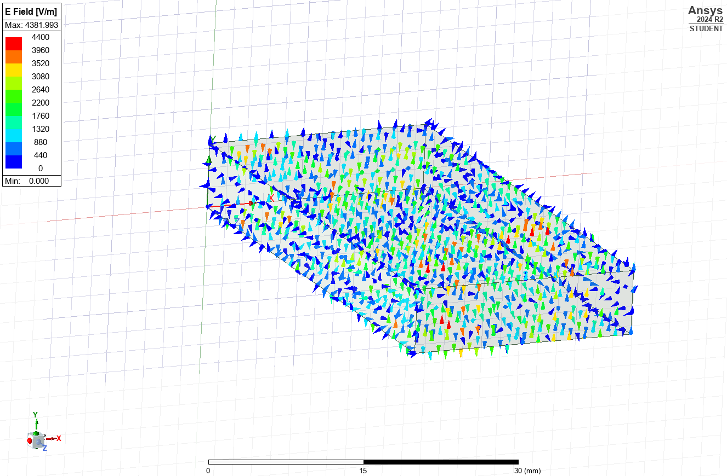
Figure 10 - Vacuum, Mode 2 E-Field Direction
This figure shows the direction of the electric field for mode 2. Noteworthy is the end of the waveguide where the directions of the E-field correspond to the directions of the mode in Figure 3.
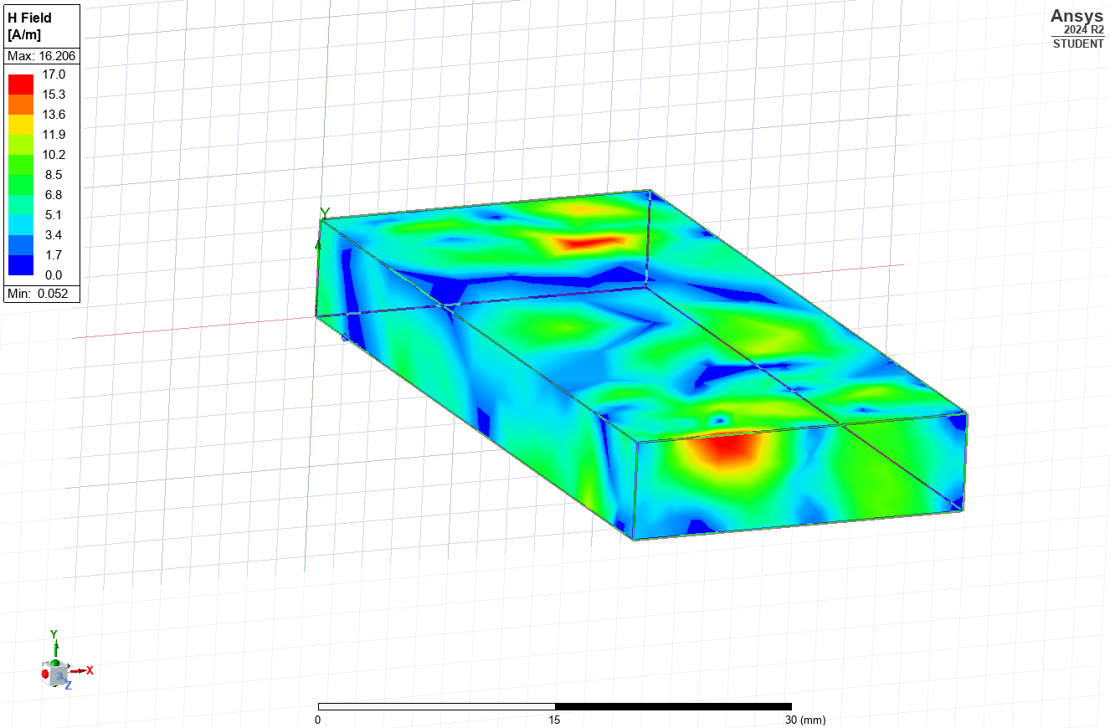
Figure 11 - Vacuum, Mode 2 H-Field Heat Map
This image shows the magnetic field intensity for mode 2 with obvious focus points at both ends. These are likely to induce current. The end of the waveguide almost corresponds to the mode being passed through it.

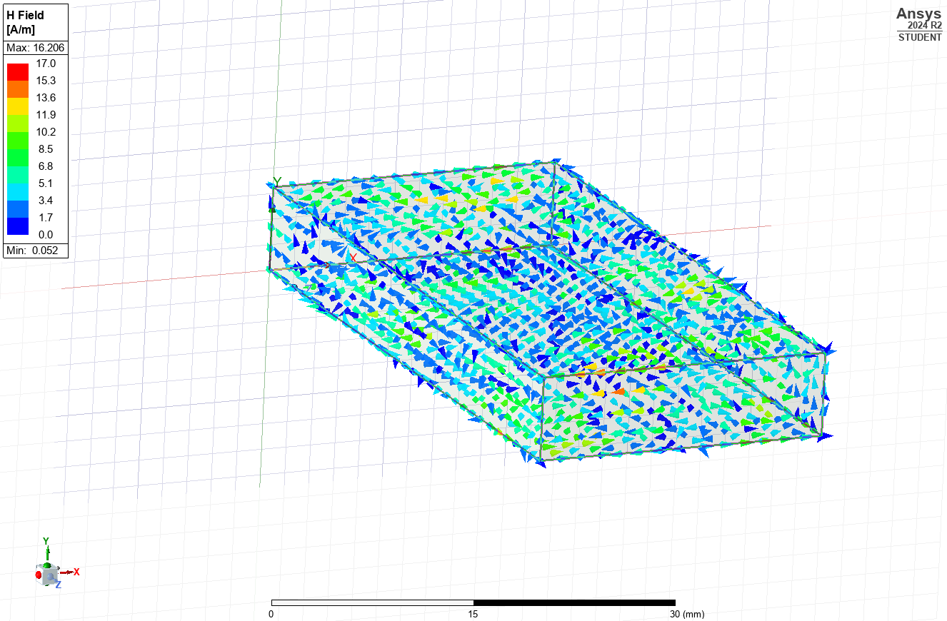
Figure 12 - Vacuum, Mode 2 H-Field Direction
This shows the direction of the magnetic field intensity for mode 2.

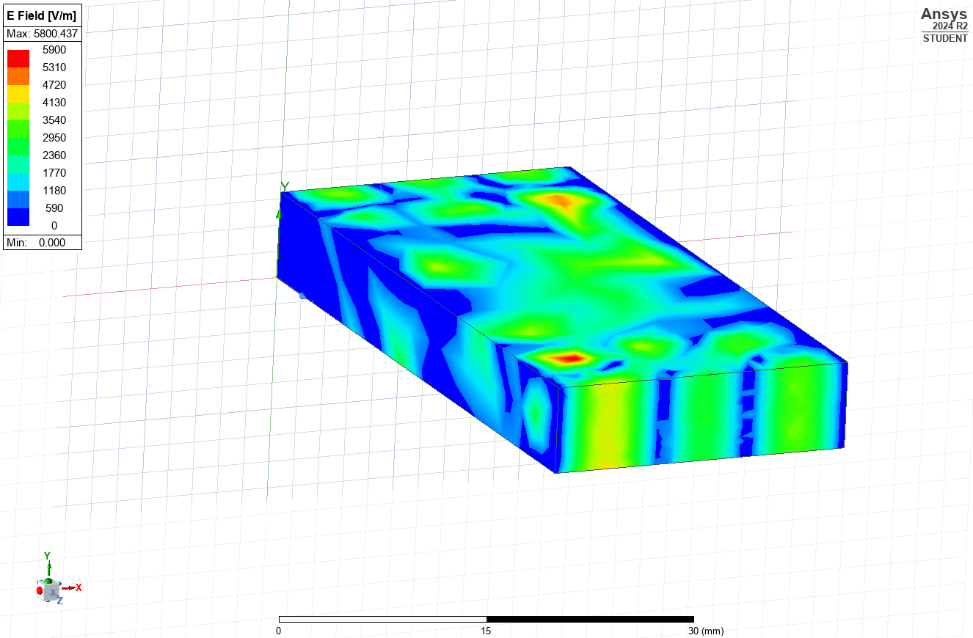
Figure 13 - Vacuum, Mode 3 E-Field Heat Map
This figure displays the electric field strength for mode 3. The pattern on the end of the waveguide matches what would be expected based on the mode in Figure 4.

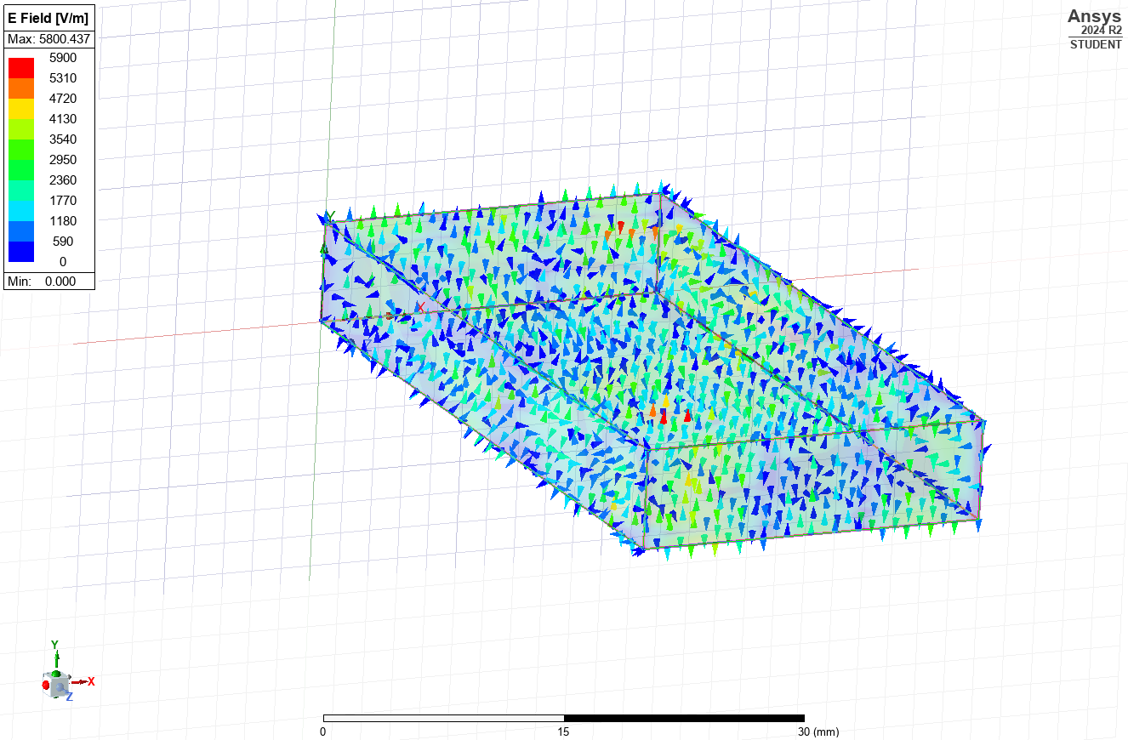
Figure 14 - Vacuum, Mode 3 E-Field Direction
This figure shows the direction of the electronic field for mode 3.
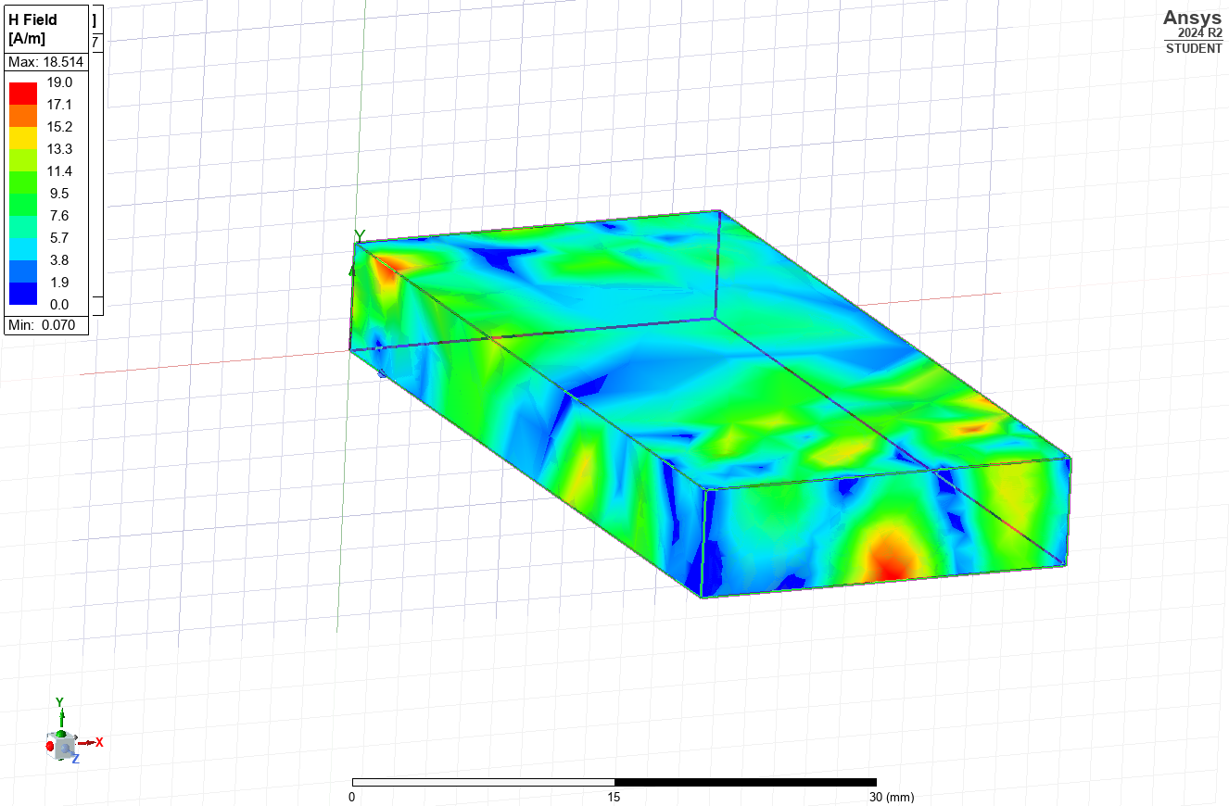
Figure 15 - Vacuum, Mode 3 H-Field Heat Map
This figure shows the magnetic field intensity for mode 3 in the waveguide.

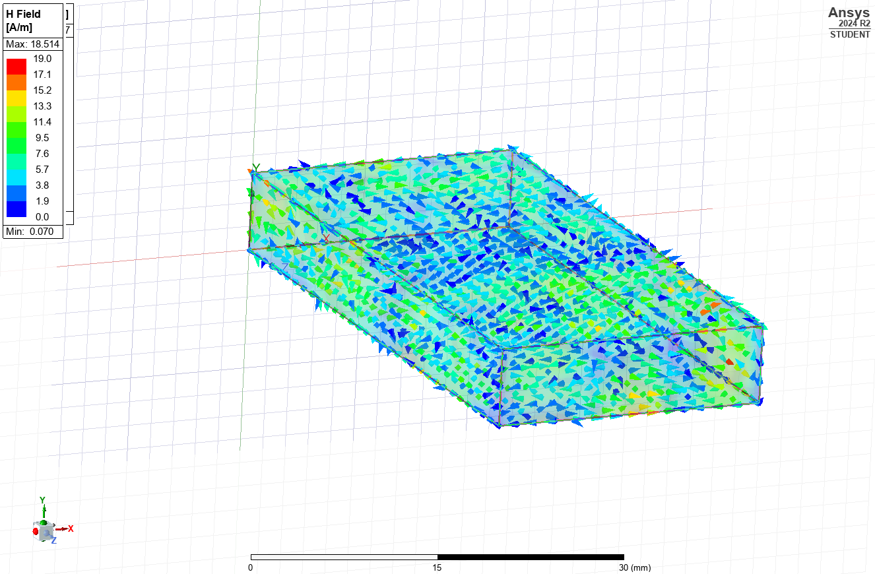
Figure 16 - Vacuum, Mode 3 H-Field Direction
This figure shows the direction of the magnetic field.

1.3 – Calculations
$$f_{c}=\frac{c}{\sqrt{ε_{r}μ_{r}}}\sqrt{({\frac{m}{2a})}^{2}+{(\frac{n}{2b})}^{2}}$$
Equation 1 - Cutoff Frequency
c=3*10⁸
ε_{r}= permittivity of free space
μ_{r}= permeability of free space
a=23*10⁻³
b=6.5*10⁻³

Mode 1
m=1
n=0
f_{c}=6521739130 Hz = 6.52 GHz (2.d.p)
Mode 2
m=2
n=0
f_{c}=13043478260 Hz = 13.04 GHz (2.d.p)
Mode 3
m=3
n=0
f_{c}=19565217390 Hz = 19.57 GHz (2.d.p)

1.4 – Conclusions
The conclusions which can be drawn are that the waveguide does not always function as expected. If the waveguide was achieving its purpose of transfering a wave from one end to the other then the same modal pattern as seen in Figure 2, Figure 3 and Figure 4 would be seen at the exit port. This is not the case in every one of the graphical representations of the E-field and H-field. Figure 13 and Figure 9 provide an accurate recreation of the mode that was fed in from the other end suggesting that the waveguide works as intended.
The theoretically calculated values for the cutoff frequency are very close to the simulated values (6.48 GHz vs 6.52 GHz for mode 1, 12.99 GHz vs 13.04 GHz for mode 2 and 19.50 GHz vs 19.57 GHz for mode 3). This suggests that the simulation is accurate.

1.5 – Teflon Method
The method to create the Teflon filled waveguide was identical to the method outlined in 1.1 - Method. The only difference is the inside being Teflon instead of vacuum.

1.6 – Teflon Results
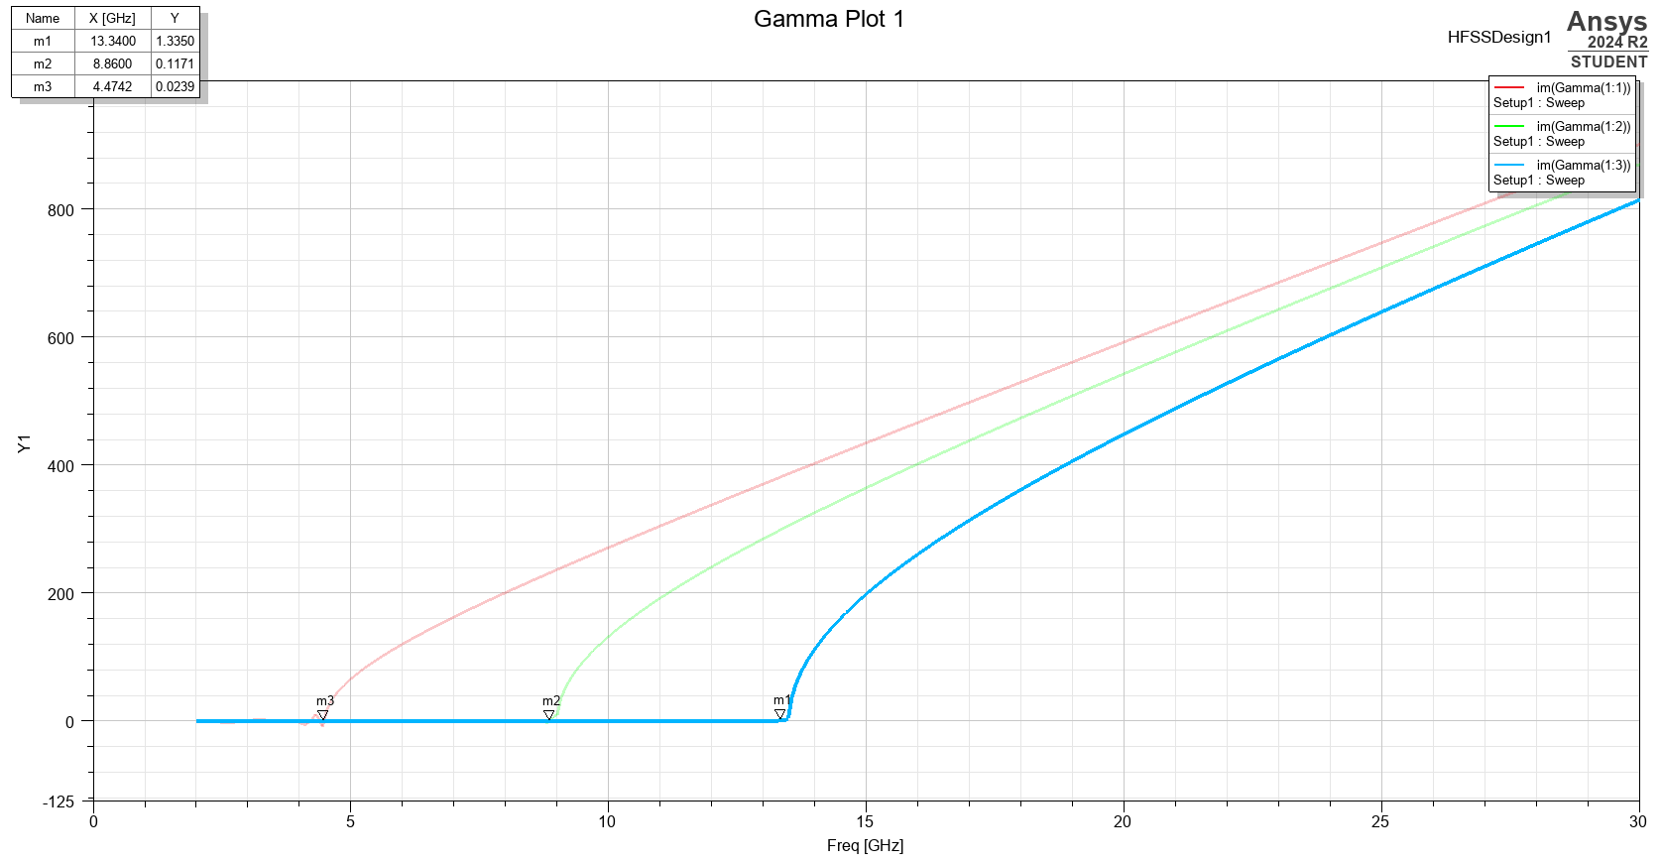
Figure 17 - Teflon Gamma Plot
This graph shows the simulated cutoff frequencies for all 3 modes in a Teflon waveguide. Mode 1 is 4.47 GHz, mode 2 is 8.86 GHz and mode 3 is 13.34 GHz.
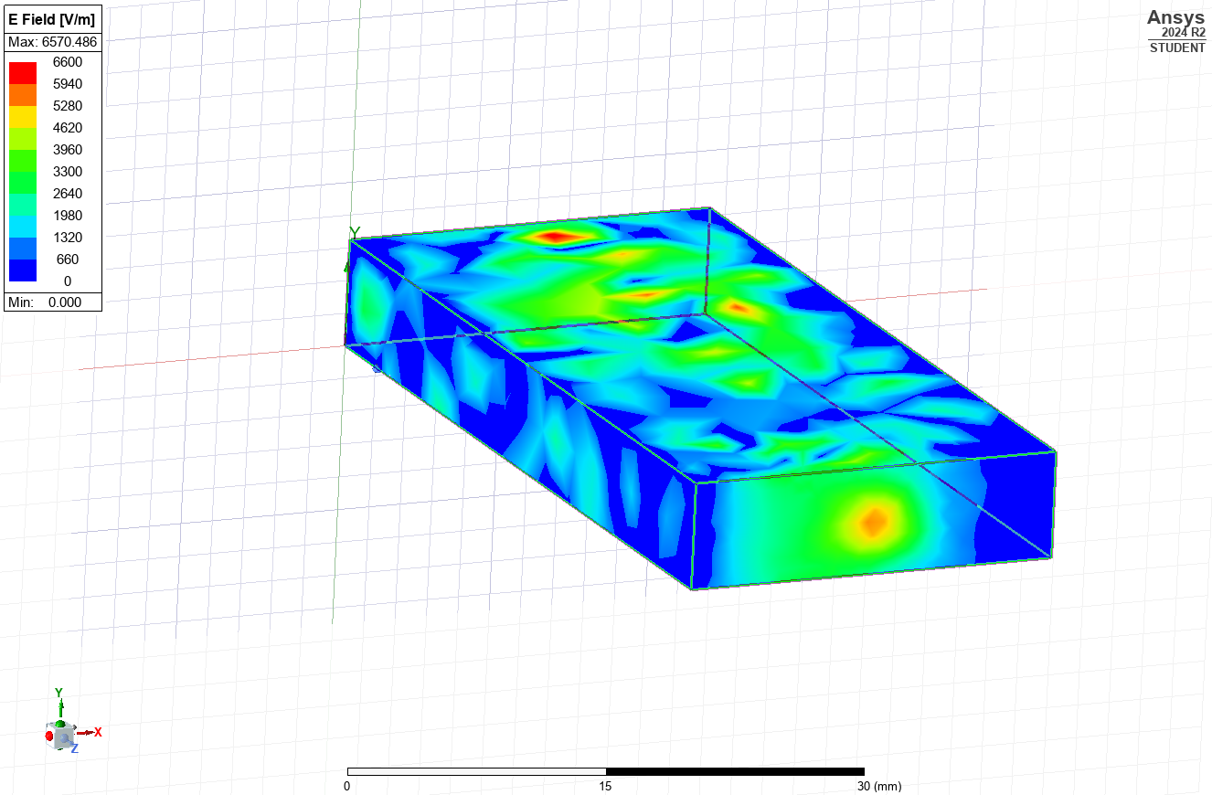
Figure 18 - Teflon, Mode 1, E-Field
This figure shows the electric field strength on the Teflon waveguide. The pattern lines up with what would be expected from mode 1.

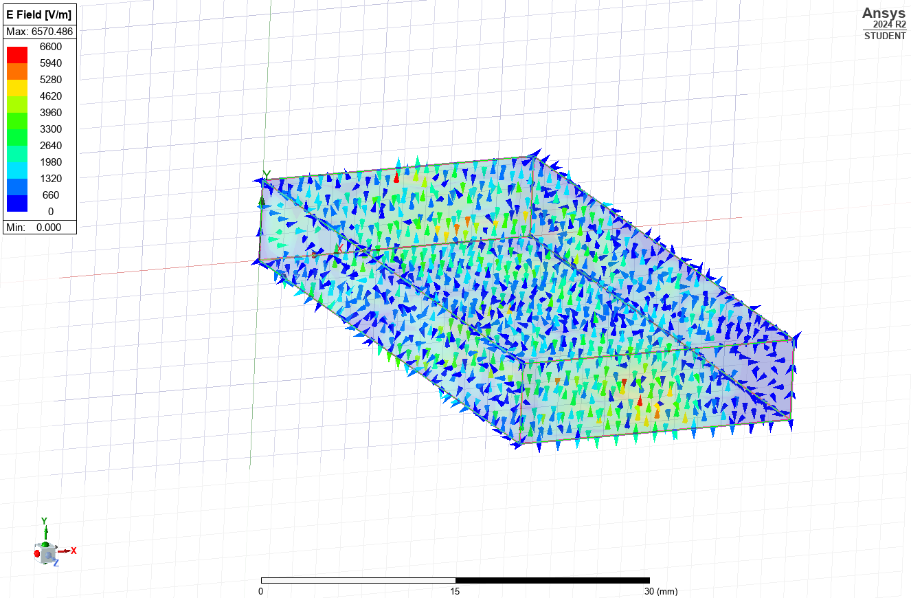
Figure 19 - Teflon, Mode 1, E-Field Direction
This figure shows the direction of the electric field for mode 1.

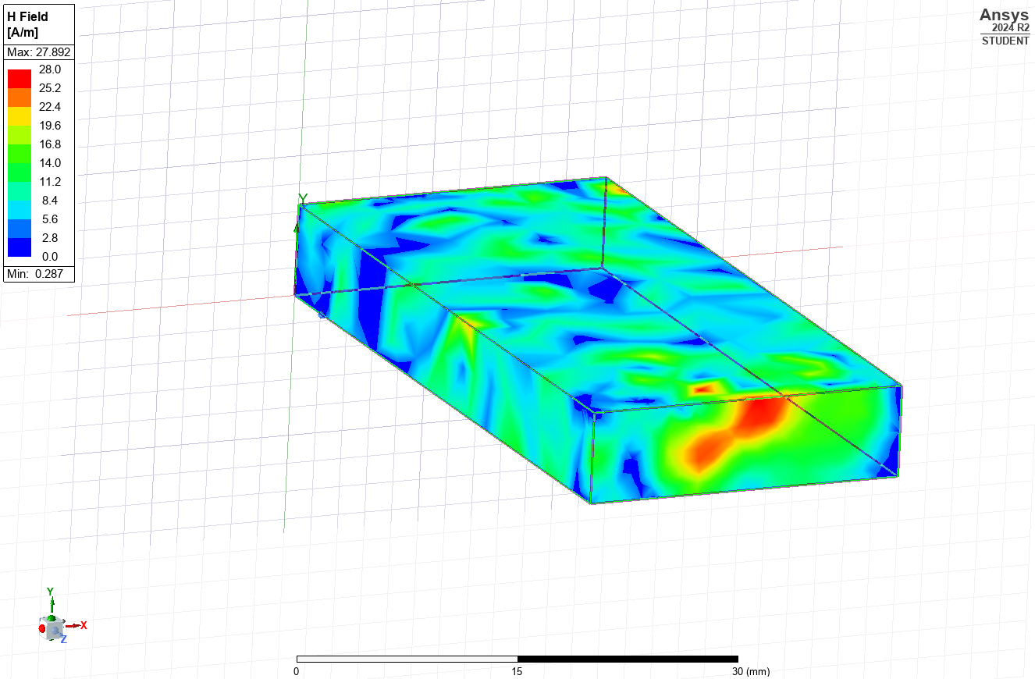
Figure 20 - Teflon, Mode 1, H-Field
This figure shows the magnetic field intensity. The pattern of high and low intensity matches the mode.

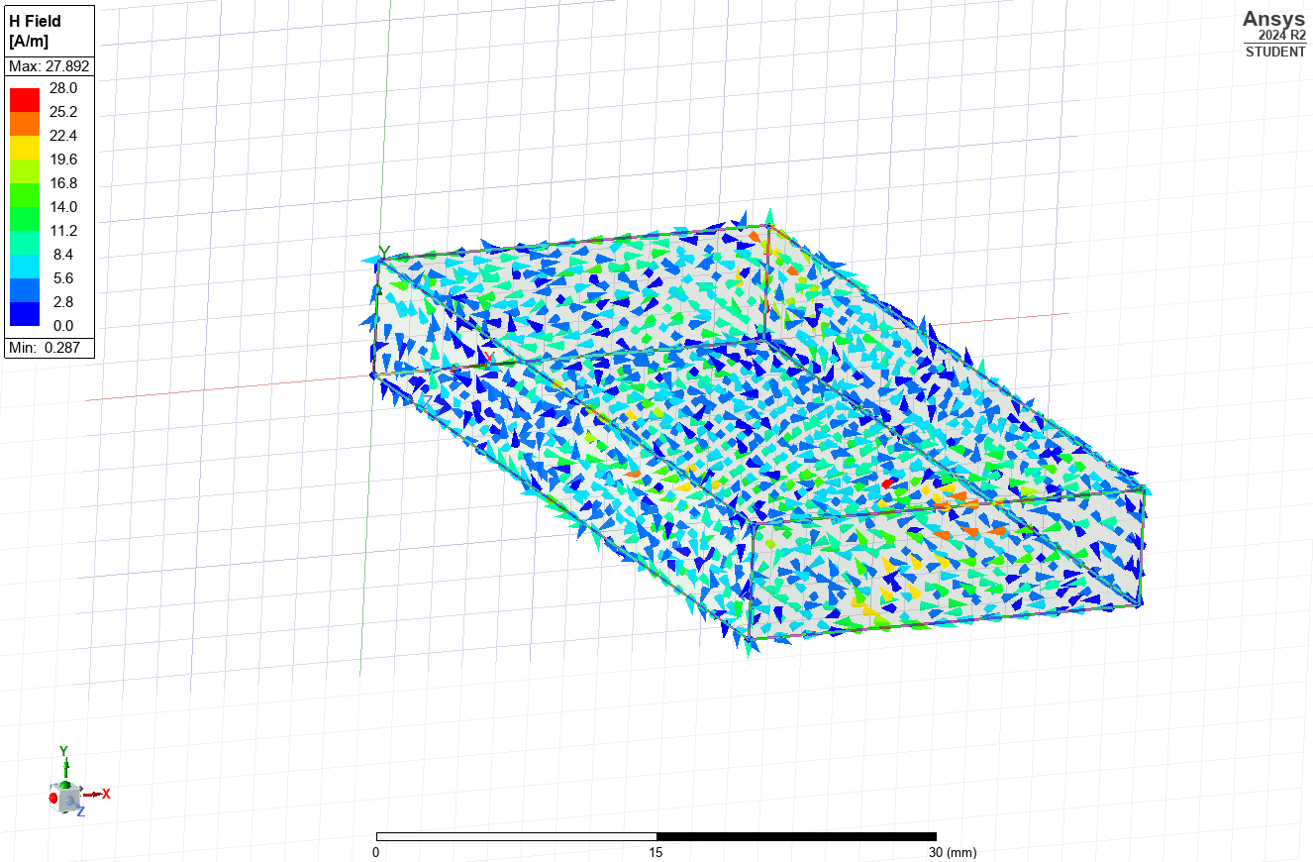
Figure 21 - Teflon, Mode 1, H-Field Direction
This figure shows the direction of the magnetic field for mode 1.

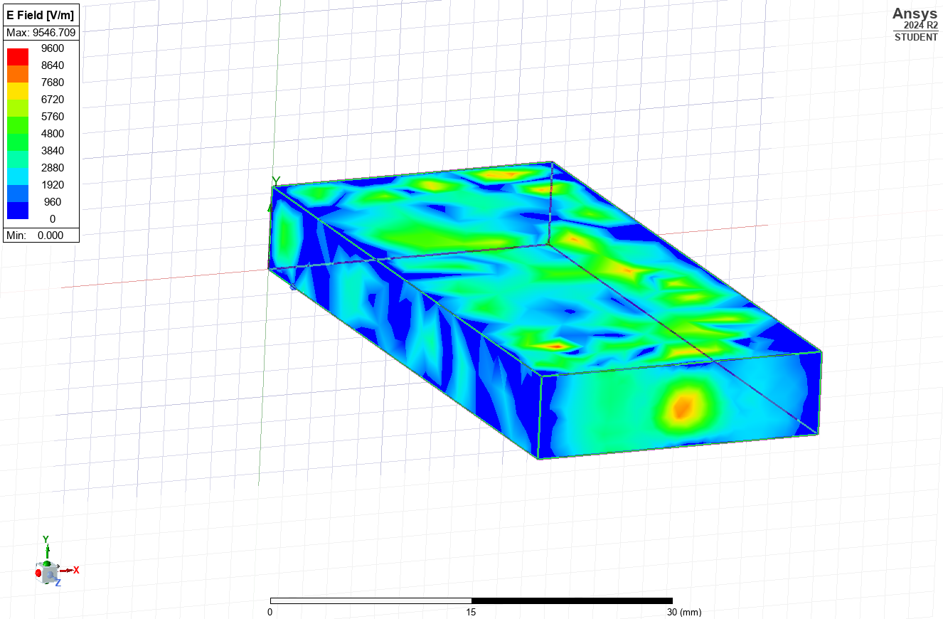
Figure 22 - Teflon, Mode 2, E-Field
This figure shows the electric field strength for mode 2 and the pattern does not match what would be expected.

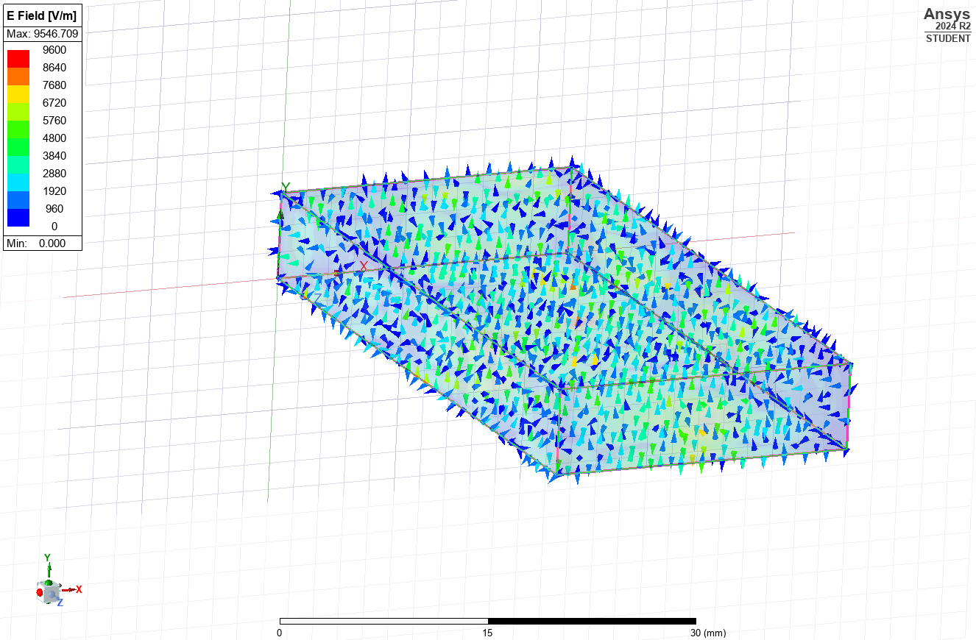
Figure 23 - Teflon, Mode 2, E-Field Direction
This figure shows the direction of the electric field for mode 2.

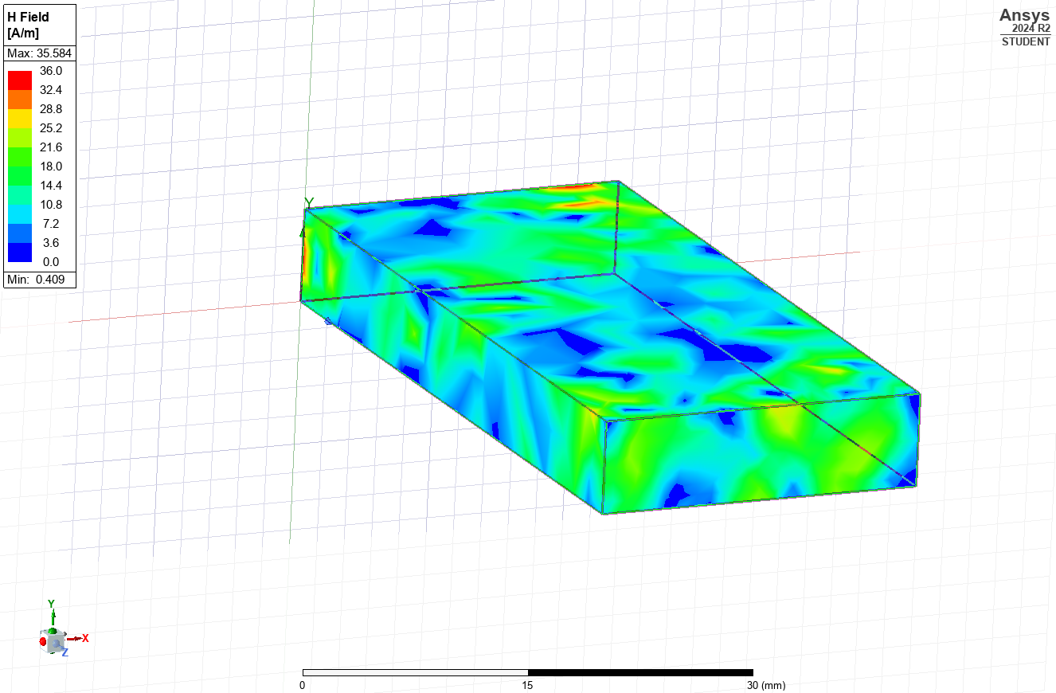
Figure 24 - Teflon, Mode 2, H-Field
This figure shows the magnetic field intensity for mode 2. This does not match the pattern of mode 2 and is likely caused by the geometry of the waveguide.

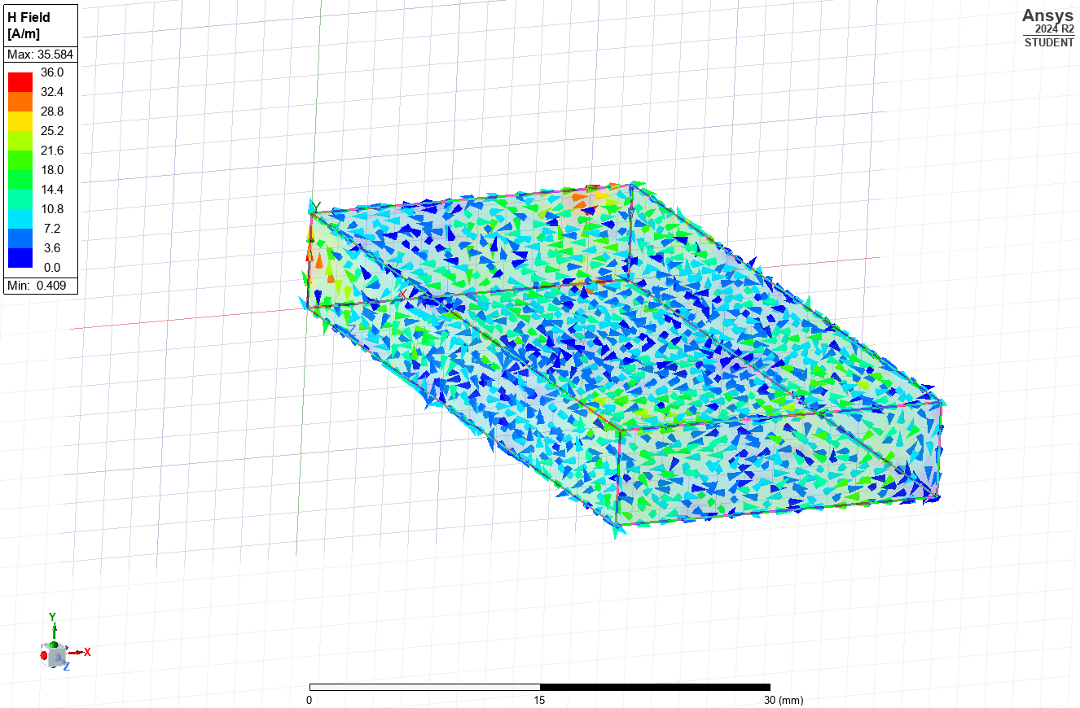
Figure 25 - Teflon, Mode 2, H-Field Direction
This figure shows the direction of the magnetic field for mode 2.

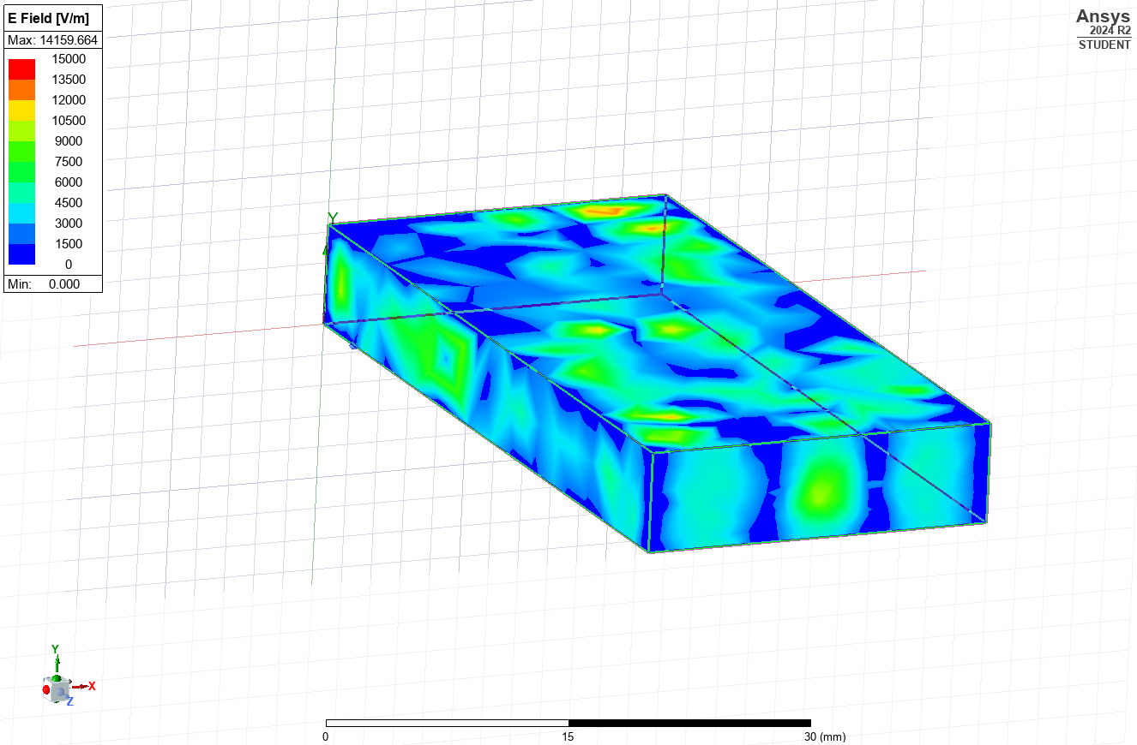
Figure 26 - Teflon, Mode 3, E-Field
This figure shows the electric field strength for mode 3. The pattern produced by the simulation matches what would be expected from mode 3.

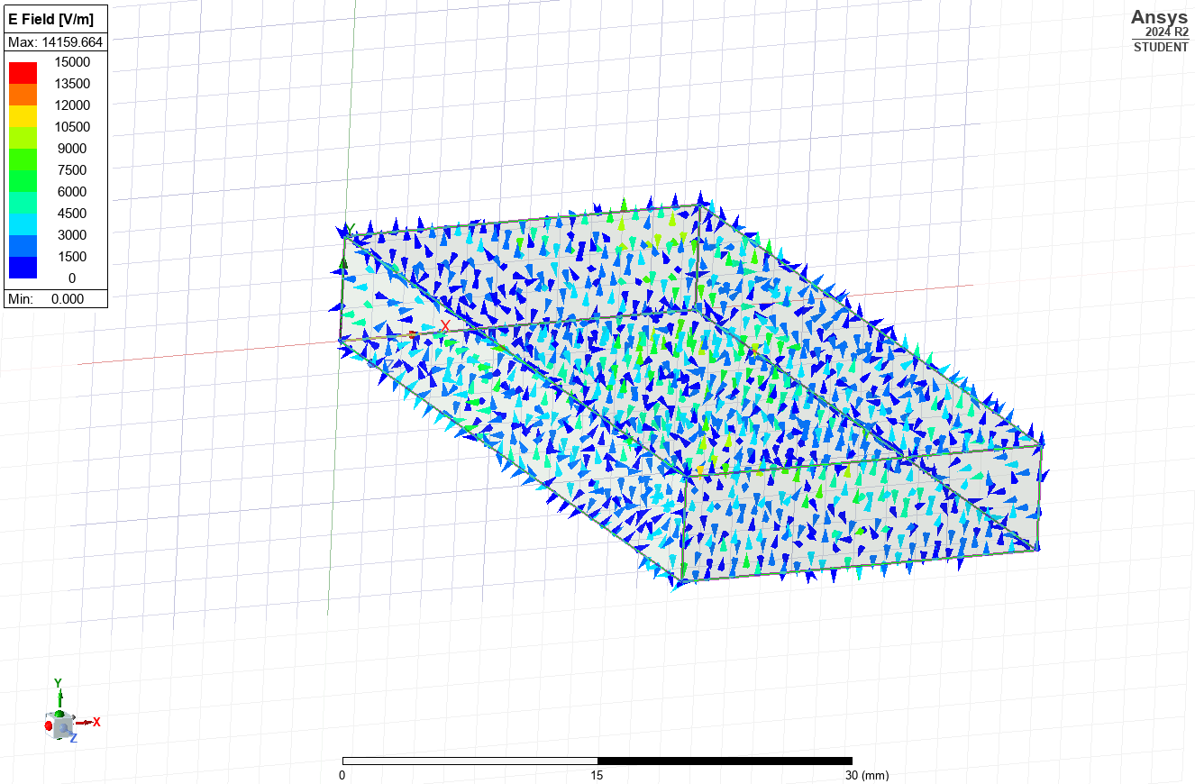
Figure 27 - Teflon, Mode 3, E-Field Direction
This graphic shows the direction of the electronic field for mode 3.

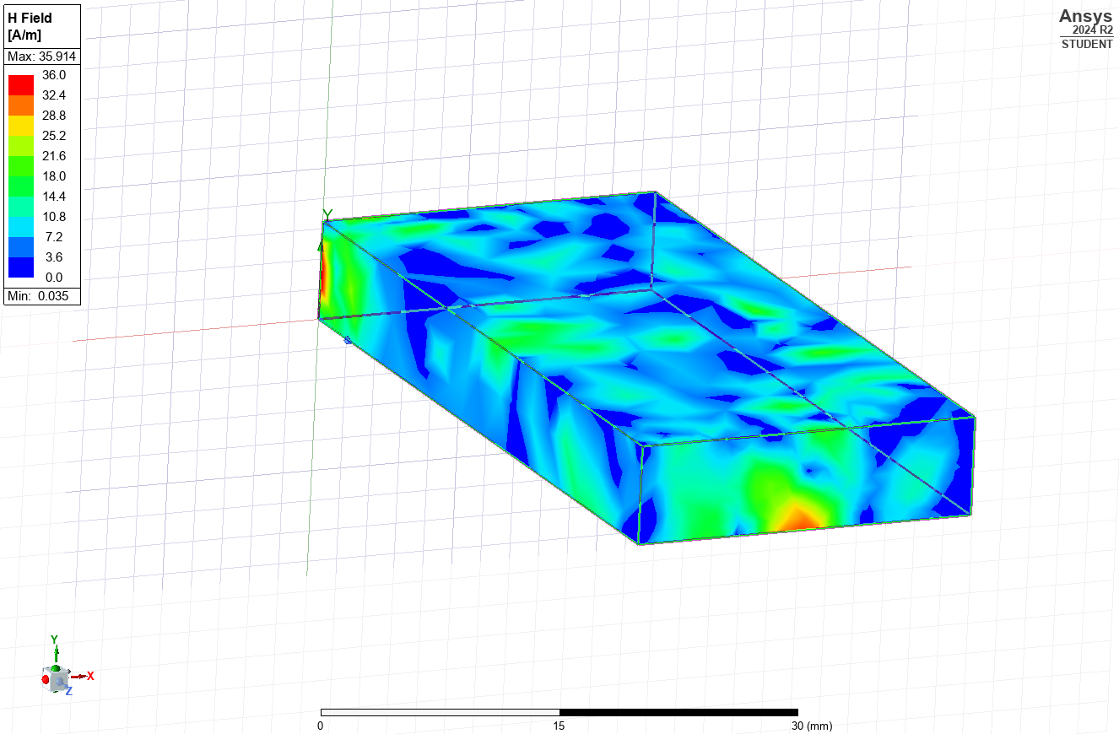
Figure 28 - Teflon, Mode 3, H-Field
This figure shows the magnetic field intensity for mode 3. The pattern produced partially matches what would be expected but does not fully match the pattern of mode 3 meaning the wave is not traveling along the waveguide properly.

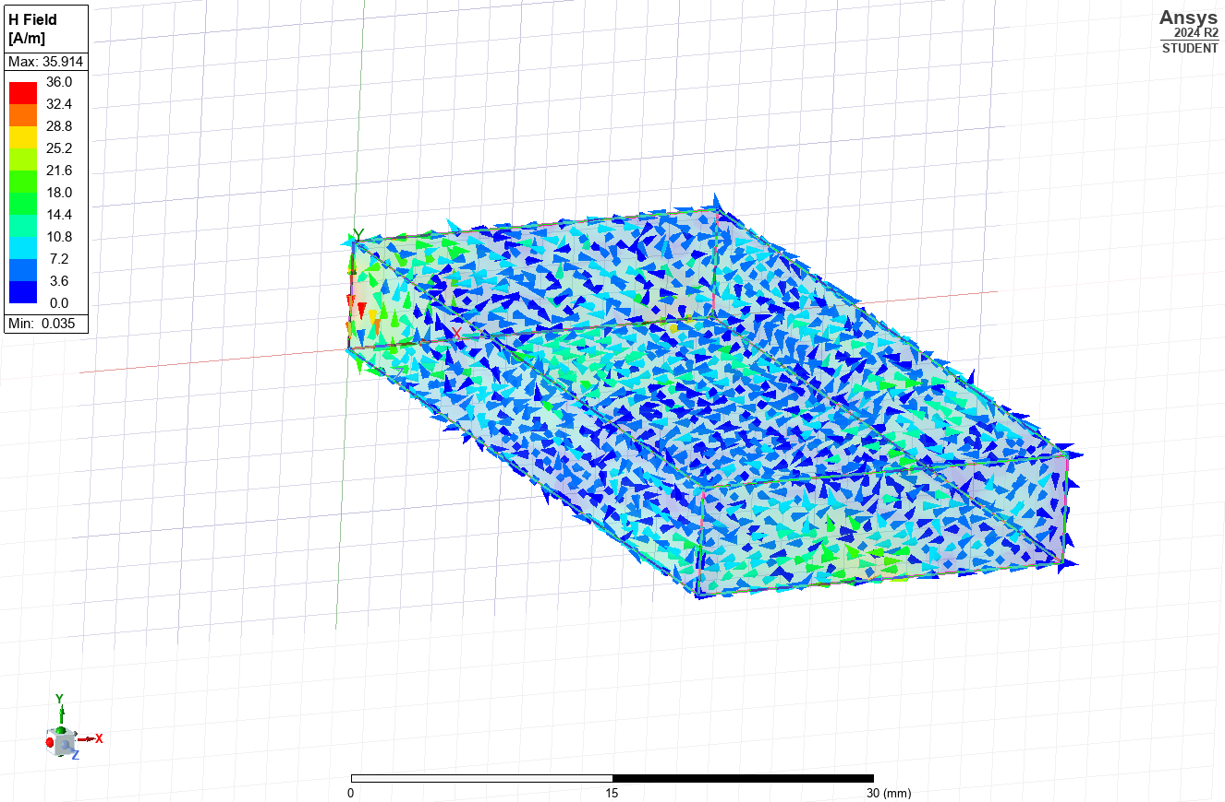
Figure 29 - Teflon, Mode 3, H-Field Direction
This figure shows the direction of the magnetic field for mode 3.

1.7 – Teflon Calculations
$$f_{c}=\frac{c}{\sqrt{ε_{r}μ_{r}}}\sqrt{({\frac{m}{2a})}^{2}+{(\frac{n}{2b})}^{2}}$$
Equation 1 - Cutoff Frequency
c=3*10⁸
ε_{r}= permittivity of Teflon = 2.1 [5]
μ_{r}= permeability of Teflon = 1
a=23*10⁻³
b=6.5*10⁻³

Mode 1
m=1
n=0
f_{c}=4500427561 Hz = 4.50 GHz
Mode 2
m=2
n=0
f_{c}=9000855122 Hz = 9.00 GHz
Mode 3
m=3
n=0
f_{c}=13501282680 Hz = 13.50 GHz

1.8 Teflon Conclusions
In conclusion, having a Teflon filling instead of a vacuum reduced the cutoff frequencies for all modes. This is because the waves travel more slowly through a medium which reduces the wavelength so a lower frequency wave can enter the waveguide and be compressed to the required frequency to propagate through the waveguide [6].

Section 2 – Dipole Antenna

2.1 – Method
To create the dipole antenna, a 1mm radius that was the required length to transmit 231mm waves.
L= λ / 2
Equation 2 - Length of a Dipole
Using Equation 2, the length of the dipole antenna was 115.5mm. Once this was extruded, an excitement was placed at the centre point of the length. Once the antenna was constructed, a solution was created and validated and a simulation run. Once the simulation was completed, the results were extracted into various formats.

2.2 – Results
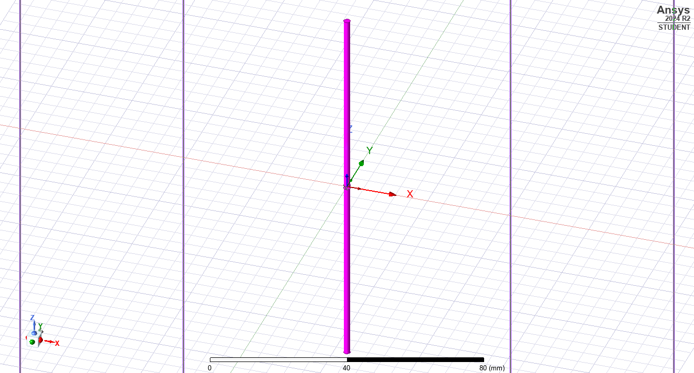
Figure 30 - Dipole Antenna being Constructed

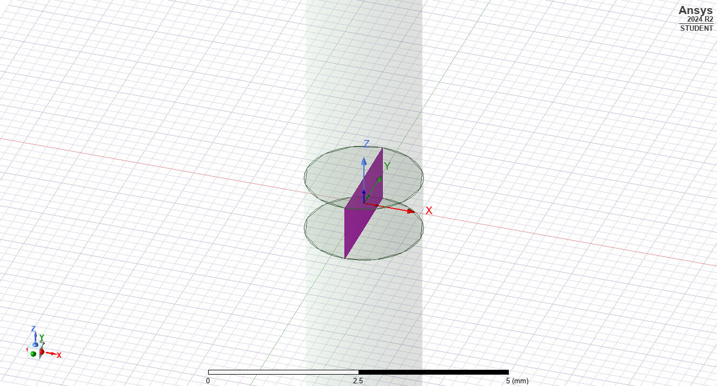
Figure 31 – Excitation being added

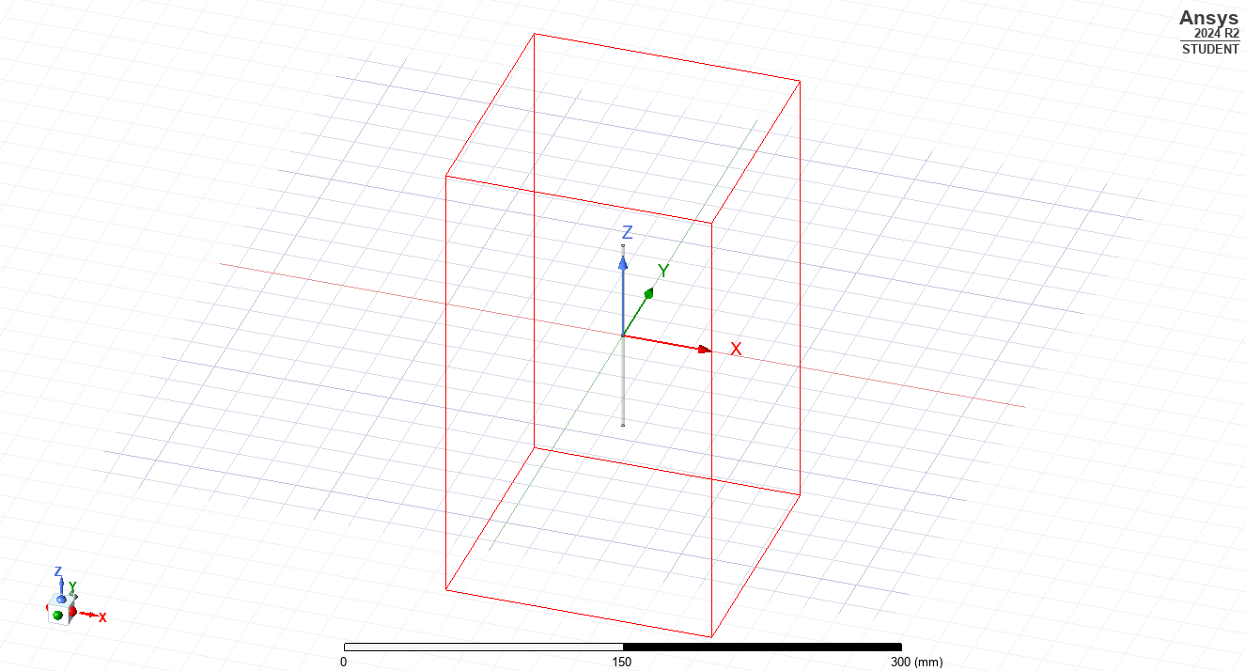
Figure 32 - Scope of the simulation

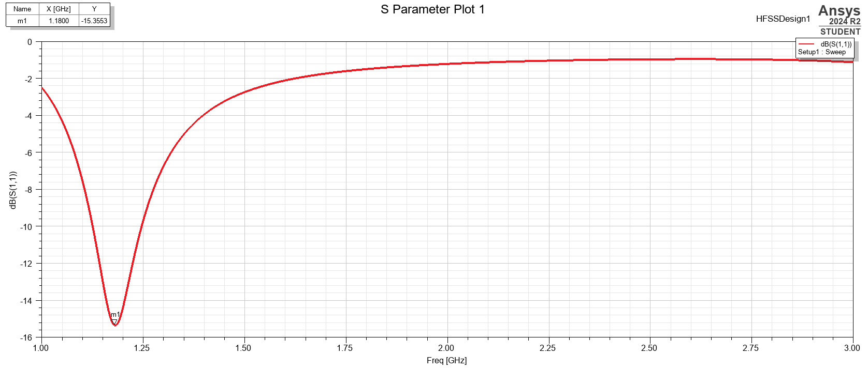
Figure 33 - S Parameter Plot
This S parameter plot suggests that operating frequency will be 1.18 GHz (2.d.p).
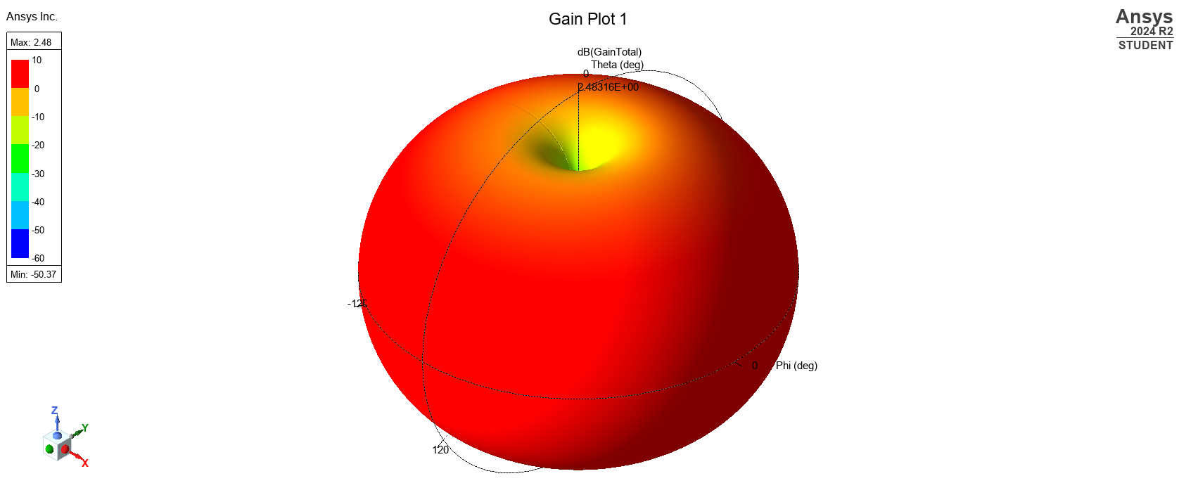
Figure 34 - Graphical representation of emission

2.3 – Calculations
As the length of the dipole is one half wavelength, the operating frequency can be calculated as follows:
f=c/λ
Equation 3 - Frequency, Speed, Wavelength
λ=231*10⁻³ m
c=3*10⁸ ms⁻¹
f = 1298701299 Hz = 1.30 GHz (2.d.p)

2.4 – Conclusions
In conclusion, the dipole antenna will operate at a frequency of 1.18-1.30 GHz and will extend 57.75mm either side of the emitter. The discrepancy in the simulated value and the theoretically worked out value for operating frequency may be attributed to an insufficient simulation. The emission it produces will be cylindrical with uniform emission in a ring around the length with a null at either end.

References

[1] | N. Marcuvitz, in Waveguide Handbook, McGraw Hill, 1951.
[2] | M. R. a. A. B. Abdul Qadir Khan, “Various Types of Antenna with Respect to their Applications: A Review,” INTERNATIONAL JOURNAL OF MULTIDISCIPLINARY SCIENCES AND ENGINEERING, vol. 7, no. 3, 2016.
[3] | A. Ishimaru, in Electromagnetic Wave Propagation, Radiation, and Scattering: From Fundamentals to Applications, John Wiley & Sons, 2017.
[4] | S. C. R. a. S. P. Robert Kingman, An experimental observation of Faraday’s law of induction, Berrien Springs, Michigan : American, 2000.
[5] | “The Engineering Tool Box,” [Online]. Available: https://www.engineeringtoolbox.com/relative-permittivity-d_1660.html. [Accessed 25 04 2025].
[6] | M. Steer, “LibreTexts Engineering,” NICE CXone Expert, [Online]. Available: https://eng.libretexts.org/Bookshelves/Electrical_Engineering/Electronics/Microwave_and_RF_Design_II_-_Transmission_Lines_%28Steer%29/06%3A_Waveguides/6.04%3A_Rectangular_Waveguide?utm_source=chatgpt.com. [Accessed 25 04 2025].

