

Master of Business Administration Programme
LCMB7035 - Dissertation

Innovation of Product Offerings and Its Impact on Consumer Perception – A Case Study of Sainsbury’s in London

Supervisor: Gladius David Kulothungan

Student’s Name: Shahida Akter
Student’s ID: 2424896
Word Count: 2573

Date of Submission: 7th November 2025

Table of Contents
Chapter 1: Introduction 4
1.1 Background of the Research 4
1.2 Research Rationale 4
1.3 Research Aim, Objectives, and Questions 5
Aim 5
Objectives 5
Research Questions 5
Chapter 2: Methodology 5
2.1 Research Philosophy 6
2.2 Research Approach 6
2.3 Research Strategy 6
2.4 Research Choice 7
2.5 Data Collection and Sampling. 7
2.6 Data Analysis 7
2.7 Reliability and Validity 7
2.8 Ethical Considerations 7
Chapter 3: Literature Review 8
3.1 Digital Brand Identity and Consumer Perception 8
3.2 Product Innovation and Customer Value 8
3.3 Customer Relationship and Loyalty 9
3.4 Consumer Behaviour Theories in Innovation 10
3.5 Literature Gaps 11
3.6 Theoretical Framework: Relationship Marketing Theory 12
Chapter 4: Research Limitations 12
Chapter 5: Research Ethics 12
Chapter 6: Timeline 13
Chapter 7: Conclusion 13
Reference 14

Chapter 1: Introduction

1.1 Background of the Research
Innovation in the contemporary UK retail market has taken the place of competitiveness. Supermarkets should not be a store of low prices and convenience only, but one that responds to the changing customer demands. The current shoppers are in search of freshness, variety and safer foods, but at a price and with convenience. This has made product innovation strategy-needed and not a marketing instrument. The same shift is reflected in Sainsbury, one of the leading retailers in the UK (Ploll et al., 2022). Its Meal Deal, which is a set menu of a main, snack, and a beverage, is an example of how innovation may combine the elements of value, variety, and convenience into a single experience. Through regular changes of its assortment, introduction of healthier options and incorporation of loyalty pricing through Nectar, Sainsbury adapts to the shifting tastes with the help of innovation. It is a sign that retail innovation is not just the new product, its creation; it influences consumer attitudes, generates trust, and improves satisfaction (Woods, Doherty and Stephens, 2021). However, there is relatively little research that investigates the impact of these strategies on the perception of the customers and their long-term loyalty.

1.2 Research Rationale
The purchasing behaviour in the UK food retail sector, which is a dynamic field, has been significantly changed by changes in the lifestyle of consumers, an increase in the use of digital conveniences, and the rise in health awareness. Customers have started to evaluate value based not only on price, but also on what is thought to be the level of innovativeness and relevance of the products (Upadhyay, Kumar and Akter, 2022). As an example, one customer could choose Sainsbury over a competitor retailer due to the innovative services that the former offers seem to be fresher or more sensitive to personal needs. This paper is hence of importance since it focuses on how consumers interpret innovation and not the design processes by firms. This investigation will identify whether innovation can help customers feel real positive experience, or are the innovative propositions of Sainsbury (especially the Meal Deal) just a promotion tactic by investigating how customers perceive innovative propositions developed by the company (Iyelolu et al., 2024). The results will guide retailers on how they can strike the right balance between innovation and authenticity and make sure that the added value makes a difference to the target group.

1.3 Research Aim, Objectives, and Questions

Aim
To critically examine how innovative product offerings at Sainsbury’s influence consumer perception, satisfaction, and loyalty in the London market.

Objectives
- To explore how Sainsbury’s innovative offerings, such as the Meal Deal, affect perceived customer value.
- To identify factors that shape customer attitudes toward innovation in food retail.
- To analyse how innovation contributes to customer satisfaction and loyalty.

Research Questions
- How do consumers perceive innovation in Sainsbury’s product offerings?
- What specific elements of innovation create positive or negative perceptions?
- How does product innovation influence repeat purchase behaviour and loyalty?

Chapter 2: Methodology
This chapter describes the entire study procedure using the research onion by Saunders et al. (2007) as the research framework. The model will help to structure every level of the research design, including philosophical position and data collection, so that it will provide a consistent and methodologically adequate approach.
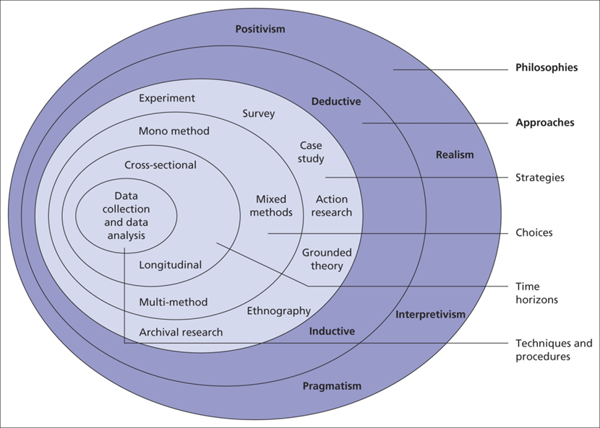
Figure 1: Research Onion Model
Source: (Iyelolu et al., 2024)

2.1 Research Philosophy
The last level of the Research Onion is the philosophical one. This research takes a positivist ontology, which holds that knowledge can be identified, measured, and studied objectively. Considering the objective to establish the trends and relationships between innovation and consumer perception, a positivist paradigm is considered suitable (Omowole et al., 2024). It enables the application of quantitative data and statistical tests to explain observed trends as opposed to advanced or uncertain methods.

2.2 Research Approach
The next level is that of reasoning. The inductive method of reasoning is chosen; the aim is to build knowledge out of the facts as opposed to testing the previously formed assumptions. The research will gather the impressions of the consumers towards the innovative products of Sainsbury and will interpret the obtained findings with regard to behaviour and loyalty (ERU, TOPUZ and COP, 2022). Induction is considered appropriate since it allows generalising findings of specific empirical observations in a flexible manner.

2.3 Research Strategy
At this level, a quantitative orientation is used as a survey strategy. Surveys facilitate effective data collection of a large sample size and are commonly used to investigate consumer perceptions (Hartfield, 2024). The implementation of an online Google Form will ensure ease of access and convenience for the respondents.

2.4 Research Choice
One quantitative design is that of a mono-method. Numerical data will only be collected and analysed statistically (Geissdoerfer et al., 2023). This option supports objectivity in methodology and provides quantifiable evidence with regard to consumer attitudes towards innovation.

2.5 Data Collection and Sampling.
Primary data will be collected using a structured questionnaire of Google Forms that will be conducted with fifty consumers in London who are habitual shoppers at Sainsbury’s. The sampling will be based on convenience, which will include recruiting the respondents through the internet, Facebook, and WhatsApp (Aramyan et al., 2021). The scale will be based on a 5-point Likert scale to determine the levels of agreement with constructs of innovation, satisfaction, and loyalty.

2.6 Data Analysis
All data obtained will be analysed with the help of Microsoft Excel or SPSS. The results will be summarised by use of descriptive statistics (frequency distributions, means, percentages), and the inferential statistics (in the form of correlation analysis) shall be used to test the correlation between innovation and consumer perception (Babu et al., 2024).

2.7 Reliability and Validity
The pilot test will entail five respondents to determine the clarity of items. Cronbach’s alpha will be determined to test internal consistency, hence, to confirm reliability (Babu et al., 2024). The validity will be strengthened by the logically constructed items based on available consumer-behaviour literature.

2.8 Ethical Considerations
Informed consent shall be obtained from all the participants before the study. No personal identifiers would be captured, and therefore anonymity would be maintained (Roe et al., 2022). The data will be kept in a safe place and will only be utilised in an academic sense.

Chapter 3: Literature Review
The literature review investigates the role of product offering innovation on consumer perception, satisfaction and loyalty in the retail food industry. It uses branding, innovativeness, and consumer behaviour theories in developing the conceptual basis of the current research on Sainsbury.

3.1 Digital Brand Identity and Consumer Perception
The most important thing in terms of value and trust evaluation by consumers is the brand identity. According to Jiang, Qin and Li (2022) well-managed and strong identity is an indicator of reliability, quality, and innovation. In the modern retailing world, such an image goes beyond logos and packaging, including online communication, customisation of services and touching the heart. Sainsbury’s uses online innovation as a way of strengthening the brand relationship (Iyelolu et al., 2024). According to Purcărea et al. (2022), the Nectar loyalty program is one of the examples of such a tool; by combining personalised discounts and online monitoring, the retailer forms a relationship that seems contemporary and close. As soon as a customer feels that a brand recognises their liking, they relate it to sympathy and concerns. The empirical literature of consumer psychology shows that this perception leads not only to purchase intentions but also to a long-term relationship with the brand (Roe et al., 2022). In turn, brand identity innovation is a process of establishing trust, which guarantees the customers that the brand is developing based on their needs. In the case of a firm like Sainsbury, such a perception can also turn into loyalty despite being in a supermarket environment that is very competitive.

3.2 Product Innovation and Customer Value
Product innovation involves the introduction or change in products that enhance quality, convenience or emotions. Product differentiation theories assume that customers will experience superior value when they see products that are differentiated with respect to their competitors. This is a common practice in the food industry that requires menus, packaging, or nutritional changes to be done continuously (Geissdoerfer et al., 2023).
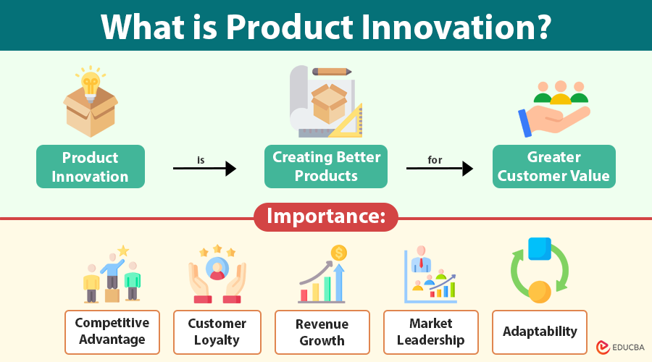
Figure 2: Product Innovation
Source: (Geissdoerfer et al., 2023)
This is evident in Sainsbury by its changing Meal Deal. Abrardi, Cambini and Rondi (2022) state that the introduction of new sandwich flavours and vegan and low-calorie as well as the rotation of the new flavours and introduction of high-quality lines called Taste the Difference, shows how innovation maintains the freshness in consumer experience. These changes are viewed by customers as evidence that the brand is listening to their needs. The perceived-value construct states that consumers do not just judge products based on price, but on the benefits that they attain, e.g. convenience, quality or satisfaction (Aramyan et al., 2021). The perceived value is high when Sainsbury’s combines variety and affordability. Innovation is therefore a marketing and strategic instrument which helps to improve customer experience.

3.3 Customer Relationship and Loyalty
According to Khaled et al. (2020) customer loyalty is built out of the recurring pleasant experiences which create emotional and behavioural bonds. Literature studies have shown that innovation enhances loyalty by renewing customer interest and avoiding brand boredom. Even small innovations can re-energise the customers in competitive markets. This process has been explained by Oliver (1999) with the help of a framework of loyalty that consists of four stages: cognitive, affective, conative, and action loyalty (Geissdoerfer et al., 2023).
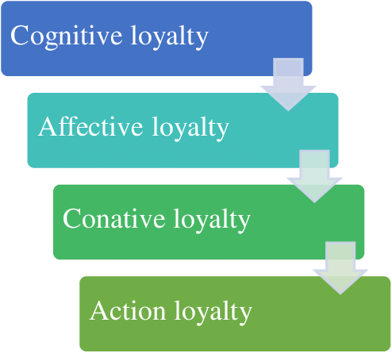
Figure 3: Oliver’s Loyalty Framework
Source: (Geissdoerfer et al., 2023)
To begin with, customers learn of the product advantage (cognitive). When innovation meets expectations, emotional attachment takes place (affective). Commitment (conative) is then motivated through continued satisfaction, leading to habitual repurchase (action). Sainsbury’s uses innovation in order to take customers through this path (Upadhyay, Kumar and Akter, 2022). Indicatively, when consumers see more healthy or seasonal Meal Deals, they feel that their inclinations are being addressed. This contentment leads to repeat buying and reinforcement of brand advocacy. As such, innovation is a long-term relationship process and not a single attraction.

3.4 Consumer Behaviour Theories in Innovation
The behavioural theories require the analysis of consumer behaviour in relation to innovation. The Diffusion of Innovation Theory of Rogers (1962) provides a framework for the dissemination of new ideas via groups, in which innovators, early adopters, early majority, late majority and laggards respond in varying ways to change (Roe et al., 2022).
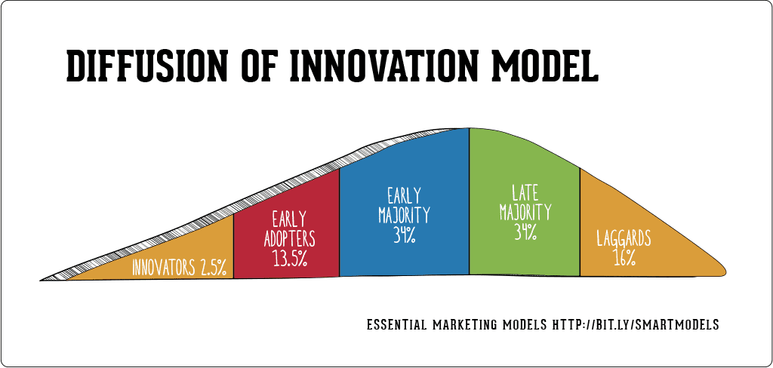
Figure 4: Rogers’ Diffusion of Innovation Theory
Source: (Roe et al., 2022)
The early adopters in a supermarket setting are usually young health health-conscious, and digitally active shoppers. Kwangsawad and Jattamart (2022) found that they rapidly experiment with new products or technologies, including loyalty apps or plant-based lines, and the experiences that they have can affect the rest of the customer base. The advantage is that retailers such as Sainsbury’s can tell who the adopters are and use their feedback to improve their offerings. According to the behavioural theories, risk perception influences adoption; in case an innovation is not perceived as necessary or certain, customers reject it (Iyelolu et al., 2024). As a result, the retailers need to convey the advantages of products of the new products. Good marketing reduces the state of doubts and helps in acceptance.

3.5 Literature Gaps
Though innovation in the retail industry has been widely researched academically, the literature on empirical studies related to the UK supermarket industry is scant. Studies like Šálková, Hes and Kučera (2023) focus on manufacturing or technology sectors instead of fast-moving consumer goods. The studies on the impacts of particular factors on consumer perception in the supermarkets are still young in the field of product innovation (ERU, TOPUZ and COP, 2022). Not much research has been done on real-life cases like Sainsbury’s Meal Deal that combines price strategy, product rotation and brand message. Such a research gap is one of the reasons why this particular study is necessary to explore the impact of innovation on consumer perception and behaviour within a real-life retail context.

3.6 Theoretical Framework: Relationship Marketing Theory
This study has been given the theoretical framework by the Relationship Marketing Theory (Gronroos, 1994). The theory focuses on the building and maintenance of long-lasting relationships based on trust, satisfaction, and mutually valued relationships. It is a conceptualisation of marketing not simply as a trans-acting but as a collaboration between consumer and business overall (Aramyan et al., 2021). In this study, innovation is considered a type of relationship maintenance. The constant availability of new and applicable goods is an indicator of the attentiveness and reliability of Sainsbury. This is interpreted by the consumers as a sign that the brand takes the preferences of the consumer seriously. The result is more profound loyalty and a positive emotional attachment. This research can be carried out using the Relationship Marketing Theory, as it has a direct relationship with innovation and customer retention (Woods, Doherty and Stephens, 2021). It not only explains what the consumers like but also why they continue to stick with the same retailer. In cases where the innovation builds trust, it maintains long-term loyalty and strengthens the brand relationship in general.

Chapter 4: Research Limitations
This empirical study has limitations like any other. Only fifty participants were sampled, limiting extrapolation beyond the London metropolitan area. Additionally, Sainsbury customers in London may not reflect UK customer attitudes (Ploll et al., 2022). Structured online questionnaires limit the qualitative information that semi-structured interviews could have yielded. Self-reported honesty and self-perception may be biased or inaccurate. Time constraints from the research timetable hampered follow-up analyses.

Chapter 5: Research Ethics
This research is in total compliance with the ethical standards that were issued by CIU Business School. All participants will be shown a detailed informed-consent statement outlining the nature of participation, procedures, and the risk of being included in the research at the start of the Google Forms questionnaire. It will focus on voluntary participation, whereby the respondent is free to drop out without any punishment (Babu et al., 2024). No personally identifiable data would be gathered, and anonymity would be guaranteed. All the information will be kept safely in the encrypted Google infrastructure, and only the principal investigator will be able to access it. The information will only be used for academic purposes and will be destroyed at the end of the project, hence protecting confidentiality and adhering to the rights of the participants.

Chapter 6: Timeline
Milestones | W1 | W2 | W3 | W4 | W5 | W6 | W7 | W8 | W9 | W10 | W11 | W12
Introduction | ■ | ■
Literature Review |  | ■ | ■ | ■
Methodology |  |  | ■ | ■ | ■
Data Collection |  |  |  |  | ■ | ■ | ■
Data Analysis |  |  |  |  |  |  | ■ | ■ | ■
Report Writing |  |  |  |  |  |  |  |  | ■ | ■
Completion |  |  |  |  |  |  |  |  |  |  | ■ | ■
(■ = Active Weeks)

Chapter 7: Conclusion
Innovation is very crucial in the way consumers view and relate to a brand. The customer of today requires freshness, variety, and change of retailers. Sainsbury mirrors the same by its dynamic Meal Deal and tailored loyalty schemes, which reinforce trust and worth (Aramyan et al., 2021). The survey of Google Forms in this research will be used to find out the impact of such innovations on the emotions, satisfaction, and loyalty of customers. It will also determine the areas where the product range, pricing, or health focus generates the most responses. The findings will inform Sainsbury in narrowing its strategies towards enhancing brand loyalty and customer engagement.

Reference
Abrardi, L., Cambini, C. and Rondi, L. (2022) ‘Artificial intelligence, firms and consumer behavior: A survey’, Journal of Economic Surveys, 36(4), pp. 969–991. Available at: https://doi.org/10.1111/joes.12455.
Aramyan, L. et al. (2021) ‘Food waste reduction in supply chains through innovations: a review’, Measuring Business Excellence, 25(4). Available at: https://doi.org/10.1108/mbe-11-2019-0105.
Babu, M.M. et al. (2024) ‘Exploring big data-driven innovation in the manufacturing sector: evidence from UK firms’, Annals of Operations Research, 333. Available at: https://doi.org/10.1007/s10479-021-04077-1.
ERU, O., TOPUZ, Y.V. and COP, R. (2022) ‘The Effect of Augmented Reality Experience on Loyalty and Purchasing Intent: An Application on the Retail Sector’, Sosyoekonomi, 30(52), pp. 129–155. Available at: https://doi.org/10.17233/sosyoekonomi.2022.02.08.
Geissdoerfer, M. et al. (2023) ‘Drivers and barriers for circular business model innovation’, Business Strategy and the Environment, 32(6). Available at: https://doi.org/10.1002/bse.3339.
Hartfield, T.R. (2024) ‘Overcoming Data Barriers: Strategies for New Entrants to Achieve Differentiation in the UK Food Retail Market’, Journal of World Economy, 3(3), pp. 68–83. Available at: https://www.pioneerpublisher.com/jwe/article/view/992.
Iyelolu, V. et al. (2024) ‘Driving SME Innovation with AI solutions: Overcoming Adoption Barriers and Future Growth Opportunities’, International Journal of Science and Technology Research Archive, 7(1), pp. 036–054. Available at: https://doi.org/10.53771/ijstra.2024.7.1.0055.
Jiang, K., Qin, M. and Li, S. (2022) ‘Chatbots in retail: How do they affect the continued use and purchase intentions of Chinese consumers?’, Journal of Consumer Behaviour, 21(4). Available at: https://doi.org/10.1002/cb.2034.
Khaled, A.S. et al. (2020) ‘The role of innovation on Indian retail industry’, International Journal of Business Innovation and Research, 23(4), p. 435. Available at: https://doi.org/10.1504/ijbir.2020.111793.
Kwangsawad, A. and Jattamart, A. (2022) ‘Overcoming customer innovation resistance to the sustainable adoption of chatbot services: A community-enterprise perspective in Thailand’, Journal of Innovation & Knowledge, 7(3), p. 100211. Available at: https://doi.org/10.1016/j.jik.2022.100211.
Omowole, B.M. et al. (2024) ‘Barriers and drivers of digital transformation in SMEs: A conceptual analysis’, International Journal of Scholarly Research in Science and Technology, 5(2), pp. 019–036. Available at: https://doi.org/10.56781/ijsrst.2024.5.2.0037.
Ploll, U. et al. (2022) ‘Sustainable Innovations: A Qualitative Study on Farmers’ Perceptions Driving the Diffusion of Beneficial Soil Microbes in Germany and the UK’, Sustainability, 14(10), p. 5749. Available at: https://doi.org/10.3390/su14105749.
Purcărea, T. et al. (2022) ‘Major Shifts in Sustainable Consumer Behavior in Romania and Retailers’ Priorities in Agilely Adapting to It’, Sustainability, 14(3), p. 1627. Available at: https://doi.org/10.3390/su14031627.
Roe, M. et al. (2022) ‘Drivers and challenges of internet of things diffusion in smart stores: A field exploration’, Technological Forecasting and Social Change, 178, p. 121593. Available at: https://doi.org/10.1016/j.techfore.2022.121593.
Šálková, D., Hes, A. and Kučera, P. (2023) ‘Sustainable Consumer Behavior: The Driving Force of Innovation in Retail’, Sustainability, 15(24), p. 16648. Available at: https://doi.org/10.3390/su152416648.
Upadhyay, A., Kumar, A. and Akter, S. (2022) ‘An analysis of UK retailers’ initiatives towards circular economy transition and policy-driven directions’, Clean Technologies and Environmental Policy, 24(1). Available at: https://doi.org/10.1007/s10098-020-02004-9.
Woods, R., Doherty, O. and Stephens, S. (2021) ‘Technology Driven Change in the Retail sector: Implications for Higher Education’, Industry and Higher Education, 36(2), p. 095042222110091. Available at: https://doi.org/10.1177/09504222211009180.

