

Module Name: Managing Enterprise
Module Code: BMSW4011
Assignment Name: Business Plan and Reflection
Student Name: Cristina Limbau
Student Number: 2410885
Lecturer: Melanie Squire
Deadline: Friday, 4th July 2025, 23.59

AI Acknowledgement
I confirm that I have not presented any AI generated materials as my own work.
I confirm that I have copies of my drafts, notes, and other resources I used, which I may be asked to provide in evidence.

Contents
CL Nails and Beauty – Business Plan 4
1. Company Concept and Origins of the Idea 4
2. Legal Structure of the Business 4
3. Mission Statement 5
4. USP 5
4. Aims and SMART Objectives 5
Aim 5
SMART Objectives: 5
5. Marketing and PR Plan 6
6. 7 Ps of Marketing 7
7. Physical Location 8
8. Human Resource Strategy 9
Organisation Structure: 9
9. Market Research 9
Primary Research: 9
Secondary Research: 10
10. Financial Resources 10
11. Cash Flow 11
Cash Flow Tool 11
11. SWOT Analysis 11
Strengths: 12
Weaknesses: 12
Opportunities: 12
Threats: 12
Key Weakness: 12
Action Plan: 12
Individual Reflection 13
1. New Business Skills and Knowledge Gained 13
2. Entrepreneurial Trait to Develop 13
3. Investment Decision as an Angel Investor 14
Reference List 15

CL Nails and Beauty – Business Plan

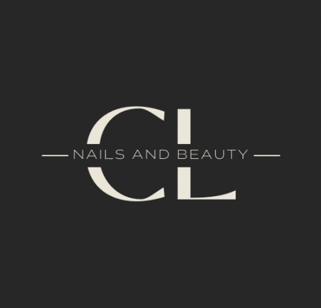

1. Company Concept and Origins of the Idea
CL Nails and Beauty is a premium beauty salon specialising in high-quality nail services, expertly sculpted brows, eyelash extensions, and advanced hair removal techniques. The concept was developed to address a market need for a luxurious, inclusive space that delivers expert treatments with precision and care. The idea originated from a long-standing passion for beauty and a vision of creating a professional and welcoming beauty oasis where clients feel empowered through self-care (Finch, 2022; Kotler and Keller, 2016).

2. Legal Structure of the Business
CL Nails and Beauty will operate as a Limited Company (Ltd). This structure provides a clear legal distinction between the business and its owner, offering limited liability, improved credibility, and enhanced access to funding (Williams, 2022). Although it involves higher administrative duties and associated costs, the structure supports future scalability and investor confidence (Barringer and Ireland, 2022; Finch, 2022).

3. Mission Statement

CL Nails and Beauty – Where beauty meets precision. Empowering self-expression through luxurious beauty treatments.
4. USP
CL Nails and Beauty offers a luxury beauty experience that combines expertly trained technicians, premium products, and personalised service in a serene, modern environment. Unlike high-street salons focused on volume, CL Nails and Beauty prioritises quality, comfort, and client relationships—ensuring every visit feels exclusive, professional, and tailored to individual style and wellness needs.

4. Aims and SMART Objectives
Aim: To become the leading beauty salon in the local area within the first 12 months of operation, known for exceptional service quality and client satisfaction (Barrow et al., 2021).

SMART Objectives:
- Achieve 800 returning clients by the end of the first year.
- Recruit two qualified beauty therapists within the first month (Armstrong et al., 2023).
- Grow the business’s social media following to at least 5,000 by month 6, with consistent posting four times per week.
- Reach £12,000 in monthly revenue by month 12.
- Launch three branded signature treatments within two months, generating 25% of monthly income by year-end (Soltanifar et al., 2021).

5. Marketing and PR Plan
The primary target market comprises women aged 18–40. Younger consumers are trend-conscious and highly active on social media platforms such as Instagram and TikTok, whereas mature clients value classic aesthetics, high service standards, and exhibit strong brand loyalty (Kim and Kim, 2021; Shi, 2023).

Marketing strategies will include:
- Launch promotions offering discounted signature treatments.
- Printed materials such as business cards and loyalty schemes.
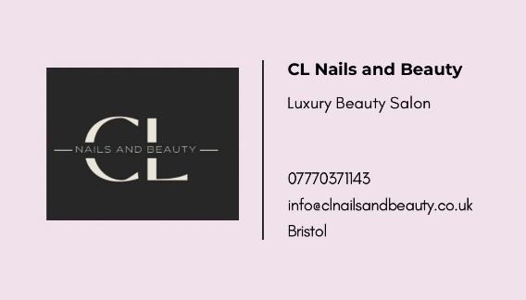
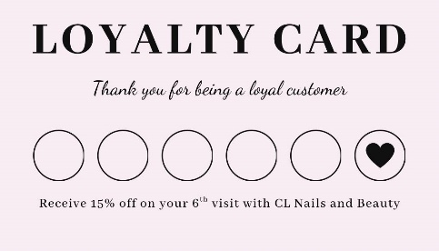
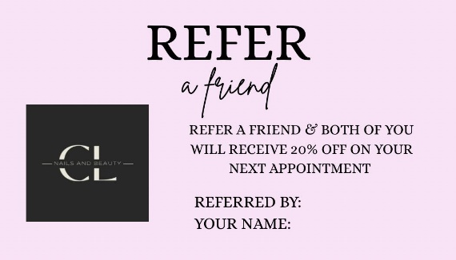
- A robust social media strategy, including influencer partnerships.
- A professional Facebook launch post.
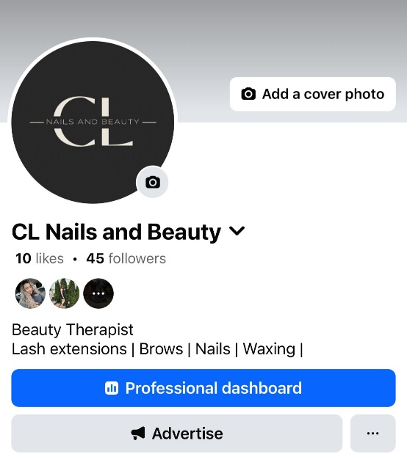
- Paid digital advertisements targeted at local users.

According to a customer survey, new clients are more likely to find out about new beauty salons through social media and recommendations, which will help the business in their marketing strategy.

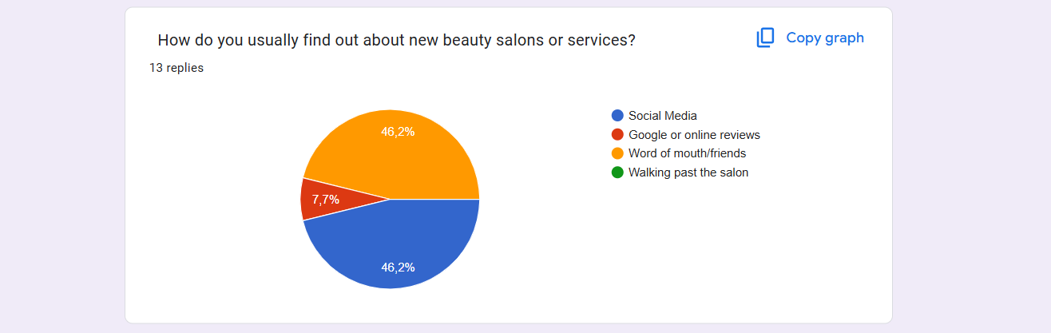
The strategy follows a differentiation model, emphasising bespoke client experience and high-quality branding (Hooley et al., 2020; Whittington et al., 2023; Kotler and Keller, 2016).

6. 7 Ps of Marketing
- Product: Luxury beauty treatments
- Price: Affordable pricing aligned with quality and positioning.
- Place: Strategically located high-street unit with strong footfall in Bristol (Armstrong et al., 2023).
- Promotion: A mix of digital marketing, influencer collaborations, and printed media.
- People: Qualified, professional therapists delivering exceptional service.
- Process: Efficient online booking and consultation system.
- Physical Evidence: High-end salon design, branded uniforms, visible credentials (Barrow et al., 2021).

7. Physical Location
The business will operate in a high-traffic commercial zone in Bristol, Gloucester Road with convenient parking and visibility from main roads. The selected area is populated with complementary businesses, supporting walk-in opportunities. Location analysis confirms high demand for beauty services in the area (Barrow et al., 2021; Burns, 2016).

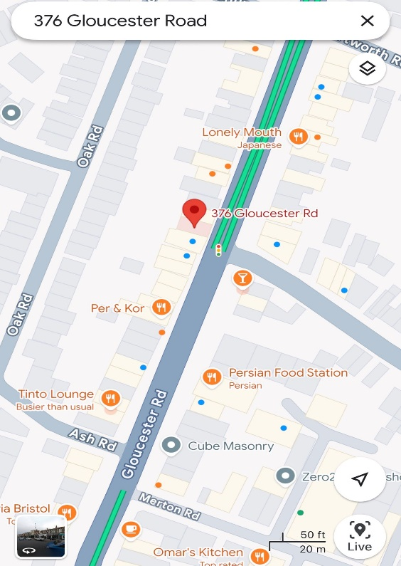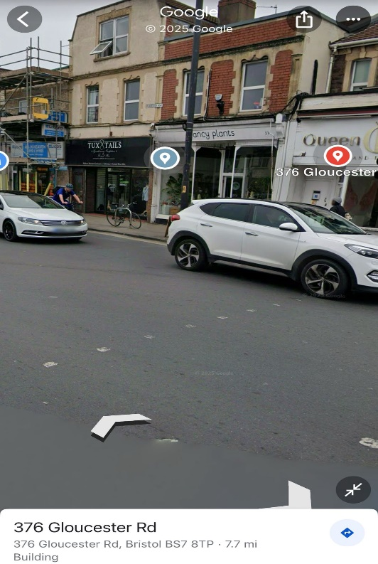

8. Human Resource Strategy
The salon will employ two full-time beauty therapists. These individuals will also manage cleaning tasks and client bookings. The founder will oversee management, perform treatments, handle inventory, customer service, and financial records. Recruitment will be conducted via professional job boards and beauty schools (Finch, 2022).

Organisation Structure:
- Salon Manager: Oversees operations, finances, and branding.
- Beauty Therapist 1: Specialises in nails, lash extensions, customer service.
- Beauty Therapist 2: Specialises in brows, waxing, salon maintenance.

9. Market Research
Primary Research: An online survey revealed that clients prioritise practitioner skill, product quality, and customer service when choosing a beauty salon. These findings highlight the need for expertise, safe and effective products, and a welcoming client experience. CL Nails and Beauty will focus on these areas by investing in staff training, using premium products, and delivering excellent customer service through dedicated training. This strategic focus aims to build trust, encourage repeat business, and generate positive word-of-mouth, positioning the salon for long-term success and strong market presence.
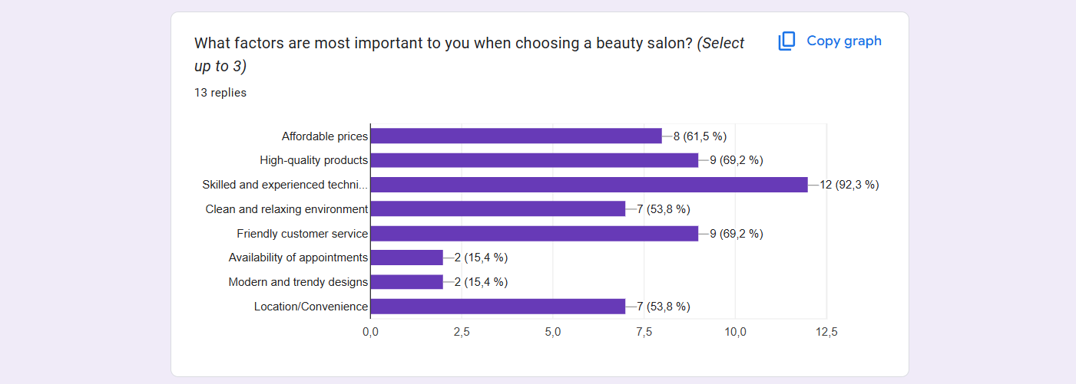
Secondary Research: Industry reports highlight a strong post-pandemic recovery in the beauty sector, particularly among Generation Z and Millennials. Social media continues to drive beauty trends (Jovanka and Putri, 2024; Shi, 2023).
This research guided the decision to focus on premium aesthetics, customer service, and social media engagement (Williams, 2022; Jones et al., 2022).

10. Financial Resources
The business will require an initial capital of £20,000, comprising £10,000 in personal savings and a £10,000 bank loan (Whittington et al., 2023).
Startup Costs Include:
- Salon refurbishment and equipment: £5,000
- Initial stock: £2,000
- Branding and marketing: £200
- Rent deposit and legal fees: £4,000
- Initial wages: £4,500
- Contingency fund: £4,500
The business is projected to reach a steady increase in revenue aligned with brand visibility (Barringer and Ireland, 2022).

11. Cash Flow

Cash Flow Tool
The cash flow forecast outlines CL Nails and Beauty’s expected financial path, emphasising the need for strong budgeting and liquidity control. It shows steady revenue growth as the client base expands. This tool aids in identifying high and low-income periods, supporting smart financial decisions and effective capital management. Forecasting also reassures stakeholders like investors and banks by offering clear financial projections. By anticipating income and expenses, the business can stay adaptable and resilient in a competitive market, ensuring stability and readiness to reinvest as needed.

11. SWOT Analysis
A robust SWOT analysis enables businesses to align internal capabilities with external market dynamics, forming the foundation for strategic decision-making and sustainable growth (Ramadhan, Wijayantini & Gunawan, 2024).

Strengths:
- High-quality services
- Premium brand identity

Weaknesses:
- Limited brand identity awareness
- No client base at launch

Opportunities:
- Social media beauty-driven trends
- Strategic location and walk-in potential

Threats:
- Economic fluctuations
- Local market competition
Key Weakness: The salon’s main weakness is low initial brand awareness and no existing client base, making early growth challenging. To address this, CL Nails and Beauty will use targeted marketing, including influencer partnerships, referrals, loyalty schemes, and engaging social media. Budget constraints will be managed through organic content, word-of-mouth, and selective paid ads (Dyson and Franklin, 2020).

Action Plan:
- Initiate partnerships with local influencers.
- Introduce client referral programs.
- Deploy paid online marketing campaigns.
- Implement a loyalty rewards system to retain clients (Armstrong et al., 2023).

Individual Reflection

1. New Business Skills and Knowledge Gained
Throughout the process of developing my business plan for CL Nails and Beauty, I have gained a wide range of new business skills and knowledge. One of the most valuable areas of learning for me has been financial planning. Creating a 12-month cash flow forecast helped me understand how to estimate income, track expenses, and manage cash effectively. I now recognise how important financial forecasting is to the sustainability of a new business, especially in the early stages.
I also developed a stronger understanding of marketing strategies. Using models like the 7 Ps of Marketing and SWOT analysis allowed me to analyse my business from different perspectives and consider how to position it in a competitive market. Conducting market research gave me insight into customer needs and behaviour, and I learned how to use this information to shape my services and marketing approach. Writing the business plan also improved my ability to communicate business ideas clearly and professionally.

2. Entrepreneurial Trait to Develop
One entrepreneurial trait I’ve realised I need to develop is confidence in taking risks. I tend to be quite cautious when making decisions, especially when there's uncertainty involved. While this has helped me stay organised and avoid unnecessary mistakes, I now understand that being overly cautious can sometimes hold me back from seizing new opportunities.
To improve this, I plan to challenge myself by stepping outside of my comfort zone more often. I aim to attend business networking events and connect with other entrepreneurs to gain inspiration and advice. I also want to try small, low-risk initiatives within my business to build experience and gradually grow more confident in making bold decisions. I believe that by learning from both successes and setbacks, I can strengthen this trait over time.

3. Investment Decision as an Angel Investor
If I were an angel investor looking at my own business plan, I would approach the opportunity with both interest and caution. On one hand, I believe the concept behind CL Nails and Beauty is strong. It targets a clear market need, offers high-quality services, and is backed by a well-structured plan. The brand identity is clear, and there is a real passion driving the business forward, which I think would be attractive to investors.
On the other hand, I would also recognise the risks. The business is new, with no existing customer base or track record. The marketing budget is quite limited, which could slow down growth in the beginning. However, knowing how committed I am to this business and how willing I am to learn and adapt, I would still consider investing. With the right support and strategic planning, I truly believe the business has the potential to grow and succeed.

Reference List
- Armstrong, G., Kotler, P. and Opresnik, M. O. (2023) Marketing: An Introduction. 15th edn. Harlow: Pearson.
- Barrow, C., Barrow, P. and Brown, R. (2021) The Business Plan Workbook. 10th edn. London: Kogan Page.
- Barringer, B. R. and Ireland, R. D. (2022) Entrepreneurship: Successfully Launching New Ventures. 6th edn. Harlow: Pearson.
- Burns, P. (2016) Entrepreneurship and Small Business. 4th edn. London: Macmillan International.
- Deakins, D. and Freel, M. (2012) Entrepreneurship and Small Firms. 6th edn. London: McGraw-Hill Education.
- Dyson, J. R. and Franklin, E. (2020) Accounting for Non-Accounting Students. 10th edn. Harlow: Pearson.
- Finch, B. (2022) How to Write a Business Plan. 7th edn. London: Kogan Page.
- Hooley, G. J. et al. (2020) Marketing Strategy and Competitive Positioning. 7th edn. Harlow: Pearson.
- Jovanka, A. and Putri, K.Y.S. (2024) ‘Analysis of Generation Z's Consumer Behaviour’, International Journal of Finance, Insurance and Risk Management, 14(3), pp. 96–104.
- Jones, P., Hillier, D. and Comfort, D. (2022) ‘The beauty industry and sustainability’, International Journal of Sales, Retailing and Marketing, 11(3), pp. 15–22.
- Kim, J. and Kim, H. (2021) ‘Changes in purchasing patterns’, Journal of Cosmetic Science, 72(3), pp. 211–220.
- Kotler, P. and Keller, K. L. (2016) Marketing Management. 15th edn. Harlow: Pearson.
- Ramadhan, R., Wijayantini, B. and Gunawan, Y. (2024) ‘SWOT Analysis in Determining Marketing Strategy’, Academic Journal of Digital Economics and Stability, 38(1), pp. 129–138. doi: 10.51699/economics.v38i1.253.
- Shi, R. (2023) ‘The Influence of Marketing Strategy on Consumer Behavior in the Cosmetics Industry’, Highlights in Business, Economics and Management, 23, pp. 623–629.
- Soltanifar, M., Hughes, M. and Göcke, L. (2021) Digital Entrepreneurship. Cham: Springer.
- Whittington, R. et al. (2023) Exploring Strategy: Text and Cases. 13th edn. Harlow: Pearson.
- Williams, S. (2022) The Financial Times Guide to Business Start-Up 2021/2023. 32nd edn. Harlow: Pearson.

