AC 1.1
EBP is the “conscientious, explicit and judicious” use of the best available evidence (Briner, 2024), assessing its relevance, validity and reliability. For Technivara, which operates in a rapidly-changing industry, EBP ensures decisions are grounded in sound data.
With so many contradictory views on effective workplaces (CIPD, 2025), we often rely on heuristics like conformity or authority bias (Barends and Rousseau, 2018, p.65). An evidence-based approach applies “healthy scepticism” (Briner, 2020), helping avoid bias and resist quick fixes, anecdotes, and gut feelings that may be shaping Technivara’s traditional processes. Such fads encourage “solutioneering” (Briner, 2020) where professionals push appealing ideas, cherry-picking evidence to fit the case. EBP counters this by defining the problem first, helping organisations focus on what really matters and increasing the likelihood of positive outcomes.
EBP goes beyond people analytics, combining organisational data, practitioner expertise, scientific research, and stakeholder perspectives, giving each form of evidence equal weight (Briner, 2024). This triangulation helps to cross-check facts and add context. CIPD’s six-step approach involves diagnosing the problem; acquiring and appraising evidence; identifying patterns; applying findings; and assessing outcomes (CIPD, 2025b). This reduces the risk of poor decisions and provides a clear rationale. Ultimately, this strengthens HR’s credibility (Briner, 2024), boosting their influence in the workplace.
However, EBP demands effort, including training in research skills and critical thinking. Since evidence-based HR is still in its infancy, many studies remain inaccessible and overly complex for non-academic audiences (Barends et al., 2017). EBP can clash with cultures that reward speed of action over quality, and in HiPPO-driven organisations, where authority outweighs other evidence (Briner, 2020), practitioners may need to challenge entrenched views, particularly as Technivara was established many decades ago. EBP depends on high-quality (Marson, 2022), accessible data and practitioners’ ability to understand and apply scientific research (Barends et al., 2017). Without this, implementation is hindered.
At Technivara, EBP can help tackle a lack of diversity. Workforce data (e.g. demographics, retention figures, surveys) can reveal causes and consequences of the lack of diversity, such as reduced innovation. HR expertise on effective solutions, external evidence (e.g. benchmarking and peer-reviewed articles), and stakeholder input (e.g. from employees, clients, general public) can provide information about how decisions will be received (Barends and Rousseau, 2018, pp.9-10). Once this evidence is evaluated and biases identified, findings can inform targeted interventions, such as training. A feedback loop (Armstrong, 2023, p.110) can then track impact and inform adjustments.
EBP can help address repeated employee lateness by combining insights from experienced people managers, affected staff, and unions, with attendance data, productivity metrics, and academic research on absenteeism. Evidence should be critically appraised for relevance, reliability and validity before identifying trends and determining the most effective actions, such as a policy revision. Continuous evaluation ensures resources are not wasted on ineffective initiatives (Waite et al., 2021, p.48).
Overall, while EBP requires resources and an organisational culture that supports research, it lowers the risk of costly poor judgements. It empowers professionals to minimise unconscious bias and its negative business effects, and justifies HR’s position in an organisation.

AC 1.2
Technivara might undertake a SWOT analysis, which involves brainstorming the Strengths, Weaknesses, Opportunities and Threats of the organisation or a specific project. In the context of expansion, it can pinpoint where investment would have the greatest impact, e.g. technology, estates or people. Information gathering is only the first step; findings require analysis, such as assessing the likelihood of threats, and should be aligned with Technivara’s values to guide strategic priorities. SWOT can mitigate risks and identify opportunities to drive business health e.g. emerging AI tools (CIPD, 2025a), while encouraging strategic thinking, a core business skill.
Compared to PESTLE, SWOT considers both internal and external factors, arguably making it more comprehensive. Yet, Chermack and Kasshanna (2007) argue it is too rigid and simplistic, especially in such fast-paced, volatile industries like Technivara’s. It offers only a current snapshot and must be repeated regularly. CIPD argues that an effective SWOT analysis requires time and collaboration (CIPD, 2025a), however it relies on the skills of managers undertaking it, who may make incorrect assumptions, omissions, and dominant voices may influence the factors (Chermack and Kasshanna, 2007, p.392), leading to biased results. People professionals should therefore challenge managers where necessary and ensure a balance between gathering insufficient and excessive data to avoid “paralysis by analysis” (CIPD 2025a).
Overall, SWOT can be an effective starting point to guide Technivara’s strategic direction, but decisions should not be based on this alone.
Technivara can hold focus groups to collect more in-depth primary data through open discussions and an observation of nonverbal cues. This method allows exploration of issues and attitudes, such as gauging Technivara’s readiness for digital transformation. They can uncover pain points in the current paper-based system, benefits and drawbacks of digitisation, barriers like skills gaps, and concerns arounds ethics/data security (Marchington et al., 2021, p.463). These qualitative insights can guide the rollout of digital systems, but may need to be combined with quantitative methods like surveys.
Focus groups are time-consuming and resource-intensive, requiring recording and transcription (Bell, Bryman and Harley, 2022, p.468), and results may be subjective (Horn, 2009, p.390). Dominant personalities can lead to groupthink and suppress diverse views, and participant numbers are limited compared with surveys. Groups should therefore be representative, and skilled facilitators must balance guidance/prompts with free discussion (Bel, Bryman and Harley, 2022, p.458).
Focus groups champion employee voice and can encourage buy-in during change (CIPD, 2024a), but the lack of anonymity combined with Technivara’s traditional climate may lead to participants providing socially desirable responses, diminishing the reliability of the data (Marchington et al., 2021, p.462). Using an external facilitator can help address this. Importantly, focus groups should not be superficial exercises creating the “illusion of consultation”, while decisions have already been made (Bell, Bryman and Harley, 2022, p.456). This could damage trust and create disengagement.
Overall, focus groups enable open discussion amongst stakeholders, capturing valuable perspectives, but due to challenges with group dynamics, they require careful facilitation and should be complemented by other methods.

AC 1.3
Critical thinking is the practice of analysing information objectively, assessing the reliability, validity and relevance to reach informed conclusions (Waite et al., 2021, p.51). In Technivara’s fast-paced, competitive industry, applying these principles ensures debate is evidence-based, rational and productive.
Rather than accepting ideas at face value, critical thinking involves comparing evidence for triangulation, evaluating arguments for consistency, and testing them rigorously to reduce the risk of misinformed decisions, such as during strategy discussions or project planning (Waite et al., 2021, p.46).
Humans often rely on quick, instinctive “system 1” thinking which is prone to bias and reinforces existing beliefs (Barends and Rousseau, 2018, p.66). While useful for everyday decisions, it can mislead in complex situations. Critical or “system 2” thinking must be applied to counter emotions, cultural scripts and personal agendas (Chatfield, 2022a, p.250). Underpinning contributions with evidence also increase credibility when making HR proposals, such as for new processes or features.
Knowing when to distrust intuition and having the self-awareness to recognise internal bias is key (Chatfield, 2022b). Asking questions such as “how was the conclusion reached?” (Open University, 2024) helps ensure rational contributions. It is important to set aside personal feelings to establish facts. Communication should also be clear and accessible to all colleagues, avoiding unnecessary terminology that obscures understanding (Chatfield, 2022a, p.192).
Inviting feedback and actively seeking evidence that challenges existing views supports balanced, fair debate (Barends and Rousseau, 2018, p.69). A collaborative, inclusive culture where critique is safe allows ideas to be tested against diverse perspectives, including objective “outsiders” (McRaney, 2011, p.58). Practitioners should remain open to adapting their views as evidence evolves (Chatfield, 2022c), reducing the risk of groupthink.
Equally, others’ ideas should be assessed by seeking evidence and clarifying arguments. Breaking down arguments into the premises and conclusions helps to spot the assumptions, which can then be challenged constructively (Chatfield, 2022a, p.51). For example, if a manager at Technivara argues for adopting a recruitment technology because a competitor uses it, the assumptions include: what works for the competitor will work for Technivara, that the competitor was well-informed/researched, and that their success stems from the technology. Applying the principle of “charity” (that all arguments deserve to be stated in their strongest form), allows respectful challenge and debate (Chatfield, 2022a, p.58).
Overall, applying critical thinking at Technivara ensures ideas are clear, logical, and evidence-based. It encourages richer debate and can lead to innovative, well-reasoned and appropriate workplace solutions.

AC 1.4
Technivara can apply structured decision-making techniques to avoid “kneejerk reactions” (Armstrong, 2023, p.589) and increase the likelihood of success.
Future Pacing (FP) is a technique in which participants are guided to mentally rehearse future scenarios before making decisions, engaging the “Depth Mind” (Adair, 2022, p.17) rather than being overwhelmed by excess information. This approach can help evaluate the potential impact of decisions on an organisation.
For example, FP can help decide whether to invest in an AI tool. Key stakeholders might visualise the organisation 18 months after implementation and compare it to a scenario where a competitor adopted the tool but they did not. Prompts could include: What results are we seeing? What are stakeholders saying? What talent/skills are required? Following this exercise, group discussions and evidence-gathering can assess likely outcomes and anticipate obstacles (Scoblic, 2020). Insights from FP can then inform scenario-planning and risk assessments.
FP provides managers with perspective, helping them determine how much effort/resources to commit to decisions, ensuring they are proportionate to potential consequences (Adair, 2022, p.54). Research indicates that such proactive, forward-thinking leadership is linked to improved organisational performance (Kiss et al., 2022). By emphasising long-term impact over immediate rewards, FP discourages reactive decision-making and delay discounting (Johnson et al., 2020), while promoting creativity (Lyu et al., 2022) and alignment with organisational goals.
Technivara could apply rational decision-making, evaluating options using logic, reason, and facts to reach well-informed conclusions (Uzonwanne, 2016). Adair’s (2022) five-step process can guide decisions on topics like attrition and business expansion. The steps are: (1) define the objective, (2) collect and analyse relevant information, (3) generate feasible options within resource constraints, (4) make the decision using the “lobster pot model” (prioritising criteria as “must”, “should”, or “might”), and (5) implement and evaluate to ensure sustainability (Adair, 2022, p.28).
Unlike intuitive decision-making which risks overlooking key factors (Lamb, 2019), this structured approach ensures decisions are evidence-based, transparent and justifiable, increasing organisational accountability (Waite et al., 2021, p.115), particularly when financial or people-related stakes are high.
Step 4 involves systematically eliminating weaker options through analysis of advantages, disadvantages, risks and gains, compared against the original objective in Step 1 (Adair, 2022, p.29). For example, in tackling high turnover, options like flexible working or leadership training could be evaluated and ranked according to organisational priorities (such as cost-effectiveness), leaving the solution that best meets the criteria. When scaling the business, options might include automation or expanding into new markets. This process reduces “satisficing” (settling for the first acceptable solution rather than the optimal one) (Becker, 2021), which is particularly relevant in Technivara’s fast-paced environment where pressure to act quickly is high.
Ultimately, rational decision-making ensures decisions are well informed, while FP reduces short-term bias and promotes mindful decisions, particularly when underpinned by data.

AC 1.5
People practitioners should act as Technivara’s moral compass, protecting stakeholders and upholding organisational values (Waite et al., 2021, p.70), with utilitarianism supporting efficient outcomes and deontology ensuring fairness and consistency.
Utilitarianism argues that the right decision is the one that brings the greatest happiness to the greatest number (Smith and Mitchell, 2022, p.154). It supports wellbeing for its own sake (CIPD, 2015), but also assists critical organisational decisions by maximising overall outcomes. For example, if staff surveys show rising concerns about mental health, while data indicates only five percent use the benefit of subsidised public transport, a utilitarian approach would favour replacing it with an EAP. This benefits the most and uses resources efficiently. Utilitarianism aligns with evidence-based practice as data/metrics are often used to justify decisions. It supports “good work” (CIPD, 2023), since prioritising initiatives that serve the majority supports healthier employment practices.
However, wellbeing is difficult to measure in a single currency (Armstrong, 2023, p.48), and utilitarianism risks overlooking minority or vulnerable groups. A manager might deny flexible working requests from employees if they believe it would reduce overall team performance, for example. Whilst treating everyone equally, this ignores individual differences, as highlighted by equity theory (Smith and Mitchell, 2022, p.159). Utilitarianism can appear harsh, undermine psychological safety, and impact organisational culture, making it more competitive than collaborative. By sacrificing a few for the many, it may conflict with principles of fairness, social justice and respect (Armstrong, 2023, p.49).
In contrast, deontology argues that actions are right or wrong irrespective of consequences (Armstrong, 2023, p.48). This clear framework emphasises duty to rules and procedures set out in policies and contracts (Marchington et al., 2021, p.189). For example, consistently enforced pay scales or applying disciplinary policies equally regardless of seniority. It could also guide equal opportunities in recruitment through consistent scoring criteria (CIPD, 2015). By upholding individual rights over group interests, it supports fairness and transparency.
If Technivara needed to reduce costs, a deontological approach would prioritise their duty to fairness and dignity, for example through voluntary redundancies so no one is targeted unfairly, or retraining/redeployment. A utilitarian approach might favour immediate redundancies, accepting that some staff will be harmed in order to protect the jobs of the majority and overall business health.
Overall, there is no one correct framework (CIPD, 2015), so decision-makers at Technivara should apply sensitivity and ensure alignment with context and organisational values (Waite et al., 2021, p.70). A hybrid approach, using deontology to uphold rights and utilitarianism to ensure practices are far-reaching, offers a balanced way to navigate ethical dilemmas.

AC 3.1
Technivara should use both financial and nonfinancial measures to identify areas of improvement and opportunities for growth. Since people are likely Technivara’s biggest asset and expense (McCutcheon, 2014), people practitioners require financial and data literacy to drive integrated strategies (Armstrong, 2023, p.573).
A key financial measure is the income statement, which summarises revenue, expenses, and profit over a given period (Waite et al., 2021, p.59). Whilst a state school may focus primarily on the quality of service, for Technivara, a private-sector company, profitability is central. Income statements can provide transparency to stakeholders, allowing financial health and resource use to be tracked over time, highlighting any patterns which can inform strategic direction (Pradia, 2024, p.3). Categories such as costs of goods sold (COGS) and operating income reveal drivers of profit changes, like energy costs or overtime, helping to identify overspending (Stobierski, 2019). These insights can guide policy changes, client contract renegotiations, and benchmarking against competitors (Albrecht et al., 2016, p.126). Depreciation is particularly helpful to Technivara, helping to forecast equipment replacement. It can also guide investment decisions, indicating whether revenue could fund new technologies to assist with expansion (Stobierski, 2019). However, whilst it can estimate Technivara’s future trajectory, it is ultimately an historical statement and does not provide information such as cash flow. Furthermore, it relies on accurate data, often requiring external auditing to ensure reliability.
A useful nonfinancial measure is HR Key Performance Indicators (KPIs), such as turnover, absence rates, and time-to-hire, which link people practices to organisational goals (Hill, 2024). For example, training participation and effectiveness rates can indicate whether the workforce meets the skills required for expansion. Exit data alongside salary average KPIs may reveal pay disparities between newer and long-serving engineers, flagging disengagement or turnover risks before they impact finances (HiBob, 2025). KPIs can be monitored over time, compared amongst teams or departments, and benchmarked against industry peers.
However, some metrics that are central to Technivara, like creativity or innovation, are difficult to measure. Over-emphasis on numbers and targets can also encourage managers to manipulate data (e.g. under-reporting sickness), instead of addressing underlying issues. At Technivara, the limited HR capacity, siloed paper-based systems, and a lack of analytical skills may restrict data access and interpretation. A clear data strategy is therefore essential for KPIs to effectively measures performance (Cassidy, 2024).
Overall, the income statement provides insights into profitability and efficiency, but its retrospective nature limits forward planning. KPIs offer a more holistic view and can highlight risks to performance, but they rely heavily on sound data which may be a barrier in Technivara, a well-established organisation. Using both provides a more balanced and reliable assessment of performance.

AC 3.2
Value creation refers to how people professionals deliver positive organisational outcomes (Taylor and Woodhams, 2022, p.6). They play a multi-faceted role, contributing to Technivara’s strategic objectives, supporting managers, driving change, and ensuring professional, efficient administration (Ulrich, 1998, cited in Armstrong, 2023, p.93). This includes recruitment and selection, managing employee relations, learning and development, mechanisms for employee voice, championing inclusion, and providing insights on workforce issues (Armstrong, 2023, p.44). Being “outcomes-driven” is a key component of the CIPD Profession Map (CIPD, 2024), meaning impact should be measured to ensure benefits are realised for both the organisation and its people.
At Technivara where competition for engineers and technicians may be high (Flaig, 2025), people practitioners could design targeted recruitment strategies to meet critical skills needs (Armstrong, 2023, p.41). As human capital is a “critical asset” influencing organisational performance (Marchington et al., 2021, p.100), careful job design, robust selection, and fair processes are vital. The people function can strengthen Technivara’s brand and Employee Value Proposition (EVP), minimising turnover and ensuring competitive advantage over other electronic engineering firms (Armstrong, 2023, p.574). To evaluate effectiveness, Return on Investment (ROI) analysis can measure financial returns on initiatives such as a new digital onboarding system. By comparing investment costs (e.g. licenses, training, productivity loss) with measurable outcomes (e.g. reduced onboarding time, productivity gains), HR can demonstrate value using the ROI formula (Hill, 2024). This justifies spending and highlights HR’s dual role in managing daily processes and delivering long-term strategic impact.
People practices could also contribute by nurturing a climate of positive employee relations that drives high performance, creativity, and psychological safety. This may involve coaching managers, ensuring fair and inclusive policies, and embedding wellbeing and rewards that boost motivation/engagement (Cassidy, 2022a). For example, to help ease the intense project-driven environment at Technivara, a monthly paid “wellbeing hour” could be introduced to reduce burnout. Effectiveness could be evaluated through staff wellbeing surveys before and (3 and 6 months) after implementation. A combination of Likert-scale questions (exploring stress, engagement, and psychological safety) and open-text feedback, would provide quantitative and qualitative insights (Bell, Bryman and Harley, 2022, p.235). Comparing results with metrics such as sickness absence or first-year turnover allows triangulation, strengthening the business case for further resources and ensuring HR decisions remain data-driven and credible (Cassidy, 2022a).
Overall, people practices could add value at Technivara by aligning with organisational goals and enabling employee success. Measuring impact through ROI and evaluation surveys ensures contribution is visible and evidence-based, reinforcing HR’s role as both a strategic partner and champion of employee experience.

AC 2.1
Department | Leavers as a % against total in each Department | Vacancies as a % against total in each Department | Positions filled as a % of total in each Department
Audio Technical | 23% | 31% | 12%
Offices and Administration | 27% | 33% | 33%
Research and Development | 13% | 50% | 50%
Quality control | 50% | 75% | 75%
Dispatch | 27% | 40% | 40%
Engineering | 23% | 23% | 9%
Casting | 50% | 83% | 33%
Sales & Marketing | 33% | 25% | 25%
Human Resources | 25% | 25% | 25%
Design | 25% | 42% | 17%

To calculate the percentages, I used the formula: (Leavers or Vacancies or Positions Filled / Total in Each Department) x 100
Excel helped to validate the raw data, and formulas could be inserted into one cell and easily applied to the whole column, saving time compared to manual calculations.

AC 2.2
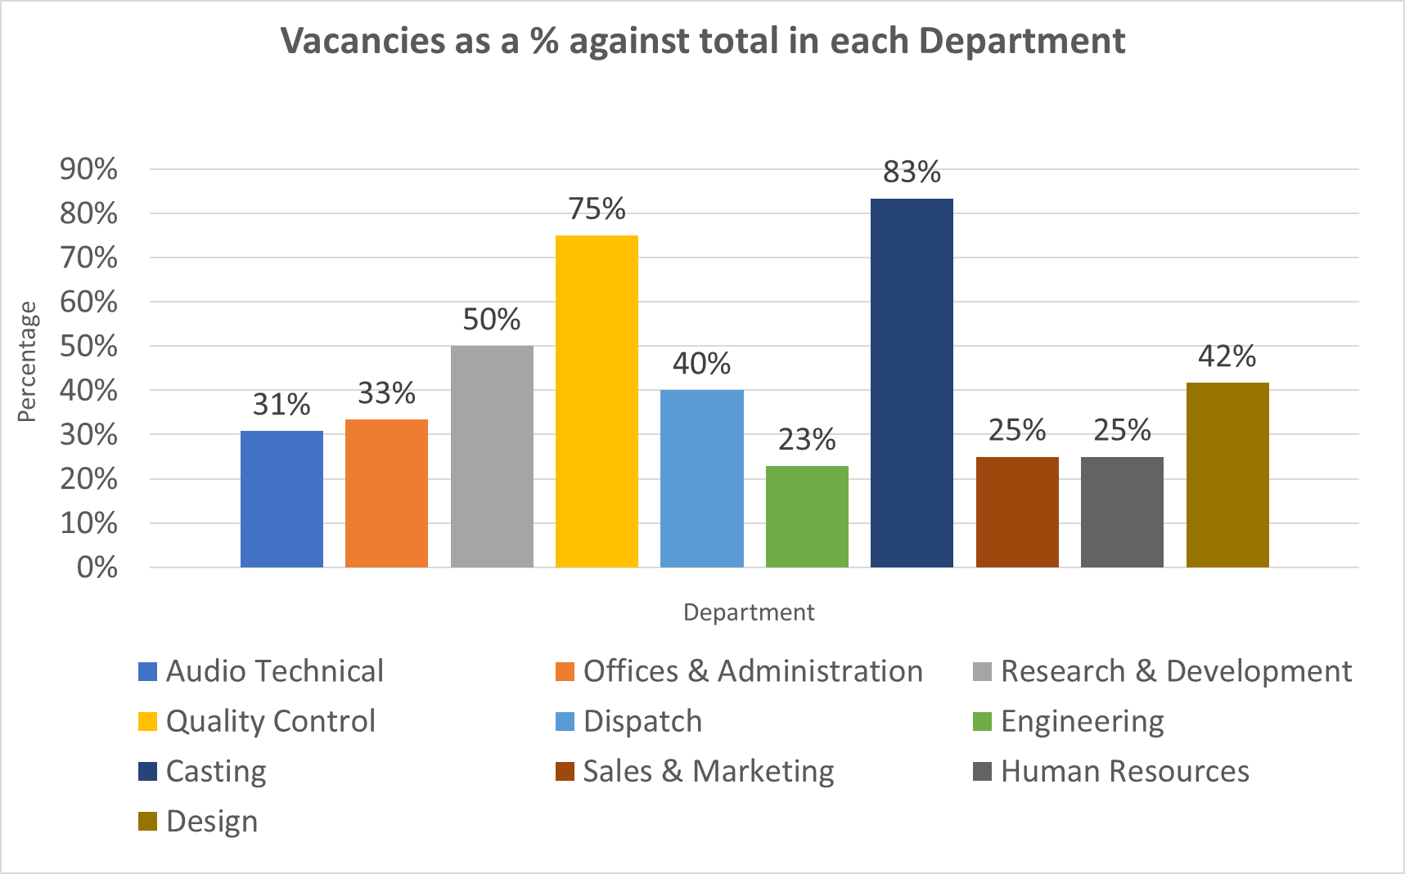

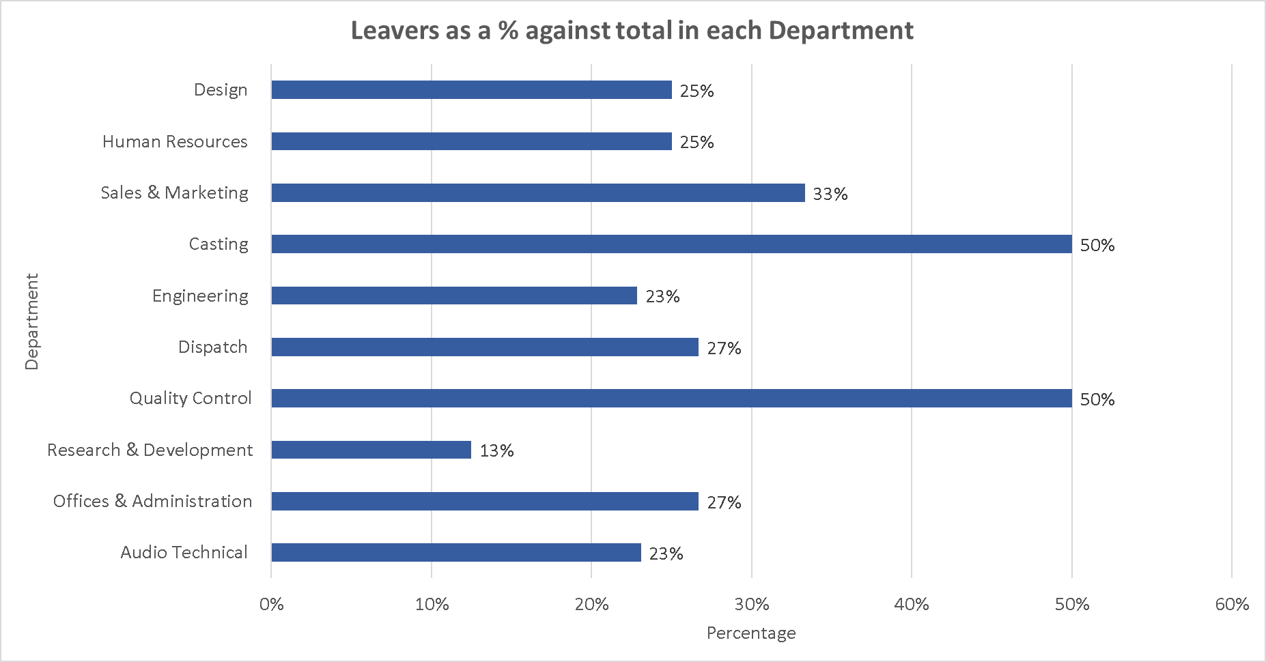

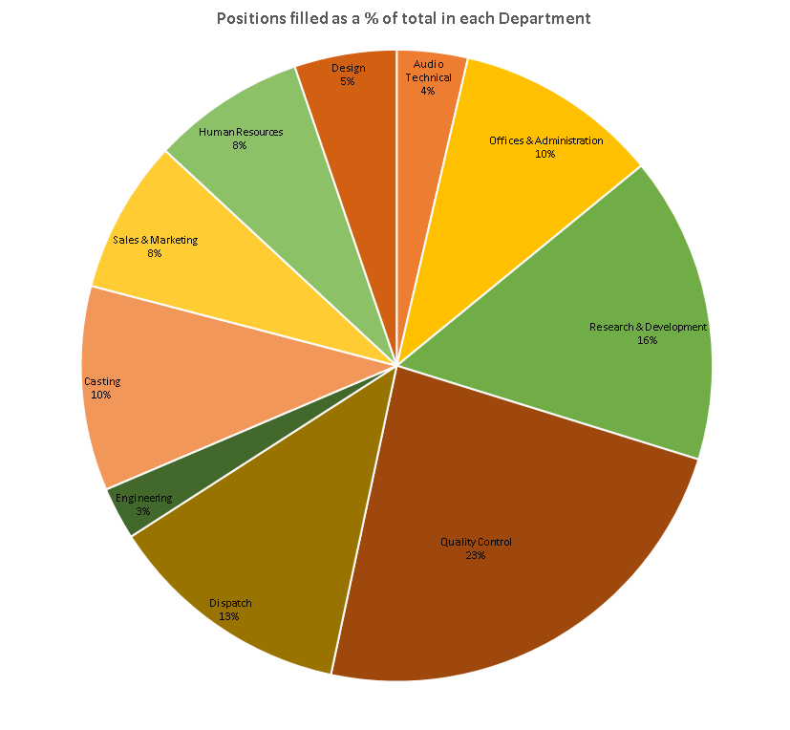

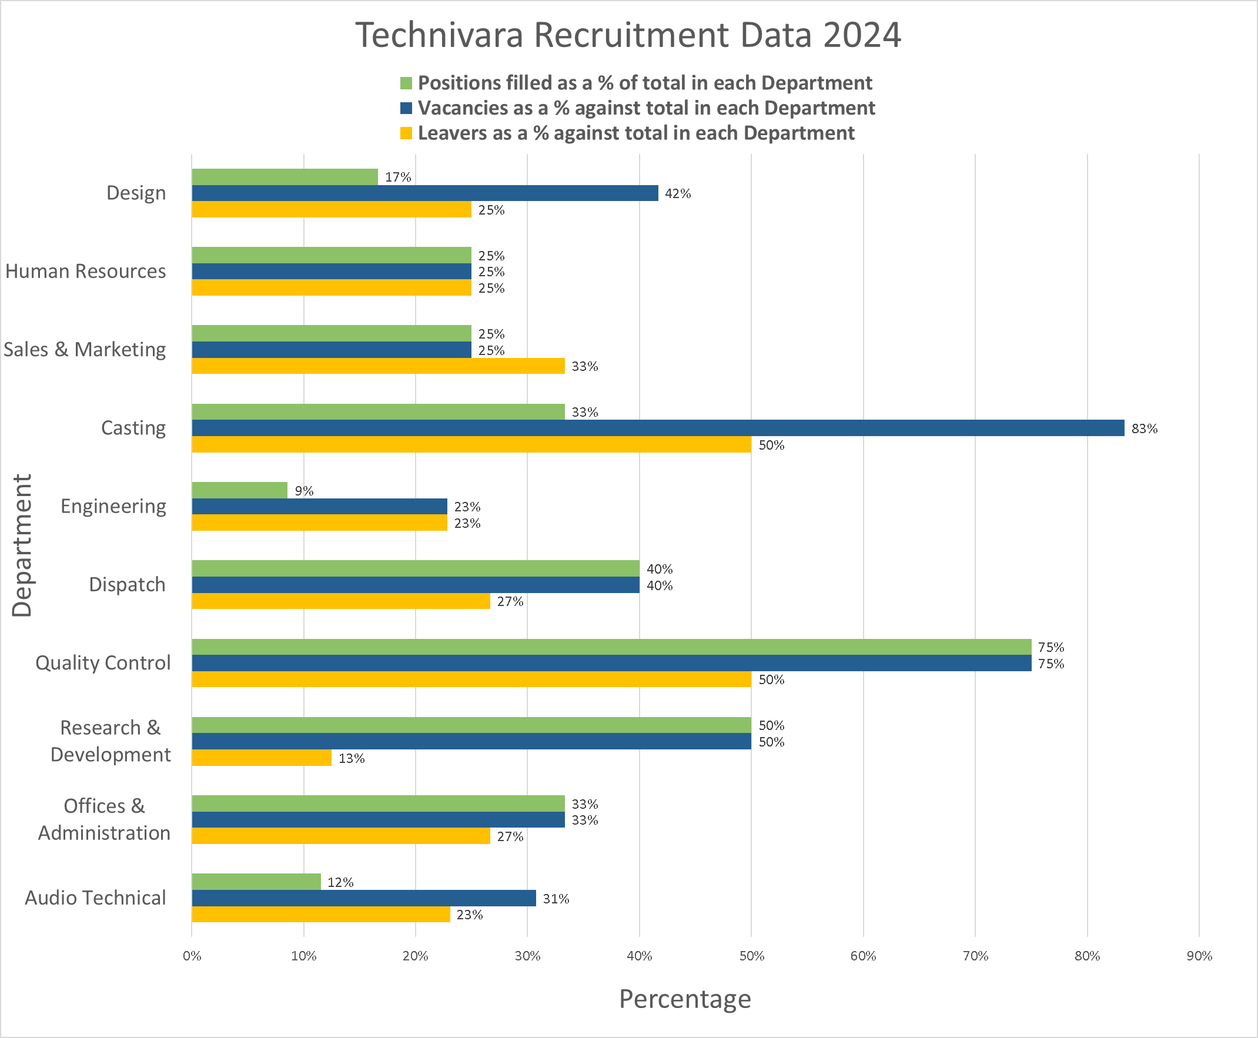

AC 2.3

Introduction

Table 2 summarises Likert-scale survey feedback from 42 participants of a recent L&D activity. Employee feedback is vital for assessing the value of L&D for individuals, teams and the organisation as a whole (Marchington et al., 2021, p.305). By examining patterns, I will provide evidence-based recommendations to optimise future learning interventions so they support Technivara’s growth and keep pace with evolving workplace practices.

Evaluation Summary

The evaluation data highlights significant concerns regarding the effectiveness of the activity. While the facilitator’s expertise and use of materials were positively received (93% agreed the facilitator was knowledgeable), improvements are needed in structure and consideration of learning preferences, with 33% disagreeing and 43% unsure if their preferences were addressed. Engagement was very low (5%), and 79% disagreed that learning outcomes were achieved, despite 93% confirming clear objectives were provided at the start. This suggests objectives were not reinforced throughout the activity. Additionally, respondents expressed uncertainty around the activity’s relevance to performance targets (29% disagreed, 57% unsure) and the employment of the learning to their roles (33% disagreed, 52% unsure). This underscores the need for improvement, as effective L&D methods will be crucial in equipping staff to drive Technivara’s expansion.

Recommendations

To address the limited application of learning to working roles, I recommend conducting job role analysis and training needs analysis using performance review data and input from employees and line managers. Exploring what staff currently know, and what they want and need to learn, can inform future L&D design and ensure alignment with actual job demands (Cassidy, 2022b). Given that 57% of participants were unsure whether the learning was linked to performance targets, this should be a moderately high priority. As this may be a significant undertaking for Technivara, with its limited data-driven processes, implementation should begin with a departmental pilot within three months, with the aim of organisation-wide adoption within 18 months.

Resource implications include significant staff time, such as stakeholders providing structured input and HR accessing and analysing performance data, which may be especially time-consuming given Technivara’s paper-driven approach. Financial costs could involve analytics software and potentially an external consultant. However, this investment would ensure L&D activities are targeted, relevant and evidence-based, improving engagement and the transfer of learning. In turn, this would strengthen the link between learning outcomes and both individual and business performance (Hayden, 2025c), with financial returns through increased productivity and reduced turnover.

Failure to act risks continued disengagement and wasted investment in ineffective training. Potential barriers include access to performance data and manager bias in job role analyses, which could be mitigated through expert support and structured guidance.

Secondly, I recommend developing a pre-training questionnaire to gather staff learning preferences to inform the format and structure of L&D activities. A blended learning approach would increase accessibility and engagement. The questionnaire should address Kolb’s (1995) four learning modes by exploring preferred methods (e.g. case studies, business games, scenarios, group work, observations, theory discussions), as well as technology use, and level of formality (Kolb, cited in Marchington et al., 2021, pp.298-299). Understanding learner profiles and working environments beforehand ensures training accommodates diverse needs (Marchington et al., 2021, p.302), reducing barriers and boosting motivation. Involving staff in design also encourages ownership and accountability for their own learning (Hayden, 2025b), as it demonstrates that Technivara value their input.
Combining experiential and social learning (Armstrong, 2023, p.342) further supports the application of skills to the job, a key concern from the data, through practical “real life” exercises and peer-to-peer discussion, enhancing understanding and retention (Marchington et al., 2021, p.304). Costs include staff time completing questionnaires, HR time designing and analysing questionnaire data, and facilitator time re-designing L&D interventions with learning preferences in mind. Minimal costs would be incurred for survey platforms (e.g. Microsoft Forms), although digital tools may be needed to support blended learning, such as simulation software. Without these improvements, L&D risks being perceived as “one-size-fits-all” or a “tick-box exercise”, rather than an opportunity to develop, reducing engagement and learning transfer (Hayden, 2025b). With only 5% of participants meaningfully engaged, I suggest this action is prioritised within the next three months, ahead of the next activity.
Potential barriers include low questionnaire response rates and delays in training due to the extra time required for customisation, which could postpone essential projects at Technivara and impact business outcomes. However, without impactful and transferable L&D activities the risk of staff dissatisfaction and turnover increases (Hayden, 2025a), which can lead to higher long-term costs.

Finally, I recommend interactive “pulse checks”, such as mini-quizzes and polls, during and at the end of L&D sessions to gauge understanding (Marchington et al., 2021, p.302) and review the achievement of learning outcomes. This provides immediate feedback to facilitators, allowing weaker areas to be addressed in real time, while recapping content and outcomes improves knowledge retention and engagement (Hayden, 2025a).

This will also strengthen evaluation metrics by measuring the impact and success of L&D activities rather than just attendance (Cassidy, 2022b), providing an accessible first step toward the data-driven HR culture that Technivara currently lacks. Costs include a moderate amount of staff time for facilitators to develop quizzes aligned with learning outcomes, while costs for digital tools that support quizzes are typically minimal, as many free platforms are available (for instance, Mentimeter has a free monthly plan that includes up to 50 participants). Questions should be balanced in difficulty; overly simple ones reduce engagement, while overly difficult quizzes can demotivate and be perceived as tests rather than learning aids, and such stress hinders effective learning (Hayden, 2025b). Given their low cost and ease of implementation, I recommend introducing these immediately.

Conclusion

Overall, my recommendations aim to enhance Technivara’s L&D activities by making them more relevant, engaging, accessible and measurable, through role and training needs analysis, questionnaires and real-time feedback. These actions address employee concerns while supporting Technivara’s development into a more data-driven organisation.

Bibliography
Adair, J. (2022) Decision making and problem solving: break through the barriers and banish uncertainty at work. 5th edn. London: Kogan Page.
Albrecht, C., Gardner, T., Allred, S., Winn, B., and Condie, A. (2016) ‘To sit at the table, you have to know the language: important financial metrics for HR directors’, Strategic HR review, 15(3), pp. 123–128. Available at: https://doi.org/10.1108/SHR-02-2016-0021
Anderson, V. (2013) Research methods in human resource management: Investigating a business issue. London: Chartered Institute of Personnel and Development.
Barends, E. and Rousseau, D. (2018) Evidence-based management: how to use evidence to make better organizational decisions. London: Kogan Page
Barends, E., Villanueva, J., Rousseau, D.M., Briner, R.B., Jepsen, D.M., Houghton, E., and Have, S. (2017) ‘Managerial attitudes and perceived barriers regarding evidence-based practice: An international survey’, PLOS ONE, 12(10). Available at: https://doi.org/10.1371/journal.pone.0184594 (Accessed: 8th August 2025).
Bashford, S. (2021) Life isn't fair – but your workplace can be. Available at: https://www.peoplemanagement.co.uk/article/1744353/life-not-fair-workplace-can-be (Accessed: 22nd August 2025).
Becker, J. (2021) How to transform your decision-making process. Available at: https://www.peoplemanagement.co.uk/article/1744085/how-to-transform-your-decision-making-process (Accessed: 12th August 2025).
Bell, E., Bryman, A. and Harley, B. (2022) Business research methods. 6th edn. Oxford: Oxford University Press.
Briner, R. (2020) An Evidence Based Approach to Workplace Management, Rob Briner. 2nd June. Available at: https://www.youtube.com/watch?v=b4FSqy0AJrA (Accessed: 20th August 2025).
Briner, R. (2023) Evidence-based HR and people analytics are the same, right? Afraid not. Available at: https://www.peoplemanagement.co.uk/article/1851101/evidence-based-hr-people-analytics-same-right-afraid-not (Accessed: 1st August 2025).
Briner, R. (2024) WHAT IS EVIDENCE BASED HR AND WHY IS IT IMPORTANT? (Interview with Rob Briner). 19th March. Available at: https://www.youtube.com/watch?v=udnBorQwP-g (Accessed: 20th August 2025).
Cameron, S. (2021) The Business Student's Handbook: Skills for Study and Employability. Harlow: Pearson.
Cassidy, N. (2022a) What value does HR bring to today's organisations? [podcast] 12th July. Available at: https://www.cipd.org/uk/knowledge/podcasts/purpose-and-value-of-hr/ (Accessed: 26th July 2025).
Cassidy, N. (2022b) Evidence-based L&D: measuring learning transfer [podcast] 8th March. Available at: https://www.cipd.org/uk/knowledge/podcasts/transfer-of-learning/ (Accessed: 7th September 2025).
Cassidy, N. (2024) Driving performance with people analytics [podcast] 30th July. Available at: https://www.cipd.org/uk/knowledge/podcasts/people-analytics-and-performance/ (Accessed: 8th August 2025).
Chatfield, T. (2022a) Critical Thinking. 2nd edn. London: SAGE Publications Ltd.
Chatfield, T. (2022b) What is Critical Thinking and Why Should I Care? 16th June. Available at: https://www.youtube.com/watch?v=l8nCXfjISU4 (Accessed: 14th August 2025).
Chatfield, T. (2022c) 10 Commandments for Critical Thinking 10 by Tom Chatfield. 12th July. Available at: https://www.youtube.com/watch?v=wbq_VzTElrQ (Accessed: 14th August 2025).
Chermack, T.J. and Kasshanna, B.K. (2007) ‘The use and misuse of SWOT analysis and implications for HRD professionals’, Human Resource Development International, 10(4), pp. 383-399. Available at: https://doi.org/10.1080/13678860701718760
CIPD (2015) Ethical decision-making: Eight perspectives on workplace dilemmas. Available at: https://www.cipd.org/globalassets/media/comms/the-people-profession/profession-map-pdfs/ethical-decision-making-2015-eight-perspectives-on-workplace-dilemmas_tcm29-9564.pdf (Accessed: 18th August 2025).
CIPD (2017) Evidence-based practice: an introduction. 4th July. Available at: https://www.youtube.com/watch?v=ikJ687g2tPo (Accessed: 2nd August 2025).
CIPD (2023) CIPD Manifesto for Good Work. Available at: https://www.cipd.org/uk/about/public-policy/our-priorities/manifesto-good-work/ (Accessed: 18th August 2025).
CIPD (2024a) Using technology responsibly: Guidance for people professionals. Available at: https://www.cipd.org/uk/knowledge/guides/responsible-technology-use (Accessed: 18th August 2025).
CIPD (2024b) Professional values and purpose. Available at: https://www.cipd.org/uk/the-people-profession/the-profession-map/explore-the-profession-map/professional-values-purpose (Accessed: 22nd August 2025).
CIPD (2024c) Finance skills for HR: A perfect partnership for organisational success. 15th February. Available at: https://www.youtube.com/watch?v=6Rt831DyOjM (Accessed: 24th August 2025).
CIPD (2025a) SWOT Analysis. Available at: https://www.cipd.org/uk/knowledge/factsheets/swot-analysis-factsheet/ (Accessed: 18th August 2025).
CIPD (2025b) Evidence-based practice for effective decision-making. Available at: https://www.cipd.org/uk/knowledge/factsheets/evidence-based-practice-factsheet (Accessed: 5th August 2025).
CIPD (2025c) Job design. Available at: https://www.cipd.org/uk/knowledge/factsheets/job-design-factsheet/ (Accessed: 9th September 2025).
Edwards, J. (2020) Future Pacing and Why You Want to Use It. Available at: https://medium.com/sales-copywriting-content-marketing-with-jim/future-pacing-and-why-you-want-to-use-it-a5fc1078513 (Accessed: 19th August 2025).
Flaig, J. (2025) Engineering ‘could face NHS-like workforce crisis’ without skills focus in Industrial Strategy. Available at: https://www.imeche.org/news/news-article/engineering-could-face-nhs-like-workforce-crisis-without-skills-focus-in-industrial-strategy (Accessed: 22nd August 2025).
Hayden, D. (2025a). Learning needs analysis. Available at: https://www.cipd.org/uk/knowledge/factsheets/learning-needs-factsheet/ (Accessed: 6th September 2025).
Hayden, D. (2025b). Methods of delivering learning interventions. Available at: https://www.cipd.org/uk/knowledge/factsheets/learning-methods-factsheet/ (Accessed: 6th September 2025).
Hayden, D. (2025c). Learning evaluation, impact and transfer. Available at: https://www.cipd.org/uk/knowledge/factsheets/evaluating-learning-factsheet/
(Accessed: 6th September 2025).
Hill, S. (2024) People analytics: Guide for people professionals. Available at: https://www.cipd.org/uk/knowledge/guides/analytics-practitioner-guide/ (Accessed: 22nd August 2025).
Horn, R. (2009) The business skills handbook. London: Chartered Institute of Personnel and Development.
Johnson, K.L., Bixter, M.T. and Luhmann, C.C. (2020) ‘Delay discounting and risky choice: Meta-analytic evidence regarding single-process theories’, Judgment and Decision Making, 15(3), pp. 381–400. Available at: https://doi.org/10.1017/S193029750000718X
Kaplan, R.S. and Norton, D.P. (1996) ‘Linking the balanced scorecard to strategy’, California Management Review, 39(1), pp. 53-79. Available at: https://doi.org/10.2307/41165876
Kiss, A.N., Cortes, A F., and Herrmann, P. (2022) ‘CEO proactiveness, innovation, and firm performance’, The Leadership Quarterly, 33(3). Available at: https://doi.org/10.1016/j.leaqua.2021.101545
Lamb, P. (2019) Critical thinking [podcast]. 5th November. Available at: https://www.cipd.org/uk/knowledge/podcasts/critical-thinking/ (Accessed: 22nd July 2025).
LinkedIn Learning (2024) Financial Accounting Foundations: The income statement [online]. Available at: https://www.linkedin.com/learning/financial-accounting-foundations/the-income-statement-24007294?resume=false&u=77966930 (Accessed: 12th August 2025).
Lufkin, B. (2021) Do 'maximisers' or 'satisficers' make better decisions? Available at: https://www.bbc.co.uk/worklife/article/20210329-do-maximisers-or-satisficers-make-better-decisions (Accessed: 5th August 2025).
Lyu, B., Liao, X., and Yang, Y. (2022) ‘Relationships Between Temporal Leadership, Transactive Memory Systems and Team Innovation Performance’, Psychology Research and Behaviour Management, 2022(15), pp. 2543 - 2559 Available at: https://doi.org/10.2147/PRBM.S380989
Marchington, M., Wilkinson, A., Donnelly, R., and Kynighou, A. (2021) Human resource management at work: the definitive guide. 7th edn. London: Kogan Page.
Marson, L. (2022) 4 reasons HR must clean its people analytics data. Available at: https://www.techtarget.com/searchhrsoftware/tip/4-reasons-HR-must-clean-its-people-analytics-data (Accessed: 5th August 2025).
McCutcheon, D. (2014) Finance know-how vital to HR success. Available at: https://www.hrreporter.com/news/hr-news/finance-know-how-vital-to-hr-success/315178 (Accessed: 20th August 2025).
McRaney, D. (2011) You are not so smart. New York: Gotham Books.
Mentimeter (2025) Plans that get people talking. Available at: https://www.mentimeter.com/plans (Accessed: 9th September 2025).
Open University (2024) Critically processing what you read. Available at: https://help.open.ac.uk/critical-reading-techniques/critically-processing-what-you-read (Accessed: 31st August 2025).
Rousseau, D.M. (2019) Evidence-based management: helping managers make better decisions. October 31st. Available at: https://doi-org.ezproxy.uwtsd.ac.uk/10.69645/ZPZZ5835 (Accessed: 12th August 2025).
Scoblic, J.P. (2020) ‘Learning from the Future’, Harvard Business Review, 98(4), pp. 38–47. Available at: https://research-ebsco-com.ezproxy.uwtsd.ac.uk/linkprocessor/plink?id=2492da75-e9f5-3693-91f2-0ee063957a05 (Accessed: 17 August 2025).
Sharp, R. (2019) Ethics and HR. Available at: https://www.hrmagazine.co.uk/content/features/ethics-and-hr/ (Accessed: 19th August 2025).
Shinde, S. (2025) ‘From Perceived Inequity to Retention: Leveraging Equity Theory in Contemporary Workforce Management’, RESEARCH REVIEW International Journal of Multidisciplinary, 10(4), pp. 292–300. Available at: https://doi.org/10.31305/rrijm.2025.v10.n4.032
Smith, J. and Mitchell, J. (2022) ‘The behaviour of the people professional’ in Taylor, S and Woodhams, C (eds.) Studying Human Resource Management. London: Kogan Page, pp. 141 – 171.
Stobierski, T. (2019) Financial Statement Analysis. Available at: https://online.hbs.edu/blog/post/financial-statement-analysis (Accessed: 20th August 2025).
Stobierski, T. (2020) 13 Financial Performance Measures Managers Should Monitor. Available at: https://online.hbs.edu/blog/post/financial-performance-measures (Accessed: 24th August 2025).
Taylor, S. (2019) Resourcing and Talent Management: The Theory and Practice of Recruiting and Developing a Workforce. 9th edn. London: Kogan Page.
Taylor, S., and Woodhams, C. (2022) ‘The people management contribution; in Taylor, S and Woodhams, C (eds.) Studying Human Resource Management. London: Kogan Page, pp. 1-20.
Tooes, T. (2017). HRD's pocket guide to... profit and loss. Available at: https://www.hrmagazine.co.uk/content/features/hrds-pocket-guide-to-profit-and-loss/ (Accessed: 24th August 2025).
Uzonwanne, F.C. (2016) ‘Rational Model of Decision Making’, in Global Enclyclopedia of Public Administration, Public Policy, and Governance. Available at: https://doi.org/10.1007/978-3-319-31816-5_2474-1
Waite, K., Beevers, K., Small, N., Tomlinson, K., and Hussain, S. (2021) People Practice: A Complete Guide. London: Kogan Page.

