

Martial Art Fitness App

by
Paul Newman
1805494

Supervisor: Gaynor Thomas
Second Marker: Second Marker’s Name

Project submitted as part of the requirements for the award of BSc(Hons) Web Development

Declaration FORM AND FORM OF CONSENT
DECLARATION

I, Paul Newman declare that I am the sole author of this Project; that all references cited have been consulted; that I have conducted all work of which this is a record, and that the finished work lies within the prescribed word limits.
This work has not previously been accepted as part of any other degree submission.

Signed: Paul Newman

Date: 28/4/23

FORM OF CONSENT

I Paul Newman I hereby consent that my Project, submitted in candidature for the BSc(Hons) Web Development degree, if successful, may be made available for inter-library loan or photocopying (subject to the law of copyright), and that the title and abstract may be made available to outside organisations.
Signed: Paul Newman

Date: 28/4/23

Contents
Declaration FORM AND FORM OF CONSENT 1
2 Table of Figures 4
3 Introduction 6
3.1 Aim 7
4 Research and Review of Literature 8
4.1 What is out there? 8
4.1.1 WI-fit mma 8
4.1.2 Prodomitor 9
4.1.3 Mobile Technology 10
4.1.4 Thenics 14
4.1.5 Fitify 14
4.1.6 FitStar Apps 14
4.1.7 Alpha Progression Gym Logger 15
4.1.8 Muscle Man 15
4.2 Conclusion 16
5 Research and/or Development Methodology 17
5.1 Research Philosophy 20
5.2 Data Collection 22
6 Design and Implementation 26
6.1 Design ERD 26
6.1.1 Design Flow chart 27
7 Analysis 28
7.1 Survey-based Results 28
7.1.1 Forms results 28
7.2 Research Conclusion 39
7.3 CODE 40
7.3.1 Index Code 40
7.3.2 About Code 44
7.3.3 Signup Code 45
7.3.4 Submit Code 48
7.3.5 Login Code 50
7.3.6 Header Code 51
8 Conclusion 52
8.1 Summary 53
8.2 Recommendations for Further Research 53
9 Reflection 54
10 Bibliography 55

Table of Figures
Figure 1 Fighting Trainer on Google play [1] 7
Figure 2 Wi-fit MMA Trainer 7
Figure 3 Prodomitor [2] 8
Figure 4 Kyoshi Sensei Paul Newman demo jap [4] 10
Figure 5 Kyoshi Sensei Paul Newman demo Maeger [4] 10
Figure 6 Kyoshi Sensei step one floor [4] 11
Figure 7 Kyoshi Sensei step two floor [4] 11
Figure 8 Kyoshi Sensei step 3 floor [4] 11
Figure 9 Kyoshi Sensei Paul Newman Demo Bokken [4] 12
Figure 10 Kyoshi Sensei Paul Newman Demo Bokken side view [4] 12
Figure 11 Kyoshi Sensei Paul Newman Numcuku [4] 12
Figure 12 Thenics fitness App 13
Figure 13 Fitify Fitness App [1] 13
Figure 14 FitStar Back Workout [1] 13
Figure 15 Alpha Progression [1] 14
Figure 16 Research Methods for business [6] 16
Figure 17 Classic research model [5] 17
Figure 18 Research Table [5] 18
Figure 19 Waterfall Model [7] 18
Figure 20 Marital art form part one 21
Figure 21 Marital art Form part Two 22
Figure 22 Marital Art form Part Three 23
Figure 23 Martial art form Part Four Likert Scale 24
Figure 24 ERD basic data base design 25
Figure 25 Results of the questionnaire 27
Figure 26 Akido Table 28
Figure 27 Judo Table 29
Figure 28 Jujitsu Table 30
Figure 29 BJJ Table 31
Figure 30 Kickboxing Table 32
Figure 31 Hong Fist Table 33
Figure 32 Iaido Table 34
Figure 33 Taekwondo Table 35
Figure 34 Muay Thai Table 36
Figure 35 Karate Table 37
Figure 36 All Martial Arts Table 38
Figure 37 About page 43
Figure 38 Sign up page. 46
Figure 39 Sickness/Injury screen. 46
Figure 40 The Healthy screen 46
Figure 41 SQL database 48
Figure 42 SQL database branches 48
Figure 43 SQL user information 48
Figure 44 SQL workout branch 48
Figure 45 The Login page. 49

Introduction
Since there aren't many martial arts fitness apps for smartphones or computers, the author has chosen to look into the idea of either finding or making one. In order to find an appropriate platform on which to build a prototype version of the app for testing and demonstration, this research will examine several mobile and web technologies. The literature review will look at various technologies and related applications and evaluate how relevant they are to the suggested app. The most appropriate data and features will be chosen for the prototype based on the results of this study. The ultimate goal of this research is to identify the parts that are most appropriate for the suggested prototype.

Aim
The author will use the S.M.A.R.T. criteria to develop appropriate aims and objectives for the proposed project. It should be noted that certain time frames may be subject to change as the project progresses to the next stage, since no formal requirements have been established yet. This document should be considered a provisional plan only.
- To maximize the diversity of skill sets and data in the app, information will be collected from various martial arts over a period of six months. The following arts will be included: kickboxing, Brazilian jiu-jitsu (BJJ), kendo, jujitsu, judo, aikido, karate, and traditional Japanese jujitsu.
- In order to develop an app that caters to the unique needs of each martial art, it's important to gather input from practitioners of each discipline. Since the requirements can vary significantly between martial arts, it's essential to find out what each group would like to see in the application. For example, boxing is primarily focused on upper body striking and uses leg work for stamina, while Brazilian jiu-jitsu (BJJ) is all about grappling on the ground and engages the entire body. As a result, stamina, flexibility, and knowledge base requirements can vary greatly between the two sports. To gather the necessary data, several methods such as observation, monitoring, testing, and trial will be employed.
- The data collected will be used to create various workout plans, each tailored to have different physical and mental effects on the user to varying degrees. Developing multiple workout plans requires significant planning and modification based on each regimen. This will affect the timeline of the project as each plan will need to be planned ahead of time and adjusted accordingly.
- The exercise plan will be created to accommodate individuals of all backgrounds, including experienced martial artists and physically handicapped people. To attain varying degrees of effectiveness, it will contain both energetic and passive activities. There will be a major time investment in research and development to guarantee the security of all users. This will entail thoroughly analysing potential dangers and taking precautions to keep both users and others safe.
- Once the workout routines have been developed, they will be tested on a diverse group of users for a minimum of three months each to establish a baseline for each individual. The timeline may need to be adjusted as necessary to ensure accurate and comprehensive data collection.
- To address the issue of user retention, the project will also determine the percentage of users who discontinue using fitness apps. This is especially important given the significant decline in the number of people who visit the gym after only a few months. Despite the potential benefits of fitness apps, there is compelling evidence that users tend to abandon their training programs quickly. Therefore, this stage of the project will focus on identifying factors that contribute to user attrition and developing strategies to increase user engagement and motivation.

Research and Review of Literature
The author wants to find out what features and applications practitioners of marital arts would want to see in a fitness app.

What is out there?
Although there are a few martial arts fitness applications available to the general public, they still do not enjoy the same level of popularity as traditional fitness or weight-loss apps, despite improvements made over the past five years. For instance, while some of these apps offer training on over 90 MMA moves and techniques, they do not provide information on stretching, fluid intake, or dietary guidance to support weight loss and overall health. Additionally, these apps do not offer any features to support mental health, which is becoming increasingly important in the fitness industry.
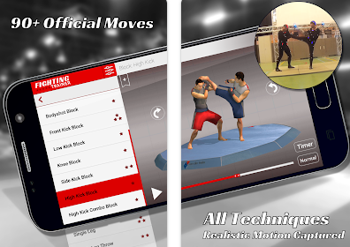
Figure 1 Fighting Trainer on Google play [1]

WI-fit mma
In 2011, the Wii Fit attempted to capitalize on the martial arts fitness market by offering UFC and boxing games that allowed users to train like professional fighters. However, this effort was short-lived as many boxers and martial artists did not find it practical to train in their living rooms, which are often viewed as the focal point of the house and may not provide enough space or privacy for effective training.

Figure 2 Wi-fit MMA Trainer

Prodomitor
Prodomitor was a popular fitness tool among fitness enthusiasts in the early 2000s. However, as technology advanced and smartphones became more ubiquitous, Prodomitor lost its popularity and fell out of favour among fitness enthusiasts. Pedometers are devices that track the number of steps taken by the wearer. They are commonly used in fitness and healthcare applications to monitor physical activity and help individuals achieve fitness goals. Pedometers typically use accelerometers to measure movement and may also have additional features such as calorie counters, distance trackers, and heart rate monitors. With the advancement of technology, many smartphones now have built-in pedometer apps, and wearable fitness trackers such as Fitbit also include pedometer functions.
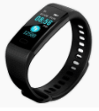
Figure 3 Prodomitor [2]

Mobile Technology
This software can be accessed using any modern smartphone, enabling users to practice and train their workout routines at their convenience, whether they are at work, at home, or even while taking a walk outside.
The proposed application will incorporate various workout modes that will cater to both physical and mental aspects of health. It will offer features such as proper breathing techniques to aid in faster recovery, fluid intake options based on individual health requirements, and body type assessment for tailored workout routines. Meditation, which is an essential component of martial arts, will also be incorporated to help users refocus after each session. The application will provide a holistic approach to fitness, aiming to improve overall well-being and not just physical appearance.
- The incorporation of proper breathing techniques into the workout modes of the fitness app is an important feature that promotes quicker recovery and overall well-being. Research has shown that proper breathing during exercise can increase oxygen flow to the muscles, enhance endurance, and reduce fatigue. By providing users with the guidance and tools to practice proper breathing techniques, the app can improve their overall performance and reduce the risk of injury [3].
- The importance of proper hydration cannot be overstated, especially during physical exercise. The app will provide personalized recommendations for fluid intake based on the user's individual health status, fitness goals, and the specific workout they are doing. For example, if a user is doing a high-intensity workout that causes significant sweating, they may need to consume more fluids to prevent dehydration. The app may also suggest certain types of fluids, such as water, sports drinks, or coconut water, depending on the user's needs. Proper hydration can improve athletic performance, aid in recovery, and prevent injury.
- Determining the user's body type and challenges they may face is crucial in creating effective workout plans. The app can incorporate a feature that analyses the user's body type and provides customized workout plans based on their unique needs. For instance, an ectomorph body type may require a different workout plan than a mesomorph or endomorph body type.
- Moreover, Providing guided meditation can be an important component of the app to help users refocus and achieve mental clarity after each session. This can help reduce stress and anxiety, promote relaxation, and improve overall mental health. The app can offer guided meditation sessions or provide tips on how to meditate effectively. Additionally, users can track their progress in mindfulness and meditation to help them stay motivated and engaged with the app.

For everyone, the app would offer a variety of physical activities, such as but not limited to:
Using kicks, more complex combinations, and even the most basic striking. Martial arts techniques and combinations, such as strikes, kicks, and grappling moves, Cardiovascular exercises, such as running, jumping jacks, and high knees. Cardiovascular exercises: -
- such as running, jumping jacks, and high knees.
- Strength training exercises, such as push-ups, squats, and lunges.
- Flexibility and mobility exercises, such as yoga and stretching routines.
- High-intensity interval training (HIIT) workouts, which involve short bursts of intense exercise followed by periods of rest.
- Low-impact workouts, which are ideal for individuals with joint or mobility issues.
- Customized workout plans based on individual goals and fitness levels.
- Virtual sparring sessions or shadowboxing to simulate real-life training scenarios.
- Partner workouts for those who want to train with a friend or family member.
- Cool-down exercises to help prevent injury and promote muscle recovery.

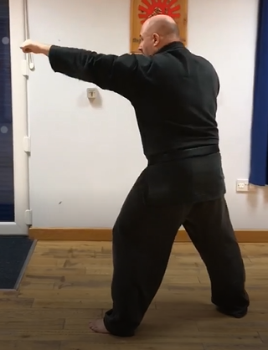
Figure 4 Kyoshi Sensei Paul Newman demo jap [4]
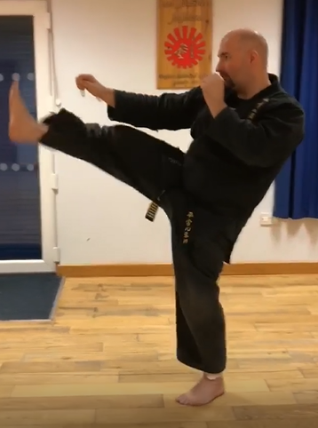
Figure 5 Kyoshi Sensei Paul Newman demo Maeger [4]

- Floor work is a great addition to any workout routine as it engages the entire body and helps improve flexibility, balance, and coordination. Some floor work exercises that could be included in the app are:
- Plank variations: Planks are a great way to engage your core muscles, and there are many variations to challenge yourself, such as side planks, plank jacks, and plank up-downs.
- Hip bridges: This exercise targets the glutes and helps strengthen the lower back muscles. It can also improve posture and reduce lower back pain.
- Lunge variations: Lunges are an effective way to work the legs, hips, and glutes. There are many variations to choose from, including walking lunges, reverse lunges, and jumping lunges.
- Crab walks: Crab walks are a fun and challenging exercise that works the entire body, particularly the core, glutes, and shoulders.
- Side lying leg raises: This exercise targets the hips and outer thighs, helping to tone and strengthen these muscles.
- By incorporating these exercises and more into the app, users can create a well-rounded workout routine that improves their overall fitness and wellbeing.


Figure 6 Kyoshi Sensei step one floor [4]
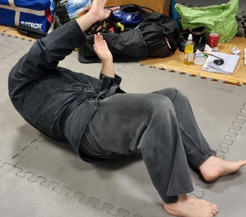
Figure 7 Kyoshi Sensei step two floor [4]
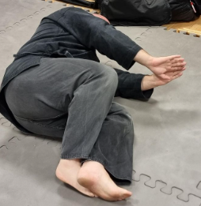
Figure 8 Kyoshi Sensei step 3 floor [4]
- Weapons (bokken) drills are a great addition to the app's workout modes because they can improve fitness and also provide a unique and engaging experience for users. By focusing on the weapon, itself, users can shift their attention away from any aches or pains they may be experiencing and put more effort into their training. Additionally, weapons drills can help improve coordination, balance, and agility, as well as provide an opportunity for users to learn a new skill.

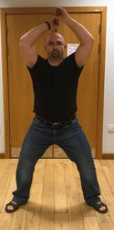
Figure 9 Kyoshi Sensei Paul Newman Demo Bokken [4]
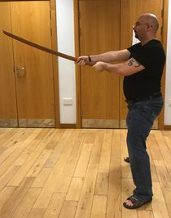
Figure 10 Kyoshi Sensei Paul Newman Demo Bokken side view [4]
- Weapon drills like nunchucks can be a great way to improve hand-eye coordination, as well as overall body coordination, balance, and strength. By practicing with nunchucks or other weapons, users can challenge themselves to move in new and complex ways, which can lead to improvements in their overall fitness and athletic ability.

Figure 11 Kyoshi Sensei Paul Newman Numcuku [4]
Adding gamification elements such as a points system and the ability to compete with friends can help increase motivation and engagement with the app. Gradually increasing the difficulty level of workouts as the user becomes stronger and fitter can also provide a sense of accomplishment and progress, which can further boost motivation. Overall, these features can help users stay committed to their fitness goals and maintain a consistent workout routine.
Many fitness apps on the market cater to specific goals such as building muscle or losing weight and may not offer a comprehensive range of workout modes that cater to various aspects of physical and mental health. Additionally, some apps may only provide basic routines, which may not be sufficient for more experienced users who are looking for a greater challenge. This is why developing a fitness app that caters specifically to martial arts practitioners can be beneficial, as it can offer a unique set of workout modes that incorporate various martial arts techniques and principles.

Thenics
An advanced gymnast fitness app may not be suitable or useful for regular people or injured users. Advanced gymnastics techniques require a high level of skill and strength and attempting them without proper training and preparation can result in injury. Furthermore, an app geared towards advanced gymnastics may not provide modifications or alternatives for those with injuries or physical limitations, which can limit its usefulness for such users. It is important for fitness apps to cater to a wide range of users with varying levels of experience and abilities, and to provide safe and effective workouts for all.

Figure 12 Thenics fitness App

Fitify
While the fitness app may not offer specific guidance on nutrition, it can still be useful for preventing injuries in a few ways. Firstly, the app can provide users with information on proper form and technique for exercises, which can help reduce the risk of injury during workouts. Additionally, the app can offer varying levels of difficulty for exercises, allowing users to gradually progress and avoid pushing themselves too hard too quickly, which can also help prevent injuries. However, nutrition is certainly an important aspect of injury prevention, and it may be beneficial to seek out additional resources or guidance on this topic to complement the use of the fitness app.

Figure 13 Fitify Fitness App [1]

FitStar Apps
This app has a specific focus on helping users with bad back injuries and aiding in their recovery, rather than providing a broad range of exercises and guidance for overall fitness. This could be useful for individuals who have specific needs related to their back health and are looking for targeted exercises and recovery techniques. However, for those seeking a more comprehensive approach to fitness, this app may not be as suitable. It's important for individuals to consider their own personal goals and needs when selecting a fitness app. 
Figure 14 FitStar Back Workout [1]

Alpha Progression Gym Logger
This app is more targeted at people who are interested in bodybuilding or powerlifting than at the general public or people who are injured. These workouts frequently take a lot of time and energy, and they might not be suited for people with specific health issues or physical limitations. Additionally, these workouts might not be the greatest strategy for people who just want to keep or get in better shape and maintain a healthy lifestyle.

Figure 15 Alpha Progression [1]

Muscle Man
Although this software is essentially identical to Alpha Progression, it goes into much more detail on the body's interior components to help you visualise what is happening to your body as you advance through the programme.
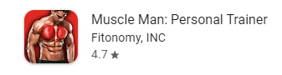

Conclusion
Overall, there are a variety of fitness apps available in the market that cater to different goals and needs. While some apps may provide detailed information on the body's anatomy and offer targeted exercises for specific health issues, others may be geared towards bodybuilding or advanced gymnastics techniques. It is important for individuals to consider their own personal goals and needs when selecting a fitness app and to ensure that the app they choose provides safe and effective workouts that are suitable for their fitness level and any physical limitations they may have. While fitness apps may not provide specific guidance on nutrition, they can still be useful for injury prevention through proper form and technique guidance and by offering varying levels of difficulty for exercises. Ultimately, the key to success in achieving fitness goals lies in a balanced approach that combines regular physical activity, healthy nutrition, and rest and recovery.

Research and/or Development Methodology
Once they have a better understanding of the existing literature, they can refine their hypothesis or research question and design a study that will test it. The design of the study will depend on the type of research being conducted, such as experimental, correlational, or observational. Researchers will then collect data, analyse it, and interpret the results. The interpretation of the results may lead to new hypotheses, further research, or revisions to existing theories.
Throughout the research process, researchers must also consider ethical considerations, such as obtaining informed consent from participants, ensuring confidentiality, and minimizing harm to participants. They must also consider the validity and reliability of their measures and control for extraneous variables that could impact the results.
In summary, the research process involves starting with a hypothesis, refining it through a review of the literature, designing a study, collecting, and analysing data, and interpreting the results. It is an iterative process that can lead to new hypotheses, revisions to existing theories, and new avenues of research. Ethical considerations and controlling for extraneous variables are also crucial components of the research process [5].
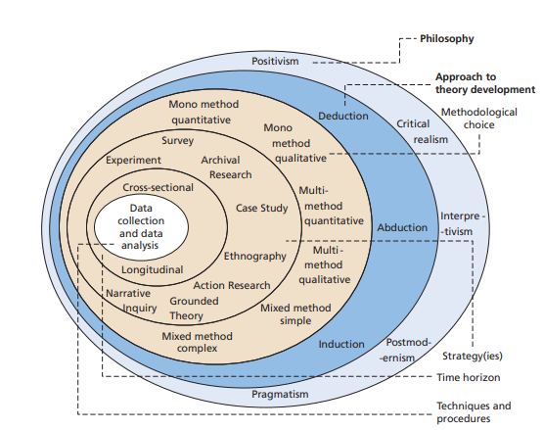
Figure 16 Research Methods for business [6]
Once a theory and hypothesis are established, the next step is to design a study to test the hypothesis. This involves determining the appropriate research methods and data collection techniques, such as surveys, experiments, or observations. Researchers must also consider factors such as sample size and selection, data analysis methods, and ethical considerations. After the study is conducted, the data is analyzed and interpreted. This involves examining the results to determine whether they support or reject the hypothesis. If the hypothesis is supported, the results may be used to provide evidence for the theory. If the hypothesis is not supported, researchers may need to revise their theories or hypotheses and conduct further research.

Overall, the research process is an iterative one, with each step informing the next. It is important for researchers to be flexible and open to changing their hypotheses or methods as needed based on the results of their studies [5].

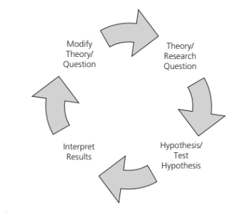
Figure 17 Classic research model [5]
Quantitative research is a method that involves the collection and analysis of numerical data. The primary advantage of quantitative research is that it enables researchers to collect large amounts of data that can be easily analysed and interpreted using statistical methods. This can lead to the discovery of patterns or trends that may be missed using other research methods. Additionally, the results of quantitative research are often considered more objective because they are based on numerical data. On the other hand, the primary disadvantage of quantitative research is that it may oversimplify complex phenomena by reducing them to numbers. It may also fail to capture the richness and complexity of human experiences, emotions, and behaviours, as well as their underlying context. Moreover, the use of predetermined categories or scales may not capture the full range of variation or nuance in the data.
Qualitative research, on the other hand, involves the collection and analysis of non-numerical data such as words, images, or observations. The primary advantage of qualitative research is that it allows researchers to explore complex phenomena in detail and depth, capturing the richness and complexity of human experiences and perspectives. It can also generate new insights and hypotheses that can inform future research.
The primary disadvantage of qualitative research is that it is typically more time-consuming and resource-intensive than quantitative research. It can also be subject to researcher bias or interpretation, as the analysis is often subjective and dependent on the researcher's perspective. Moreover, the results may be difficult to generalize to larger populations, as the sample size is often small and non-representative [5].
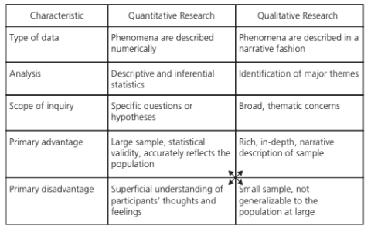
Figure 18 Research Table [5]
Systems Development Lifecycle (SDLC) provides a framework for managing the development, deployment, and maintenance of software systems. Each stage of the SDLC involves a set of activities and deliverables that help ensure the quality and effectiveness of the system being developed. The SDLC is often used by software development teams and project managers to guide the process of creating, deploying, and maintaining software systems. By following the SDLC, stakeholders can gain a better understanding of the system being developed, its requirements, and its expected outcomes.
However, even with the SDLC in place, the creation, deployment, or upgrade of a system can still be challenging for all stakeholders involved. Factors such as changing requirements, shifting priorities, and unexpected issues can all impact the success of a system development project. Effective communication, collaboration, and problem-solving skills are critical for ensuring that the SDLC is executed successfully and that stakeholders are satisfied with the final outcome.
In addition to knowledge and methods derived from a study of each of the six Systems Development Lifecycle stages 1) Collecting and analysing requirements, 2) creating systems, 3) putting systems into practise and coding them, 4) testing, 5) deploying, and 6) keeping systems up and running The creation, deployment, or upgrade of a system can be difficult for all stakeholders. These tasks can usually be quite difficult; however, the process can be made easier.
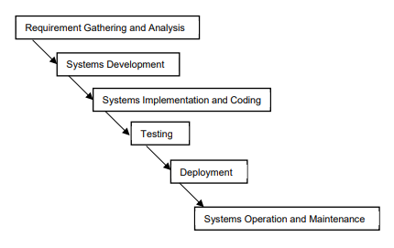
Figure 19 Waterfall Model [7]

Research Philosophy
As a language model, I cannot determine the specific details of your project. However, I can provide you with general information about positivism as a research philosophy and how it relates to quantitative data.
Positivism is a research philosophy that emphasizes empirical observation and the scientific method to test and validate theories. It assumes that the world can be studied objectively, and that data can be measured and analysed to draw conclusions. In a positivist approach, researchers collect quantitative data through structured methods such as surveys, experiments, and statistical analysis. Based on your statement, it seems that your project will use a positivist approach to measure the time it takes to complete each phase of the project. This data can be quantified and analysed to identify patterns or trends and draw conclusions about the efficiency of the project. However, it's important to note that positivism is not the only research philosophy and that other approaches, such as interpretivism, may be more appropriate depending on the research question and context.
- The number of needs that could not be fulfilled owing to constraints is also a measurable aspect that can be included in the study. This can help identify any limitations or challenges that the project faced and inform future decision-making processes.
- Throughout the testing period, of the project that adheres to the positivist research philosophy. By quantitatively measuring the number of errors found during testing, the study can provide objective data on the system's performance and identify areas that need improvement.
- In a deductive approach to research, the researcher starts with a theory or hypothesis, and then conducts research to test that theory or hypothesis. The researcher will collect quantitative data through observation, testing, and experimentation, and use statistical analysis to test the hypothesis. This approach is often used in positivist research, which aims to discover objective, universal truths about the world through empirical observation and measurement.
Inductive research is often associated with phenomenology, which aims to understand and interpret the meaning of experiences as described by individuals. This philosophy is commonly used in qualitative research and is focused on exploring subjective experiences, feelings, and perspectives of individuals, rather than measuring objective data.
In this project, using inductive research and phenomenology will allow the researcher to gain a deeper understanding of the experiences, perspectives, and opinions of individuals involved in the system development lifecycle. By collecting and analysing qualitative data, the researcher can identify themes, patterns, and insights that may not have been apparent through quantitative data analysis alone. This approach can also help to generate new hypotheses and theories, which can then be tested through further research using a deductive approach.
However, it is important to note that mixing philosophies can sometimes lead to methodological issues, such as conflicting research methods and data analysis techniques. Therefore, it is crucial to carefully consider the research question and objectives when choosing a research philosophy and to ensure that the chosen methodology aligns with the research goals.
Experimenting is sometimes referred to as a deductive technique of research, which is defined as the process of getting quantitative data by observation, experimentation, and testing. This may be seen as the act of gathering information. The findings of these tests should either confirm and support or reject the hypotheses that were developed while researching the report's literary content. This is the purpose of the project.
While it is generally not advised to mix philosophies, which involves exploring and understanding the subjective experiences and perspectives of individuals. In this approach, researchers focus on gathering rich, descriptive data through methods such as interviews, focus groups, and observations. The goal is to gain a deeper understanding of the phenomenon being studied from the perspective of those who have experienced it.
For example, in a study on the experiences of cancer patients undergoing chemotherapy, a phenomenological approach would involve conducting in-depth interviews with patients to understand their unique experiences, emotions, and perspectives related to the treatment process. The data collected would then be analysed to identify common themes and patterns that emerge from the patients' stories, providing a rich and nuanced understanding of their experiences. While phenomenology is typically associated with qualitative research, it is important to note that some researchers may incorporate elements of both deductive and inductive approaches in their work, depending on the nature of the research question and the data being collected.

Data Collection
In this section we are looking at the type of questions that will be used to find the data for mainstream and for the outliers of the information needed while not having a specific age, or gender or rank of the martial artist. To gather data for both the mainstream and outliers of the information needed, the research questions should be open-ended and designed to allow participants to provide a wide range of responses. For example:

Figure 20 Marital art form part one

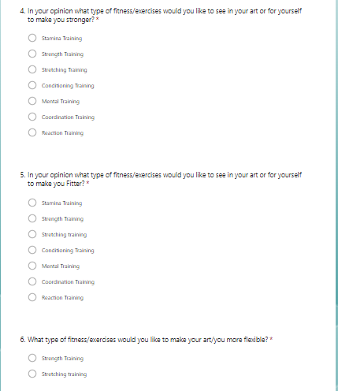
Figure 21 Marital art Form part Two
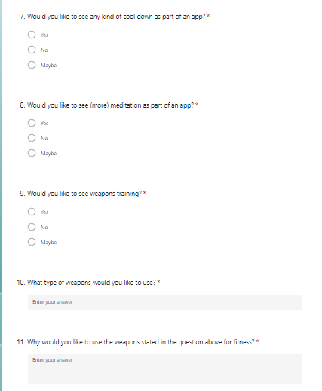
Figure 22 Marital Art form Part Three

Figure 23 Martial art form Part Four Likert Scale
These types of questions allow for a variety of answers, which can help capture both mainstream and outlier perspectives. It is also important to avoid asking questions that are too specific to age, gender, or rank, as this can limit the range of responses and potentially exclude important perspectives.

Design and Implementation

Design ERD
An Entity Relationship Diagram (ERD) is a visual representation of the entities (objects or concepts) and their relationships to each other in a database. It helps to define and organize the relationships between the tables in a database, making it easier to manage and retrieve data. Using an ERD in the basic framework for an app is a good practice to ensure that the database is organized and structured in a way that supports the app's functionality. As you mentioned, the eventual schema for the full implementation would need to be more complex to accommodate more features and data, but starting with a basic ERD is a solid foundation to build upon. It's important to note that the ERD should be regularly reviewed and updated as the app evolves, and new features are added. This will ensure that the database remains efficient and effective in supporting the app's functionality.
The provided database serves as the foundation for the app's prototype, as highlighted in the flow chart section. However, for the complete implementation, the schema would require a much more intricate structure.

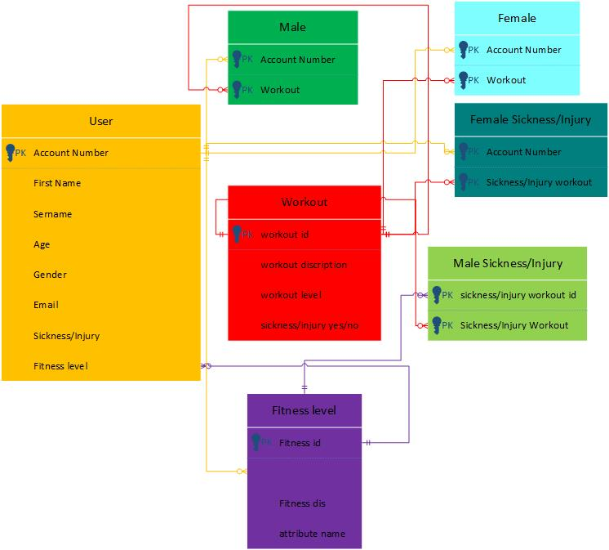
Figure 24 ERD basic data base design

Design Flow chart

It is clear that the app would require a significant amount of data and information to be stored in order to provide users with comprehensive and effective guidance on fitness and wellness. The proposed database schema is a crucial aspect of the app's development, as it would serve as the backbone for organizing and accessing all of this data. While the prototype schema may be kept simple, it is important to keep in mind the potential for scalability and expansion as the app grows and more features are added. With a robust and well-designed database schema in place, the app has the potential to offer users a personalized and effective approach to achieving their fitness and wellness goals.

Analysis

Survey-based Results

Forms results
In this section it discovered the results in the forms for what other Marital artists want in there current training or what is lacking in it to better improve them self’s and the art to which they are studding, In each art form 10 questions were given out to random men and women to fill in and this is what was found in each the survey provided some pre-development results which guided the development of the prototype :
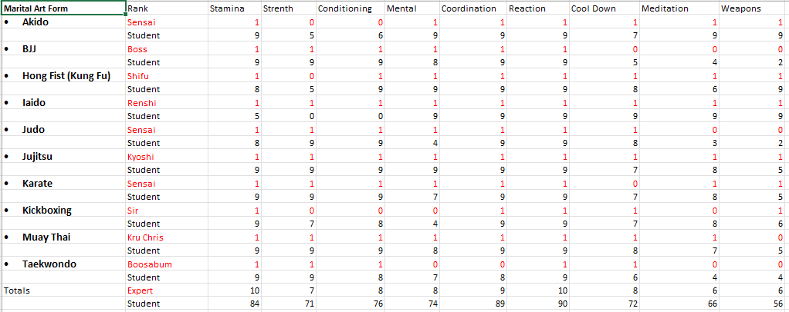
Figure 25 Results of the questionnaire
To understand what the app will initialize first, it is important to have a clear understanding of each martial art form and the specific needs and requirements of practitioners within each form. This understanding will guide the development of the app and ensure that it meets the needs of its users. For example, practitioners of Brazilian Jiu-Jitsu may have different needs than practitioners of Muay Thai or Taekwondo. Therefore, it is essential to analyse the survey results for each martial art form separately and develop specific features for each form. This will enable the app to provide personalized and tailored training plans for each user based on their martial art form and specific needs : -

Akido
Morihei Ueshiba created the Japanese martial art of Aikido at the start of the 20th century. The phrases "the way of harmonious spirit" and "the way of merging with life energy" are frequently used in translations.
Akido Instead of confronting an opponent's strike head-on with force, Aikido methods typically involve deflecting it with circular movements and joint locks. Instead, then aiming to overwhelm an opponent, the objective is to use their own force and momentum against them. Aikido stresses the development of mental and spiritual discipline in addition to physical techniques. Harmony and compassion are values that practitioners strive to develop, both for others and for oneself. Training in aikido frequently includes both solo movement and meditation practise as well as partner practise of various techniques. It is frequently seen as a martial art that places more of an emphasis on self-defence and conflict resolution than on aggression or rivalry [8].

Figure 26 Akido Table
Based on the data in the table, it appears that the students surveyed would like to see more emphasis on strength and conditioning in Aikido training. This is indicated by the high percentage of respondents (80%) who indicated that they would like to see more focus on strength and the majority of respondents (60%) who indicated that they would like to see more focus on conditioning. It is worth noting that there is relatively low agreement among respondents regarding other areas of focus, such as self-defence or sparring.

Judo
Judo is a contemporary martial art and combat sport from Japan that emphasises using the strength and movements of an adversary against them. Jigoro Kano, who researched different traditional Japanese martial arts and combined their ideas into a new system, created it in the late 19th century.
In Judo, the goal is to throw or takedown an opponent to the ground, render them immobile with a pin, or compulsorily submit them with a joint lock or chokehold. It is a highly strategic and technical sport that calls for a blend of physical prowess, mental fortitude, and tactical knowledge. Judo is practised by people of various ages and ability levels, and it's frequently taught as both a sport for competition and a means of self-defence. Techniques used in judo training include throws, joint locks, chokes, and grappling techniques. These exercises are done with a partner or an opponent and can be done standing up or on the ground. Judo places a strong emphasis on the ideas of mutual welfare and benefit, so practitioners are urged to improve both their physical and mental skills while also assisting others in doing the same. Judo contests are often broken down into weight divisions and age groups and are subject to stringent guidelines to protect the wellbeing of all competitors. In general, Judo is a demanding and gratifying martial art and sport that can boost self-confidence, mental focus, and physical health [9] [10].

Figure 27 Judo Table
In the case of Judo, respondents indicated that the martial art lacks meditation and weapons training, which used to be part of the old style of Judo during Kyuzo Mifune's time.

Jujitsu
Japanese Jujitsu, often called Jujutsu or Jiu-Jitsu, is a traditional martial art from Japan that places an emphasis on close-quarters combat moves such blows, joint locks, throws, and grappling techniques. During the feudal era, it emerged in Japan as a form of self-defence for samurai warriors.
With the help of numerous techniques, practitioners of Japanese Jujitsu can immobilise or incapacitate an adversary by learning to leverage their opponent's strength and momentum against them. Instead of concentrating on sport competition, the art places an emphasis on effective and practical strategies that can be employed in everyday settings. Training for Japanese Jujitsu combines physical preparation, technique practise, and partner or sparring drills. Students often begin by learning fundamental moves like joint locks and throws before moving on to more complex ones as they acquire experience. Japanese Jujitsu has a strong emphasis on adjusting methods to various situations and opponents rather than relying on set techniques, which is one of its defining characteristics. Because of this, practitioners must have rapid thinking and reflexes, as well as the flexibility to modify their techniques as necessary. Ultimately, Japanese jujitsu is a flexible and powerful martial art that can raise self-confidence, mental focus, and physical conditioning. It is frequently studied as a kind of self-defence by members of the military and police enforcement, and it is also practised by anyone looking for a useful type of martial arts instruction [11] [12].

Figure 28 Jujitsu Table
This particular style of Jujitsu comprehensively encompasses all facets of the questionnaire, leaving no stone unturned in its pursuit of a thorough and rigorous approach.

BJJ
Brazilian Jiu-Jitsu, sometimes known as BJJ, is a martial art and combat sport that places a focus on grappling and ground fighting tactics. Although it originated from the conventional Japanese forms of Jujitsu and Judo, it has subsequently acquired a distinctive style and set of moves.
The goal in BJJ is to take an opponent to the ground, control them, or compel them to submit using grappling manoeuvres. It's an extremely technical sport that calls for a balance of physical stamina, suppleness, and analytical thinking. In BJJ training, a range of techniques are learned and performed in both standing and ground positions, including joint locks, chokes, and different grappling methods. BJJ emphasises ground fighting and submission holds, in contrast to other martial arts that predominantly emphasis striking techniques, making it a very effective martial art for self-defence and in competition. BJJ practitioners frequently train in gis, or traditional martial arts garb, and employ a belt system to denote experience and rank. To ensure safety and fairness, competitions are often broken down by weight class and rank and adhere to tight rules and regulations. Because BJJ practitioners must be able to endure lengthy training sessions and use strategy and problem-solving abilities to defeat opponents, the sport is also renowned for emphasising physical fitness and mental discipline. People of various ages and ability levels, from recreational practitioners to competitive combatants, engage in this well-liked martial art and combat sport [13].

Figure 29 BJJ Table
According to the data collected in the table on Brazilian Jiu-Jitsu (BJJ), the students expressed a desire for an expanded cool-down period that includes meditation as well as some introductory training in basic weapons techniques. This information suggests that incorporating these elements into the curriculum may enhance the overall training experience for BJJ students.

Kickboxing
Kickboxing is a combat sport and martial art that mixes Western-style boxing skills with components of traditional martial arts like Karate and Muay Thai. It is often practised in a ring, or another contained environment and involves punching, kicking, and kneeing an opponent.
In kickboxing, fighters are separated into weight classes and engage in three-minute bouts of combat. When a fighter strikes an opponent, points are awarded, and the winner may be determined by decision, technical knockout, or knockout. Training for kickboxing frequently include physical preparation, technique practise, and sparring or partner drills. With conditioning workouts, practitioners build their physical strength, agility, and endurance as well as a variety of striking and defence skills. As kickboxing teaches practitioners how to strike efficiently and protect against attacks, it is frequently employed as a self-defence training method. Several organisations hold events and competitions worldwide in this well-liked style of martial arts competition. In general, kickboxing is a demanding and gratifying martial art and combat sport that can boost self-confidence, mental focus, and physical conditioning. People of various ages and skill levels, from amateur enthusiasts to professional combatants, engage in it [14] [15].

Figure 30 Kickboxing Table
As per the findings in the table analysing the feedback from kickboxing students, there was a notable request for a greater emphasis on strength training and contact conditioning, coupled with an increased focus on mental training. These results suggest that incorporating targeted programming to develop these areas could potentially enhance the overall training experience for students in kickboxing.

Hong Fist (Kung Fu)
Traditional Chinese martial art known as Kung Fu (sometimes spelled Gong Fu) includes a variety of methods and stances. It has a lengthy history and has had a huge impact on numerous different martial arts all over the world.
Practitioners of Kung Fu are taught a variety of striking, kicking, grappling, and joint-locking techniques as well as instruction in using weapons. Using an opponent's power and movements against them, practitioners of this technique focus on efficiency, adaptability, and flexibility. Training in kung fu frequently combines physical preparation, technical practise, and partner or sparring drills. Forms, which are organised sequences of motions that mimic fighting scenarios, are another thing that students can master. Kung Fu is an all-around adaptable and powerful martial art that can boost self-confidence, mental focus, and physical fitness. It's importance to culture and history, as well as for self-defence, are frequently explored [16].

Figure 31 Hong Fist Table
The data obtained from the analysis of Hong Fist training program indicates a dearth of strength training components. In light of this, the students have expressed a desire for a more robust strength training regimen to be incorporated into the program. Addressing this concern may potentially augment the training experience and overall proficiency of students in Hong Fist.

Iaido
Iaido is a Japanese martial art that focuses on practising simultaneous sword drawing and use. Iai, which means "to draw," and do, which means "way" or "path," combine to form the word "Iaido."
By the practise of techniques for utilising a sword in various settings, or "Zanshin," the aim of Iaido is to reach a state of total mental and physical readiness. Although it can be performed with a partner or in a group, it is frequently practised alone. Iaido techniques often entail taking the sword from its scabbard, striking a fictitious foe, and then swiftly and smoothly re-sheathing the weapon. Practitioners gain a greater feeling of awareness, control, and discipline via this exercise. Iaido is performed to develop a calm and concentrated mind in addition to its martial qualities. It is regarded as a type of meditation. Because to the discipline, respect, and humility required by the practise, it is frequently seen as a technique to build character. Iaido is practised in a variety of schools or styles, each with unique methods and customs. The most well-known schools are Seitei Iaido, Muso Shinden Ryu, and Muso Jikiden Eishin Ryu. Iaido is a martial art that focuses on both the improvement of physical skill and technique as well as the cultivation of inner peace and control [17].

Figure 32 Iaido Table
An analysis of the data gathered from the Iaido table highlights a significant deficiency in the program's strength and physical conditioning components. The findings reveal a noteworthy absence of targeted exercises aimed at enhancing physical endurance, muscular strength, and flexibility. Addressing this deficiency in the Iaido curriculum may lead to improvements in students' physical abilities and overall performance in the art.

Taekwondo
The main emphasis of the Korean martial art of taekwondo is on kicking techniques. Three letters make up the word "Taekwondo": "Tae" denotes a foot or leg, "Kwon" denotes a fist or hand, and "Do" denotes a method or path. They stand for using one's hands and feet to defend oneself as a unit.
Fast, dynamic, and forceful kicks, as well as numerous hand strikes and blocks, are all hallmarks of taekwondo. Also, it stresses the value of maintaining good physical and mental health as well as respect for others and oneself. Taekwondo was created as a means of self-defence in the Korean military, where it has its roots. Since then, it has developed into a well-liked martial art and sport that is practised by individuals of all ages and skill levels worldwide. Practitioners of Taekwondo study a range of moves, including as punches, kicks, strikes, and blocks. They also learn "patterns," or forms, which are sequences of predetermined motions that act as fights against fictitious foes. Competitive There are competitions in taekwondo at the local, national, and international levels. Athletes in taekwondo engage in sparring and forms contests in several categories based on their age, gender, and degree of proficiency. All things considered, Taekwondo is a martial art that places a strong emphasis on the development of physical prowess and skill, as well as morality and respect. It is a demanding and satisfying practise that has the potential to improve practitioners' lives in many ways [18] [19].

Figure 33 Taekwondo Table
The table analysing the various martial arts styles reveals a conspicuous number of aspects that are perceived to be lacking by the students. The data collected highlights a considerable gap between the existing training program and the students' expectations, with numerous deficiencies in various aspects of the styles identified. Addressing these inadequacies may potentially lead to a more comprehensive and fulfilling training experience for students in these styles.

Muay Thai
Thai boxing, usually referred to as Muay Thai, is a combat sport and martial art that has its roots in Thailand. It is well renowned for its strong punches, kicks, elbows, and knee strikes.
Given that it places a strong emphasis on both striking and clinching techniques, muay Thai is frequently regarded as one of the most effective and useful martial arts for self-defence. Muay Thai fighters develop their self-defence skills as well as their ability to strike their opponents with deadly blows. Muay Thai has many utilitarian applications, but it's also a well-liked competitive sport. Muay Thai competitors engage in competitive matches, frequently in a ring, and prevail via knockout or points. To ensure safety, weight classes are used to group fighters, and rules are established for each encounter. Techniques including punches, kicks, knees, and elbows, as well as clinching and grappling methods, are frequently used in Muay Thai training. To hone their skills and tactics, practitioners also practise in shadowboxing, pad work, bag work, and sparring. Strength, conditioning, and endurance are stressed during muay Thai training, which is noted for its intensity and physical demands. The importance of mental toughness is also emphasised because great fighters must be able to endure discomfort and exhaustion. In general, Muay Thai is a martial art and combat sport that places a focus on skills for hitting and clinching. It is a well-liked competitive sport all over the world and is well-known for its practical self-defence applications as well as its strenuous physical requirements [20].

Figure 34 Muay Thai Table
Classical Muay Thai is distinguished by its notable emphasis on weapon usage, a practice that is not as prominent in western martial arts styles. The data collected from students indicates a desire for a stronger connection to the traditional techniques and practices of the old styles, particularly with regards to weapons training. Addressing this request may potentially enhance the students' appreciation and understanding of classical Muay Thai while providing a more comprehensive training experience.

Karate
Martial arts like karate, which began in Okinawa, Japan, are today practised all over the world. Due to the fact that practitioners utilise their hands and feet as weapons, the word "karate" literally translates to "empty hand."
Punches, kicks, knee, and elbow strikes are just a few of the striking methods used in karate. In order to protect against attacks, it also involves blocking and evasive methods. Karate has a strong emphasis on mental discipline, respect, and self-control in addition to its physical components. Karate practitioners are urged to abide by a code of ethics called as the "Dojo Kun" in order to cultivate a strong spirit and a sense of humility. There are numerous types of karate, each with unique methods and customs. Shotokan, Goju-Ryu, Shito-Ryu, and Wado-Ryu are some of the most well-known styles. Karate training normally consists of a variety of methods, such as fundamental body motions, forms (commonly referred to as kata), sparring, and self-defence moves. By practising a variety of drills and exercises, practitioners also seek to increase their level of physical fitness and mental concentration. Karate is another well-liked competitive activity, and local, national, and international competitions are held in it. Karate competitors compete in both sparring and forms contests and are divided into many categories according on their age, gender, and degree of proficiency. Ultimately, Karate is a martial art that places a focus on both mental focus and respect, as well as physical power and technique. It is a demanding and satisfying practise that has the potential to improve practitioners' lives in many ways [21] [22].

Figure 35 Karate Table
Karate, as presently structured, lacks a substantive cool-down period, as observed from the data collected. However, a significant number of students have expressed a desire for an extended cool-down period to be included in the program. Addressing this feedback by incorporating targeted cool-down exercises may potentially enhance the overall training experience and physical recovery of students in Karate.

The total amount across the board

Figure 36 All Martial Arts Table

Research Conclusion
In conclusion, the analysis of the data from the various martial arts styles reveals that there are significant areas for improvement in the training programs. Specifically, the majority of students surveyed in Aikido, Judo, BJJ, kickboxing, Hong Fist, and Iaido expressed a desire for greater emphasis on strength and conditioning training. Additionally, there were requests for specific elements such as meditation, weapons training, and cool-down periods. The data collected underscores the importance of incorporating these elements into the training programs to enhance the overall training experience for students. Addressing these inadequacies may potentially lead to a more comprehensive and fulfilling training experience, as well as improve the physical abilities and performance of students in these martial arts styles.

CODE

Index Code
<!DOCTYPE html>
<?php
// Database configuration
$servername = "localhost";
$username = "root";
$password = "";
$dbname = "fitness_db";
// Create a database connection
$conn = mysqli_connect($servername, $username, $password, $dbname);

// Check if connection was successful
if (!$conn) { die("Connection failed: " . mysqli_connect_error());
}
?>
<html>
<head>
<title>Login</title>
</head>
<body>
<h1>Login</h1>
<?php if (isset($error)) { ?>
<p style="color: red;"><?php echo $error; ?></p>
<?php } ?>
<form method="post" action="">
<label for="password">Username:</label>
<input type="text" id="uid" name="uid" required><br>
<label for="password">Password:</label>
<input type="password" id="userPassword" name="userPassword" required><br>
<input type="submit" name="submit" value="Login">
</form>
</body>
</html>
<?php
// Check if login form was submitted
if (isset($_POST['submit'])) {
$uid = $_POST['uid'];
$userPassword = $_POST['userPassword'];
// Query to check if user exists in the database
$sql = "SELECT * FROM users WHERE username= '$uid'";
$result = mysqli_query($conn, $sql);
// Check if user exists and password is correct
if (mysqli_num_rows($result) > 0) {
$row = mysqli_fetch_assoc($result);
$un=$row['username'];
$pw=$row['userpassword'];
echo $un.$pw;
if (($uid==$un)&&($pw==$userPassword)) {
// Login successful, redirect to home page
header("Location: about.php");
exit();
} else {
// Password is incorrect
$error = "Incorrect password";
}
} else {
// User does not exist
$error = "User does not exist";
}
}
// Close database connection
mysqli_close($conn);
?>

Index
The code for the header file that establishes the connection to the database is the first thing in the code. The login form then appears with two fields for the username and password. To ensure that both fields are filled in before submission, the form additionally has validation. The PHP code runs a SELECT query to see if the username is present in the database after the form has been submitted. The code then verifies whether the provided password matches the user's stored password if the query returns a record, indicating that the user is real and therefore exists. The user is taken to the home page if the password matches; otherwise, an error message indicating that the password is invalid is displayed.
It should be noted that this code is merely a simple illustration and shouldn't be used in production without additional security safeguards, such as the usage of prepared statements to thwart SQL injection attacks. This example's HTML code generates a straightforward login form. It has a submit button and two input fields, one for the username and one for the password. The POST method is used by the form to transmit data to the server for processing. Additionally, the page will provide an error notice if there is a problem with the login procedure.
By examining if the submit button was pressed, the PHP code first determines whether the login form was submitted. If so, it uses the $_POST superglobal to extract the username and password from the form. After that, a database SELECT query is run to see if the entered username already exists in the "users" table. The PHP code fetches the password saved for that username from the database and checks to see whether it matches the entered password if the query returns a response, which indicates that the entered username is present in the database. The user is taken to the main page if their passwords match.
After a successful login, the user is forwarded to the home page by the browser using the header() function, which sends a raw HTTP header to the browser. After the redirect header has been transmitted to the browser, the current script is terminated using the exit() function. The PHP code uses the $error variable to set an error message if either the username or password are incorrect. PHP's echo statement is used in an if block to display this error message in the HTML code. If $error is set to a value, a paragraph element with the error message highlighted in red is displayed. Keep in mind that the code must avoid SQL injection attacks, prepared statements should be utilised rather than directly concatenating variables in the SQL query. In order to bind variables to the query at runtime and prevent harmful SQL code injection by attackers, prepared statements can be used with placeholders. Similarly, before being entered into the database, passwords should be hashed with a safe technique. Even if they gain access to the database, attackers will find it far more difficult to acquire passwords as a result.
To prevent SQL injection attacks, the code could be modified with prepared statements. Additionally, to increase security, the password should be hashed before being stored in the database.

About Code
<?php
include_once 'headder.php';
?>
<section class="about">

<h2 style="color:green;
text-align: center;
font-size:50px;">The About page!!</h2>
<h1 style="color:green;
text-align: center;
font-size:40px;"> This page talks about what the app can do for people</h1>
<p style="color:green;
text-align: center;
font-size:30px;">This page explanins how to add yourself and train with whatever level in the Marital Arts you want with days and times!</
</section>

About
The "header.php" file, which probably comprises the header area of the website, contains PHP code. Then, it uses HTML markup to add a "About" section to the page and inline CSS to style it. With headings and paragraphs to organise the content, the "About" part of the app contains details about the app and how to use it. The material on the website's "About" page is rendered thanks to this code.

Figure 37 About page
It appears that this screenshot serves as a placeholder, using the Hei Jo Shin Jujitsu logo as an example of where the logo would be placed in the app. The about page, on the other hand, would feature a wide range of information about the app, including pictures, written descriptions, and even gifs to help convey the various types of training involved. Overall, the about page would serve as an important source of information for potential users, providing a comprehensive overview of the app's features and capabilities.

Signup Code
<!DOCTYPE html>
<html lang="en">
<head>
<meta charset="UTF-8">
<meta name="viewport" content="width=device-width, initial-scale=1.0">
<title>Fitness Menu</title>
</head>
<body>
<h1>Fitness Menu</h1>
<form action="submit.php" method="post">
<label for="surname">Surname:</label>
<input type="text" name="surname" required><br>
<label for="forename">Forename:</label>
<input type="text" name="forename" required><br>
<label for="age">Age:</label>
<input type="number" name="age" required><br>
<label for="gender">Gender:</label>
<select name="gender" required>
<option value="male">Male</option>
<option value="female">Female</option>
<option value="other">Other</option>
</select><br>
<label for="email">Email:</label>
<input type="email" name="email" required><br>
<label for="health_status">Health Status:</label>
<select name="health_status" required>
<option value="sick">Sick</option>
<option value="injured">Injured</option>
<option value="healthy">Healthy</option>
</select><br>
<label for="fitness_level">Fitness Level:</label>
<select name="fitness_level" required>
<option value="starter">Starter</option>
<option value="intermediate">Intermediate</option>
<option value="advanced">Advanced</option>
</select><br>
<input type="submit" value="Submit">
</form>
</body>
</html>

Signup
Multiple input fields with labels are included in the HTML code for the form. While the "email" field is of the "email" type, the "name," "age," and "gender" fields are of the "text" type. The "health status" and "fitness level" fields are of the "radio" kind, and the user can choose from a variety of possibilities. The form additionally has a "submit" button that the user can click to submit their information in addition to the input fields. The "POST" method is used by the form to send data to the "submit.php" script for processing. To make sure that the data is in the right format and that all needed fields are filled out, the PHP script that processes the form data should do validation on the input. The script can then use the user's information to carry out another action or store the data in a database. To preserve the user's privacy, it's crucial to make sure that any sensitive information, such the user's email address, is handled securely. The "required" attribute on the form element ensures that the user fills out all fields before submitting the form. Additionally, the "action" element is set to "submit.php," which indicates that when a user clicks the submit button, the form data will be passed to the "submit.php" script.
The PHP script "submit.php" handles processing the form data once the user presses the submit button. The PHP script accepts the form data using the HTTP POST method, processes it as needed, such as validating and sanitising it, and then stores the data in a database or takes other actions. The "submit.php" PHP script receives the form data once the user submits their input. Using the supplied credentials, the script establishes a connection to a database called "fitness_db". The user's data is then inserted into the database's "users" table. The script then outputs a screen based on the user's health. A screen labelled "Sickness/Injury Screen" is shown if the user is ill or hurt. If not, a screen with the title "Healthy Screen" is shown.
In conclusion, this HTML website offers a form for customers to fill out and send their personal data to a PHP script for processing. Based on the user's health, the PHP script displays the appropriate screen after storing the data in a database.
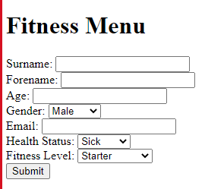
Figure 38 Sign up page.
This page serves as a blank canvas for the front-end programmer to add a splash of colours and creativity, making it more visually appealing and captivating to the user's eyes. The page will be designed to be cantered and spaced out more, giving it a more polished and aesthetic look.

Figure 39 Sickness/Injury screen.
In this screen, users who are sick or injured will find a comprehensive guide on what foods and drinks to consume, as well as recommended training based on their specific illness or injury. The workout plan is designed to gradually ease them back into fitness and aid in their recovery process.

Figure 40 The Healthy screen
This screen provides a detailed overview of the diet and training program for both healthy and advanced users. Users can access information on the specific foods to eat, the recommended quantity of water to drink, and the type of training that will help them achieve their fitness goals. The workout plan is designed to be implemented on a day-to-day basis, with gradually increasing levels of intensity to help users progress towards their fitness goals. Overall, this screen offers a comprehensive approach to health and fitness, catering to both beginner and advanced users.

Submit Code
<?php
// Database connection
$servername = "localhost";
$username = "root";
$password = "";
$dbname = "fitness_db";
$conn = new mysqli($servername, $username, $password, $dbname);
if ($conn->connect_error) {
die("Connection failed: " . $conn->connect_error);
}
// Insert user data into the database
$sql =

"INSERT INTO users (surname, forename, age, gender, email, health_status, fitness_level) VALUES (?, ?, ?, ?, ?, ?, ?)";
$stmt = $conn->prepare($sql);
$stmt->bind_param("ssissss", $surname, $forename, $age, $gender, $email, $health_status, $fitness_level);
$surname = $_POST['surname'];
$forename = $_POST['forename'];
$age = $_POST['age']; $gender = $_POST['gender'];
$email = $_POST['email'];
$health_status = $_POST['health_status'];
$fitness_level = $_POST['fitness_level'];
$stmt->execute();
//Display the appropriate screen based on the health status
if ($health_status == 'sick' || $health_status == 'injured') { echo "<h1>Sickness/Injury Screen</h1>"; } else { echo "<h1>Healthy Screen</h1>"; }
//Close the database connection
$stmt->close(); $conn->close(); ?>

Submit
This PHP code is in charge of taking user information from an HTML form and adding it to a MySQL database. The first line of code defines the credentials for connecting to the database and creates a mysql connection. The script displays an error message and terminates execution if the connection fails. The script then creates a SQL statement to add the user data to the database's "users" table. The user's surname, first name, age, gender, email, health status, and degree of fitness are all placeholders in the statement. Using the bind_param() function, the script then associates these placeholders with the real values entered by the user into the HTML form. The script then uses the $_POST superglobal array to retrieve the data from the form fields before executing the SQL statement with the execute() method. This updates the database with the user's info.
The script then does a last health check on the user before displaying the proper screen in accordance with that state. The "Sickness/Injury Screen" is shown if the user is ill or hurt. If not, the "Healthy Screen" is shown. The prepared statement and database connection are then both closed by the script.
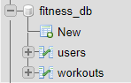
Figure 41 SQL database

Figure 42 SQL database branches
Figure 43 SQL user information
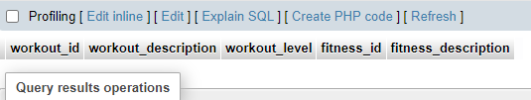
Figure 44 SQL workout branch

Login Code
<section class="login">
<h2>Login</h2>
<div class="login-form-form">
<form action="login.inc.php" method="post">
<input type="text" name="uid" placeholder="Username...">
<input type="text" name="userPassword" placeholder="Password...">
<button type="Submit" name="Submit">Login</button>
</form>
</div>
</section>

Login
The website's login form is displayed in this HTML part. The user can enter their username and password in the form's two input areas. When a user clicks the "Login" button, the form is sent to the PHP script "login.inc.php". The login form is contained within a "login" area, which gives the user a visual clue that this component relates to the website's login feature. To further emphasise the form's intended use, a heading with the word "Login" is included in the section. The form's input fields feature placeholder text that indicates what the user should enter in each field. The user will find it simpler to comprehend what information is required of them as a result.
Overall, the website's login form is made simple and user-friendly by this HTML part.

Figure 45 The Login page.
This is a basic login screen designed for testing purposes. The final login screen will be more visually appealing and user-friendly and will be designed by the front-end programmer.

Header Code
<!DOCTYPE html>
<html lang= "en" dir="ltr">
<head>
<meta charset="utf-8">
<title>Martial Art Fitness</title>
</head>
<body>
<nav>
<div class="wrapper">
<table>
<tr>
<td>
<img src="logo.png" alt= "blog logo"/>
</td>
<td>
<a href="about.php">About </a>
</td>
<td>
<a href="signup.php">Sign up </a>
</td>
<td>
<a href="index.php">Login </a>
</td>
</tr>
</table>
</div>
</nav>
<div class="wrapper">

Header
This is the start of an HTML webpage that includes a navigation menu with links to various pages on the website. The logo of the website is also displayed in the menu. The webpage is titled "Martial Art Fitness" and has an initial structure created with the use of a wrapper. The actual content of the page is yet to be added.

Conclusion
In conclusion, the development of this app will involve a significant amount of data collection due to the comprehensive information required, including the following:
- Medical information provided by specialized doctors, such as those specializing in sickness and illnesses, physical therapy, or chiropractic care, to ensure that users receive accurate and reliable medical advice.
- Nutritional information provided by a qualified nutritionist with knowledge of healthy food options and budget-friendly alternatives to accommodate users with financial constraints, while also being mindful of potential food allergies and dietary restrictions.
- Physical fitness information provided by experienced martial artists in multiple forms of martial arts to provide a comprehensive approach to physical activity.
- Meditation techniques and practices provided by a yogi to help users manage their mental health and reduce stress levels.
- A full list of L.I.F.T (Low Intensity Fitness Training) exercises will be included in the app, along with modifications to accommodate users with injuries or physical limitations. The list will provide a range of exercises that are low-intensity and accessible for individuals with varying fitness levels, including those who may be recovering from an injury or have a medical condition that limits their physical activity.
- A fitness instructor for The app will provide a full list of training exercises for both normal and very experienced users. The list will include a range of exercises designed to accommodate varying fitness levels, from beginner to advanced, with modifications and progressions provided to challenge users as they improve their fitness. The exercises will also be categorized based on the user's level of experience to ensure that each user is challenged appropriately and can progress at their own pace.
To ensure that the app is effective and user-friendly, a team of programmers and coders will be essential to develop, test, and optimize the app's performance.

Summary
To ensure that the app contains all necessary information at a basic level, it would be essential to employ specialized doctors, such as a doctor specializing in sickness and illnesses and a doctor with a physical specialty, or a chiropractor or physiotherapist, to gain a well-rounded understanding of the medical aspects. A nutritionist with knowledge of both healthy food options and budget-friendly options for those with financial constraints would also be necessary. Additionally, the nutritionist would need to have extensive knowledge of the potential dangers of the recommended food choices. A yogi could be involved to assist with the meditation side of the app. Furthermore, at least two martial artists who are top experts in multiple forms of martial arts and have at least 20 years of experience in each form should be included to ensure a comprehensive approach to physical fitness. Finally, a team of programmers and coders would be necessary to develop and test the app.

Recommendations for Further Research
If experts in their respective fields are unable to form a committee, an alternative option could be to use AI technology to monitor app users. With the advancements in AI, it is now possible for an AI system to monitor user activity and retrieve relevant information from the internet within seconds.

Reflection
The development of a comprehensive health and fitness app requires the involvement of experts in various fields, such as specialized doctors, nutritionists, martial artists, and programmers. This team of professionals would provide a well-rounded understanding of the medical and physical aspects necessary to ensure that the app contains all the required information at a basic level.
To achieve this, the team would need a doctor specializing in sickness and illnesses, and another doctor with a physical specialty, such as a chiropractor or physiotherapist. Additionally, a nutritionist with knowledge of healthy and budget-friendly food options would be necessary, along with extensive knowledge of potential dangers associated with certain foods. A yogi could also be included to assist with the meditation aspect of the app. Furthermore, at least two martial artists with top-level expertise in multiple forms of martial arts and a minimum of 20 years of experience in each form should be included to ensure a comprehensive approach to physical fitness. Finally, a team of programmers and coders would be required to develop and test the app.
In the absence of a committee of experts, an alternative option could be to use AI technology to monitor app users. With advancements in AI technology, it is possible for an AI system to monitor user activity and retrieve relevant information from the internet within seconds.
After six months of examining the amount of information required to develop a functional app, it was determined that a minimum of six months of testing would be necessary for users to observe improvements in both their physical and mental health. Overall, the development of a comprehensive health and fitness app requires the involvement of experts in multiple fields and a considerable amount of time and testing to ensure its efficacy.

Bibliography

[1] | play.google.com, “play.google.com,” [Online]. Available: https://play.google.com/. [Accessed 22 10 12].
[2] | lightinthebox.com, “lightinthebox.com,” MiniInTheBox.com, [Online]. Available: https://www.lightinthebox.com/. [Accessed 22 10 12].
[3] | A. Müller, “The importance of breathing during exercise.,” in Sport und Gesellschaft, (2016).
[4] | K. S. P. Newman, Writer, Hei Jo Shin Jujitsu. [Performance].
[5] | S. W. VANDERSTOEP, “RESEARCH METHODS FOR EVERYDAY LIFE,” in RESEARCH METHODS, Published by Jossey-Bass, 2009.
[6] | M. N. SAUNDERS, “Research Methods for business,” in Research Methods , pearson, 2019.
[7] | M. Kramer, “BEST PRACTICES IN SYSTEMS DEVELOPMENT LIFECYCLE: AN ANALYSES BASED ON THE WATERFALL MODEL,” Review of Business & Finance Studies, pp. 79-84, 2018.
[8] | G. Shioda, “Aikido,” in Aikido: The Master Course.
[9] | R. Stevens, “Judo,” in The Fundamentals of Judo.
[10] | N. Adams, “Judo,” in Life in Judo.
[11] | W. Jay, “Jujitsu,” in Small-circle Jujitsu.
[12] | N. Higashi, “Jujitsu,” in Kokushi-Ryu Jujitsu.
[13] | R. Gracie, “BJJ,” in Mastering Jujitsu.
[14] | C. Delp, “Kickboxing,” in Kickboxing.
[15] | J. Ritschel, “Kickboxing,” in The Kickboxing Handbook.
[16] | W. K. Kit, “Art of Shaolin Kung Fu,” in The enlightenment.
[17] | in The Art of Japanese Swordsmanship.
[18] | D. Cook, “Taekwondo,” in Taekwondo.
[19] | K. Hornsey, “Taekwondo,” in Old Taekwondo.
[20] | E. Krauss, “Muay Thai,” in Muay Thai Unleashed.
[21] | D. Mitchell, “Karate,” in Karate.
[22] | B. A. Haines, “Karate,” in Karate's History and Traditions.

