Construction Portfolio: Structural Performance of Reinforced Concrete in the Barbican Estate
Written by Seren Adams
Student ID: 2502932
Date: 9th March 2026
Word Count: 2030

Table of Contents

Title Page………………………………………………………………………………………………….1
Table of Contents……………………………………………………………………………………….2
Introduction……………………………………………………………………………………………….3
Original Design & Method of Construction………………………………………………………4
Analysis of Framing Material……………………………………………………………………….5-8
Negative Impact of Concrete Production on the Community and Environment…….9
Conclusion……………………………………………………………………………………………….10
Part 4- Maths…………………………………………………………………………………………….11-12
References……………………………………………………………………………………………13-14

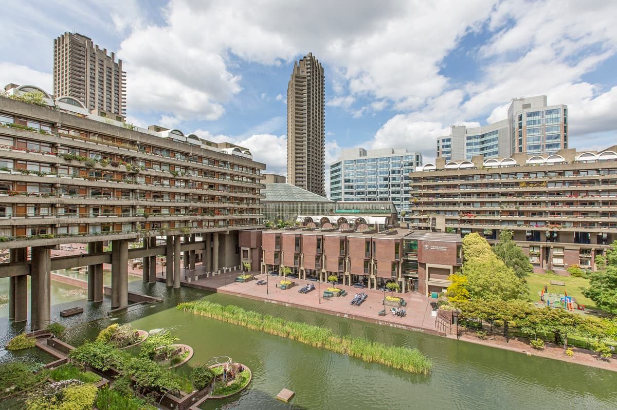
The Barbican Estate, London.

Figure 1. Image to show the Barbican Estate (The Standard, 2019).

- Introduction
The Barbican Estate, located in the city of London, is a large mixed-use residential and cultural development. The scale and layout of the development, including its residential towers and podium structure, can be seen in Figure 1. Designed by architects Chamberlin, Powell and Bon as a post- war regeneration project during the mid-1960s the estate took 11 years to complete. Today, it is home to more than 4,000 residents, across over 2,060 flats, and features an elevated podium walkway alongside a major arts centre (City of London, 2025).
Reinforced concrete was chosen as the primary structural material, offering the strength and durability needed for such a large, ambitious project. At the time, it also provided an economical solution, as labour costs were relatively low and concrete suited the scale of construction. The estates architectural and historical significance has since earned its Grade II listed status. (Barbican Living, n.d.).
This report examines the original design and construction methods of the Barbican Estate, focusing on the performance of the reinforced concrete frame, and considers key factors such as structural behaviour, durability, resistance to weathering, construction efficiency and the integration of building services. Additionally, the report explores lifecycle challenges including adaptation, refurbishment and eventual demolition, while reflecting on the environmental implications surrounding concrete production and use.

- Original Design & Method of Construction
Reinforced concrete was chosen as the core framing material for the Barbican Estate due to its high compressive strength, fire resistance and ability to be shaped into complex architectural forms. The estate comprises several towers and terrace blocks, therefore construction efficiency was a priority. Using concrete allowed repetitive structural grids to be formed, simplifying construction while maintaining durability. Its heavy weight also provides excellent acoustic separation, which is particularly important in high- density residential developments (Linda Clarke, 2012)
The terrace buildings feature a simple reinforced concrete structure. Load- bearing cross walls were used to support vertical loads, which reduced construction complexity, saved time, and lowered costs. Junctions between the walls and slabs provided longitudinal stability, as the stiffness of these connections reinforced the blocks (Barbican Living, n.d.).
In contrast, the towers were constructed using a reinforced concrete frame combined with load- bearing cross and shear walls. This arrangement distributes vertical loads through the floor slabs into the walls, which are then transferred to the pile foundations. The shear walls also provide lateral stability, helping the towers resist wind forces. Beneath the residential blocks lies a podium structure constructed from large reinforced concrete slabs and beams. The podium is designed to support not just the residential loads but also public facilities such as car parks and service areas below (Barbican Living, n.d.)
Due to the site’s post-war history, including areas affected by bombing, a sturdy foundation solution was required. The estate is supported by bored reinforced concrete pile foundations, extending to stable strata below ground level. These foundations transfer loads from the superstructure through a pile cap into deep concrete piles embedded in stronger soil layers, as illustrated in Figure 2. (City of London, 2025).
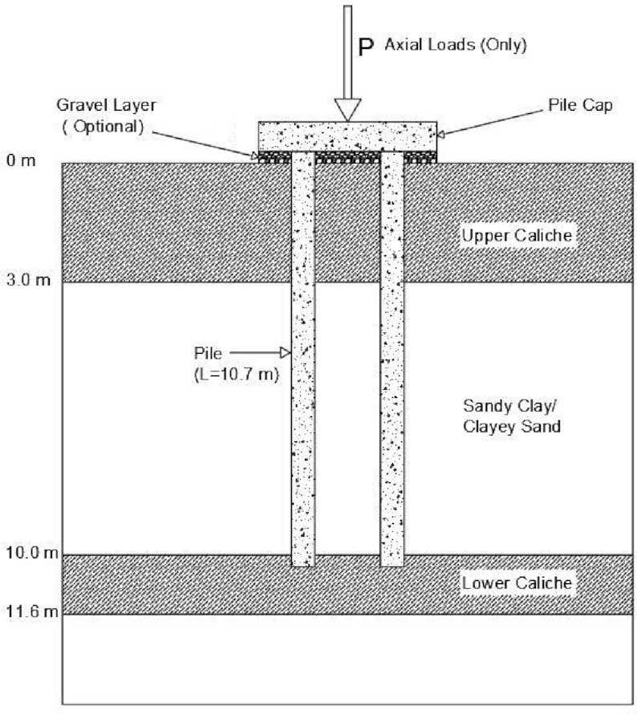

Figure 2- typical bored reinforced concrete pile foundation transferring structural loads to stable ground.

3. Analysis of the Framing Material
3.1 Strength, durability & Climatic Resistance
Reinforced concrete was selected for the Barbican estate due to its high compressive strength, durability, and suitability for exposed urban environments. When combined with steel reinforcement, it can resist both compressive and tensile forces, allowing slabs, beams, and walls to act together as a stable structural system, as shown in Figure 3. This makes it particularly suitable for large scale residential developments where long-term reliability is essential. (Designing Buildings Ltd, 2023).
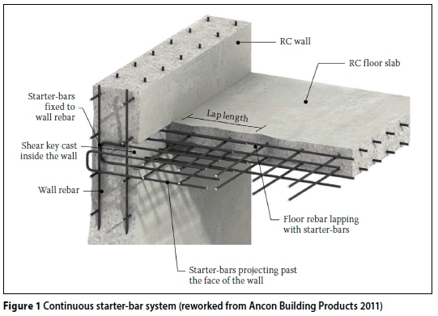
Figure 3- Reinforced concrete section showing steel reinforcement resisting tensile forces while concrete resists compression.

Reinforced concrete also offers strong fire resistances as it protects embedded steel and retains structural integrity longer than steel in high temperatures (Designing Buildings Ltd, 2023). This advantage would have been especially valuable in post war housing design, when fire safety considerations were becoming increasingly important. Its mass also improves acoustic performance by reducing sound transmission between dwellings (Designing Buildings Ltd, 2023).
However, the long-term performance of reinforced concrete depends heavily on environmental conditions and ongoing maintenance. At the Barbican Estate, much of the concrete was intentionally left exposed as part of its Brutalist design (Barbican Living, n.d.), which increases its vulnerability to weathering. One of the main issues is carbonation, where carbon dioxide from the air reacts with the concrete and reduces its alkalinity. Over time, this can allow the steel reinforcement to corrode. As the steel expands, it can crack the surrounding concrete, leading to both structural and visual damage (Designing Buildings Ltd, 2023).
Located in central London, the estate is exposed to high moisture levels, urban pollution, and fluctuating temperatures. These conditions can accelerate deterioration by increasing concrete permeability and promoting chemical reactions within the material (Designing Buildings Ltd, 2023). Consequently, exposed concrete structures from the post- war period often require periodic repair to address staining, surface degradation, and reinforcement corrosion, particularly in polluted urban settings. This demonstrates that although reinforced concrete can achieve a long service life, its performance depends on ongoing inspection, maintenance, and timely repair intervention (CRSI, n.d.).
Overall, the Barbican estate illustrates both the strengths and limitations of reinforced concrete as a framing material. Its high load-bearing capacity, fire resistance and longevity made it well suited to the large-scale residential development (CRSI, n.d.). Nevertheless, prolonged exposure to moisture, pollution, and carbonation highlights the importance of long- term maintenance planning when reinforced concrete is used in urban environments.
3.2 Time, Labour, Programme and Cost Compared with Steel Framing
Reflecting both the scale and complexity of the Barbican Estate, construction was carried out in multiple phases between the 1960s and the late 70s.
The use of in- situ reinforced concrete contributed to the long construction period, as this method is generally slower compared to steel framing. Steel structures are often prefabricated off- site and then assembled rapidly on site (Structural Guide, n.d.), whereas concrete construction involves several stages, including formwork, reinforcement placement, pouring, and curing at each level. These steps take time, which is why steel is often preferred in modern construction where speed is important (Structural Guide, n.d.) In addition, steel framing can allow for larger spans and more flexible layouts, making future modifications easier.
However, the use of concrete was viable at the time of construction as labour costs in the UK were much lower and concrete was considered as one of the most suitable options economically for large scale housing developments (GZ Industrial Supplies,2024).
From a long- lasting lifecycle perspective, concrete structures often provide cost benefits through their durability, fire resistance and less need for applied fire protection compared to a steel frame (CRSI, n.d.). Although, when evaluating long- term value, damage due to weathering and reinforcement corrosion are factors which must be considered as these have associated costs.

3.3 Integration of Building Services
Integrating building services into reinforced concrete structures can be challenging, as ducts and pipework usually need to be planned before the concrete is poured. Making changes later can be difficult and expensive, so early coordination between structural and services design is essential (Designing buildings Ltd, 2023). At the Barbican Estate, this was managed by placing services within designated cores and vertical risers, allowing them to be installed without affecting the main structure (Barbican Living, n.d.).
In more recent refurbishments, adding modern systems such as improved ventilation or digital infrastructure has required alternative solutions. These often include surface- mounted services or suspended ceilings, which allow upgrades without major structural alterations. This approach helps maintain both the function and appearance of the original buildings (CRSI, n.d.; Structural Guide, n.d.).

3.4 Demolition and End- of Life Considerations
When reinforced concrete structures reach the end of their service life, demolition can be difficult and time consuming. Due to its weight and strength, concrete usually must be broken down mechanically, and the steel reinforcement must then be separated before recycling. This adds both time and cost to the process (Concrete Society, 2025).
Despite this, some materials can still be reused. Crushed concrete, for example, can be used as recycled aggregate in new construction, reducing the need for raw materials and limiting waste (GCCA, 2023). In the case of the Barbican Estate, demolition is unlikely due to its listed status, and refurbishment is a more realistic option. This helps retain the embodied carbon within the structure and reduces the environmental impact compared to rebuilding.

4. Negative Impact of Concrete Production on the Community and Environment
Concrete is widely used in construction, but its production has significant environmental and social impacts. The main issue comes from cement manufacturing, which requires raw materials such as limestone to be heated at very high temperatures. This process uses large amounts of energy and releases carbon dioxide, making it a major contributor to global emissions. (International Energy Agency, 2023)
Concrete production can also affect local communities. Quarrying for raw materials can damage landscapes, create dust, and increase noise from heavy vehicles. It can also reduce air quality for nearby residents (Concrete Society, 2025, UK Parliament,2004). Transporting materials further adds to emissions.
However, concrete does have some advantages over its lifecycle. Its durability means structures can last for many years without needing major replacement, which can reduce long- term resource use (GCCA, 2023). This creates a trade-off, where the environmental cost is initially high, but can be partly balanced over time through longevity.
With regards to developments such as the Barbican Estate, reinforced concrete enabled the construction of large, durable structures intended to serve the city of London for generations. Nevertheless, the environmental and community impacts associated with its production remain significant. Reducing these effects will require improvements in material efficiency, greater use of recycled aggregates, and the adoption of lower- carbon cement alternatives. Therefore, the challenge for the construction industry lies with balancing the structural and economic benefits of reinforced concrete with the urgent requirement to reduce its environmental footprint (GCCA, 2023).

Conclusion
This case study shows that reinforced concrete is a strong and reliable material for large scale housing developments such as the Barbican Estate. Its strength, fire resistance, and durability make it well suited to high density construction (Designing Buildings Ltd, 2023; CRSI, n.d.).
However, there are also clear limitations including its susceptibility to weathering, longer construction times, and reduced flexibility for future adaption. Additionally, the environmental impact of cement production highlights the need for more sustainable approaches (Structural Guide, n.d.). Compared to steel framing, concrete can be slower to build and more difficult to adapt, which can be a disadvantage in modern developments where flexibility is important (Designing Buildings Ltd, 2023; Structural Guide, n.d.).
From an environmental perspective, the high carbon emissions linked to cement production remain a major concern. Although concrete structures can last a long time, reducing the need for replacement, there is still a need to improve sustainability through better material use and lower- carbon alternatives (Designing Buildings Ltd, 2023).
Overall, the Barbican Estate highlights both the strengths and drawbacks of reinforced concrete. It remains a practical and effective material, but its long-term success depends on careful design, regular maintenance, and consideration of environmental impacts. As construction today increasingly prioritises adaptability and carbon reduction, the Barbican estate shows that reinforced concrete remains a viable construction method when integrated with a carefully considered design approach.

Part 4- Maths- Sieve Analysis
Sieve Size (mm) | Mass(g) | % on sieve | % Passing
125 | 0 | 0 | 100
75 | 0 | 0 | 100
63 | 0 | 0 | 100
37.5 | 120 | 9.6 | 90.4
20 | 137 | 10.96 | 79.44
10 | 143 | 11.44 | 68
6.3 | 105 | 8.4 | 59.6
3.35 | 45 | 3.6 | 56
2 | 130 | 10.4 | 45.6
1.18 | 63 | 5.04 | 40.56
0.6 | 105 | 8.4 | 32.16
0.3 | 102 | 8.16 | 24
0.212 | 109 | 8.72 | 15.28
0.15 | 98 | 7.84 | 7.44
0.063 | 55 | 4.4 | 3.04

Percentage retained on each sieve (% on sieve)
% retained = (mass retained on sieve (g) / total sample mass (g) ) x 100
e.g – 120 / 1250 x 100 = 9.60%
Cumulative % retained = sum of all previous % retained values
e.g- 9.60 + 10.96 = 20.56%
% passing = 100 – Cumulative % retained
100 – 20,56 = 79.44%

- Calculate percentage of fine and coarse aggregate in the mix.
Fine aggregate= 56%
Coarse aggregate= 44%

D) Comment on this sample aggregates particle size distribution and suitability for direct use as an aggregate.
The particle size distribution shows a wide range of sizes, with larger particles retained in the bigger sieves and finer particles passing through the smaller ones. This indicates that the material is well graded, meaning there is a good spread of particle sizes.
Well graded aggregates are beneficial in concrete production because the smaller particles fill the gaps between larger ones. This improves strength, density, and workability, while also reducing the amount of cement paste required.
The sample contains approximately 56% fine aggregate and 44% coarse aggregate, suggesting a reasonably balanced mix suitable for general concrete use. However, the relatively low amount of material passing the finest sieve (0.063 mm) indicates a low fines content. This may improve drainage but could slightly reduce cohesiveness.
Overall, the grading appears suitable for use in concrete, provided it complies with the relevant limits set out in standards such as BS EN 12620.

References
Barbican Living, n.d. Structure of buildings in the Barbican Estate. Available at: https://www.barbicanliving.co.uk/barbican-story/construction/structure/ (Accessed: 22.02.2026).
Bloomfield, R. (2019) The Barbican Estate at 50. Available at: The Barbican Estate at 50: why London's brutalist concrete housing estate and Grade II-listed landmark is so prized by home buyers | Homes and Property | The Standard (Accessed: 22.02.2026).
City of London (2025). Barbican Estate History. Available at: Barbican Estate history - City of London (Accessed: 22.02.2026).
Clarke, L. (2012) Building the Barbican 1962-1982. Available at: (PDF) Building the Barbican 1962-1982 (Accessed: 23.02.2026).
Concrete Reinforcing Steel Institute, n.d. Reinforced Concrete Benefits. Available at: https://www.crsi.org/reinforced-concrete-benefits/durability-resilience/ (Accessed on 25.02.2026).
Concrete Society (2025) Environmental impact of aggregates / Demolition & Recycling. Available at: Environmental Impact of Aggregates | Concrete Society (Accessed on 25.02.2026).
Designing Buildings Ltd (2023) Reinforced concrete. Available at: https://www.designingbuildings.co.uk/wiki/Reinforced_concrete (Accessed: 23.02.2026).
Global Cement and Concrete Association (GCCA) (2023) Essential Concrete / Concrete recycling and reuse. Available at: https://gccassociation.org/sustainability-value-of-concrete/ (Accessed on 25.02.2026).
Global Cement and Concrete Association (GCCA) (2023) Sustainability value of concrete. Available at: Sustainability value of concrete : GCCA (Accessed on 25.02.2026).
GZ Industrial Supplies (2024) Structural Steel vs Reinforced Concrete: A Comparative Analysis. Available at: https://www.gz-supplies.com/news/structural-steel-vs-reinforced-concrete-a-comparative-analysis/ (Accessed: 23.02.2026).
International Energy Agency (IEA) (2023). Cement- Analysis. Available at: https://www.iea.org/reports/cement (Accessed: 25.02.2026).
Structural Guide, n.d. Steel structures vs reinforced concrete structures. Available at: Steel Structures vs Reinforced Concrete Structures - Structural Guide (Accessed on 25.02.2026)
UK Parliament Environmental Audit Committee (2004) Environmental effects of quarrying (Written Evidence). Available at: https://publications.parliament.uk/pa/cm200405/cmselect/cmenvaud/135/135we12.htm (Accessed on 25.02.2026)

