(ACDA5011)
Owain Stuart Plant (1910280)
University of Wales Trinity Saint David
Instrumentation and control Assignment
Closed loop Control System Simulation in MATLAB and Simulink

Abstract
This assignment will discuss the control system that is used for the angular positioning system of an automatic CIWS (Close-In Weapon System) turret. The control system that was made for this assignment is a closed loop control system, this is due to this type of system providing feedback. This type of control system lets the system know what is happening after it has sent a command so that adjustments for further accuracy can be carried out. The control system comprises of many different parts so that a desired output can be met. [1] In this case the objective is to use the angular positioning system to adjust the weapon system at a specific target.

This assignment will give background information, display and discuss the results of an exercise that was conducted to design the control system for the CIWS system. The system and results were made and gained using MATLAB and SIMULINK. The designed system met the required boundaries set out by the assignment brief. The created system after a unit step was input was able to come under control in 0.901 Seconds with an overshoot of 3.98% while also being stable.

Table of Contents
1. Abstract 1
2. Introduction 2
3. Background information 2
3. Simulation model 3
4. Results 6
4.1. Scope Results 6
4.2. Transfer function 7
4.3. Pole- Zero Plots 8
4.4. Nyquist plots 10
4.5. Bode diagram 11
5. Discussion 13
6. Conclusion 13
7. References 14
7.1 Reference list 14
7.2 Bibliography 14
7.3. Table of Equations, Figures and Tables 14
7.3.1. Table of tables 14
7.3.2. Table of figures 14
7.3.3. Table of equations 14
8. Appendix 15
8.1. Pole calculations 15
8.2. Creating a Single Transfer Function 16
8.3. The Process for setting up MATLAB 18

Introduction
The assignment required that a closed loop control system be designed for use in an automatic CIWS turret angular positioning systems, this was done by using the software package MATLAB R2020b. The control systems circuit was created and run using SIMULINK and MATLAB was used to input the data, gain results, carry out calculations and to incorporate algorithms through into SIMULINK. As part of the assignment brief a system transfer function of G(s) was given this can be seen below in Equation 1. For this equation the values for a, b, and c are values assigned individually as part of the brief, these values were a= 3, b= 2 and c= 2.
$$G\left(s\right)=\frac{1}{as^{2}+bs+c}$$
Equation 1- Transfer function equation [2]
The assignment brief gave the required boundaries for the control system to be created to and must meet. These were that after a unit step input the system should be able to bring the process under control within two seconds, with the overshoot being less than 5%. [2]
To best achieve this the assignment has been split into sections firstly discussing the background information on control systems. It will then go on to discuss the simulation model that was created explaining how the circuits will work. The results gained from the simulation will then be discussed these results will then be given in the form of graphs and images to visually represent them. These results will then be discussed alongside additional research before concluding. The assignment will also have an appendix with additional relevant information included at the end.

Background information
The CIWS system is used aboard ships as a defence mechanism for various attacking threats. The weapon system that is often used in conjunction with this system is 20mm Phalanx due to its high rate of fire. This system works by utilising the control system as well as radar to search for and detect a target by acquiring it then evaluating it. The angular positioning system is then used in conjunction with the radar and control system to track targets before firing at them. This system is used as a defence mechanism for example aboard a ship where a missile is in coming so it is required to be destroyed before impact. The system does this by putting a vast number of rounds in the air at one time due to its high rate of fire, the aim is that the missiles hit the rounds before hitting the ship and detonating. [3] [4]

The CIWS system contains many different parts for its correct function but for this assignment it will concentrate mainly on creating and investigating the control system element. This system also has different control systems for different functions of the system however for this assignment the angular positioning system is what will be investigated. The controller will be used to oversee the operation of the system by sending and regulating commands for angular directional movements. The system that was created for the assignment is a closed loop control system using a PID (Proportional, Integral, Derivative) controller. This type of system is an instrument that is utilised for controlling various variables in industrial applications. An example of somewhere this control system is used is in speed control in the automotive industry for vehicle cruise control. [5] [6]

Simulation model
The information for carrying out this exercise was gained during lectures and using MATLAB’s MathWorks help centre to design, adjust the circuit, tuning, inputting the information and to gain the graphs [7] [8]. The image shown below in Figure 1 is the closed loop control system circuit that was created and used for the exercise. The main parts of the circuits are a step output to begin with followed by an add function and then a PID controller. This is connected to a transfer function which is then connected back to the add function, which is used as a comparator. The circuit also has another transfer function but this one is for the whole circuit as a comparison to the designed and tuned circuit. The system has a scope connected at different points of the circuit so that measurements can be taken and results gained.
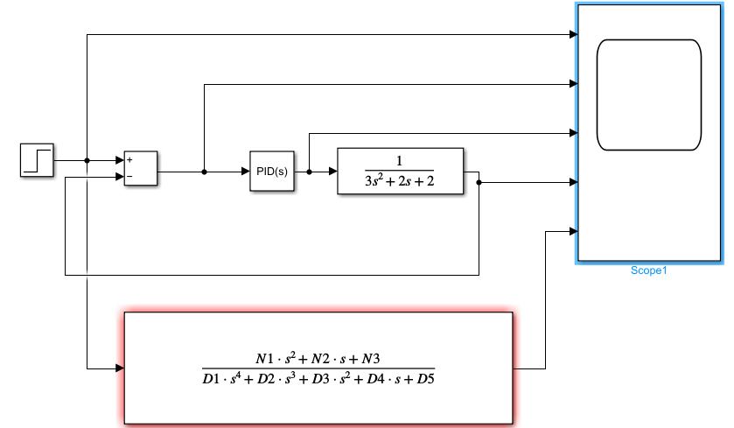
Figure 1- Circuit design for the closed loop control system
The image shown below in Figure 2 shows the transfer function that was used in the circuit and the figures that were input into it for the exercise, the numbers 3,2,2 are the numbers that were assigned in the assignment brief.
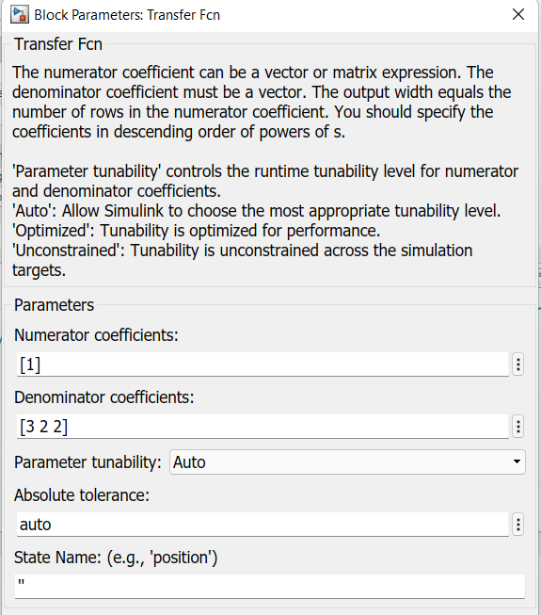
Figure 2- Parameters for the transfer function
Once the tune window was opened in SIMULINK the circuit was adjusted so that it fell in the boundaries of the assignment, meaning that the overshot was less than 5% and the process got under control within two seconds. As can be seen in Figure 4 below the overshoot is 3.98% and the settling time is 0.901 seconds meaning that the block meets the requirements.
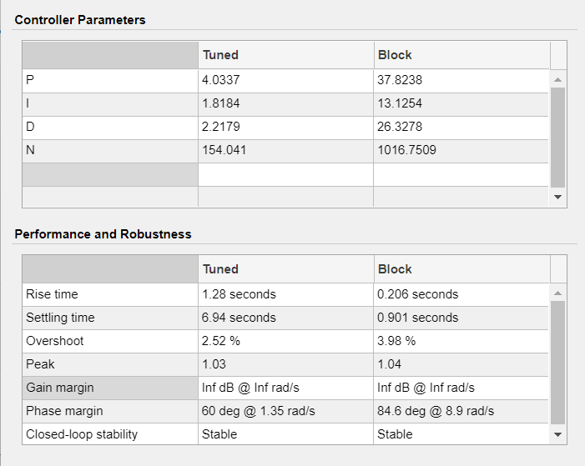
Figure 3- Tuned system parameters
The Graph below in Figure 4 shows the tuned results of the block for Amplitude vs Time. This graph was used during the tuning process in conjunction with the table above in Figure 3 to ensure the requirements for the assignment were met.
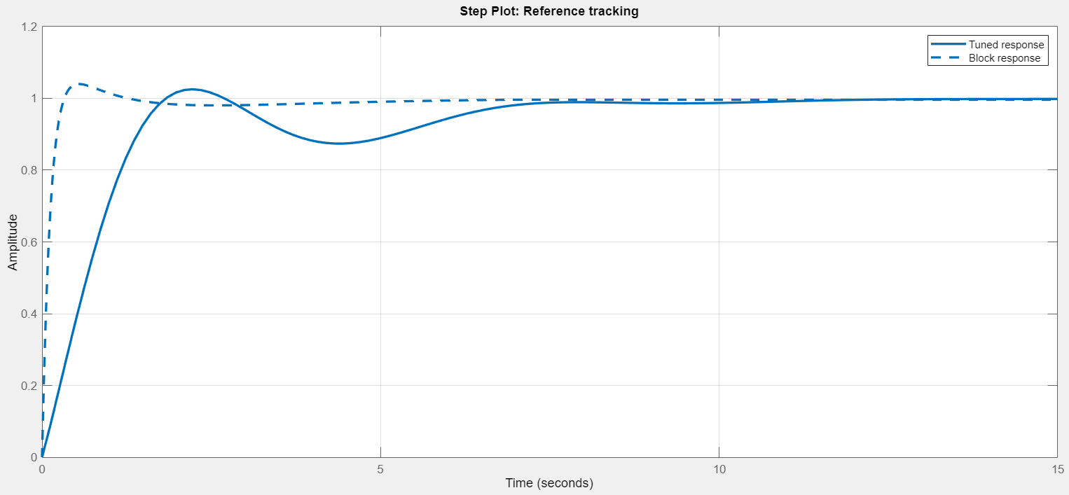
Figure 4- Graph of tuned results Amplitude vs Time
The image below in Figure 5 shows the PID controller block with the P (Proportional), I (Integral), D (Derivative) and N (Filter Coefficient) numbers for the calculation. These numbers are gained after the circuit is tuned and set to run, these numbers are utilized for calculation purposes later in the assignment.
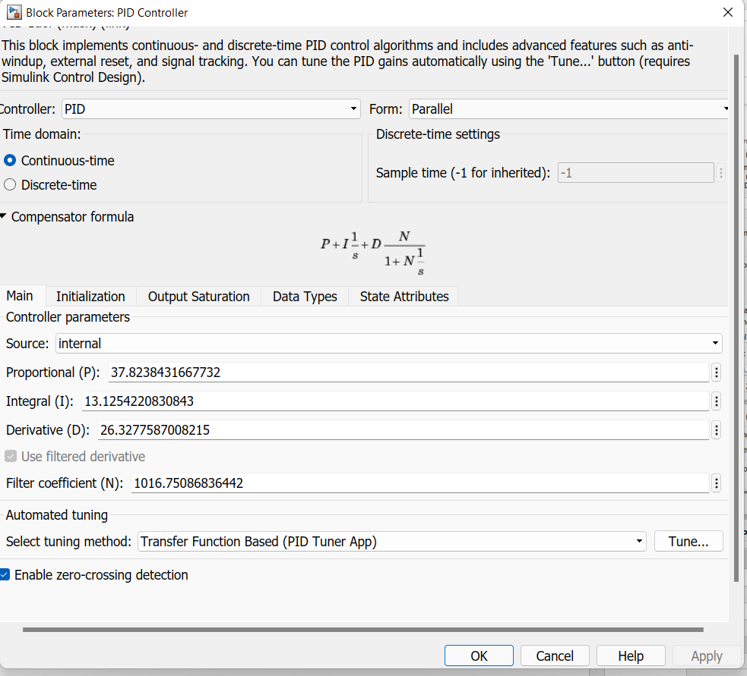
Figure 5- Block parameters for the PID controller
As discussed in the introduction and shown in Equation 1 the systems transfer function of G(s) was given as part of the assignment, this transfer function with the given numbers input is shown below in Equation 2.
$$G\left(s\right)=\frac{1}{3s^{2}+2s+2}$$
Equation 2- Transfer function with given numbers put in
This calculation is used later in the assignment and is used to calculate root polynomial transfer function. Another equation that was used for the assignment can be seen below in Equation 3.
$$Gc\left(s\right)=Kp+Ki\frac{1}{s}+Kd\frac{N}{1+N\frac{1}{s}}$$
Equation 3- Equation for forward transfer function
This equation however could not be used to gain the forward transfer function so it required simplification and substitution as can be seen in the appendix to give the equation below in in Equation 4.
$$\left(\frac{\left(Kp+KdN\right)s^{2}+\left(NKp+Ki\right)s+NKi}{{as}^{4}+(aN+b)s^{3}+(bN+c)s^{2}+cNs}\right)$$
Equation 4- Simplified and Substituted forward transfer function
The given and gained values from the exercise were then input as can be seen later in the results section in Equation 7, giving the forward transfer function for the system. The transfer function for the system now required to be calculated, this was done by taking the forward transfer function and inputting it into the formula shown below in Equation 5 where the value of H is given as 1.
$$TF= \frac{G}{1+GH}$$
Equation 5- Equation for gaining transfer function
The forward transfer function and the value of H was input into this equation with simplification carried out as can be seen in the appendix to give the equation shown below in Equation 6.
$$\frac{\left(Kp+KdN\right)s^{2}+\left(NKp+Ki\right)s+NKi}{{as}^{4}+(aN+b)s^{3}+(bN+c)s^{2}+cNs+\left(Kp+KdN\right)s^{2}+\left(NKp+Ki\right)s+NKi}$$
Equation 6- Simplified transfer function
The given numbers for this circuit were then input and calculated to give the transfer function as can be seen later in the assignment in the results section in Equation 8.

Results
As previously stated in the background information the simulated model was set to run as well as data input into MATLAB to give the graphs shown below. All the results shown below will be discussed further in the discussion section of the assignment with additional relevant information shown in the appendix.

Scope Results
The circuits scope graphical results can be seen below in Figure 6. [9]
Graph of scope results for Amplitude Vs Time
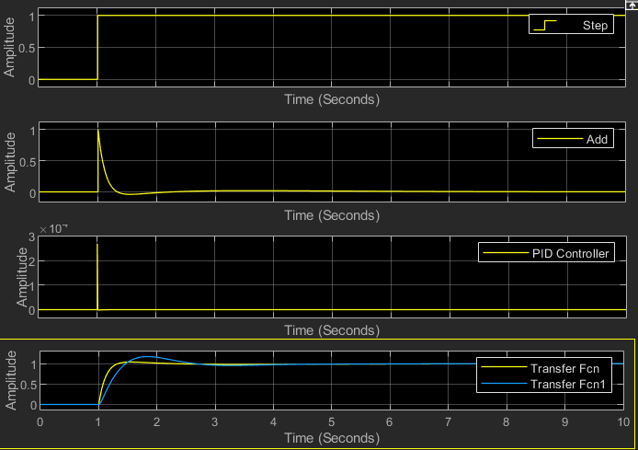
Figure 6- Graphs of MATLAB simulation results from scope

Pole- Zero Plots
The images shown below in Figures 7 shows the pole zero plot of the closed loop circuits transfer function. Following this image below is the pole zero plot for the controller and system individually, these can be seen below in Figures 8 and 9. [10]
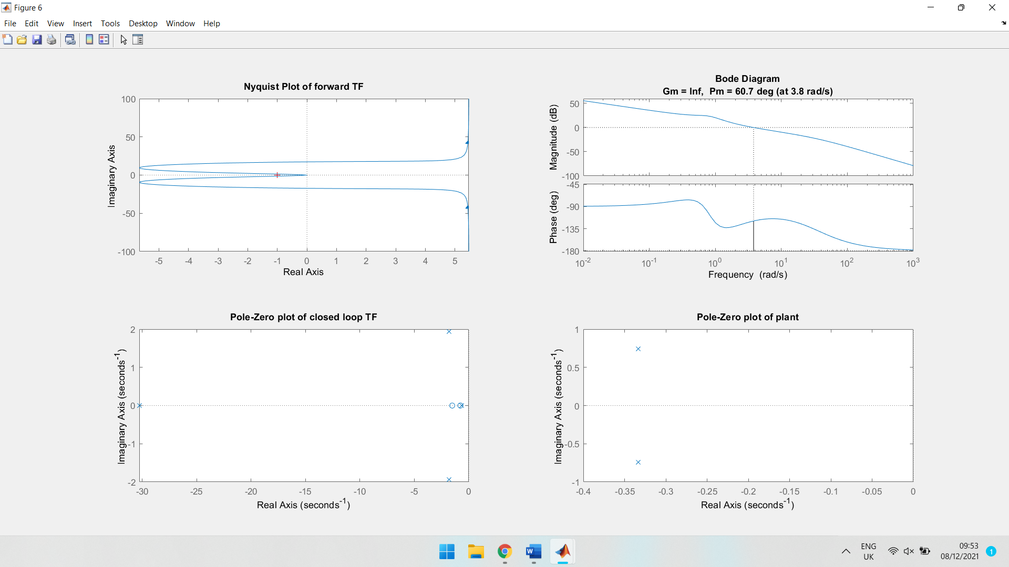
Figure 7- Pole zero plot of closed loop transfer function
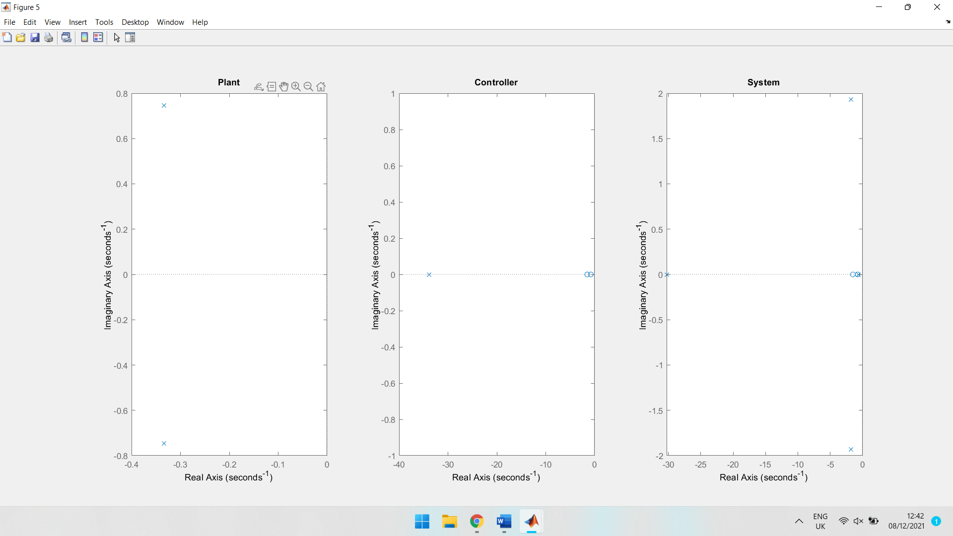
Figure 8- pole zero plot for controller Figure 9- pole zero plot for system

Nyquist plots
The images below in Figures 10 and 11 show the Nyquist plot for the forward transfer function showing Stability, frequency, delay, phase margin and whether if the system is stable. [11]
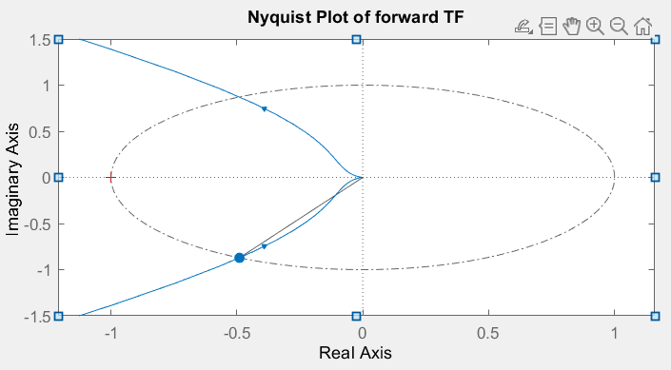
Figure 10- Nyquist plot of forward transfer function
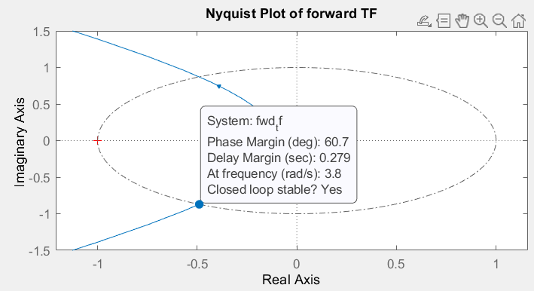
Figure 11- Nyquist plot showing Stability, frequency, delay, and phase margin

Bode diagram
The image shown below in Figure 12 is the bode diagram gained from MATLAB. [12]
Figure 12- Graphs of Frequency vs Phase and Frequency vs Magnitude

Transfer function
The values in the MATLAB pole zero plot of the plant can be seen below in Figure 13 and 14 showing the pole points and values. [10]
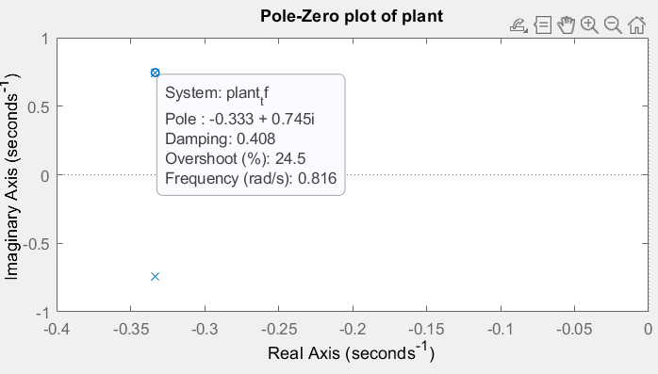
Figure 13- Pole zero plot MATLAB results
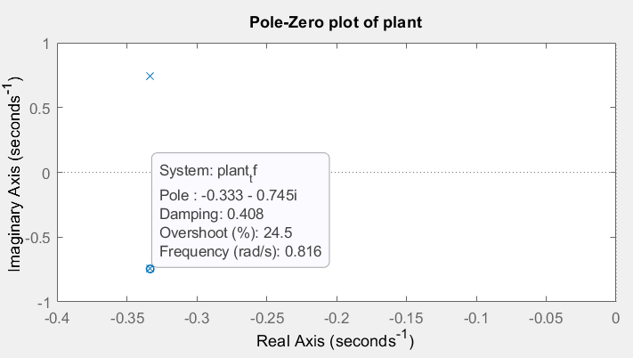
Figure 14- Pole zero plot MATLAB results
The Root function in MATLAB was used to gain further confirmation of these results this can be seen below in Figure 15. [13]
1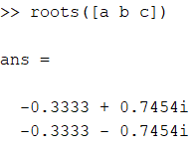
Figure 15- MATLAB confirmation of root polynomial transfer function results
Calculations were also carried out to find the forward transfer function of the controller and plant as can be seen below in Equation 7.
$$\left(\frac{342.30091s^{2}+786.0411s+403.9373}{{3s}^{4}+103.5377s^{3}+69.6918s^{2}+67.6918s}\right)$$
Equation 7- Forward transfer function for the controller and plant
Further calculations were also carried out using the forward transfer function to find the transfer function for the system this can be seen below in Equation 8.
$$\frac{342.30091s^{2}+786.0411s+403.9373}{{3s}^{4}+103.5377s^{3}+412.0009s^{2}+853.7329s+403.9373}$$
Equation 8- Transfer function for the system
The calculations and the process for gaining the transfer functions shown above in Equation 7 and 8 can be seen later in the assignment in the Appendix.

Pole zero plot points
By using the command shown in the appendix to find the points on the pole zero plot from MATLAB the results for the Forward transfer function pole zero plot points are:
p = 0.0000 + 0.0000i, -33.8459 + 0.0000i, -0.3333 + 0.7454i, -0.3333 - 0.7454i
z = -1.5199, -0.7764
By using the command shown in the appendix to find the points on the pole zero plot from MATLAB the results for the pole zero plot points for the whole system including the feedback are:
p = -30.2830 + 0.0000i, -1.7951 + 1.9320i, -1.7951 - 1.9320i, -0.6393 + 0.0000i
z = -1.5199, -0.7764

Discussion
Once the circuit was built, tuned, and running without any errors the results could then be gathered. The results that were gained have been taken straight from SIMULINK and MATLAB in graphical form giving a visual representation of the results. The data and process that was used to gain the results from MATLAB can be seen later in the assignment in the Appendix. The designed closed loop control system met the requirements set out in the assignment brief. The reason that the settling time was set to 0.901 seconds is so that it met the requirement of the brief. It was also important that the time was not set so low that it would spin too quickly that it would destroy itself due to its weight and the power required to turn it at high speed. The time and the overshoot needed to be balanced within the tolerance of the brief which was met at 3.98% as can be seen and discussed in the simulated model section in Figure 3.
The graph of the scope results shows a sample of the signal at different points in the circuit as can be seen above in the image of the circuit in Figure 1. The bottom graph in the scope display in Figure 6 shows a comparison of the simulated transfer function control and the results obtained using the equivalent formula. The blue line in the graph shows the results of the simulation and the yellow line the equivalent formula.
In the pole zero plot of the system the dominant pole is the one furthest on the left on the graph in this case -30.2830 + 0.0000i as shown in figure 8. This means that this is working the hardest and it also has the fastest decay [14] [15]. The results section above also shows the points of the pole zero plots for the forward transfer function and the closed loop transfer function gained from MATLAB.
The Nyquist graphs shown above in Figure 10 and 11 shows that the system is stable and has a phase margin at the point shown of 60.7 degrees with a delay margin of 0.279 seconds at a frequency of 3.8 radians per second [16]. The red cross shown in the image is the critical point which must not be crossed to ensure the system remains stable, as can be seen in Figure 10 above the system does not. The bode diagram shows similar information to the Nyquist plot above but in a different graphical format, showing the systems phase margin and its gain.
The root polynomial transfer function was calculated for the equation given in the assignment brief and previously shown in Equation 1 showing it to be -0.333-0.745j and -0.333+ 0.745j. The calculations and process for gaining these results can be seen later in the Appendix under pole calculations. These values were confirmed in MATLAB on the points of a pole zero plot of the plant as can be seen in the results section in Figure 13 and 14. These results were also confirmed in MATLAB using the Root function of the given figures for the assignment for a, b, and c, as can be seen in Figure 15. This result coincides with both the results that were calculated and that gained from the pole zero plot points.
The forward transfer function for the system was calculated as well as the closed loop transfer function was calculated as can be seen in the results section above. This type of defensive system is rarely used anymore due to its complexity, it has also now been superseded by other improved ship defensive systems [4].

Conclusion
The assignment discussed a closed loop control system for a CIWS turrets angular positioning system. The control system was built and simulated with the results that were gained being shown and described above. As well as the simulated exercise and information gained during lectures, additional research was done into the subject area. The circuit that was designed was stable and met the requirements set out in the brief. The correct type of control system was selected as well as it being tuned correctly as explained above. The assignment proved that the use of MATLAB over the conventional method of calculations is far superior and simpler. This is due to it being easy to do an arithmetic error in the calculated method. MATLAB has useful features for easy graphical representation of results and its ease to modify as well as other features making it far superior.

References

7.1 Reference list

[1] | R. Larson, “Open-Loop Control Revisited,” Control Engineering, vol. 52, no. 2, 2005.
[2] | S. Mosey, Level 5 assessment specification Instrumentation and control, Swansea: UWTSD, 2021.
[3] | A. A. &. R. Rendon, “A Diagnostic Approach to,” International Journal of Defense Acquisition Management, vol. 2, pp. 1-16, 2009.
[4] | D. D, Phalanx Overhaul Program, San Diego, CA: PEO (IWS), 2003.
[5] | R. A. a. R. Kandiban, “Design of Fuzzy PID controller for Brushless DC motor,” in 2012 International Conference on Computer Communication and Informatics, 2012.
[6] | D. S. S. K. S. a. S. K. M. M. K. Rout, “PID controller design for cruise control system using genetic algorithm,” in 2016 International Conference on Electrical, Electronics, and Optimization Techniques (ICEEOT), 2016.
[7] | P. G. a. A. Turevskiy, “Control System Tuning in Simulink Made Easy,” MathWorks, 2014. [Online]. Available: https://www.mathworks.com/company/newsletters/articles/control-system-tuning-in-simulink-made-easy.html?s_tid=srchtitle_controller%20tuning_2. [Accessed 14 December 2021].
[8] | R. C. a. A. T. M. Abu-Khalaf, “PID Control Design Made Easy,” MathWorks, 2009. [Online]. Available: https://www.mathworks.com/company/newsletters/articles/pid-control-design-made-easy.html?s_tid=srchtitle_controller%20tuning_3. [Accessed 14 December 2021].
[9] | MathWorks, “Scope,” MathWorks, [Online]. Available: https://www.mathworks.com/help/simulink/slref/scope.html?searchHighlight=scope&s_tid=srchtitle_scope_1. [Accessed 14 December 2021].
[10] | MathWorks, “pzmap,” Mathworks, [Online]. Available: https://www.mathworks.com/help/control/ref/lti.pzmap.html?s_tid=doc_ta. [Accessed 14 December 2021].
[11] | MathWorks, “Nyquist (Nyquist plot of frequency response),” MathWorks, [Online]. Available: https://www.mathworks.com/help/control/ref/lti.nyquist.html?s_tid=doc_ta. [Accessed 14 December 2021].
[12] | MathWorks, “Bode Diagram Design,” MathWorks, [Online]. Available: https://www.mathworks.com/help/control/ug/bode-diagram-design.html?s_tid=doc%20ta. [Accessed 14 December 2021].
[13] | MathWorks, “Represent roots of polynomial,” MathWorks, [Online]. Available: https://www.mathworks.com/help/symbolic/sym.root.html. [Accessed 14 December 2021].
[14] | D. S. &. D. R. Deepak M.Sajnekar, “ International Journal of Scientific and Research,” Comparison of Pole Placement & Pole Zero Cancellation Method for Tuning PID Controller of A Digital Excitation Control System, vol. 3, no. 4, pp. 1-7, 2013.
[15] | R. Kiyong Kim & Schaefer, “Tuning a PID controller for a digital excitation control system,” in Conference Record of 2004 Annual Pulp and Paper Industry Technical Conference, Piscataway, New Jersey, 2004.
[16] | D. C. &. D. E.Seborg, “Journal of Process Control,” Design of decentralized PI control systems based on Nyquist stability analysis, vol. 13, no. 1, pp. 27-39, 2003.
[17] | R. Dorf and R. Bishop, “Chapter 1,” in Modern Control Systems, Pearson Education Limited, 2018, p. 31.
[18] | R. Larsen, “Open-Loop Control Revisited,” Control Engineering, vol. 52, no. 2, 2005.
[19] | L. Grosenick, J. H. Marshall and K. Deisseroth, “Closed-Loop and Activity-Guided Optogenetic Control,” Neuron, vol. 86, no. 1, 2015.

Bibliography
[1] Nise N S. (2013) Control Systems Engineering; International Student Version , 7th Edition, Wiley. John Wiley.
[2] Distenfano, J, Stubberd, A & Williams, I. (2013) Schaum’s Outline of Feedback and Control Systems, 2nd Edition. Schaum’s Outlines.
[3] Dorf, R C & Bishop R H. (2016) Modern Control Systems: International Version, Pearson
[4] Prasad,J. Jayaswal, M & Priye,V. (2013) Instrumentation and Process Control, I.K International Publishing
[5] Ogata, K. (2015 Modern Control Engineering, International Version, 5th Edition. Pearson.

7.3. Table of Equations and Figures

7.3.1. Table of figures
Figure 1- Circuit design for the closed loop control system 4
Figure 2- Parameters for the transfer function 4
Figure 3- Tuned system parameters 5
Figure 4- Graph of tuned results Amplitude vs Time 5
Figure 5- Block parameters for the PID controller 6
Figure 6- Graphs of MATLAB simulation results from scope 7
Figure 7- Pole zero plot of closed loop transfer function 8
Figure 8- pole zero plot for controller Figure 9- pole zero plot for system 8
Figure 10- Nyquist plot of forward transfer function 9
Figure 11- Nyquist plot showing Stability, frequency, delay, and phase margin 9
Figure 12- Graphs of Frequency vs Phase and Frequency vs Magnitude 10
Figure 13- Pole zero plot MATLAB results 10
Figure 14- Pole zero plot MATLAB results 11
Figure 15- MATLAB confirmation of root polynomial transfer function results 11
Figure 17- Pole zero plot of plant 22
Figure 18- Nyquist plot of forward transfer function 23

7.3.2. Table of equations
Equation 1- Transfer function equation [2] 3
Equation 2- Transfer function with given numbers put in 6
Equation 3- Equation for forward transfer function 6
Equation 4- Simplified and Substituted forward transfer function 6
Equation 5- Equation for gaining transfer function 7
Equation 6- Simplified transfer function 7
Equation 7- Forward transfer function for the controller and plant 11
Equation 8- Transfer function for the system 11
Equation 9- Transfer function 18
Equation 10- Transfer function with given numbers put in 18
Equation 11- Transfer function calculation 18
Equation 12- Quadratic Equation 18
Equation 13- Figures input into quadratic equation 18
Equation 14- Quadratic equation simplified 18
Equation 15- Quadratic equation simplified further 18
Equation 16- Addition quadratic equation step 1 Equation 17- Subtraction quadratic equation step 1 18
Equation 18- Addition quadratic equation step 2 Equation 19- Subtraction quadratic equation step 2 18
Equation 20- Addition quadratic equation step 3 Equation 21- Subtraction quadratic equation step 3 18
Equation 22- Addition quadratic equation step 4 Equation 23- Subtraction quadratic equation step 4 18
Equation 24- Equation for forward transfer function 19
Equation 25- Substitution and simplification for forward transfer function step 1 19
Equation 26- Substitution and simplification for forward transfer function step 2 19
Equation 27- Substitution and simplification for forward transfer function step 3 19
Equation 28- Substitution and simplification for forward transfer function step 4 19
Equation 29- Substitution and simplification for forward transfer function step 5 19
Equation 30- Substitution and simplification for forward transfer function step 6 19
Equation 31- Given transfer function 19
Equation 33- Substitution and simplification for forward transfer function step 7 19
Equation 34- Substitution and simplification for forward transfer function step 8 19
Equation 35- Substitution and simplification for forward transfer function step 9 19
Equation 36- Substitution and simplification for forward transfer function step 10 19
Equation 37- Forward transfer function calculation 20
Equation 38- Forward transfer function calculation simplified 20
Equation 39- Transfer Function equation 20
Equation 40- Simplification for transfer function step 1 20
Equation 41- Simplification for transfer function step 2 20
Equation 42- Simplification for transfer function step 3 20
Equation 43- Simplification for transfer function step 4 20
Equation 44- Calculation for transfer function step 1 20
Equation 45- Calculation for transfer function step 2 20
Equation 46- Calculation for transfer function step 3 20

Appendix

Pole calculations
Find root of polynomial transfer function
$$G\left(s\right)=\frac{1}{as^{2}+bs+c}$$
Equation 9- Transfer function
Substitute a= 3 b= 2 c= 2
$$G\left(s\right)=\frac{1}{3s^{2}+2s+2}$$
Equation 10- Transfer function with given numbers put in
Top of the fraction is 1 so no value of S to change, therefore only the bottom needs calculating to find S:
$0=3s^{2}+2s+2$
Equation 11- Transfer function calculation
$$s=\frac{-b±\sqrt{b^{2}-4ac}}{2a}$$
Equation 12- Quadratic Equation
$$s=\frac{-2±\sqrt{2^{2}-4*3*2}}{2*3}$$
Equation 13- Figures input into quadratic equation
$$s=-\frac{-2±\sqrt{4-24}}{6}$$
Equation 14- Quadratic equation simplified
$$s=\frac{-2±\sqrt{-20}}{6}$$
Equation 15- Quadratic equation simplified further
$s=\frac{-2}{6}+\frac{\sqrt{-20}}{6}$ $s=\frac{-2}{6}-\frac{\sqrt{-20}}{6}$
Equation 16- Addition quadratic equation step 1 Equation 17- Subtraction quadratic equation step 1
$s=-0.333+\frac{\sqrt{20}*\sqrt{-1} }{6}$ $s=-0.333-\frac{\sqrt{20}*\sqrt{-1} }{6}$
Equation 18- Addition quadratic equation step 2 Equation 19- Subtraction quadratic equation step 2
$s=-0.333+\frac{4.472j }{6}$ $s=-0.333-\frac{4.472j }{6}$
Equation 20- Addition quadratic equation step 3 Equation 21- Subtraction quadratic equation step 3
$s=-0.333+0.745j$ $s=-0.333-0.745j$
Equation 22- Addition quadratic equation step 4 Equation 23- Subtraction quadratic equation step 4

Forward transfer function Calculations
Equation for forward transfer function given as Gc(s)
$$Gc\left(s\right)=Kp+Ki\frac{1}{s}+Kd\frac{N}{1+N\frac{1}{s}}$$
Equation 24- Equation for forward transfer function
Simplify the equation
$$\frac{N}{1+N\frac{1}{s}} = \frac{N}{\frac{s}{s}+\frac{N}{s}} = \frac{N}{\frac{N+s}{s}}=\frac{Ns}{N+s}$$
Equation 25- Substitution and simplification for forward transfer function step 1
Given this simplification substituted back into the equation giving
$$Gc\left(s\right)=Kp+\frac{Ki}{s}+\frac{KdNs}{N+s}$$
Equation 26- Substitution and simplification for forward transfer function step 2
Multiply Gc(s) by$\frac{s(s+N)}{s(s+N)}$
$$\left(Kp+\frac{Ki}{s}+\frac{KdNs}{N+s}\right)×\frac{s(s+N)}{s(s+N)}$$
Equation 27- Substitution and simplification for forward transfer function step 3
Simplify
$$\frac{s\left(s+N\right)Kp+\left(s+N\right)Ki+s(KdNs)}{s(s+N)}$$
Equation 28- Substitution and simplification for forward transfer function step 4
Expand Brackets
$$\frac{s^{2}Kp+sNKp+sKi+NKi+KdNs^{2}}{s^{2}+Ns}$$
Equation 29- Substitution and simplification for forward transfer function step 5
Gather like terms
$$\frac{\left(Kp+KdN\right)s^{2}+\left(NKp+Ki\right)s+NKi}{s^{2}+Ns}$$
Equation 30- Substitution and simplification for forward transfer function step 6
Multiply Gc(s) by G(s) using the given equation for G(s)
$$G\left(s\right)=\frac{1}{as^{2}+bs+c}$$
Equation 31- Given transfer function
Multiplication of Gc(s) by G(s)
$$\left(\frac{1}{{as}^{2}+bs+c}\right)×\left(\frac{\left(Kp+KdN\right)s^{2}+\left(NKp+Ki\right)s+NKi}{s^{2}+Ns}\right)$$
Equation 32- Substitution and simplification for forward transfer function step 7
Simplify
$$\left(\frac{(1)(\left(Kp+KdN\right)s^{2}+\left(NKp+Ki\right)s+NKi)}{({as}^{2}+bs+c)(s^{2}+Ns)}\right)$$
Equation 33- Substitution and simplification for forward transfer function step 8
Expand brackets
$$\left(\frac{\left(Kp+KdN\right)s^{2}+\left(NKp+Ki\right)s+NKi}{as^{4}+bs^{3}+cs^{2}+aNs^{3}+bNs^{2}+cNs}\right)$$
Equation 34- Substitution and simplification for forward transfer function step 9
Gather like terms giving the Forward Transfer Function:
$$\left(\frac{\left(Kp+KdN\right)s^{2}+\left(NKp+Ki\right)s+NKi}{{as}^{4}+(aN+b)s^{3}+(bN+c)s^{2}+cNs}\right)$$
Equation 35- Substitution and simplification for forward transfer function step 10

Taking a = 3, b = 2, c = 2 and Kp= 22.8715, Ki= 11.9346, Kd= 9.438, N= 33.8459 the forward transfer function now becomes.
$$\left(\frac{\left(22.8715+9.438×33.8459\right)s^{2}+\left(33.8459×22.8715+11.9346\right)s+33.8459×11.9346}{{3s}^{4}+(3×33.8459+2)s^{3}+(2×33.8459+2)s^{2}+2×33.8459×s}\right)$$
Equation 36- Forward transfer function calculation
This is the forward transfer function for the controller and plant as a single block simplified
$$\left(\frac{342.30091s^{2}+786.0411s+403.9373}{{3s}^{4}+103.5377s^{3}+69.6918s^{2}+67.6918s}\right)$$
Equation 37- Forward transfer function calculation simplified

Transfer function calculations
The feedback loop can be removed giving the transfer function in this case TF in the equation below.
$$TF= \frac{G}{1+GH}$$
Equation 38- Transfer Function equation
G is the Forward Transfer Function, and H is the transfer function of the feedback loop meaning it’ll be 1
$$\frac{\left[\frac{\left(Kp+KdN\right)s^{2}+\left(NKp+Ki\right)s+NKi}{{as}^{4}+(aN+b)s^{3}+(bN+c)s^{2}+cNs}\right]}{1+\left[\frac{\left(Kp+KdN\right)s^{2}+\left(NKp+Ki\right)s+NKi}{{as}^{4}+(aN+b)s^{3}+(bN+c)s^{2}+cNs}\right]×1}$$
Equation 39- Simplification for transfer function step 1
1 can be written as $\frac{{as}^{4}+(aN+b)s^{3}+(bN+c)s^{2}+cNs}{{as}^{4}+(aN+b)s^{3}+(bN+c)s^{2}+cNs}$ and multiplying by 1 changes nothing giving
$$\frac{\left[\frac{\left(Kp+KdN\right)s^{2}+\left(NKp+Ki\right)s+NKi}{{as}^{4}+(aN+b)s^{3}+(bN+c)s^{2}+cNs}\right]}{\left[\frac{{as}^{4}+(aN+b)s^{3}+(bN+c)s^{2}+cNs}{{as}^{4}+(aN+b)s^{3}+(bN+c)s^{2}+cNs}\right]+\left[\frac{\left(Kp+KdN\right)s^{2}+\left(NKp+Ki\right)s+NKi}{{as}^{4}+(aN+b)s^{3}+(bN+c)s^{2}+cNs}\right]}$$
Equation 40- Simplification for transfer function step 2
Add together denominator terms
$$\frac{\left[\frac{\left(Kp+KdN\right)s^{2}+\left(NKp+Ki\right)s+NKi}{{as}^{4}+(aN+b)s^{3}+(bN+c)s^{2}+cNs}\right]}{\left[\frac{{as}^{4}+(aN+b)s^{3}+(bN+c)s^{2}+cNs+\left(Kp+KdN\right)s^{2}+\left(NKp+Ki\right)s+NKi}{{as}^{4}+(aN+b)s^{3}+(bN+c)s^{2}+cNs}\right]}$$
Equation 41- Simplification for transfer function step 3
Simplifying gives the final Transfer Function as
$$\frac{\left(Kp+KdN\right)s^{2}+\left(NKp+Ki\right)s+NKi}{{as}^{4}+(aN+b)s^{3}+(bN+c)s^{2}+cNs+\left(Kp+KdN\right)s^{2}+\left(NKp+Ki\right)s+NKi}$$
Equation 42- Simplification for transfer function step 4
Taking a = 3, b = 2, c = 2 and Kp= 22.8715, Ki= 11.9346, Kd= 9.438, N= 33.8459 the transfer function now becomes
$$\frac{\left(22.8715+9.438×33.8459\right)s^{2}+\left(33.8459×22.8715+11.9346\right)s+33.8459×11.9346}{\begin{aligned}{3s}^{4}+\left(3×33.8459+2\right)s^{3}+\left(2×33.8459+2\right)s^{2}+2×33.8459×s+\left(22.8715+9.438×33.8459\right)s^{2} \\ +\left(33.8459×22.8715+11.9346\right)s+33.8459×11.9346\end{aligned}}$$
Equation 43- Calculation for transfer function step 1
Simplify to become
$$\frac{342.30091s^{2}+786.0411s+403.9373}{{3s}^{4}+103.5377s^{3}+69.6918s^{2}+67.6918s+342.3091s^{2}+786.0411s+403.9373}$$
Equation 44- Calculation for transfer function step 2
Combine like terms to give a transfer function of
$$\frac{342.30091s^{2}+786.0411s+403.9373}{{3s}^{4}+103.5377s^{3}+412.0009s^{2}+853.7329s+403.9373}$$
Equation 45- Calculation for transfer function step 3

The Process for setting up MATLAB
The information shown below is what was entered into MATLAB describing what each step means and why it was input. The reason there is a % in front of each statement is so that it can be put directly into MATLAB and it will not affect the input data.
%The given plant transfer function values from the assignment specification are:
a= 3
b= 2
c= 2
%Once the circuit was built and tuned the following values were obtained:
Kp= 22.8715
Ki= 11.9346
Kd= 9.438
N= 33.8459
%The transfer functions for the numerator coefficients are
N1=Kp+(N*Kd);
N2=(Ki+(N*Kp));
N3=N*Ki;
%The closed loop transfer function of the denominator coefficients is
D1=a;
D2=(a*N)+b;
D3=Kp+(N*Kd)+(b*N)+c;
D4=(N*Kp)+Ki+(c*N);
D5=N*Ki;
%The forward transfer functions for the denominator coefficients are
d1=a;
d2=(a*N)+b;
d3=(b*N)+c;
d4=c*N;
d5=0;
%Create forward transfer function
fwd_tf=tf([N1 N2 N3],[d1 d2 d3 d4 d5]);
%Create a closed loop transfer function of whole system including feedback
system_tf=tf([N1 N2 N3],[D1 D2 D3 D4 D5]);
%Create a transfer function to only show the plant
plant_tf = tf(1,[a b c]);
%Create a transfer function to only show the controller
Controller_tf = tf([(Kp+(N*Kd)) (N*Kp)+Ki N*Ki], [1 N]);
%Plot the pole-zero diagram of the plant on its own:
figure;
subplot(1,3,1);
pzplot(plant_tf);
title('Pole-Zero plot of Plant');
%Plot the pole-zero diagram of the controller on its own:
subplot(1,3,2);
pzplot(Controller_tf);
title(' Pole-Zero plot of Controller');
%Plot the pole-zero diagram of entire system with feedback:
subplot(1,3,3);
pzplot(system_tf);
title(' Pole-Zero plot of system');
%Creating a Nyquist plot for the forward transfer function
figure;
subplot(2,2,1);
nyquist(fwd_tf);
title('Nyquist Plot of forward TF');
%Create Bode plot of forward transfer function
subplot(2,2,2)
margin(fwd_tf)
title('Bode plot of forward TF')
%Create the plot of Pole-Zero diagram for the closed loop system
subplot(2,2,3);
pzplot(system_tf);
title('Pole-Zero plot of closed loop TF');
%Pole and zero plot points for the forward transfer function:
[p,z]=pzmap(fwd_tf)
%Pole and zero plot points for the whole system transfer system:
[p,z]=pzmap(system_tf)

Additional graphical results
The image below in Figure 16 shows a Graph of pole-zero plot of the plant without the pop-up boxes for the pole zero plot points present.
Figure 16- Pole zero plot of plant

The image shown below in Figure 10 shows the full Nyquist plot of the forward transfer function
Figure 17- Nyquist plot of forward transfer function

