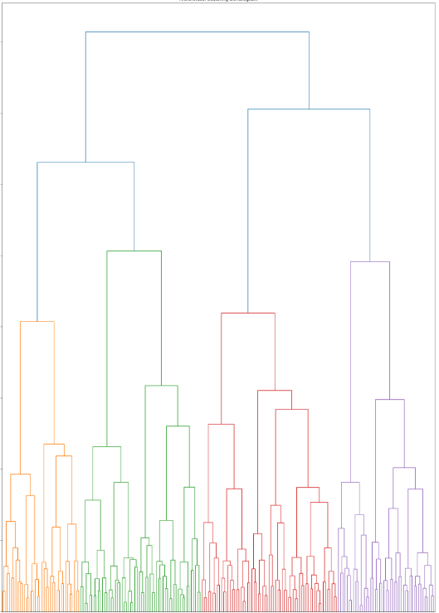


Assignment – ML Model

ACCA6011

Artificial intelligence and Machine Learning
Siân Eleri Kiely
2218899 @student.uwtsd.ac.uk
December 2025

Table of Contents
Table of Figures 3
Abstract 4
Introduction 4
Problem Statement 4
Methodology 4
Experimentation 5
1. Data Extraction and Preprocessing 5
2. Machine Learning Models 5
2.1 Decision Tree 6
2.2 Support Vector Machine 7
3. Evaluating Model Performance 8
Precision 8
Recall 8
F1 Score 8
Accuracy 8
Evaluation Summary 8
4. Hyperparameter tuning Grid Search 8
Model Performance Optimisation 9
5. Clustering: 9
5.1 Hierarchical Clustering 9
5.2 K-Means 10
5.3 Silhouette Score 10
5.4 Inertia 10
Evaluate Clustering 11
6. Supervised and Unsupervised 11
Conclusion 11
7. Results and Recommendations 12
Link to Video of Code Run Through 12
References 13
Appendix 15

Table of Figures

Figure 1 Preprocessing: convers Male to 0, Female to 1 4
Figure 2 data.info: non nulls, data type 4
Figure 3 HIGH Engagement Histogram: sessions per week and average Session Duration vs LOW engagement 4
Figure 4 Sample of bar charts: categorical data minimal influence on engagement % labels added for clarity 4
Figure 5 Feature Importance as a table: top 3 5
Figure 6 Sample Example: avg sess dur of 130min = high, 65min = medium. Feature order: Age, Gender, Location, GameGenre, PlayTimeHours, InGamePurchases, GameDifficulty, SessionsPerWeek, AvgSessionDurationMinutes, PlayerLevel, AchievementsUnlocked 5
Figure 7 Decision Tree first attempt: too many leaf nodes to read 5
Figure 8 Decision Tree Custom branch layout 5
Figure 9 Decision Tree final: max depth 6, max leaf nodes 16 for better display 5
Figure 10 Low engagement filter correlation with numerical variable data 6
Figure 11 Confusion matrices of SVM RBF baseline and SVM Linear Kernel 6
Figure 12 Decision Tree initial Precision, recall, F1 score, accuracy 7
Figure 13 Hyper tuning Grid Search on Decision Tree improvement 7
Figure 14 SVM RBF Tuned, ROC-AUC = 0.93 8
Figure 15 Hierarchical Clustering 100 samples 8
Figure 16 KMeans Clusters = 3, sessions per week and achievements unlocked 9
Figure 17 Silhouette ranges -1 to +1 group by cluster 9
Figure 18 Inertia Elbow method 9
Figure 19 Decision Tree second attempt: max depth 3 14
Figure 20 AI Fundamentals with IBM SkillsBuild Badge [17] 14
Figure 21 Decision Tree earlier version specific leaf nodes 15

Abstract
The Game Development Studio data analytics team seeks to better understand and engage the player base. Using the Predict Online Gaming Behaviour Dataset [1] from Kaggle to gain insight into using the target variable; player engagement level, categorised as high, medium or low. Kaggle [2] also has some courses on Pandas and machine learning [3]. Demographics such as age, location and gender in combination with gaming habits such as in-game purchases, playtime and session frequency used to train and predict player engagement. Supervised learning showed player behaviour was more influential than player demographic, with Sessions Per Week being most influential. Unsupervised learning shows clustering within game play intensity.

Introduction
The following details the recommendations presented by the data analytics team to Game Development Studio. Behavioural patterns amongst gamers in online environments can be discovered by using unsupervised learning techniques. In addition to evaluating Decision Tree and Support Vector Machine (SVM) model performance, player engagement prediction can be fine-tuned and analysed for suitability. Jupyter Note [4], Machine Learning, particularly Scikit-Learn [5] used throughout, as well as background reading on [6] AI in general.

Problem Statement
To better engage player base, player game engagement level needs to be understood. By establishing behavioural patterns and gaining insight into player demographic and gaming habits, data can be used for training and prediction to support future recommendations by providing business insights. Games can be better curated to the player base engagement to drive profit and reinvestment into future developments. Player engagement is a positive marker for player preference, when used as the target variable in a data set of features.

Methodology
Using a positivism research philosophy throughout, by treating the dataset objectively using quantitative measurements and applying statistical and mathematical model. Research began as primarily deductive, with the assumption engagement can be predicted from measurable features, testing with labelled outcomes, Additional exploration of patterns using clustering (unsupervised learning) by looking for structures without predefined labels. Apply model, compare, tune parameter and evaluate.
Hypothesis: player behaviour predicts engagement
Data collection: target variable Engagement Level. Predict engagement using supervised learning models, identify key behavioural drivers. Explore unsupervised clustering. Data processing: cleaning and preprocessing. Initial Exploratory Data Analysis. Assessing data quality by looking for missing values, checking data types. Examine distributions of numerical features as histograms, and categorical distributions with bar charts. Encoding and preprocessing. Numerical features standardised for SVM and clustering. [7]
Supervised learning: Data Classification: using decision tree predictive model and SVM (linear kernel and Radial Basis Function (RBF) kernel. Confusion matrices also used. Unsupervised Learning: Clustering: K-means and hierarchical clustering. Key behaviour features identified from supervised models explored using K-means. Data analysis: machine learning model.
Experimentation. Data validation. Evaluate using accuracy, precision, recall, F1-score [8]. Multiclass ROC-AUC, [9] using a One vs Rest (OvR) strategy Hyper tuning using GridSearchCV.

Experimentation

Data Extraction and Preprocessing
Before using the data, it should first be inspected. Understanding the data types, such as integer or text variable characters. In some cases, text will need converting to int, e.g. Gender into Binary 0/1 instead of male/female for decision trees. Data should also be checked for missing values. Initial Decision tree p |  | 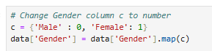  Figure 1 Preprocessing: convers Male to 0, Female to 1
- Data. info  - Shows columns and data type  - Broken into float, int, and object (text)  - Shows number of non-null values; there are no blank cells in this data set  - Data. unique  - Shows unique values,  - 1 = doesn’t apply (adds no value if all the same)  - 2 = binary values e.g. yes/no, male/female  - 40034 = all unique e.g. Player ID = no added insight. But session length can be split using <> | 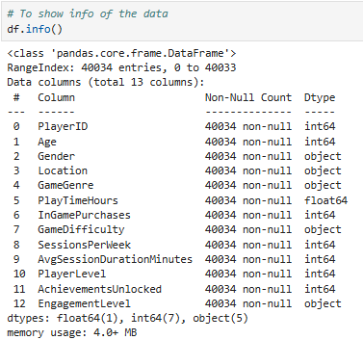  Figure 2 data.info: non nulls, data type
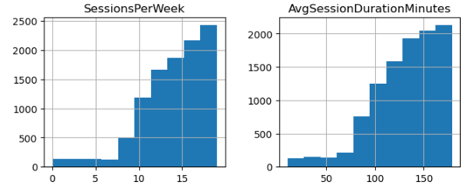

Machine Learning Models
Before training a decision tree some data exploration was performed. Including Histograms, [10] the first attempt showed uniform results, showing the dataset would be suitable for machine learning but it was filtered by high to low engagement for insights. Low engagement showed left skew for low engagement, right skew for High engagement.
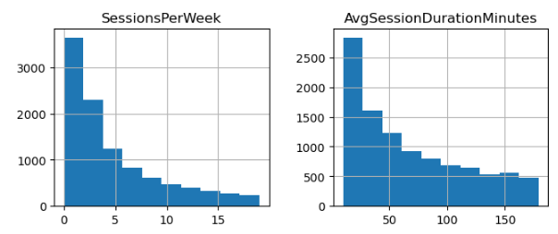

Figure 3 HIGH Engagement Histogram: sessions per week and average Session Duration vs LOW engagement
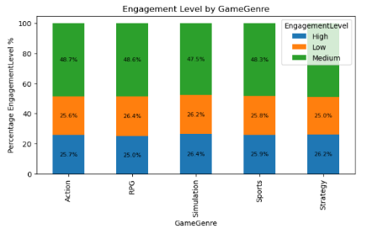
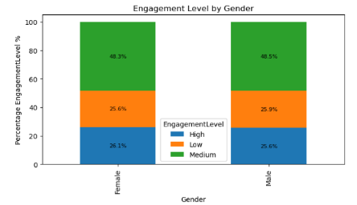
Figure 4 Sample of bar charts: categorical data minimal influence on engagement % labels added for clarity

2.1 Decision Tree
The decision tree [11] servers a valuable purpose as a classifier to get initial understanding of feature importance in relation to the target variable by splitting a data set into several “branch-like segments”, Displaying results in an “understandable representation” for easier interpretation, when producing logical rules of classification.  Starting at the root note of the training set, [12] objectively seeking the feature which will best separate the data into subsets with classes as pure (containing almost or entirely one class) as possible. Supervised learning [13] for classification. | 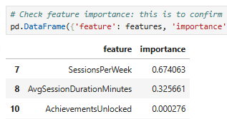  Figure 5 Feature Importance as a table: top 3
The initial diagram brought back too many results to be legible, it was fine tuned to lessen the decision tree depth, whilst also adjusting figure and font size for a readable display. The colours correspond to the classifiers ‘low, medium, high’.
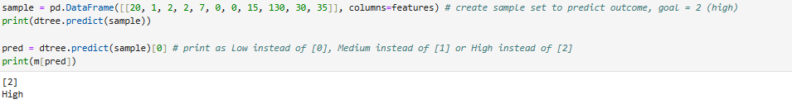
Figure 6 Sample Example: avg sess dur of 130min = high, 65min = medium.
Feature order: Age, Gender, Location, GameGenre, PlayTimeHours, InGamePurchases, GameDifficulty, SessionsPerWeek, AvgSessionDurationMinutes, PlayerLevel, AchievementsUnlocked
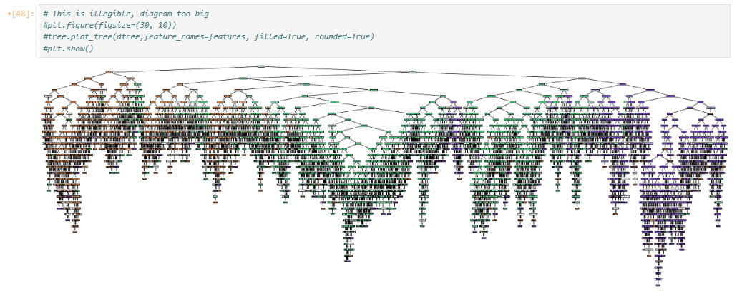
Figure 7 Decision Tree first attempt: too many leaf nodes to read
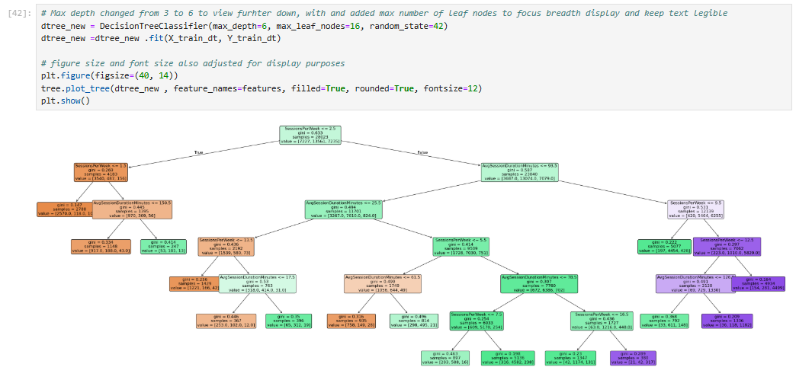

Figure 8 Decision Tree Custom branch layout
Figure 9 Decision Tree final: max depth 6, max leaf nodes 16 for better display

2.2 Support Vector Machine
Before beginning SVM, some exploratory data analysis took place, shown as eda_df to look for patterns, distributions and hints about which features related to engagement. Histograms and bar graph examples can be seen on previous pages. By grouping engagement level and computing means of numerical variables, simple but strong insights were visible. High engagement players usually have much higher session per week combined with longer session duration and higher progression. The correlation heatmaps also support numerical variable insight, once engagement level converted into numeric scale, and expanded further by filtering by engagement level to explore relationships between features. |  |  | 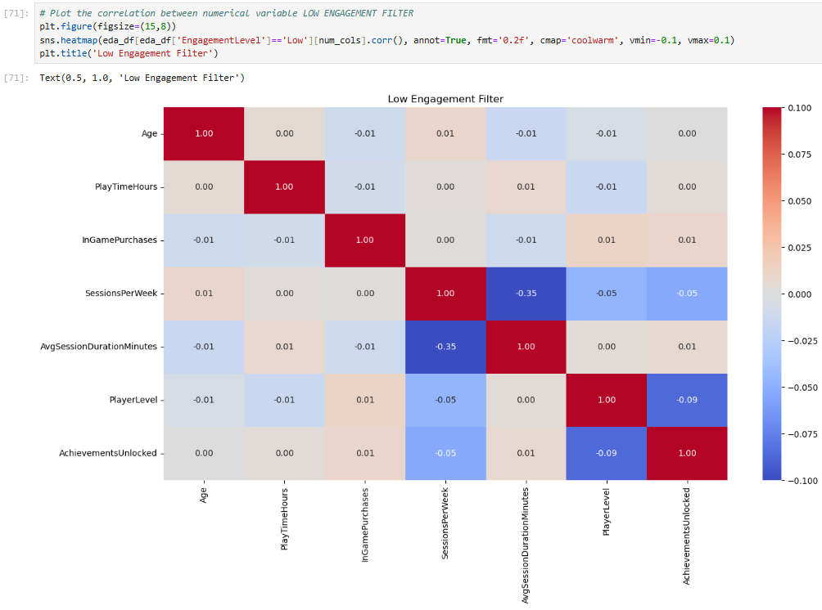  Figure 10 Low engagement filter correlation with numerical variable data
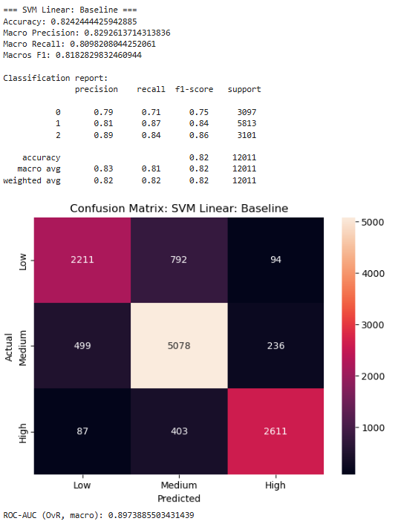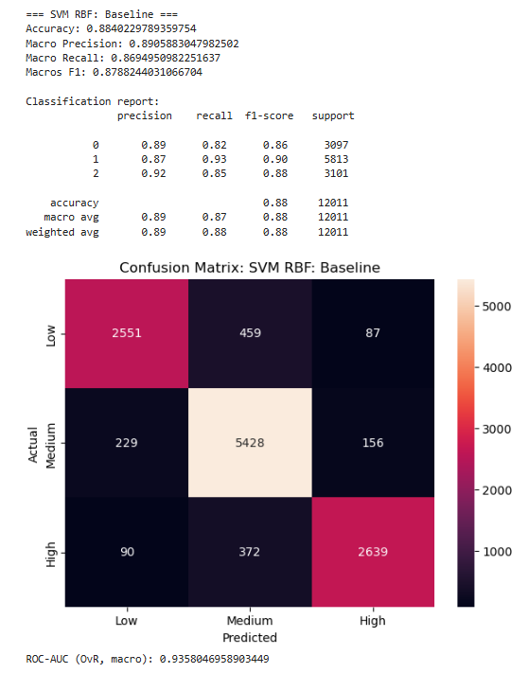
Figure 11 Confusion matrices of SVM RBF baseline and SVM Linear Kernel
Scikit learn explain SVC [14], as a form of C-Support Vector Classification. Explains, kernel such as linear, also used with the default of rbf.. RBF performed better than Kernal, significan improvement, increased to 0.88, F1 improved to 0.88 and ROC-AUC increased to 0.93. This confirms non-linear relationships exist between player behaviour and engagement level.
Confusion matrix shows high precision recall for medium engagement, Medium showing high precision (this seems consistent throughout, possibly as it’s a larger segment of the data.) Chance for some confusion between high and medium players, but low and high show clear distinction between behaviour patterns, they are the extremes. Not yet noted is the lack of outliers in this data.

Evaluating Model Performance
Precision | Recall | F1 Score |  | Accuracy
Measures how many instances predicted were actually correct. | Measures how many true instances were successfully identified by the model. | Provides a balances measure of precision & recall for fair class performance evaluation |  | Overall proportion of correctly classified, instances all classes,

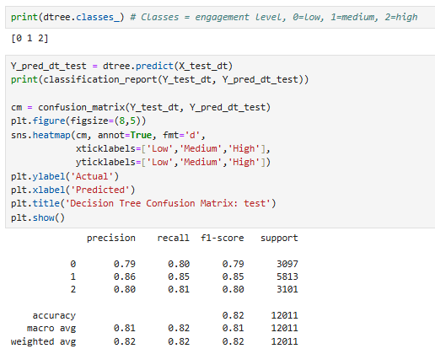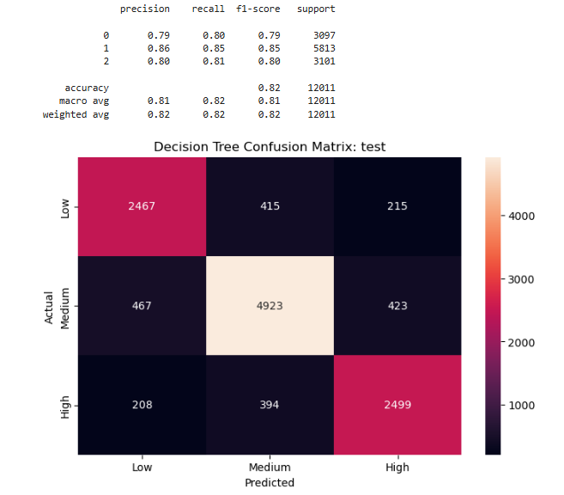
Figure 12 Decision Tree initial Precision, recall, F1 score, accuracy

Evaluation Summary
The decision tree resulted in moderate predictive performance, accuracy above 0.8, meaning it was able to learn meaningful relationships between behaviour and engagement. Initially this was scoring 1, indicating the need to split training and samples, earlier version of code removed to avoid confusion. Confusion matrix showed medium engagement was the most accurate, low and high sometimes confused for medium. Feature importance analysis revealed sessions per week and duration dominated model decisions. Demographics variable were negligible for influence.

Hyperparameter tuning Grid Search
After hyperamater running using Grid search, [15] accuracy for Decision tree increased to 0.9, F1 to 0.9, ROC -AUC to 0.93.  GridSearchCV as explained by Scikit Learn [16] “implements a fit and a score method. It also implements score_samples, predict, predict_proba” and more. Parameters optimized by cross-validation grid search over a parameter grid.  Tuning hyper-parameters of an estimator [17]. Stratified K Fold [18] |  | 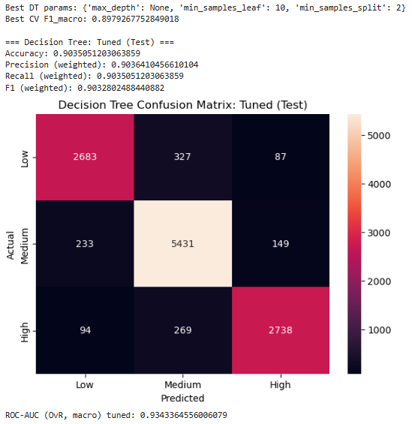  Figure 13 Hyper tuning Grid Search on Decision Tree improvement

Model Performance Optimisation
SVM with RBD kernel produced the best predictive performance. This was building on the decision tree insight, which provided strong interpretability highlighting feature importance (sessions per week etc.)  Reassuringly, results are consistent across supervised and unsupervised methods. Clustering, to be covered in the next section, will independently confirm behaviour segmentation. |  | 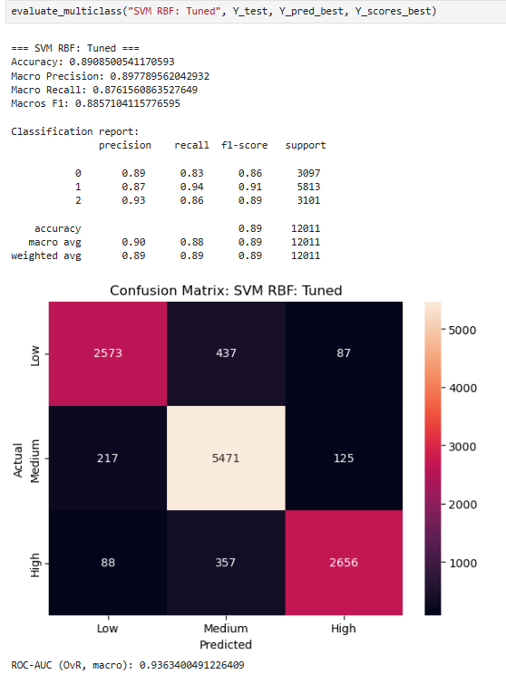  Figure 14 SVM RBF Tuned, ROC-AUC = 0.93
Clustering: | 5.1 Hierarchical Clustering
Hierarchical clustering was done after kmeans, shown on next page, but is simpler to explain in one visually. With a small sample, if the distance threshold is set to 5, there are 3 clear clusters, (supports the use of k=3 in K means clustering.) Broadly aligned. Increasing the sample size increased the clusters.  Orange: lower left: low sessions, short duration, few achievements, similar group (Low engagement cluster)  Green: left centre: later merging, moderate but varied. Mixed sessions, mixed progression, not heavy users (Medium engagement cluster: opportunity.  Red: Right Centre lower: more compact than green, less variation, higher than orange. Longer sessions, high sessions, high achievement (High cluster: retention) |  |  | 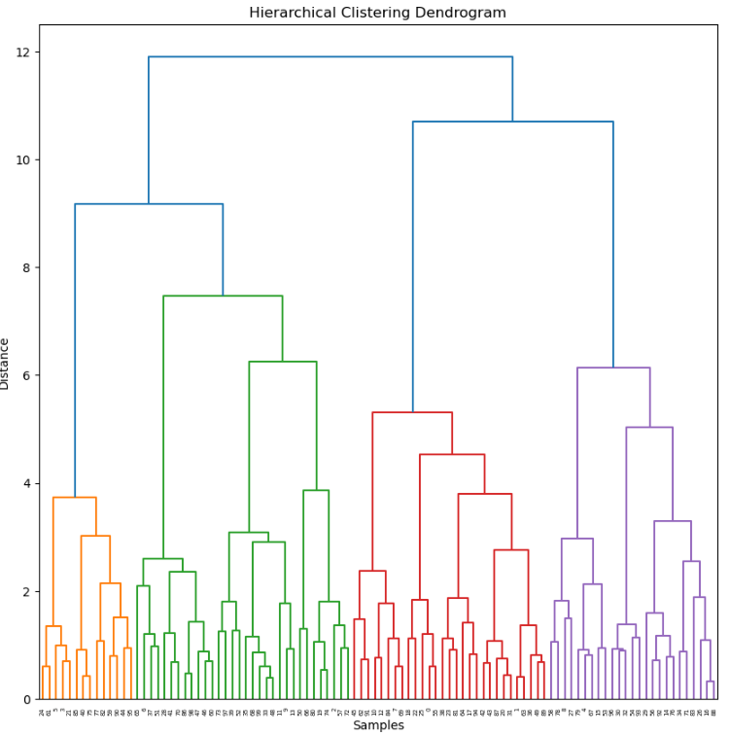  Figure 15 Hierarchical Clustering 100 samples  Purple: Right: Hardcore grinding playstyle. Very High session or long durations. Specialised high engagement subgroup. Intense focused play behaviour (retention).

5.2 K-Means
KMeans as explained by Bishop [19, p. 424] “considering the problem of identifying groups or clusters of data point in a multidimensional space”, The goal is to partition data into k clusters (3 in this case.)  The scatter plots showed clear separation when plotting sessions per week against other progression metrics. Supports hypothesis Engagement is driven by behaviour not demographics.  “K-means clustering is an algorithm used to group the objects based on features into K number of groups. It works on an unlabeled dataset (unsupervised machine learning)” |  |  | 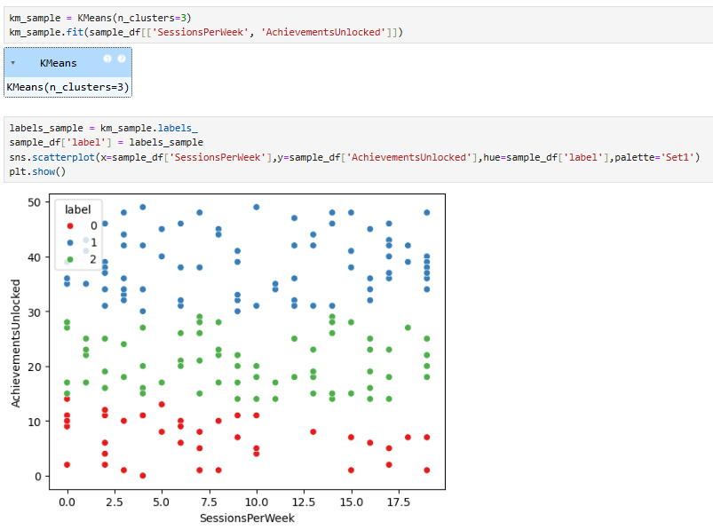  Figure 16 KMeans Clusters = 3, sessions per week and achievements unlocked

5.3 Silhouette Score
Silhouette score evaluates both the cluster cohesion and separation. Mearing how well each data point will fit within its assigned cluster vs other clusters, using a range of -1 to +1. A higher value would indicate better-defined or more separated clusters.  0.17 isn’t a great score, it’s quite modest, but for a large data set based on human behaviours which isn’t cleanly separated, it’s understandable. This isn’t an issue as such, engagement isn’t binary (as early attempts of data processing emphasised resulting in revisit.) Implies some mix, e.g maybe they don’t play often but they play for a long time |  |  | 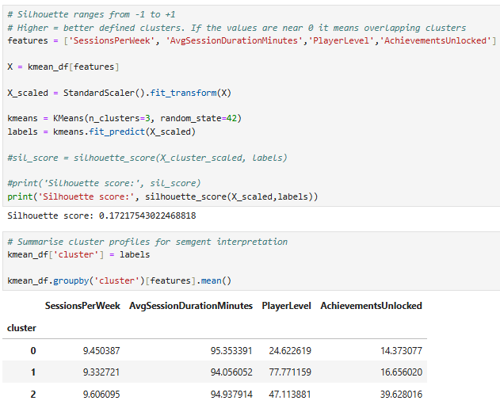  Figure 17 Silhouette ranges -1 to +1 group by cluster

5.4 Inertia
Inertia measures how tightly grouped within a cluster data point are. Lower Inertia means more compact clusters. Inertia will always decrease with more clusters. Mainly used with elbow method to identify a sensible number of clusters.  In this data set, WCSS (inertia) was calculated for k = 1 to 8. The elbow curve (Kmeanmodel.fit) shows a gentle bend at around k=3, rather than a sharp elbow.  This implies behaviour is not split into hard boundaries, instead it exists on a continuum. K=3 further justified, as the simplest meaningful segmentation without overfitting / micro clusters. |  |  | 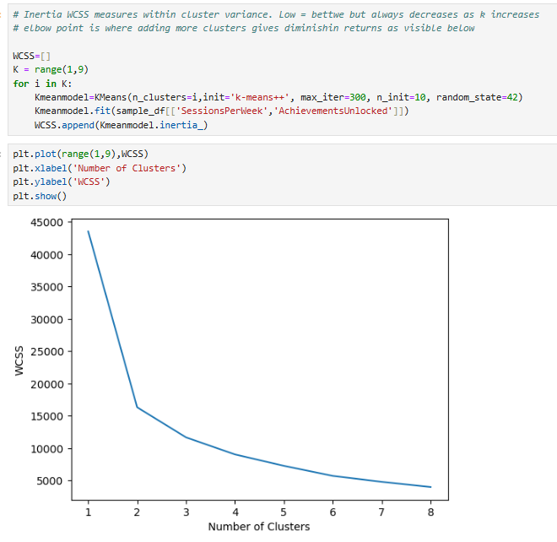  Figure 18 Inertia Elbow method

Evaluate Clustering
KMeans clustering personally was less informative than hierarchical clustering, although that may be due to a preference for visualisation. [19, p. 3] “The goal in such unsupervised learning problems may be to discover groups of similar examples within the data where it is called clustering”

Supervised and Unsupervised
Both supervised and unsupervised learning demonstrated player behaviours was more influential than player demographics. [19, p. 3] “Applications in which the training data comprises examples of the input vectors along with their corresponding target vectors are known as supervised learning problems”

Sessions Per Week was the dominant important feature apparent from the decision tree as part of the unsupervised learning. Clustering also suggested stronger patterns of play time intensity in both frequency and length, player level and achievements unlocked also seemed to correlate.

Whilst Supervised provided early insights such as sessions per week it did not fully reflect player behavioural pattern; it did however highlight important dominant features in relation to Engagement. Unsupervised learning, especially hierarchical visually demonstrated behavioural clusters.

Conclusion
The data strongly suggests player behaviour is more influential and measurable in correspondence with player engagement. Sessions Per Week and Average Duration Per Session stood out as important features. Player demographics, such as age, gender, location and even game genre had minimal impact on player engagement, the later was surprising. Instead, clustering behaviour demonstrated groups of players likely based on intensity, patterns lower figures in association with game session length and regularity, perhaps even player level and achievements evident.

Results and Recommendations
As behaviours seems strongly linked with engagement, high session volume combined with duration most noticeably. The Medium ranges present opportunity for Game Development Studio to target. With additional consideration to High engagement user retention.
Suggestions, to target low engagement user onboarding nudges, easy quests and reminders may serve to increase engagement. Medium engagement users are the majority and present the most opportunity, possibly engagement incentives include battle passes and events to encourage participation. In order to retain users with already high engagement, ranked mode may be enticing, along with exclusive challenges and prestigious content and earned customisation to demonstrate their wins and challenge engagement.

Link to Video of Code Run Through
https://youtu.be/P1-C6u5gsNA - Click Here to view

References

[1] | R. E. Kharoua, “Predict Online Gaming Behavior Dataset,” 2024. [Online]. Available: https://www.kaggle.com/datasets/rabieelkharoua/predict-online-gaming-behavior-dataset?resource=download. [Accessed 24 November 2025].
[2] | Kaggle, “Learn,” 2025. [Online]. Available: https://www.kaggle.com/learn. [Accessed 28 November 2025].
[3] | JMLR, “Journal of Machine Learning Research,” 2025. [Online]. Available: https://www.jmlr.org/. [Accessed 20 Novemebr 2025].
[4] | jupyter, “jupyter,” 2025. [Online]. Available: https://jupyter.org/. [Accessed 21 November 2025].
[5] | A. Géron, Hands-On Machine Learning with Scikit-Learn, Keras, and TensorFlow, Sebastopol: O'Reilly Media, Incorporated, 2022.
[6] | I. Millington, AI for Games, 3rd ed., Boca Raton: CRC Press, 2019.
[7] | Scikit Learn, “StandardScaler,” 2025. [Online]. Available: https://scikit-learn.org/stable/modules/generated/sklearn.preprocessing.StandardScaler. [Accessed 08 December 2025].
[8] | Scikit Learn, “f1_score,” 2025. [Online]. Available: https://scikit-learn.org/stable/modules/generated/sklearn.metrics.f1_score. [Accessed 09 December 2025].
[9] | Scikit learn, “roc_auc_score,” 2025. [Online]. Available: https://scikit-learn.org/stable/modules/generated/sklearn.metrics.roc_auc_score. [Accessed 09 December 2025].
[10] | Statistics How To, “Kurtosis: Definition, Leptokurtic, Platykurtic,” 2025. [Online]. Available: https://www.statisticshowto.com/probability-and-statistics/statistics-definitions/kurtosis-leptokurtic-platykurtic/. [Accessed 08 December 2025].
[11] | R. Nisbet, G. Miner and K. Yale, “Decision Tree,” in Handbook of Statistical Analysis and Data Mining Applications, 2nd ed., Boston, Academic Press, 2018, pp. 169-186.
[12] | N. B. Amor, S. Benferhat and Z. Elouedi, “Qualitative Classification with Possibilistic Decision Trees,” in Modern Information Processing, G. C. a. R. R. Y. Bernadette Bouchon-meunier, Ed., Amsterdam, Elsevier Science, 2006, pp. 159-169.
[13] | Scikit Learn, “1.10. Decision Trees,” 2025. [Online]. Available: https://scikit-learn.org/stable/modules/tree. [Accessed 08 December 2025].
[14] | Scikit Learn, “SVC,” 2025. [Online]. Available: https://scikit-learn.org/stable/modules/generated/sklearn.svm.SVC. [Accessed 08 December 2025].
[15] | Scikit Learn, “GridSearchCV,” 2025. [Online]. Available: https://scikit-learn.org/stable/modules/generated/sklearn.model_selection.GridSearchCV. [Accessed 10 December 2025].
[16] | Scikit Learn, “GridSearchCV,” 2025. [Online]. Available: https://scikit-learn.org/stable/modules/generated/sklearn.model_selection.GridSearchCV.html. [Accessed 08 December 2025].
[17] | Scikit Learn, “3.2. Tuning the hyper-parameters of an estimator,” © Copyright 2007 - 2025, scikit-learn developers (BSD License), 2025. [Online]. Available: https://scikit-learn.org/stable/modules/grid_search. [Accessed 08 December 2025].
[18] | Scikit Learn, “StratifiedKFold,” 2025. [Online]. Available: https://scikit-learn.org/stable/modules/generated/sklearn.model_selection.StratifiedKFold. [Accessed 10 December 2025].
[19] | C. M. Bishop, Pattern Recognition and Machine Learning, New York: Springer Science+Business Media, 2006, pp. 2-4, 124-126, 182-190,424-430, 654-675.
[20] | IBM Skills Build , “AI Fundamentals with IBM SkillsBuild,” 2025. [Online]. Available: https://www.netacad.com/courses/ai-ibm-skillsbuild?courseLang=en-US. [Accessed 20 Novemebr 2025].

Appendix
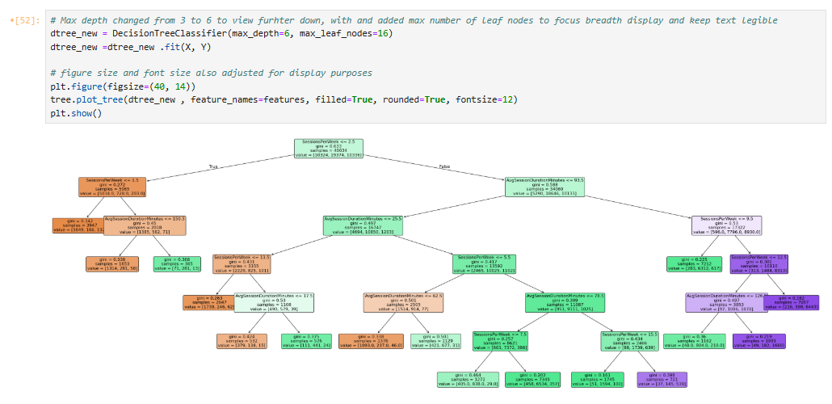
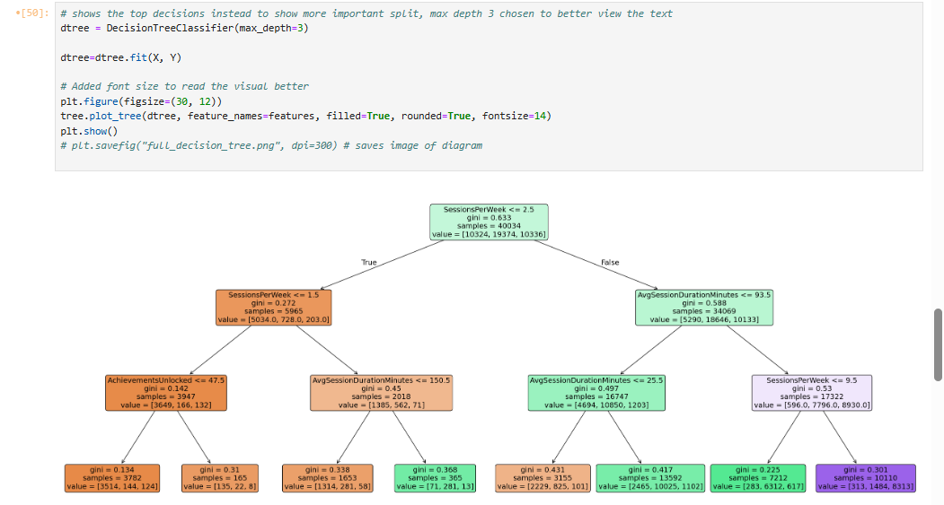
Early attempts of decision Tree. Updatied screenshots so moved these to appendix.
Figure 21 Decision Tree earlier version specific leaf nodes
Figure 19 Decision Tree second attempt: max depth 3
Figure 20 AI Fundamentals with IBM SkillsBuild Badge [20]

