MANAGING GUEST EXPERIENCE

PLACEMENT

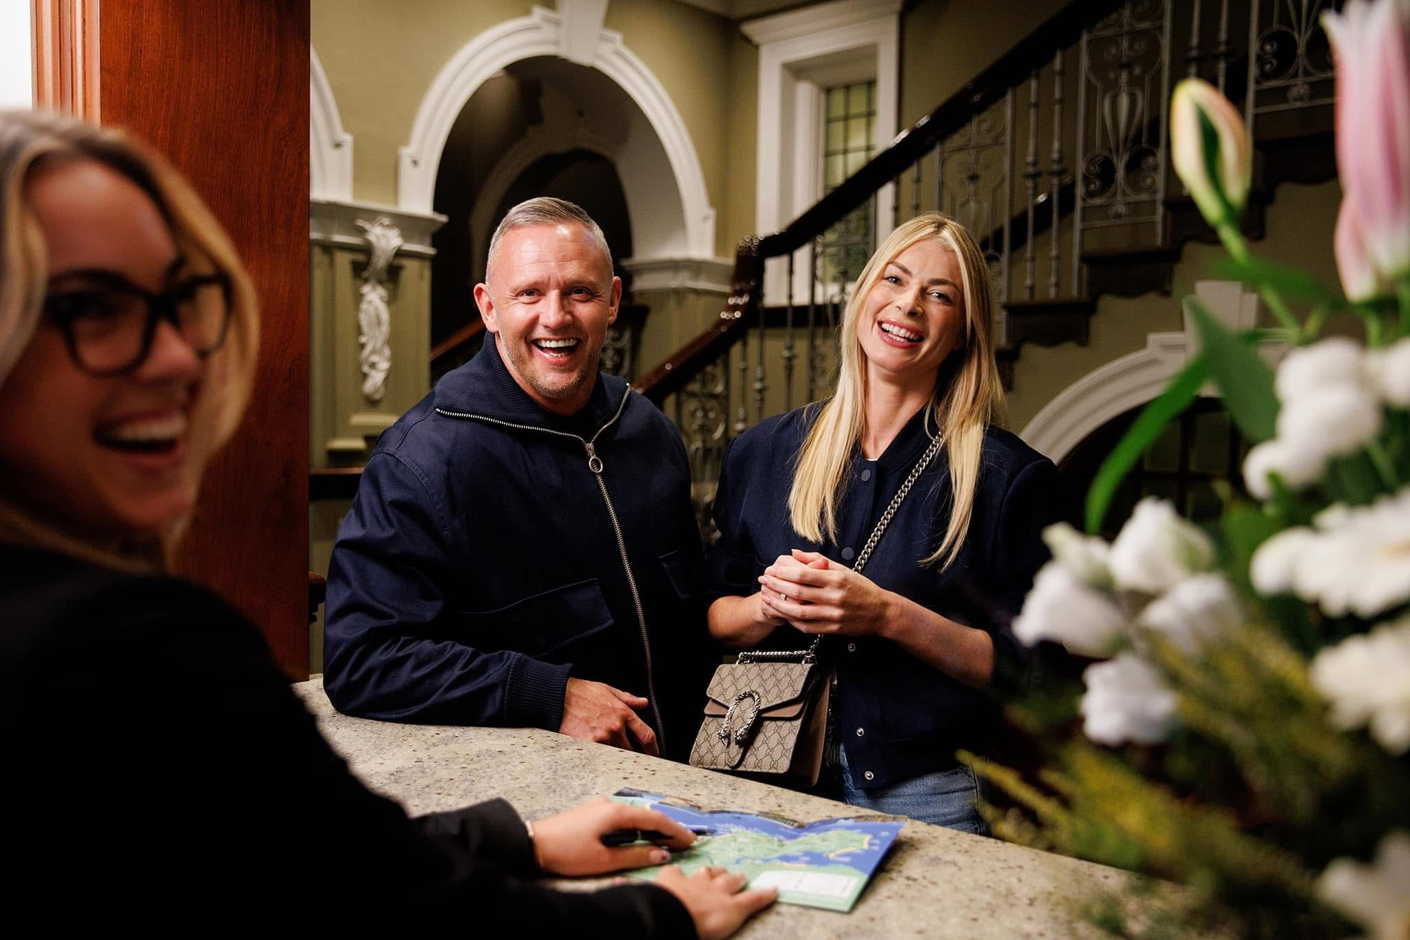

Student name: Adriana Ghiocel-Ioaniciu
Student number: 2127376
Module code: BMIH6012
Tutor name: Lisa Braisler

ACKNOWLEDGEMENT

I confirm that I have not used any AI tools in the research and creation of this assignment. I confirm that I have not presented any AI-generated materials as my own work. I confirm I have copies of my drafts, notes, and other resources I used, which I may be asked to provide in evidence.

Contents
ACKNOWLEDGEMENT 2
Part 1 . Leading part of a shift or shadowing the Duty Manager 3
Introduction 3
1.Description 4
2.Feelings 5
3.Evaluation 5
4.Analysis 6
5.Conclusion 6
6.Action plan 7
Conclusion 8
Part 2. Hotel feedback 9
Part 3 . Tutor feedback 14
Part 4 . Reflection on tutor and hotel feedback 18
Introduction 18
Main body 19
1. Understanding feedback 19
2. Impact of feedback 20
Action plan 20
Conclusion 21
References 22

Part 1 . Leading part of a shift or shadowing the Duty Manager

Introduction

This reflection looks at an incident with a visitor that happened while I was working at the hotel, helping the Front Office team and help on supervisory duties. A guest complained that he had lost an important piece of medication belonging to his wife. This meant that the reception staff had to communicate well, solve problems, and work together with lost property protocols.
The reflection is based on Gibbs' Reflective Cycle, which lets me critically look at what I did and how well the service was delivered as a whole. The goal is to find strengths, see operational flaws, and come up with plans to improve guest service performance in the future as a supervisor.
According to McLeod, S(2025) Gibbs' Reflective Cycle is a theory that was created in 1988 by Professor Graham Gibbs. It offers a structured method for learning through experience by using a structured six-step process of reflection.
It offers a clear, systematic method to reflection, taking you through phases such as summarising the experience, experiencing your emotions, evaluating what went well and what may be improved, understanding the situation, drawing conclusions, and planning future actions. This strategy allows you to gain a better understanding of your learning, identify areas for improvement, and apply your insights to future encounters, so promoting both personal and academic success.(University of Derby ,2024)

1.Description

A guest called the hotel during my shift at the front desk to say that he had forgotten his wife's very vital medicine. The visitor gave an explanation of where he thought the item was left . The first call was handled by my colleague, but she was unable to find the medicine in the area where the guest mentioned. The same visitor called again the next day. With the help of the Duty Manger, I took the call this time. The guest provided different information on the item's location and description. I took charge of the problem and carried out a more detailed search, which included room search and in lost property as well. I was able to locate the medication in the lost property after going over the things and comparing them with the guest's description. I told the guest that the item had been found right away. The guest complained since the item had not been located the first time, which created annoyance and worry, even though the problem had been fixed.

2.Feelings

At first, I felt responsible and focused on fixing the problem, especially since the guest made it clear that the medicine was very important. There was also some pressure on me because I wanted to handle the problem in a professional and good way.
I was glad and happy that I could help the guest when I found the medicine. That being said, I was worried and a little sad that the item hadn't been found during the first call, which made the guest unhappy because that medicine was very important for his wife.
the guest was upset, and he made a complaint. I thought the situation could have been handled better from the start. This made me think about how important it is to be accurate and work as a team when serving guests.
According to Mari ,D (2017), It's important for your health to understand and recognise your feelings. They are your body's way of telling you what's going on. Some feelings are harder than others, like shame, which is probably the most uncomfortable of all. But they are all important, and what matters is how you deal with them and recognise them when they come up.

3.Evaluation

There were good and bad things about this event.
The good things are that I took the initiative and was responsible for fixing the problem. After carefully listening to the guest and doing a good search, I was able to find the medicine.
There were some bad things, too. When the medicine wasn't found at first, it showed that either the lost property process or the way my colleague searched was not working well. This was inconvenient for the guest because they had to call again and felt worried and stressed.
Even though the problem was fixed in the end, the delay made the guests' experience worse overall.

4.Analysis

This shows how important it is for hospitality settings to have good service and consistent operations.
When something goes wrong, how quickly and well it is fixed are very important in how guests feel about it. In this case, the recovery was less successful because the process took too long. Even though I fixed the problem in the end, the guest was already unhappy because of the first failure.
The event also shows problems with the way things are done. Since the item was found on the second try, it's likely that the lost property procedure wasn't followed properly.
This shows how important it is for people from different areas to talk to each other. Guests are served by several teams in a hotel, and if there is a communication problem, it can have a direct effect on how the guests feel. Front Desk and Housekeeping didn't work together, which slowed down the process and made service delivery less consistent.
One last thing that was very important was emotional intelligence. The guest was not only unhappy but also worried because the medicine was so important. To handle these kinds of scenarios well, you need to understand, be patient, and communicate clearly. By really hearing and taking the problem seriously, I was able to build trust again, even though the first failure had changed the experience.

5.Conclusion

This experience showed me how important it is for guest service workers to be accurate, communicate clearly, and be responsible. I was able to fix the problem, but the initial failure showed that operational methods and teamwork were not working as well as they should.
What I learned is: - in guest service, getting the first answer right is very important.
-departments must be able to talk to each other clearly.
-being a supervisor means taking action, not just fixing problems when they happen.
-when dealing with sensitive guest problems, emotional intelligence is a must.
Overall, the experience boosted my confidence and taught me that being a leader means making sure that everyone on the team follows the same rules.

6.Action plan

According to Anna K,T(2022) The purpose of an action plan is to make it clear what resources are needed to reach the goal and set a timeline for when tasks need to be completed. An action plan breaks the goal down into steps that can be easily followed and kept track of.
To improve future performance, I will recommend implementing the following strategies:
1.Improve Lost Property Procedures:
-ensure all items are logged accurately and consistently.
-personally verify searches when dealing with important guest items.
2.Enhance Communication:
-communicate clearly with housekeeping and other departments
-follow up to ensure tasks are completed correctly.
3.Strengthen Supervisory Skills :
-take a more proactive role in guiding team members.
-double-check critical tasks to prevent service failure
-respond quickly and professionally to complaints.
-use empathy and clear communication to manage guest expectations.

Conclusion

This reflection shows how a service failure can get worse when communication and operational processes are not handled well. I was able to think critically about my activities and find ways to improve them by using Gibbs' Reflective Cycle.
Leadership helped us understand the event better, showing how important it is to respond quickly, work as a team, and be involved with supervision. Even though the problem was fixed in the end, the wait made the guest think less of the service.
This experience has made me more aware of the duties that come with being a boss, especially the need to make sure that everyone on the team is consistent and responsible. To improve the general guest experience, I will focus on better communication, checking operational processes, and using effective service recovery strategies in the future.

Part 2. Hotel feedback
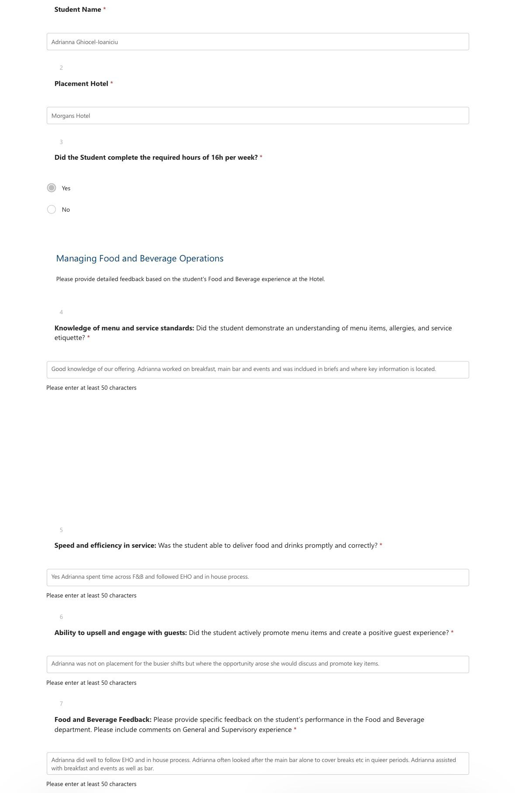
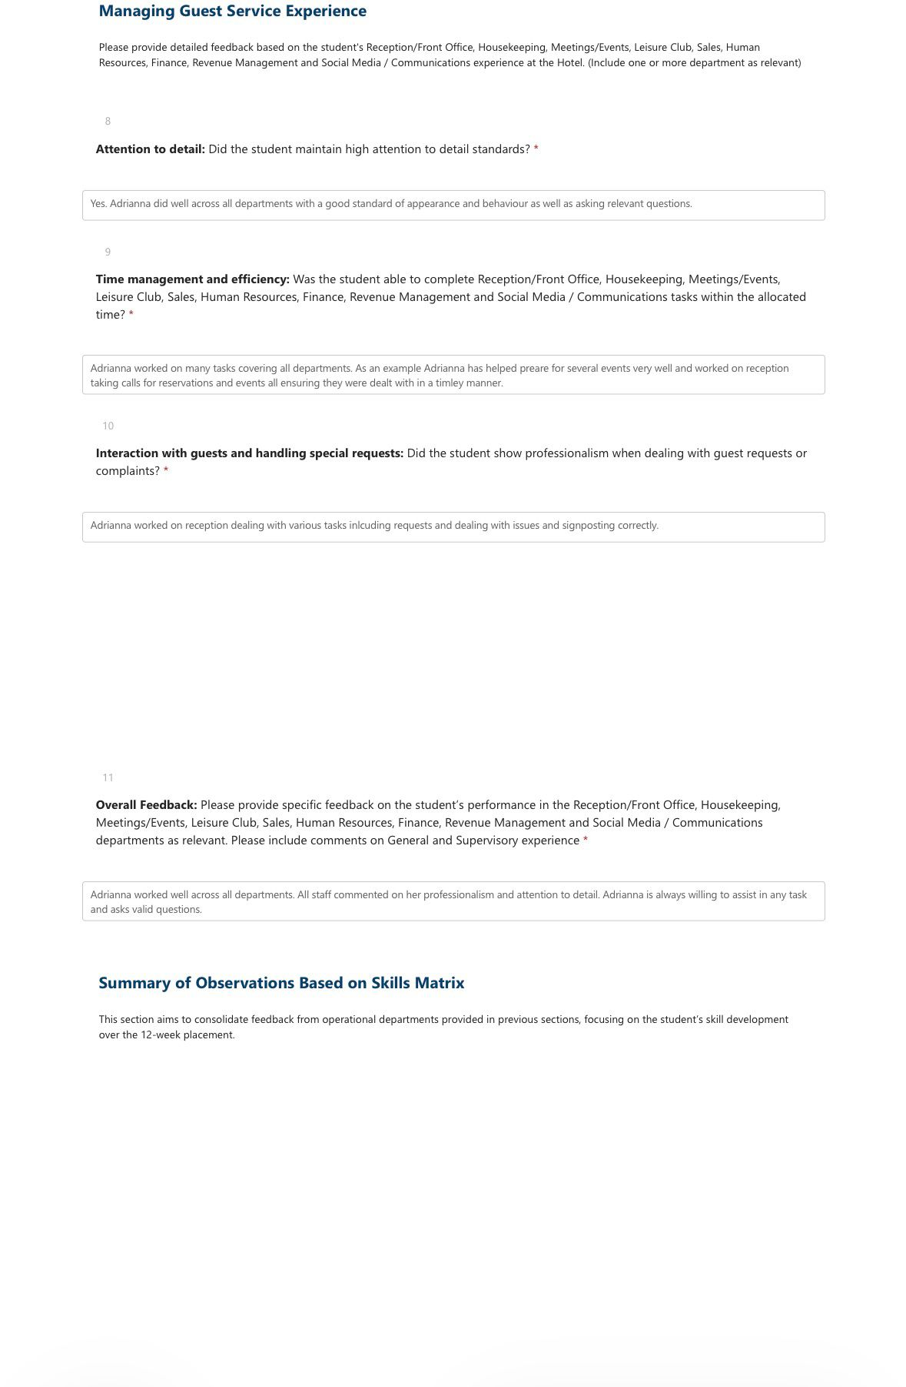
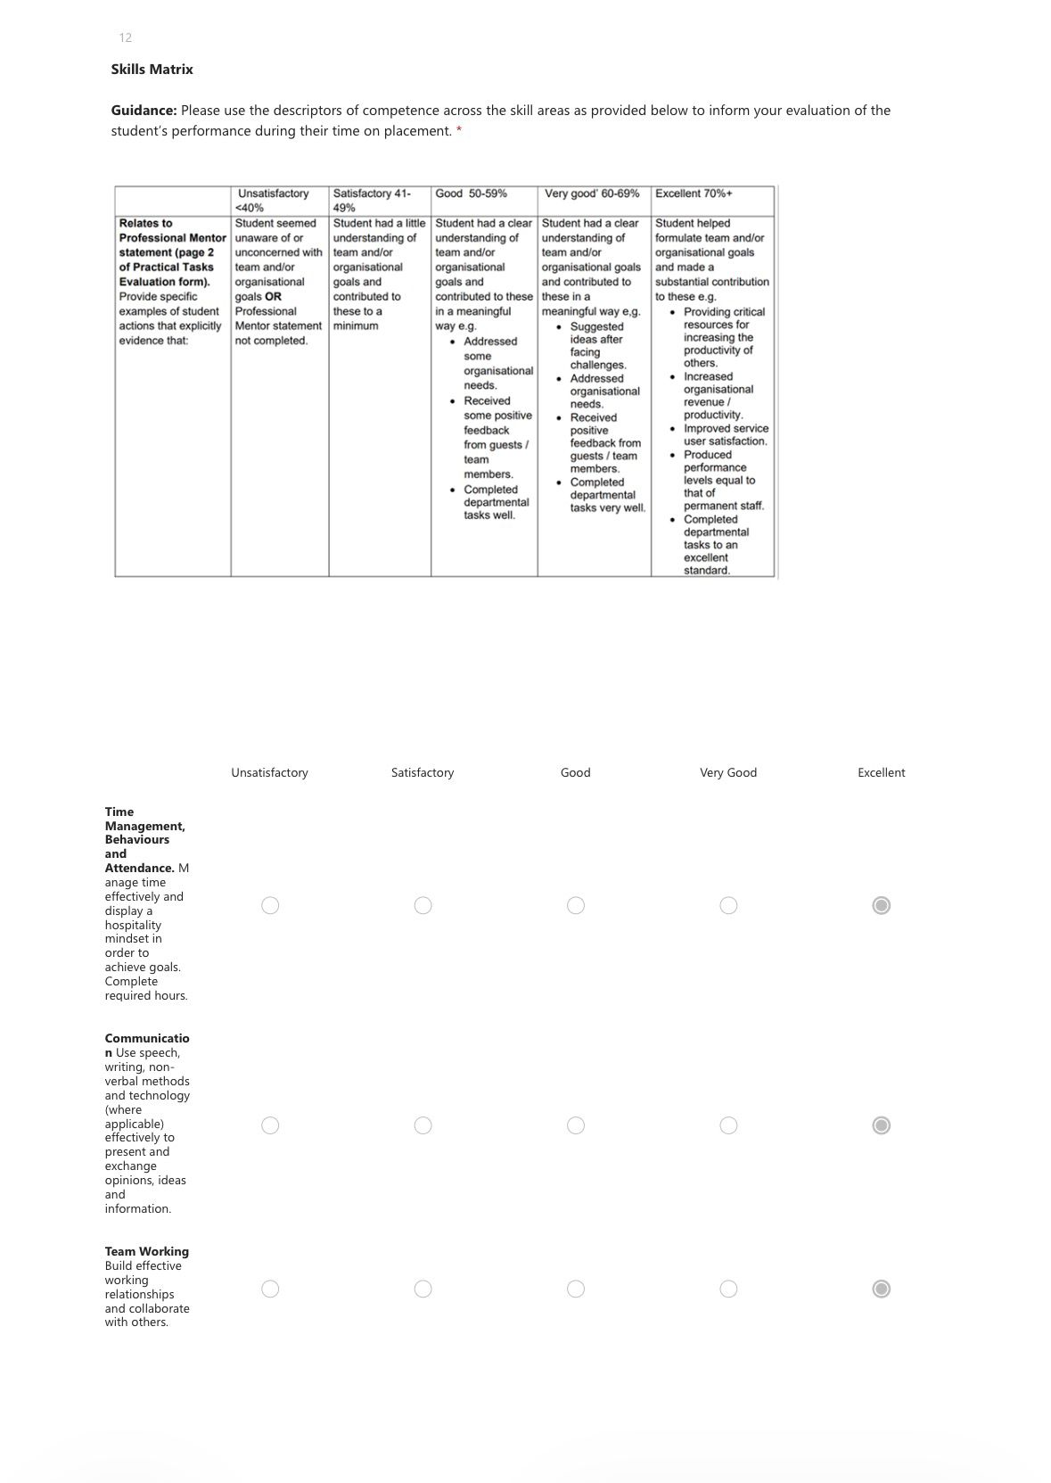

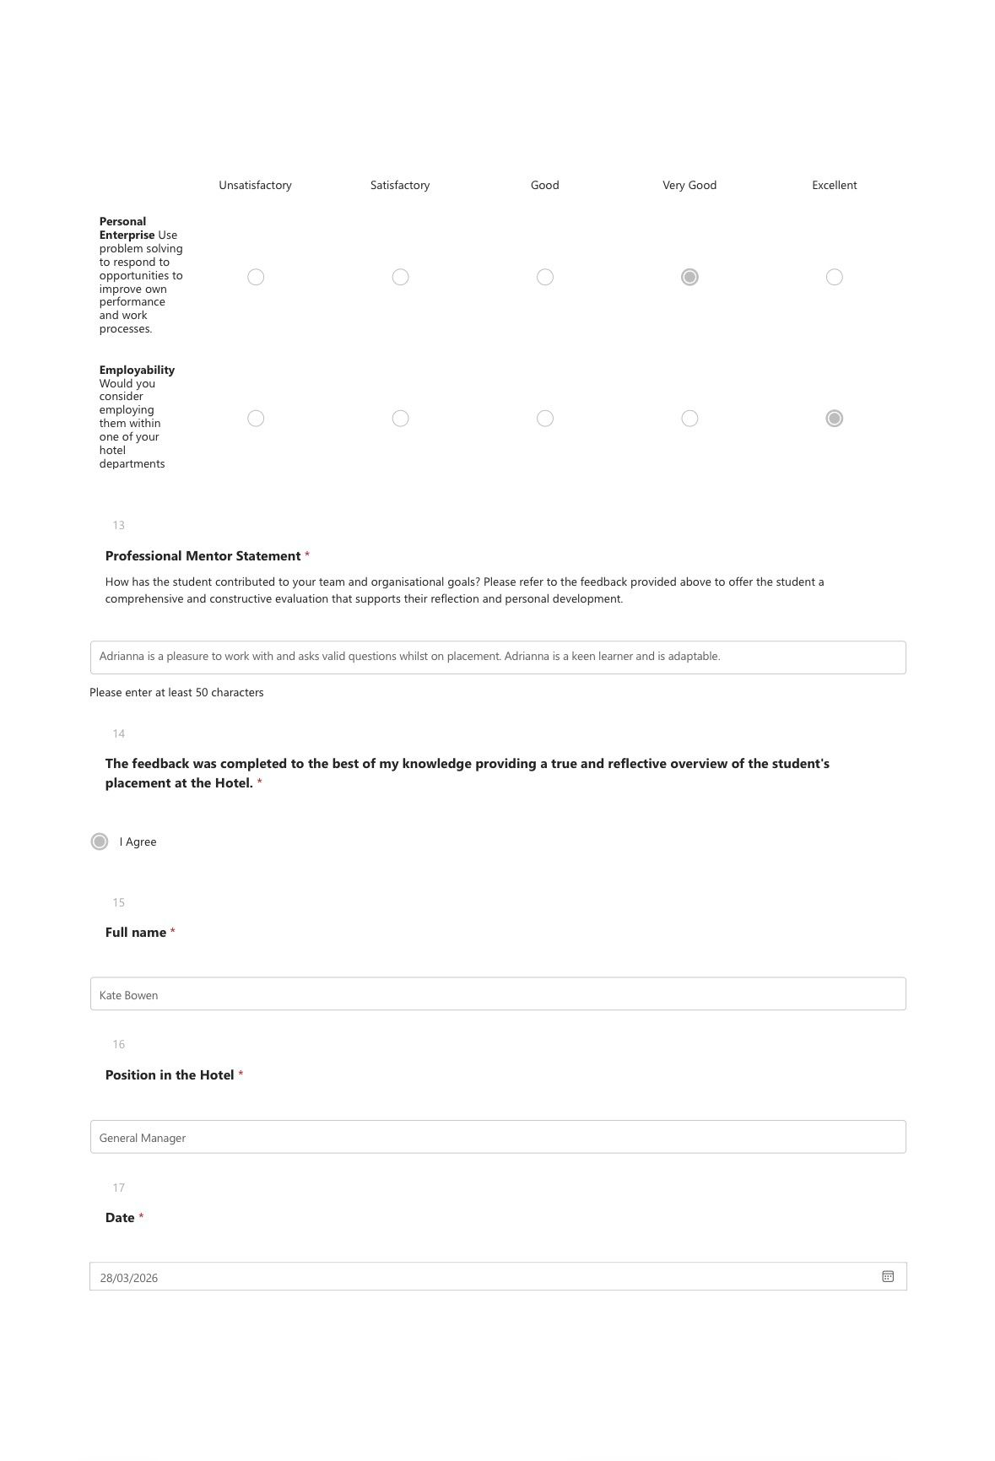

Part 3 . Tutor feedback


Tutor Feedback
Student Name: Adriana Ghiocel-Ioaniciu
Student ID: 2127376
Time Management
Adriana demonstrated a responsible and generally well-organised approach to time management during her placement. At the time of this feedback, she had gained experience across both Food & Beverage and Front Office departments, showing a willingness to engage with different areas of hotel operations in a timely manner.

She attended the majority of her scheduled shifts; however, she missed two weeks due to childcare responsibilities. Importantly, she took the initiative to arrange with the hotel to make up the missed hours and had already begun doing so at the time of this feedback, demonstrating accountability and commitment to fulfilling her placement requirements.

Adriana also consistently attended all one-to-one meetings with her tutor, as well as group sessions such as the assignment workshop, arriving punctually and showing clear dedication to her personal development and engagement with the learning process. She came prepared to these meetings, bringing relevant questions and contributing actively to discussions.

To further enhance her experience, Adriana would benefit from increasing her availability across a wider range of days and operational hours. Limiting availability can reduce exposure to busier periods and the full scope of hospitality operations; greater flexibility would allow her to gain a broader understanding of industry demands and strengthen her practical learning.

From a tutor’s perspective, Adriana has remained engaged and committed throughout, attending all scheduled placement meetings. To ensure successful completion of the placement, it will be important for her to continue meeting the required weekly hours consistently and maintain her proactive approach to managing her schedule.

Communication
Adriana’s communication throughout the placement was generally effective, with some scope for further development in professionalism and timeliness. Students were advised to communicate any absences at the time they occur. On this occasion, Adriana did not communicate her absence until the scheduled one-to-one meeting, meaning the tutor was not informed in advance. Going forward, it is important that she communicates any changes or absences promptly to ensure appropriate support can be provided and expectations are managed effectively.

Her verbal communication was consistently respectful and appropriately delivered, contributing to positive and productive interactions with staff, peers and the tutor. Adriana was polite, approachable and receptive in conversations, helping to foster a cooperative and professional environment.

Written communication, particularly via email, was consistently maintained. She was proactive in raising relevant queries and seeking clarification when needed, demonstrating initiative and a willingness to engage with her learning. This approach supports effective problem-solving and ensures she remains informed and on track.

Looking ahead, maintaining this level of communication, alongside improving the timeliness of updates, will support Adriana in maximising her overall learning experience and professional development.

Behaviour
Adriana demonstrated a professional and respectful approach throughout her placement, engaging positively with hotel staff, peers and her tutor. Overall, she conducted herself in line with workplace expectations, contributing to a supportive and well-functioning team environment.

She also demonstrated initiative in her learning by independently approaching duty managers to gain support with her development, including seeking guidance for assignment-related tasks and enhancing her overall placement experience. This reflects a genuine commitment to making the most of her opportunity.

Adriana worked effectively as part of a team, showing openness to feedback and a willingness to improve and develop.

It is important, however, that Adriana continues to recognise the value of all tasks within hotel operations, including routine duties such as cleaning. Developing a full appreciation for these responsibilities is essential, as they form a fundamental part of maintaining service quality and ensuring the smooth day-to-day running of a hospitality environment.

Looking ahead, continuing to build on these strengths, while taking greater initiative in expanding her availability and flexibility with shift patterns, will further support her development and success in future professional environments.

Problem-Solving
Adriana has demonstrated a positive and responsible approach to problem-solving throughout her placement with a growing sense of accountability and a willingness to ensure that situations are handled effectively and professionally.

A particularly strong example of this was her independent arrangement to recover missed placement shifts. This demonstrated accountability, initiative and an understanding of the importance of meeting placement requirements, as well as her commitment to maintaining professional standards despite external challenges.

Compared to Level 5, Adriana has shown clear development in her self-confidence and communication skills, alongside an increased ability to make decisions more independently. This progression indicates that she has taken on board previous feedback and is actively applying it within a practical setting, supporting her overall professional growth.

To further enhance her problem-solving abilities, Adriana would benefit from taking a more proactive approach in anticipating potential challenges and identifying solutions independently before seeking guidance. Developing greater confidence in making decisions in real-time situations will strengthen her ability to operate effectively in a fast-paced hospitality environment.

Tutor: Lisa-Marie Bassler
Signature: Lisa-Marie Bassler
Date: 1st Apr

Part 4 . Reflection on tutor and hotel feedback

Introduction

During my Level 6 placement, I received feedback from both my Hotel Manager at Morgans Hotel and my Placement Tutor. This feedback provides a critical analysis of the comments obtained from both. The objective is to perform an analysis of the ways in which this feedback has contributed to my development within the guest service operations, particularly in areas like as communication, flexibility, and professional conduct. feedback is crucial in the hospitality industry because it enables continual improvement, draws attention to strengths, and reveals areas that require improvement. In this reflection I acknowledge the limitations of my placement experience while also comparing and contrasting the perspectives of the academic world and the business world. In addition, it examines the ways in which the feedback has influenced my expectations of supervisors and specifies the important activities that will promote my growth into future managing jobs within the hospitality industry.
We can learn more about our weaknesses, our strengths, and how our actions affect other people, and what we need to work on by getting feedback. Getting to know ourselves better helps us grow as people.(University of Sussex,2024).
Weve got four types of feedback
- Constructive feedback -help us to focus on strength and weakness
- Destructive feedback -is focused only on negative aspects and criticism.
- Positive feedback – is focused on positive aspects
- Negative feedback – is focused on negative aspect but include suggestions for solution (Awork.com,2024).

Main body

1.Understanding feedback

The comments I got from my Hotel Manager pointed out a few things I did well in the front desk. I showed that I could professionally interact with guests by taking care of reservations and answering their questions. This shows that I understand what is expected of me as a guest service professional and that I can speak clearly in a front desk setting.
People also said that my professionalism and attention to detail were two of my best qualities. Keeping up a good look and asking relevant questions showed that I was ready to learn and get better. It was also pointed out that I was good at managing my time well, especially when it came to making plans and answering questions about events and making sure they were answered quickly.
From my placement tutor's point of view, my ability to handle my time well and my dedication were praised. I always showed up on time for meetings and took an involved role in the discussions. I also showed attention by making plans to make up hours I missed because of childcare obligations.
mu tutor told me that communication was one of the most important things I needed to work on. Even though I told the hotel I wouldn't be there, I didn't tell my tutor right away. This makes me realise that I don't fully understand how to communicate professionally with many people and how important it is to give information at the right time.
I didn't get to work during busy Front Desk times because almost all the time the manager gave me something else to do and this limited my experience with high-pressure situations like taking multiple guest requests at once or dealing with difficult service problems.
Overall, both types of comments point out strengths in professionalism, communication, and organisation. They also point out areas for improvement in communication consistency and more challenging Front Desk situations.

2. Impact of feedback

The feedback made it clear to me that my professionalism, communication skills, and capacity for managing visitor encounters are my greatest assets. For instance, handling reservations and attending to visitor requests helped me gain confidence in my ability to communicate effectively and clearly in a front office setting.
But the comments also pointed up significant areas for improvement. Because almost all the time ive had other duties on the bar,I had lost chances to improve my abilities like multitasking, setting priorities, and managing stressful situations. These abilities are crucial for front desk positions, especially those involving supervision.
My understanding of professional obligations was greatly impacted by the communication issue that my tutor brought out.. My sense of professionalism and accountability has increased as a result.
This feedback helps me to understand the for the front desk positions is not enough just excellent communication skills ,is needed also to be calm under pressure , and promptly attend to the needs of visitors. In general, the feedback has improved my comprehension of the requirements of front office operations and the abilities needed to advance into a supervisory position.

Action plan

An action plan includes a full list of the exact steps that need to be taken to reach a certain goal .(John Moores University Liverpool,2026).
I'm going to do a few things to get better at front office operations. First, I'll ask for more shifts during peak times, which will help me to improve my multitasking abilities and strengthen my capacity to manage stressful situations.
Second, I will enhance my communication skills. This will show professionalism and dependability.
Thirdly, I'll concentrate to improve my problem-solving abilities by being more proactive when responding to requests from visitors and trying to handle problems on my own before asking for help.
I'll also try to boost my confidence by interacting more with visitors and seeing how employees manage challenging circumstances.
These steps will help me to growth and move me closer to a supervisory position in the front office.

Conclusion

In conclusion, thinking back on the feedback I received from my placement tutor and hotel mentor has given me important new perspectives on how I performed in the front office. The comments indicated significant areas for growth, such as communication consistency and experience in high-pressure circumstances, even if it also acknowledged my skills in professionalism, organisation, and communication. My experience on front office operations helps me to understand what abilities I needed to have success on these positions . I'm determined to do better at communicating, be more available, and actively look for chances to advance my abilities going future. These steps will help me advance into supervisory or manager positions in the hospitality sector in the future.

References

Awork.com. (2024). Understanding Feedback: Types & Benefits for Growth. [online] Available at: https://www.awork.com/glossary/feedback [Accessed 18 Apr. 2026].
Hanna, K.T. (2022). What is action plan? - Definition from WhatIs.com. [online] WhatIs.com. Available at: https://www.techtarget.com/whatis/definition/action-plan [Accessed 14 Apr. 2026].
John Moores University , L. (2026). Action planning. [online] www.ljmu.ac.uk. Available at: https://www.ljmu.ac.uk/microsites/promoting-healthy-weight-in-pre-school-children/modules/behaviour-change-techniques/action-planning.
Mari, D. (2017). Why is understanding our emotions and feelings so important? [online] Counselling Psychologist | Reigate | Surrey | online | Individual & Couples therapy. Available at: https://www.drmarikovanen.co.uk/emotions-feelings-important/ [Accessed 13 Apr. 2026].
McLeod, S. (2025). Gibbs Reflective Cycle. [online] Simply Psychology. Available at: https://www.simplypsychology.org/gibbs-reflective-cycle.html [Accessed 13 Apr. 2026].
Morgans, H. (2016). Facebook. [online] Facebook.com. Available at: https://www.facebook.com/share/1ERRRXH1QM/?mibextid=wwXIfr [Accessed 13 Apr. 2026].
UNIVERSITY OF DERBY (2024). LibGuides: Resilience: Gibbs Reflective Model. [online] Derby.ac.uk. Available at: https://libguides.derby.ac.uk/develop-at-derby/resilience/gibbs-reflective-cycle [Accessed 13 Apr. 2026].
University of Sussex (2024). Giving and receiving feedback : Leadership and management : Organisational Development : Schools and services : University of Sussex. [online] www.sussex.ac.uk. Available at: https://www.sussex.ac.uk/organisational-development/leadership-management/giving-feedback [Accessed 18 Apr. 2026].

