MANAGING ENTERPRISE

BMSW4011
Task 1
Business idea: Heavenly Deserts - Cake shop

Student Name: Noemi Bagi
Student ID:2330383

Contents
Part 1 3
Introduction 3
1. Name and Concept 3
My story behind this idea 3
2. Type of organisation 3
Justification 3
3. Mission, Aim, Objectives & USP 4
Mission 4
Aims & Objectives 4
Unique Selling Proposition 4
4. Location 4
5. HR & Organisational Structure 4
Organisational Chart 5
6. Marketing 5
7. Market research 6
8. Financial Resources 8
9. SWOT Analysis 8
The biggest threat identified 9
Conclusion 9
Part 2 – Reflection 10
References 12

Part 1

Introduction
Homemade cake businesses combine the creativity and passion of individuals with the practicality of running a business. Due to the increasing number of people looking for high-quality and customized goods, home-based bakeries are becoming more popular. This business plan will help to establish Heavenly Cakes’ mission, marketing strategies, and financial projections. The goal of Heavenly Cakes is to establish a strong following on social media and provide personalized service to its customers.

1. Name and Concept
The Heavenly Cakes was established to provide high-quality homemade pastries, cakes and cupcakes. The shop’s offerings include customised designs for events, such as weddings and birthdays, as well as ready to eat treats.

My story behind this idea
I came up with the idea for the cake shop business after falling in love with baking and creating custom-made cakes for my family. I noticed a gap in the market for such cakes that were made with a personal touch.

2. Type of organisation
Heavenly Cakes is a limited liability company that can be registered as partnership. The CEO and the chairman of its board of directors are the majority shareholders of the business. The other employees of the cake shop also own shares in the company. A partnership is a type of legal entity that is owned by more than one person. It allows individuals to share in the profits and risks of a business (Herefordshire & Worcestershire Chamber of Commerce, 2020). Partnerships don’t have a separate legal status, which means they won’t be registered at Companies House.

Justification
The partners of the Heavenly Cakes will need to be nominated by the HM Revenue & Customs (HMRC). They will then share in the company’s profits and pay taxes according to their individual share (Government of UK, 2022).

3. Mission, Aim, Objectives & USP

Mission
The company’s mission is to bring joy and happiness to every occasion by making high quality homemade cakes.

Aims & Objectives
- The company’s objectives are to establish a strong first six month customer base.
- By the end of it first year, the company aims to make at least £5,000 profit per month.
- The company aims to expand its reach offering both delivery and online orders within the first year.
- Furthermore, to establish a recognisable brand, the company must perform well in marketing and customer service.

Unique Selling Proposition
The company’s USP is its ability to create custom-made cakes that are made with only organic ingredients.

4. Location
The company’s establishment is in a residential area that allows it to maintain its flexibility and reduce its overhead costs. It offers both local delivery and online orders, and its target market is made up of individuals who are looking for custom-made cakes for special occasion.

5. HR & Organisational Structure
According to Nusratovich and Usmonkhan (2022), identifying the job roles of employees based on their performance is very important in establishing productive values. Therefore, the company will initially be operated with the help of a part-time baker, a shop assistant and two partners.
The head baker of the company (first partner) is responsible for overseeing the development and production of various products. The business manager (the second partner) is responsible for marketing and managing the finance and customer service departments. The part-time assistant baker is responsible for assisting in the preparation of cake decorations and ingredients. The shop assistant will look after the physical shop, will prepare orders for delivery and assist the other members in their daily activities. Deliveries will be handled by contract-based individuals or different platforms for take-away. Additional staff members may be hired in the future, as per the shop’s increasing demand.

Organisational Chart
CEO

Figure 1: The Organisational Chart
Delivery driver
Shop assisstant
Assistant baker
Business Manager (Second partner)

6. Marketing
Heavenly Cakes’ marketing strategy will involve using various offline and online mediums to build its brand image and engage with consumers. The cake shop will also establish a loyalty program to encourage repeated orders. These strategies are aimed at building a strong brand image and attracting more potential customers.
One of the most effective ways to promote a company is through online advertising, which ca be done using Facebook, Instagram, Tik-Tok, Twitter etc. These platforms can be used to create a customised ad campaign that will help the company reach its target customers. A company’s page can also be equipped with a logo and a key message to make its message more appealing to the potential customers (Chawla and Chodak, 2021). Using twitter can help with boosting the traffic on the company’s website and improve its brand awareness, identifying also the relevant trends (Mladenović et al., 2023).

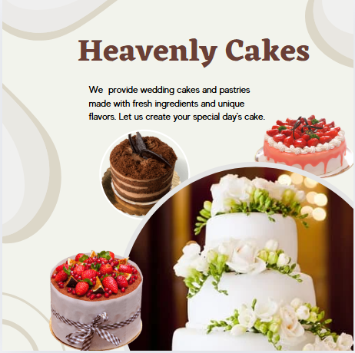
Figure 2: Social Media Post

7. Market research
The UK's sweet baked goods, cakes, and cake bars market was valued at almost £3.2 billion in 2023, which is 39% higher than in 2018 (Mintel Store, 2024). Additionally, the global market for pastries and cakes is expected to grow at a rate of 3.35% and reach a value of over USD 22.6 billion by 2028 (Technavio, 2024).
To ensure that the company can meet the needs of its customers, Heavenly Cakes conducted a comprehensive research program that involved online surveys and focus groups with potential customers. The results of the study revealed that 85% of the respondents prefer homemade cakes over the supermarket variety. The study also revealed that 60% of the respondents are interested in vegan and gluten-free options. This prompted the company to include these in its product range.
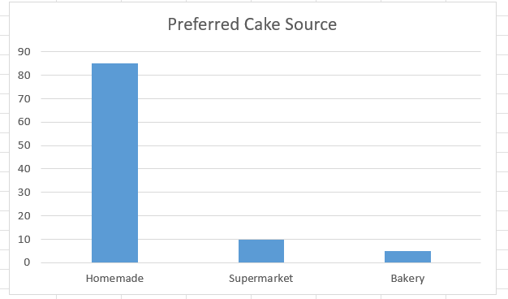
Figure 3: Preferred Cake Source

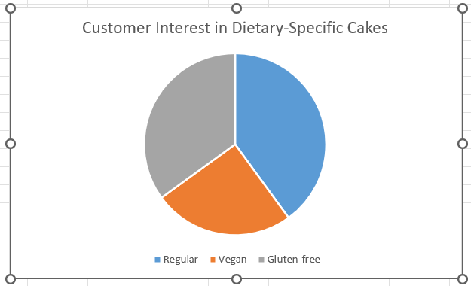
Figure 4: Customer Interest in Dietary-Specific Cakes

8. Financial Resources
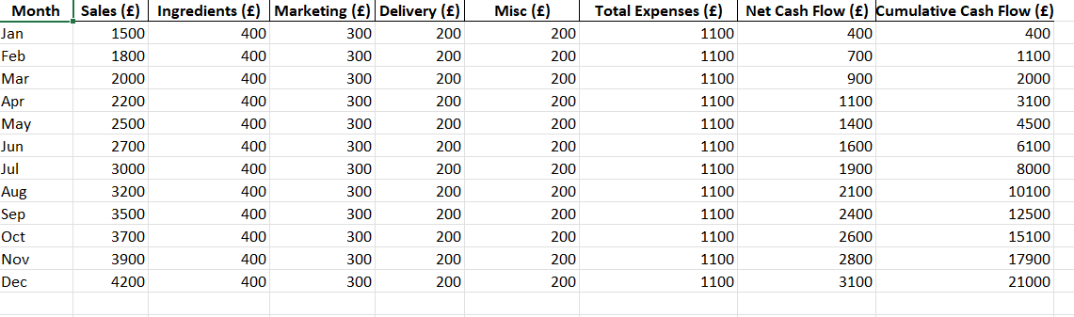
Figure 5: Cash flow over 12 months

9. SWOT Analysis
SWOT Analysis is widely used by companies in strategising. It is regarded as an integral part of the strategic process (Vlados, 2019).
Strengths | Weaknesses
- Offering a wide variety of homemade cakes  - Unique designs and recipes  - Possibility to order online and get the cakes delivered to your door | - Expensive price range can discourage potential customers from making a purchase  - It may take time to establish itself in order to be successful  - The marketing part can be challenging
Opportunities | Threats
- Offering gluten free and allergen-free cakes  - Offering other product as well, such as bread and beverages  - Suitable for large events | - The competition is higher  - The availability of certain ingredients could be affected by supply chain disruptions

Table 1: SWOT Analysis

The biggest threat identified
The cake shop's biggest threat comes from established bakeries. The key to maintaining a successful cake shop is to focus on providing high-quality ingredients, customer service, and unique designs.

Conclusion
The business model of Heavenly Cakes is characterised by its passion for creating unique and personalised cakes, as well as its ability to offer a value proposition that is unmatched in the market. It draws on the strengths of its ingredients and services and combines them with a client's unique needs. By strategically planning in areas like marketing and finance, Heavenly Cakes can establish a strong foothold in its local market and gradually broaden its distribution channels through digital order methods. The research undertaken by this business supports the business' viability, and its SWOT analysis provides valuable insight into the potential threats and opportunities.

Part 2 – Reflection
Through this business plan I managed to improve my skills and knowledge about cake businesses. I learned how to perform market research and analyse the industry’s trends, which was challenging at the beginning because I was not sure where to start from. The questionnaire I used helped me to learn about the demand for homemade cakes and how popular they are among potential customers, while vegan and gluten-free cakes are some options to consider further. Furthermore, from the market research I conducted I understand what products the best options for my business idea are. My skills to gather qualitative insights and make business decision based on results are also improved.
Working on this project helped me to understand and develop cost management, which is essential when planning a new business. The cash flow forecast combined with knowledge of expenses and start up costs enabled me to determine future financial planning requirements. The experience taught me financial management skills even though I had never used them before.
Another skill I managed to develop, and practice, was creativity while working on the marketing side. My creation of a marketing strategy enhanced my communication abilities and helped me to build a brand identity. Through digital posters for social media, I showcased my business in an attractive and persuasive way. Canva was also helpful in this situation as I managed to see some examples and use my creativity there.
My communication skills were also improved from the market research and interact with potential customers. The collaborative work approach I used and my responsiveness to feedback have greatly improved my enterprise concept. I was able to develop an exclusive value proposition for my business while identifying and filling market gaps. Therefore, I have discovered my passion for the entrepreneurship and my problem-solving skills.
The introspection process made me aware that I need to strengthen further my critical and creative thinking skills for business decision-making. I trust my capability to generate concept, yet I often find myself reluctant to pursue unconventional decisions. My limited knowledge of the UK business environment restricts capacity to think fast and act accordingly. Therefore, I am planning to improve these skills by creating new connection with professionals form this industry, participate at different events and workshops and find myself a mentor. By engaging with these interactions, I will develop a deeper comprehension of diverse corporate problem-solving techniques alongside effective innovation strategies.
To conclude, this exercise helped me to develop a business mindset while practicing essential skills to handle financial management, product development, market research execution and product marketing. I understand that my innovative thinking and decision-making skills need development, but I am dedicated to pursing this growth while expanding both my professional and persona abilities.

References
Chawla, Y. and Chodak, G., 2021. Social media marketing for businesses: Organic promotions of web-links on Facebook. Journal of Business Research, 135, pp.49-65.
Gov.uk, 2022 Government of UK [Online] Set up a business partnership. Available at: https://www.gov.uk/set-up-business-partnership. [Accessed on 8 March 2025].
Hwchamber.co.uk, 2022 Herefordshire & Worcestershire Chamber of Commerce [Online] Legal Status of your business. Available at: https://hwchamber.co.uk/support/advice/starting-a-business/business-legal-status/. [Accessed on 8 March 2025].
Mintel Store, 2024. UK Cakes, Cake Bars and Sweet Baked Goods Market Report 2024. [online] Available at: https://store.mintel.com/report/uk-cakes-cake-bars-and-sweet-baked-goods-market-report. [Accessed on 8 March 2025].
Mladenović, D., Rajapakse, A., Kožuljević, N. and Shukla, Y., 2023. Search engine optimization (SEO) for digital marketers: exploring determinants of online search visibility for blood bank service. Online information review, 47(4), pp.661-679
Nusratovich, S.K. and Usmonkhan, V.S., 2022. The role of small business and entrepreneurship in the development of the national economy. Евразийский журнал академических исследований, 2(2), pp.731-735.
Technavio, 2024. Cakes And Pastries Market Analysis Europe, North America, APAC, South America, Middle East and Africa - US, China, Germany, Russia, UK - Size and Forecast 2024-2028. [online]. Available at: https://www.technavio.com/report/cakes-and-pastries-market-analysis. [Accessed on 8 March 2025].
Vlados, C., 2019. On a correlative and evolutionary SWOT analysis. Journal of Strategy and Management.

