Daniel Huxtable

P146514

13th December 2017

Submitted in partial fulfilment of the requirement for the degree of

BA (Hons) Graphic Design

How important is the use of effective branding and design for business success?


Dissertation Lecturer: Ian Simmons
Final Word Count: 6342
Table of Contents
Introduction 3
Chapter 1 – What is a brand and why is it important? 4
Logos 5
Engagement / Loyalty 7
Emotional Advertising and Branding 9
Naming / Web 10
Customers Engagement 12
Colours 12
Typography 13
Chapter 2 – The costs of branding/design versus the benefits 14
Starbucks Case Study 14
Brand Recognition 15
Brand Perception and case study 15
Clutter 16
Primary Research 17
Agencies 17
Loyalty and Perception 18
Adding Value 18
Applied Design Thinking 19
Entrepreneurs and Franchises 19
Chapter 3 – Rebranding and the effective design for business success – Case studies 20
Rebranding 21
Conclusion 24
Appendix 1 - Headmaster of Ffynone House School 26
Appendix 2 - Survey 28
Appendix 3 - Survey 29
What do you believe a brand is? 29
Appendix 4 - Survey 32
Appendix 5 - Survey 33
Appendix 6 - Survey 34
Appendix 7 - Survey 37
Appendix 8 - Survey 38
Appendix 9 - Survey 39
Appendix 10 – Owner Suzanne Stevens - The Shop With No Name 40
References/Bibliography 41

Introduction
Businesses, how important are they? They contribute to the world economy, provide the public with essential products and services as well as luxury items. However, for a business to keep providing products and services they must remain profitable. Subsequently, they must be able to effectively communicate their brand to the public through the use of branding and design. Without the use of effective branding and design, it can be argued that businesses would not be able to showcase what they have to offer, making it questionable whether the use of effective branding and design is the most important aspect for a business to execute in order to become successful.

Branding is not just limited to design, it is a combination of design, colours, values, beliefs, colour, ethos, creative marketing and emotions. In a world which is so image orientated, people rely on being told what is the right type of product for them, often without doing their own research into the matter. This dissertation aims to investigate the effectiveness of branding and design for businesses and the potential negative impact, and weaknesses in these areas. Which could perhaps impact negatively to a business and its sales. In addition, it will use case studies from primary research and the wider business world to identify if the use of branding and design has positively affected the business. It will discuss whether harnessing the power of effective branding is of direct financial benefit to a business. ‘In the early seventies logos on clothing itself was often unheard of and if there was a logo on the garment it would often be hidden on the inside of the collar.’ Klein (2010:28) Nowadays brands and logo on clothing are commonplace, we live in a world where occasionally the brand is more important than the quality. Within contemporary society, brands and logos are normalised with the brand becoming more important than the quality. In a world full of products and services many require designers to take the helm with businesses being integral to the global financial market. ‘In 2005 there were more financial transactions in a single day than the whole of 1965.’ (Neumier 2007:6-7) This is a prime example, showing how the world has developed commercially. Therefore, brand agencies and designers have a chance to benefit from this ever-growing client base.

Chapter 1 – What is a brand and why is it important?
A brand is influenced by a variety of different aspects of design and business’ beliefs and values. (Neumier 2006:2-7) It is a combination of these factors which makes a brand. A credible brand is reliant on a logo, colours, signs and other elements. Heller and Talarico (2011:35) both suggest that a brand creates something called an ‘Identity System’. This allows the perceiver of the brand to form a familiarity to the brand or business. In turn a business can potentially benefit from sales or an increase in brand value due to it being recognisable. Olins (2005:6) believes that, ‘All successful businesses are made up of three strands’. One of these strands is based upon the craft/technical design skills. These transferable skills can be used in marketing and design for businesses. It allows them to create a variety of material for a business to use for their own benefit, in order to gain wider awareness of their brand. Creating awareness of the brand itself is imperative as without it, a business would not be able to showcase who they are and what they offer. Clark (2006:2) believes that, ‘If you combine public relations, advertising, marketing; you are on your way to start building a strong identity/marketing plan.’ This could be a formula which when adopted by a business could potentially result in a growth of income.

Olins (2005:14) states that, ‘A brand used to be perceived as simple household goods such as soap, tea, washing powder, and soap. It was a symbol of consistency.’ Nowadays, brands are everywhere and range from technological goods to financial services. Olins (2005:12) also believes that branding is the most significant gift that commerce has contributed to popular culture. Although Klein (2010:preface) doesn’t believe that design and a strong brand identity will help a business growth. However, Mootee (2013:3) argues that, ‘Some large companies have turned to design thinking in order to keep competitive’. This shows that some of the large companies are seeing the importance and the value of design skills.

Logos
Neumier (2006:1) states that, ‘A brand is not just a logo.’ However, a logo is a large influence within a brand, often the first point of contact for a stakeholder of a business and therefore gives a glimpse of what the business is and what it has to offer. Airey (2015:8) argues that, ‘A logoless company is a faceless man.’ This strong statement is supported by majorly successful companies who have a memorable logo, in which they give a snapshot of who they are in an image, text, and/or colour form.

A business’ corporate icon, image or logo does not need to be detailed or confusing, often the simplest icons can have the biggest impact. Having a simple but intelligent corporate icon or logo can be of huge potential to a business for a variety of reasons. Firstly, an intelligent logo can act as a talking point for stakeholders of the business. For example, telling a client that there is a hidden meaning within their logo could be used to build rapport. Therefore, as a result, there may be a higher probability that clients invest or engage with a business. An example of this is the G&K Martial Arts Academy logo (fig.1). The man in the logo is the Chief Instructor kicking in the World Championship final. This can be used in an elevator pitch in order to build rapport with new customers and allows employees to have a talking point with new customers. This works for both SMEs (Small Medium Enterprises) and large corporations. Apple, a multinational corporation, has a logo which has a bite taken out of it. This is a “play on words” as they are a technological company; it is a silent nod to a computer byte. This is something which Apple would very likely not bring up themselves. However, consumers may discuss this topic between them and this in turn makes the brand more well-known. It allows the public to engage more on an emotional level with the business.


(Figure 1, Daniel Huxtable, G&K Martial Arts Academy Logo: 2013)


(Figure 2, Unknown, Apple Inc. Logo: 1998)

Often the logo of a business can be used to give the viewer a quick glimpse into the business. Designers use semiotic theory to add meaning to the design for their logo and potentially make the brand more valuable.

Although not always represented by a logo, iconography can be extremely valuable for businesses. It can often be a business’ safe mark of familiarity for customers and employees. Stein (2011:49) cites Walt Disney ‘I only hope people don’t lose sight on what started it all off… a Mouse’. Although Mickey Mouse himself is not a logo of The Disney Corporation, he has become a corporate icon for the company and is a symbol of their brand. Symbolism is important for everyday life, not only for businesses, but also for national identity. Vexillologist, Kaye (2006:7) argues that you should ‘Use meaningful symbolism.’ This allows the perceiver to make a connection with the piece of branding or design.

A logo is not the only part of a brand, it involves a range of factors. Reason et al. (2016:49-50) dictates that, ‘A brand is designed to communicate the value and values of the organisations to its customers.’ The values of a business are important for a variety of reasons. Through branding, a business can show what they stand for or believe in, which allows a business to show customers and stakeholders the values it holds. Stakeholders may appreciate the fact that a company feels strongly about certain issues such as being against animal testing or child labour.

Engagement / Loyalty
Reason et al. (2016:49) declares that, ‘Along with product design branding is a major tool in customer engagement’. Engagement with a brand is important for a business, as this means that the brand is effective. Engagement with a brand can encourage customers to relate and talk about the business. This often results in customers feeling safe and ‘comfortable’ with the brand, which creates brand loyalty often leading to repeat purchases. Furthermore, as a consequence of brand loyalty customers may be happy to pay premium prices for the goods or services provided, even if quality does not differ from that of a similar business. To create this brand loyalty, it is important to use the ‘Law of consistency’ (Ries 2002:97). Consistency in branding is important, as it allows the brand to become recognisable. Thus, consumers feel safer and more secure when buying products from them.
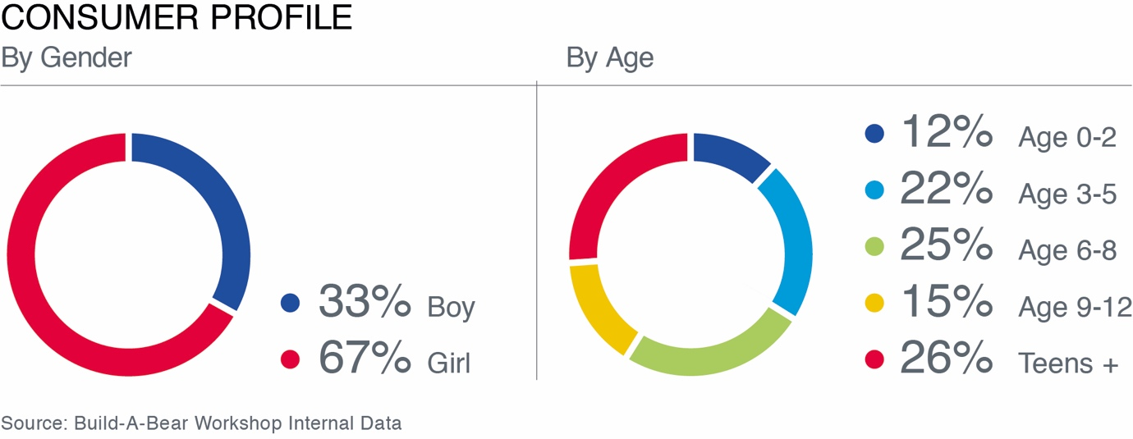
(Figure 3, Build A Bear, Annual Report: 2016)
Maxine Clark is the founder of Build a Bear Workshop, a very visual based company. They have expanded their stores significantly since beginning to trade in 1997. Their beliefs are constantly reiterated; in their end of year report, they aim to increase meaningful consumer engagement. (Annual Report, P2, 2016) Clark (2006:33) explains that, ‘If you are able to connect to your customers on an emotional level then you are on your way to building a successful company.’

Build a Bear Workshop has utilised their strong branding and beliefs to engage with their customers on a deeper level, which has led to customer loyalty. Adults who grew up from a young age with Build a Bear Workshops in their local cities have still returned to the brand, and this loyalty has resulted in a completely new demographic chain. (Fig. 3) Their consumer demographic is no longer just children, due in part to their successful marketing and branding. “Brand loyalty” has formed and their consumer profile shows that those aged thirteen plus are the main consumers of their products at 26% (the majority stake). The second highest demographic profile is from the ages six to eight at 25% of their consumer profile (Fig. 3). This demonstrates how their strong identity and marketing, has allowed them to keep their original consumers from 1997 to 2017. Even though the older age bracket may be considered “too old” for their products, customer loyalty has formed and therefore resulted in their success.

Emotional Advertising and Branding
Emotional advertising and branding is used by many of the world’s leading companies by emotionally connecting with their consumers, in turn a business can often secure a customer. (Smart Insights, 2012) If a company can think of the emotional connection their customers will have on a specific product then the business is likely to make more than just a financial connection with their customer. (Clark, 2006:22) McCain’s family meal times advert 2017 used emotional branding to connect with their customers. Using a strong 21st century look at family friends and dinner time essentially all McCain’s were advertising were chips. However, the 1 minute advert pulled on heartstrings conveying the message about families and friends eating together is so important (McCain’s, 2017). VanAuken states that in 2005 Pedigree dog food were losing customers and changed their marketing to appeal to customer’s hearts rather than their heads by harnessing the world’s love of dogs. (Branding Strategy, 2015) Businesses use consumers feelings and emotions to persuade them to buy. (Oetting, 2017)

The use of emotional branding has been prevalent in recent years. Spending on TV advertising has increased by more than 40% in recent years (Cheetham, 2017). John Lewis can be seen as a major leader in the emotional advertising sector especially around Christmas time. Every year they release an advert and within the advert they have a specific product they aim to sell, whilst also promoting the brand as a whole. In 2014, they released the Monty the penguin advert, a two-minute feature with a penguin and young boy playing. The penguin is longing to meet his truelove and it can be argued that this appeals to sentiments of family, love and the ‘togetherness’ felt especially at Christmas time. John Lewis (2014). The main product they were trying to sell was a stuffed toy of the penguin Marty and his partner Mable (Fig 9).
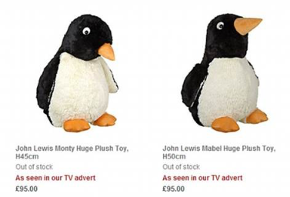
(Figure 9, John Lewis, 2014)
Using the power of animation, music, product placement and branding they were able to effectively emotionally connect with the public, this resulted in a frenzy by the British public to spend a substantial amount of money on these stuffed toys. The retail price of the larger sized toys were £95.00, however, after they sold out in stores and online they were reported to being sold on other sites such as eBay for prices upward to £500. (Eleftheriou-Smith, 2014) This shows the real power of emotional advertising and branding has for a business, and how especially at traditional ‘family’ times such as Christmas, it can immensely help to promote a business and its sales. Essentially all of this frenzy was over a stuffed toy.

Naming / Web
Having a short, snappy or clever name is extremely important for brands to decide. This allows a brand to standout, but also helps in regards to search engine optimisation. Ries (2002:148) believes that, ‘…if you can launch a good brand with a good name often you are in chance for long term website success.’ Web addresses are a big brand booster, web addresses can often help determine the success of a business. In 2002 Loans.com was bought for three million dollars (Ries 2002:148-149). This is an extreme case of how a short snappy name has been able to increase a brand’s value massively.

If a business has a website, the name should be as short as possible and easy to spell (Ries 2002:148-150). Many big brands reiterate this in their business’ website addresses, for example, apple.com or ebay.com. By having a short and memorable name as the website address, customers can easily search online and arrive at the correct destination. Difficult or complicated names can lead to frustration if customers struggle to find the website they are looking for. Boulding, the Head teacher of Ffynone School Swansea states that, ‘It is essential to keep your name and ethos of the business at the forefront as it could help you gain potential customers.’ (Appendix 1)

A local example of effective naming for brands is “The Shop with No Name”. Owned by Stevens and sells postcards and other unique items. When deciding the name of the shop she struggled to choose and decided to call it “The Shop With No Name” (Appendix 10). This was an excellent business decision and as a result the shop’s name has actually turned into a brand itself. There is a lot of competition within the Gowerton area of Swansea with similar niche shops. Due to having an individual, strong name, “The Shop With No Name” has been able to thrive, despite heavy competition (Appendix 10). Choosing the wrong name for a business could hinder a business’ growth and marketing ideas (Wheeler 2006:48). This could possibly result in a business eventually failing.

Customers Engagement
Neumier (2006:4-7) exclaims that, ‘A brand is not what you say it is, it’s what they say it is!’ Customer engagement is an excellent way to grow a brand. If people talk about the brand, this can often be a big brand cultivator. In the BBC’s The Apprentice Series 12 TV show, there was an outstanding suggestion which showed an example of brand awareness and engagement method. The candidates were asked to create a brand of Gin and sell it to retailers. When creating the brand Wood (the runner up) decided that the brand name of the gin would be called Giin. Pronounced “Shiin” he said that this would be a good customer engagement method, as customers would debate over the way it was pronounced. (BBC, 2016). Engagement methods like this work for some of the biggest brands in the world such as Primark, Nike, and Adidas, and these brands have sparked debates for decades. Customer engagement has been used to promote Old Mout cider where they have been using the fact that people have been saying the name wrong for years as a new marketing technique. (Fig 8)
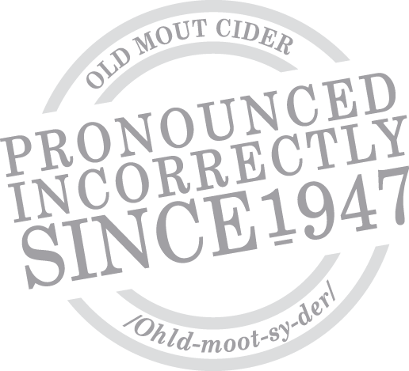
(Figure 8, n.d)

Colours
The use of colour psychology can be extremely important for a business. For example, A business that specialises in selling very minimalist white furniture, may not want to have a colourful logo with 4 different colours. However this does vary from business to business. Build a Bear stores were painted in primary colours in 2005, as the target market at the time was primarily children. (Clark 2005:35) This allowed children to feel comfortable within the stores, as primary colours are an integral part of a child’s development, adding to a better experience for the children and resulted in making the business more profitable. (Financial Report 2006).


(Figure 4, Janoff, Apple Inc Logo: 1977)
The Apple logo from 1977 (fig 4) was an excellent use of colour for the time/culture. The use of multiple colours was used, because colour computers had just started to be released. This gave them a modern look to move into the new technological era.

Typography
Typography is of vital importance to the world for many reasons. It allows the perceiver to decipher the language to convey meaning. Without typography, we would have to rely on pure image to communicate, and in some instances this is impractical. Wheeler (2006:114) states that, ‘Typography is a core building block of an effective identity programme.’ A fundamental element when building a brand is the identity programme of a business. Additionally, being able to effectively give a literal meaning with the use of words, typography can also be used for other methods. The use of typography has evolved throughout the years, as has the ever-growing database of fonts. Companies such as Apple are instantly distinguishable because of their consistent and intelligent use of typography for their brand. A brand needs to use effective and appropriate typeface for its informational needs. If it is not used appropriately, it might not have the intended effect. Spiekermann cited by Wheeler (2006:114) states that, ‘Type is magical. It not only communicates a word’s information, but, conveys a subliminal message.’ A business can use words to simply convey a message to their customers, whether it be in the form of advertising or via their website.

Chapter 2 – The costs of branding/design versus the benefits
Some businesses may reject the idea of change, branding or design as they do not know if the benefits outweigh the costs. The expense of having a professional Graphic Designer or Brand Agency to help the business can be costly, from SMEs to large multi-national corporations. This example of opportunity cost is where a decision must be made on whether it is worth investing on a certain part of the business such as branding or marketing, or whether funds should be directed towards stock or an inventory system.

Starbucks Case Study
Klein believes that you do not need to focus on branding in order to have a successful business. In 2009, Starbucks opened their own unbranded coffee shop in Seattle to avoid being judged by its own label in a heavily monopolised area. It was found that the shop was massively successful despite not having used the branded name ‘Starbucks’. (Klein, 2010:XV) This is an example of how a massively branded name may not be necessary in order to be successful. However, the counter-argument to this is that the shop’s name “15th Avenue Coffee and Tea” helped form a brand itself and therefore the success was due to this. Upon further research, Starbucks explained that they created this shop to give their designers ‘creative freedom’, therefore despite not using the name Starbucks it became a brand name. (Starbucks, n.d.)

Brand Recognition
Being a brand can often mean a business is more noticeable and this could have an adverse effect on a company. Having good ethics is a massive part of modern culture within a business. However, society sometimes believes that branding and marketing towards children is unethical. In France it is illegal to market towards children. There should always be an ethical factor which comes into the branding for businesses. Often a business can create a good brand in terms of design work or customer engagement, yet the actual quality of products is poor and does not reflect the image the brand is aiming to portray. Being more noticeable may leave a brand open to ridicule if they are perceived to be unethical.

Brand Perception and case study
Branding has given people a perception that the German technology market is a sign of guaranteed good quality products/services. (Olins 2014:11). Due to effective branding, we can have a perception about a product even before we have seen or experienced it ourselves. This can be extremely helpful for businesses within the German technological market. However, due to the power of branding it could also be seen as unethical and misleading, as not all companies are guaranteed to have a quality product or service. Olins (2014:14) argues that the notion “made in turkey” implies that it is cheap and bad quality. However, Turkey also offers some of the world’s greatest quality products. (Olins 2014:16) This form of branding of sectors and industries can often be misleading. For example, the Volkswagen emissions scandal where Volkswagen lied about their cars emissions has been said to have severely ‘damaged the made in Germany badge’ (The Guardian, 2015).

Another drawback is that a business may spend a lot of money on a design and, yet the design may not have the desired response. The brand needs to be remembered for all the 'right' reasons; quality, design, customer service. In addition, it must be reassuring and familiar to regular customers, but appealing and exciting to attract new customers. Olins (2005:15) argues that, ‘The reason why we buy from brands is because we like them, if we didn’t like them we simply would not buy them’. This suggests that when designing the brand the designer and company needs to ensure that it is done effectively and guarantee they test out the brand on unbiased people before releasing it. Nangia (Prototypr,2017) argues that ‘Consumers make decisions based upon how they feel. Therefore, if a consumer is frustrated due to bad design they will not buy from the business.’ In turn the business will lose revenue. This is an example of how a poor design can adversely affect a business. Design needs to be effective and able to clearly convey what the intended message is in order for the consumer to enjoy their experience.

Clutter
When faced with a new idea, product, or marketing scheme from competition, businesses become concerned regarding the impact this may have on their revenue. Sometimes this can lead to quickly coming up with ideas and then releasing a poorly designed/thought out idea. This could results in a rivalry of clutter between the corporations. (Neumier 2007:9) Meaning that both companies end up spending money on ineffective design that simply has little power. It would be more beneficial for businesses to take time and pay for an effective designer who is not only talented in design, but also excellent at knowing the business itself. The public can often feel confused and overwhelmed due to substandard advertising which can often be available. (Sacharin, 2001:16). A combination of these factors would allow the designer to know what values the business and its customers have. As Reason (2016:49) states, ‘A brand should be designed to communicate the value and values of the organisation to its customers.’ Therefore, if the designer can understand these values then they are much more likely to design more meaningful content.

Primary Research
As part of primary research, I surveyed small business owners asking, “What would put them off getting a brand identity?” (Appendix 9). Of note it was interesting that out of the 20 responses to this question, 22% of businesses were concerned regarding uncertainty surrounding the benefits they would gain as a result of the branding. However, the overwhelming majority stated that that there was nothing that would put them off getting a brand identity.

Agencies
Olins (2005:6) conveys that, ‘Many design agencies and brand development agencies use their skills in order to help their clients seduce customers to buy from them.’ This is an example of the pure power of brands and design for businesses. These ‘experts’ are within our modern world and their job is simple; to make money for their clients using their power of design. Nowadays, these design services are a part of a big industry themselves. The latest value of the UK design and creative industry is worth £76.9 billion a year. It contributes £8.8 million to the UK economy every hour, and the industry is growing at an incredible rate. (Design Council, 2016)

Olins (2005:11) believes that, ‘The power of brands and branding will continue to grow’. In turn, meaning that the experts such as businesses and designers must strive to learn and develop a greater understanding of what makes a brand work. Designers should use Clark’s theory, to develop an effective brand, you need to identify the core user of your product and tailor your marketing message to them. (Clark 2006:35) If a business can harness the power of the brand, then significant value can be added to products or services. Branding can make goods more desirable and luxurious to the consumers.

Loyalty and Perception
Good branding and products can create customer loyalty and as a result businesses can charge premium prices. 50% of customers would pay 20-25% more in premium prices for their favourite brands before swapping to an alternative brand. (Neumier 2007:100) This suggests the power of branding and why it is so important. It can be argued that the quality of premium products are not much better than their own-branded products. Although not a premium brand of food, McDonalds has been branded in such a way that they are seen as the “King of the fast food industry” (Neumier 2007:5). Through their branding, they have been able to attract millions of people throughout the world. (Martin, 2009:2) Their golden arches branding has allowed them to give the appearance that they are good quality and value for money, despite perhaps the fact that they do not sell the healthiest food options available. (Martin, 2002:25)

Adding Value
A well-designed brand can add value to the business. Olins (2014:63) states that the statistics surrounding the Coca-Cola corporation and its brand are simply staggering. The brand valuations experts always rate it amongst the world’s top 10. In 2012 the brand was worth $7.8 billion. The value of Coca-Cola as a brand is extraordinary, it has been argued that the value of a brand is so important that the value should be worked out and put on the balance sheet. (Neumier 2006:12) Often the brand and idea of a new product can mean that businesses can make a higher estimation of what a brand is worth to buy a business. In 1977 Raymond founded Victoria’s Secret. By 1982 it was sold for $1 Million as an inflated price and in 2013 it reached $6.6 billion in sales. (Blakeman, 2014)

Applied Design Thinking
Reason et al. (2016:VII) claim that businesses like Apple, Dyson, and Phillips have raised the awareness of the value of design, and have their own “in-house” designers. This is advantageous for several reasons; the designers will know the business and values and are more likely to design an effective brand or material. The word effective is important in the context of a world where we are bombarded with countless designs, marketing material and branding. All of which are what a business needs to flourish and be successful. Hopkins (2015:71) states that, ‘Advertising is much like a war.’ It is essential that a company stands out against competition and the designer must understand the business they are designing for. Reason et al. (2016:6) admits that design can increase customer retention. Mootee (2013:16) agrees that ‘If you use applied design thinking for your businesses it is a strategy for innovation and success.’ As a result, making your business a lot stronger in the long run with the use of design.

Entrepreneurs and Franchises
When reviewing larger businesses which offer franchises, most them are big brands and have a strong identity. A positive factor of being part of a franchise is that it can offer the franchisee a chance to run a business without having to worry about creating a strong brand, as the brand is established and has a pre-existing customer base. However, it is important to recognise that even with the backing of a strong identity the business may fail due to other factors. This business model has been very attractive for business people and entrepreneurs. It lessens the risk of setting up your own business. 67% of entrepreneurs fail within the first year meaning that only 33% survive. Most businesses fail because their brand fails to attract the right customers (Success Harbour, 2017). Therefore, it is imperative that businesses target the right audience. Olins (2008:8) claims that, ‘A brand is simply a business’ character’. Consequently, if the organisation’s personality is not the correct one for their audience then it will not necessarily be successful.

Chapter 3 – Rebranding and the effective design for business success – Case studies
Neumier (2006: preface) claims that, ‘Branding is arguably the most powerful business tool since the spreadsheet’. This statement is dynamic and arguably accurate as many businesses rely on the power of their brand to attract customers. As part of primary research, I contacted Boulding, the headmaster of Ffynone House School, a Private School in Swansea. In 2012, the school almost closed down due to a decline in student numbers. Despite maintaining high standards, the school was failing to attract new students.

I asked Boulding what he thought a brand was. Boulding believes that a brand is something which is immediately recognisable in the form of images. Boulding claims that strong branding and marketing has helped increase the number of students in the school from 2012 – 2017. (Appendix 1) Branding has allowed Ffynone to publicise that they are still in business, thriving and growing in popularity. It is said that publicity and branding are always important even when times are difficult. (Appendix 1) Boulding states that he would not consider a rebrand in terms of the logo as he believes that the old logo is good for their purpose. However, Ffynone has gone through a major rebrand in terms of their other promotional material, as before 2012 they had little to no marketing campaigns. Subsequently, they have modernised their marketing material and identified that the effectiveness of their advertising on radio, website, flyers and bus adverts have helped significantly to increase numbers.
Boulding claims that ‘The bus banners win hands down in terms of the feedback and response.’ (Appendix 1)

Rebranding
Due to several reasons rebranding has been a controversial topic. A rebrand is where a company will have to redesign their business design assets as they may not fit their current needs. Wheeler (2006:54) states that, ‘Most brand identity initiatives entail a redesign.’ This could happen for many reasons, with one of the most important factors being that the business may have changed their market or potential audience. Resulting in the need to redesign to appeal to a new market and keep up with competitors. However, primary research shows, only 60% of small business owners state that they would consider a rebrand. Although this is a majority, I wanted to uncover why the 40% of businesses did not want a rebrand. (Appendix 5)

Upon completing further research into this matter, I discovered that many businesses who did not want the rebrand chose this because they are happy with what they have currently. This suggests that perhaps they are not thinking about their business in the future or perhaps even potential growth.

“I feel our brand is well established and wouldn't like to confuse existing clients as well as new clients who are aware of my company” – Web hosting services
“We spent a great deal of time looking at our market place. Our brand fits in with our target customer” – Historic Decorator
(Appendix 6)

Most of the businesses from the primary research who argued in favour of a rebrand stated that this is essential for all businesses due to the rapid evolution of the industry. The survey was taken by small local business owners who did not have a vast knowledge of design and branding themselves. However, the majority of them realised the importance of design and branding for their business. Out of the 20 business owners 100% of them claimed that effective branding and design is of importance for their business. (Fig.5)
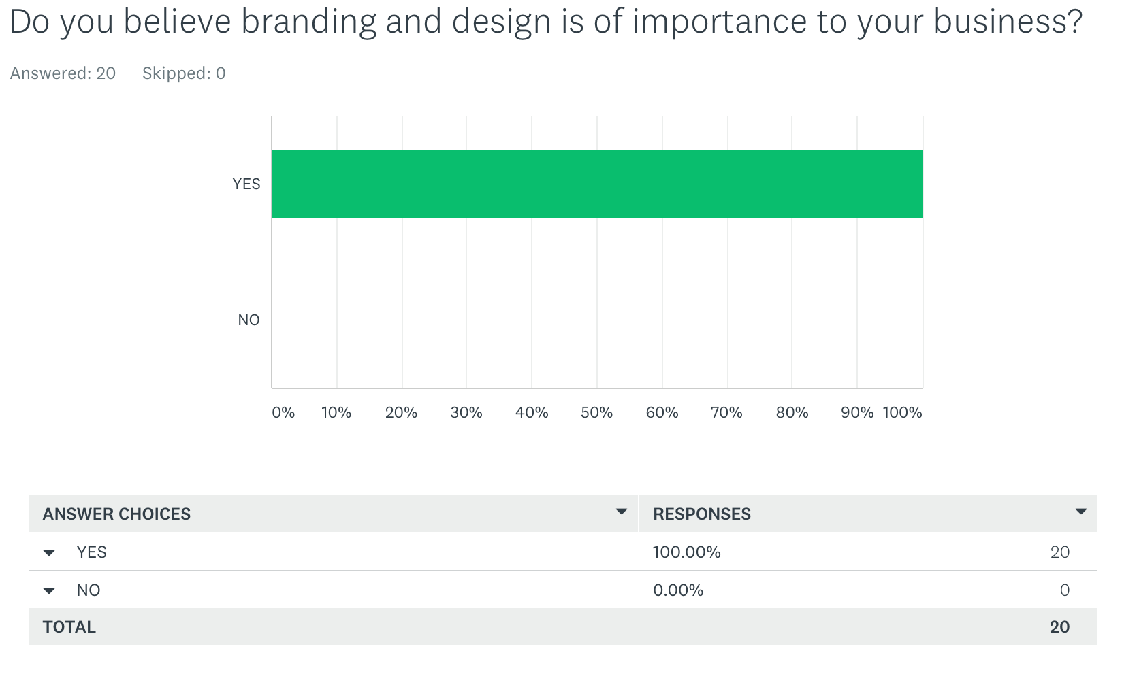
(Figure 5, Primary Research, 2017)

One of the latest rebrands for a big multinational business is Thomson to (TUI). Hall states that, ‘Successfully coordinating a rebrand is tricky business. In essence it is a simple matter of following basic marketing principles’ (Avanti Travel Insurance, 2017) A rebrand requires the approval of company stakeholders. Although few customers may believe that their loyalty has been disputed, a lot of customers will stay using TUI due to their product and reputation. (Hall, 2017)

TUI is the German company that owns Thomson and First Choice. They decided in 2016 they would rebrand the two travel companies to become one and seem more internationally recognised. The TUI rebrand is clever as they have kept the idea of keeping the T-I, and have just changed their name. This allows their existing customers to feel that they are the same company. The logo imagery is another example of clever customer engagement. It represents Thomson/TUI taking you to your destination as well as showing a “smile” in their logo. This complements TUI’s new slogan on their latest advertisement campaign, “Discover your smile”. (Faull, 2017, Tui 60 advert).
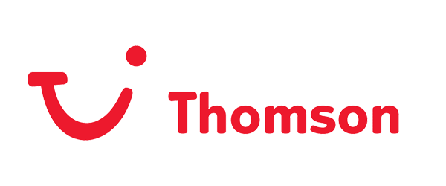
(Figure 6, Thomson Logo, Unknown)


(Figure 7, TUI Logo Rebrand, 2017)

A key reason why Thomson rebranded to TUI is because it has given them a more universal name allowing them to sell their business services abroad. Thomson is a British name, therefore changing it has allowed it to sound more global. As Neumier (2016:17) argues, ‘The most successful brands are not static but fluid’. This is an extremely bold proclamation, however this could be the reason why some successful businesses end up not being profitable, as they do not ‘move with the times’. It can be argued that this was perhaps the case with Ffynone House School and therefore the threat of closure resulted in giving them the boost to modernise their marketing methods.

However, there are arguments against branding and rebranding. In 1985 Coco-Cola rebranded to “Coke”, they also changed their recipe. This decision proved negative for Coco-Cola as they subsequently had 400,000 complaints due to the new rebrand and recipe change. After their market share fell to 1.4% they decided to change it back to the original brand within 87 days. (Diagonal View, 2017)

The editor of 99Designs.com states that businesses with ‘boring’ designs can still be successful. Etsy the online marketplace started in 2007, it now has $300 million in revenue. Yet, its website is extremely basic and the logo is plain orange and has never gone through a redesign. Despite this it is still profitable. eBay has been criticised for its continual rebranding efforts as they are constantly trying to evolve and stay modern. However, eBay in 2016, earned a profit of $8.8 billion and was on the top 30 list of online businesses, whereas Etsy was not on the list at all. (Income Diary, n.d.) It could be argued that eBay are more successful than Etsy because of their non-stop efforts trying to rebrand to modernise their business.

Conclusion
Whilst researching and analysing this dissertation, it is apparent that the use of design and branding is of vital importance to businesses and organisations throughout the modern world. This relates to businesses both large and small allowing them to add immense value to their business without having to invest in physical assets. Although monetary costs are incurred in this use of design and branding, the benefits of subsequently having an effective brand enormously compensate for the monetary loss. Part of my primary research was delving into the world of SMEs and seeing what their thoughts were on design and branding for their businesses and whether or not they see the importance of it. They openly stated that they believed it could be a major factor in what makes a business successful. We live in a world where image is extremely important and perhaps even where the quality of the product does not matter as much as the brand itself.

A brand can meaningfully communicate the essence of a business and care for its image and beliefs. The power of design and branding can make a failing business start to succeed again such as in the case of Ffynone House school. Brands must continuously demonstrate their ability to be coherent and ultimately flexible in order to evolve and to appeal to their market. This ensures that the business stays modernised, fresh, and relevant when facing the ever changing and ever developing world. A business does not need to rebrand or redesign frequently, as the designer should effectively design to accommodate the possibility of the future and therefore be flexible. Analysing and therefore forecasting the future is important in allowing the business and brand to be effective before evolving onto the next best image.

As the world evolves so should societies and businesses outlook on situations, our image orientated world is ever expanding and with this businesses are looking more to branding and designers to make them more appealing and to keep them competitive. The use of effective branding and design can help both SMEs and multi-national companies ensure their success. These use of effective branding and design has allowed businesses both large and small to thrive in our modern world ensuring economic sustainability and consumers having their needs being fulfilled.

Appendix 1 - Headmaster of Ffynone House School
What is branding to you?
An immediately recognisable, eye-catching set of images, webpages and publications that are associated with Ffynone and which raise awareness in the local area

Since the almost closure in 2012 do you think that the use of strong branding and marketing has helped increase the number of pupils in the school?
Yes. It has given us the opportunity to publicise the fact that the school remains in business, is thriving and continuing to grown in strength and popularity.

How many students are in your school currently and has this increased recently if yes why?
Pupil numbers have increased from a low point of 82 to 122 in the five years since closure was first announced. It will take a further two years for the last of the affected cohorts to ‘grow out’ of the school in the upper sixth form.

There has been an upsurge in recent years in your marketing campaign (on buses etc.). do you feel this has influenced the amount of pupils at your school and if yes why?
Yes – two reasons:
- Raising awareness of our existence in Swansea, given that the local authority have no interest in us and do not provide any information regarding independent educators to pupils in their maintained schools.
- Attracting specific pupils (Years 6, 9 and 11) to our Open Days and GCSE & A-level options events.
As a small business/charitable company how important do you think branding and design is for promoting your and other organisations?
Publicity and branding are always important even when times are hard! Essential to keep our name, our values and the school ethos in the forefront of our potential ‘customers’

How important is an online presence for your school?
Crucial – this is the first port of call for many of our prospective pupils who are new to the area or who have no former association with the school from siblings or neighbours. We need a vibrant site that demonstrates our excellence, standards, activities and philosophy.

What do you believe are the best forms of advertising for your school?
We have done market research on the effectiveness of radio/web/streaming/flyers and bus adverts. Bus wins hands down in terms of feedback and response!

Would you consider rebranding your school logo?
Probably not

Why?
Our current logo has quite a clean look and we’ve gone through about three logos in the last 15 years!

Appendix 2 - Survey

What is the name of your business and/or the sector you operate in?

- GFXDistrict & ThinkPremade
- Cazbah Ltd
- Heaven Hair & Beauty Emporium
- Jess' Hair
- HDMS DESIGN – Design Sector
- D&I Tropicals Ltd Aquatic retail
- My Wicked Little Eco Shop
- Digital Routes
- Aka martial arts and Gemini Auctions
- Harris & Thompson - Historic decorators
- Capricorn Fitness Ltd
- HornyCooArt Arts and Entertainment
- SFEAR Kickboxing - Health & Fitness
- Personal Image - Hair & Beauty.
- Lips kick - makeup
- House of Callaway - online retail/women's health products
- Simply Do Ideas - software / technology
- Bishops Martial arts / security
- Fightwear Store UK - Kickboxing Sector
- Mark Williams Groundworks Construction.

Appendix 3 - Survey

What do you believe a brand is?
GFXDistrict & ThinkPremade - Web hosting - A continuous idea or theme which illustrates the identity of the company & business. This communicates the ethos and house style of the company theme throughout all material, making a recognisable icon.

Cazbah Ltd - A name and logo that helps to identify and differentiate your company from your competitors.

Heaven Hair & Beauty Emporium - It is the logo and image a company portrays

Jess' Hair a Logo that is of my business and other advertising material

HDMS DESIGN – Design Sector Consistency and your logo

D&I Tropicals Ltd Aquatic retail - It's something you believe in 100% and can sell on to customers knowing they will be totally satisfied.

My Wicked Little Eco Shop - A brand is a design or feature of a product or service that distinguishes itself from rivals.

Digital Routes - Logo, colours, fonts, style

Aka martial arts and Gemini Auctions - A service or product

Harris & Thompson Historic decorators - A brand shows and markets the image of your business. It gives identify

Capricorn Fitness Ltd - It’s a unique identity within any given service or sector

HornyCooArt Arts and Entertainment - A known quantity

SFEAR Kickboxing - Health & Fitness - 1. Instantly recognisable as you, 2. Believable and trusted, 3. Simple

Personal Image Hair & Beauty - Something that allows clients/customers to recognise your business.

Lips kick makeup - A type of product that you believe is better than its competitors.

House of Callaway online retail/women's health products - A brand is an image that envelopes an entire business as well as it's concept. When talking with my business partner about our 'brand', I've described wanting it to appear like a 'lifestyle choice' to our customers rather than simply a few products for sale

Simply Do Ideas software / technology - Hmm, good question! The way the organisation is perceived by its target audience?

Bishops Martial arts / security - A corporate identity associated with quality goods

Fightwear Store UK - A brand is the values of a business as well as the design consistency and the beliefs of a business together.

Mark Williams Groundworks Construction - A message of who you are, and/or what you do

Appendix 4 - Survey
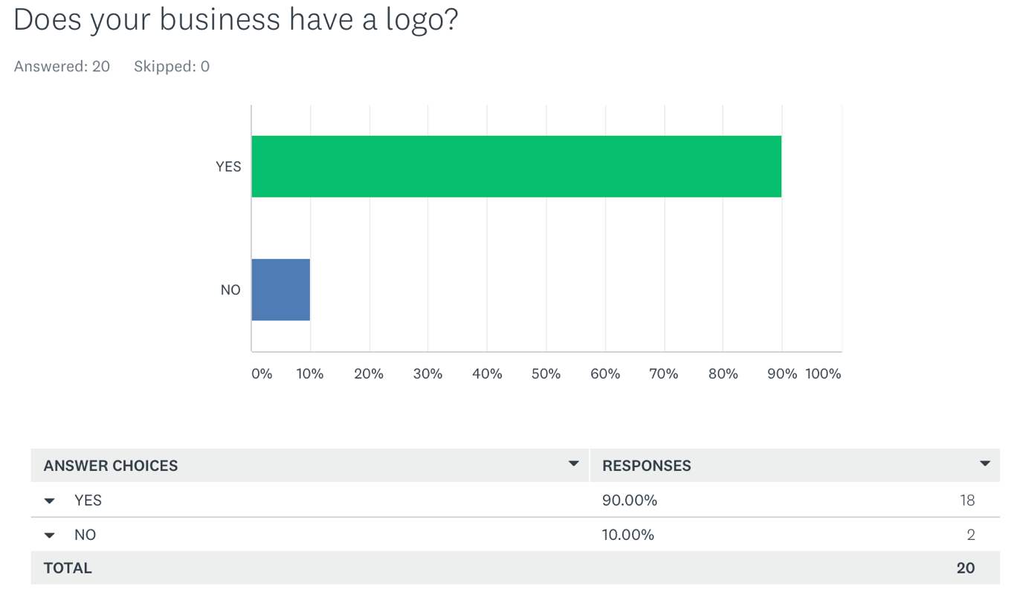

Appendix 5 - Survey
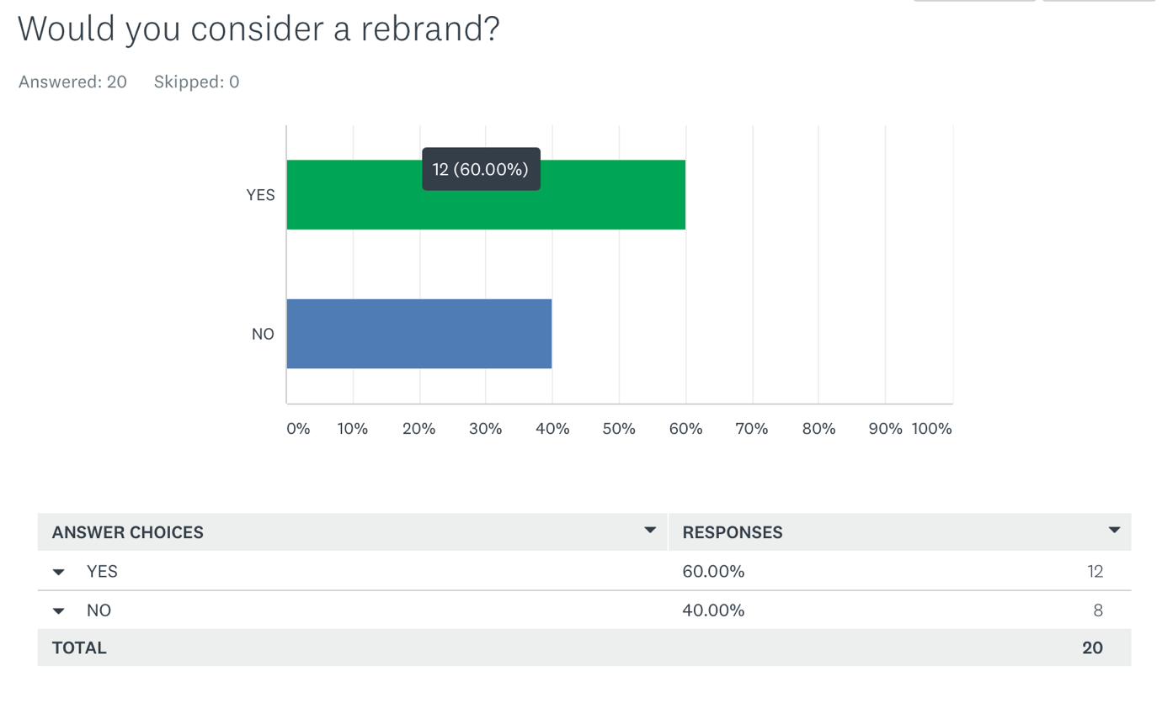

Appendix 6 - Survey
GFXDistrict & ThinkPremade As a company or business developments so does your initial vision, to keep up to date with the market and your customers it can be achieved with a rebrand. Depending on the company size, these changes might be more often or substantial than others.

Cazbah Ltd If the scope of the business changes a re-brand could communicate what the business actually does more effectively.

Heaven Hair & Beauty Emporium I am happy with my own image

Jess' Hair To help us look more appealing in our new area

HDMS DESIGN – Design Sector It is important to evolve with the times

D&I Tropicals Ltd Aquatic retail - It takes years to build up, so why change it if it works for you.

My Wicked Little Eco Shop If I felt that my business had evolved and needed rebranding to reflect that change.
Digital Routes I feel our brand is well established and wouldn't like to confuse existing clients as well as new clients who are aware of my company

Aka martial arts and Gemini Auctions Happy with what I have

Harris & Thompson - Historic decorators We spent a great deal of time looking at our market place. Our brand fits in with our target customer.

Capricorn Fitness Ltd My brand already rocks.
HornyCooArt Arts and Entertainment If my style of art needed remodelling/modernising I would consider

SFEAR Kickboxing - Health & Fitness Businesses should always evolve. My business is 80% Kickboxing, but in nine months it'll likely be 20%. In this case keeping a kickboxer logo doesn't explain us well enough. We'll use two logos for each end of the business and merge them together where appropriate. The name will remain.

Personal Image - Hair & Beauty. Fresh look and business promotion.

Lips kick – makeup Because I took a lot of time get mine to work

House of Callaway - online retail/women's health products I believe that, over time, all businesses can and should consider rebranding, even if its only to reassess how they appear to the public in the changing economy/population

Simply Do Ideas - software / technology The brand we started with perhaps doesn’t appeal to a new and key market.

Bishops Martial arts / security My company is known by brand

Fightwear Store UK - Kickboxing Sector As time goes on your brand must adapt and change depending on their needs and therefore we may consider a rebrand in the future

Mark Williams Groundworks Construction. Although I am happy at the moment things change and you must change with them.

Appendix 7 - Survey

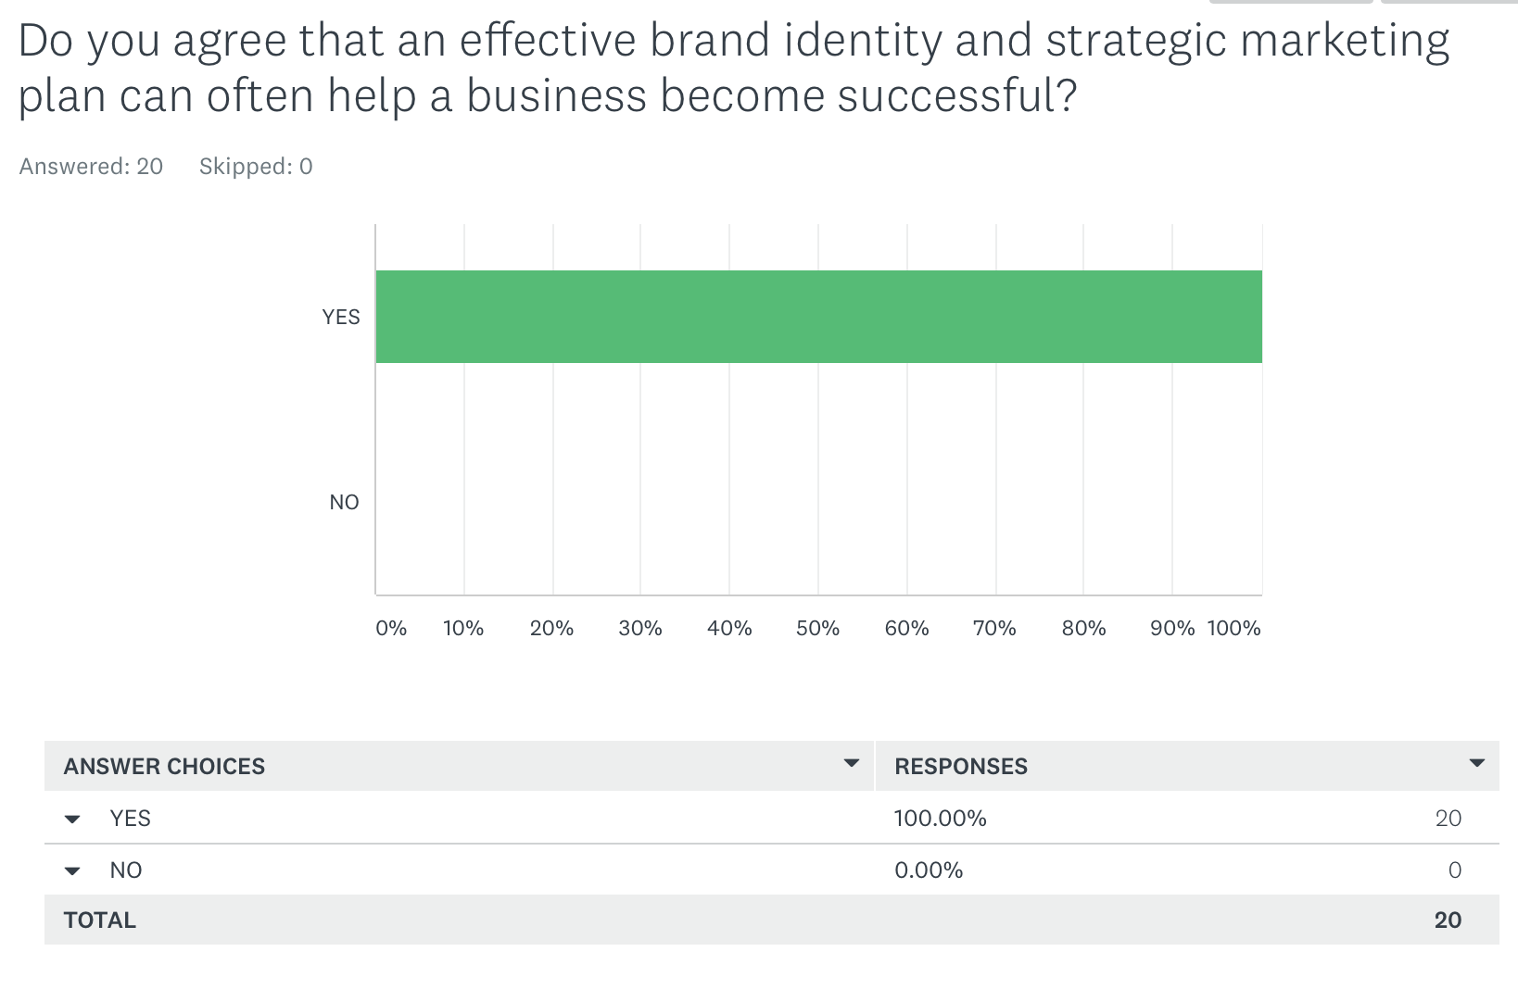

Appendix 8 - Survey
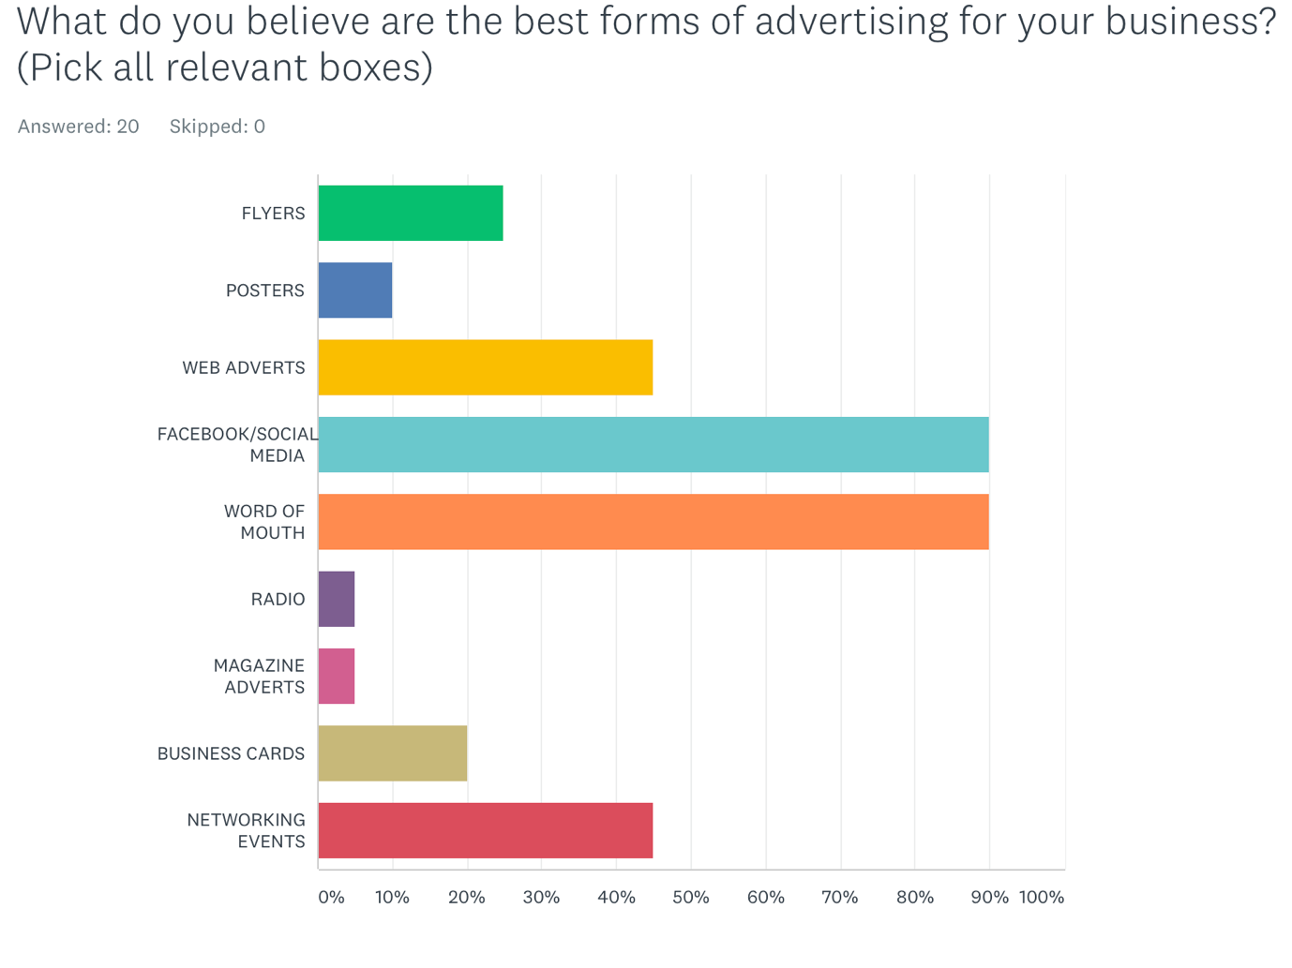

Appendix 9 - Survey
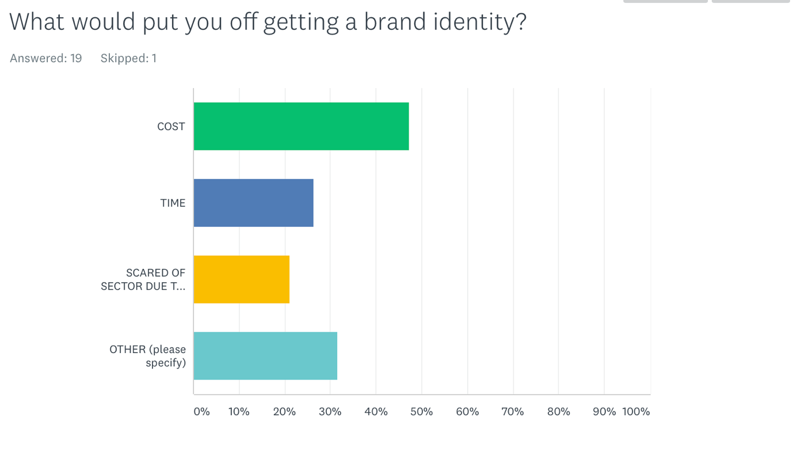

Appendix 10 – Owner Suzanne Stevens - The Shop With No Name
Do you believe that having such a clever/unique name has helped your business become successful?
Yes, it has made us become memorable and unique in such a highly competitive area, within Gowerton, Gorseinon, and Dunvant.

What is a brand to you?
A brand is a producer of a products or service.

What is the best form of advertising for your business?
Facebook/Instagram.

References/Bibliography
Airey, D. (2015). Logo Design Love, Annotated and Expanded Edition, Second Edition. [Place of publication not identified]: Peachpit Press.

Anon, (2006). [ebook] Build a bear. Available at: http://library.corporate-ir.net/library/18/182/182478/items/236139/BBW_10K.pdf [Accessed 9 Dec. 2017].

BBC. (2016). Courtney can't decide on his brand, Gin, Series 12, The Apprentice - BBC One. [online] Available at: http://www.bbc.co.uk/programmes/p04jrsb0 [Accessed 7 Dec. 2017]
BBC News. (2017). Christmas ad spend 'to hit record high'. [online] Available at: http://www.bbc.co.uk/news/business-41933877 [Accessed 11 Dec. 2017].

Blakeman, E. (2014). The tragic story of the man who invented Victoria's Secret. [online] Telegraph.co.uk. Available at: http://www.telegraph.co.uk/men/fashion-and-style/11261445/The-tragic-story-of-the-man-who-invented-Victorias-Secret.html [Accessed 9 Dec. 2017].

Build a bear Annual Report, (2016). [online] Available at: http://www.annualreports.com/HostedData/AnnualReports/PDF/NYSE_BBW_2016.pdf [Accessed 8 Oct. 2017].

Clark, M. and Joyner, A. (2006). The bear necessities of business. Hoboken, N.J.: Wiley.

Cooper, J. (n.d.). Logo Design. Unknown: Amazon.

Design Council. (2015). New government figures show UK has largest design sector in Europe. [online] Available at: https://www.designcouncil.org.uk/news-opinion/new-government-figures-show-uk-has-largest-design-sector-europe [Accessed 14 Nov. 2017].

Dunlop, M. (n.d.). 30 Richest Internet Entrepreneurs. [online] How To Make Money Online. Available at: https://www.incomediary.com/30-richest-internet-entrepreneurs [Accessed 1 Dec. 2017].

Eleftheriou-Smith, L. (2014). Penguin toy sales up 300% on eBay following John Lewis 'Monty'. [online] The Independent. Available at: http://www.independent.co.uk/news/uk/home-news/penguin-toy-sales-up-300-on-ebay-following-john-lewis-monty-christmas-advert-9875694.html [Accessed 11 Dec. 2017].

Facebook.com. (2017). Diagonal View. [online] Available at: https://www.facebook.com/diagonalview/videos/10154940727362353/ [Accessed 10 Dec. 2017].

Hall, D. (2017). Why is Thomson Changing its Name to Tui, and What Does This Mean for Cruise-Lovers? | Avanti Travel Insurance. [online] Avanti Travel Insurance. Available at: https://www.avantitravelinsurance.co.uk/thomson-changing-cruise/ [Accessed 28 Nov. 2017].

Heller, S. and Talarico, L. (2008). The design entrepreneur. Gloucester, Mass: Rockport.

Hopkins, C. (2015). Scientific Advertising. unknown: First Printing.

John Lewis Christmas Advert Monty The Penguin. (2014). [video] Available at: https://www.youtube.com/watch?v=iccscUFY860 [Accessed 11 Dec. 2017].

Kaye, T. (2006). Good flag, bad flag. Trenton, NJ: North American Vexillological Assoc.

Klein, N. (2010). No logo. Johanneshov: MTM.

Lipp, D. (2013). Disney U. [New York]: McGraw-Hill Education.
Wheeler, A. (2006). Designing brand identity. 2nd ed.

Löhr, J. (2015). Has 'made in Germany' badge been harmed by the Volkswagen scandal?. [online] the Guardian. Available at: https://www.theguardian.com/business/2015/nov/02/made-in-germany-harmed-volkswagen-scandal [Accessed 26 Nov. 2017].

Logo Design Love. (2014). Rob Janoff on his logo for Apple | Logo Design Love. [online] Available at: https://www.logodesignlove.com/rob-janoff-apple-logo-designer [Accessed 1 Nov. 2017].

Mail Online. (2014). John Lewis Christmas toy will cost you £95. [online] Available at: http://www.dailymail.co.uk/news/article-2823270/This-year-s-John-Lewis-Christmas-ad-boy-toy-penguin-melting-hearts-want-buy-toy-cost-95-tiny-version-12.html [Accessed 11 Dec. 2017].

McCains Family Meal Time. (2017). [video] Available at: https://www.youtube.com/watch?v=aJ9fjN1az9g [Accessed 10 Dec. 2017].

Meszaros, G. (2016). What Percentage of Businesses Fail - The Real Number. [online] Small Business Advice Help For Startups and Entrepreneurs. Available at: https://www.successharbor.com/percentage-businesses-fail-09092015/ [Accessed 30 Oct. 2017].

Monty and Mable. (2014). [image] Available at: http://www.dailymail.co.uk/news/article-2823270/This-year-s-John-Lewis-Christmas-ad-boy-toy-penguin-melting-hearts-want-buy-toy-cost-95-tiny-version-12.html [Accessed 11 Dec. 2017].

Mootee, I. (2013). Design Thinking for Strategic Innovation: What They Can't Teach You at Busi. John Wiley & Sons.

Neumeier, M. (2006). The brand gap. 1st ed. Indianapolis, Ind.: New Riders.

Neumeier, M. (2007). Zag. 1st ed. Berkeley, Calif.: New Riders.

Neumeier, M. (2016). The brand flip. 1st ed. [Place of publication not identified]: New Riders.

Old Mout. (n.d.). agegate - Old Mout. [online] Available at: https://www.oldmoutcider.co.uk [Accessed 8 Dec. 2017].

Olins, W. (2005). On brand. London: Thames & Hudson.

Olins, W. (2008). The brand handbook. London: Thames & Hudson.

Olins, W. (2014). Brand New. 1st ed. London: Thames & Hudson ltd.

Oetting, J. (2017). Emotional Advertising: How Brands Use Feelings to Get People to Buy. [online] Blog.hubspot.com. Available at: https://blog.hubspot.com/marketing/emotions-in-advertising-examples [Accessed 10 Dec. 2017].

OS X Daily. (n.d.). Carve an Apple Logo pumpkin. [online] Available at: http://osxdaily.com/2010/10/15/carve-an-apple-logo-pumpkin/ [Accessed 1 Nov. 2017].
Prototypr. (2017). The Cost of Bad Design – Prototypr. [online] Available at: https://blog.prototypr.io/the-cost-of-bad-design-40fa7921c602 [Accessed 30 Nov. 2017].

Reason, B., LÓvlie, L. and Flu, M. (2016). Service Design for Business: A Practical Guide to Optimizing the Customer E. John Wiley & Sons.

Ries, A. and Ries, L. (2012). The 22 immutable laws of branding. New York, NY: HarperBusiness.

Roger Martin. (2009). The design of business: why design thinking is the next competitive advantage. Boston: Unspecified.

Sacharin, K. (2001). Attention!. New York: Wiley.

Smart Insights. (2012). What is emotional branding? - Smart Insights. [online] Available at: https://www.smartinsights.com/online-brand-strategy/emotional-branding-means-customers-stay-loyal-for-the-long-haul/ [Accessed 10 Dec. 2017].

Starbucks Coffee Company. (2017). 15th Ave Coffee & Tea | Starbucks Coffee Company. [online] Available at: http://www.starbucks.co.th/coffeehouse/store-design/15th-avenue [Accessed 2 Nov. 2017].

Stein, A. (2011). Why we love Disney. New York, NY: Lang.

VanAuken, B. (2015). How Brands Make Emotional Connections | Branding Strategy Insider. [online] Branding Strategy Insider. Available at: https://www.brandingstrategyinsider.com/2015/09/how-brands-make-emotional-connections.html#.Wi1nWBicZE4 [Accessed 10 Dec. 2017].

YouTube. (2017). TUI 60 Advert. [online] Available at: https://www.youtube.com/watch?time_continue=58&v=xe1p97YgoU4 [Accessed 29 Nov. 2017]

