Marketing Essentials

Supporting Marketing Plan

Introduction
Marketing for an organization is not only promoting the products in the market but also working with the adoption of changes in the market and making the organization advanced from the consideration of market factors (Jobber and Ellis-Chadwick, 2020). This report has been conducted to bring all these factors to light. In this report the company Jo and Joe has been used as example and the marketing issue has been addressed in this report. The issue of marketing that the company Jo and Joe is facing is negative reviews from the customers which is causing a lower brand value in the market. While conducting this report, the 5Cs, marketing mix 4p, communication mix, PESTLE analysis, and SWOT analysis have been used.

Situation analysis

The situation analysis with 5 C have been presented below:

Company
- Strengths: Jo and Joe could have a solid brand reputation, distinctive products, and a loyal clientele. They may have a skilled marketing team and creative marketing plans.
- Weaknesses: There may be issues with the company's branding, which is inconsistent and may have trouble reaching consumers online. The correct market segmentation and client interaction may also provide difficulties for them.
- Opportunities: Jo and Joe may be able to increase their market share, create new goods or services, and use social media and internet platforms to further promote their brands.
- Threats: Threats to Jo and Joe's success include fierce competition, unfavourable customer feedback, and a quickly shifting market environment. To stay ahead, they must overcome these obstacles and adjust to new trends.

Customers
Customer segmentation is the practice of breaking down a market into separate groups of people or businesses with comparable traits, interests, or behaviours in order to better understand and serve their unique preferences and wants (Bowie et al., 2017). Jo and Joe's target audience may be identified and categorized using criteria like demographics, psychographics, and behavioural patterns through the use of customer segmentation and targeting. Jo and Joe may create tailored marketing plans that appeal to various client categories by learning about their customers' preferences and wants.

Competitors
Other businesses who operate in the same industry and target the same clientele may be considered Jo and Joe's rivals. This may include both well-known companies with a significant market presence and up-and-coming rivals looking to disrupt the market (Smith and Zook 2020). Competitors may provide comparable goods or services, differentiate themselves through unique characteristics, or use distinct marketing techniques to draw in and keep clients.

Collaborators
Business associates, partners in supply chains, distributors, and strategic relationships are examples of Jo and Joe's collaborators. These partners are essential to the success and expansion of the firm because they assist its operations by providing resources, supplying goods or services, increasing market reach, or boosting brand recognition (Kotler et al., 2020).

Climate
- Political: Legislation, political stability, and policies that may have an impact on the operations and environment of businesses.
- Economic: A company's financial performance may be impacted by economic factors including inflation, currency rates, and consumer spending trends.
- Sociocultural: Social and cultural developments, consumer attitudes, and conduct that may affect consumer preferences and the demand for Jo and Joe's goods and services.
- Technological: New developments and innovations in technology that may have an influence on business operations, marketing plans, and the marketplace.
- Legal: The company's operations and compliance needs may be impacted by legal considerations such as labour laws, intellectual property rules, and consumer protection legislation (Clow & Baack, 2013).
- Environmental: Aspects of the environment that may have an impact on a company's operations and reputation, such as sustainability procedures, climate change, and ecological concerns.

Marketing Mix
- Product: Jo & Joe's offers, including their distinctive qualities, level of excellence, and selection of goods and services.
- Price: The price strategy used by Jo and Joe, taking into account elements including cost, competition, and customer perception of value.
- Place: The places and distribution routes via which clients may access Jo and Joe's goods or services (Chaffey and Ellis-Chadwick, 2019).
- Promotion: The marketing communication techniques that Jo and Joe employ to get their products and services known to potential customers, pique their interest, and influence them to buy them (Ghauri, 2014). This includes using advertising, sales promotions, public relations, and digital marketing methods.

Objectives
Smart Factors | Objectives
Specific | To analyse each feedback and determine the issue that is causing negative review.
Measurable | Measuring how much negative ratings are there.
Attainable | Can be attained by labelling all the comments and reviews in website and social media.
Relevant | Relevant with connecting the customers directly through their comments and reviews.
Time-based | To make a plan and execute in 1 year.

Strategy
The business can use the following tactics to deal with the problem of bad reviews for Jo and Joe:
- Prompt response: Timely and proactive responses to unfavourable assessments are essential. The business should keep an eye on online review sites and social media platforms, recognize customer complaints, and swiftly provide a resolution or an apology (Housden, 2008).
- Management of consumer feedback: Use a methodical methodology to collect and examine customer feedback. This will make it easier to spot persistent problems and take appropriate action to stop unpleasant experiences from happening again.
- Service recovery: Regain the confidence and loyalty of unsatisfied consumers by providing a remedy or compensation. Refunds, savings, or unique displays of concern for their experience can be included in this.
- Online reputation management: Encourage pleased clients to post good reviews to actively manage the business's online reputation. This will assist balance out the negative feedback and enhance people's perceptions of Jo and Joe as a whole.
- Employee education: Employees should get training on how to effectively manage challenging circumstances and offer exceptional customer service (Ryan, 2012). Giving employees the tools, they need to resolve problems successfully helps stop bad situations from getting worse.

Tactics
Here's a communication mix strategy that Jo and Joe can employ to effectively communicate with consumers regarding the issue:
- Public Relations (PR): Make use of PR initiatives to manage the business's reputation and deal with the problem. To offer factual information and portray Jo and Joe's viewpoint, create press releases, plan media events, and interact with journalists. The business may influence public opinion and temper unfavourable attitudes by upholding openness and open communication (Baines, Fill and Page, 2013).
- Social media marketing: Use social media sites to interact with customers directly. Keep an eye out on social media for unpleasant comments, and answer right away with empathy and openness. Showcase Jo and Joe's dedication to client happiness by openly sharing updates, responding to complaints, and offering solutions. To emphasize the company's advantages, aggressively promote favourable experiences and user-generated content.
- Email marketing: Use email campaigns to communicate with customers directly and address their issues. Send tailored emails that acknowledge the problem, describe the measures taken to fix it, and extend appropriate incentives or discounts as a sign of goodwill (Hair, Block and Roering, 2015). This focused conversation can deepen the relationship with current clients and restore their faith in Jo and Joe.
- Influencer Collaborations: Work with experts in your field or influencers that have the same ideals as Jo and Joe. Engage people in the creation of content, the sharing of positive experiences, and the resolution of consumer complaints. This may spread encouraging messages and reach a larger audience, demonstrating the business' commitment to addressing problems and raising customer satisfaction.
- Brand Ambassadors: Choose devoted clients who have enjoyed working with Jo and Joe, and turn them into brand advocates. Encourage them to tell others about their experiences and to tell their networks about the company. Positive brand perception may be produced by these sincere testimonials, which can balance out unfavourable assessments.
- Offline Events and Partnerships: To develop in-person relationships with customers, organize events, support charitable endeavours, or take part in pertinent industry shows (Harris, 2017). This offers a chance to personally handle issues, demonstrate Jo and Joe's dedication to client happiness, and collect input to further enhance goods and services.

Action
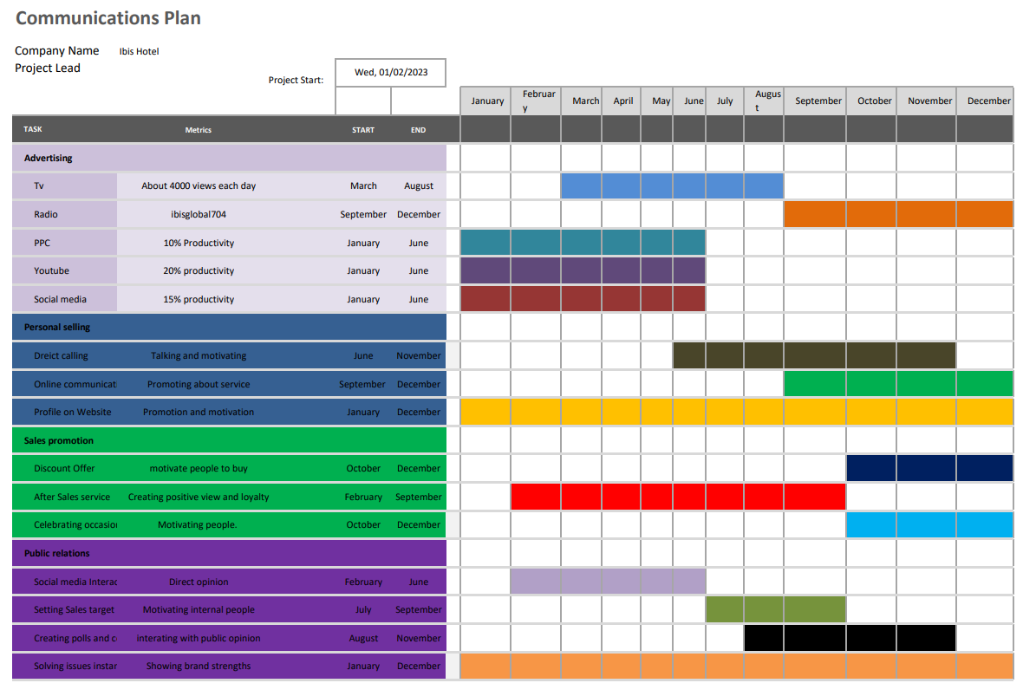
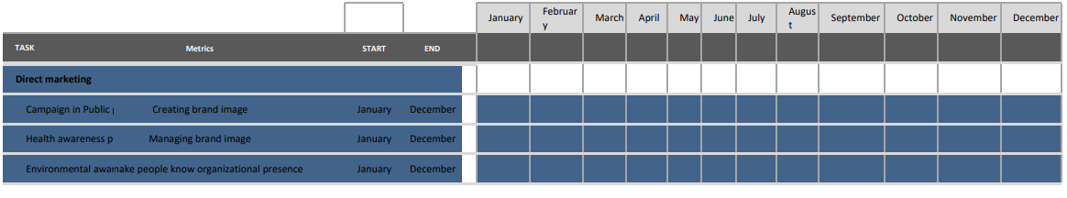

Control
Prior to implementation, it is crucial to define clear objectives and key performance indicators (KPIs) in order to evaluate the effectiveness of a marketing plan. Metrics like website traffic, conversion rates, client involvement, social media followers, and income earned may be included in this. These indicators should be regularly monitored and analysed to assist pinpoint areas where the strategy is working and those where changes may be required. To make sure the strategy stays applicable and successful, it's also critical to monitor client opinions and sentiments, as well as competition activities. The ultimate criterion for determining a marketing plan's effectiveness should be how effectively it contributes to long-term growth and profitability while also meeting the overall business objectives.

Conclusion
One of the most important aspects of preserving a strong business reputation and developing consumer loyalty is responding to bad reviews. Jo and Joe may overcome this difficulty by putting into practice a thorough marketing communication mix plan. Organizations may efficiently connect with customers and solve their problems through quick social media responses, open public relations campaigns, educational content marketing, individualized email communications, offline events, and robust customer care channels. Jo and Joe can restore customer happiness, increase trust, and establish themselves as a customer-centric brand in the market by actively engaging with consumers, exhibiting their dedication to addressing difficulties, and sharing good experiences.

References
Jobber, D. and Ellis-Chadwick, F (2020), Principles and practice of marketing. 9th ed. London:
Bowie,D. Buttle,F. Brookes,M & Mariussen,A (2017), Hospitality Marketing.3rded, Routledge, London
Smith PR & Zook ZE (2020) Marketing Communications. 7thed, Kogan Page, London
Kotler, P., Armstrong, G., Harris, L. and He, H., 2020.Principles of marketing.8thEuropeaned,London: Pearson Education Limited.
Clow, K & Baack, D (2013), Integrated Advertising, Promotion and Marketing Communications.6thed, Pearson, London
Chaffey, D and Ellis-Chadwick, F. (2019) Digital Marketing. 7thed,Pearsons, London.
Ghauri, P N (2014) International Marketing, 4thEd, McGraw Hill, London
Housden M (2008), Marketing Research & Information, Butterworth Heinemann, Oxford.
Ryan, D. (2012) Understanding Digital marketing: Marketing Strategies for Engaging The Digital Generation. Kogan Page, London.
Baines, P., Fill, C. and Page, K., 2013. Essentials of marketing. Oxford: Oxford University Press.
Hair, J., Block, C. and Roering, K., 2015. Essentials of Consumer Behavior. Journal of Marketing, 41(1), p.126.
Harris, J., 2017. Essentials of Marketing Research. Australasian Marketing Journal (AMJ), 12(2), pp.73-75.

