Andrei Alexandru Agopian
Student number: 1905498

Module: Effective Teamworking and Communication / BMSW4002
Title: Effective Teamwork and Communication

Lecturer: Afzal Munna

Effective Teamwork and Communication
1905498 | Lecturer: Afzal Munna
Cert he skills for the workplace
Andrei Agopian
2019
What made mankind shine a torch to the path of evolution and reach this far on the evolutionary scale - allowing it to supersede other species - is its ability to organize, innovate and acquire knowledge. All the above mentioned, are greatly owed to our innate ability to communicate. To expand on that, humans are superior to other forms of life in “the activity or process of expressing ideas and feelings or of giving people information” (Oxford Advanced Learner’s Dictionary, 2019).
The purpose of this paper is to establish what communication is, how it is done – by looking at types and models – and how it can be improved. We will also attempt to look at how the business world benefits from an effective method of passing on information, as well as adding our own personal experience from the workplace into it.

Importance of Communication in Management
As with most areas, in management, being able to convey information in a correct and precise fashion, it is of utmost importance. The quality of a manager becomes irrelevant when communication with the people he must manage breaks down. And in business that can be the difference between a successful enterprise and one that goes extinct.
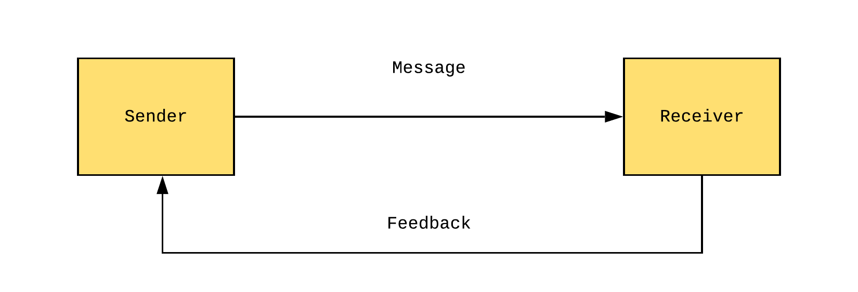
Fig.1 “Communication Basic Model”
Communication becomes distorted if the message is not clear, the sender is dishonest about his intentions, body language is not in line with the message or the receiver simply does not understand it. Be that due to physical or mental inability or social misconceptions or presuppositions. The author of “Guide to Management”, Ann Franck, identifies seven key steps to follow to ensure efficiency:
- Consider your audience
- “Keep it simple, stupid (KISS)”
- Use plain language (without resorting to jargon)
- Be an active listener
- Control your body language
- Be honest
- Maintain a balance between positive and negative words
Without communication the role of manager simply cannot exist, as it is one of the building blocks of the job. From planning and organizing to motivating your team and correcting their attitude, communication is a strongly focused on skill, whether at the hiring stage or throughout a person’s career within a company.

Communication Models and Theory
A communication model refers to the way the process is described using its key components, as well as identifying those. One of the first people to have had a look at it was the famous Greek philosopher Aristotle.
His focus was the speaker, who the Greek sees as an “active” contributor to the interaction, whereas the audience remains “passive”. Thus, in Aristotle’s view, communication is a one-way process from A to B, where the sender prepares a message beforehand and at the right moment expresses himself (Fig.2).
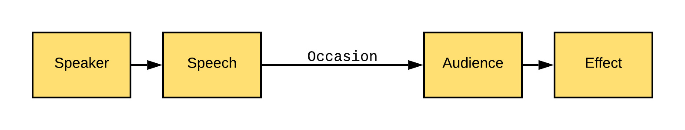
Fig.2 “Aristotle’s Model”
The downside of this model is that there is no concept of feedback. We can’t be certain whether the message/speech was received and understood and if the speaker achieved his purpose. In this case the “effect” may or may not exist. Consider this scenario: a politician giving a campaign speech, but in the audience there’s a deaf person. The team supporting the candidate made no provision for deaf people, therefore communication did not happen (Bajracharya, 2018).
Locke, Descartes, Russell, Wittgenstein are only a few of the other philosophers who came after Aristotle and tried to decipher language and human interaction, striving to achieve a deeper understanding of the processes involved.
To their work, Alfred Korzybski added his efforts, which in 1933 culminated in a book titled “Science and Sanity”. Here he proposed a heightened focus on what happens in a human brain during communication (Bowman and Targowski, 1987).
From then on, the focus shifted from a philosophical approach to a more mathematical one – modern inventions changed the playing field and the need of a model that is more applicable in describing telephone networks, for instance, arose. Claude Elwood Shannon and Warren Weaver describe communication using a more complex scheme. As noticed in the figure below, the thing that stands out is “noise”, which denotes anything that distorts the message.
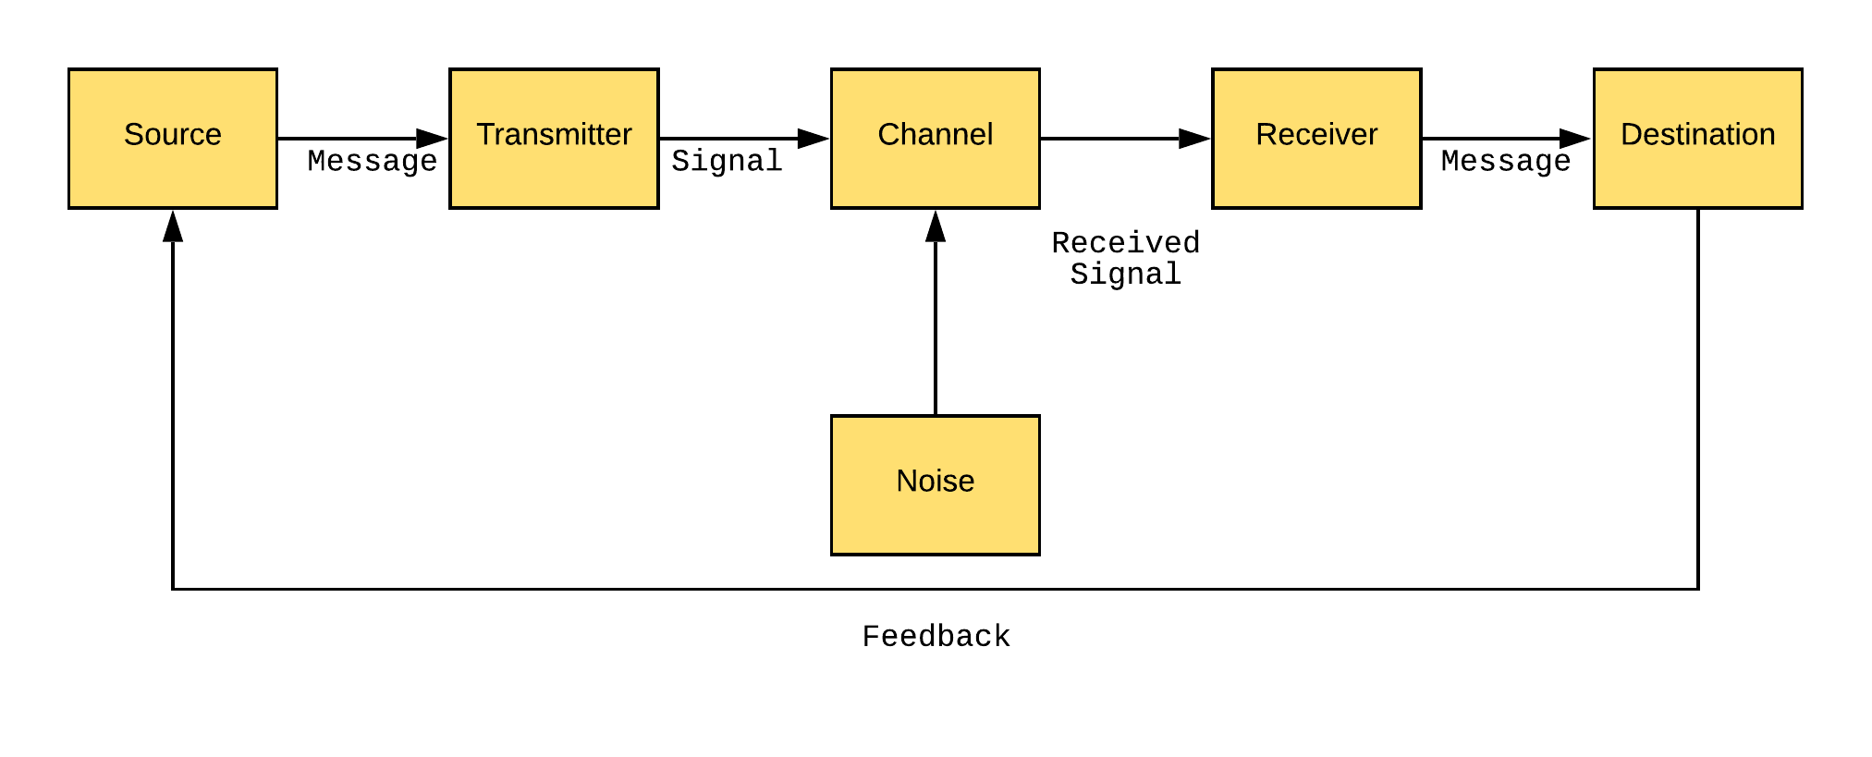
Fig.3 “Shannon-Weaver Model”
Another important aspect of this model is the presence of “feedback”, the receiver acknowledges being in possession of the message, thus making it a two-way system. Due to being so detailed (takes in account the channel, signal that gets influenced by noise), it is hailed as “the standard of communication models”.
However, it is because of this level of technicality that the system suffers, making it harder to interpret from a human side. It was built around technology and to some extent neglects the social factors (Businesstopia,2019).
David Berlo was aware of this, and in 1960, he proposed a model that focused on four key elements:
- Sender/Source
- Message
- Channel
- Receiver
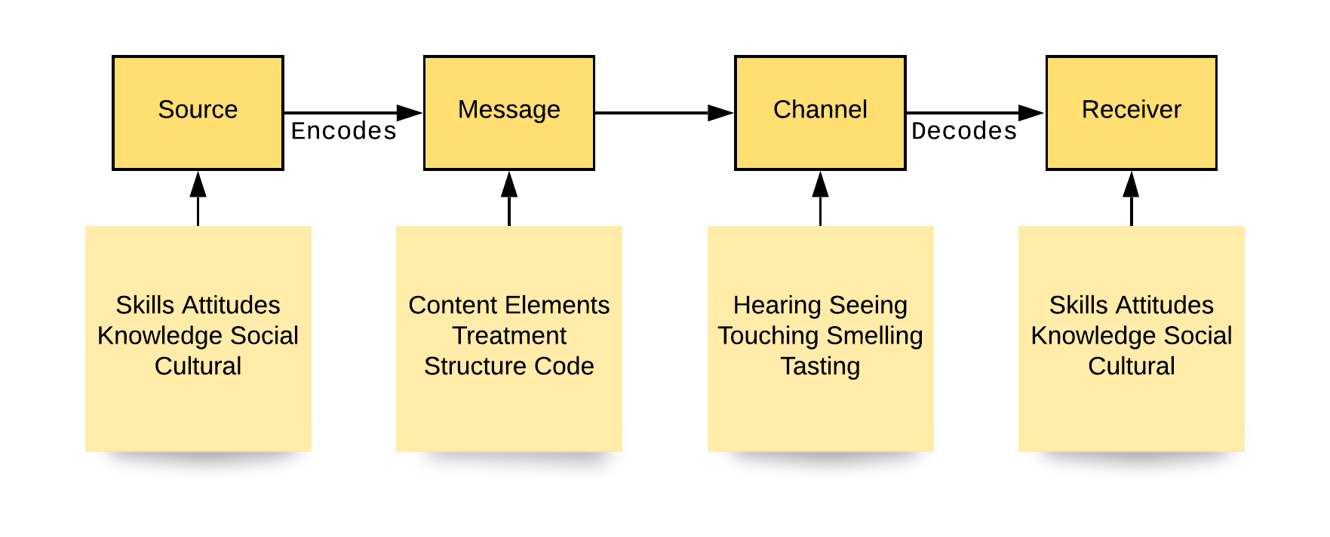
Fig.4 “Berlo’s Model”

The addition on this model is the description of all the factors that come into play when communicating. Known as SMCR (from its four main elements), Berlo states that a source encodes a message, based on its skills, knowledge, attitudes, social system and cultural background, which then gets passed through a channel (hearing, seeing, touching, smelling, tasting) to a receiver. The last one has its proprietary skills, knowledge, attitudes and so on.
Main negative features are the lack of feedback from the diagram and the fact that the concept of noise dissipates between elements such as the skills, knowledge and background of sender and receiver. Although it does encompass a lot, it is both a simplification (fewer main elements) and a complication (noise is broken down into parts and lacking, one thing that jumps to mind is emotion).
Schramm’s model, on the other hand, is a closed circuit a loop, that brings into discussion the idea of fluidity, with both sender and receiver being able to switch roles. In this model, both sender and receiver, have very similar structures, and they’re identified through the word “interpreter”. The first interpreter encodes a message which gets decoded when reaches a second interpreter and then the circle starts anew, with the second one becoming the first.
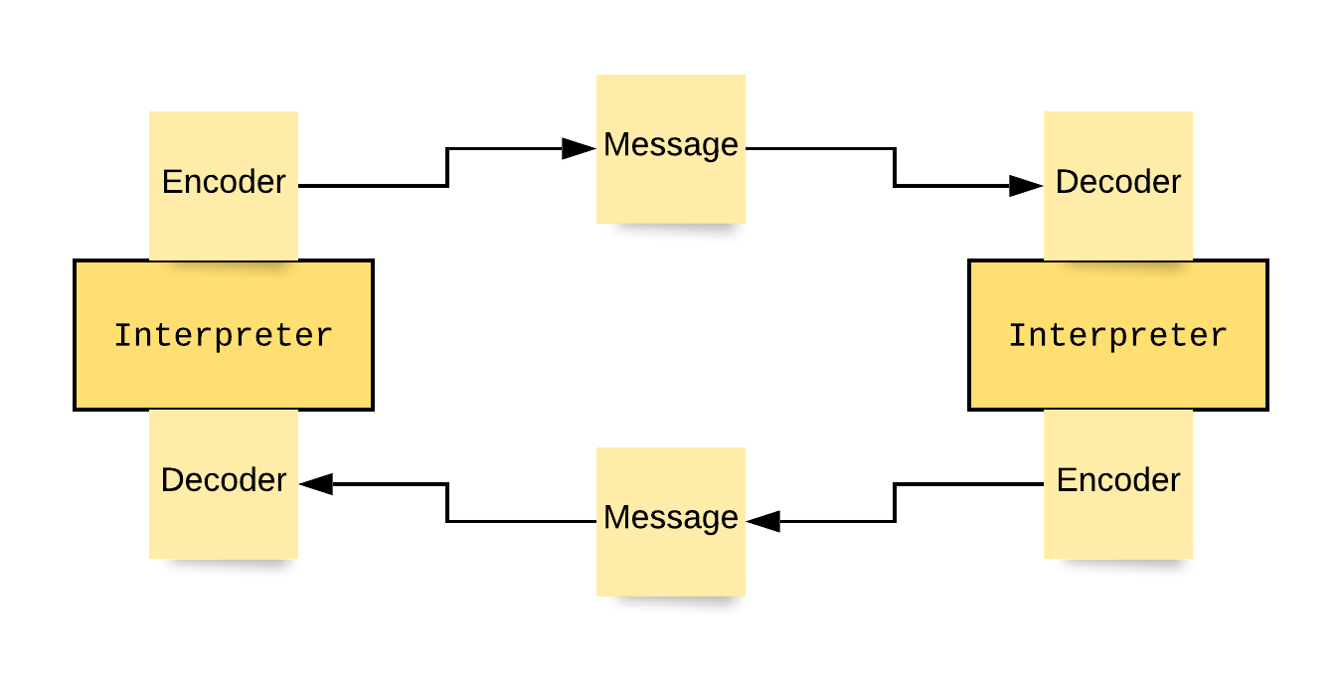

Fig.5 “Schramm’s Model”

The main observation on this description of the communication process is that it assumes that it always comes in a full circle. The feedback is always given, and the roles are inversed. But from our quotidian experience we know that not to be the case. There are situations when, as the saying goes, “our words fall on deaf ears”, or, to use a business/military favourite expression, communication is not effective.

The importance of Effective Communication
To talk about why it is important for communication to be done in a concise, precise and correct manner, it’s best to look at examples when this process fails and analyse it on a case by case scenario. Without going straight into the various situations, we can see that failure in communication leads to negative consequences.
One of our in-class exercises was the story of a kitchen manager and his inability to get through to his staff. One day he asked one of the employees to put a raw chicken tray in the fridge and the next day he discovered his pleas were not heard. In that scenario, the manager did not take in account the noise of the machinery, whether the kitchen porter understood what he wanted from him or if the message was received. The communication relied on only one channel – verbal – and there was no follow up to that.
For communication to be effective it must have an acknowledgment on behalf of the receiver that the message was received and understood. And in our case, there was no follow up either, the manager used only one channel. The idea of using multiple channels to ensure effectiveness is most common in areas such as business management and military deployments, where the stakes are high – loss of capital or loss of life.
If we are looking for efficiency, we can look at it through the Shannon-Weaver model’s perspective and then it becomes a maximum reduction of noise (Robinson, 2019). Or using Berlo’s, it comes from being highly skilled and knowledgeable, aware of social and cultural differences and having the correct attitude between sender and receiver (Belonwu, 2019).

Methods of Communication
Communication is split in two main categories, verbal and non-verbal, with two more that stand out by themselves due to their peculiarity, written and visual (Indeed Career Guide, 2019).
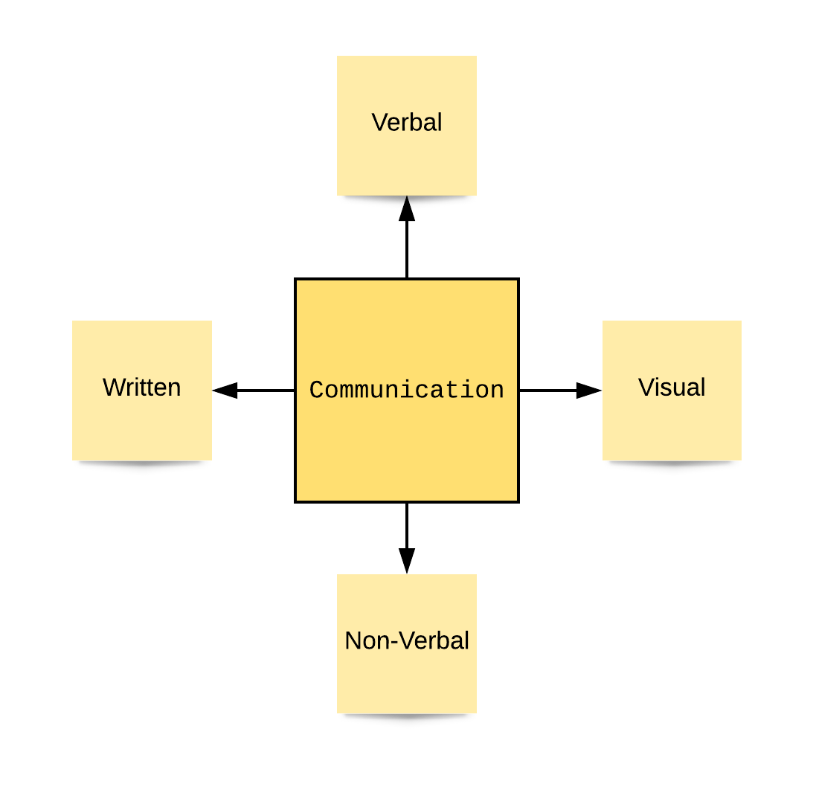

Fig.6 “Methods of Communication”

The verbal method refers to the transmission of information via words. It is the most often used for casual conversation between friends, presentations, phone calls and anything that requires speed and efficiency. It is highly dependent on the receiver being able to decode the message from the source, with Berlo’s model being the most sensible to describe it as it takes in account a variety of obstructing factors.
Non-verbal encompasses all that is body language, mimic and facial expression. Unlike the verbal method, this is something we even do unconsciously: the way we walk, sit and gesture is on for as long as we live. Something we might want to add here is that all that pertains to non-verbal is far more revealing about one’s character and predispositions than anything that person utters. Controlling and being aware of the image you’re projecting is by no means an easy feat. According to Lise Bourbeau, a famous French-Canadian author and philosopher, there are five “wounds” visible on a person that “speak volumes” about that person’s history.
A third type of communicating is the written one. It is different from the two mentioned above because it involves training and education. Be that with pen and paper or typing away on a keyboard, writing is the most formal method for passing on information. It is something that humans as a specie have acquired quite recently in our evolution and have perfected over thousands of years.
Least but not last, we have the visual method. It consists of using images, such as drawing and photographs, to convey a message. What makes it stand out is that it allows for free interpretation. For instance, two people looking at the same Picasso painting get two very distinct messages. It is used a lot to supplement written communication, as a way of clarifying (graphs on an expense report, signs that are universal, learning aid) and artistical expression.


Fig.7 “Pablo Picasso – Les Femmes d’Alger”

Communication Between Management and Employees
The organizational structures we have put in place as a society rely heavily on communication. The transmission of information is the most important aspect of our lives, be that from human to human, human to machine or machine to machine.
Companies’ birth, growth and downfall is the responsibility of their managers, and they rely on the support of their employees, thus making communication between the two a vital aspect of normal operation.
Verbal communication in a fast-paced environment, such as modern times business corporations, is not always possible and often ephemeral. For this reason, most communication is done in writing (memos, emails, notice bulletins, reports), with minor interjections of verbal in the form of weekly, monthly yearly meetings.
Although the rule – be that established in the hiring process or just unspoken but known – is that an employee needs to follow a process of escalation to be able to contact the top tier management, the reverse is not also valid. If in the past a manager would only have time to speak only with his closest employees, technology made it possible – via email for example – for that manager to contact all the company at once when the demand arose.
In terms of the skillset a manager must possess we can touch on ability to make himself understood, ability to actively listen, to mentor and to instruct his or her staff (Emerald, 2019). All this keeping in mind that he or she must be approachable, but not become friends with the employee. This situation often leads to conflict and, eventually, the breakdown of communication (Markos, 2019).

Communication in my department is done always via at least two channels (verbal, email and sometimes text/phone call at the same time), as the nature of it leaves little room for error. Any exchange of information is restricted to the people affected by it (due to the need for privacy) and it is done in a rapid, concise and efficient manner.
Issues arise from communication with other departments, where people have a different mindset and system of prioritization. A specific example is a constant avoidance of participation in refresher courses, reasons given being trivial excuses such as “it’s boring”, “I already did it” or “I don’t have time”.
There are areas we can and will improve, but for the most part, for a team formed of people from different countries and different social systems and cultural backgrounds, we are making progress.

Conclusion
In this assignment we looked at what communication is and how different models attempt to comprehend it. It is by no means a simple process and scientists are still trying to fully explain it. The models presented above, for the many questions they answer, leave as much unresolved. For if communication was just the simple process of exchanging information, it does very little to explain what information has exchanged. As Shannon-Weaver is very adequate in describing the process if it had happened between two robots, on humans it is less efficient. For instance, a man extends an invitation to a woman for a cup of coffee. She promptly rejects the invitation, running off stating she is in a rush and the information transaction is concluded. However, what each exchanged is very different:
- The man received the information the woman finds him inadequate
- The woman was flattered by the invitation, but she was rushing that day to finish her errands
Next time they meet, she would like to offer him the coffee, however he’s not too keen to accept. Knowing that previously she rejected him – and not understanding her motives – he assumes he was her second pick for company. Feeling offended, he’s the one rejecting the invitation this time. The message the woman receives after this exchange is the same one the man received after the first encounter. On the surface two people were unable to go together for a coffee, on a deeper level the same two had an argument and have fallen out.
This should give us some insight in the complexity of communication and even if someone were to make a diagram and add on it “surface meaning” and “deeper meaning”, it would only be the tip of the iceberg.

List of References/Bibliography
Bajracharya, S. (2019). Aristotle's Model of Communication - Businesstopia. [online] Businesstopia. Available at: https://www.businesstopia.net/communication/aristotles-model-communication [Accessed 6 Dec. 2019].
Belonwu, V. (2019). [online] Smallbiztrends.com. Available at: https://smallbiztrends.com/2013/11/20-ways-to-communicate-effectively-in-the-workplace.html [Accessed 6 Dec. 2019].
Bowman, J. and Targowski, A. (1987). Modelling the Communication Process: The Map is Not the Territory. Journal of Business Communication, 24(4), pp.21-34.
Brubaker, D. and Coble, L. (2005). The hidden leader. Thousand Oaks, Calif.: Corwin Press.
Businesstopia. (2019). Shannon and Weaver Model of Communication - Businesstopia. [online] Available at: https://www.businesstopia.net/communication/shannon-and-weaver-model-communication [Accessed 6 Dec. 2019].
Emerald.com. (2019). [online] Available at: https://www.emerald.com/insight/content/doi/10.1108/CCIJ-01-2018-0019/full/pdf?title=communicatingorganizing-for-reliability-resilience-and-safety-special-issue-introduction [Accessed 6 Dec. 2019].
Harvard Business Review. (2019). Three Elements of Great Communication, According to Aristotle. [online] Available at: https://hbr.org/2013/01/three-elements-of-great-communication-according [Accessed 6 Dec. 2019].
Indeed.com. (2019). 4 Types of Communication (With Examples) | Indeed.com. [online] Available at: https://www.indeed.com/career-advice/career-development/types-of-communication [Accessed 6 Dec. 2019].
Franck, A. (2019). The Financial Times Guide to Management. [online] O’Reilly | Safari. Available at: https://www.oreilly.com/library/view/the-financial-times/9780273792864/html/title.html [Accessed 6 Dec. 2019].
Markos, S. (2019). [online] Citeseerx.ist.psu.edu. Available at: http://citeseerx.ist.psu.edu/viewdoc/download?doi=10.1.1.466.1591&rep=rep1&type=pdf [Accessed 6 Dec. 2019].
Oxfordlearnersdictionaries.com. (2019). communication noun - Definition, pictures, pronunciation and usage notes | Oxford Advanced American Dictionary at OxfordLearnersDictionaries.com. [online] Available at: https://www.oxfordlearnersdictionaries.com/definition/american_english/communication [Accessed 6 Dec. 2019].
Robinson, L. (2019). Effective Communication. [online] HelpGuide.org. Available at: https://www.helpguide.org/articles/relationships-communication/effective-communication.htm [Accessed 6 Dec. 2019].
Web-a-ebscohost-com.ezproxy.uwtsd.ac.uk. (2019). [online] Available at: https://web-a-ebscohost-com.ezproxy.uwtsd.ac.uk/ehost/pdfviewer/pdfviewer?vid=1&sid=45dc0d29-c6f0-4a77-b8d3-42046f03cd30%40sessionmgr4007 [Accessed 6 Dec. 2019].

Appendices

