Module: Managing Enterprise in the 21st Century

A REPORT ON BUSINESS PLAN - SEREN

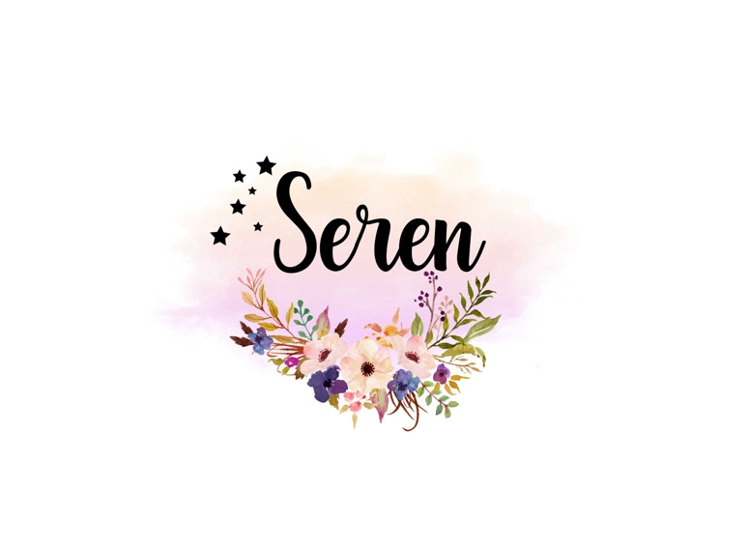
Submitted By

Salma Siddika
Student ID 2118578
Date: 2022
Word count: 1923

Table of Contents

1.0 Introduction ………………………………………………………………………………………….3

- Detail of the business…………………………………………………………………………… 3

  - Mission statement……………………………………………………………………….4
  - Aim of business……………………………………………………………………………4
  - Objectives of business………………………………………………………………….4
  - USP ……………………………………………………………………………………………..5
  - Product and service offered by Seren…………………………………………..5
  - Business Process summary…………………………………………………………..6

- Physical - location of business, equipment required ……………………………..7

- Human resources………………………………………………………………………………….8
  - Job role ………………………………………………………………………………………..8

- Marketing activities……………………………………………………………………………..9
  - Primary research……………………………………………………………………………9
  - Secondary Research…………………………………………………………………...11
  - Marketing and promotional activities For Seren………………………….12

- Financial resources…………………………………………………………………….…….14
  - First 12 month cash flow forecast…………………………………………………15
  - First 12 month financial forecast summery……………………………………15

- SWOT Analysis……………………………………………………………………………………15
- Conclusion………………………………………………………………………………………….16
- References………………………………………………………………………………………..17
- Appendices……………………………………………………………………………………….18

- Introduction:
This report describes the business plan on my online fashion boutique “Seren”. In this business I would like to produce east-west fusion clothing in Bangladesh and Import them to UK. My intention is to sell those clothing to women in the UK through online shop (website, social media). In this report I have discussed the mission statement, objectives and aim of the business. This report also features the products and service customers going to receive. Finally there is a 12 month financial projection and SWOT analysis given to understand the feasibility of the business.
I started this business in 2009 and sold clothing through eBay. However, due to other work commitments, I had to stop that business in 2014. I am so passionate about this business that I would like to revive it now. In this report I have described the reasons behind restarting the business and discussed detail plan to run the business.

2.0 Detail of the Business:
Name of business: “Seren”
Owner: Salma Siddika

“Seren” is a fusion fashion brand mixing eastern and western styles into clothing for ladies. Fusion fashion is essentially combining two or more styles from different cultures into one. Any culture can be fit into the mix, but Western and Indian styles seem to be getting more attention these days. This type of fashion style is admired by different age groups and cultural backgrounds. Fusion clothing incorporate bold and innovative style that celebrates the beauty of eastern culture. (Johal E., 2022)

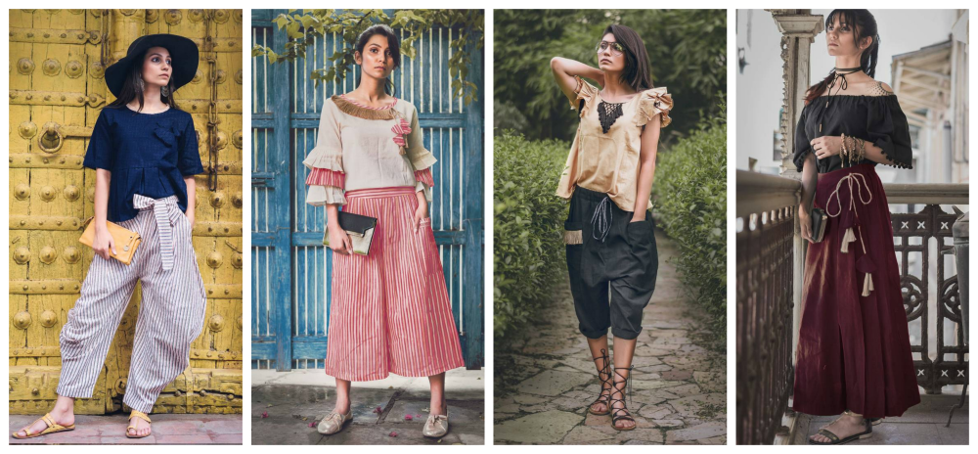
Picture: Example of fusion clothing (Kaushik, R., 2019)
Type of business ownership: Sole Trader because it has the simplest and cheapest legal structure. As a sole trader I can operate the business alone or with employees, so long as I comply with Legal obligations and the Fair Trading Acts. (Smith, G.,2005)

According to Morris, M., By far sole trading is the most popular and easy way of getting into business. I simply notify HM Revenue & Customs so that they can change my income tax and NI status to self-employed. I will now pay NI contributions in Class 2 and Class 4. Legally, I and the business are one. Anything the business does is my responsibility. So I’ll have full control on my business. (2011, p.94).

However there are some drawbacks of the sole tradership. Legally, any losses my business makes are my personal responsibility. (GOV.UK, n.d.). If the business fails owing money, the debts are my personal debt. (Morris, M. , 2011).

As a result it could be difficult to secure business loan. However I have been in touch with Barclays bank for business loan and I found out that I’m eligible to get a business loan as a sole trader with my current circumstances at an interest rate of 20.61% per annum (fixed) for 3 years. (www.barclays.co.uk, n.d.)

  - Mission statement: Eastern Design Western Style
  - Aim of business:
- Strong Social Media presence with at least 10K follower in each of my Facebook page and Instagram account within first 12 months.
- Generate at least 200 regular repeat customers.
- To have a website with the brand name at 6th Month.
- By 12th Month, website should generate 25% of total sales

2.3 Objectives of business:

- Produce clothing in Bangladesh and import them to UK every 4 months.
- Promote in website and social media before and after the products arrive in the UK,
- On 6th Month, I would like to establish my own website to sell clothing directly from website
- Hire social media influencer to promote clothing every 4 months.
- At least £2000 sale each month.

2.4 USP

Unique designs with the essence of Bangladeshi elements and fabric exclusively available to the brand “Seren.”

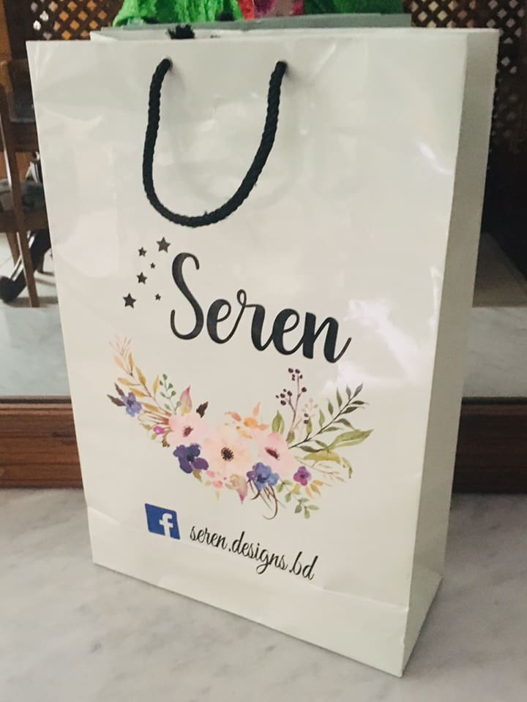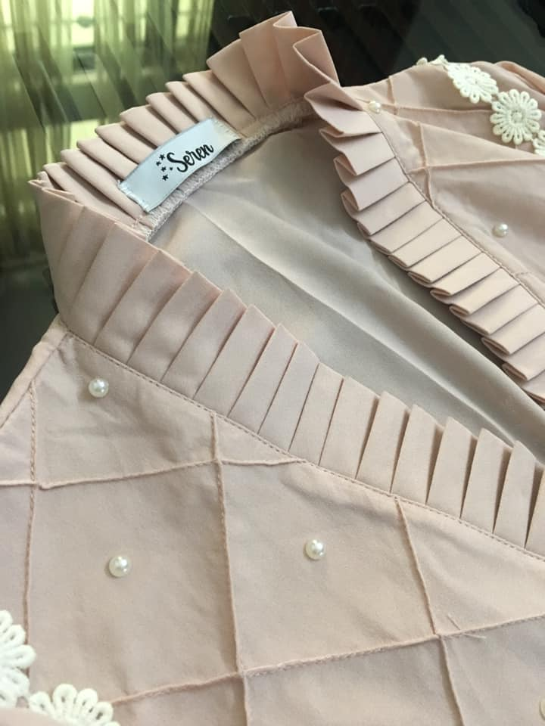

Seren Shopping bag Seren brand logo

  - Product and service offered by Seren:

I would like to produce unique fusion clothing with my brand name “Seren” from Bangladesh and import the clothing to UK. The designs will be only available to the Brand “Seren.” I have good connection with suppliers and cloth production factories in Bangladesh so I can control the production process. Producing in Bangladesh also cheaper. I have previous experience of clothing production as well. Seren’s fashion range would include tops, long and short dress, bottoms and scarves. I then would like to sell these clothing online through Social Media and website (www.serendesignsbd.co.uk). I would sell through social media for first 6 months and on 6th month I would introduce my website because within first 6 months I want to establish my social media presence and have 5K followers on each of my social media account and then it’s easier to promote my website.

There would be special offers and discount during festive season (Summer, Diwali, Eid, Christmas).

2.6 Business Process summary:

Step 1 | Finalize Designs according to Season
Step 2 | Contact supplier in Bangladesh, describe the design, Finalize the fabric material/raw material  Organize Social Media accounts  (Facebook, Instagram, TikTok) and website (from month 6)  Renovate/ organize storage (garage) to accommodate incoming stock.
Step 3 | Monitor Production  Plan marketing campaign
Step 4 | Photoshoot the products in Bangladesh to cut cost
Step 5 | Import by sea freight  Promote the photographs in social media and website before the products arrive to UK.  Make promotional videos
Step 6 | Product arrive in the UK. Pay import TAX/VAT and receive the goods at storage facility (garage). Sort them and store  Start Google, Facebook, Instagram paid promotions  Hire social media influencer to promote goods  Distribute flyers to potential customers.  Promote special offers
Step 7 | Start receiving order  Deliver to through royal mail  Provide customer service  Get feedback from customers
Step 8 | Repeat from step 1

Here are some example pictures of the products I would like to produce and import to the UK:

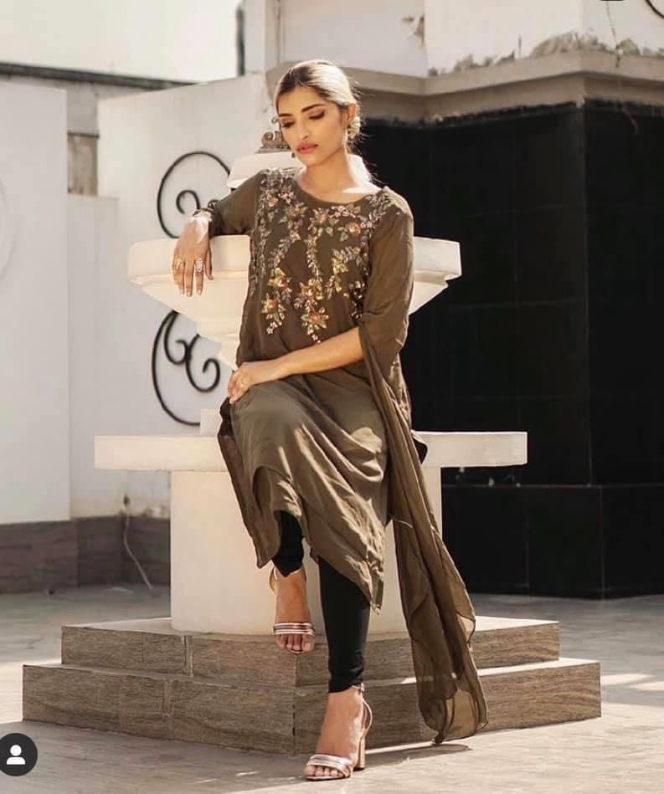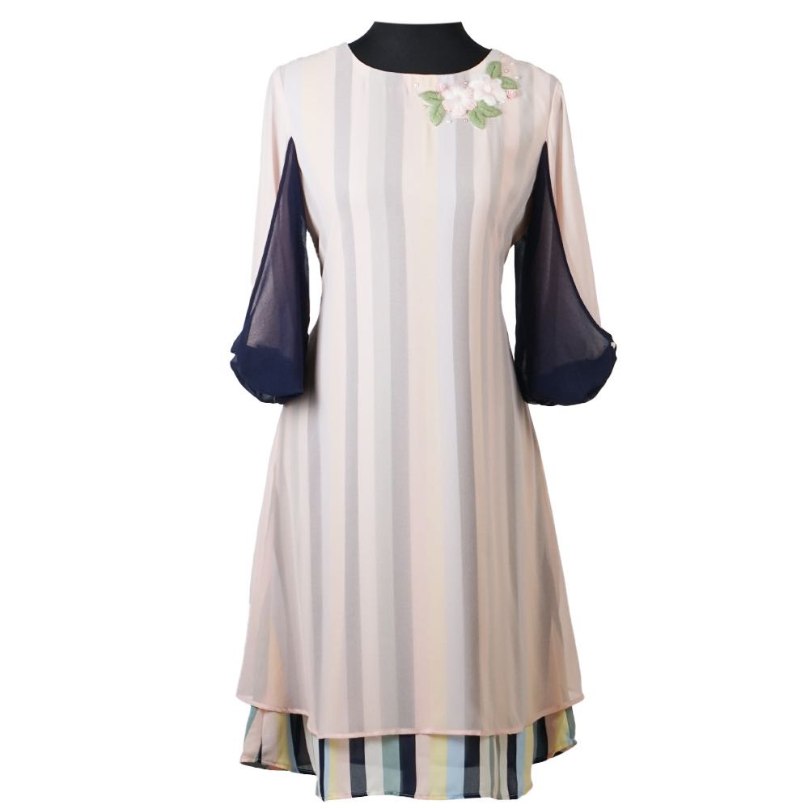

3.0 Physical - location of business, equipment required:
I would like to start the business in my garage to reduce startup cost. As its an online business, physical location is not highly important. I need to renovate the space with shelving, work station and photography background to take pictures of the products. Although I plan to photograph the products in Bangladesh to cut cost, I would need photography facility in my garage as well. I would need a mannequin which I already have. I would also need packaging material, a computer and a printer.
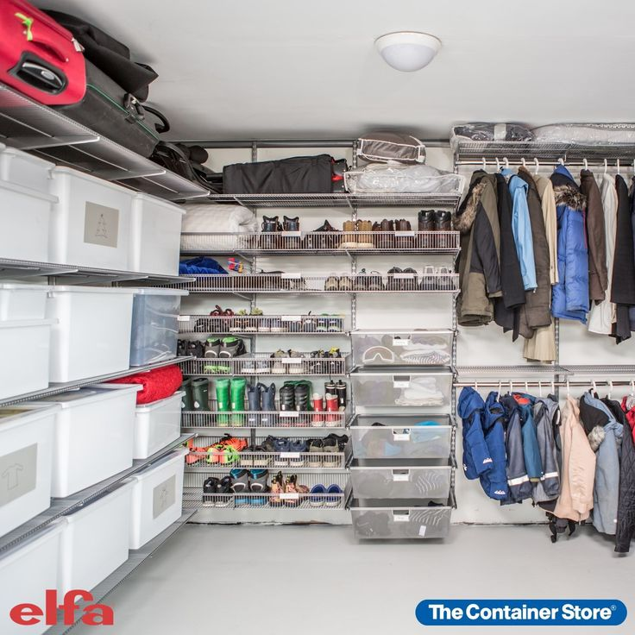 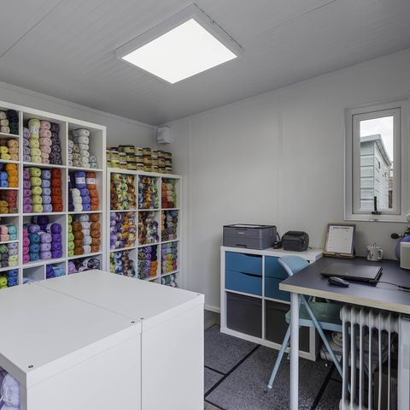Example: Garage turned into storage and workstation

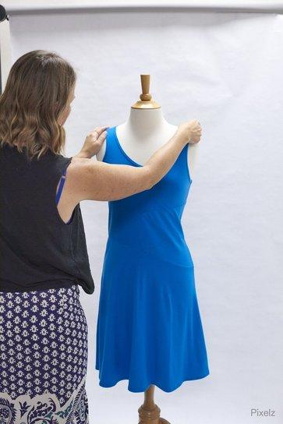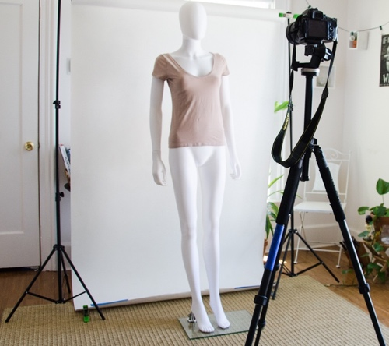

Example: Product photography set up

- Human resources – For the first 12 months I’ll only work for the business. However I will hire free-lancer photographer and social media influencers in contract basis.

4.1. My job role :
- Finalize designs for each season
- Communicate with supplier in Bangladesh and select raw material for the product
- Explain the product to the supplier, monitor production and making sure production in done on due time
- Photograph the products in Bangladesh
- Arrange import to UK
- Arrange port clearance
- Make sure the products are stored safely
- Advertise the product in social media and website with pictures and video clips.
- Contact with social media influencers and arrange live
- Communicate with customers and answer their query
- Fulfill orders by posting them to customer
- Manage return and refund
- Provide customer service through email and phone.

5. Marketing activities
I have done market research to plan products and marketing activities.

5.1 Primary research:
I have created a questioner to find out market demography, product planning and marketing planning. This questioner was distributed to ladies in the UK . Total 14 Responses received and their responses were analyzed as below:

1st column is the question asked
2nd column is the response received
3rd column shows the application of the response received.

Questions | Response | Application
Demographic | 100% Respondents are Female  79% of the respondent is in the age limit 25-44 | This result helped me to find out target customer group
Ethnicity | 57% Bangladeshi, 36% White | This result helps to develop product design and create marketing content
Favorite Brand | 29% replied Zara, | Helps me to plan products
Interest in fusion clothing | 100% showed interest | Helps me to plan products
Maximum spending on one clothing | £50-£150 | Helps me to plan product cost and markup
What kind of clothing you buy most? | Top, bottom and long dress  Got most responses | Helps me to plan product
What kind of fabric in clothing you prefer the most? | 64% answered 100% cotton.  28% Answered silk | Helps me to plan on product material
Expected service | 66.7% responded with special discount | Helps me to plan marketing activities, offer discount and

Some graphical representation of the responses received from market research
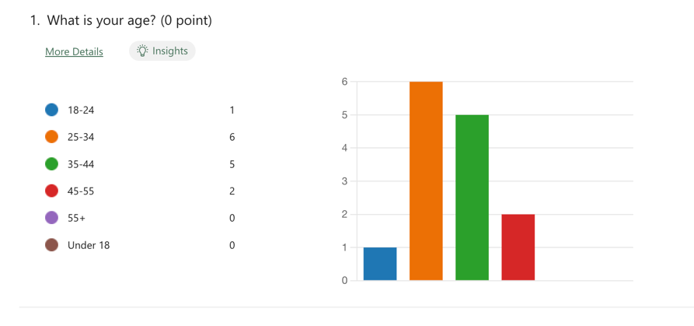
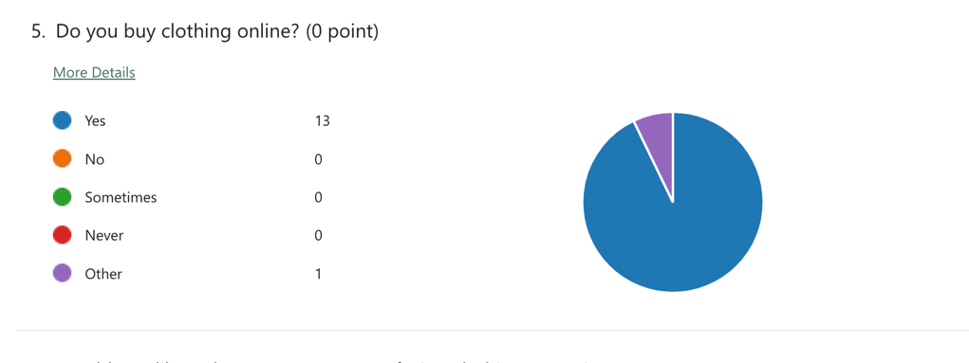
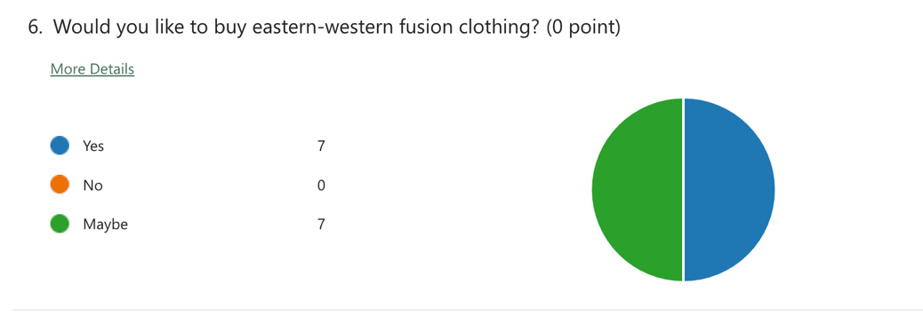
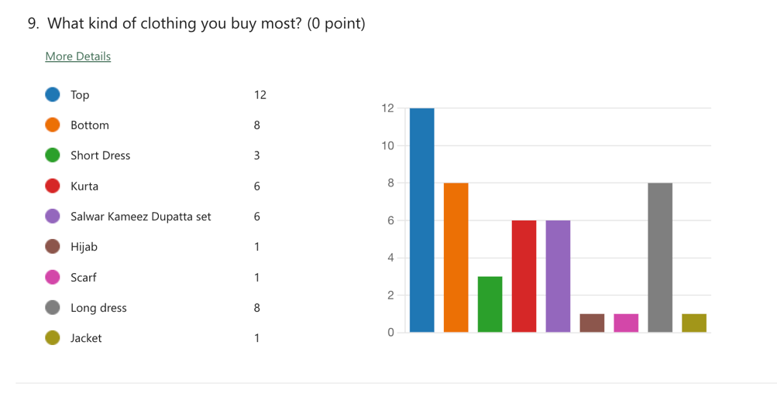

5.2 Secondary Research:
According to Statista, UK female fashion market is at a growing phase which will continue to grow at least up to 2025. (n.d). I have conducted a secondary market research on current competitors, particularly Khaadi.com and www.asos.com, to see what product and service they are offering. From their product range I have gathered an idea of product price and design. The services Khaadi is offering which I found interesting and applicable to my business are, free return, spread the cost of paying with services like Klarna's website and Clearpay Website and seasonal special offer and collection. (uk.khaadi.com, n.d.)
From ASOS website I found some offers that might be useful to my business such as 10% student discount, gift voucher and refer a friend discount. (ASOS.com, 2018).

5.3 Marketing and promotional activities For Seren

- Logo, flayer, business card
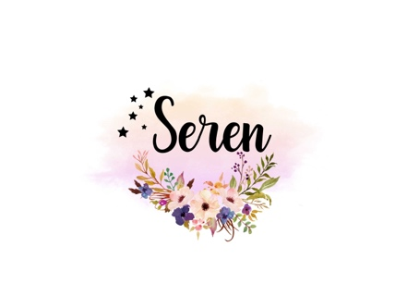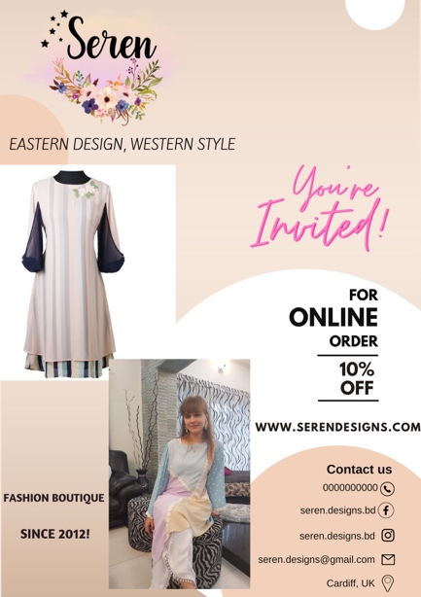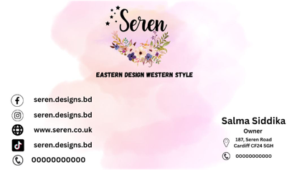
Picture: Logo, Flyer and Business card (canva.com, 2012).

- Online paid Promotion in google, Facebook and Instagram. I already have existing Seren Facebook page with 2.5K followers in the UK which I would like to activate again to increase followers.

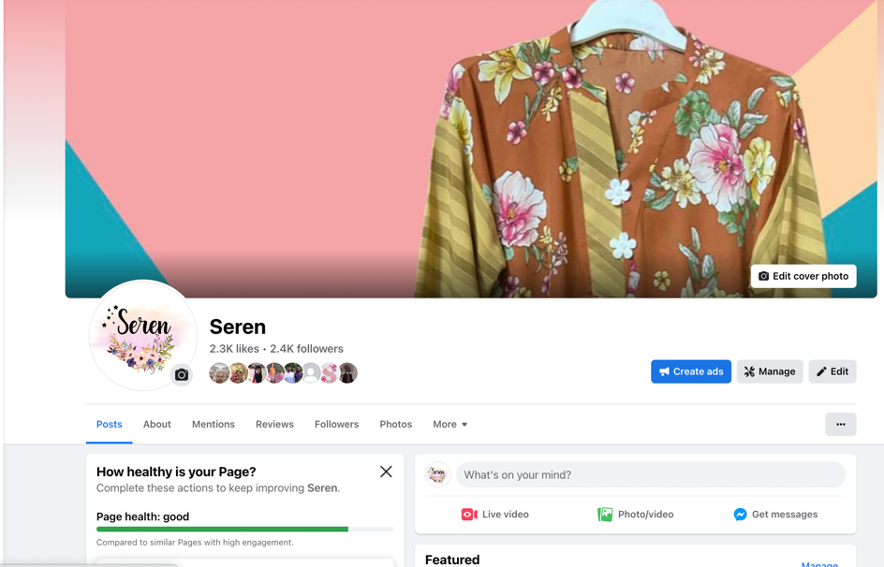
Picture: Facebook page

- Social Media influencer
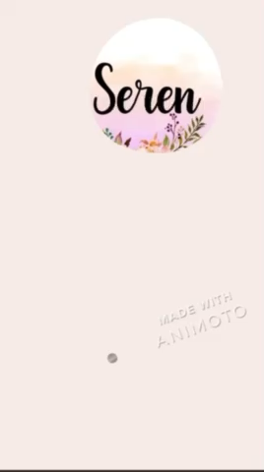
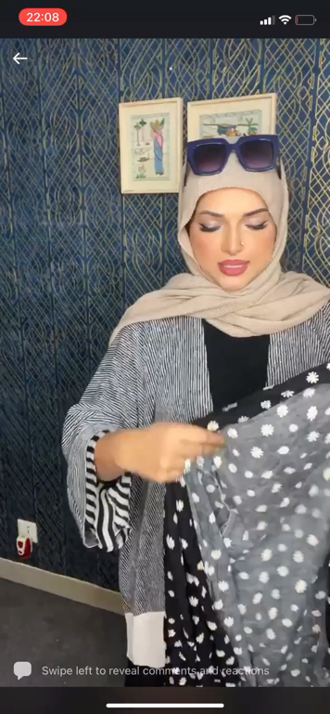

Video: Examples of social media influencer and promotional video

- Short promotional videos (reel, TikTok)
- Special offer for 1st time buyer
- Reward points
- Free gifts or free delivery with purchase over certain value
- Free return
- 10% Student discount
- Special reward for positive customer reviews
- Special offers during festive time
- Attend fashion exhibition to demonstrate clothing directly to customers.
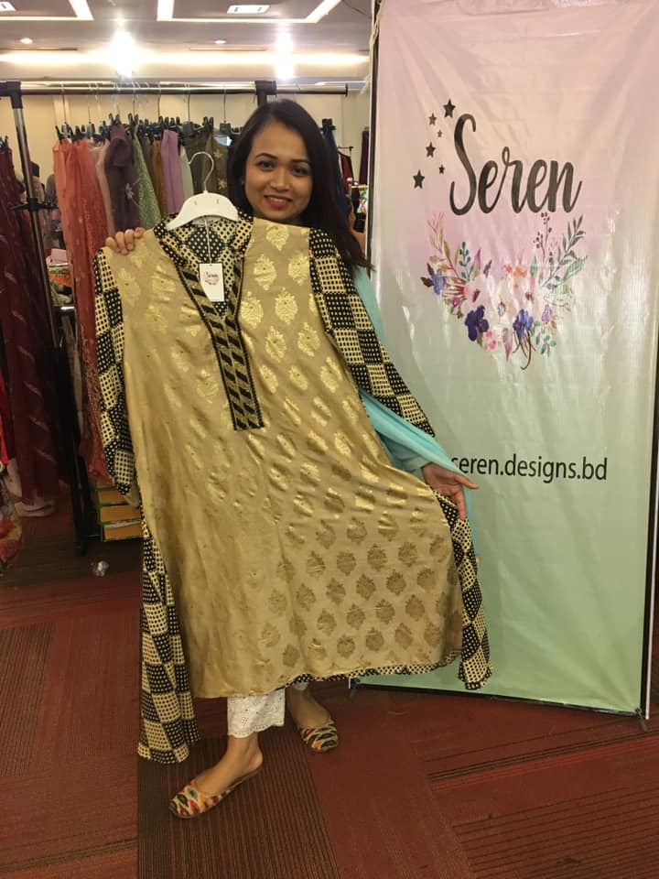
Picture: Seren attending a fashion exhibition (www.facebook.com, n.d.)

6.0 Financial resources

Initial Investment required £8,500
Personal investment:
Bank loan: £5000
At an interest rate of 020.61% for 3 years, monthly repayment £183.00
Cumulative pay after 3 years £6588.00

6.1 First 12 month cash flow forecast:
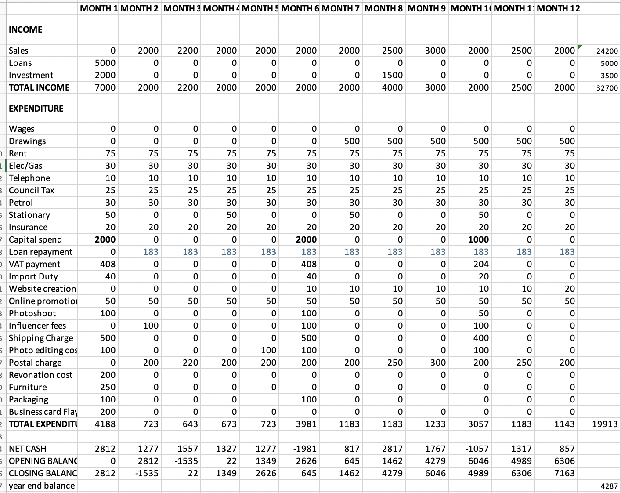

This cash flow was done using import information such as import cost, import TAX, Duty and VAT from HMRC and SimplyDuty.com.
Website development quotation taken from www.ionos.co.uk. Estimated shipping freight charge from Bangladesh to UK taken from ship.freightos.com.

6.2 First 12 month financial forecast summery
Total Investment | £8500
Total Sales | £24,200
Total Expenses | £19,913
Year End profit | £4,287.00

7.0.SWOT Analysis
STRENGTHS  - Experience and passion  - Good connection with supplier  - Good knowledge of import process  - Experienced in online marketing and selling  - Good number of existing customer base in the UK | WEAKNESSES  - Import charge has gone up due to Brexit and Ukraine war  - Product cost gone up
OPPORTUNITIES  - Diverse fashion market than ever  - Strong social media selling platform  - More people shop online. Global ecommerce sales are going to double before the end of this decade. (R. Kazimierz, 2022)  - Customers are more involved in digital platform  - More digital marketing tools available  - Recession | THREATS  - Other competitors  - Ukraine war can effect shipping charge and time.

8.0 Conclusion

The market research shows that at this moment there is a great demand for fusion fashion. Diversity in this country makes it very suitable for new fashion brand. So there is huge opportunity to grow this business. Regular market research, quality product, good customer service, proper financial planning and smart marketing activities mixed with my passion can make Seren a very successful business

10. References

ASOS (2018). ASOS. [online] ASOS. Available at: https://www.asos.com.

barclays.co.uk. (n.d.). Business loans | Business loan calculator | Barclays. [online] Available at: https://www.barclays.co.uk/business-banking/borrow/loans/?campaign=Business_Lending-Brand&chnnl=PSB&gclid=CjwKCAiAyfybBhBKEiwAgtB7fm4Gzmp-FouNynGPiFR0943lsYyJjhs7djQOtIOfSrsxhn8Z379ojBoC1vcQAvD_BwE&gclsrc=aw.ds [Accessed 24 Nov. 2022].

Canva (2012). Canva. [online] Canva. Available at: https://www.canva.com/

facebook.com. (n.d.). Facebook. [online] Available at: https://www.facebook.com/seren.designs.bd [Accessed 27 Nov. 2022].

GOV.UK. (n.d.). Set up as a sole trader. [online] Available at: https://www.gov.uk/set-up-sole-trader.

ionos.co.uk. (n.d.). Website and online shop builders from IONOS. [online] Available at: https://www.ionos.co.uk/websites/ [Accessed 26 Nov. 2022].

Johal E (2022) What is Fusion Fashion? [online] Available at: https://www.nesavaali.com/blogs/news/what-is-fusion-fashion#:~:text=It [Accessed 27 Nov. 2022].

Kaushik, R.(2019)Indo Western - Perfect Fusion Wear for Women. [online] Available at: https://thelifestyleway.com/indo-western-perfect-fusion-wear-for-women/ [Accessed 27 Nov. 2022].

khaadi.com. (n.d.). Returns and Exchange. [online] Available at: https://uk.khaadi.com/returns-exchange [Accessed 26 Nov. 2022].

Morris, M. (2011). Starting a successful business (7th ed.). Kogan Page

ship.freightos.com. (n.d.). https://ship.freightos.com/. [online] Available at: https://ship.freightos.com/.

SimplyDuty. (n.d.). SimplyDuty - Duty and Tax Calculation Made Simple. [online] Available at: https://www.simplyduty.com/.

Smith, Glenn (2005) Why even small business should 'Go Corporate'! Glenn Smith explains why establishing a limited liability company makes better sense for sole traders and partnerships. NZ Business. 2005, Vol.19 (4), p.13. Adrenalin Publishing Ltd.

Statista. (n.d.). UK apparel market revenue by category 2012-2025. [online] Available at: https://www.statista.com/forecasts/1156087/apparel-market-revenue-by-category-united-kingdom.

R. Kazimierz. (2022)Online Shopping Statistics: Ecommerce Trends for 2022. [online] Available at: https://www.tidio.com/blog/online-shopping-statistics/#is-there-an-increase-in-online-shopping.

10.0 Appendices

Marketing research questioner

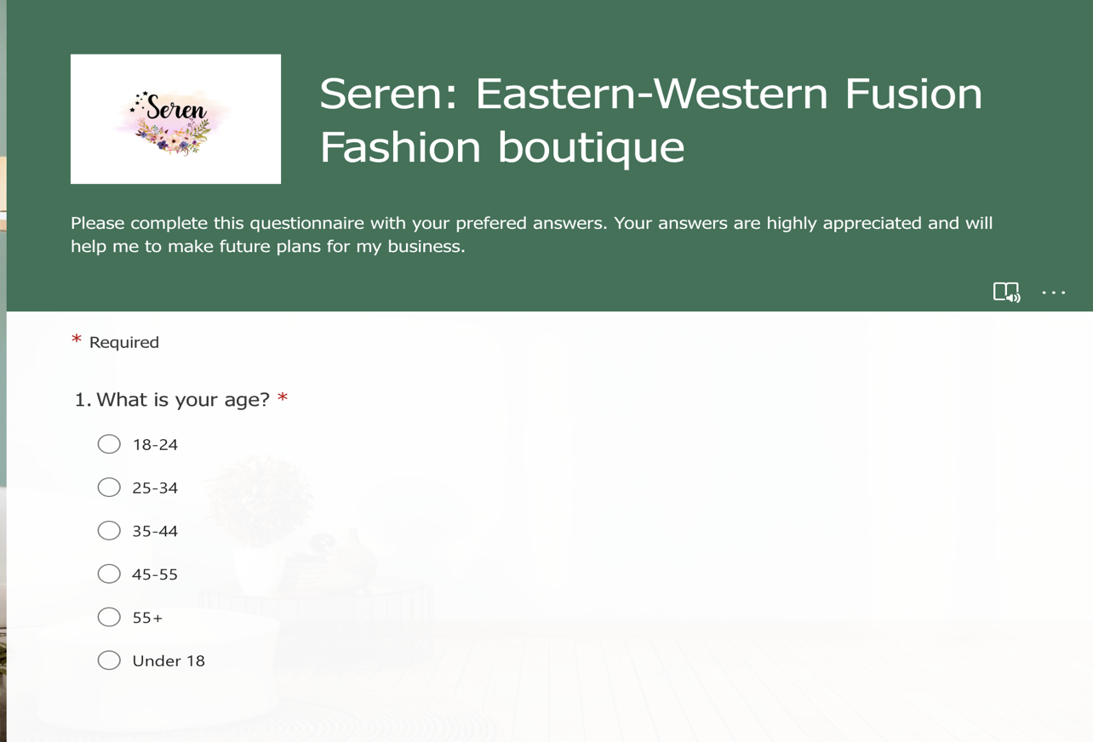

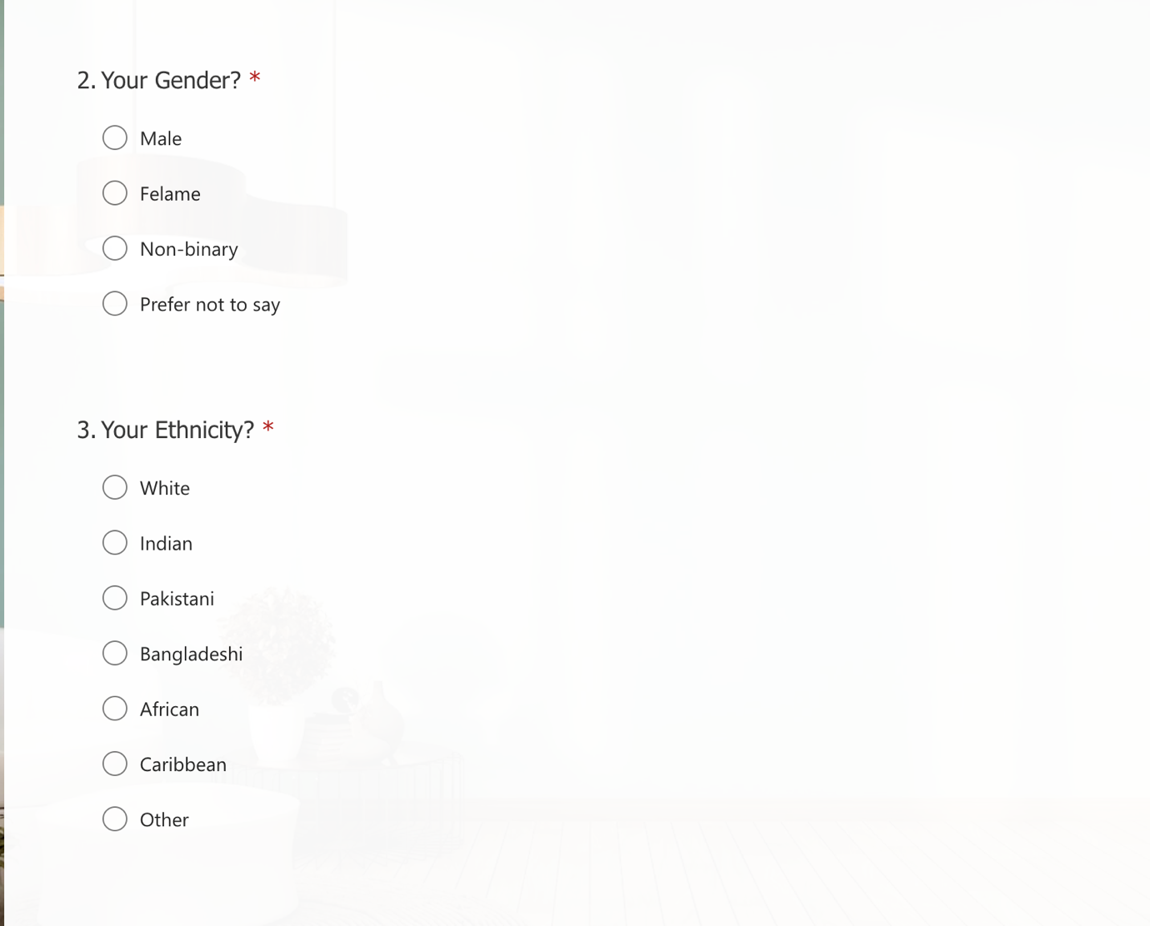

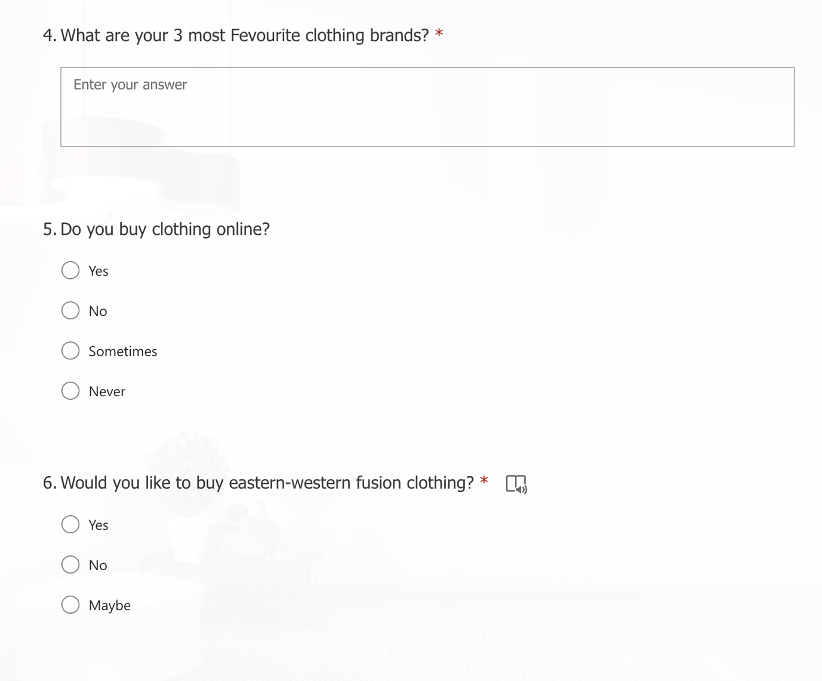
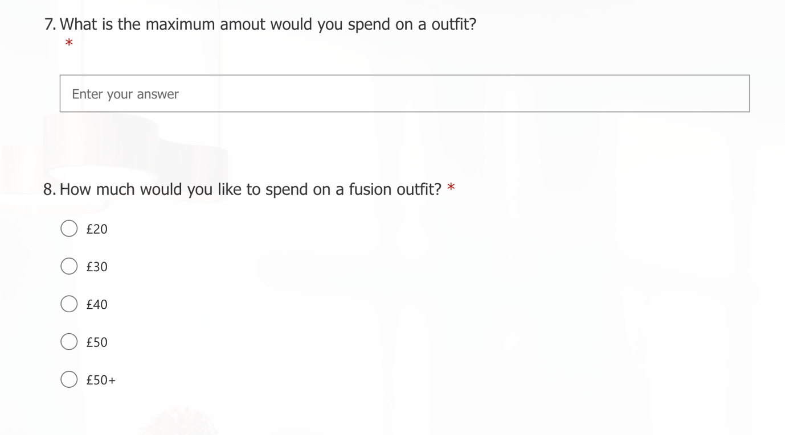
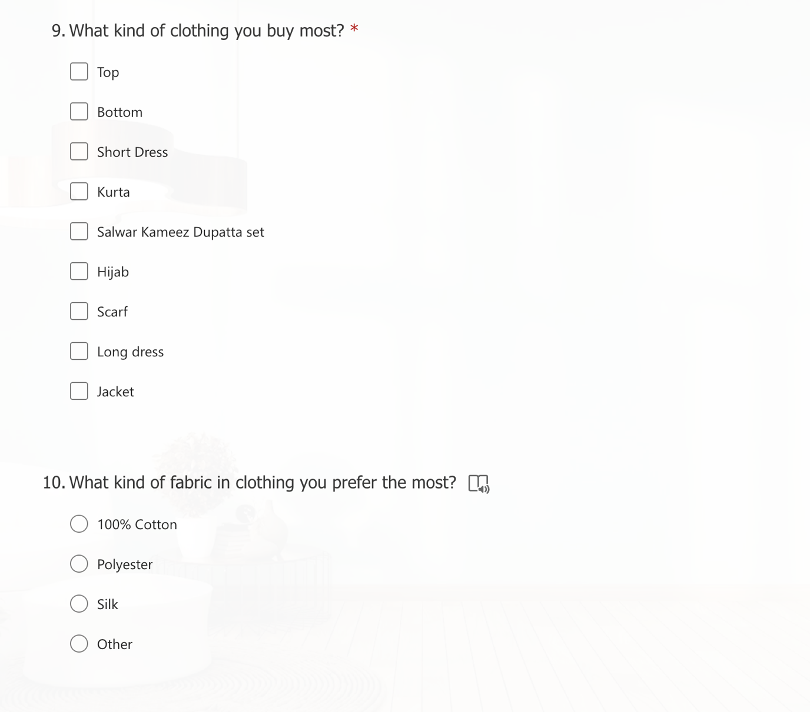
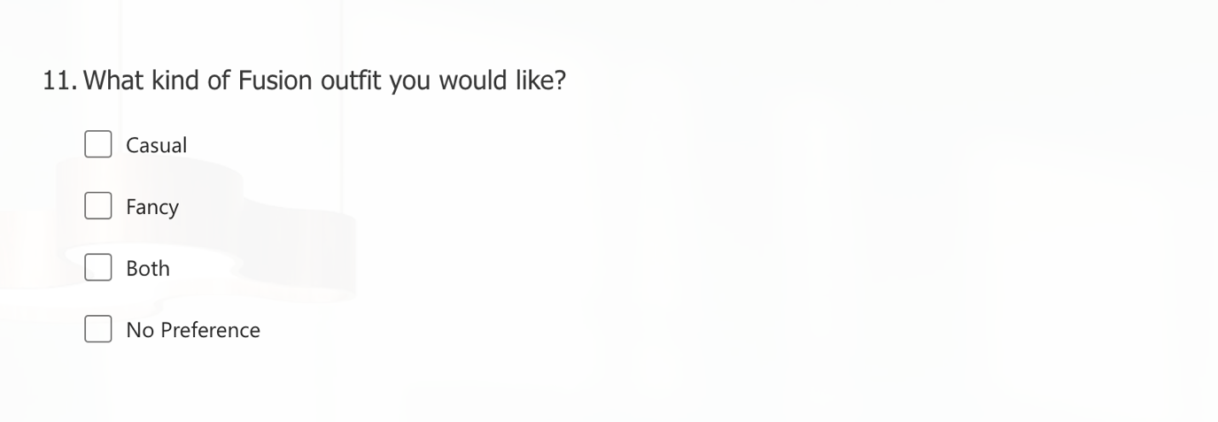
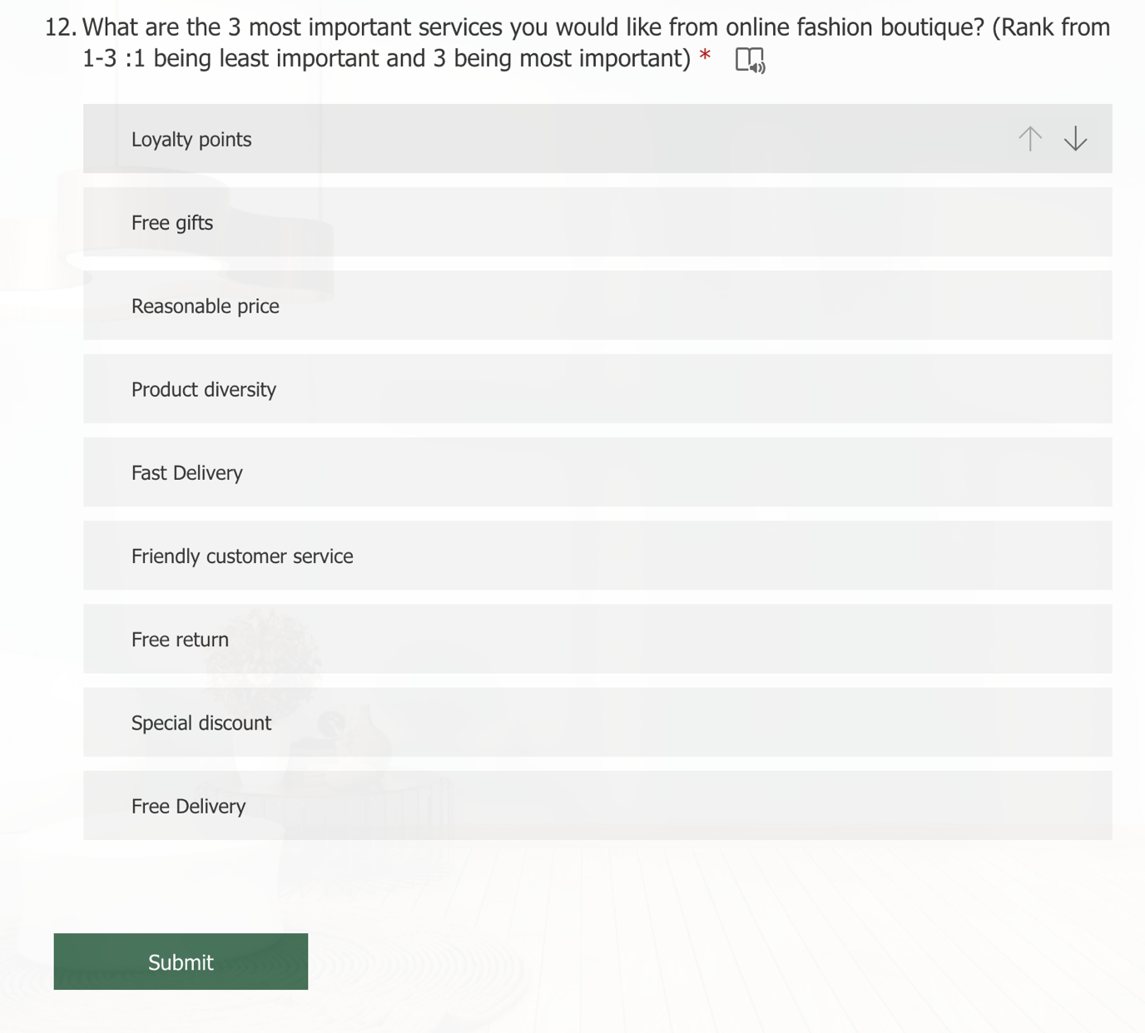

Responses received



