TraceOff Presentation Report – TraceOff Presentation Part two
Student Name: | Alexandru Ichim | Student Email: | 2323396@student.uwtsd.ac.uk
Programme: | BSc Computing Portfolio, BA Computer Animation, BA Games Design. | Student ID: | 2323396
Module: | Emerging Trends | Deadline: | 17 Aug 2026
Module Code: | ACCB6019 | Word count (Reflection): | About 1000
Lecturer: | Sadeque Shaikh | Marks availability date: | 17/09/2026
Assignment Title: | Hackathon 2026 | Feedback date: | 17/09/2026

Table of Contents
TraceOff Presentation Report – TraceOff Presentation Part two 1
Part 2 – Individual reflection on the TraceOff Presentation 2

Part 2 – Individual reflection on the TraceOff Presentation

They are utilising of those which are existent already is the following as the project utilises well known open source code instruments such as Sherlock and M AIGRET at the same time with APIs such as have I been pwned HIBP pause instruments of cybersecurity very rarely necessitate to reproduce the wheel they have success by mixing up existing instruments which results to uh seamless and look alike workflow.
I learned that high possibility of sensible fragility of these tools which is perceived as a critical issue and problem which is outlined as what happens when MAIGRET or Sherlock is destroyed? Well when the safety and security instrument strongly depends on developers of web nature and external coding examples the levelling up modifies a lot such as a website making updates to its user interface or rejecting requests as will destroy your instrument.
There's a upkeep issue and the maintenance in both technical and visual details is the following as the deck of the presentation reads tools like this die of neglect not hosting bills as in security and safety in terms of cyber issues and the cyber field overall upkeeping and maintaining and taking care of the code to prevent a very modifying threat and web field overall is way more harder and difficult than helping to upkeep them by paying servers or other services which are based on the web and also it's hard to find them trustworthy.
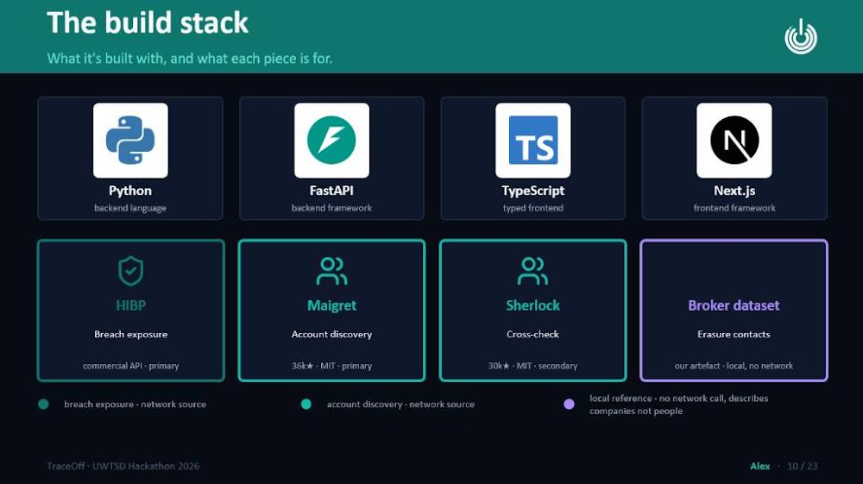
The double use idea and ethics and code of conduct is the following instruments function both ways which stands for a crucial reflection which I have now in my mind which portrays as any tool that reveals exposure can be turned on someone else. It means that an instrument built and constructed to assist protective security and safety or privacy and confidentiality may very easily and sensibly be made like an arm and weaponized by followers or stalkers engineers of social nature or actors of malicious nature to put individuals up the Creek.

As in terms of design for the main cybersecurity scenario and not only the user or the actor as I can't check verify and investigate all the utilizers intentions or plants as I must construct technical security barriers and borders and embed them within the software application itself as this trace off application this section always verification gates and checking up to make sure that a user actually is in possession of the identity and the description they are verifying investigating and looking for including searching in deep mode.

Disclosure in a level the way which is in put the harm at minus as the instrument heights up the raw information and data except when It's necessary to show it and present it. It presents and portrays high level and quality summary 1st Tier 1 and everything in a nutshell and uh in no way portrays the most and the highest sensitive level of the broker information and data tier 3 to take care steps of precaution to forecast the application platform from getting to be an exploitation tool of information which needs to be prevented from such risks.
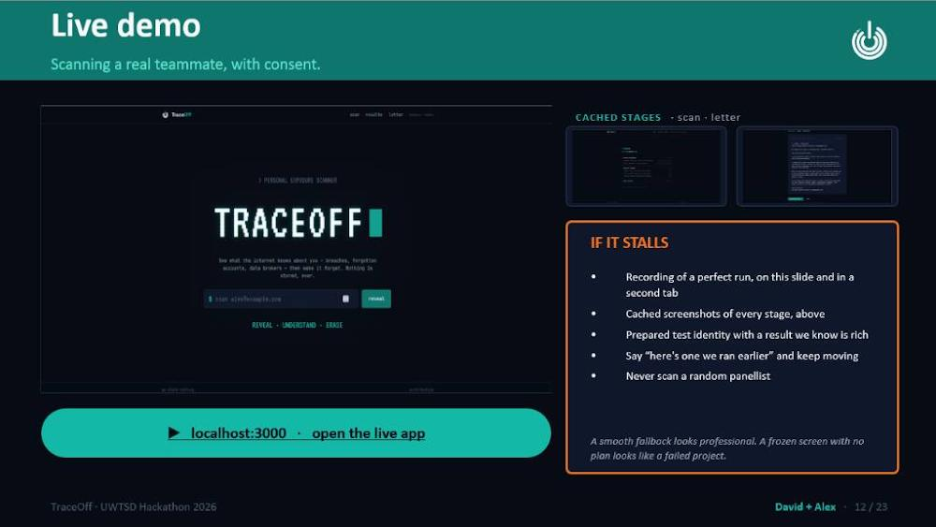
Minimising the trust and the bond and design of the privacy which consists of the following things such as 0 storage nature of the architecture and the components which is portrayed by having the statement we store nothing which means that the project doesn't store any information and data about an individual and also minuses it's self surface of attack and sensibility. If the application platform does not keep data it's more safer and secure and it cannot breach data and information escape it if it is being broken into the platform.

Processing in terms of in cloud which is online disc processing using an online platform would you put your files and you store them online or you can process it in your local hard drive or local tablets or device memory which means that the broker data set as they say for the nation connections is kept local on the hard drive with no need for networking or calling. This prevents third party applications or traffic interceptors or Internet scanners from viewing in an exact way which brokers a very exact user or person is targeting.

History on the side of the client or the customer consists of the following which are characteristics of the future exporting of the data is made in a signed piece of paper which is consisting in a report for the person to keep as this shifts and changes information responsibility completely away from the provider of the service to the user's discretion.
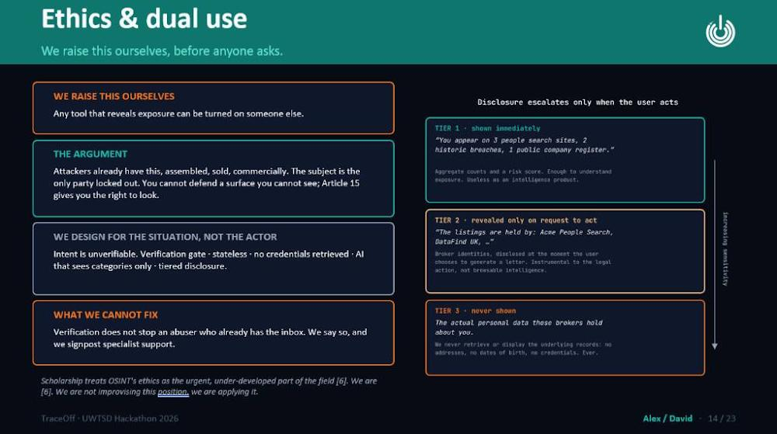
Connecting the gap and the space between the law and technology in terms of cybersecurity consists of the following which means that the unutilized skeleton of infrastructure in legal terms which I have learned from the presentation that it highlight emphasises a lot on a huge real world problem of security which portrays as the following and it has been quoted Britain gave people a stronger right to erasure run America and never build the infrastructure to use it - it means that the safety and security instruments are in plus needed and necessary not only to research find and investigate bugs of technical nature but to assist and aid citizens and that's easily safely securely and completely door exercise and get familiar with rights of legal nature such as the general data protection regulation article 15 out of 17.

In terms of vulnerability and sensitivity in the inbox which is a core limitation approved and recognised in the back of the presentation It is that it has been portrayed that identity checking and verifying completely depends on access of the e-mail As in in just in case a spammer was already taking control of a person's inbox of e-mail and information verification of a basic nature is applied and it is just that the results of the applications it portrays that it is failed completely.
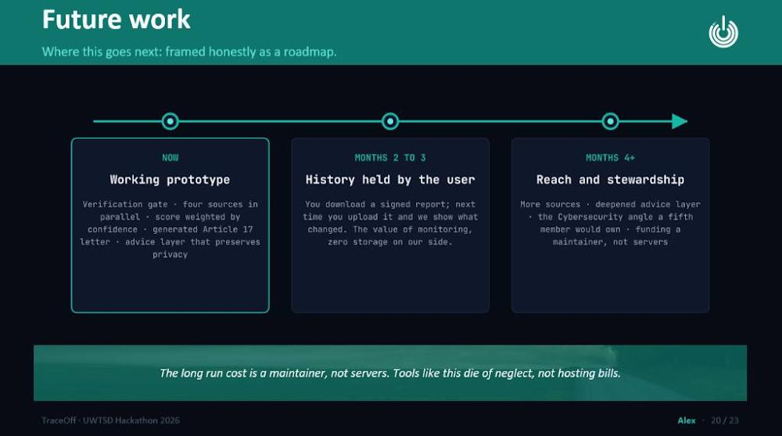
In terms of operational safety and security op SEC in demonstrations it conveys that the risks of live scanning and verifying as the team notes and portrays never scan a random panellist. In terms of cybersecurity overall performing a scan without a consent or in public for everyone to see strongly violates the regulations and rules of privacy and security and may result though unexpected embarrassing or even dangerous and damaging disclosures.

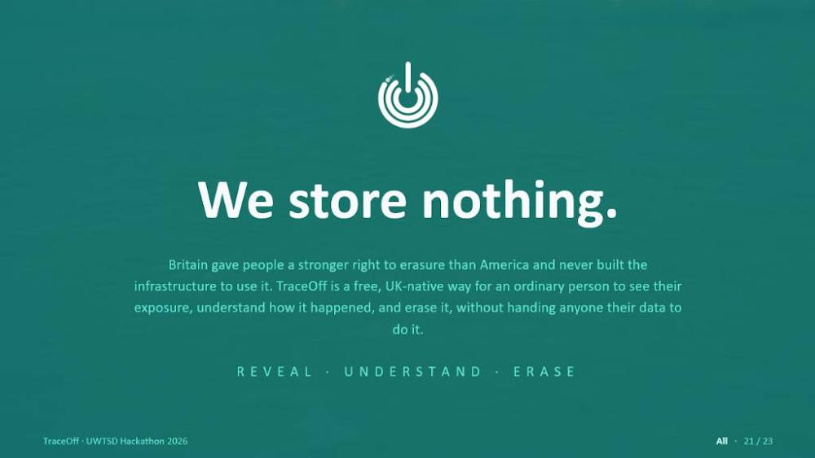
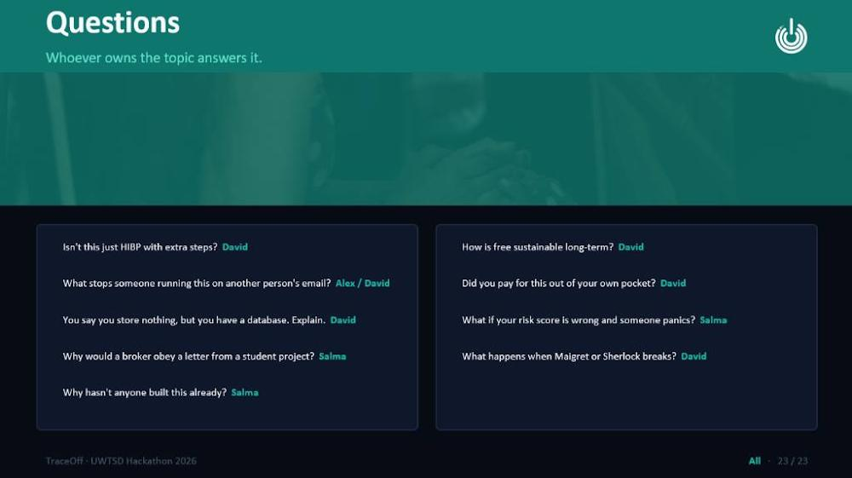

References
[1] A. Moallem, "Cybersecurity, privacy, and trust," pp.1107–1120, 2021,
[2] C. Knibbs and G. Hibberd,A Practitioner’s Guide to Cybersecurity and Data Protection: How to Ensure Client Confidentiality, Taylor & Francis, 2023.
[3] B. Bohar et al., , "Sherlock: an open-source data platform to store, analyze and integrate big data for biology," vol. 10, no. 409, pp.409, 2021,
[4] W. Shang, Z. Wang, A. Afanasyev, J. Burke and L. Zhang, "Breaking out of the cloud: Local trust management and rendezvous in named data networking of things", in Proceedings of the Second International Conference on Internet-of-Things Design and Implementation, pp. 3–13.
[5] S. Dolev, P. Florissi, E. Gudes, S. Sharma and I. Singer, "A survey on geographically distributed big-data processing using MapReduce," vol. 5, no. 1, pp.60–80, 2017,
[6] Z. Zou et al., , "Blind Gods and Broken Screens: Architecting a Secure, Intent-Centric Mobile Agent Operating System," 2026,
[7] C. Senker, Cybercrime and the DarkNet: Revealing the hidden underworld of the Internet, Arcturus Publishing, 2016.
[8] B. Kukul, "Personal data and personal safety: Re-examining the limits of public data in the context of doxing," vol. 13, no. 3, pp.182–193, 2023,
[9] M. Harley, Pentesting APIs: A practical guide to discovering, fingerprinting, and exploiting APIs, Packt Publishing Ltd, 2024.
[10] B. Bohar et al., , "Sherlock: an open-source data platform to store, analyze and integrate Big Data for computational biologists," vol. 10, pp.409, 2023,

