06/05/2019
Benjamin Atkins
1809782
Database Design (The Book Store)
ACCB4013 – Information Engineering
Table of Contents
- Introduction
- Design
- Implementation
- User Guide
- Evaluation
- Appendices

Abstract
In this report the author will discuss the development of the Database Manage System (DBMS) for Dylan’s Book Store. Its purpose is to outline the problems faced between design and implementation of DBMS’s as well as explanation of resolutions for these issues faced. It will firstly cover design and move onto explanations of the implementation process.

- Introduction
The report will cover the issues faced during the development stages from preliminary Entity Relationship Diagrams (ERD) to implementation of the database through Microsoft Access and the use of it in through forms, reports and queries as well as a user guide for the Database (DB). Later in the appendices there will be the ERD’s development stages in 3 versions.

- Design
Upon firstly inspecting the brief the author began to theorise basic ideas for entity relations throughout tables, See appendix A. Many of the tables displayed in the preliminary ERDs were found in later iterations but during the first stages of implementation found that many of the fields within their tables were either redundant or would not implement correctly with the required solution. This led to the development into v0.5, see appendix B. Where after importing the tables, applying validation and entity relationships, the diagram illustrated more accurate and concise tabling of fields.
Moving further into the implementation stages, when adding forms, queries and reports the author found that they needed to further alter their ERD and began changing relationships around primarily the “SaleofBook” table as the relationships present in v0.5, See appendix B. was causing problems on forms and decided to go for a more illogical way of relating them through supplier accounts in order to improve usability on the Sales form, see appendix C.

- Implementation
When first implementing the system into a DBMS the author found many flaws in their ERDs. They then went on to modify this to suit the needs of the system and began to build their forms and user navigation as well as implement queries and reports into the system for more usability. See below for screenshots of forms, reports and queries with relevant explanation;
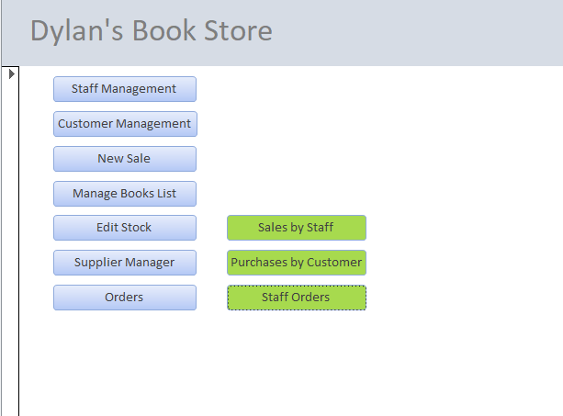
Master Page

The master page allows users to navigate through the system with buttons clearly labelled for their functions, this serves as the home page for all interaction with the DBMS.
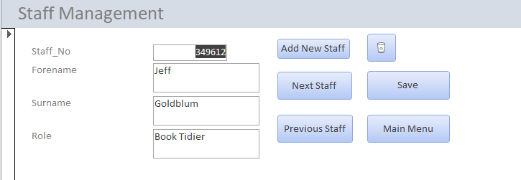
Staff Management Form

This form serves to allow interaction with staff records, it allows for creation and deletion of staff from the Database as well allowing navigation to view individual records.

Customer Management
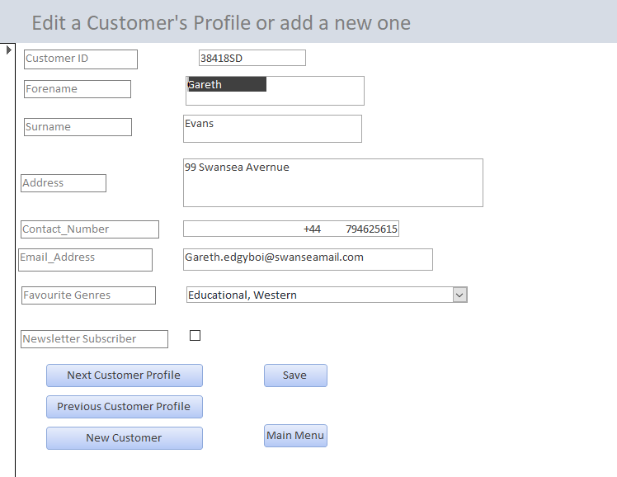
This form allows users to create, delete or view customer profiles in the database.
Sales Form
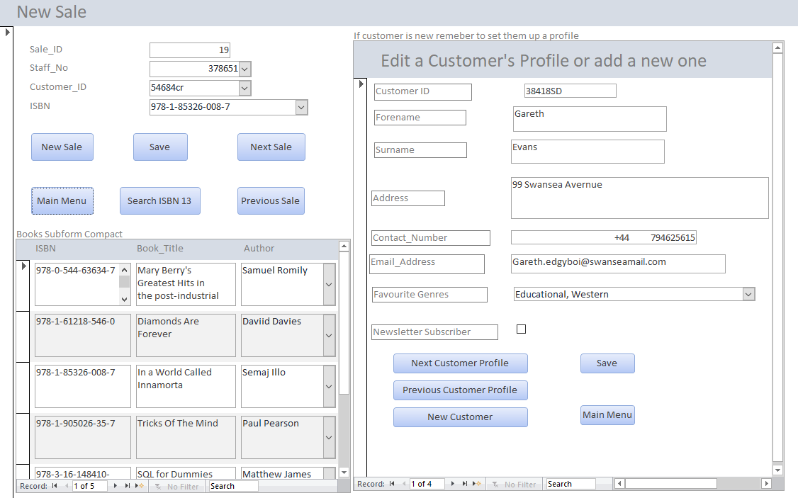
This form is for the purposes of processing new in-store sales, it is primarily for creation of new sales but allows users to view previous sales, it additionally displays the list of all books in the DB for reference as the ISBN 13 number must be entered manually into the sales form, as well as having the customer management sub form embedded as a usability feature if the customer is new as well as to serve as a reminder to staff.

Books Form
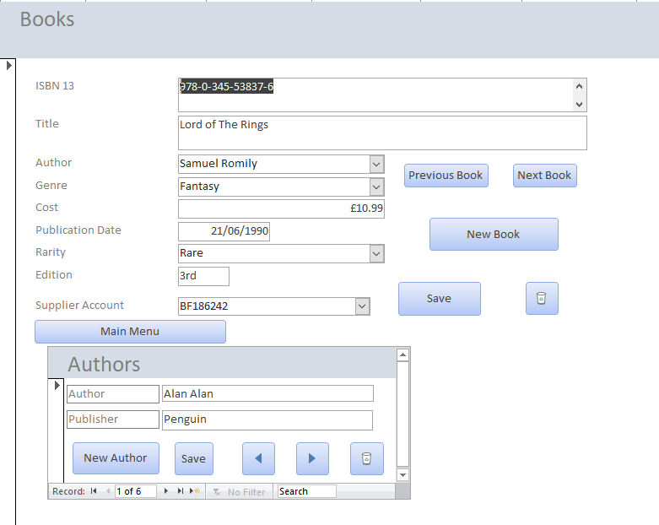
This form allows users to view, add or remove books from the system, these books are not the ones currently in stock but rather to serve as reference for orders, for ISBN 13 numbers and general information purposes. The form also serves as the sole point for interaction with the author’s table as shown in the embedded sub form “Authors”.

Stock Form
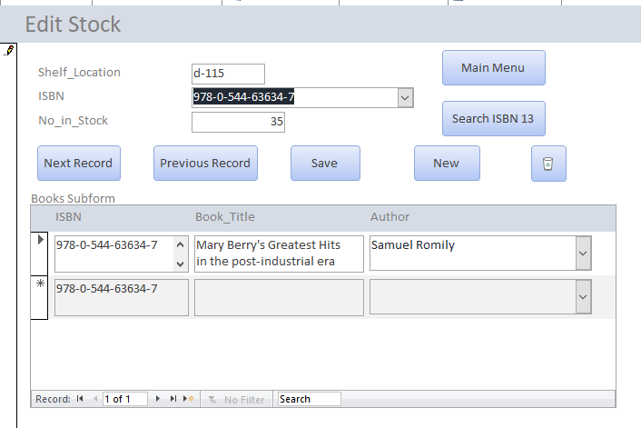
This form allows user to view and interact with the stock table in the DB, it also allows user to use an ISBN 13 search query as reference as well as having displaying book information based on matching the ISBN 13 currently selected on the main form.

Supplier Form
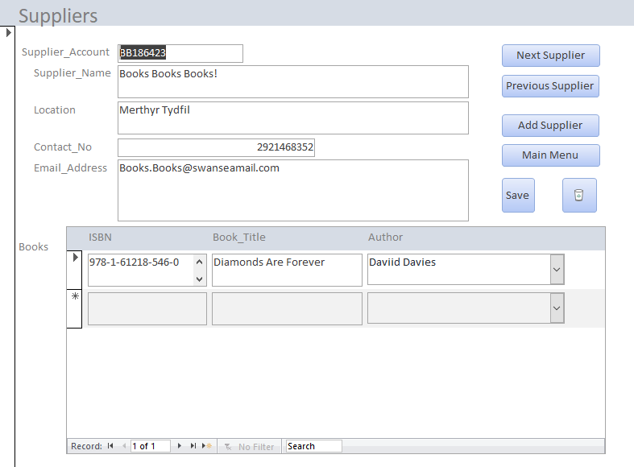
This form allows users to view, edit, add and remove suppliers in the system it also uses a sub form generated from a query to display the books that that supplier stocks as well as some very basic information.

Orders Form
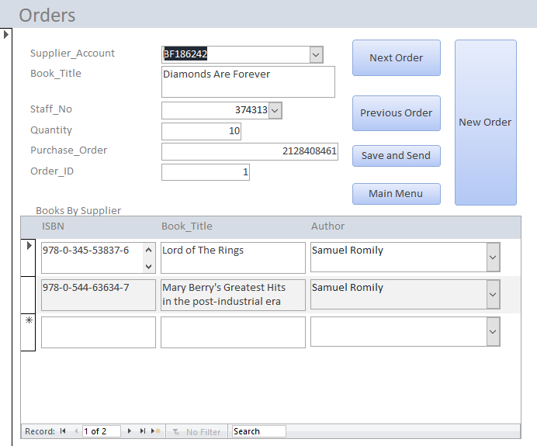
This form allows users to manage current orders as well as add new ones, it will also show the books available by the currently selected supplier with some basic information.

Purchases by Customer Report
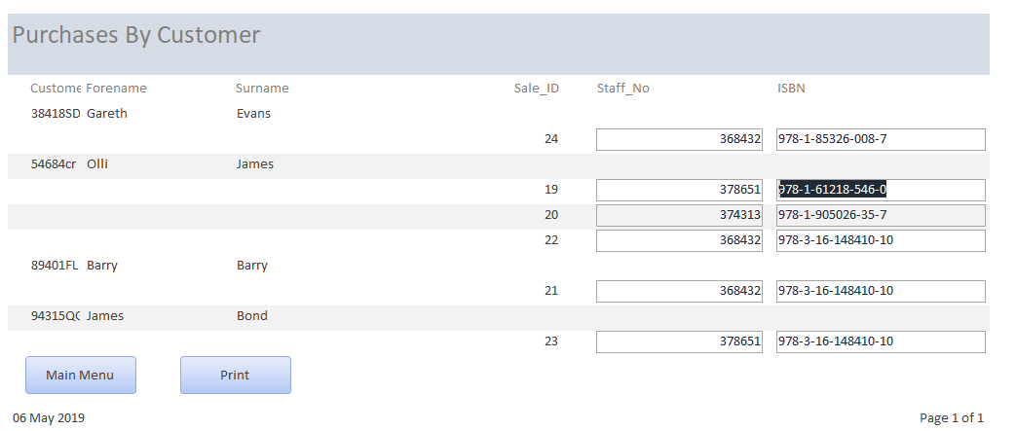
This report generates a structured breakdown of what customers have purchased what items in the database as well as their sale ID, ISBN number of the book and staff number of whoever processed the purchase.

Sales by Staff Report
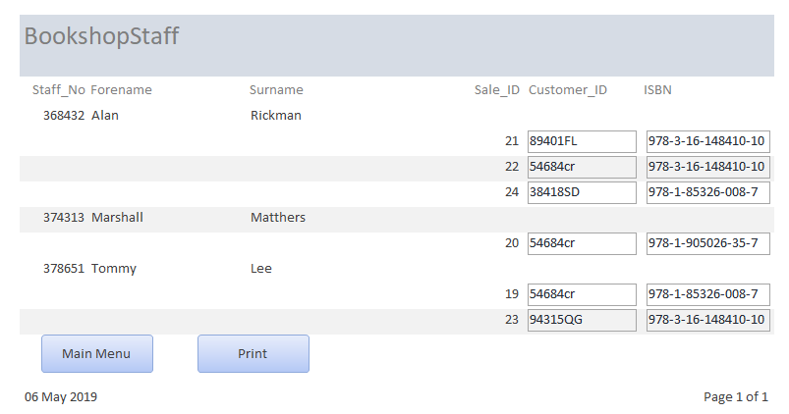
This report displays a breakdown of how many items staff members have sold, the sale ID of the purchase, ISBN number of the purchased items and purchasing customer’s ID.

Staff Orders report
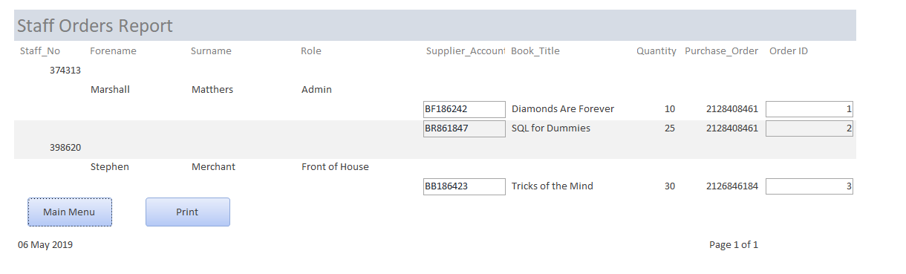
This report displays all the staff orders in the DB sorting them by which staff member has made them detailing item, quantity, order ID, PO number and to which supplier account.

Use of SQL
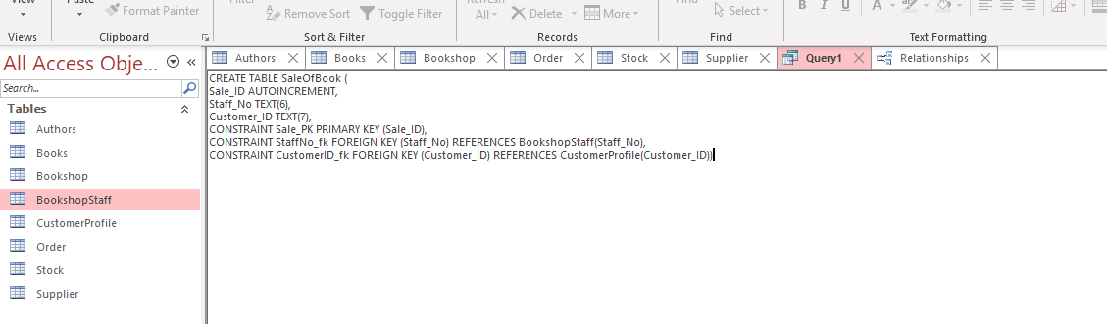
From the screenshot you can see the use of SQL to create tables as well as primary and foreign key relationships and implementation of field sizes through SQL.

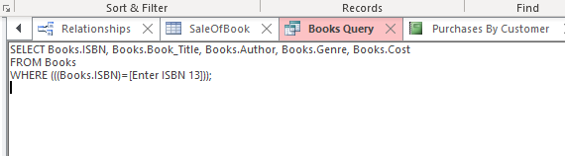
In this screenshot you can also see the use of SQL in a query to find books based upon the ISBN 13 number entered this is used on several forms in the DB.

- User Guide:

- At first you will be presented with the Database’s main menu screen as seen to the left, this serves as your “hub” to the rest of the system and will allow you to navigate through all of the functions of the Database, buttons on the page will allow you to navigate with a click and “main menu” buttons, present on all pages, will allow you to return to this screen at any time.

- The buttons on the left are for forms to interact with the databases records, most will follow the same concise format and all have very similar buttons please see a few of the pages below and an explanation on the function of each button

- Next ****: this button will move to the next record on the table this may include updating some of the sub forms on the page but these will be explained in step 3.

- Previous ****: This will move to the previous record on the table.

- New ****: this will seemingly clear all the fields on the main form and allow you to enter in new values for a new record, following entering these please remember to press save

- Save: Saves the current record and applies any changes.

- Trash can icon: deletes current record.

- Search ISBN 13: brings up a dialogue box in which you can type the ISBN 13 number of a book to display the entry in the books table.

- Main Menu: returns you to the home screen.

- On some forms, as seen in the images above, there are sub forms, these are other forms embedded within the main to allow for more functionality and you can interact with them the same way as in other forms. Some will update with information depending on key information selected in the main forms such as ISBN 13 number or supplier account.

- The green buttons on the main page are used for generating reports and will bring you to a page with only two buttons, print (to print the current report) and main menu (to return you to the main menu screen) these reports contain useful information depending on the one you have selected.

- Conclusion

In conclusion the author has found that there are many problems between design and implementation of a DBMS, and has found it very challenging to overcome some of the problems faced, they feel that they have done a good attempt at making a working model but with little experience with DBMSs and SQL found it challenging to learn through implementation.

- Appendices
Appendix A. ERD v0.1
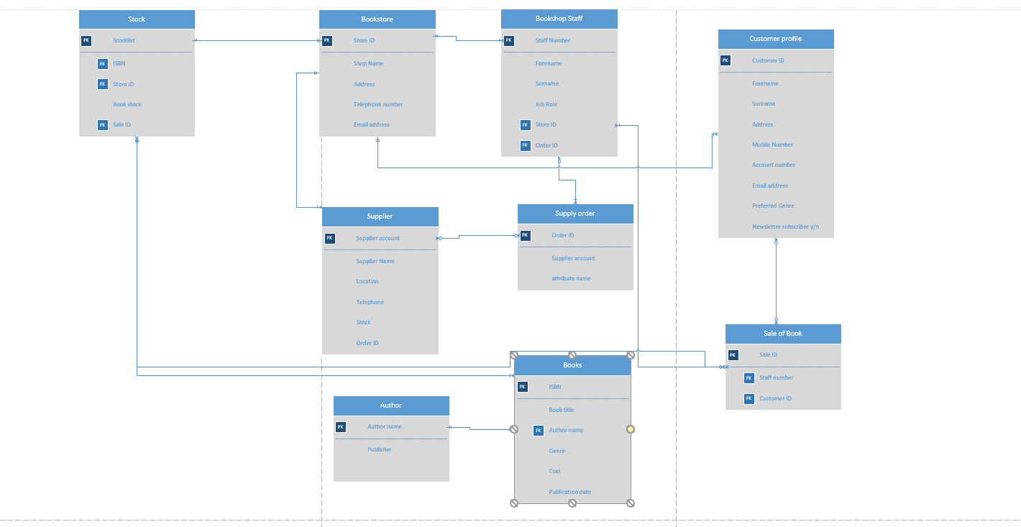

Appendix B. ERD v0.5
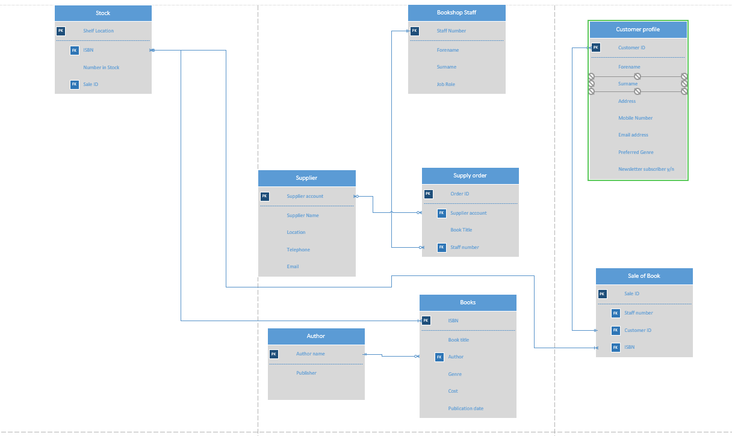
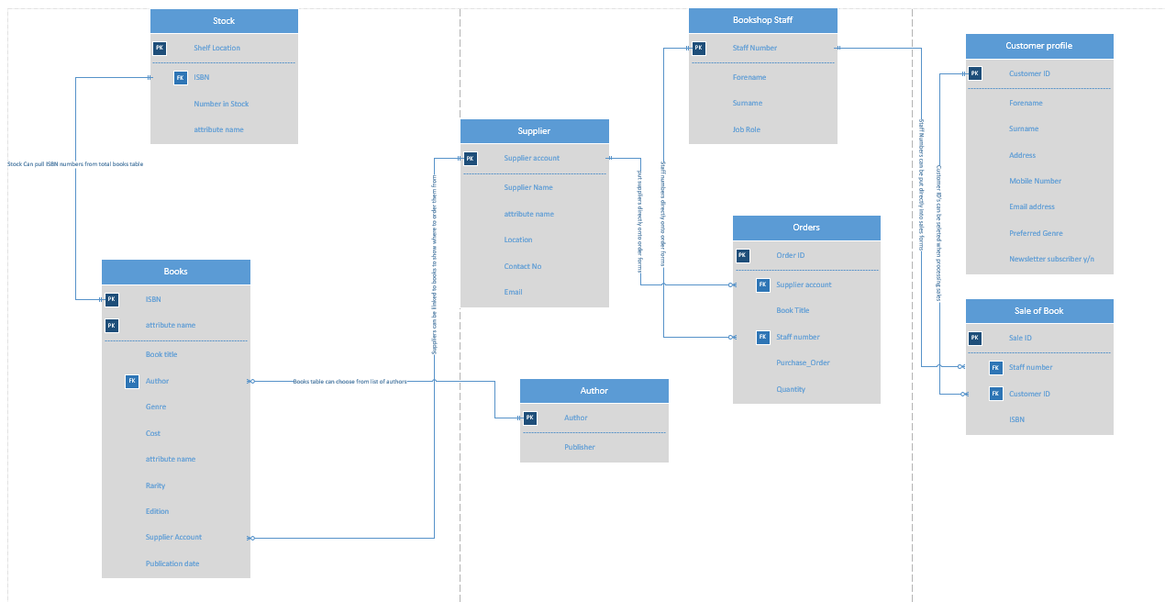
Appendix C. ERD V1.0

