

Natasha Louise Ellis 2309153
Change makers: Building your Personal Brand for Sustainable Employment
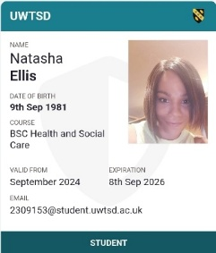
Component 1

Contents
Task 1 5
Task 2 Network Map and Rationale - Guidance 6
TASK 3 BLOG 7
Task 4- NHS Equality, Diversity, and Inclusion Quiz 8
Task 5- A Letter to Yourself 9
Task 6- GANTT Chart (200 words equivalent) 10
Task 7- Making Changes- Report 12
Task 8- Self-Reflection 13
Appendix: Task 2- B: Tables - Bonding and Linking 15
Appendix: Task 3- A: - Blog 16
References for Task 1 18
References for Task 2 19
References for Task 3 19
References for Task 4 20

Task 1

Personal Branding is a strategic career technique that promotes identity and improves career outcomes (Gorbatov, Khapova and Lysova, 2019). Research indicates that individuals experience better career satisfaction and increased employability.
My personal brand is built on listening, attention to detail, time management, eagerness to learn, and persistence (Indeed, 2025). These qualities already help me perform well in both academic and household responsibilities. I recognise that I need to develop them further to achieve my career goals in CALMS, the NHS, and the education sector (Gorbatov, Khapova, and Lysova, 2019). To strengthen my brand, I will improve my digital presence on platforms such as LinkedIn, Indeed and UWSTD systems, showcasing achievements and values that align with employers’ expectations. I also intend to gain further professional training in safeguarding and IT systems (Medicus, 2025). (NHS England, 2025) focuses on the importance of communicating values through platforms such as the Future NHS Digital Primary Care Workspace. Recruiters are more likely to recommend candidates with strong brand equity, as it signals credibility and professionalism (Pahos et al., 2025).
By updating my SWOT analysis and expanding my skills, I can position myself as a reliable, adaptable, and empathetic candidate, ready to progress towards my dream roles using (UWSTD, 2025).

Task 2 Network Map and Rationale - Guidance

As shown in Appendix: Task 2- A: Network Map, I have actively built a selective personal network across four dimensions: career, support, social, and community. My professional connections include university tutors, academic peers, LinkedIn connections, and my Indeed profile, which I use to showcase my skills and engage with NHS professionals. These connections support academic progression and job readiness (Ling & Dale, 2014).
Support ties, family, disability services, GP, and mental health networks provide emotional and practical stability (Woolcock, 2005). Social ties such as friends, student colleagues, and informal peer networks offer encouragement and shared experience. My community ties are currently limited to informal Facebook groups (photography, cooking), with future goals to join professional associations (e.g. BACP, NHS Trust forums) and engage in local volunteering (Ling & Dale, 2014; Woolcock, 2005).
Bonding ties are strong and protective. Linking ties are emerging, as services connect me to institutions but not yet to senior professionals. Bridging ties remain minimal, limiting exposure to diverse groups.
As illustrated in Appendix: Task 2-B: Support Table, my support connections highlight these strengths and gaps. I recognise these areas for improvement and will address them by joining professional groups, attending NHS recruitment events, and expanding community engagement. These actions reflect my commitment to building a hybrid network, which research shows enhances access to resources and career success (Comet, 2007).

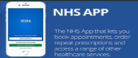
Quick Facts:
NHS App: Book appointments, order prescriptions, view results (NHS, 2023).
Remote GP consultations save travel time (NHS England, 2023a).
7% of UK households lack internet access (ONS, 2020).
Top Tip for Patients: Ask your GP surgery for help if you struggle with digital tools (NHS England, 2023b).
Did You Know? NHS England has a framework to make digital healthcare more inclusive (NHS England, 2023a).
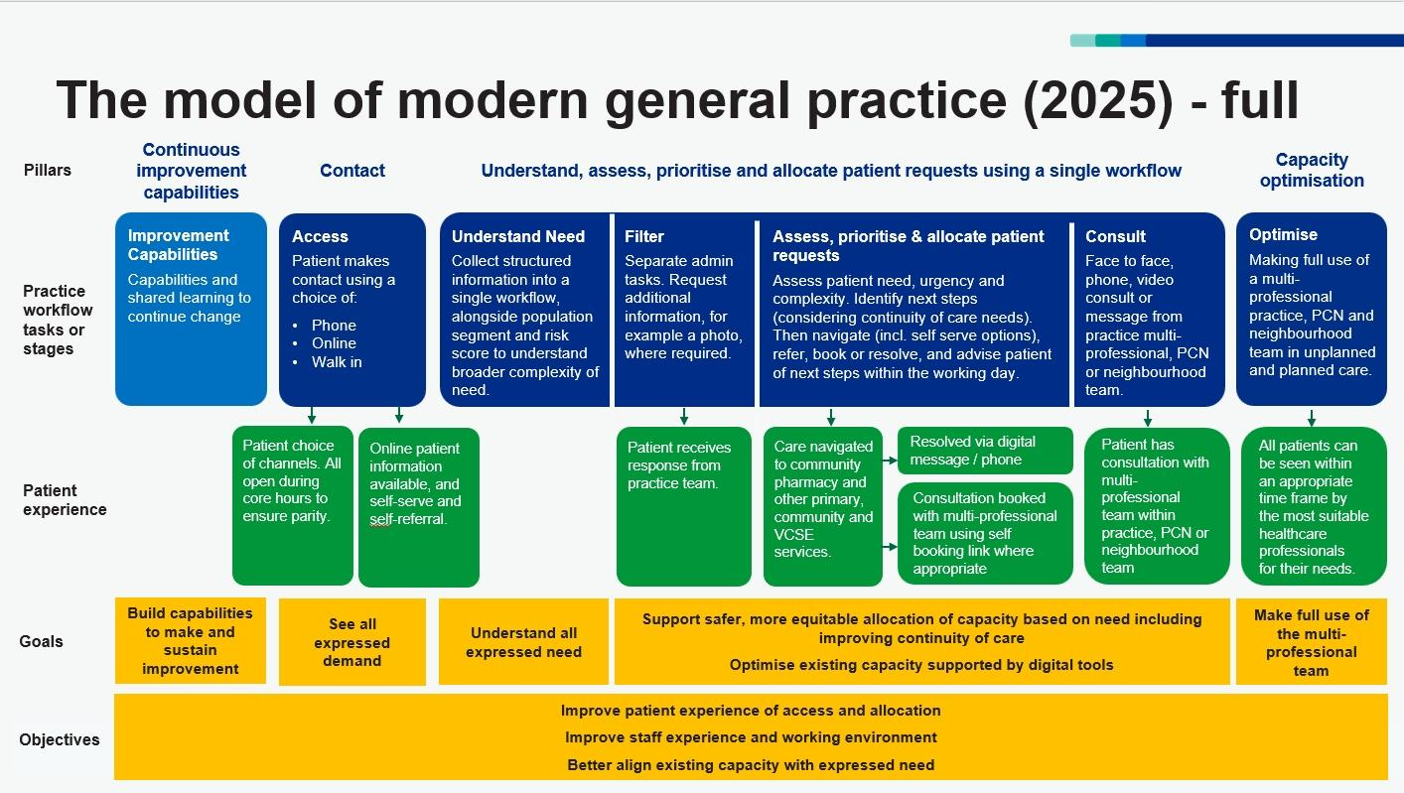
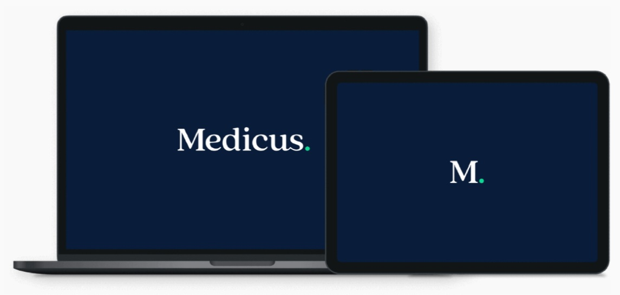

TASK 3 BLOG
The NHS in Your Pocket: Digital Health and Telemedicine

Introduction: Digital health is reshaping how patients access care in the UK. From online GP appointments to the NHS App, technology is becoming a vital part of everyday healthcare. For service users, this shift offers both opportunities and challenges (NHS England, 2023a).

Opportunities: One clear benefit is convenience. Remote consultations mean patients can speak to a GP without travelling, saving time and reducing pressure on surgeries (NHS England, 2023a). The NHS App allows users to book appointments, order repeat prescriptions, and view test results from home (NHS, 2023). Digital records also improve continuity of care, as professionals can access up‑to‑date information quickly, reducing duplication and errors (Wills, Mistry & Gowar, 2025).

Digital tools can also increase choice and control. People with mobility challenges, caring responsibilities, or long‑term conditions benefit from easier access to services. Telemedicine supports faster triage, helping clinicians prioritise urgent cases and manage demand more effectively (NHS England, 2023a).

Barriers: However, there are important barriers. Not all patients have reliable internet access or the digital skills needed to use apps and online systems. This “digital exclusion” risks leaving behind older adults, low‑income households, and those with limited technology (ONS, 2020). Privacy and data security are also concerns; patients need confidence that their sensitive health information is protected when stored or shared electronically (ICO, 2025). NHS England has recognised these challenges and developed a framework for inclusive digital healthcare (NHS England, 2023b).

Conclusion: Digital health is not a replacement for face‑to‑face care, but it is becoming a vital complement. The challenge for the NHS is to balance innovation with inclusivity, ensuring every patient can benefit.

Task 4- NHS Equality, Diversity, and Inclusion Quiz
- Primary Goal: The plan aims to create a fairer, more inclusive NHS by tackling discrimination and improving staff experience (NHS England, 2023).
- Gender Pay Gap: It promotes transparent pay reporting and targeted action plans to close gaps in recruitment and reward (NHS England, 2023).
- Intersectionality: Intersectionality means recognising how overlapping identities (e.g. race, gender, disability) can compound disadvantage (NHS England, 2023).
- Psychological Safety: Staff need to feel safe to speak up and report concerns without fear, improving wellbeing and patient safety (NHS England, 2023).
- Internationally Recruited Staff: The plan supports fair induction, cultural awareness training, and career development pathways to improve retention and experience (NHS England, 2023).
- Leadership Role: Leaders are expected to model inclusive behaviors, embed EDI into strategy, and be accountable for progress (NHS England, 2023).
- Reducing Health Inequalities. One approach is improving access to occupational health and wellbeing support for underrepresented staff groups (NHS England, 2023).
- Data Collection Collecting and analysing data helps identify inequalities, monitor progress, and ensure targeted interventions are evidence-based (NHS England, 2023).
- Flexible Working: Flexible working supports inclusion by accommodating diverse needs, such as caring responsibilities or disability (NHS England, 2023).
- Bullying and Harassment The plan promotes zero-tolerance policies, clear reporting routes, and restorative approaches to rebuild trust (NHS England, 2023).

Task 5- A Letter to Yourself

Dear Younger Me,

I know things felt overwhelming back then. You were juggling responsibilities, trying to stay strong for everyone, and silently carrying the weight of uncertainty. Your well-being was low, and you didn’t know how to ask for help. I wish you had known then what I’ve learned now about emotional intelligence and resilience.

You didn’t need to be perfect. Emotional intelligence isn’t about hiding emotions; it’s about recognising them, understanding what they mean, and responding with self-awareness. If you had paused to reflect, you would have seen that your frustration was rooted in exhaustion, not failure. You were doing your best.

Resilience isn’t just about “coping”—it’s about adapting, growing, and bouncing back. You had strength, but you didn’t yet know how to use it to protect your well-being. You didn’t know that setting boundaries, asking for support, and practising self-compassion were signs of resilience, not weakness.

If I could guide you now, I’d tell you to trust your instincts, speak up when things feel too heavy, and lean into the support around you. You are not alone. You are capable, and you are allowed to take care of yourself, too.

Everything you’ve faced has shaped the person I am today, someone who understands the value of emotional insight and the power of persistence. I’m proud of you for surviving, and I’m here to keep building the future you dreamed of.

With love,
Me

Task 6- GANTT Chart (200 words equivalent)
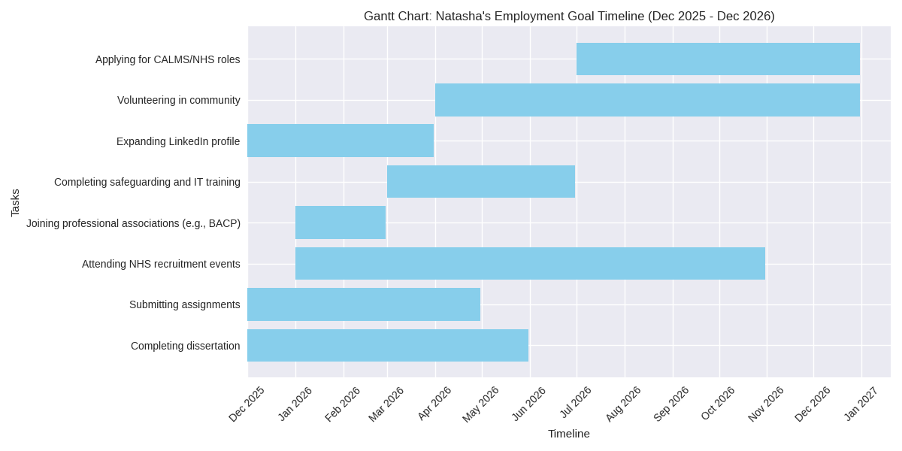The Gantt chart illustrates the sequence of tasks I must complete between December 2025 and December 2026 to achieve my future employment goals. It begins with academic milestones, including completing my dissertation and submitting assignments, which are scheduled from December 2025 to May 2026. Alongside these, I will expand my LinkedIn profile to strengthen my digital presence and showcase my skills to potential employers.
From January 2026, I will attend NHS recruitment events and join professional associations such as BACP, which will help me build bridges and link ties within the health and social care sector. Between March and June 2026, I plan to complete safeguarding and IT training, ensuring I meet professional standards and enhance employability.
Community engagement through volunteering is scheduled from April to December 2026, providing practical experience and strengthening my personal brand. Finally, from July to December 2026, I will focus on applying for CALMS and NHS roles, using the skills, networks, and qualifications developed throughout the year.
This structured timeline demonstrates how I will balance academic, professional, and community activities to progress toward my long-term career goals in healthcare and counselling.

.
Task | Dec 2025 | Jan 2026 | Feb 2026 | Mar 2026 | Apr 2026 | May 2026 | Jun 2026 | Jul 2026 | Aug 2026 | Sep 2026 | Oct 2026 | Nov 2026 | Dec 2026
Complete dissertation | ●●●●● | ●●●●● | ●●●●● | ●●●●●
Submit assignments | ●●●●● | ●●●●● | ●●●●● | ●●●●● | ●●●●●
Expand LinkedIn profile | ●●●●● | ●●●●●
Attend NHS recruitment events |  | ●●●●● | ●●●●● | ●●●●●
Join professional associations |  | ●●●●● | ●●●●●
Complete safeguarding & IT training |  |  | ●●●●● | ●●●●● | ●●●●●
Volunteering in the community |  |  |  | ●●●●● | ●●●●● | ●●●●● | ●●●●● | ●●●●● | ●●●●● | ●●●●● | ●●●●● | ●●●●● | ●●●●●
Apply for CALMS/NHS roles |  |  |  |  |  |  |  | ●●●●● | ●●●●● | ●●●●● | ●●●●● | ●●●●● | ●●●●●

Task 7- Making Changes- Report
As manager of the care home, I propose implementing a digital care record system to replace existing paper-based documentation. This change will enhance the accuracy of resident information, reduce duplication, and improve communication between staff and external healthcare professionals.
To achieve this, I will follow Lewin’s Change Model, which involves three stages: unfreezing, changing, and refreezing (Lewin, 1947). In the unfreezing stage, I will raise awareness of current inefficiencies and highlight the benefits of digital systems. During the change stage, staff will receive training in digital literacy, data entry, and confidentiality. Finally, in the refreezing stage, the new system will be embedded into daily routines, with ongoing monitoring and feedback to ensure sustainability (The Knowledge Academy, 2025).
The necessary skills include IT competence, adaptability, communication, and teamwork. Staff must also demonstrate resilience and openness to learning, as the transition may initially feel challenging.
Possible barriers include resistance to change, particularly among staff less confident with technology, and concerns about data security. To address these, I will provide tailored training, peer mentoring, and clear policies on information governance. I will also emphasise how digital systems reduce workload and improve resident care.
By applying structured change management and supporting staff development, this initiative will modernise the care home, improve efficiency, and enhance the quality of care delivered to residents.

- The Knowledge Academy (2025) Lewin’s Change Model in Healthcare with Real Life Example. Available at: https://www.theknowledgeacademy.com/blog/lewin-s-change-management-model/

Task 8- Self-Reflection
Description:
During this module, one of the most significant learning experiences for me was developing my career plan and creating a Gantt chart to structure my future employment goals. This task required me to think critically about my priorities and the steps needed to achieve them.
Feelings:
At first, I felt anxious because mapping out my future seemed overwhelming. However, as I worked through the tasks, I became more confident and motivated, realising that I could organise complex goals into manageable steps.
Evaluation:
What went well was my ability to use organisational skills to break down tasks clearly. I also improved my academic writing and referencing. However, I could have engaged more deeply with professional networking opportunities earlier in the module.
Analysis:
This experience mattered because it highlighted my strengths in planning and resilience, while also showing me that I need to be more proactive in building bridging ties within my network. It revealed that I value structure and clarity, but I sometimes hesitate when faced with uncertainty.
Conclusion:
I could have approached networking with greater confidence and sought feedback sooner. This would have helped me expand my professional connections more effectively.
Action Plan:
In the future, I will continue to use structured tools like Gantt charts and reflective models to guide my practice. I will also commit to attending NHS recruitment events and joining professional associations to strengthen my career pathway.

Gibbs, G. (1988) Learning by Doing: A Guide to Teaching and Learning Methods. Oxford: Oxford Polytechnic.

Appendix: Task 2 – A: Network Map- Social Network
Social Networks
Social
Support
Community
Career
Image 1: Personal Network Map – Career, Support, Social, and Community Dimensions (Adapted From (Ling & Dale, 2014; Burt, 2005;).
This diagram illustrates the structure of my personal network, showing how bonding, bridging, and linking ties connect across academic, emotional, and community support systems. Colour-coded clusters represent different dimensions, with arrows indicating flow and influence.

Appendix: Task 2- B: Tables - Bonding and Linking
Dimension | Connection from Support | Social Capital Type
Career | Disability services enable academic success and job readiness | Bonding and linking
Social | Family and mental health support help maintain peer relationships | Bonding
Community | GP and services may refer you to local wellbeing groups or charities | Linking

Table 1: How Support Links to career, social, and community dimensions through Bonding and Linking ties (Adapted From (Ling & Dale, 2014; Burt, 2005;).
This table shows how support ties contribute to career, social, and community outcomes. It categories each link by the type of social capital involved.

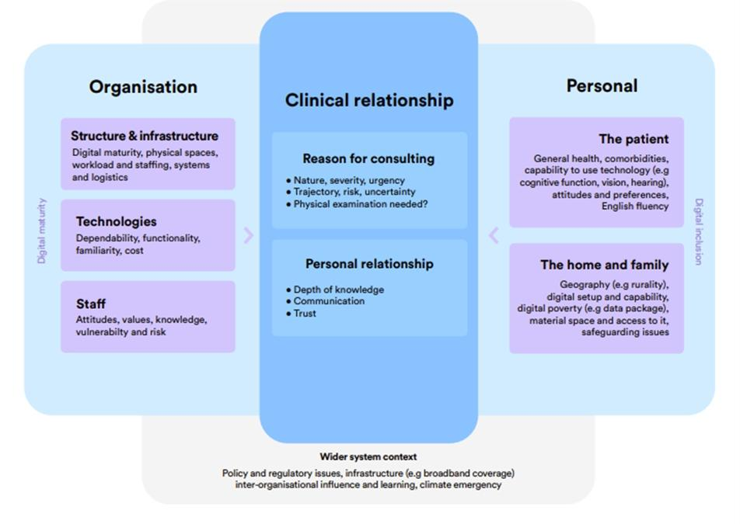
Appendix: Task 3- A: - Blog

Image 1: Factors influencing remote consultations (Adapted from NHS England, 2023a)

This diagram shows how remote consultations are shaped by multiple factors. It highlights the role of organisational systems (e.g. staffing, technology), clinical relationships (e.g. trust, urgency), and personal circumstances (e.g. digital literacy, home setup). It also includes wider system issues like broadband access and safeguarding risks. The image supports the blog’s message that digital health must be inclusive, flexible, and responsive to individual needs.

NHS England (2023a) Remote consulting. Available at: https://www.england.nhs.uk/long-read/remote-consulting/ (Accessed: 27 November 2025).

Appendix: Task 3- B: - Blog

Image 2: Modern general practice model (Adapted from NHS England, 2023a)

This infographic outlines how general practice is being redesigned to improve access, triage, and capacity. It shows a single workflow where patient requests are assessed and allocated based on urgency, risk, and need.
Patients can choose how they contact their GP (online, phone, walk-in), and digital tools help match demand to available capacity. The model also highlights the importance of continuous improvement, clinical triage, and using wider system resources like Primary Care Networks.
The image supports the blog’s message that digital health is part of a broader transformation in how care is delivered, aiming for safer, more equitable access for all patients.

References for Task1

Gorbatov, S., Khapova, S.N. and Lysova, E.I. (2019) ‘Get noticed to get ahead: The impact of personal branding on career success’, Frontiers in Psychology, 10, pp. 1–13. Available at: https://doi.org/10.3389/fpsyg.2019.02662 (Accessed: 25 November 2025).
Pahos, N., Polyportis, A., Kyriakopoulos, N. and Van der Heijden, B.I.J.M. (2025) ‘The effects of personal brand equity on hiring recommendation: why, how, when…?’, Journal of Brand Management, 32, pp. 458–475. Available at: https://doi.org/10.1057/s41262-025-00394-z (Accessed: 25 November 2025).
Medicus Health (2025) User guides. Available at: https://medicus-health.zendesk.com/hc/en-gb/categories/16272114968733-User-guides- (Accessed: 27 November 2025).

NHS England (2025) Health informatics academic courses and professional qualifications. Available at: https://www.england.nhs.uk/long-read/health-informatics-academic-courses-and-professional-qualifications/ (Accessed: 27 November 2025).
Indeed (2025) Personal attributes for interviews. Available at: https://uk.indeed.com/career-advice/interviewing/personal-attributes (Accessed: 27 November 2025).

References for Task2

Ling, C. & Dale, A. (2014) ‘Agency and social capital: characteristics and dynamics’, Community Development Journal, 49(1), pp. 4–20. Oxford: Oxford University Press. Available at: https://academic.oup.com/cdj/article/49/1/4/297120 (Accessed: 27 November 2025).

Woolcock, M. (1998) ‘Social capital and economic development: Toward a theoretical synthesis and policy framework’, Theory and Society, 27(2), pp. 151–208. Available at: https://www-jstor-org.ezproxy.uwtsd.ac.uk/stable/657866 (Accessed: 27 November 2025).

Comet, C. (2007) ‘Review of Brokerage and Closure: An Introduction to Social Capital by R.S. Burt]’, European Sociological Review, 23(5), pp. 666–667. Available at: http://www.jstor.org/stable/4621255 (Accessed: 27 November 2025).

References for Task3

NHS England (2023a) Remote consulting. Available at: https://www.england.nhs.uk/long-read/remote-consulting/ (Accessed: 27 November 2025).
NHS (2023) NHS App and your NHS account. Available at: https://www.nhs.uk/nhs-app/ (Accessed: 27 November 2025).
Wills, E., Mistry, P. & Gowar, C. (2025) Designing inclusive and trusted digital health services with people and communities. The King’s Fund. Available at: https://www.kingsfund.org.uk/insight-and-analysis/long-reads/inclusive-digital-services-people-communities (Accessed: 27 November 2025).
Information Commissioner’s Office (2025) Health data. Available at: https://ico.org.uk/for-organisations/uk-gdpr-guidance-and-resources/individual-rights/right-of-access/health-data/ (Accessed: 27 November 2025).
Office for National Statistics (2020) Internet access – households and individuals, Great Britain. Available at: https://www.ons.gov.uk/peoplepopulationandcommunity/householdcharacteristics/homeinternetandsocialmediausage/bulletins/internetaccesshouseholdsandindividuals/2020 (Accessed: 27 November 2025).
NHS England (2023b) Inclusive digital healthcare: a framework for NHS action on digital inclusion. Available at: https://www.england.nhs.uk/long-read/inclusive-digital-healthcare-a-framework-for-nhs-action-on-digital-inclusion/ (Accessed: 27 November 2025).

References for Task 4
NHS England (2023) NHS Equality, Diversity and Inclusion Improvement Plan. Available at: https://www.england.nhs.uk/publication/nhs-edi-improvement-plan/ (Accessed: 27 November 2025).

