Project Management Report

Name: Kai Strand-Regan

Module Code: ACDA5004

Tutor: Sue Maw

Date: 31st of January 2020

Contents
Abstract 3
1. Introduction 4
2. Risk Management 4
3. Code of Practise 6
3.1. Sustainability 6
3.2. Ethical and Legal 7
4. Quality Assurance 8
4.1. Efficiency 8
4.2. Quality Metrics 9
5. Conclusion 9
6. Appendices 10
7. References 17

Abstract
This report looks at many elements that need to be considered when completing a group project. There are helpful screen shots and references to help the reader understand what is being communicated. The report aims to help the reader understand the planning that is being put in place for the BRS project.

Introduction
This report will cover a range of responsibilities when completing a project, from risk management to ethical and legal codes of practise. It will give a good understanding of what is required to ensure a project has been thoroughly planned and not let any detail fall through. If all reasonable procedures have been considered, then the expectations of the project should be predictable within reason.

Risk Management
Risk management is essential to any project, it is important that project members understand the risks involved when undertaking a such a task. The following is a basic list of the possible risks associated with the BRS project:
- Completing the hardware
- Completing the database
- Completing the website
- Buying the correct parts
- Completing the project on time
- Agreeing on designs
- Complying with copyright laws
All these issues have different levels of risk, in order to get a clear understanding with what needs to be prioritised a Risk Evaluation Matrix [1] has been created with a tolerance line.
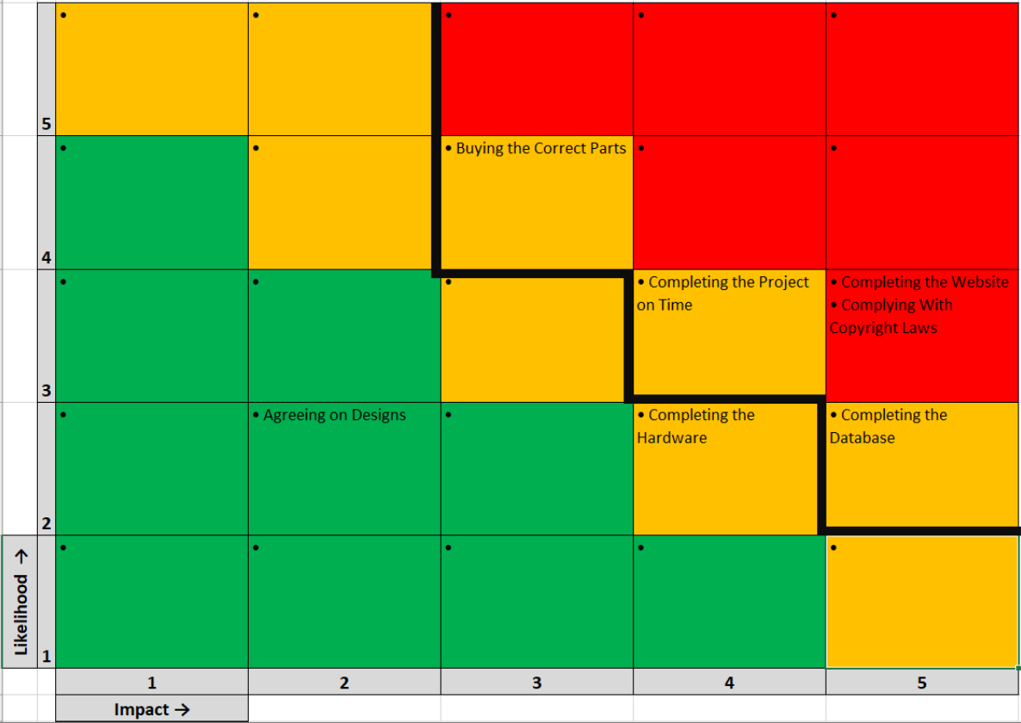
Figure 1 Risk Matrix

The tolerance line has been decided based on the impact of the potential risks that have been considered. Most of the risks have been included in this list although nothing has a high potential which indicates the project is likely to succeed, at least at this stage. Now that the risks have been given a value each risk has been given a status, as the table below shows.
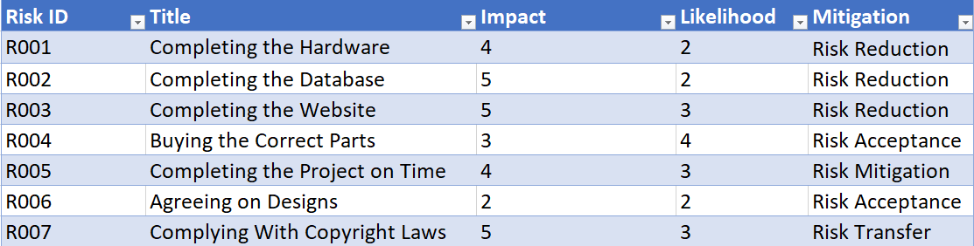
Figure 2 Risk Matrix table
Risk Reduction means that the risk is accepted but procedures have been put in place to reduce the likelihood. For this project prototypes have been created for the three core elements, hardware, database, web design, this should reduce the risk of them failing. Clear concepts have also been in place for each of the core elements.
Risk acceptance is where avoiding the risk would cause more harm to the project than if the risk is accepted. In the case of buying the correct parts and agreeing on designs the risk impact is not very high.
Risk mitigation is the status that ‘completing the project on time’ has been given, since the project members have taken steps to make sure there are backups of the project progress. This is a key step in making sure progress is not lost, thus making sure the project is completed on time.
Finally risk transfer is the status given to ‘complying with copy right laws’, this is because the project members are not a legal team. Therefore, this risk would be transferred to a law firm and the Intellectual Property Office [2].
The risk matrix was created to give an estimated idea on what the major risks would be and then offer some solutions to these by prioritising the main risks. It was important to understand the necessary procedures that needed to be taken in order to avoid/reduce these risks.

Code of Practise
This section will look at the different codes of practise to consider when developing a project, the focus will be on making sure that the project takes into consideration users in the future. This includes, ethical, legal and technological codes that will need to be followed.

Sustainability
The sustainability of a project looks at the environmental impact of the technology being used, along with considering the long term affects. The word “sustainability” often gets confused, some associate it with “saving the planet [2]” and others think that sustainability refers to “literally everything [2]”.
For the purpose of this report “sustainability” will refer to how the project will impact planet environmentally, from the impact of new hardware to the possible systemic impact.
This section would be described as the ‘First Order’ which looks at what impact the existence of the product will have.
The product being created requires no new hardware as it runs of a Raspberry Pi, uses an existing fingerprint scanner and a basic screen. However, it is possible that if this was implemented on a large scale then some servers would need to be introduced instead of it all using the PI and fingerprint scanner given the fact there will be too many students that need to be recorded. Aside from this the only materials being used are wood for the frame, although this might change to plastic or metal depending on the organisation’s preference.
Another issue with a new project is that it can increase the travel for group members to make sure everything is completed on time. One way which the project members have insured that less travel is needed is by using shared folders on OneDrive which has allowed members to upload finished work and ask for opinions on improving.
Another communication service that has been utilised is WhatsApp which allows the group to send quick and easy messages. This ensures that everyone is meeting up when agreed, and that nobodies travel time is wasted.
The ‘Second Order’ looks at if the existence of the product will reduce people’s impact on the environment. There is a good argument that the BRS will be greener as it is aimed at replacing a paper-based system to digital, although some argue that “the paper-making process is sustainable [3]” in the case of this project a tutor still needs to input the data digitally at a later date so the paper becomes redundant.
The ‘Third Order’ looks at the long-term effects of the product such as how it could lead to a reduction in carbon emissions or change how buildings are designed. The BRS is a low impact device in this sense as it can fit on any desk along with being able to connect with most modern hardware. It is unlikely to reduce many external emissions but at the same time unlikely to make a negative impact.
After looking at sustainability and what impact there is from the product being created the pros outweigh the cons. From a reduction in paper to saving peoples time the product is a low impact device that has a net positive environmental result.

Ethical and Legal
The codes of practise will follow the British Code of Conduct [4] which “a unique and powerful endorsement of your professional integrity”. While the project hasn’t officially been passed by the BCS, the ethical and legal side will look to mimic what would be considered appropriate.
Starting with the ethical side, the BRS system does not look to discriminate against any body at the university. However, there is an understanding that some students with disabilities might be unable to place their thumb/finger due to physical limitations. The project designers believe that in this case pupils would also be unlikely be able to sign with a pen, the solution provided would be that it is up to the tutor to manually sign them as present during or after the lesson.
Another consideration for the project is the website design, some prototype designs have been described as “hard to read” due to the colour contrast. It will be important to the team that they test the designs with different ages and especially those that require help with their eyesight.
Figure 4 before colours were changed
Figure 5 after colours were changed
The hover buttons have already been improved to make the background text a better contrast along with the mission statement changing to black.
International students may require a signature, and this might single them out if they are unable to use the BRS device. The best solution to this so far has been to add a digital signature pad [5] to the device so that the pupil is able to sign their name during lesson. Further meetings have been planed with university staff to get a clear understanding on what will be required.
All design choices will be thoroughly considered as it is important that all users feel comfortable using the design layout. Something which will be added at some point is a Welsh option so that tutors who wish to work through a Welsh medium may do so.
The legal side needs to consider the security of personal data, which has been discussed amongst the project leaders. There is no question that the data being stored is ‘personal data’ as the ‘General Data Protection Regulation’ describes personal information as “information that relates to an identified or identifiable individual [6]”.
The solution is that the devices data will be protected by the universities firewall which is expected to follow The Data Protection Act 2018 [6]. The exception to this might be that biometric data (especially from foreign students) could have more laws put in place, given that currently, the only laws in place come from Europe [7].
Looking at the ethical and legal codes of practise it is clear that the project team needs to take them seriously as some key concerns have been raised. Most notably, discriminating against students with physical limitations and the possibility that international students will be unable to use the device.
From a legal perspective it will be important that the data protection code the university follows covers biometric data. It is also likely that these laws will be updated in the coming years so the company will need to update their system in accordance with the new laws if required.

Quality Assurance
In this final section the focus will be on quality assurance, which looks to show what procedures have been set in order to ensure the product will meet expectations.

Efficiency
To have a successful product the creation process must be efficient, more delays and mistakes leads to project members becoming unhappy and likely causes a worse quality product. For this project communication has been essential which is why (as mentioned above) the group has used several forms of communicating and tracking members contributions. Below is a screen shot of the completed tasks that were set to make sure the project was being completed on time, so far progress has been running as planned with a couple of minor delays.
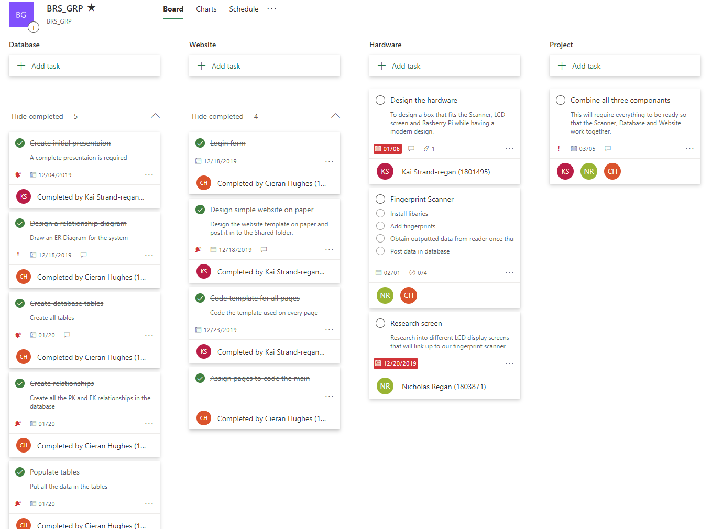
Figure 6 Microsoft Planner

Quality Metrics
Feedback from both inside and outside the project is essential to ensure customer satisfaction which is one of the quality metrics [10]. A questionnaire was created at the start of the project to receive feedback on the initial idea which help to decide the name along with a confirmation that the project was in demand.
Failure rate is another factor that will be considered, most notably if the BRS system is able to update student records and store student data. This will be tested once the team is happy with the prototype.
Quality control will be very important once the device is being made in batch as there is a possibility of the hardware having errors in its structure. The solution to this is random sampling, for example 1 in 10 of the systems will be inspected. Depending on the quality of the product it can be assumed that the other 9 are in a similar condition.
Once the quality control process has started it will be important to track the defect rate as the design might have to be altered if there are too many defects within a certain time frame, for example 10 defects in a month would raise some concerns.
Ratings will also be important, it is likely that the website will have a ‘feedback’ section where tutors will be able to offer their input on what they think could be improved. This makes sure the user base is happy with the product they are using which is important.

Conclusion
This report has covered many areas that are crucial for a project to succeed, from looking at the risks to understanding the codes of practise. Which included sustainability, ethical considerations and legal obligations. The report has given a good insight to how the BRS project is being handled, for more information on the project please read the appendices below.

Appendices
This following is the PID, references for the main report can be found on the last page.

Project Initiation Document (PID)

Kai Harley Strand-Regan

Project Management and Research Methods (ADCA5003)

University of Wales Trinity Saint David – Swansea

Sue Maw

6th of December 2019

Contents
Abstract 3
Introduction 3
What is the project? 4
Objectives 4
Scope 4
Constraints 4
Authority 4
Project Organisation Chart 5
The Resources 5
Hardware 5

Abstract
This report will cover the planning of a group project that the author Kai Harley Strand-Regan has been a part of. It has looked at the objectives along with showing a project plan of the entre project.

Introduction
The document will be a Project Initiation Document (PID) which is the first step too planning a project. It will follow a standard structure, objectives, scope, constraints, authority and resources (OSCAR). Before that there will be a brief description of the project, this should give a clear explanation of the project plans and goals that introduces the reader to the idea.

What is the project?
Project name: Biometric Registration Systems (BIS)
The project looks at solving an issue that some Universities have, this being their registration system, and will offer an idea that has many advantages which the group believes outweighs the down sides.
The premise of the Registration system is that fingerprints are used in place of signing a physical piece of paper. This should save both student and tutors time, the idea is that it will be more reliable than a signature as technically another pupil could sign their friend in. The new system will have the pupil sign in and out while recording the time this was done.
The project is mainly focusing on the application side, this will be a website, tutors and the university will be able to use to see their attendance of pupils along with being able to change the data. If a student has authorized absents for example, they can do this anytime.

Objectives
At the end of this project the primary goals will be to have:
- A working piece of hardware
- A database with student names
- A website that tutors can use
- A way of producing graphs and charts to show attendance trends
These goals are achievable although they will require time, it is possible that only the basics will be accomplished given the time period.

Scope
BIS will be targeted towards universities and in this case will be tested at University of Wales Trinity Saint David Swansea. There is room for this to work in other areas although that is not the aim, currently UWTSD Swansea will be the focus.

Constraints
The time for completing this project will be the groups main constraint. However, there will be extensive planning that should give a clear understanding of what will be completed and as time goes on the group may reconsider how much of the project is essential.
Budget shouldn’t be a huge concern although hardware will be required it is likely that it will be within their budget.

Authority
The project sponsor is UWTSD Swansea as the project is being created on their campus and in conjunction with one of their courses.
The project manager is Cieran Hughes they are going to take part in many of the project areas along with ensuring the rest of the team get their work done.

Project Organisation Chart
A chart has been created to get a good idea of the team structure, with there only being three members it is likely that people will double up on roles. However, this is the main role for each member.

The Resources
The team has discussed what equipment will be needed along with the cost, it is likely that the prototype will not cost more than £150 which is a good price.

Hardware
The team have decided to work using a Rasberry Pie [1], fingerprint scanner [2] (adafruit) and an LCD [3] screen. Other hardware such as computers will be readily available.

Project Plan
The group have used Microsoft Planner to organise their tasks and timeline. They have been able to create a clear progress structure that takes into consideration holydays and difficulty of the given task. The next page shows the tasks that are needed for completion of the project.
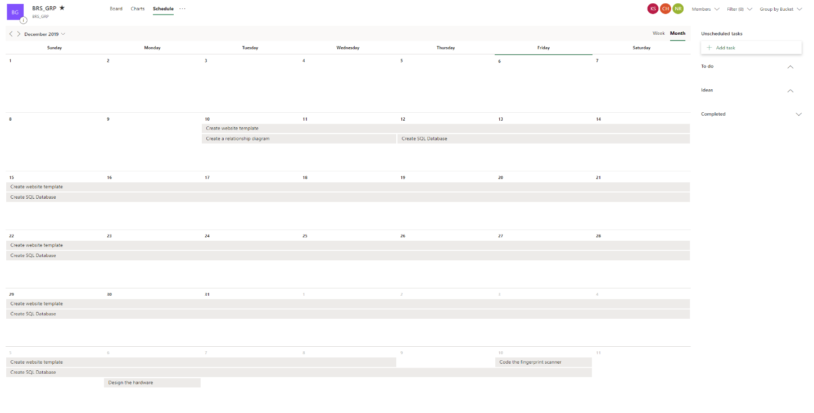
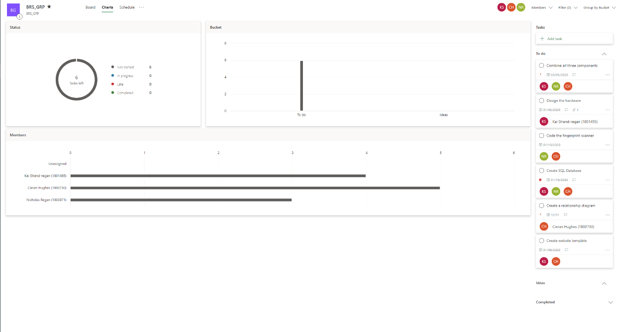
The main flaw with Microsoft Planner is the white background, a link has been provided to make viewing easier. The first screen shot shows the number of tasks and who has been assigned. The second screen shot is a timeline for when the tasks need to be completed.
Figure 1
https://tasks.office.com/uowtsd.onmicrosoft.com/en-us/Home/PlanViews/FSNoBilWCEi-kBcjpXzQBpYAFue4?Type=PlanLink&Channel=Link&CreatedTime=637112430269480000

Figure 2
https://tasks.office.com/uowtsd.onmicrosoft.com/en-us/Home/PlanViews/FSNoBilWCEi-kBcjpXzQBpYAFue4?Type=PlanLink&Channel=Link&CreatedTime=637112431053310000

Conclusion
The PID has outlined all the planning for the registration team and how they intend to complete their project. It is essential to be smart about planning as that is the bases from which a good project is created.

Bibliography

[1] | T. P. Hut, “Raspberry Pi 4 Model B,” [Online]. Available: https://thepihut.com/products/raspberry-pi-4-model-b. [Accessed 06 December 2019].
[2] | T. P. Hut, “Adafruit Fingerprint sensor,” Adafruit , [Online]. Available: https://thepihut.com/products/adafruit-fingerprint-sensor?variant=27740485969&currency=GBP&gclid=Cj0KCQiAno_uBRC1ARIsAB496IWmgTlMjfkMRE0HARldKIxZm42cJ9H9oi5rInqHfypaSK6L3_mhBJwaAhhhEALw_wcB. [Accessed 06 December 2019].
[3] | T. P. Hub, “Adafruit 5.0" 40-pin 800x480 TFT Display without Touchscreen,” Adafruit, [Online]. Available: https://thepihut.com/products/adafruit-5-0-40-pin-800x480-tft-display-without-touchscreen?variant=27739549969&currency=GBP&gclid=CjwKCAiArJjvBRACEiwA-Wiqq1lDqOh8hgYl9cfy6qj1EYiMhC-0I3cE0BHL2w6j0xXZ_3YCUai_1RoC46UQAvD_BwE. [Accessed 06 December 2019].

References

[1] | F. Wilson, “How to Use the Risk Assessment Matrix in Project Management,” ntaskmanager, 22 November 2018. [Online]. Available: https://www.ntaskmanager.com/blog/risk-assessment-matrix/. [Accessed 21 January 2020].
[2] | L. Hosey, “A Brief History Of ‘Sustainability’,” HUFFPOST, 11 09 2016. [Online]. Available: https://www.huffpost.com/entry/a-brief-history-of-sustai_b_12787800?guccounter=1&guce_referrer=aHR0cHM6Ly93d3cuZ29vZ2xlLmNvbS8&guce_referrer_sig=AQAAAK6NQ5i6I0HWbV09HrLLmkc0JEQSlzKfcUCvSjF70DZD2ZWPOX1pVWEtByU8R9zgSAavQL3Xl4ZeEpbW6REb2w7v3tlb9t1z4Kg1Xk2DjT. [Accessed 27 01 2020].
[3] | A. Moodie, “Is digital really greener than paper?,” Gardian, 04 02 2014. [Online]. Available: https://www.theguardian.com/sustainable-business/digital-really-greener-paper-marketing. [Accessed 28 01 2020].
[4] | NA, “BCS Code of Conduct,” BCS, NA NA NA. [Online]. Available: https://www.bcs.org/membership/become-a-member/bcs-code-of-conduct/. [Accessed 28 01 2020].
[5] | NA, “ST-BE105-2-UEVL Evolis Sig100 10.5 cm Digital Signature Capture Pad,” ERS, NA NA NA. [Online]. Available: https://www.ers-online.co.uk/o8102/st-be105-2-uevl-evolis-signature-capture-pads?gclid=CjwKCAiA1L_xBRA2EiwAgcLKA4ePzvbYYb0tVfWiBgFziiUn1tfw6PJIbSSr0w424zGNRjXaN40RKRoCYHsQAvD_BwE. [Accessed 28 01 2020].
[6] | GOV, “Data protection,” GOV.UK, NA NA NA. [Online]. Available: https://www.gov.uk/data-protection. [Accessed 28 01 2020].
[7] | “Biometric data and data protection regulations (GDPR and CCPA),” THALES, 28 01 *Last updated* 2020. [Online]. Available: https://www.gemalto.com/govt/biometrics/biometric-data. [Accessed 28 01 2020].
[8] | W. KENTON, “Triple Bottom Line (TBL),” Investopedia, 03 05 UPDATED, 2019. [Online]. Available: https://www.investopedia.com/terms/t/triple-bottom-line.asp. [Accessed 27 01 2020].

