NAME- Iosif schian
ID-2408084

A JOURNEY IN DIGITAL DEVELOPMENT: A REFLECTIVE PORTFOLIO OF ACADEMIC AND PROFESSIONAL SKILLS

Table of Contents
Part 1 3
Slide 1: Introduction & Portfolio Overview 3
Slide 2: Artifact 1 – Microsoft PowerPoint Project 3
Slide 3: Artifact 2 – Everyday Digital Identity & Workspace 4
Slide 4: Artifact 3 – Financial & Data Literacy Tools 5
Slide 5: Conclusion & Future Impact 6
Part 2 8
Introduction 8
My Work 8
My Development 8
Reflection 9
Conclusion 9
References 10

Part 1

Slide 1: Introduction & Portfolio Overview
- This presentation shows my personal portfolio of the key digital skills.
- The products I selected correspond to various levels of my technology base.
- These strategic artifacts show how I have learnt throughout the module.
- Any project will entail considerable growth of my applied software competence (Gadot and Tsybulsky, 2025).
- Technical competence is essential to the contemporary business and academic achievement.
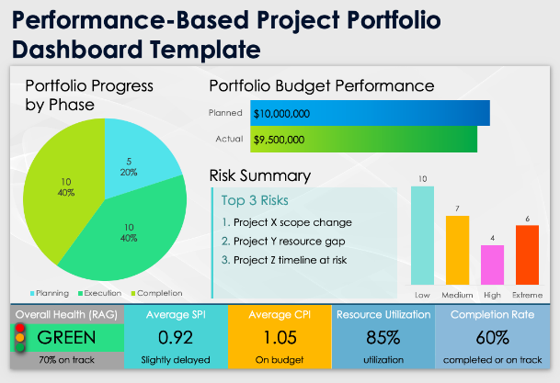
Speaker Notes:
Greetings, my presentation on digital skill development. My portfolio is based on a change of technology anxiety towards absolute digital independence. Specific reflection can directly improve my task efficiency, and I will illustrate it by evaluating specific artifacts. This body of work places technology as a way of unremitting self-perfection in business worlds.

Slide 2: Artifact 1 – Microsoft PowerPoint Project
- The FreshBite Meal project creates a corporate menu design on a professional basis.
- In Microsoft power point, there is proper document alignment and visual container.
- Categorized areas will ensure the maximum availability of data to typical customers (Taylor, 2023).
- Clear brand color decisions are made, which offer a positive visual text hierarchy.
- Designing organized layouts makes me ready to work in a real company.
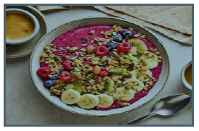
Speaker Notes:
I have made use of Microsoft PowerPoint rather than plain word processors in FreshBite menu because it has features of location that is visual. Classification of information into rigid categories was a big boost in consumer legibility. This activity assessed the direct effect of layout composition on reader engagement, which is a massive step towards professional document management.

Slide 3: Artifact 2 – Everyday Digital Identity & Workspace
- I also tend to use Google often, when I make particular information retrieval queries.
- Gmail usage produces secure and highly professional formal communication lines.
- Group message networks facilitate real-time collaborations with important peers.
- Evaluation of communication channels facilitates the effectiveness of everyday activities and hierarchy (Altulaihan et al., 2023).
- Official Microsoft Support guides helped to get over my advanced account set-up limitations.
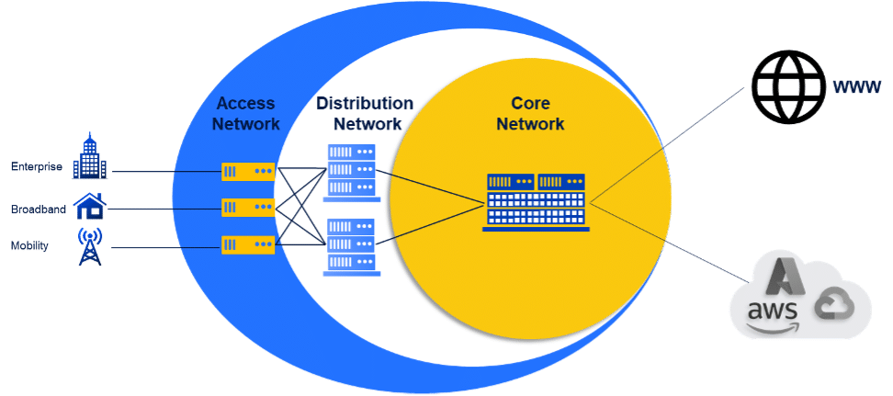
Speaker Notes:
This slide is a critique of my daily administrative kit, which is information retrieval and safe communication. The UWTSD Bitesize guides visit has transformed my system of organizing storage folders. Another area that is examined is efficiency of tools to ensure that I have always selected the correct platform on the specific job that a corporation needs.

Slide 4: Artifact 3 – Financial & Data Literacy Tools
- I use personal banking systems to carry out independent fiscal monitoring.
- Ensure protection of important data minimizes the existing digital privacy security risks.
- The level on which I trusted the platform also rose considerably once I mastered the basics of databases.
- Financial data transparency assists in bridging the gap regarding higher-order analytic activities (Farooq et al., 2025).
- Minimization of technology dread establishes the needed digital fortitude in business landscape.
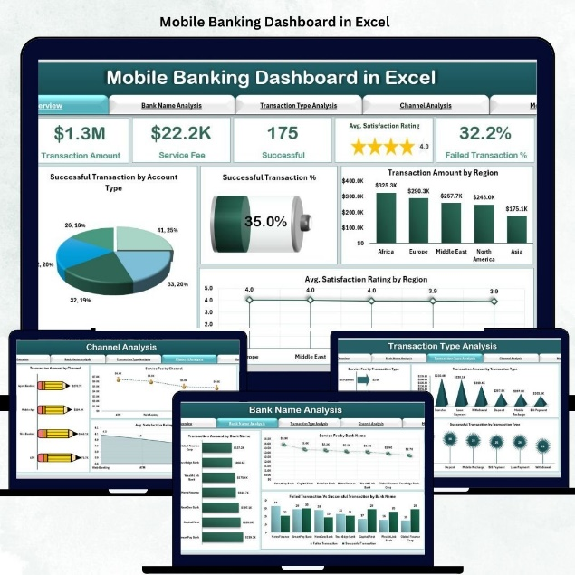
Speaker Notes:
First, data interfaces created titanic technical resistance in standard system upgrades. I also changed platform management which is independent after being trained on safe verification measures using banking interfaces. This essential development fills the gap between routine data security activities and complex informational auditing systems, which are present in large business organizations.

Slide 5: Conclusion & Future Impact
- Developed digital skills will aid my present research goals in higher education.
- Refined presentation skills ensure proper communication in the business circles.
- Effective use of online search is a behavior that will ensure quick resolution of problems in life.
- The long-term career flexibility is ensured with dependency to full independence (Tokovska, Zaťková and Jamborová, 2022).
- Regular critical reflection will make common technological apparatuses productive success.
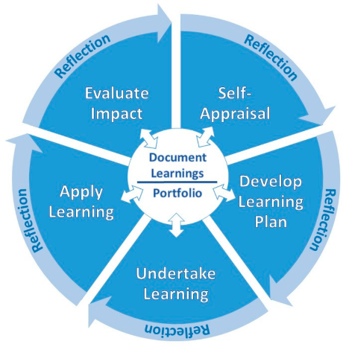
Speaker Notes:
In conclusion, the learned competencies in this module provide a strong foundation on which to perform it later. The direct benefit of these computer skills is in designing academic reports, project management at work, and daily information systematization. Evaluation of the software I regularly use makes me competitive in a more automated professional world.

Part 2

Introduction
Critically, my digital portfolio is a collection of significant artifacts used to show how my digital capability has systematically developed during this module. It is a combination of my first audit of digital footprint, communication workflows, and a strategic business design project. I picked these specific examples because they provide comparisons of the empirical data of my base constraints and the elevated visual and administrative abilities that I gained during the term. These items combined form a transitional journey, because I could transform my early technological anxiety into a self-confidence of autonomous, computational self-confidence.

My Work
A digital footprint audit of my regular use of Google, Gmail, and WhatsApp confirmed the essential knowledge of data-capturing skills and demonstrated an incoherent personal workflow. I bridged this gap in operations by developing a professional and categorized menu of the "FreshBite Meal” using Microsoft Power point. Training to master visual matches, price stability and container forms meant I had to investigate software options further than the basic automated templates. The text layouts and negative spaces were well balanced to enhance the readability by the consumers (Schrader et al., 2026). Consequently, I can now manage organized cloud catalogs independently, with sophisticated web parameters, and create stringent data protection profiles in bank and social apps.

My Development
At the very beginning, this module assigned me a very limited digital application because of technical problems and interfacephobia. I began to plan my information poorly and ended up with poor spatial planning, uneven margins, and unorganised blocks of text that were executive in nature.
However, the course assignments took my technical practice to a different level. I personally shifted to very systematic presentation design models by pushing away unbalanced and disordered content (Olalekan Kehinde, 2025). The skills of my text layouts, using vectors, and protecting personal information on the Internet have changed my passive use of the system to the obvious and independent ability.

Reflection
During this learning process, I also came to understand that digitally competence is not a fixed trait and it is a dynamic skill that can be optimized with the help of guided practice. Engaging in formal literature and support frameworks also helped me to improve technically (Fagbore et al., 2022). Specifically, I have studied typography with the help of the UWTSD Digital Skills Bitesize tutorials, layout grids with the help of Microsoft Support documentation, and file management systems with the help of the Moodle guidance videos. Through this particular loop, i.e. reading the literature, applying it as design drafts and juxtaposing my steps with the standards, I could learn how to evaluate my own decisions objectively.

Conclusion
My current digital abilities have become an invaluable base of my future academic and professional pursuits. Such skills will allow me to write research reports and cleaning presentations decks in further courses. I can organize files and organize business documents in my occupation, enabling me to conduct the daily administration and marketing process successfully. Ultimately, it is this literacy that allows me to handle my personal communication networks, conduct advanced web searches and even bank securely with financial banking software in my day to day life.

References
Altulaihan, E., Alismail, A., Hafizur Rahman, M.M. and Ibrahim, A.A., 2023. Email security issues, tools, and techniques used in investigation. Sustainability, 15(13), p.10612.
Fagbore, O.O., Ogeawuchi, J.C., Ilori, O., Isibor, N.J., Odetunde, A. and Adekunle, B.I., 2022. Predictive analytics for portfolio risk using historical fund data and ETL-driven processing models. Journal of Frontiers in Multidisciplinary Research, 3(1), pp.223-240.
Farooq, M., Younas, R.M.F., Qureshi, J.N., Haider, A. and Nasim, F., 2025. Cyber security risks in DBMS: Strategies to mitigate data security threats: A systematic review. Spectrum of engineering sciences, pp.268-290.
Gadot, R. and Tsybulsky, D., 2025. Taxonomy of digital curation activities that promote critical thinking. Smart Learning Environments, 12(1), p.17.
Olalekan Kehinde, A., 2025. Leveraging machine learning for predictive models in healthcare to enhance patient outcome management. Int Res J Mod Eng Technol Sci, 7(1), p.1465.
Schrader, N.B., Meißner, B., Fischer, P., Röder, D., Ertl, M., Meybohm, P. and Schmid, B., 2026. Extraction and processing of intensive care chart data from a patient data management system. Frontiers in Digital Health, 8, p.1747227.
Taylor, T., 2023. Development of medication administration protocols for in-home pediatric feeding cases. Behavior Modification, 47(4), pp.959-982.
Tokovska, M., Zaťková, T.Š. and Jamborová, Ľ., 2022. Digital competencies development in higher education institutions: A mixed methods research study. Emerging Science Journal, 6(Special Issue), pp.150-165.

