Module Title: Introduction to Business

Module Code: LCBB4007
Assignment Type: Essay

Student Name:

Student ID:

Introduction
The following essay will provide an analysis of the external and internal factors which influence the decision-making and business strategies of the retail-based company, Marks and Spencer. This analysis will be done with the help of PESTLE and SWOT analysis. The retail-based organisation was founded in the year 1884 by Thomas Spencer and Michael Marks (marksandspencer.com, 2024). The headquarters of the company is situated in London, in the UK and the company owns a large number of franchises within the country as well as in other parts of Asia and Europe. The organisation provides its customers with clothing, food and other home products (Refer to Appendix 1). The mission of the company is to avail high-quality products to its customers at a reasonable price. It is a public company and is registered within the legal system as a public limited company. The company generated a net global revenue of 11.9 million GBP within the year 2023 (Smith, 2024).

Discussion
Several external factors can affect the business undertakings of the retail-based company which can be identified with the aid of PESTLE analysis. Political factors which can affect the business strategy of the retailer include government stability, tariff regulations, and Geopolitical stability. For instance, the high stability of the company Government of the UK can reduce the occurrence of violence, chaos and disputes within the country. This can enable the company to run its business operations with a high level of efficiency and protect its properties from being damaged (Partington, 2022). Economic aspects which can impact the business procedures of the organisation consist of economic growth and inflation rates. Since the UK has economic growth of 4.3 per cent as of 2023, customers within the market have a much higher spending power which would enable the company to maximise its profit margins (Clark, 2023) (Refer to Appendix 2). The low inflation rate of 4 per cent can also be quite profitable for the company as it will be able to maintain low costs and provide its customers with products at a much more reasonable price (Clark, 2024). There are also certain sociocultural aspects which the company has to integrate within its business strategies such as social responsibilities and demographic shifts. For example, to uphold its social responsibilities the company implemented its ‘Plan A’ initiative to combat changes in climates and reduce its wastage (marksandspencer.com, 2024) (Refer to Appendix 3). The company also has to keep up with technological development and has to integrate advanced technology within its stores to keep up with its competitors. Integrating AI and data analytics within this business mainframe can aid the company in actively addressing the wants and desires of its customers and enhancing customer experiences (marksandspencer, 2024). This would aid the company to boost its customer retention levels (Oosthuizen et al., 2021). Environmental factors that can impact the business outcomes of the retailer include climatic changes, management of waste and energy usage. For addressing these factors, the company has to actively invest in Research and Development to ensure that the franchises of the company integrate the utilisation of efficient ways of minimising the wastage of resources, combating climatic changes and deploying renewable energy. This can aid the company to boost its reputation within the market and increase customer loyalty. The company also has to abide by the laws which have been enforced by the English legal system regarding employment, customer welfare and trading regulations (Smith, 2024). In case, the company fails to abide by these laws, it might face lawsuits and claims from its employees, customers, and even the governing body which might scar its reputation and decrease its revenues by a substantial margin.
There are several strengths which enabled the retail organisation to become one of the leading retailers within the UK. The strong brand reputation of the company due to its high-quality products and remarkable level of reliability is one of its most recognised strengths. This has aided the company in attracting new customers towards its outlets and enhanced the level of loyalty among its existing customers. The enterprise also provides a variety of products such as clothes, food and other household necessities (Benzaghta et al. 2021). This variation in products has helped the company to address and fulfil the needs and requirements of a majority of its consumers. There are also certain weaknesses of the company which can negatively affect the operations undertaken by it. Since the majority of the retailer’s revenues are generated from the market of the UK, the company can be negatively affected by shifts in preferences and spending habits of customers residing within the country. This lowers the profit margins of the company and affects its economic stability. The company is also lacking in establishing an international presence when compared to its competitors (marksandspencer.com, 2024). Such low international presence can lower its share within the global market and may limit its potential to grow within other countries. Though various weaknesses may affect the company, there are also certain opportunities which can aid the company. Marks and Spencer are quite famous for its innovations and the wide variety of new products it has introduced. Thus, the company can integrate this innovativeness and utilise technological assets to enhance the experiences of its customers. The company can also extend its reach by expanding its franchises to various developing parts of Asia and Africa (Ståhls, 2020). This can reduce the company’s dependence on the market of the UK. However, the emergence of new competitors can act as a threat to the company as it may reduce its share within the market and affect its customer retention levels. Disruption within the supply chain of the company can also be recognised as a potential threat as this may affect the capability of the store to provide the customers with their products and address their needs.

Conclusion
The above-written essay aimed at identifying and discussing the internal and external factors which can impact the business operations and strategies undertaken by the retail-based company of Marks and Spencer. A brief overview of the company was also highlighted within the essay which specified the organisation’s founding date, variety of products sold by it, type of organisation and certain financial information. Furthermore, a SWOT analysis of the company was also presented within the module which aided in identifying the strengths, weaknesses, opportunities and threats which may affect the business and its revenues. Finally, the essay ended by analysing and evaluating the various external aspects that may alter the decision-making of the organisation with the help of a PESTLE analysis. This segment discussed the political, economic, social, technological, legal and environmental aspects which the organisation may have to integrate within their business strategy to sustainably flourish.

References
Benzaghta, M.A., Elwalda, A., Mousa, M.M., Erkan, I. and Rahman, M., (2021). SWOT analysis applications: An integrative literature review. Journal of Global Business Insights, 6(1), pp.55-73.
Clark, D., (2023). Annual growth of gross domestic product in the United Kingdom from 1949 to 2023. [Online] Available at: https://www.statista.com/statistics/281734/gdp-growth-in-the-united-kingdom-uk/#:~:text=The%20United%20Kingdom's%20economy%20grew,10.4%20percent%20decline%20in%202020. [Accessed 22 February 2024].
Clark, D., (2024). Inflation rate for the Consumer Price Index (CPI) in the United Kingdom from January 1989 to January 2024. [Online] Available at: https://www.statista.com/statistics/306648/inflation-rate-consumer-price-index-cpi-united-kingdom-uk/#:~:text=The%20UK%20inflation%20rate%20was,11.1%20percent%20in%20October%202022. [Accessed 22 February 2024].
marksandspencer, (2024). MARKS & SPENCER ANNOUNCES TECHNOLOGY TRANSFORMATION PROGRAMME. [Online] Available at: https://corporate.marksandspencer.com/media/press-releases/marks-spencer-announces-technology-transformation-programme [Accessed 20 February 2024].
marksandspencer.com, (2024). About Us. [Online] Available at: https://corporate.marksandspencer.com/about-us [Accessed 22 February 2024].
marksandspencer.com, (2024). Plan A: Our Planet. [Online] Available at: https://corporate.marksandspencer.com/sustainability/plan-a-our-planet [Accessed 23 February 2024].
Oosthuizen, K., Botha, E., Robertson, J. and Montecchi, M., (2021). Artificial intelligence in retail: The AI-enabled value chain. Australasian Marketing Journal, 29(3), pp.264-273.
Partington, R., (2022). ‘Enough circus’: UK business leaders call for economic stability after Truss exit. [Online] Available at: https://www.theguardian.com/business/2022/oct/20/uk-business-leaders-economic-stability-truss [Accessed 15 February 2024].
Smith, P., (2024). Revenue of Marks & Spencer worldwide from financial year 2010 to 2023. [Online] Available at: https://www.statista.com/statistics/413349/group-revenue-marks-and-spencer-mands/#:~:text=Marks%20%26%20Spencer%20revenue%20worldwide%202010%2D2023&text=In%20the%20year%20ending%20April,pounds%20from%20the%20previous%20year. [Accessed 22 February 2024].
Ståhls, A., (2020). The Origin and Evolution of the Marks With Reputation Doctrine.

Appendices
Appendix 1
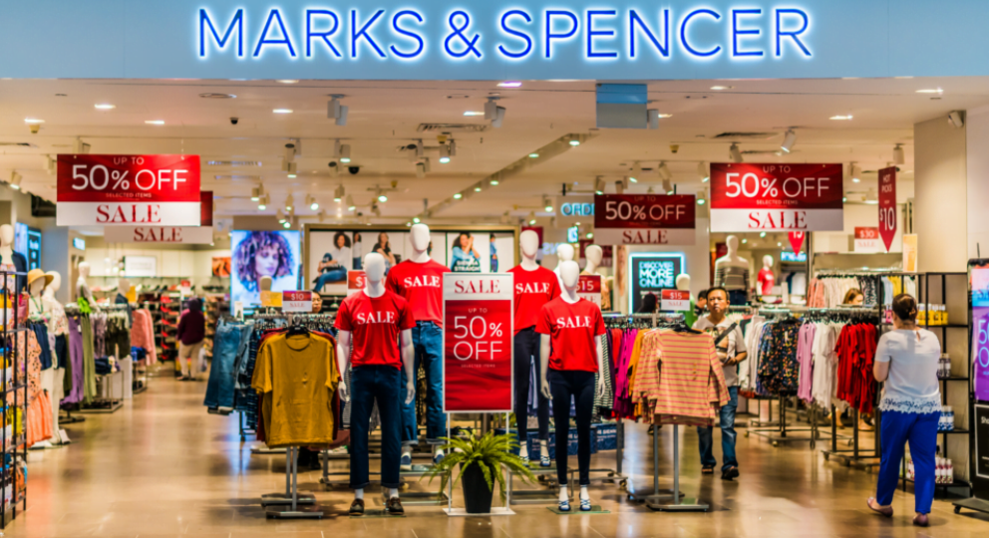
Appendix 2
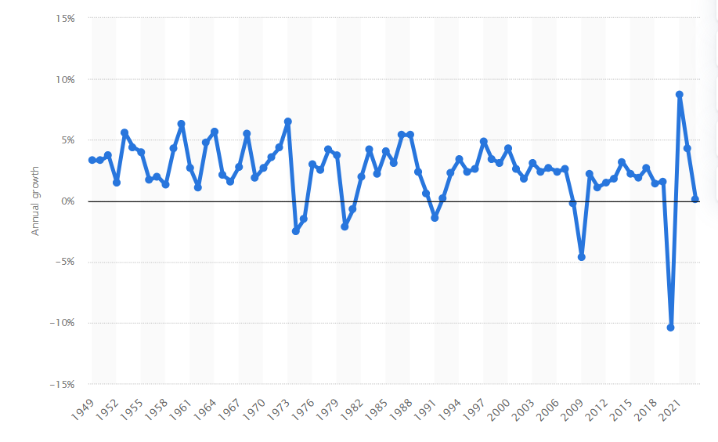
Appendix 3


