- WHERE THEORY AND PRACTICE MEET
“We see our customers as guests to a party, and we are the hosts. It’s our job every day to make every important aspect of the customer experience a little bit better.”
—Jeff Bezos, Amazon founder, and CEO
Initiation of the topic choice of the report
The purpose of this report is to demonstrate during the research the extent of the company's profit is related to the application of knowledge management methods as well as knowledge transfer. The coronavirus pandemic has changed the lives of all people. The emerging economic downturn is already referred to in international articles as a “closure” like the Great Recession of 2008 or the Great Depression of 1929. Covid-19 posed a primary and immediate threat to human health and, secondarily and indirectly, caused significant economic changes.
Hypothesis
The author of the report assumes that the more profitable a company is, the more effectively it applies knowledge management methods, the faster it develops and grows, which further strengthens its ability to create new trends as a sample company Amazon.com.
Method of proof, analysis
To process of the dissertation will be evaluated as a knowledge transfer theory and SECI, The Wiig, models based on the theory, model, and principles of knowledge management.
The world's leading countries have almost without exception switched to online procedures (shopping, education, home office, etc.) Consumer demand has shifted towards online use following the COVID-19 pandemic, e.g., the McKinsey map illustrates the unprecedented success of e-commerce worldwide. With the development of technology, the generalisation of electronic devices, and the expansion of Internet access, the spread of online shopping seems unstoppable. Amazon.com is undoubtedly one of the biggest winners in the pandemic, as it has become the world market leader during this time. The pandemic has created ideal conditions for certain sectors, such as the success of several businesses (Netflix, Spotify). However, 2020 not only shows the recovery of the digital economy. Technology plays a major role in the life cycle of information systems. The digital switchover took place years earlier, but the new type of coronavirus has given a huge boost to the transition, and by 2020, this form of innovation has become essential for many businesses to survive. Of course, economic success is not entirely at the expense of the pandemic, as the success of management operations (Laudon and Laudon, 2014) depends heavily on the information available and, in part, on the functions that make up the process. It is essential that information is received and passed on from people within the system, and the organisation can use this information so effectively that it can be progressive or even breakthrough.
In the part of the conclusion, the report will be able to support the assumption in the introduction through the main functional units and outline new opportunities that may be a challenge for the company in the future.
Expected sketch
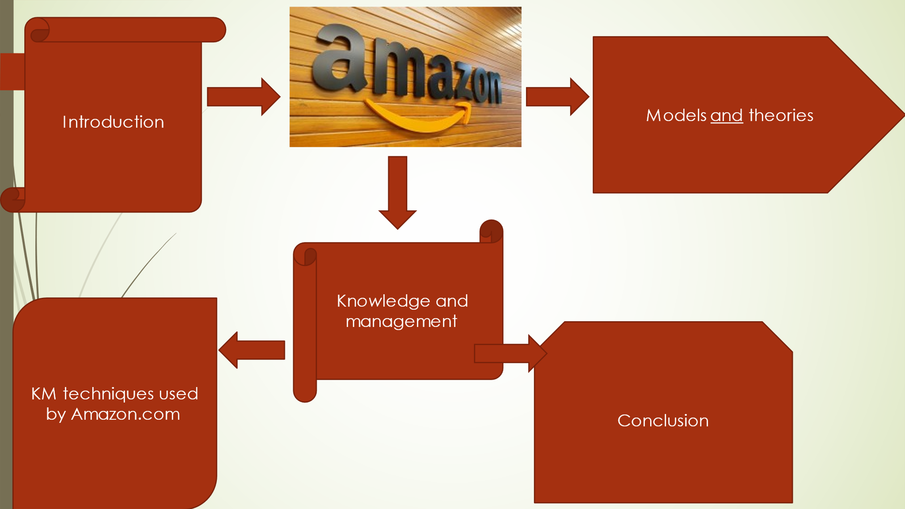
Part of excepted references

Class lecture references 2020.

Management Information Systems, Managing the Digital Firm
https://repository.dinus.ac.id/docs/ajar/Kenneth_C.Laudon,Jane_P_.Laudon_-_Management_Information_Sysrem_13th_Edition_.pdf
Last access 03/11/2021

The great consumer shift: Ten charts that show us shopping behavior changing, August 4, 2020, Article By Tamara Charm, Becca Coggins, Kelsey Robinson, and Jamie Willkie
https://www.mckinsey.com/business-functions/marketing-and-sales/our-insights/the-great-consumer-shift-ten-charts-that-show-how-us-shopping-behavior-is-changing
Last access 02/11/2021

The Knowledge Management Genius of Amazon.com
https://learningsolutionsmag.com/articles/1480/the-knowledge-management-genius-of-amazoncom
Last access 03/11/2021

