Implementation of the Internet of Things (IoT) & Blockchain Industry 4.0 Technologies in the Analytical Instrumentation Field, within Chemical Manufacturing Industries

Table of Contents
Introduction 3
Condition-based Monitoring Using Internet of Things (IoT) Technologies 4
Introduction to types of maintenance regime used in chemical industries 4
Modern Communication Protocols & Programming available on modern analyser equipment 5
Use of ‘Highway Addressable Remote Tranducer’ (HART) over existing instrumentation loops 6
Automated Validation and Calibration of Analytical Instruments 8
Work notifications 9
Blockchain Technology for Improved Traceability of Calibrations 10
Conclusions 11
References 12
Appendices 15
Blockchain – Lab sample tracking 15

Introduction

This essay will investigate the opportunities industry 4.0 technologies offers in the field on analytical instrumentation in the chemical manufacturing industry. This instrumentation provides chemical composition data (eg, % or PPM data about components within a mixture, or complete stream analysis), or physical property data to operators (eg, density, calorific value etc) (Van den berg & Smilde, 2002). Such instrumentation is required for process control, personal and process safety, asset protection, and environmental or other regulatory requirement and compliance purposes. Therefore, it is critical that it is properly designed (including designing for reliability), and properly maintained by technicians to maintain business continuity for many industrial chemical companies.

Analytical instrumentation is a growth area, and as such, recruitment and retention of technically qualified personnel can become challenging (ARC Advisory Group, 2019). This issue can potentially be even more challenging for smaller countries, or in start-up situations, but using Industry 4.0 technology, there are ways to optimise use of potentially limited trained personnel. In the chemical industry, often lost production time has a significant financial impact on a company – so the inability to recruit trained, competent staff would be a significant issue, potentially impacting business viability. Often training staff for specialised activities can be take months or even several years depending on the role or any pre-existing experience – apprenticeships in the UK, for example, can be up to 4 years long to initially qualify as a technician (Department for Education, 2022) – it is therefore incredibly difficult for a new company, in a smaller country to suddenly train the required number of staff for a new large-scale facility. Post-apprenticeship technicians will still be at a junior level, and a successful company requires a variety of experience levels (i.e., some technicians with years of post-apprenticeship experience to deal with advanced trouble shooting which can only occur on the job). Furthermore, the technician training is primarily ‘on the job’, meaning in start-up situations, the ability to properly train new technicians is incredibly challenging.

This essay will focus primarily on the use of the Internet of Things related technologies and their potential applications for condition-based monitoring in the chemical manufacturing industry. Furthermore, blockchain technology will be explored for its potential usage in improving analytical instrumentation, but equally this could apply to more generic instrumentation. In both cases, it will be assumed that the organisation is located within a smaller country, with a more limited number of trained, competent staff available – and by assuming this, the essay will focus on how to run a lean and efficient maintenance organisation which makes best of use the technicians and engineers that are available for utilisation. It is assumed that the company has Subject Matter Experts (SMEs) available in other areas of the business or other geographies, who could assist with the implementation of some of the Industry 4.0 technologies by remote access so no, or limited, physical presence in the facility is needed.

Condition-based Monitoring Using Internet of Things (IoT) Technologies

Introduction to types of maintenance regime used in chemical industries
With process industries, maintenance regimes can typically be summarised as preventative, or reactive. In essence, this means is the strategy to plan maintenance for before or after a failure of a system (in this case, an analytical instrument). Preventative maintenance can then further be classed as time-based or frequency-based, or condition-based. This is summarised graphically below (Sirvio, 2015).

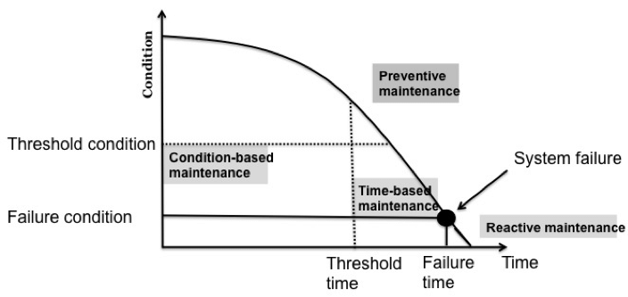
Graphical summary of maintenance regime types typically used within chemical manufacturing process industries (Sirvio, 2015).

In general, most companies rank and categorise their assets based on risk and will use a mixture of approaches depending upon the relative criticality of the system – there are certain situations whereby running to failure is logical (i.e. a measurement may have been important in the past, but due to a plant change is now less useful - therefore it no longer justifies preventative maintenance prioritisation in terms of labour and cost). In general, for critical equipment, chemical companies use preventative maintenance as they want to avoid failures which can impact production and therefore business economics, or have a regulatory consequence. However, generally time-based maintenance is more prevalent. The Internet of Things (IoT) can make transition from time-based to condition-based simpler for a business by automating the detection of the ‘threshold condition’, as seen in the graph above.

Condition based monitoring is a strategy to use information about equipment condition to suggest appropriate maintenance actions (Teixera, et al., 2020). This allows a business to effectively time maintenance to avoid breakdown of equipment which could lead to losses, or also to avoid excessive time-based frequency maintenance which may be unnecessary. Where a business may have a shortage of qualified technicians and engineers, this allows for the time of the existing to be properly prioritized to have maximum impact on productivity.

This section of the essay will focus on opportunities for IoT technologies to effectively identify the ‘threshold’ condition that will allow for optimum reliability of equipment (i.e. avoid equipment or system failures) but equally allow for optimum utilisation of available maintenance personnel.

Modern Communication Protocols & Programming available on modern analyser equipment
Modbus TCP (transmission control protocol) IP (internet protocol) has become a wide spread, industry standard communication protocol (Bai, et al., 2018). Modern analyser equipment can be connected via TCP-IP Modbus networks to allow large data transfer from an analyser to the DCS, including from any slave devices (eg, flowmeters, pressure meters etc). Previously, industry was more reliant on analogue signals (eg, 4-20mA), which would require extensive cabling – for example, to run a 20 copper pair cable may be prohibitively expensive for analogue or digital signals, but using Modbus TCP-IP, a single fibre or Cat5e cable can be used to transmit thousands of signals. It is the abundance of these signals, properly used, which can be tailored to implement condition based maintenance to ensure the organisation runs with a lean maintenance organisation, and maximises performance of their asset base.

One such example of using this is by making custom programs: Siemens ‘Max Basic’ is a programming language which can be used to optimise Siemens Maxum II analysers with custom programs (Siemens, 2019). This is further enhanced by ‘StatMon’ which is a integrated statistical tool which is pre-built into Siemens equipment (Siemens Industry, Inc, 2019) – this allows trends and data to be stored in the analyser, which MaxBasic programming can then pull into the a Modbus table for reporting to distributed control systems (DCS) or a data historian.

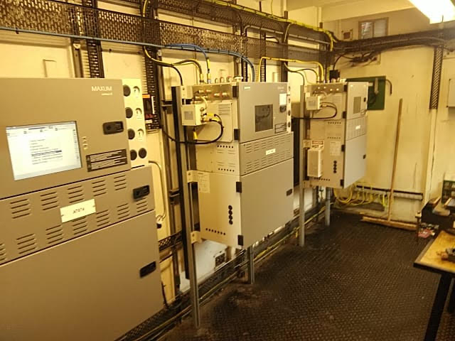
Example of Modbus TCP-IP network connected, Siemens MAXUM II Gas Chromatograph analysers housed in an analyser shelter in a chemical plant.

On a GC, we can use to measure key variables such as:-

On a gas chromatograph analyser, peak should ideally be Gaussian, with the tail of the peak being indicative of the health of the system (Wahab, et al., 2017). Measuring the ‘tail’ of a peak, or the ‘start height’ of a following peak, would therefore indicative of inject valve performance. A threshold could be set at a pre-determine voltage value to best optimise maintenance.

It would also be possible a parameter which is the addition of all the area of all peaks, or the unnormalized total of peaks (Elster Instromet, 2017). The analyser will correct or normalise itself in operation, but feeding the pre-correct total value to a historian would be indicative of overall health, as the normalisation program is likely to be most accurate with a sensible tolerance around 100%. For example, if this was to drift lower than 75%, this may indicative of fouling in the inject valve resulting in less sample actually being injected into the analyser.

There are many other potential applications for this on a GC, including but not limited to:
Flame on detection for flame ionisation detectors by running a program to vary the air fuel ratio to generate a false peak which is indicative of flame health;
Electronic pressure controller issues identification – where minor changes in pressures could be indicative of small bore tubing starting to plug;
General peak data depending on application – for example, peak start times, peak baseline start heights etc.

Internet of Things applications where the analyser forms local loops with flow and pressure instruments (4-20mA), and then feeds back this data via Modbus to prevent excessive cabling.

Use of ‘Highway Addressable Remote Tranducer’ (HART) over existing instrumentation loops

Existing 4-20mA analogue instruments could benefit from HART (Highway Addressable Remote Transducer) communication – this allows communication between HART enabled field instruments, and a host device with the instrument vendors software installed, in both directions (Gubjal, et al., 2019). This operates as a digital signal, superimposed upon the 4-20mA analogue signal (Ajmeri, 2014) – this means the additional capabilities from HART can potentially be realised without any additional cabling requirements to compatible field instruments. This is a significant advantage – the cable itself, has a cost, but quite often, on a large chemical facility, the cost of running new cables is prohibitive as it requires extensive scaffolding or rope access.

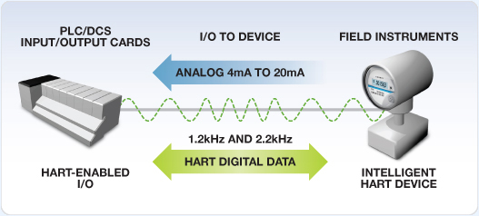
Image detailing how HART works on existing 4-20mA analogue signals by super-imposing digital signals (Johnson, 2012)

Whilst previously, this was most commonly used by technicians to interrogate instruments using a communicator device, many distributed control system providers now offer solutions such as ‘interface modules’, such as the FBM214 from Foxboro, that allow a more fixed solution to transfer this data real time to the DCS (Invensys Process Systems, 2010). This data can then be monitored from a single location, and maintenance resource prioritised effectively.

For example, in the case of a pH analysis instrument, the standard analogue signal would be the pH value, typically ranged 0-14 pH (4-20mA), but a HART signal can be digitally superimposed upon this without impact to the analogue value. Many vendors, including Emerson / Rosemount, have analyser instruments which can output diagnostic impedance measurements, which are a signal of sensor health (Emerson, 2019). pH measurements are often critical to a business, for example, they can be used to identify leaks in reboilers or heat-exchangers (i.e. if condensate becomes more acidic, it is an early indication of tube failure), but often measuring pH in high purity water, defined by ASTM D5464 as water with a conductivity <100 micro Siemens, is problematic due to the lack of ionic strength of the sample causing slow response or inaccuracies in readings (Thermo Scientific, 2014). Having additional parameters report to the DCS, besides the pH itself, along the same single pair cable, has considerable advantages to achieve ‘threshold’ values for when maintenance on the system is needed to avoid complete failure.

Another example could be a conductivity measurement, although this would equally apply to a number of water quality analysers, which potentially have a design temperature limitation. Likewise with pH, conductivity can be used in condensate as an indicator of exchanger or reboiler failure as it should rise when ions are present, although a disadvantage of conductivity is that it is non-specific (i.e. chemical dosing, scaling in pipes may show as high conductivity which are not heat exchanger failure related). An example is the Yokgawa SC8SG which has a design temperature 100 degrees Celsius (Yokogawa Electric Corporation, 2022) – many condensate or steam applications will require cooling to meet this design temperature requirement. ASTM D 1066 shows how in power plants, often samples need be cooled through a cooler before parameters such as pH, conductivity, dissolved oxygen, silica etc are measured. Transmitting the temperature of the sample, which would be post-cooler, would be indicative of cooler health. A sudden, unexplained rise in temperature could lead to a quick and safe isolation of the analysers before they were run at a temperature above their design limits, whilst the cooler is fixed or replaced, or cooling water supply is restored. In the chemical industry, compliance with IEC EN 60079 or ATEX Directive 2014/34/EU is also mandatory and the ‘T Limit’ or temperature limit, is needed for compliance to prevent explosions from sparks which could occur in a hazardous area (European Comission, 2014).

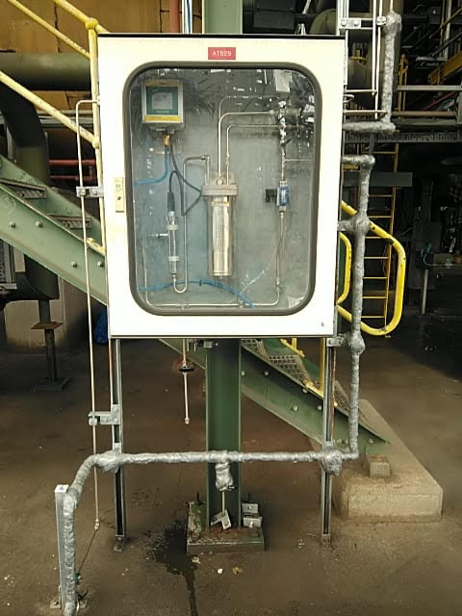
Example photo of a conductivity system, showing the cooler which reduces to sample temperature so that it does not exceed limits of analyser. Cooler could fail, or cooling water supply could be interrupted – HART is able to transmit temperature along the existing 4-20mA used for conductivity to give early warning signs of this.

More generic HART functions are available, such as checking the analogue trim, simulating values to DCS, verification of tag, wiring and power supply (Ajmeri, 2014) – whilst these are unlikely to impact condition based monitoring, and improving mean time between failures, it could be argued that the ability to test these from a communicator (or DCS screen) will aid in mean time to repair (MTTR). MTTR is a key performance indicator for maintenance and efforts should be made to reduce this value as much as possible to ensure an efficient maintenance workforce. This applies to all instrumentation and is not specific to analytical instrumentation.

Automated Validation and Calibration of Analytical Instruments
In order to check performance of an analyser, it is necessary to validate or benchmark it against a known standard. Depending on the media, this could be through a cylinder which is provided by a calibration gas company, with appropriate contents to the measurement, traceable to national standards. Or it be via cross-check versus a lab instrument which has been calibrated to traceable standards – issues surrounding this will be explored in the blockchain section later in this essay.

If it possible to have a stable mixture in a cylinder, traceable to standards, then this option is preferred. Ordinarily, a technician would need to attend on a set frequency to run the gas through the analyser, but using IoT, this can be now requested remotely, or even scheduled automatically.

In certain cases, an analysers ‘normal’ value may be zero – for example, an analyser may be analysing a sample of ambient air and looking for a component which has the potential to leak from the chemical processes. In these cases, auto-validation significantly reduces the chances of an unrevealed failure, where the analyser has failed, but because of its normal reading, it potentially would not be noticed until it’s next physical check by a technician. This could lead to catastrophic conditions in the case of an ambient air analyser where a leak is not detected, and operations would assume that an analyser is still functional. It is not usually feasible for a technician to check every instrument every day, but auto-validation can be set so it occurs every few hours. Furthermore, it can operate outside of working hours – this allows the end-user to identify any potential issues with day – night temperature cycles which could impact analytical instrumentation which is heavily reliant on temperature controllers for ovens.

Siemens GC Portal software communications via Modbus (or OPC) and allows the above features. Should a validation fail, an error occurs which can be transmitted via Modbus. Or, if set, auto-calibration where the calibration of the analyser is adjusted automatically without technician intervention (Siemens, 2018). The latter requires special care and attention as calibration could mask an issue with the validation system (examples including solenoid not firing, calibration gas cylinder empty), or an issue with the analyser itself (for example, excessive peak tailing which should not be compensated for by calibration) – this is not recommended unless specific additional checks are implemented which are outside of the scope of this essay.

Auto-validation should result in better reliability, through more frequent tests, with a lower cost of ownership which is very important in a labour resource constrained environment.
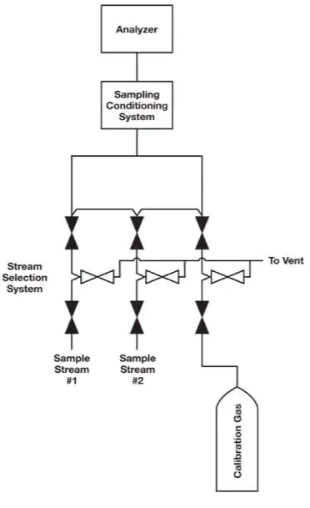
Example of a stream switch sample handling system (Waters, 2013), showing the calibration gas stream.

Work notifications

All of the above examples ultimately result in data being sent to a data historian, which on its own, is of benefit, but does not completely improve the situation for maintenance. Maintenance personnel in a lean organisation are unlikely to have sufficient time to monitor trends and parameters continuously, they therefore need a system to inform them of which tasks are required. Many companies use SAP – traditionally, operators would raise work orders when an event had already occurred. In order to properly achieve condition-based maintenance, SAP must be programmed to monitor data coming into a data historian, and raise work notifications accordingly (Wahab, 2022). Wahab (2022) further describes how ‘greater than or lesser than conditions’ can be insufficient in many situations and describes the features available for condition-based monitoring within SAP, such as setting notification priories based upon the data being received.

In the case of a chemical manufacturer in a smaller country, the above SAP set-up could be handled by SME’s remotely from larger facilities. This would mitigate against any shortages in labour or skills in a smaller country or start-up.

Blockchain Technology for Improved Traceability of Calibrations

Sampling versus a laboratory can often lead to issues, the most prominent of which is sampling error. An online gas chromatograph, for example, has a cycle time which can vary significantly from a minute to an hour. The sample needs to be accurately time-stamped and labelled to the particular instrument which the sample represents. Industry 4.0 and blockchain technology has potential solutions to this problem – a QR code could be used on the sample station which automatically identifies the sample to the analyser, and the exact moment the sample is taken.

A limitation of this would be that operator discipline would still be required to sample at near the inject time of the cycle – this could be difficult in the event that the cycle time is long. However, blockchain technology would still optimise even a poorly timed sample so it corresponds to the most appropriate analyser inject.

The concept of blockchain was first associated with Cryptocurrencies, sometimes defined as ‘Blockchain 1.0’ (Suman & Patel, 2021) – currencies could be decentralised, with no person having control of it, and no way to edit or change any transaction histories. This leads to absolute transparency which has obvious advantages for a currency. Blockchain 3.0 describes where the above advantages could be utilised outside of economic situations – such as situations described above in the chemical industry.

Blockchain can be used to improve transparency of calibration processes: blockchain is tamper-proof as changes in the inputs lead to changes in the hash (X & Kraft, 2021). For example, to edit an initial hash, would mean changing all subsequent hashs. This gives customers confidence as the traceability of the calibration is fully transparent and auditable. This has been implemented in settings for health care sample management by HSBlox (Tirumalarju, 2019) – a similar practise could be adopted by chemical companies, as suggested in appendix 1.

Essentially, through QR code scanning at each stage, as shown in appendix 1, it is possible to significantly reduce the potential for sampling error in a sampling regime and allow checks for procedural compliance by the operator, but also give absolute transparency to calibration process – this may prove to be incredibly valuable to external customers, who may place demands on quality systems implemented by the business.

Conclusions

Industry 4.0 technology offers potential for chemical manufacturing businesses to improve productivity, cost competitiveness, and even mitigate against shortages in specialised staff, by using the Internet of Things to implement a predictive, condition-based monitoring strategy of analytical instrumentation maintenance. Specific examples are included in this report which could be field tested in a trial environment by a chemical manufacturer, before a wider-roll out. Many of the examples included could be implemented so that they could be managed remotely, which may further benefit corporations who have a global footprint with facilities in many countries, some of which may have a more challenging labour market. It is conceivable that a multinational organisation could have a single SME team setting up maintenance triggers based on threshold values for their company’s entire global base of facilities. Many of the examples (e.g., those mentioned during the HART section) can be implemented on older facilities and retroactively installed as they primarily use existing infrastructure and cabling.

It should also be noted that many threshold values can be variable – if maintenance resource becomes more constrained for any reason, these threshold values can be evaluated (remotely) to accommodate the new maintenance technician resource availability. In effect, the SME will be able to balance between maintenance resource and equipment reliability (in essence by avoiding complete system failures) depending on the business needs and capabilities at a given point in time.

Furthermore, the adoption of blockchain technologies could improve the management of the calibration of analysers. Firstly, by improving traceability with a transparent blockchain structure which cannot be tampered with, which identifies where and when the sample was taken, which machine it was analysed on and by whom. A work notification could be generated automatically by the system if the online analyser is out of tolerance in terms of calibration versus the lab report based upon pre-agreed limits (again, potentially avoiding human error in calculation or any possibility of forgetting to raise a notification). This would give customers confidence that the product they are buying meets their quality requirements and needs, or in other examples may satisfy regulators requirements, or help the business obtain external certification from other organisations (eg, ISO). Furthermore, this would likely lead to less human error and therefore a reduction in incorrect calibrations which may impact the business operationally.

This essay describes using blockchain to control an internal calibration procedure, but likewise companies could begin to demand similar transparency from external companies who provide traceable standards.

In conclusion, adoption of the practises described with appropriate care and skill from relevant SMEs, should result in a positive effect on the business bottom line by allowing maintenance to be run as efficiently as possible, but without events which cause complete system failure, and potentially aid compliance with relevant regulations in safety or environmental applications set by external authorities.

References
Ajmeri, A., 2014. Options for HART Data System Integration. [Online]
Available at: https://web-material3.yokogawa.com/Options_for_HART_Data_System_Integration.pdf
[Accessed 23 May 2023].
ARC Advisory Group, 2019. Online Process Analyzers. [Online]
Available at: https://www.arcweb.com/market-studies/online-process-analyzers
[Accessed 19 May 2023].
Bai, Q. et al., 2018. Compact Modbus TCP/IP protocol for data acquisition systems based on limited hardware resources. Journal of Instrumentation, Volume 13.
Department for Education, 2022. Apprenticeship off-the-job training. [Online]
Available at: https://assets.publishing.service.gov.uk/government/uploads/system/uploads/attachment_data/file/1110377/20221011_OTJ_Guide_v4_-_For_22_23_Rules_Final.pdf
[Accessed 21 May 2023].
Elster Instromet, 2017. EnCal 3000 Gas Chromatograph. [Online]
Available at: https://docuthek.kromschroeder.com/documents/download.php?lang=de&doc=58102
[Accessed 21 March 2023].
Emerson, 2019. On-line electrode impedence measurement. [Online]
Available at: https://www.emerson.com/documents/automation/application-data-sheet-on-line-electrode-impedance-measurement-rosemount-en-70778.pdf
[Accessed 10 May 2023].
European Comission, 2014. Equipment for explosive atmospheres (ATEX). [Online]
Available at: https://single-market-economy.ec.europa.eu/single-market/european-standards/harmonised-standards/equipment-explosive-atmospheres-atex_en
[Accessed 12 May 2023].
Gubjal, A., Gaware, S. & Mane, P., 2019. HART Communication Based Distributed Measurement System. International Journal of Research and Analytical Reviews, 6(2).
Invensys Process Systems, 2010. FMB214 HART Communication Input Interface Module. [Online]
Available at: https://www.nexinstrument.com/assets/images/pdf/P0922VT.pdf
[Accessed 3 May 2023].
Johnson, T., 2012. HART Communication Networks Are Improved by Small, Flexible, Low-Power Modem ICs. Analog Dialogue, Volume 46.
Siemens Industry, Inc, 2019. Process Analyzer Management. [Online]
Available at: https://assets.new.siemens.com/siemens/assets/api/uuid:b6bd50d7-d338-45d0-adf2-ce35ac7186cc/version:1632851643/piafl-00060-1118usa.pdf
[Accessed 23 May 2023].
Siemens, 2018. Gas chromatograph portal, reference manual 10/2018. [Online]
Available at: https://cache.industry.siemens.com/dl/files/016/109762016/att_972237/v1/A5E03944542001-gas-chromatograph-portal-manual.pdf
[Accessed 21 May 2023].
Siemens, 2019. MaxBasic Tutorial and User’s Guide Basic Programming for Maxum II. [Online]
Available at: https://cache.industry.siemens.com/dl/files/221/19020221/att_1007425/v1/MaxBasicHelp.pdf
[Accessed 7 May 2023].
Sirvio, K., 2015. Intelligent systems in maintenance planning and management. Intelligent Systems Reference Library, Volume 87, pp. 221-245.
Suman, A. & Patel, M., 2021. An Introduction to Blockchain Technology and Its Application in Libraries. [Online]
Available at: https://digitalcommons.unl.edu/cgi/viewcontent.cgi?article=12649&context=libphilprac
[Accessed 19 May 2023].
Teixera, H., Lopes, I. & Braga, A., 2020. Condition-based maintenance implementation: a literature review. Procedia Manufacturing, Volume 51, pp. 228-235.
Thermo Scientific, 2014. Measuriung pH of pure water and other low conductivity waters. [Online]
Available at: https://assets.fishersci.com/TFS-Assets/LSG/Application-Notes/AN-PHPURE-E-0914-RevA-WEB.pdf
[Accessed 21 May 2023].
Tirumalarju, D., 2019. HSBlox launches blockchain solution for trial sample management. [Online]
Available at: https://www.clinicaltrialsarena.com/news/hsblox-digital-sample-manager/
[Accessed 9 May 2023].
Van den berg, F. & Smilde, A., 2002. How to choose the right process analyzer. Analytical Chemistry, 74(13), p. 368.
Wahab, M., Patel, D. & Armstrong, D., 2017. Peak Shapes and Their Measurements: The Need and the Concept Behind Total Peak Shape Analysis. LCGC North America, 35(12), p. 846.
Wahab, S., 2022. Condition-Based Maintenance in SAP S/4HANA Cloud 2202 Maintenance Management. [Online]
Available at: https://blogs.sap.com/2022/02/15/condition-based-maintenance-in-sap-s-4hana-cloud-2202-maintenance-management/
[Accessed 21 May 2023].
Waters, T., 2013. Industrial Sampling Systems Reliable Design & Maintenance for Process Analyzers. s.l.:Swagelok Company.
X, Z. & Kraft, M., 2021. Blockchain technology in the chemical industry. [Online]
Available at: https://como.ceb.cam.ac.uk/media/preprints/c4e_mk306_blockchain_Annual_Review.pdf
[Accessed 18 May 2023].
Yokogawa Electric Corporation, 2022. General specifications - conductivity detectors/sensors. [Online]
Available at: https://web-material3.yokogawa.com/GS12D08G02-00E.pdf
[Accessed 18 May 2023].

Appendices

Blockchain – Lab sample tracking

