Programs in C and Documentation

Neil O’Mahoney
Undergraduate Cyber Security BSc.

Table of Contents
Part A (Understanding) 3
Q1. What is a variable and why are they important in writing programs? 3
Q2. Explain why the for-loop can also be referred to as a counting-loop and give an example of when you would use it. 4
Q3. Explain what an array is, what their features are, and give an example of when you would use one. 6
Part B 7
Question 1 7
Exercise 2: 9
Exercise 3 11
Exercise 4 12
Annex A 15
Question 1 Testing 15
Question 2 Testing 20
Question 3 Testing 25
Question 4 Testing 27
Bibliography 31

Part A (Understanding)

Q1. What is a variable and why are they important in writing programs?
‘A variable is a container in a C program in which a data value can be stored inside the computer's memory.’ [1] These variables can be called inside a program, assigned meaningful names (as long as the naming convention is followed).
The above is further backed up by W3 Schools definition of a variable’s primary purpose as ‘..To store data in memory for later use.’ [2].
It is helpful when defining a variable to give it a meaningful name:
Rather than just a letter which means nothing to someone who has just started reading the code.
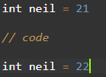
It is important to remember that a variable is just that; something that can change. The above code on screen demonstrates the integer variable called ‘neil’ starts out life as ‘21’ this is changed in the middle by some code and the data store eventually changes to ‘22’. The reason why it changes is unimportant in this instance, the fact that it has changed is. The variable ‘neil’ is just referencing that something is contained within.
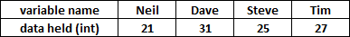
// some code goes here
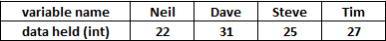
The above graph is show to represent the variable ‘neil’ more graphically.
Within C there are 4 basic different types: ‘char’, ‘int’ , ‘float’ and ‘double’. Each are assigned a different amount of memory within the computer. Char is a single character. ‘int’ is short for integer (a whole number). ‘Float’ is short for ‘floating point’ and correct to 6 decimal places. Double is a floating-point and has 10 decimal places.
According to [3] there are a certain set of rules that must be followed when naming a variable:
- Try not to exceed 31 characters as they may case issues with some compilers
- A mix of cased text
- Numbers are fine also
This is further developed by [4] who go on to say that:
- underscores are also perfectly fine
- Reserved words are now allowed (unless capitalised) int, continue etc.
- The first character must be a number or a letter.

Q2. Explain why the for-loop can also be referred to as a counting-loop and give an example of when you would use it.

A loop is ‘A look is a piece of code in a program that automatically repeats.’ Found inside this there is a test condition with, that while is still true will continue indefinitely. A ‘For-Loop’ has an initialiser, test expression and an incrementor. When the test-expression is false the loop finishes.
An example of a ‘For loop’ might be when a user incrementally increases a value. i.e. after turn one is turn 2 and so on until it reaches a predefined value. Think of it as 21 guesses. When the value of guesses reaches 21 then the game must be solved or it ends.
There is something called a ‘while loop’. This differs from a ‘For’ loop. The test expression is unknown. This might be used for example when a user is trying to guess a number between 1 and 100. The user might guess correctly on the first go or maybe forgetful and take 200 turns.
Count controlled loops are loops which have predefined test expressions. In other words, the number of possible iterations set to occur is defined.
Below is a graphical representation of a loop.

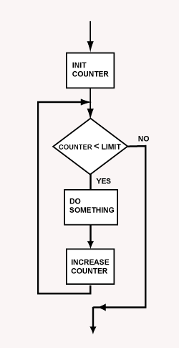
Fig 1. Graphical representation of a loop [5]

To help explain the body of the syntax, the figure below explains the position of the code:
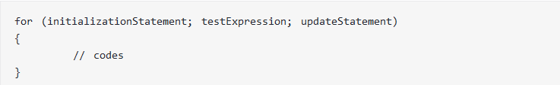
[6]
To help understand that syntax of the code the loop works by the following:
1. initialisation statement executes for one time only.
2. The test expression is checked. Unless the expression is 0/false then the ‘for loop’ will execute.
3. The update statement is processed.
A further example is shown below, the code is designed to find numbers = to zero or divisible by 3 up to 1001:
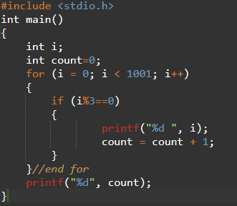
- the initialisation statement says that ‘I’ is equal to zero
- the test expression checks that ‘I’ is less than 1001.
- The update statement increments ‘I’ by one.
- The code prints onto the screen any number it finds that is divisible by 3
Output:
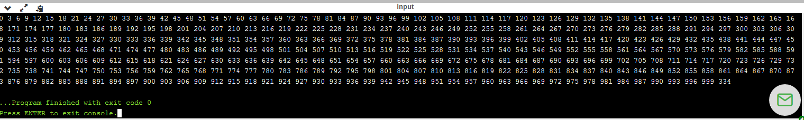

Q3. Explain what an array is, what their features are, and give an example of when you would use one.
As defined by W3 schools is ‘The array is a data structure in C programming, which can store a fixed-size sequential collection of elements of the same data type.’ [7] In other words, instead of declaring multiple variables, just declare one and predefine the amount that the array can hold.
Arrays are multiple items of the same type or multiple items in a single variable. Arrays have square brackets and the number within the brackets reserves 5 spaces in memory to store data. The stored data is called elements. Multiple elements collected together are called an array. 0 to what ever number you have stored are the elements that you are able to work with NOT 1 – 5 in the example below.
An array is a linear data structure this means that it is sequential. The memory that it uses size is fixed and is a static data structure. A benefit of this is that you can access any element directly with constant complexity. If you wish to add new data to an element and the element is already full then a new array must be created and old elements have to be added. When an array is created its reserved memory cannot be used. This can be a disadvantage of arrays.
The below diagram shows the data type (integer), array name (age) and the size of the array (5).
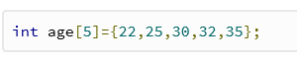
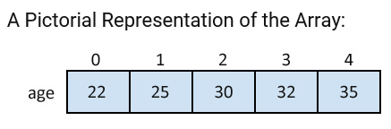
Fig 2 Array displaying ages of users [7]
An alternative to an array could be storing the variables separately. This is unscalable, however and if a number increased from 5 to 500 then this would make managing the variables very difficult and complex. The array is the perfect solution to this problem.
Features of a one dimensional array are:
- Array size should be positive numbers only
- String array terminates with null character
- Array elements are countered from 0 t n-1
- Useful for multiple reading of elements.

Part B

Question 1
Problem identification: This problem relates to varied types of data being inputted, stored and regurgitated later on.
Analysis of solution: It would be best to have upper and lower limits for things such as age and height. Similarly, with text being inputted the user could have upper and lowercase. To that end it would be best to account for both. A while loop has no end until the range has been met. This means that it will repeat the question should it be inputted incorrectly.
The variables would need to be outside of the while loop limitations so that the user can input them and go to the next question.

Code
#include <stdio.h> //lib or header file
void main() //main function - starting point for all programs
{
int age=-1; //value outside of while loop boundary
float height=0.4; //value outside of while loop boundary
char name='7'; //value outside of while loop boundary

while (age<0 || age>121) //lower and upper limit, user is unlikely to be over 121
{
printf("Enter your age "); //printed on screen for user to see
scanf("%d",&age); //variable ‘age’ is read and updated
}
while (height<0.5 || height>2.1) //lower and upper limit, user is unlikely to be over 2.2m
{
printf("how tall are you in metres? eg. 1.7 "); //printed on screen for user to see
scanf("%f",&height); //variable height is read and updated
}
while ((name<'a' || name>'z') || (name<'A' || name>'Z')) //lower and upper values, both upper and lower case can be inputted here.
{
printf("Please enter the first letter of your name:"); //printed on screen for user to see
scanf(" %c",&name); //extra space on %c scanf and variable is read in as ‘name’
printf("thanks, %c, %.2f, %d", name, height, age); //variables are printed onto the screen that the user inputted earlier
return 0;//exits the program
}

}

Exercise 2:
Problem identification: user needs to input data for a circle and triangle which will be subtracted from one another.
Analysis of solution: first the user has to input the size of a circle. This is because the second calculation is on a triangle that fits inside the circle. There will need to be a calculation that the triangle isn’t displaying larger dimensions than the circle.
As a limitation of size, it is defined that the circle cannot exceed 100.
As a limitation it is defined that the height and base cannot exceed 2x that of the radius of the circle. This, of course may or may not be mathematically correct calculating the dimensions, however limitations are needed.
A final calculation will need to be written that calculates the area of a circle, the area of a triangle and subtracts one from the other displaying the final solution to the user.

Code
#include <stdio.h> //library or header file.

int main() //main function and starting point for all programs.
{
int num1=-1, num2=101, num3=101, result; //predfined variables outside of limit.

while(num1<0 || num1>100) //while loop for inputted circle radius is between 0 and 100
{
printf("Welcome to the Circle Worker-outer Program!\n Enter in the radius of the area you are trying to find: "); //printed on screen
scanf("%d", &num1); //variable num1 is radius of circle
}
while(2*num1<num2) //while loop height is less than 2x that of the radius of the circle.
{
printf("Enter the area of the triangle height: "); //question printed on screen
scanf("%d", &num2);//variable num2 is height of triangle
}
while(2*num1<num3) //while loop base is less than 2x that of the radius of the circle.
{
printf("Enter the area of the triangle base: "); //question printed on screen
scanf("%d", &num3);//variable num2 is base of triangle
}
result = 3.142*num1*num1-num2*num3/2;// 3.142 is pie and inputs are calculated and subtracted away from area of triangle
printf("the total is: %d\n", result); //result printed on screen
}//end of program

Exercise 3
Problem identification user needs to input prices of a product 5 times. A calculation is then done on the sum of those prices and the sum plus 20%.
Analysis of solution A way of inputting and storing variables (an array) would likely be used to be calculated later on. A known counted loop rather than a while loop will be used to calculate the inputted prices.
Once all the inputs are made an addition calculation is made. One the sum of the inputs is made a second calculation would be made to add on 20% VAT to the total of the previous calculation.

Code
#include <stdio.h> //library or header file.
int main() //main function and starting point for all programs.
{
int mynumbers[5] = { -1,-1,-1,-1,-1 }; //array with variables already outside of normal operations
int count, sum = 0; //count is declared as a value later, sum is given 0
float total, vat; //numbers most likely to be decimal
for (count = 0; count < 5; count++) //count declared as 0, comparison statement requires it less than 5, update statement incremenats by +1 each time
{
while (mynumbers[count] < 0 || mynumbers[count]>100) //limitations for while loop to compare
{
printf("please enter the price you wish to enter in: "); //printed on screen
scanf("%d", &mynumbers[count]); //number scanned in and declared as integer given an increment according to count variable
}
sum = sum + mynumbers[count]; //mynumber array are added together
vat = sum * 1.2; //total of sum multiplied by 1.2 (20% VAT)
}
printf("Sum of my numbers = %d\n", sum); //Sum is printed for user to see
printf("Sum of my answers + VAT = %f", vat); //Sum+ VAT is printed for user to see
}

Exercise 4
Problem identification: program created that asks if users wish to participate. Fruit machine that needs to return a message and increment a counter each time a user spin’s. Jackpot, line and double 5’s all return a value and different message to the user on the screen.
Analysis of solution: use randomise to create 3 separate value. Use a loop that will compare the 3 values and return a result based on that. Create a cumulative score board.
#include <stdio.h> //library or header file.
#include <stdlib.h>//library or header file.
#include <time.h>//library or header file.
void main()
{
int myarray[3]; //3 elements within array
int low = 1; //lowest of range
int high = 5; //highest of range
srand(time(NULL)); //seed randomness
int i, count=0; //counter, current count
char choice; //for playing again

printf("Do you want to play JACKPOT? (y/n)"); //printed on screen
scanf(" %c", &choice); //choice is read into program
while (choice == 'y' || 'Y') //comparison
{
for (i = 0; i < 3; i++) //counter set to 0, comparison of counter to 3, update statement increase of 1 known number of loops hence 'for'
{
myarray[i] = rand() % (high - low + 1) + low; //random number is read into array
}
printf("The numbers are: "); //printed on screen
for (i = 0; i < 3; i++) //3 individual counters, known number of loops (3) hence for loop
{
printf("%d ", myarray[i]); //prints 3 numbers on screen from myarray array table.
}
if (myarray[0] == 5 && myarray[1] == 5 && myarray[2] == 5) //comparison of 1,2,3 variables to see if theres a match
{
count = count + 2000; //variable counter adds 2000 points to count total
printf("\n\nWell done, that's the JACKPOT!\n\n"); //printed on screen
printf("Count=%d", count);// display of running total
}
else if //if not matching the above jackpot
(myarray[0] == myarray[1] && myarray[1] == myarray[2]) //compare the first element with the second and third element
{
count = count + 20; //increase the counter by 20
printf("\n\nThats a line\n\n"); //print onto page
printf("Count=%d", count); //running total
}
else if //if not matching the jackpot or line else statements
((myarray[0] == 5 && myarray[1] == 5) || (myarray[1] == 5 && myarray[2] == 5) || (myarray[0] == 5 && myarray[2] == 5)) //compare the first element with the second and third elements to see if this equals to 5
{
count = count + 100; //increase the counter by 100 points
printf("\n\nThats two 5's!!\n\n"); //output statement
printf("Count=%d", count); //running total on screen
}
else
{//start of else statement
printf("\nOK, maybe another time\n\n"); //this is outputted if there are not matches from above.
printf("Count=%d", count); //running total is still displayed.
} //end of else statement

printf("\n\n"); //line break
printf("Do you want to play JACKPOT? (y/n)"); //outputted on screen
scanf(" %c", &choice); //choice is inputted and checked against top
}
printf("\nOK, maybe another time\n\n"); //outputted if user does not wish to play
} //end of program

Annex A

Question 1 Testing
Number of Test | 1
Program Name | Question 1 Program
Type of Test | Normal Operation
Data Inputted | 35
Expected output | Proceed to next question
Actual Output | Proceeded to next question
Pass/ Fail | Pass
Date of Test | 21/02/2019
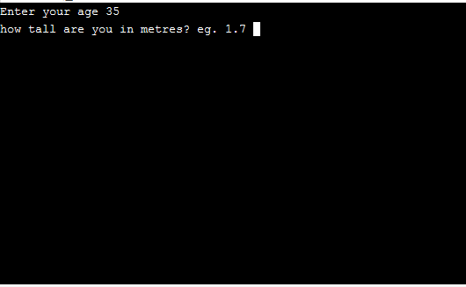
Number of Test | 2
Program Name | Question 1
Type of Test | Boundary Operation
Data Inputted | 121
Expected output | Repeat question
Actual Output | Repeat question
Pass/ Fail | Pass
Date of Test | 21/02/2019
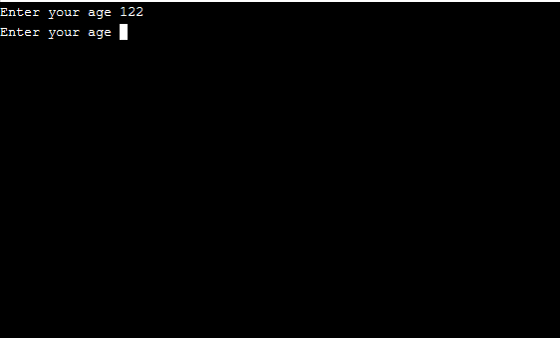

Number of Test | 3
Program Name | Question 1
Type of Test | Abnormal Operation
Data Inputted | t
Expected output | Program crash
Actual Output | Program crash
Pass/ Fail | Pass
Date of Test | 21/02/2019
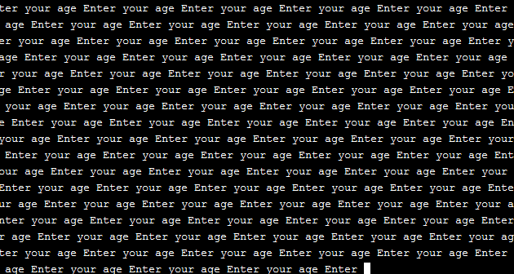
Number of Test | 4
Program Name | Question 1 Program
Type of Test | Normal Operation
Data Inputted | 1.73
Expected output | Proceed to next question
Actual Output | Proceeds to next question
Pass/ Fail | Pass
Date of Test | 21/02/2019
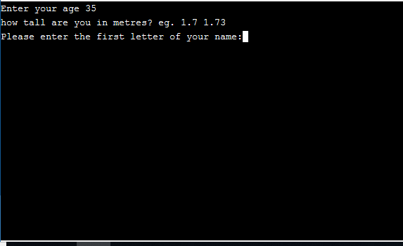

Number of Test | 5
Program Name | Question 1 Program
Type of Test | Boundary Operation
Data Inputted | 2.2
Expected output | Repeats question
Actual Output | Repeat question
Pass/ Fail | Pass
Date of Test | 21/02/2019
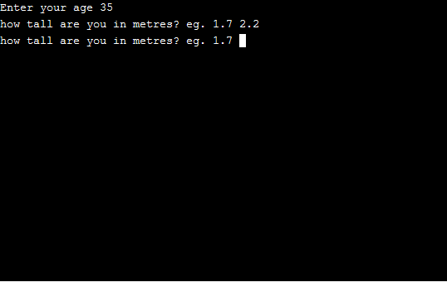
Number of Test | 6
Program Name | Question 1 Program
Type of Test | Boundary Operation
Data Inputted | s
Expected output | Program crash
Actual Output | Program crash
Pass/ Fail | Pass
Date of Test | 21/02/2019
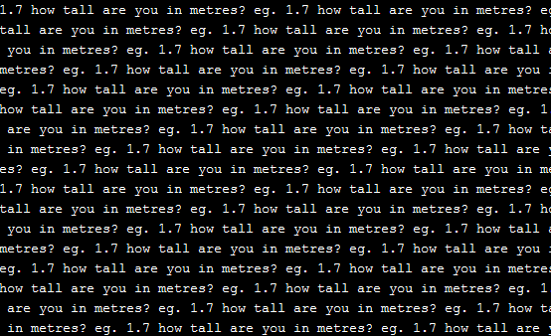

Number of Test | 7
Program Name | Question 1 Program
Type of Test | Normal Operation
Data Inputted | N
Expected output | Questions end and outputs data
Actual Output | Questions end and outputs data
Pass/ Fail | Pass
Date of Test | 21/02/2019
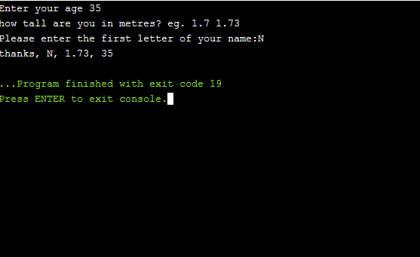
Number of Test | 8
Program Name | Question 1 Program
Type of Test | Boundary Operation
Data Inputted | z
Expected output | Questions end and outputs data
Actual Output | Questions end and outputs data
Pass/ Fail | Pass
Date of Test | 21/02/2019
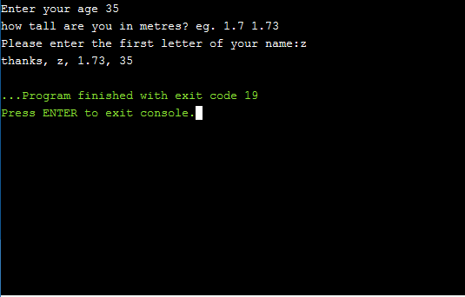

Number of Test | 8
Program Name | Question 1 Program
Type of Test | Abnormal Operation
Data Inputted | 4
Expected output | Program crash
Actual Output | Questions end and outputs data
Pass/ Fail | Fail
Date of Test | 23/02/2019
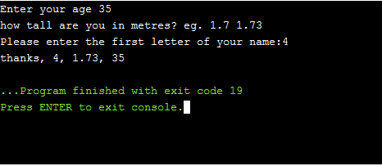

Question 2 Testing
Number of Test | 1
Program Name | Question 2 Program
Type of Test | Abnormal Operation
Data Inputted | 10
Expected output | Proceed to next question
Actual Output | Proceed to next question
Pass/ Fail | Pass
Date of Test | 23/02/2019
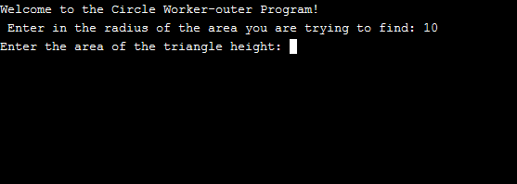
Number of Test | 2
Program Name | Question 2 Program
Type of Test | Boundary Operation
Data Inputted | 101
Expected output | Repeats question
Actual Output | Repeats question
Pass/ Fail | Pass
Date of Test | 23/02/2019
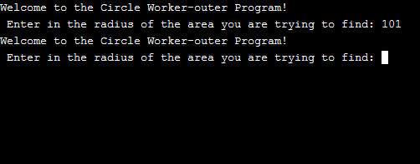

Number of Test | 3
Program Name | Question 2 Program
Type of Test | Abnormal Operation
Data Inputted | f
Expected output | Program Crash
Actual Output | Program Crash
Pass/ Fail | Pass
Date of Test | 23/02/2019
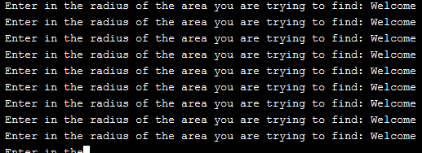
Number of Test | 4
Program Name | Question 2 Program
Type of Test | Normal Operation
Data Inputted | 5
Expected output | Proceed to next question
Actual Output | Proceed to next question
Pass/ Fail | Pass
Date of Test | 23/02/2019
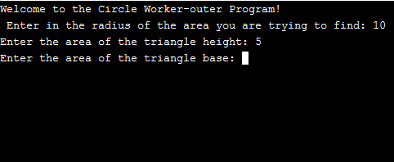

Number of Test | 5
Program Name | Question 2 Program
Type of Test | Boundary Operation
Data Inputted | 101
Expected output | Repeats Question
Actual Output | Repeats Question
Pass/ Fail | Pass
Date of Test | 23/02/2019
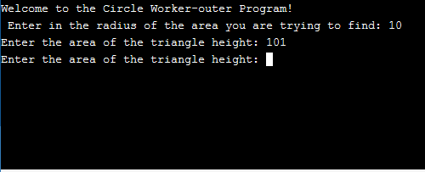
Number of Test | 6
Program Name | Question 2 Program
Type of Test | Abnormal Operation
Data Inputted | f
Expected output | Program Crash
Actual Output | Program Crash
Pass/ Fail | Pass
Date of Test | 23/02/2019
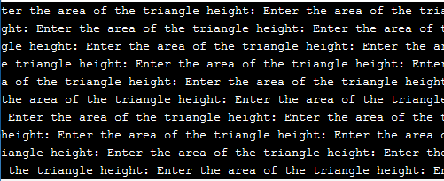

Number of Test | 7
Program Name | Question 2 Program
Type of Test | Normal Operation
Data Inputted | 5
Expected output | Program calculates area of shaded area
Actual Output | Program calculates area of shaded area
Pass/ Fail | Pass
Date of Test | 23/02/2019
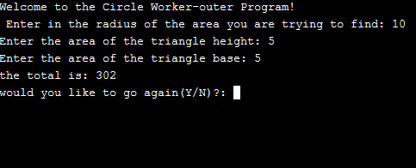
Number of Test | 8
Program Name | Question 2 Program
Type of Test | Boundary Operation
Data Inputted | 101
Expected output | Question is repeated
Actual Output | Question is repeated
Pass/ Fail | Pass
Date of Test | 23/02/2019
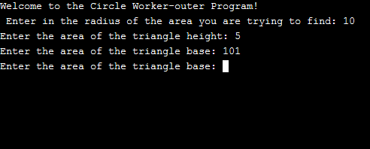

Number of Test | 9
Program Name | Question 2 Program
Type of Test | Abnormal Operation
Data Inputted | f
Expected output | Program Crash
Actual Output | Program Crash
Pass/ Fail | Pass
Date of Test | 23/02/2019
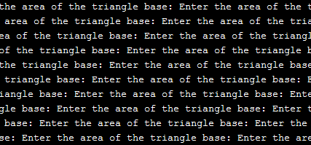

Question 3 Testing
Number of Test | 1
Program Name | Question 3 Program
Type of Test | Boundary Operation
Data Inputted | 21
Expected output | Moves on to next Question
Actual Output | Moves on to next Question
Pass/ Fail | Pass
Date of Test | 23/02/2019
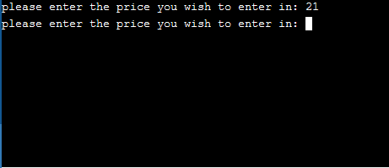
Number of Test | 2
Program Name | Question 3 Program
Type of Test | Boundary Operation
Data Inputted | 101 (please note this had to be typed in 6 times to ensure it was doing the desired operation and not just moving to the next question)
Expected output | Repeats Question
Actual Output | Repeats Question
Pass/ Fail | Pass
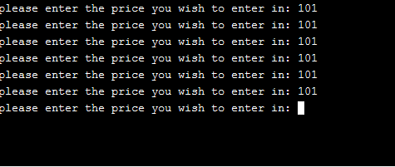
Number of Test | 3
Program Name | Question 3 Program
Type of Test | Abnormal Operation
Data Inputted | s
Expected output | Program crash
Actual Output | Program crash
Pass/ Fail | Pass
Date of Test | 23/02/2019
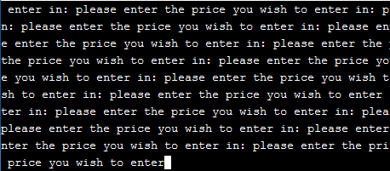
Number of Test | 4
Program Name | Question 3 Program
Type of Test | Normal Operation
Data Inputted | 10 (correct input has happened 5 times)
Expected output | Proceed to answers
Actual Output | Proceed to answers
Pass/ Fail | Pass
Date of Test | 23/02/2019
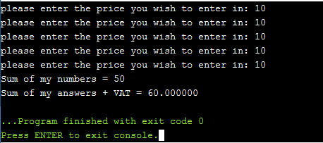

Question 4 Testing
Number of Test | 1
Program Name | Question 4 Program
Type of Test | Normal Operation
Data Inputted | y
Expected output | Program runs jackpot program
Actual Output | Program runs jackpot program
Pass/ Fail | Pass
Date of Test | 23/02/2019
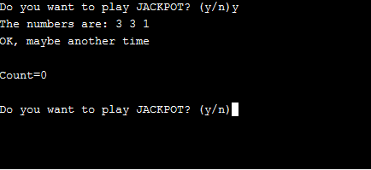
Number of Test | 2
Program Name | Question 4 Program
Type of Test | Abnormal Operation
Data Inputted | 5
Expected output | Program exits
Actual Output | Program runs jackpot program
Pass/ Fail | Fail
Date of Test | 23/02/2019
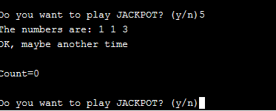
Number of Test | 4
Program Name | Question 4 Program
Type of Test | Boundary Operation
Data Inputted | Y
Expected output | Program runs jackpot program
Actual Output | Program runs jackpot program
Pass/ Fail | Pass
Date of Test | 23/02/2019
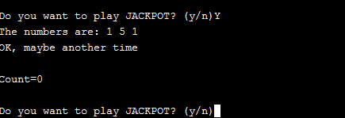
Number of Test | 4
Program Name | Question 4 Program
Type of Test | Normal Operation
Data Inputted | y
Expected output | 2x 5’s are generated
Actual Output | Program congratulates user and adds 100 points to the counter.
Pass/ Fail | Pass
Date of Test | 23/02/2019

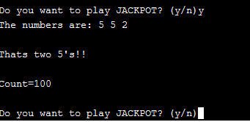
Number of Test | 5
Type of Test | Normal Operation
Data Inputted | y
Expected output | 3 same numbers are generated
Actual Output | Program congratulates user and adds 20 points to the counter.
Pass/ Fail | Pass
Date of Test | 23/02/2019
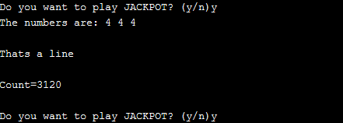
Number of Test | 6
Program Name | Question 4 Program
Type of Test | Normal Operation
Data Inputted | y
Expected output | 3 x 5‘s are generated
Actual Output | Program congratulates user and adds 2000 points to the counter.
Pass/ Fail | Pass
Date of Test | 23/02/2019
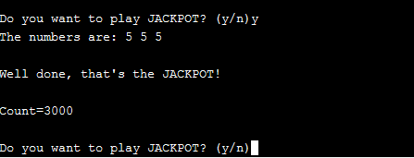

Bibliography

[1] | M. McGrath, C Programming, 4 ed., Leamington Spa: Easy Steps, 2014, p. 21.
[2] | G. Ghosh, “w3 schools,” Unknown Unknown 2019. [Online]. Available: https://www.w3schools.in/c-tutorial/variables/. [Accessed 11 Feb 2019].
[3] | Unknown, “C Programming Constants and Variables,” Unknown Unknown 2019. [Online]. Available: https://www.programiz.com/c-programming/c-variables-constants. [Accessed 11 Feb 2019].
[4] | Unknown, “C Variable Naming Rules,” Unknown Unknown 2019. [Online]. Available: http://www.c4learn.com/c-programming/c-variable-nameing-rules/. [Accessed Feb 11 2019].
[5] | Unknown, “Counting Loop,” Unknown Unknown Unknown. [Online]. Available: http://chortle.ccsu.edu/assemblytutorial/Chapter-18/ass18_10.html. [Accessed 23 01 2019].
[6] | Unknown, “C Programming for Loop,” Unknown Unknown Unknown. [Online]. Available: https://www.programiz.com/c-programming/c-for-loop. [Accessed 12 02 2019].
[7] | G. Ghosh, “C Arrays,” Unknown Unknown Unknown. [Online]. Available: https://www.w3schools.in/c-tutorial/arrays/. [Accessed 2019 Jan 23].

