
Service Improvement Report
Module: Quality Assurance and Service Improvements
(LCHS7006)
Student Name: Vishal Kishor Hirani
Student ID: 2431583
Course: MSc Public Health and Social Care in Practice
Lecturer: Shepherd Ziko
University: University of Wales Trinity Saint David – London Campus

Table of Contents
1. Introduction 3
1.1 Background to the Bristol Royal Infirmary Scandal 3
1.2 Systemic Failures and Public Health Implications 3
1.3 Purpose and Structure of the Report 4
2 Main Body 4
2.1 Root Cause Analysis Using the Fishbone (Ishikawa) Model 5
2.1.1 People Factors 5
2.1.2 Process Failures 6
2.1.3 Leadership Failures 6
2.1.4 Cultural Factors 6
2.1.5 Equipment and Resource Issues 7
2.1.6 Policy and System-Level Failures 7
2.2 Donabedian Model: Structure, Process and Outcome Evaluation 8
2.2.1 Structural Failures 9
2.2.2 Process Failures 9
2.2.3 Outcome Failures 9
2.3 SWOT Analysis of the Bristol Case 10
2.3.1 Strengths 10
2.3.2 Weaknesses 10
2.3.3 Opportunities 10
2.3.4 Threats 11
2.4 Academic Literature and Theoretical Integration 11
2.4.1 Systems Theory and the Swiss Cheese Model 11
2.4.2 Leadership Theory 12
2.4.3 Organisational Culture Theory 12
2.4.4 Human Factors Perspective 12

3. Recommendations 13
3.1 Strengthening Clinical Governance and Accountability 13
3.2 Implementing PDSA Cycles for Continuous Improvement 14

3.3 Applying PDCA to Improve Reliability and Compliance 14
3.4 Using Lean Principles to Reduce Waste and Improve Flow 15
3.5 Applying Six Sigma (DMAIC) to Reduce Variation 16
3.6 Leadership Transformation 17
3.7 Building a Transparent, Learning Culture 17
4. Conclusion 18
5. References 20

Strengthening Clinical Governance and Quality Assurance: Lessons from the Bristol Heart Surgery Inquiry

1. Introduction
The Bristol Royal Infirmary paediatric cardiac surgery scandal remains one of the clearest and most distressing examples of systemic quality failure within the NHS. Between 1984 and 1995, children undergoing complex cardiac surgery at Bristol experienced mortality rates far higher than comparable centres performing the same procedures. The subsequent public inquiry estimated that between 30 and 50 deaths could have been prevented had appropriate governance mechanisms, clinical monitoring, and organisational oversight been in place (Bristol Royal Infirmary Inquiry, 2001). What makes the Bristol case particularly significant is that the failures persisted for more than a decade despite warnings from clinicians, concerns from families, and external criticisms from visiting specialists. Rather than being an accidental cluster of outcomes, Bristol represented profound structural weaknesses in how the NHS assured quality and safety at the time (Walshe & Offen, 2001).
Prior to the late 1990s, the NHS did not have a fully developed clinical governance framework, meaning organisations were not formally required to undertake regular clinical audits, publish performance data, or benchmark outcomes against national standards (Scally & Donaldson, 1998). Quality assurance was largely dependent on individual professional responsibility and local managerial initiatives, leading to substantial variability across the country. Bristol’s paediatric cardiac service operated within this regulatory vacuum. An over-reliance on professional self-regulation and weak channels of communication created conditions where poor practice was not only possible but able to continue unchecked for years (Reason, 2000; Dixon-Woods et al., 2014).
The Bristol scandal was not simply a clinical failure; it represented a fundamental breach of trust between a public institution and the population it served. Quality failures within healthcare systems have broad public health implications, not only because they result directly in harm but because they erode confidence, reduce service utilisation, and expose systemic inequities (Department of Health, 2001). The case forced policymakers to confront the weaknesses of a health system that lacked transparency, accountability, and a culture of continuous learning. As a result, it became a catalyst for widespread reforms, including the establishment of the National Institute for Clinical Excellence (NICE), the Commission for Health Improvement (CHI), mandatory clinical governance frameworks, and public reporting of performance data (Walshe & Offen, 2001; NHS England, 2013).
The purpose of this report is to analyse the failures in clinical governance and quality assurance at the Bristol Royal Infirmary using a range of established theoretical frameworks. These include the Fishbone Diagram and the Donabedian Model, which together provide deeper, multidimensional insights into system weaknesses (Donabedian, 1988). A SWOT analysis will then explore the organisational and contextual influences that contributed to the failures. Based on the insights generated from these tools, the report will propose an evidence-based, practical, and sustainable improvement plan. This plan draws on recognised methodologies such as PDSA cycles, Lean principles, Six Sigma, and contemporary leadership theory to support meaningful change.

2. Main Body
The failures at the Bristol Royal Infirmary paediatric cardiac unit between 1984 and 1995 emerged from a complex interplay of structural, cultural, clinical, and organisational weaknesses. Examining these failures requires a structured approach that utilises established quality improvement models. This section applies the Fishbone Diagram, the Donabedian Model and SWOT analysis to unpack the root causes of the clinical governance breakdown. It also integrates peer-reviewed research and critical evaluation to demonstrate how these frameworks explain the systemic nature of the quality failures and support evidence-based recommendations. These combined models provide a more nuanced picture of why failures persisted for so long, reinforcing that no single factor can explain the scale of harm observed (Reason, 2000).

2.1 Fishbone (Ishikawa) Analysis of Root Causes
The Fishbone Diagram is widely used in healthcare quality improvement to categorise the underlying causes of adverse outcomes. Applied to the Bristol case, it identifies failures across people, processes, leadership, equipment, policy, and environment (Reason, 2000).
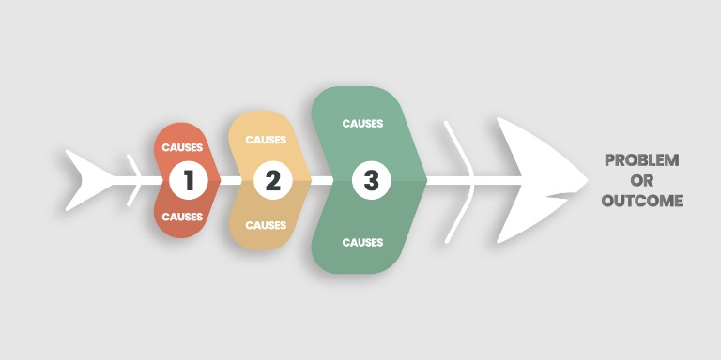
Figure: Fishbone Diagram (Reason, 2000)
This multi-factor perspective is particularly valuable in complex clinical settings where errors typically arise from system weaknesses rather than isolated mistakes (Donabedian, 1988).

2.1.1 People Factors
The Bristol Inquiry found significant deficits in clinical competence among the paediatric cardiac surgeons, particularly in relation to complex neonatal surgery (Bristol Royal Infirmary Inquiry, 2001). Surgeons continued performing high-risk procedures despite lacking the specialist expertise required. Professional development was minimal, and external peer review was absent.
The culture discouraged junior staff from questioning senior decisions, contributing to a lack of critical oversight (Kennedy, 2001). Research indicates that psychological safety is essential for raising concerns, and its absence magnifies risk (Edmondson, 1999; Dixon-Woods et al., 2014). This environment made it extremely difficult for staff to interrupt unsafe practices or highlight early warning signs.

2.1.2 Process Failures
Processes for clinical audit, documentation, and review were either non-existent or inconsistently applied. Mortality data were poorly recorded and rarely compared to national performance, despite the stark differences that should have triggered urgent investigation (Scally & Donaldson, 1998).
There were no standardised clinical pathways for paediatric cardiac surgery, and postoperative monitoring lacked structured protocols. Ineffective processes significantly increase patient harm, consistent with wider patient safety evidence showing that weak systems contribute more to adverse events than individual errors (Vincent, 2010).
Research consistently shows that poor processes significantly increase variability in outcomes, placing patients at heightened risk. At Bristol, these weaknesses allowed dangerous patterns to continue without intervention (NHS England, 2013).

2.1.3 Leadership Factors
Leadership contributed substantially to the overall decline in performance. Senior clinicians resisted scrutiny and failed to acknowledge poor results, while managerial leaders lacked the authority or confidence to challenge them (Kennedy, 2001).
Bass (1999) highlights that transformational leadership is essential in high-risk environments, yet leaders at Bristol demonstrated neither transformational nor transactional qualities.
The lack of psychological safety further discouraged staff from raising critical concerns (Dixon-Woods et al., 2014). Effective leadership should create a culture where difficult conversations are normalised, yet this was entirely absent.

2.1.4 Cultural Factors
The organisational culture at Bristol was characterised by defensiveness, hierarchies and professional elitism. Vaughn’s (1996) concept of the “normalisation of deviance” explains how repeated exposure to poor outcomes can lead staff to accept them as normal.
This was evident in the Bristol unit, where persistently high mortality was rationalised rather than challenged. Staff concerns were dismissed, and families’ complaints were minimised. Dixon-Woods et al. (2014) argue that learning cultures enable organisations to grow and adapt, but Bristol embodied a culture of silence and avoidance. This culture also prevented staff from openly discussing failures, undermining the development of a balanced and Just Culture that supports learning (Dekker, 2012).
Over time, this reinforced harmful behaviours, making meaningful change increasingly unlikely and weakening the organisation’s sensitivity to early warning signs, a key principle of high-reliability systems (Weick & Sutcliffe, 2007).

2.1.5 Equipment and Resource Issues
While not the primary cause, outdated equipment, insufficient paediatric facilities and limited specialist nursing staff contributed to poorer outcomes. Paediatric cardiac surgery requires highly specialised infrastructure, and Bristol lacked dedicated high-dependency units and appropriate monitoring technologies (Bristol Royal Infirmary Inquiry, 2001).
Resource constraints exacerbated clinical risks and placed further pressure on already stretched teams, demonstrating the critical importance of adequate resourcing in specialist care.

2.1.6 Policy and System-Level Failures
Before national reforms introduced after 1999, the NHS lacked mandatory governance structures. There were no national guidelines, no standardised audit processes and no external inspection mechanisms (Department of Health, 1998). Hospitals operated autonomously, and professional self-regulation prevailed. As a result, Bristol existed in a system with inadequate regulatory oversight.
Reason’s (2000) systems theory explains that weak external monitoring allows latent failures to remain undetected, especially in complex environments. These weaknesses reflect long-standing concerns about regulatory gaps in the NHS, where oversight systems have historically struggled to detect poor performance early (Walshe, 2003). This broader system failure helped create conditions where local problems could escalate unchecked.

The Fishbone analysis highlights that Bristol's failures were systemic, involving interconnected weaknesses across clinical competence, leadership behaviours, governance structures and organisational culture.

2.2 Donabedian Model: Structure, Process and Outcome Evaluation
The Donabedian Model offers a structured framework for analysing the quality of healthcare services (Donabedian, 1988). Applying this model to Bristol clarifies how structural and process failures led directly to poor clinical outcomes. This structured lens helps illustrate how organisational design and daily clinical practice interact.

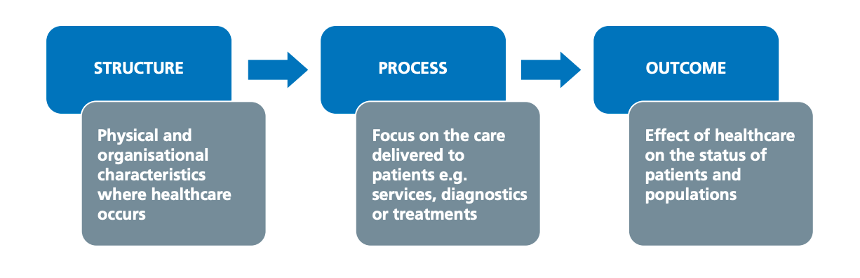
Figure: Donabedian Model (Donabedian, 1988)

2.2.1 Structural Failures
Structural elements at Bristol were fundamentally flawed. The organisation lacked a clinical governance framework, did not require or support external peer review, and had limited investment in paediatric specialist resources. Leadership positions lacked clear accountability, and decision-making was heavily clinician-dominated (Kennedy, 2001).
Other structural issues included insufficient specialist nurses, inadequate intensive care capacity, and outdated theatres. Donabedian (1988) emphasises that structural factors form the foundation for safe and effective care; without them, processes and outcomes inevitably deteriorate. These issues demonstrate that structural neglect can undermine even the most skilled clinical teams.

2.2.2 Process Failures
Clinical processes were fragmented, inconsistent and poorly documented. There were no standard operating procedures for complex paediatric procedures. Communication breakdowns were frequent, particularly during handovers and postoperative care.
Processes for risk identification, incident reporting and clinical audit were ineffective or absent. Donabedian’s model highlights that poor processes prevent early detection of deterioration, undermining reliability. This aligns with NHS England (2013), which emphasises that high-reliability systems require consistent adherence to evidence-based protocols.

2.2.3 Outcome Failures
The outcomes at Bristol were catastrophic: elevated mortality, significant morbidity among survivors, and profound psychological distress among families. Poor communication further compounded harm, with families reporting inadequate explanations and misleading reassurances (Bristol Royal Infirmary Inquiry, 2001).
These outcomes reflect systemic weaknesses across structure and process. Donabedian’s model clearly shows that unsafe outcomes were a predictable result of deficiencies in the first two domains.

2.3 SWOT Analysis
A SWOT analysis provides a strategic overview of the internal and external factors influencing the Bristol failures.
Strengths
- A dedicated workforce committed to children’s well-being (Kennedy, 2001).
- Pockets of good practice in adult cardiac surgery showing potential for excellence.
- A large regional population offering opportunities for benchmarking and comparative analysis (Kennedy, 2001).
Weaknesses
- Absence of clinical governance systems (Scally & Donaldson, 1998).
- Poor communication between staff groups and leadership.
- Deficient specialist training and supervision.
- Defensive culture with no psychological safety.
- Inadequate paediatric surgical infrastructure.
- Lack of clear accountability mechanisms (Scally & Donaldson, 1998).
Opportunities
- National reforms following the Bristol Inquiry, including NICE and CHI (Department of Health, 2001).
- Growing emphasis on evidence-based medicine and clinical audits.
- Adoption of improvement methodologies such as Lean, Six Sigma and PDSA cycles.
- Potential collaboration with specialist centres for shared learning (Department of Health, 2001).
Threats
- Public distrust and reputational damage.
- Staff burnout and retention challenges post-scandal.
- Increased litigation and scrutiny affecting morale.
- Wider NHS variations in governance maturity posing continued risks.

The SWOT analysis reveals that systemic weaknesses overwhelmed local strengths, signalling the need for large-scale reform rather than isolated improvements.

2.4 Academic Literature and Theoretical Integration
2.4.1 Systems Theory and Swiss Cheese Model
Reason’s (2000) Swiss Cheese Model demonstrates how multi-layered system vulnerabilities align to cause harm. Bristol exemplified this, as deficiencies in leadership, audit, supervision, communication and national oversight converged. This model emphasises that harm occurs when all defensive layers fail simultaneously.

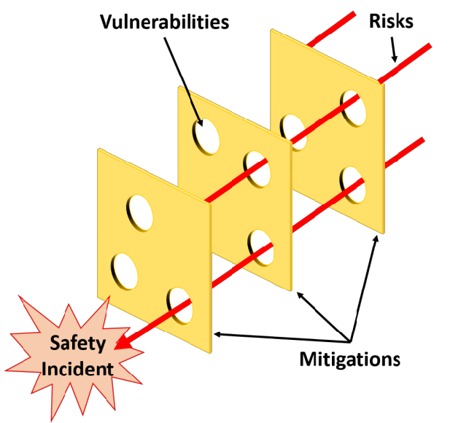
Figure: Swiss Cheese Model (Reason, 2000)

2.4.2 Leadership Theory
Transformational leadership fosters engagement, safety culture and transparency (Bass, 1999). Bristol’s leadership failed to meet these principles, instead displaying resistance, fragmentation and denial.

2.4.3 Organisational Culture Theory
Schein (2010) argues that deep cultural norms shape behaviour. At Bristol, cultural norms included the belief that raising concerns threatened team cohesion. This aligns with Vaughan’s (1996) normalisation of deviance theory, where deviant practices gradually become accepted as routine.

2.4.4 Human Factors
Poor communication, inadequate handovers and unclear roles significantly increased risks. Research consistently shows communication failures are a major cause of harm (Joint Commission, 2016). Human factors principles stress the importance of teamwork, clarity and shared situational awareness.

3. Recommendations
The failures identified through the Bristol Inquiry demonstrate that sustainable improvement requires a comprehensive, multi-level strategy targeting governance, leadership, culture, data, workforce, and clinical systems. The recommendations below integrate established quality improvement methodologies including PDSA, PDCA, Lean, and Six Sigma to address the identified root causes and support long-term organisational resilience.

3.1 Strengthen Clinical Governance and Accountability
The absence of structured governance at Bristol was a major contributor to the failures. Clinical governance must now form the foundation of organisational practice (Scally and Donaldson, 1998).
Key Actions
- Implement mandatory mortality and morbidity reviews supported by standardised templates to ensure consistency and transparency (Kennedy, 2001).
- Benchmark surgical and postoperative outcomes against national and international datasets to detect outliers early (Walshe and Offen, 2001).
- Establish a multidisciplinary governance committee responsible for analysing risk trends, overseeing corrective actions and maintaining compliance with national standards.
Clear accountability must be embedded across all levels of leadership. Strengthening governance also aligns with national priorities set out in the NHS Patient Safety Strategy, which emphasises safer systems and a proactive safety culture (NHS England, 2019). Clinical leads, surgical consultants, and operational managers should have defined patient-safety objectives integrated into appraisals, ensuring ownership of quality outcomes (Dixon-Woods et al., 2014).

3.2 Implement PDSA Cycles for Continuous Improvement
The PDSA methodology ensures ongoing learning rather than isolated interventions (Langley et al., 2009).
PLAN
Develop detailed, evidence-based clinical pathways outlining preoperative assessment, intraoperative protocols and postoperative monitoring. Collect baseline data on surgical complications, communication breakdowns, and resource gaps.
DO
Pilot these pathways within the paediatric cardiac unit. Provide targeted training in human factors, communication skills and early detection of deterioration. Human factors training should also be mandated, consistent with WHO guidance emphasising communication, teamwork and situational awareness (WHO, 2009).
STUDY
Review pilot outcomes using quantitative data (mortality, complications) and qualitative feedback from staff and families (NHS England, 2013).
ACT
Refine pathways and disseminate the improved protocols across the service. Embed them into organisational policy and competency frameworks to ensure sustainability.
PDSA supports incremental change, making it particularly suitable for complex, evolving environments such as paediatric cardiac surgery.

3.3 Apply PDCA to Improve Reliability and Compliance
PDCA reinforces consistency, minimising variation in clinical processes (Deming, 1986). This is crucial given the inconsistent handovers, poorly structured documentation, and variable monitoring identified at Bristol.
PLAN
Identify processes with high variability—handover practices, escalation procedures, surgical preparation routines.
DO
Introduce structured communication tools such as SBAR, procedural checklists and early warning score systems.
CHECK
Conduct compliance audits, workflow observations, and staff surveys to evaluate reliability.
ACT
Address gaps through workflow redesign, targeted coaching or integration of tools into electronic health systems.
PDCA ensures improvements become embedded in routine practice rather than remaining isolated initiatives.

3.4 Integrate Lean Principles to Reduce Waste and Improve Flow
Lean thinking focuses on removing inefficiencies and creating smooth, reliable care pathways (Womack & Jones, 2003). Inefficiencies at Bristol—delays in diagnosis, duplication of documentation, extended waiting times—contributed directly to risks.
Key Lean Actions
- Conduct full pathway process mapping to identify delays, bottlenecks and unnecessary steps from referral to discharge.
- Standardise high-risk processes such as theatre preparation, equipment checks and escalation procedures.
- Introduce daily multidisciplinary huddles to enhance real-time coordination, improving communication and reducing errors.
Lean improvements reduce patient waiting, enhance staff capacity and promote operational clarity.

3.5 Apply Six Sigma (DMAIC) to Reduce Variation and Enhance Quality
Six Sigma provides a structured, data-driven approach suited to high-risk procedures such as paediatric cardiac surgery (George, 2003).
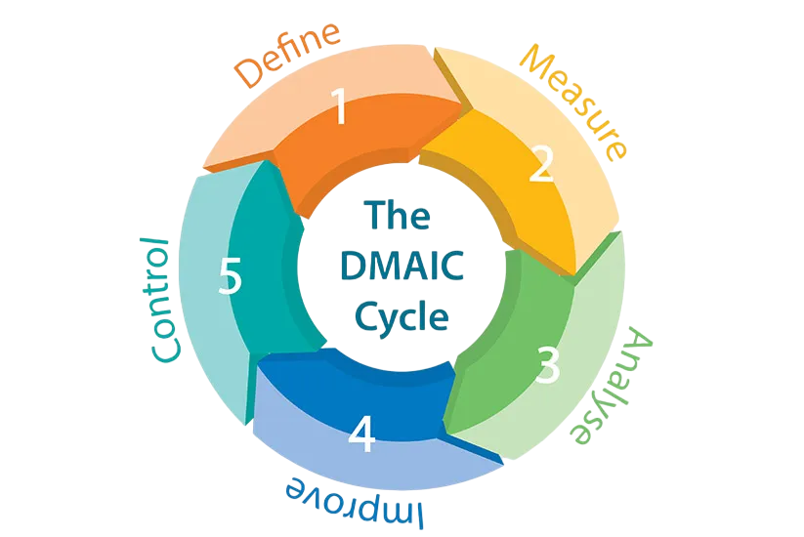
Figure: DMAIC Diagram (George, 2003)

DEFINE
Identify risks including inconsistent surgical technique, delayed escalation and variable postoperative monitoring.
MEASURE
Collect numerical data on mortality, anaesthetic complications, documentation completeness and response times.
ANALYSE
Determine variability contributors such as skill gaps, inconsistent communication and lack of early warning systems (Kennedy, 2001).
IMPROVE
Introduce simulation-based training, structured MDT briefings and standardised postoperative protocols.

CONTROL
Deploy real-time dashboards, routine competency assessment and regular external peer review to maintain gains.
Six Sigma aligns with the Bristol findings by targeting unwarranted variation that led to inconsistent performance.

3.6 Leadership Transformation
Leadership failure was central to the Bristol failures. Strong leadership is essential to creating a safe, transparent environment. Transformational leadership principles—empowerment, vision, and shared accountability—should guide organisational reform (Bass, 1999).

Leadership Recommendations
- Mandatory leadership development for consultants and senior managers.
- Adoption of Kotter’s (1996) 8-step model to support cultural and structural change.
- Regular leadership walk-rounds to reinforce visibility and accountability.
Leadership programmes should also incorporate coaching and mentoring to support emerging leaders. Evidence suggests that compassionate, inclusive leadership improves team functioning and enhances communication (West et al., 2015).

3.7 Build a Transparent, Learning Culture
Bristol’s culture of secrecy and defensiveness must be replaced with openness, psychological safety, and shared learning (Dixon-Woods et al., 2014).
Key Cultural Actions
- Introduce a no-blame incident reporting system to encourage early detection of risks (CQC, 2020).
- Conduct regular multidisciplinary learning events to review incidents and share learning.
- Involve families in co-designing service improvements to rebuild trust and enhance accountability.
The organisation should also contribute learning to regional and national collaboratives, ensuring system-wide transparency. Developing a learning organisation aligns with the WHO Global Patient Safety Action Plan, which calls for transparency, shared learning and leadership commitment (WHO, 2021).

4. Conclusion
The Bristol Heart Surgery Inquiry exposed one of the most serious failures of clinical governance and quality assurance in NHS history. The scandal demonstrated how poor outcomes can persist when organisations lack transparency, leadership, accountability and a culture of learning (Kennedy, 2001; Walshe & Offen, 2001). Using models such as the Fishbone Diagram and the Donabedian Model, this report has shown that Bristol’s failures were systemic rather than \individual. Weak structures, fragmented processes and a defensive culture produced catastrophic outcomes that could have been prevented (Donabedian, 1988; Reason, 2000).
The analysis also showed that leadership and culture play critical roles in sustaining safe practice. Without strong governance structures and open communication, even skilled clinicians cannot provide safe care (Dixon-Woods et al., 2014; Bass, 1999). Similar themes of secrecy, poor leadership and weak governance were later echoed in the Mid Staffordshire Inquiry, further highlighting systemic risks across the NHS (Francis, 2013). The recommendations proposed—including PDSA cycles, DMAIC methodology, leadership development, data transparency and cultural transformation—offer a comprehensive strategy for improving quality in complex healthcare environments (Langley et al., 2009; George, 2003). These approaches not only address the root causes of Bristol’s failures but also align with contemporary expectations of accountability, learning and patient-centred care (NHS England, 2013).
Ultimately, the lessons from Bristol remain deeply relevant. Healthcare systems today continue to face pressures from workforce shortages, rising complexity and increasing public expectations (Department of Health, 2001). Ensuring that robust governance systems, strong leadership and transparent quality mechanisms are embedded within healthcare organisations is essential for safeguarding patients (Scally & Donaldson, 1998). The Bristol tragedy serves as a powerful reminder that without sustained commitment to quality assurance, failures can go unnoticed until harm becomes unavoidable. Sustained improvement requires vigilance, openness and a shared commitment to learning at every level of the organisation, reinforcing the need for continuous reflection, external scrutiny and a proactive approach to identifying emerging risks before they escalate (CQC, 2020; West et al., 2015).

5. References
Bass, B.M. (1999) ‘Two decades of research and development in transformational leadership’, European Journal of Work and Organizational Psychology, 8(1), pp. 9–32.
Bristol Royal Infirmary Inquiry (2001) Learning from Bristol: The Report of the Public Inquiry into Children’s Heart Surgery at the Bristol Royal Infirmary 1984–1995. London: The Stationery Office.
Care Quality Commission (2020) The State of Health Care and Adult Social Care in England 2019/20. Newcastle upon Tyne: CQC.
Dekker, S. (2012) Just Culture: Balancing Safety and Accountability. 2nd edn. Boca Raton: CRC Press.
Deming, W.E. (1986) Out of the Crisis. Cambridge, MA: MIT Press.
Department of Health (1998) A First Class Service: Quality in the New NHS. London: The Stationery Office.
Department of Health (2001) National Service Framework for Older People. London: Department of Health.
Dixon-Woods, M., Baker, R., Charles, K. et al. (2014) ‘Culture and behaviour in the English National Health Service: overview of lessons from a large multimethod study’, BMJ Quality & Safety, 23(2), pp. 106–115.
Donabedian, A. (1988) ‘The quality of care. How can it be assessed?’, JAMA, 260(12), pp. 1743–1748.
Edmondson, A.C. (1999) ‘Psychological safety and learning behavior in work teams’, Administrative Science Quarterly, 44(2), pp. 350–383.
Francis, R. (2013) Report of the Mid Staffordshire NHS Foundation Trust Public Inquiry. London: The Stationery Office.
George, M.L. (2003) Lean Six Sigma for Service: How to Use Lean Speed and Six Sigma Quality to Improve Services and Transactions. New York: McGraw-Hill.
Joint Commission (2016) Sentinel Event Data: Root Causes by Event Type 2004–2015. Oakbrook Terrace, IL: The Joint Commission.
Kennedy, I. (2001) The Bristol Royal Infirmary Inquiry: Final Report. London: Department of Health.
Kotter, J.P. (1996) Leading Change. Boston: Harvard Business School Press.
Langley, G.J., Moen, R., Nolan, K.M., Nolan, T.W., Norman, C.L. and Provost, L.P. (2009) The Improvement Guide: A Practical Approach to Enhancing Organizational Performance. 2nd edn. San Francisco: Jossey-Bass.
NHS England (2013) Human Factors in Healthcare: A Concordat from the National Quality Board. London: NHS England.
NHS England (2019) The NHS Patient Safety Strategy: Safer Culture, Safer Systems, Safer Patients. London: NHS England.
Reason, J. (2000) ‘Human error: models and management’, BMJ, 320(7237), pp. 768–770.
Scally, G. and Donaldson, L.J. (1998) ‘Clinical governance and the drive for quality improvement in the new NHS’, BMJ, 317(7150), pp. 61–65.
Schein, E.H. (2010) Organizational Culture and Leadership. 4th edn. San Francisco: Jossey-Bass.
Vaughan, D. (1996) The Challenger Launch Decision: Risky Technology, Culture, and Deviance at NASA. Chicago: University of Chicago Press.
Vincent, C. (2010) Patient Safety. 2nd edn. Chichester: Wiley-Blackwell.
Walshe, K. (2003) Regulating Healthcare: A Prescription for Improvement? Maidenhead: Open University Press.
Walshe, K. and Offen, N. (2001) ‘A very public failure: lessons for quality improvement from the Bristol Royal Infirmary’, Quality in Health Care, 10(4), pp. 250–256.
Weick, K.E. and Sutcliffe, K.M. (2007) Managing the Unexpected: Resilient Performance in an Age of Uncertainty. 2nd edn. San Francisco: Jossey-Bass.
West, M., Armit, K., Loewenthal, L., Eckert, R., West, T. and Lee, A. (2015) Leadership and Leadership Development in Health Care: The Evidence Base. London: The King’s Fund.
World Health Organization (2009) Human Factors in Patient Safety: Review of Topics and Tools. Geneva: WHO.
World Health Organization (2021) Global Patient Safety Action Plan 2021–2030. Geneva: WHO.
Womack, J.P. and Jones, D.T. (2003) Lean Thinking: Banish Waste and Create Wealth in Your Corporation. Revised edn. London: Simon & Schuster.

