
Evaluation on the Successful the United Kingdom has been in Counter Terrorism
Research Propsal
Andrew James – 1700591 – Date – 01/07/2022 – word count -1327
7

Contents
Introduction 2
Aim 2
Objectives 3
Literature Review 3
Methodology 4
Ethical Considerations 6
Data Analysis 6
Resource and Time Management 6
Gantt Chart 7
Reference List 7

Introduction
This dissertation will try to evaluate how successful the United Kingdom (UK) has been in trying to Counter Terrorism, the threat of terrorism is not just been an issue since the turn of the 21st Century but also since the end of Second World War, there has also been incidents prior to the Second World War that could be classed as terrorism. For the purpose of this research, it will mainly focus on incidents that involved either the UK military or Police.
In the UK there many incidents of security forces being used in counter terrorism operations, examples are The Troubles and threats of terror from groups internationally (Staniforth, 2013). There have new and changing technologies that have been making increasingly difficult to gather information to stop planned attacks (MI5, 2022) In their book Poynting and Whyte (2012) assert that countries, mainly Western countries, have constructed the viewpoint of themselves as victims and not the perpetrators of their own form of state terrorism.

Aim
The aim of the dissertation is to evaluate how successful the UK has been in trying to Counter Terrorism. This will be achieved by reviewing famous examples of operations that members of the UK security forces has taken part in, this review will look to see what the operations objectives were, were they successful in achieving this objective and what lessons were learned for future Counter Terrorism operations.
To achieve this aim, it will be achieved by the use of objectives. The reason for using objectives is explained by Gratton and Jones (2004) as being essential in helping to guide the research in answering the question, the viewpoint of Gratton and Jones (2004) is supported by Sreejesh et al (2013), they further add that the objectives should be clear and precise as possible.

Objectives
The objectives for this dissertation are:
- Evaluate previous academic literature on noteworthy counter terrorism operations.
- Produce a methodology, to help in gathering of data.
- Analyse data collected on counter terrorism.
- Make recommendations on what makes a good counter terrorism operation.

Literature Review
With the increase of the number of terrorist attacks within the UK, it became time that counter terrorist police units within the UK had standard equipment and training (Smith, 2019), they used the 2012 London Olympics has the perfect opportunity to introduce these changes. The plan according to Smith (2019) was to create a large firearms specialist teams that could be shifted either by helicopter or by vehicle to any of the sites being used by the Olympics or anywhere else in the UK that a terrorist attack is either happening or is imminent, a way this was going to be achieved is by having Specialist Firearms Officer (SFO) team from various UK police forces working together.
One of the most famous counter terrorism operations that happened in the UK, is the Iranian Embassy Siege in 1980. It started when six terrorist, whose goal was to have a separatist Arab state in one of Iran’s provinces (Forces, 2020). The unit tasked with rescuing the hostages was the Special Air Service more commonly known as the SAS (Forces, 2020). On the day of the assault both Phillips (2016) and Fremont-Barnes (2012) say that the SAS was split up into two teams, Blue and Red. The Red team was tasked with securing the second, third and fourth floors of the building, while the Blue team was tasked with securing the basement, ground floor and the first floor (Phillips, 2016). By the end of the assault only one of the six terrorist was captured alive, the others being killed during the assault (Forces, 2020).
The opinion of Ramraj (2006) is that for a counter terrorism strategy to be effective has to move away from short term goals and coercive strategies, toward social and political strategies that are intended to address the alienation of minorities, Ramraj (2006) suggests that this strategy can be seen in Northern Ireland where he first says that the military gad to be sent into the country due to the rise in violence, but this could be seen as causing more tension due to the involvement not being equal, the Belfast agreement in 1997, Ramraj (2006) believe this was the moment when the transition from short term goals to combatting terrorism to fixing the underlying issues for minorities in Northern Ireland.
A defining moment in terms of Counterterrorism is the Paris Attacks in 2015. The UK’s immediate response to the attacks was to strengthen security forces presence, Syal (2015) mentions that when the then Home Secretary Theresa May was asked on the Andrew Marr Show that were the rumours of SAS were on the streets, May replied that there were arrangements between the Police and the Military when support is needed. The idea of soldiers on the streets of the UK is not unreasonable, as the ITV (2017) reported that soldiers were on the streets of London after the terror threat was raised, the soldiers were deployed to guard major locations such as Buckingham Palace and Downing Street.

Methodology
Defining the term research is rather difficult has experts have their own views on what research is, Kumar (2010) opinion is that research is a scientific search for information on a specific topic. On the other hand, Khan (2011) says that research is to discover new or improve knowledge about a specific topic, the opinion of Mishra and Alok (2017) believe that research is trying to find facts which are unknown and have yet to be exposed.
There are variety of ways of collecting research, to help explain these different methods Saunders et al (2015) have created what they call a Research Onion, it will be the use of this research onion that will help create a philosophy that will accomplish the aims and objectives that the dissertation has set out.
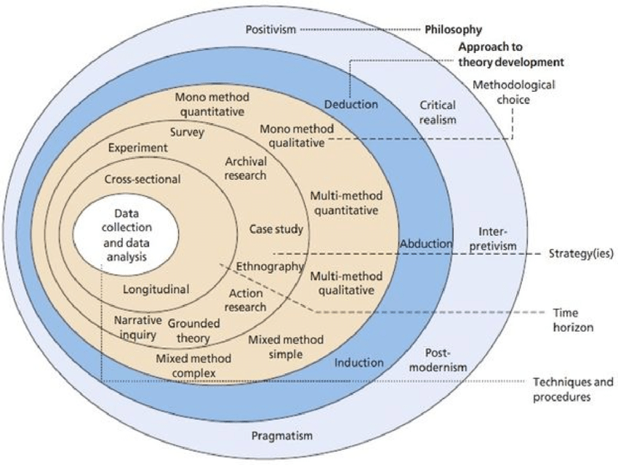
(Saunders et al, 2015)
For the purpose of this dissertation, the research methods that will be used are:
- Interviews – This will ask participants about what they have experienced while on Counterterrorism operations.
- Case Study – This will use secondary resources; this will look at a couple of specific events in regard to Counterterrorism and note the lessons learned.

Ethical Considerations
The participants that will take part in the interview will be over 18 years of age, this is to prevent children from being involved. The dissertation will be confidential and unbiased. A possible issue could be that for participants may bring up painful experiences due to the things they have seen, to avoid this issue they will be allowed time to take a break and also the aim is to ask for more strategic questions rather than personal questions. Another potential issue could be that some of the information could be confidential, to avoid this issue names of people not involved in the dissertation will not be used and potential information that is not already public known will not be used.

Data Analysis
The interviews will be done either in person or through video call like Microsoft Teams, if it is not possible to do the interviews in person, a benefit of using Teams is that the call can be recorded.

Resource and Time Management
To aid this research a variety of methods of gathering resources will be used, the first resource to gather information will be the internet. The internet is a great way of gathering resources such as books and journals, these type of resources are good because they would give credible information due to being peer-reviewed. A disadvantage of using the internet is that some websites may not be credible, to avoid this potential issue the dissertation will use the university’s online library, the use of websites will come from sites that are known to be credible. To help in time management, the dissertation will use a Gantt chart, this chart is helpful because it sets out the major dates for the dissertation and also the time scales.

Gantt Chart
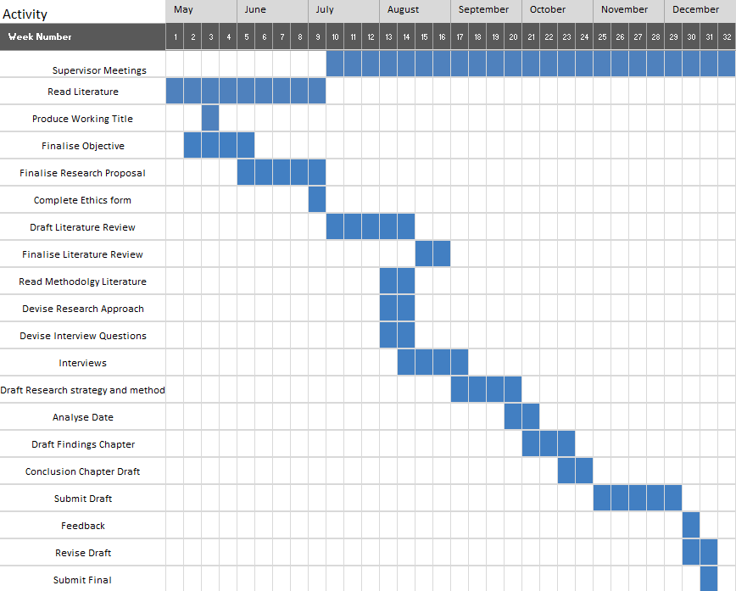

Reference List
Alok, S. and Mishra, S. (2017) Handbook of Research Methodology: A Compendium for Scholars and Researchers. New Delhi: Educreation Publishing.

Gratton, C. and Jones, I. (2004) Research Methods for Sports Studies. New York: Routledge.

Forces (2020) The Day The SAS Became Famous: Operation Nimrod And The Iranian Embassy. Available at https://www.forces.net/news/day-sas-became-famous-operation-nimrod-and-iranian-embassy. (Accessed: 8th June 2022).

Fremont-Barnes, G. (2012) Who Dares Wins: The SAS and the Iranian Embassy Siege 1980. Bloomsbury Publishing.

ITV (2017) Soldiers on Streets of London after terror threat raised. Available at https://www.itv.com/news/update/2017-05-24/soldiers-seen-at-parliament-after-terror-threat-raised/. (Accessed: 29th June 2022).

Khan, J. (2011) Research Methodology. New Delhi: A.P.H Publishing Corporation.

Kumar, R. (2010) Research Methodology. London: SAGE.

MI5 (2022) Counter-Terrorism: Introduction to Counter-Terrorism. Available https://www.mi5.gov.uk/counter-terrorism. (Accessed: 1st June 2022).

Phillips, R. (2015) Operation Nimrod: The Iranian Embassy Siege. Shilka Publishing.

Ramraj, V. (2006) ‘Counter-Terrorism Policy and Minority Alienation: Some Lessons from Northern Ireland’, Singapore Journal of Legal Studies, pp 385-404. Available at https://dspace.library.uvic.ca/bitstream/handle/1828/7826/ramraj_victor_singjls_2006.pdf?sequence=1. (16th June 2022).

Saunders, M. Lewis, P. and Thornhill, A. (2015) Research Methods for Business Students. 7th edn. London: Pearson.

Smith, S. (2019) London’s Armed Police: Up Close and Personal. Yorkshire: Pen and Sword Books.

Sreejesh, S. Mohapatra, S. and Anusree, M. (2013) Business Research Methods: An Applied Orientation. London: Springer.

Staniforth. A. (2013) The Routledge Companion to UK Counter-Terrorism. London: Routledge.

Syal, R. (2015) ‘UK security increases after Paris attacks’, The Guardian, 15th November. Available at https://www.theguardian.com/uk-news/2015/nov/15/uk-security-paris-attacks-theresa-may. (Accessed: 29th June 2022).

