How to Convert your PowerPoint Presentation to a PDF for Turnitin Submission
NOTE: it is highly advised you consult the ‘Reduce your File Size’ instructions first before saving to a PDF. This will ensure you file size is not too big for Turnitin.

- Click on the Microsoft Icon in the top left corner of your screen.

- Over your curser over ‘Save A’ and then click on ‘PDF or XPS’

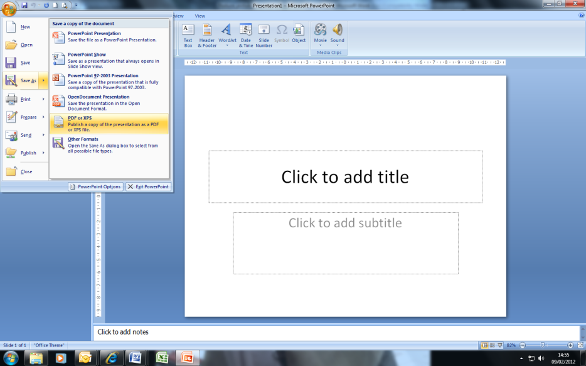

- Insert a file name and click on ‘Publish’

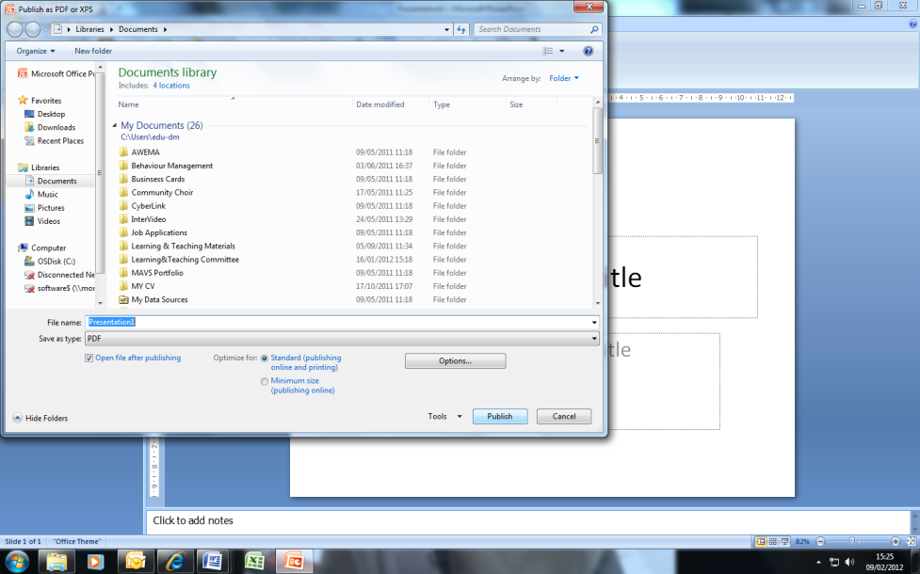

Now you have a file which can be uploaded to Turnitin!

