University of Wales Trinity Saint David

Wales Institute of Science and Art


Materials Testing and Sustainability of Composites for Motorsport and Automotive Industries

Automotive Materials and Sustainability (ACHA6012)

Chloe Rees
2218480
March 2026
Word Count: 3101
Table of Contents
1 Introduction 3
2 Literature Review 4
3 Sustainability 5
3.1 Lifecycle Context 5
3.2 Raw Material Extraction 5
3.3 Aluminium 5
3.4 Manufacturing Considerations 5
3.5 Use-Phase Performance and Sustainability 6
3.6 End-of-Life 6
4 Experiments 7
4.1 Introduction 7
4.2 Aluminium 8
4.3 Kevlar 10
4.4 Carbon Non-Woven 12
4.5 Carbon Woven 14
4.6 Flax Non-Woven 16
4.7 Flax Woven 18
4.8 Carbon Epoxy 20
4.9 Comparison 22
5 Recommendations and Future Developments 24
5.1 Material Recommendations 24
5.2 Sustainability Strategy and Material Trade Off 24
5.3 Application in Motorsport and Automotive Industries 24
5.4 Future Research and Development 25
6 Conclusion 26
References 27
Table of Figures 29

1 Introduction
Advanced composite materials are being used extensively due to the growing need for lightweight, high-performance constructions in the automotive and motorsport industries. In situations where performance and efficiency are crucial, fibre reinforced composites, especially carbon offer better strength than conventional material such as aluminium. However, because of their low recyclability and intensive production procedures, these materials are often linked to major environmental impact despite their advantages. Evaluating substitute material can lessen environmental effect while keeping decent material performance is becoming more important as sustainability becomes a future goal in engineering.

This study aims to evaluate the trade-off between sustainability and mechanical performance in material used in the automotive and motorsport industries. In order to this, a controlled tensile testing is done to evaluate important parameters, such as strength, stiffness, failure and toughness. In addition to a lifecycle assessment of the environmental impact of these materials compared between the bio-based and conventional materials.

2 Literature Review
Because of their high strength-to-weight ratio and capacity to be tailored for particular structural purposes, fibre reinforced composite materials have become increasingly popular in engineering. Composites provide much better specific stiffness and strength that conventional and metallic materials like aluminium, allowing for significant weight savings. Aluminium alloys are usually having a Young’s modulus of about 70GPa and tensile strengths of 150-500MPa (Callister & Rethwisch, 2018). Aluminium’s weaker specific mechanical qualities make it less appropriate for high-performance applications, despite benefits like ductility, corrosion resistance and ease of fabrications (Polmear, 2005)

Some of the best composite’s systems are carbon fibre reinforced polymers (CFRPs), especially in automotive and motorsport applications. According to (Oller & Marí, 2013), carbon fibre can reach Young’s modulus of 200-600GPa and tensile strengths of above 3000MPa. Fibre alignment within the polymer matrix controls their performance, allowing for effective load transfer. Fibre architecture is crucial; non -woven systems are more isotropic but perform worse mechanically, whereas woven composites give multidirectional strength and enhanced crack resistance (Soutis, 2005). Mechanical response and energy absorption are further influenced by interfacial bonding and fibre dispersion (Yan, et al., 2014).

Composites made of natural fibres, especially flax-based systems, have become more environmentally friendly options. Flax fibres are appropriate for some applications because they usually have a tensile strength of 500-1500MPa and a Young’s modulus of 50-70GPa (Yan, et al., 2014). However, dependability is diminished by variations in fibre quality (Pickering, et al., 2016). although bio-composites, which combine natural fibres with bio-based resins, have a lower environmental effect, they must be processed carefully to prevent flaws like voids and weak interfaces (Koronis, et al., 2013).
Kevlar composites are useful in impact resistance applications due to their high tensile strength of 3000MPa and excellent energy absorption (Bandaru, et al., 2016). They frequently outperform carbon fibre under impact loading (Majumdar, et al., 2013).
In general, natural fibre composites are becoming more prevalent in non-critical components that prioritise sustainability, while carbon fibre composites predominate in high-performance.

3 Sustainability

3.1 Lifecycle Context
It is necessary to evaluate the sustainability of the materials tested over their entire lifecycle, not just based on mechanical performance. This is especially crucial for automotive and motorsport applications, where materials are frequently chosen mainly for their strength, rigidity and the ability to maintain low weight. The materials focused on are aluminium, carbon epoxy, woven bio-carbon, non-woven bio-carbon, and flax woven bio, with Kevlar relevant due to its use as lightweight and impact resistant structures. It is essential to adopt a lifecycle approach, as materials that perform well in production may still have significant environmental costs during their production or disposal (Alrehaili, et al., 2025).

3.2 Raw Material Extraction
During the raw material stage, carbon epoxy is anticipated to have the biggest environmental impact. Despite having good structural performance, the manufacture of carbon fibre requires a lot of energy, and traditional epoxy solutions are usually petroleum-based, which results in large, embodied impact (De, et al., 2024). Although bio-carbon material with renewable resin content may provide some impact reduction, the overall sustainability advantage is limited because the reinforcing is still carbon fibre. Therefore, rather than being completely sustainable solutions, this material should be considered transitional. Flax woven bio composites offer a better choice when it comes to raw materials. Flax is a plant-based, renewable material that usually has a lower carbon footprint than synthetic fibres, but mechanical performance suffers as a result (Wodag, et al., 2025).

3.3 Aluminium
Aluminium’s different sustainability profile makes it a useful benchmark. Although primary aluminium manufacturing requires a lot of energy and has a significant impact during the extraction process, it is highly recyclable in current industrial systems. The entire lifespan performance of recycled aluminium is improved since it uses a lot less energy than primary production (Al-Alimi, et al., 2024). Despite being heavier than composite alternatives, it is a relevant and sustainable material choice due to its extended service life and recyclability, especially when whole lifecycle consequences are taken into account (Lu, et al., 2024).

3.4 Manufacturing Considerations
During the manufacturing stage, notable variations occur. Layered composite methods, which might result in material waste from cutting, trimming and resin application, are commonly used to manufacture carbon epoxy and bio-carbon laminates. The environmental impact of each component in motorsports is increased by limited production numbers and strict quality standards. While non-woven constructions may be easier to manufacture but have worse structural performance, woven bio-carbon often delivers more constant in-plane qualities. Although flax-based composites are more susceptible to moisture, fibre variability and durability issues, they provide enhanced sustainability because of renewable reinforcing and bio-based systems (Margoto & Milani, 2025).

3.5 Use-Phase Performance and Sustainability
Carbon-based material offers definite benefits during use by reducing weight therefore enhances performance, handling, braking and acceleration while lowering operational energy consumption. Their prolonged use despite significant production implications can be explained by this benefit. However, the environmental cost of manufacturing may exceed these operational benefits if parts need to be replaced frequently because of deterioration or corrosion (Alrehaili, et al., 2025). Bio-based composites might be appropriate for semi-structural or interior applications where minimising environmental impact is more important than reducing performance (Ajayi, et al., 2025)

3.6 End-of-Life
For composite materials, end-of-life management continues to be a significant constraint. Circularity is limited by the difficulty of recycling conventional thermoset composites, such as carbon epoxy into high-performance goods. If processing is not optimised, bio-carbon and flax composites encounter comparable difficulties. On the hand, aluminium’s lifespan benefits are reinforced by its ability to be effectively collected and reused through established recycling systems (Pakdel, et al., 2021).

Figure 1 shows that composites are extremely expensive and are hardly recyclable making them difficult to become more sustainable.
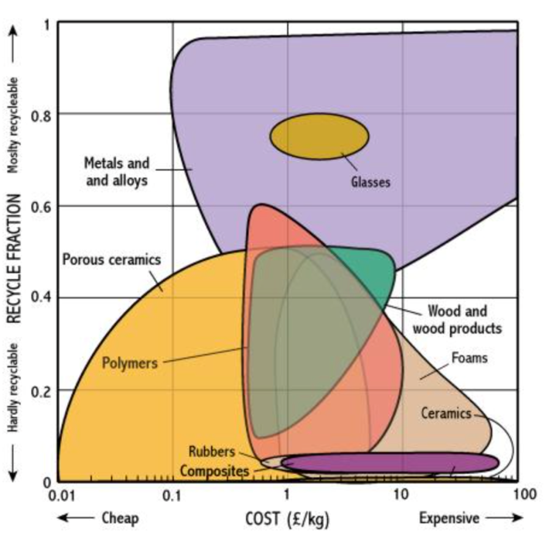

Figure 1- Recyclability of materials (Anon., n.d.).

4 Experiments

4.1 Introduction
This section assesses the mechanical behaviour of chosen materials under tensile loading and describes the experimental methods. The study compares more sustainable materials like flax and bio-based composites with more traditional materials like carbon composites and aluminium. To determine their appropriateness for engineering and motorsport applications, emphasis is concentrated on finding variations in strength, stiffness, and deformation behaviour.
All material specimens underwent controlled tensile testing using a universal testing apparatus. Data on load and displacement were continuously recorded while each sample was subjected to a uniaxial load at a constant displacement rate until failure. MATLAB was used to create stress-strain and load-displacement curves since engineering stress and strain were computed using the actual specimen dimensions.
For every material, several samples were examined to guarantee consistency and dependability. Important mechanical characteristics, including as ultimate tensile strength, stiffness, strain to failure, and toughness, were averaged. These numbers were utilised to verify results against published literature and compare material performance.

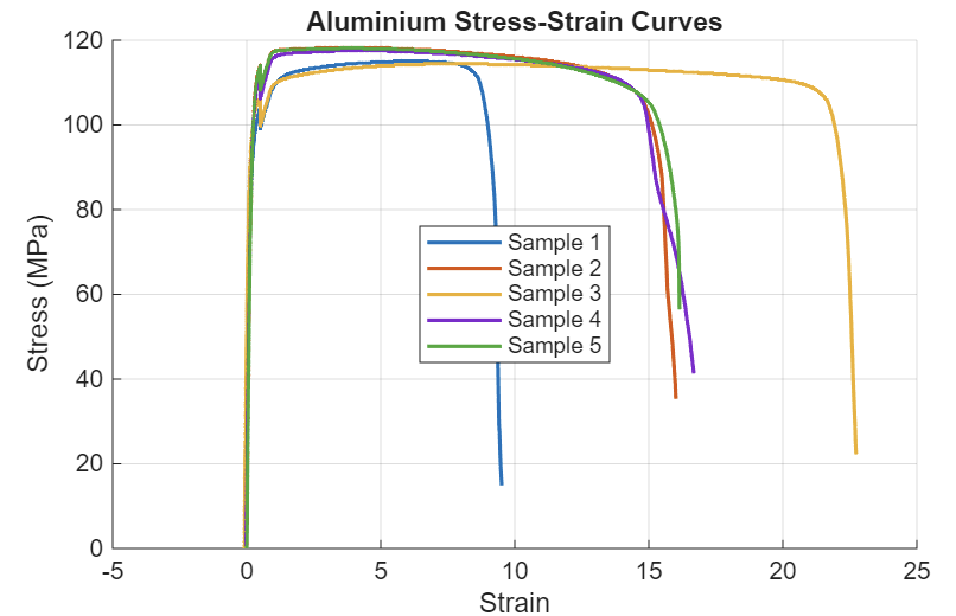
4.2 Aluminium
Figure 2- Stress and strain of aluminium.

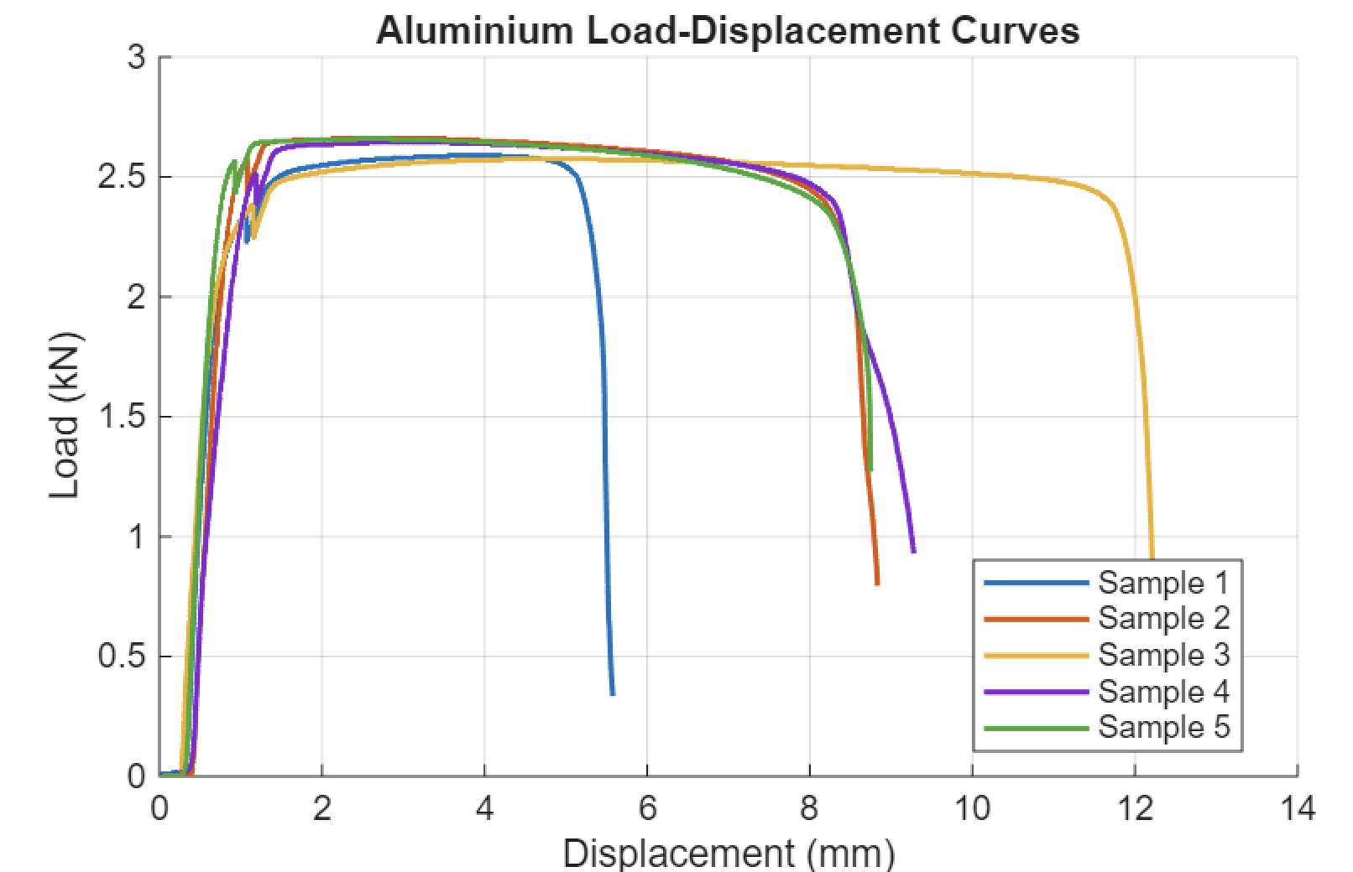

Figure 3- Load and displacement of aluminium.

With an average ultimate tensile strength of 116.6 MPa and a comparatively low Young's modulus of 48.6 GPa, indicating moderate stiffness, the aluminium exhibits conventional ductile metallic behaviour. Significant plastic deformation capacity is confirmed by the high average strain of 4.29 and a toughness of 1803 MJ/m³, indicating that the material can absorb a significant amount of energy before failing. This characteristic, which permits strain hardening and necking under load, is controlled by dislocation movement. Applications needing energy absorption and damage tolerance rather than maximal stiffness are indicated by the combination of moderate strength and high ductility.
These results are consistent with aluminium alloys like 6061, which generally show high elongation and UTS values of 110–125 MPa (Hirsch, 2011), supporting the experimental results.

4.3 Kevlar

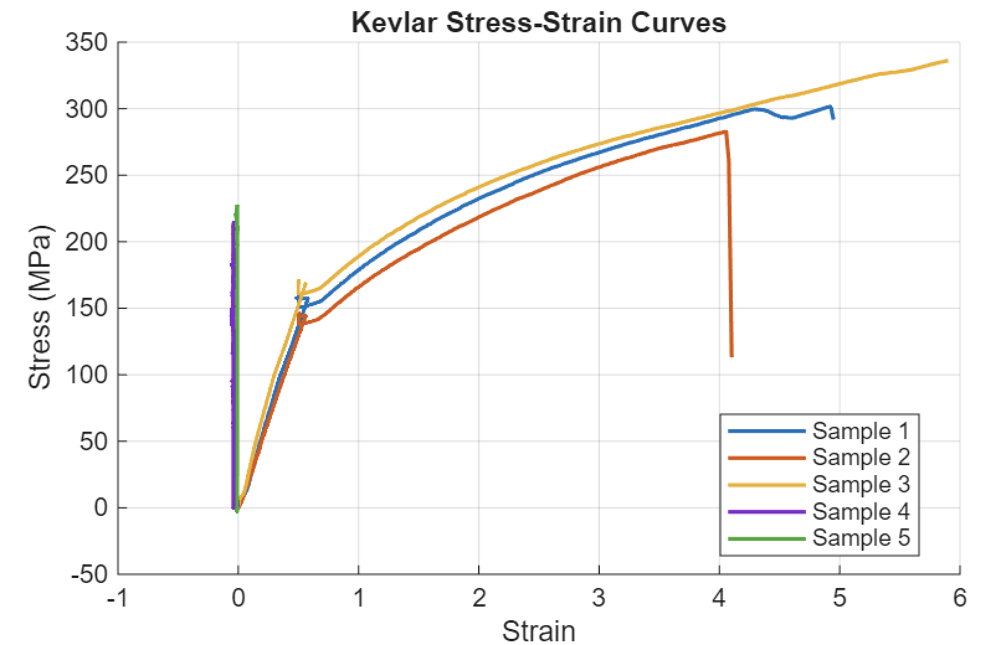
Figure 4- Stress and strain of Kevlar.
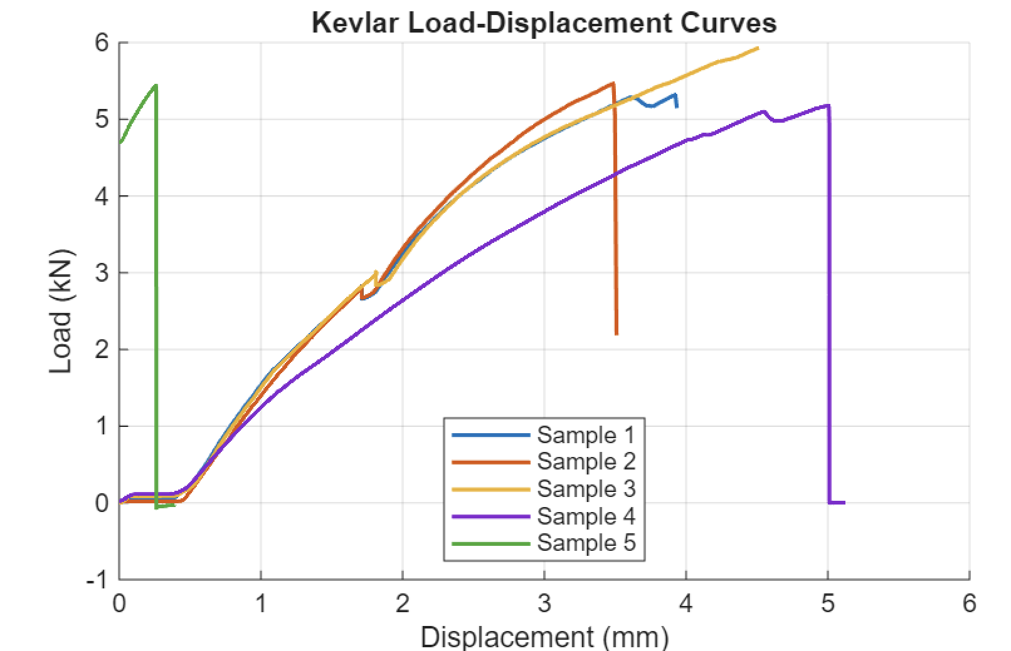

Figure 5- Load and displacement of Kevlar.
Strong resistance to deformation is demonstrated by the Kevlar composite's high average tensile strength of 272.6 MPa and noticeably higher stiffness of 235.5 GPa when compared to aluminium. However, the reduced toughness of 693 MJ/m³ and lower strain to failure at 2.97 indicate limited plastic deformation, with failure being predominantly controlled by fibre breakage rather than yielding. This is a reflection of aramid fibres' load-bearing process, which produces high strength but decreased ductility by effectively transferring stress along fibre directions.
The material is appropriate for impact-resistant applications because of its great load-carrying capacity and minimal energy absorption. The veracity of the results is confirmed by literature, which shows that Kevlar composites generally achieve strengths exceeding 300 MPa depending on fibre orientation (Zhang, et al., 2013).

4.4 Carbon Non-Woven

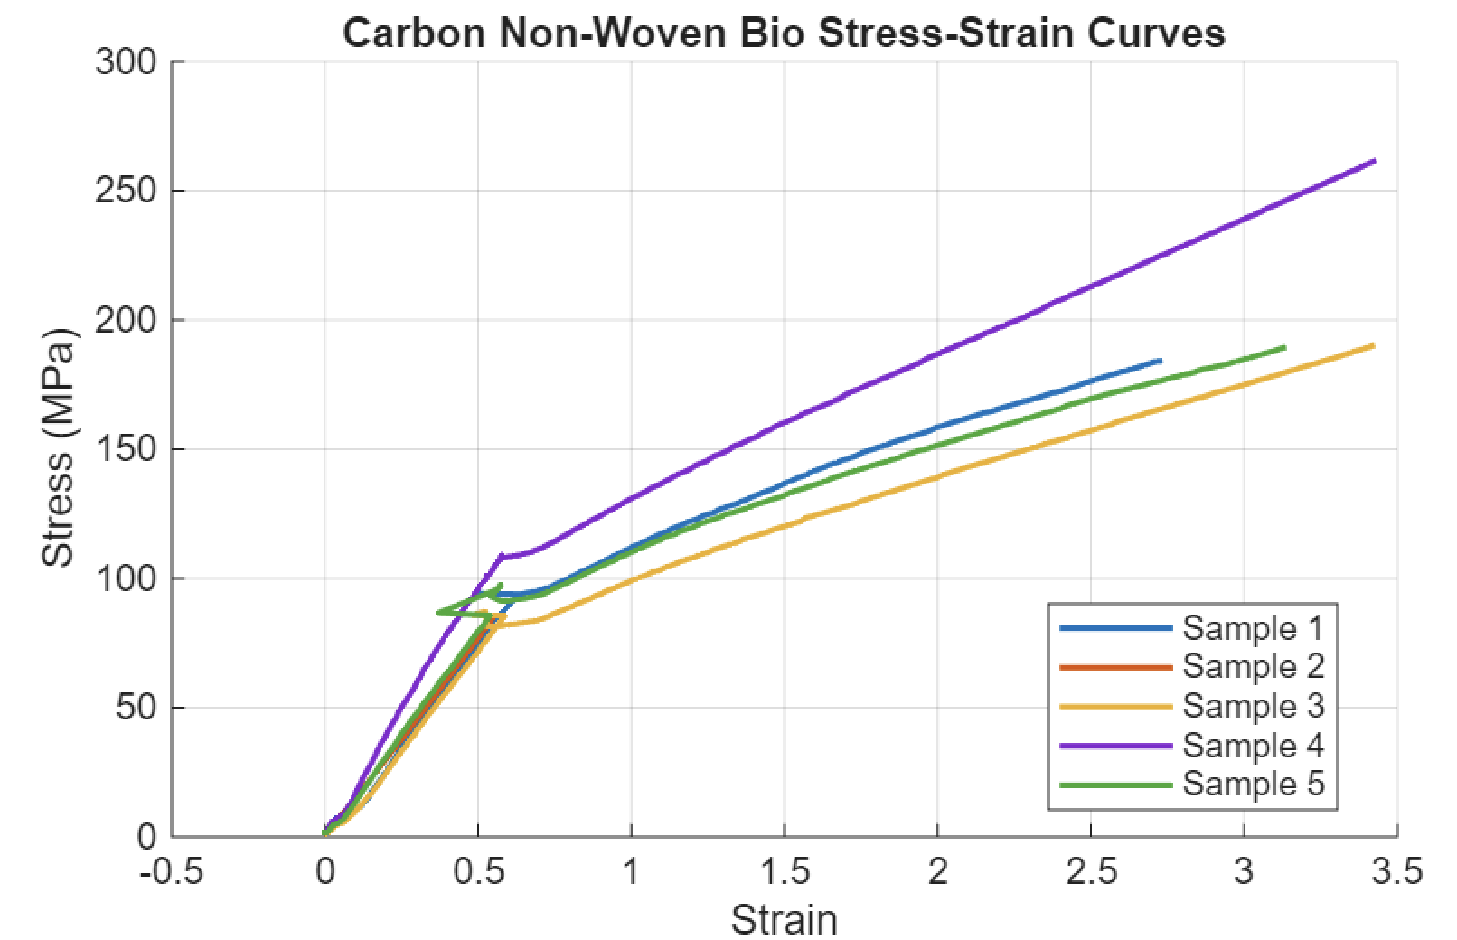
Figure 6- Stress and strain of Carbon Non-Woven.

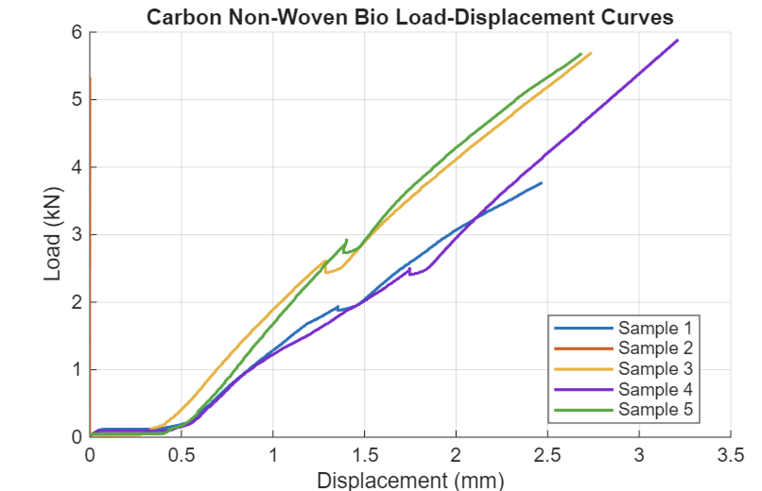

Figure 7- Load and displacement of Carbon Non-Woven.
With an average tensile strength of 200.8 MPa and a low stiffness of 12.3 GPa, the carbon non-woven bio composite exhibits balanced but diminished mechanical performance, suggesting inadequate resistance to elastic deformation. In comparison to conventional carbon composites, the comparatively high strain of 2.66 and moderate hardness of 345 MJ/m³ indicate better deformation capability. The random fibre orientation, which decreases directional strength but permits more uniform stress distribution and progressive failure, controls this behaviour.
As a result, the material shows improved resistance to damage at the price of maximum stiffness and strength. The experimental findings are supported by the literature on non-woven composites, which reports decreased mechanical performance but enhanced isotropy and energy absorption as a result of improper fibre alignment (Faruk, et al., 2012)

4.5 Carbon Woven
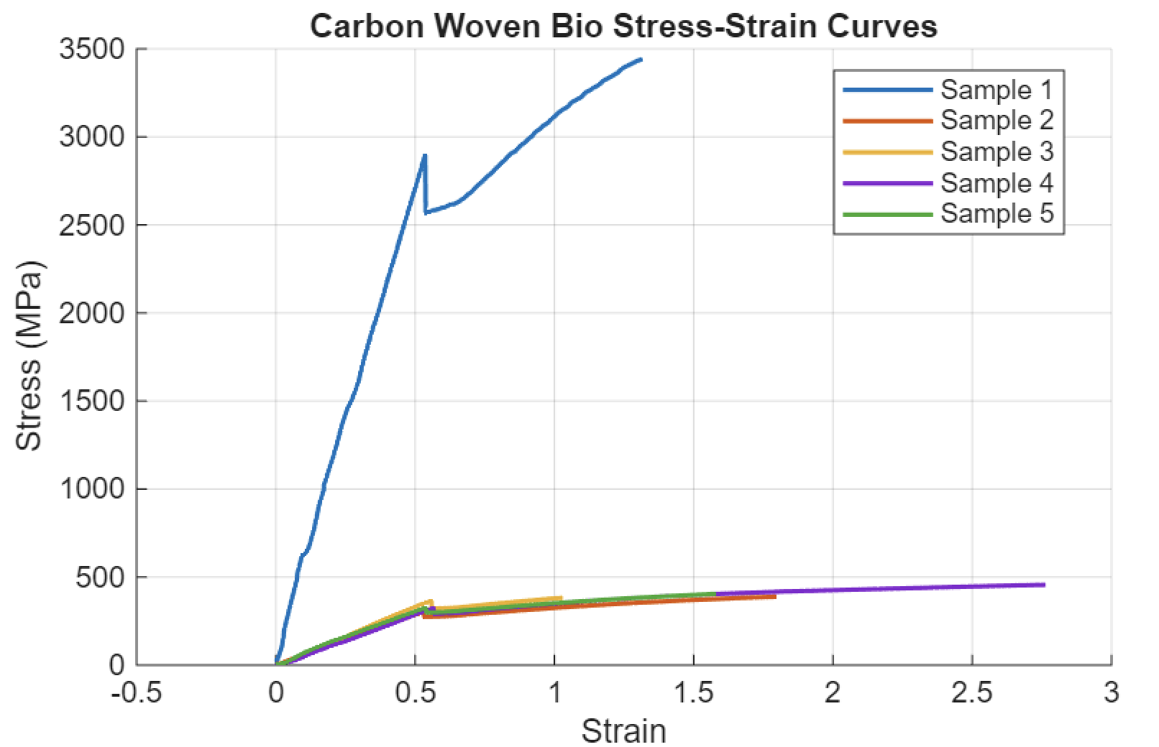

Figure 8- Stress and stain of Carbon Woven.

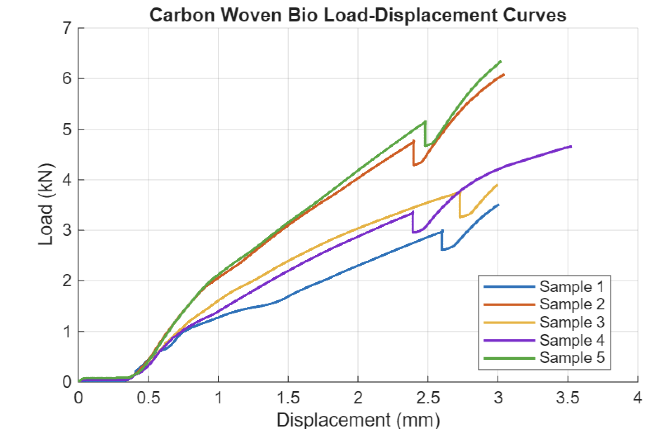

Figure 9- Load and Displacement of Carbon Woven.

With a high average tensile strength of 1014.6 MPa and stiffness of 148.5 GPa, the carbon woven bio composite exhibits noticeably improved mechanical performance, showing robust load-bearing capacity and resistance to deformation. The reduced strain to failure of 1.70 indicates inadequate ductility, with matrix cracking and fibre fracture predominating over plastic deformation. The toughness number of 1066 MJ/m³ shows that energy absorption and strength are in equilibrium.
When compared to non-woven systems, this behaviour indicates effective load transfer along aligned threads inside the woven framework, boosting mechanical performance. Strengths in the range of 600–1200 MPa, depending on fibre architecture, are generally reported in the literature for woven carbon composites (Mallick, 2007), indicating that the experimental results are within predicted limits.

4.6 Flax Non-Woven
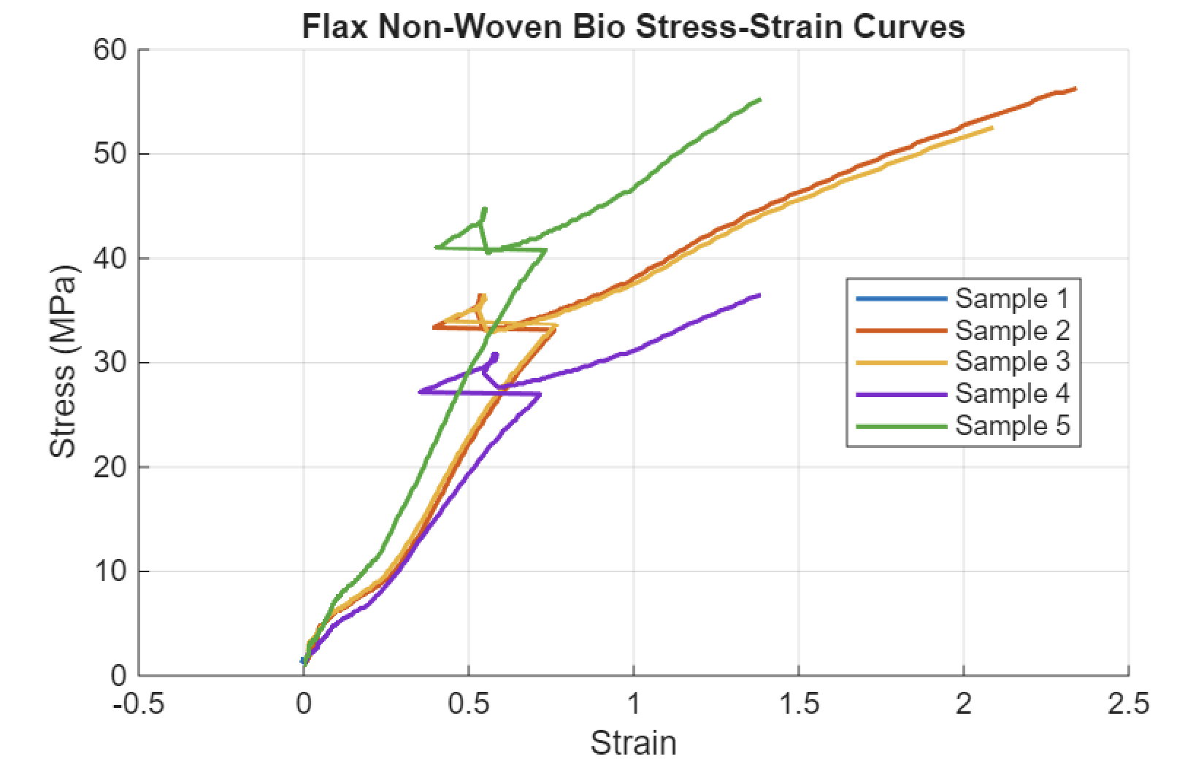
Figure 10- Stress and stain of Flax Non-Woven.
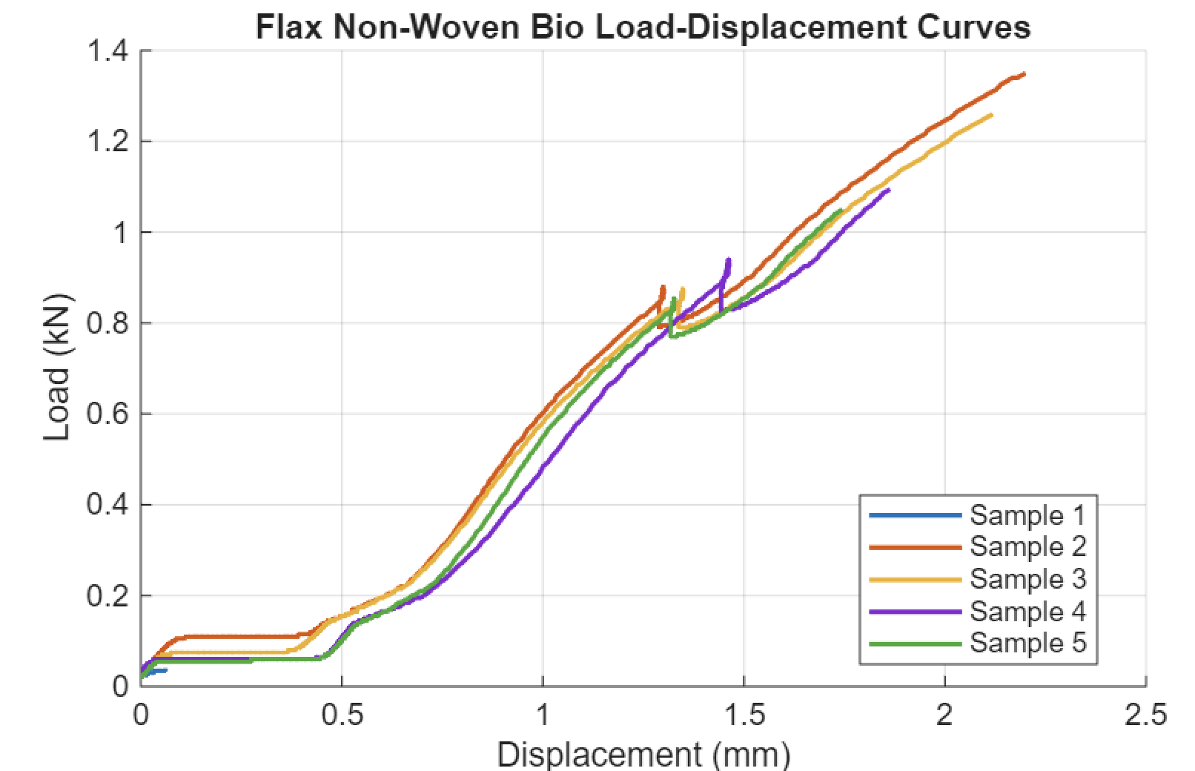
Figure 11- Load and Displacement of Flax Non-Woven.

The flax non-woven composite has the lowest mechanical performance, with a moderate stiffness of 41.6 GPa and an average tensile strength of 50.0 MPa. The extremely low toughness of 47.4 MJ/m³ and comparatively high strain of 1.44 point to inadequate energy absorption and restricted load-bearing capacity. Weak fibre-matrix bonding and random fibre orientation control the behaviour, which leads to ineffective stress transfer and early failure mechanisms such matrix cracking and fibre pull-out.
This implies that while the material might work well for low-load or sustainable components, it is not appropriate for structural purposes. Flax composites with tensile strengths between 30 and 80 MPa have been reported in the literature (Pickering, et al., 2016), which is in good agreement with the experimental results.

4.7 Flax Woven

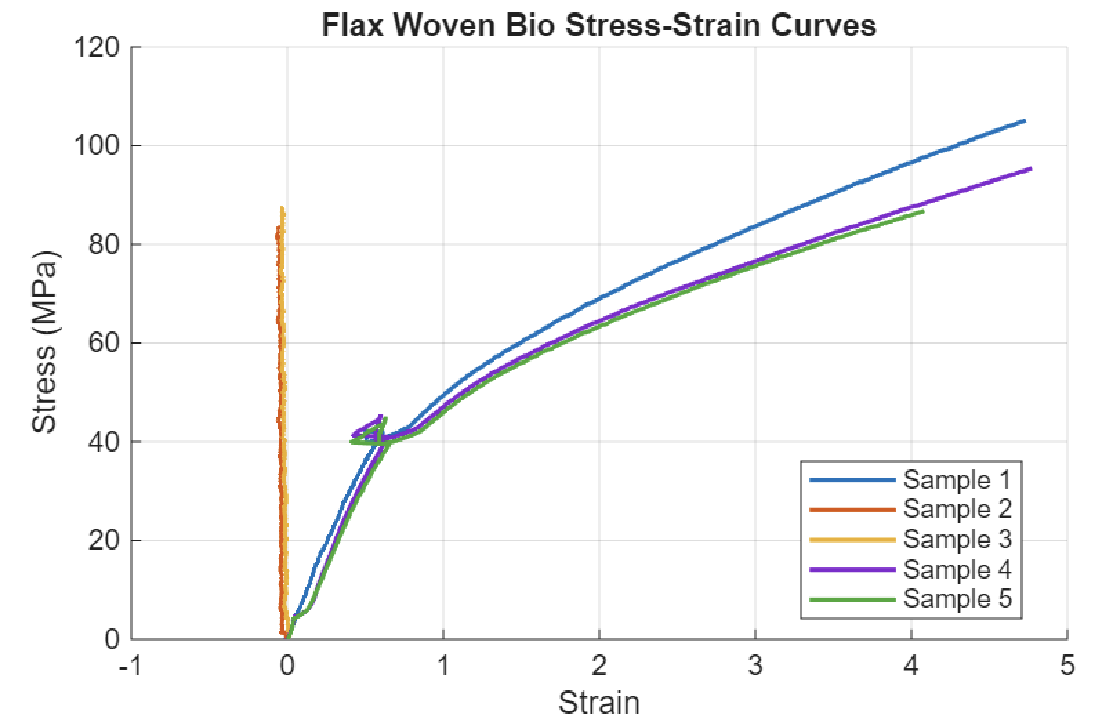
Figure 12- Stress and strain of Flax Woven.
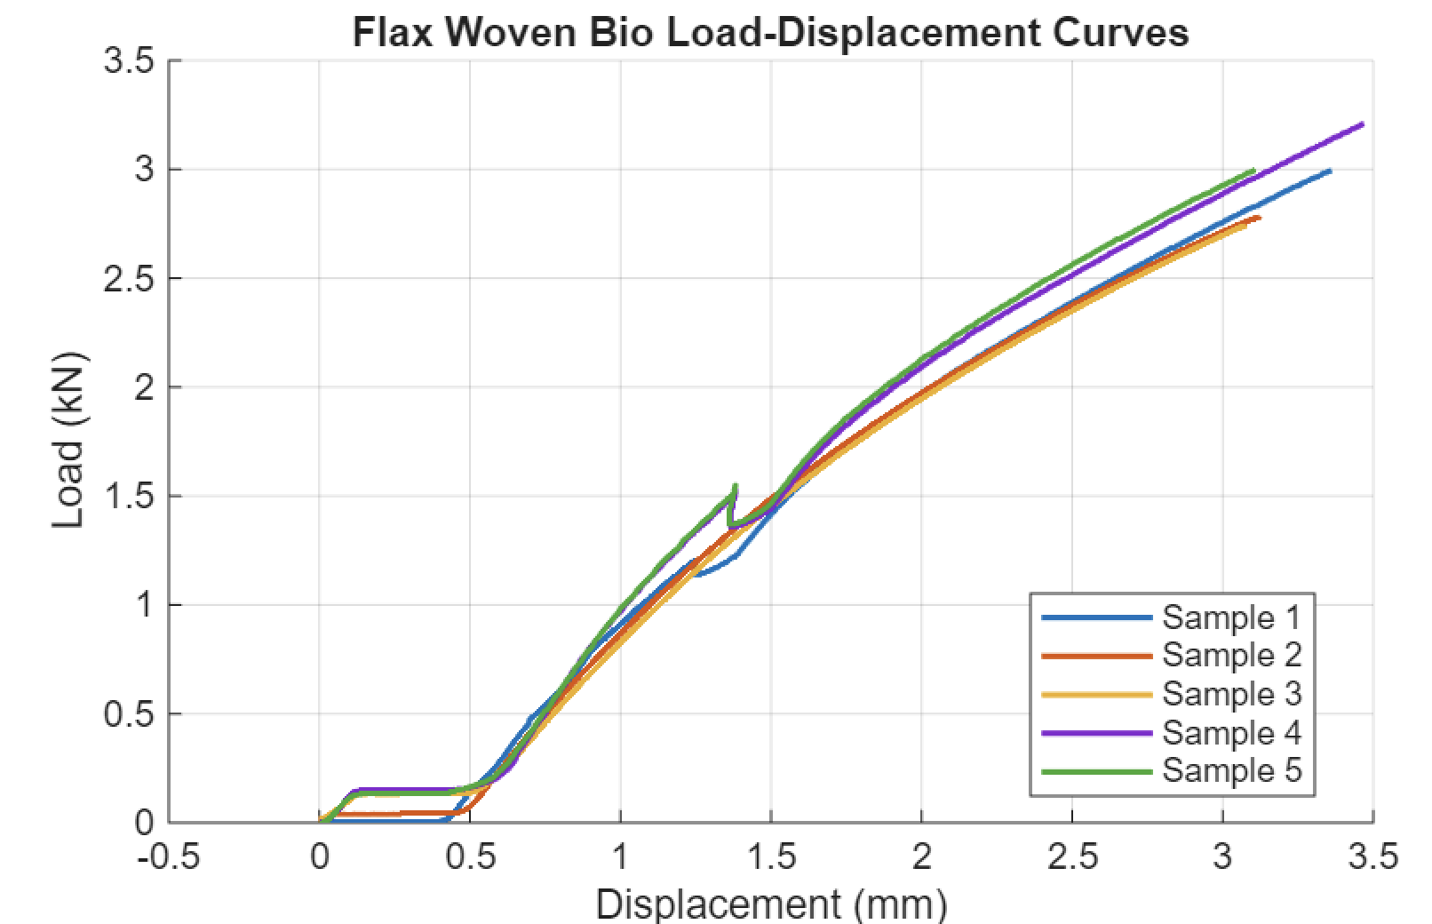
Figure 13- Load and Displacement of Flax Woven.

Because of better fibre alignment, the flax woven composite performs better than the non-woven version. The structured fibre orientation improves load transfer efficiency, leading to higher tensile strength and stiffness even if strength values are lower than those of synthetic composites. A shift from random fibre-dominated deformation to more fibre-controlled load carrying is reflected in the behaviour.
Even with this improvement, the material's hardness and strength are still lower than those of carbon-based composites, suggesting that its structural capabilities is limited. On the other hand, better reliability is suggested by the more consistent mechanical response. Research supports the observed behaviour by confirming that woven natural fibre composites have better mechanical properties than non-woven versions because of better fibre alignment and bonding (Pickering, et al., 2016).

4.8 Carbon Epoxy
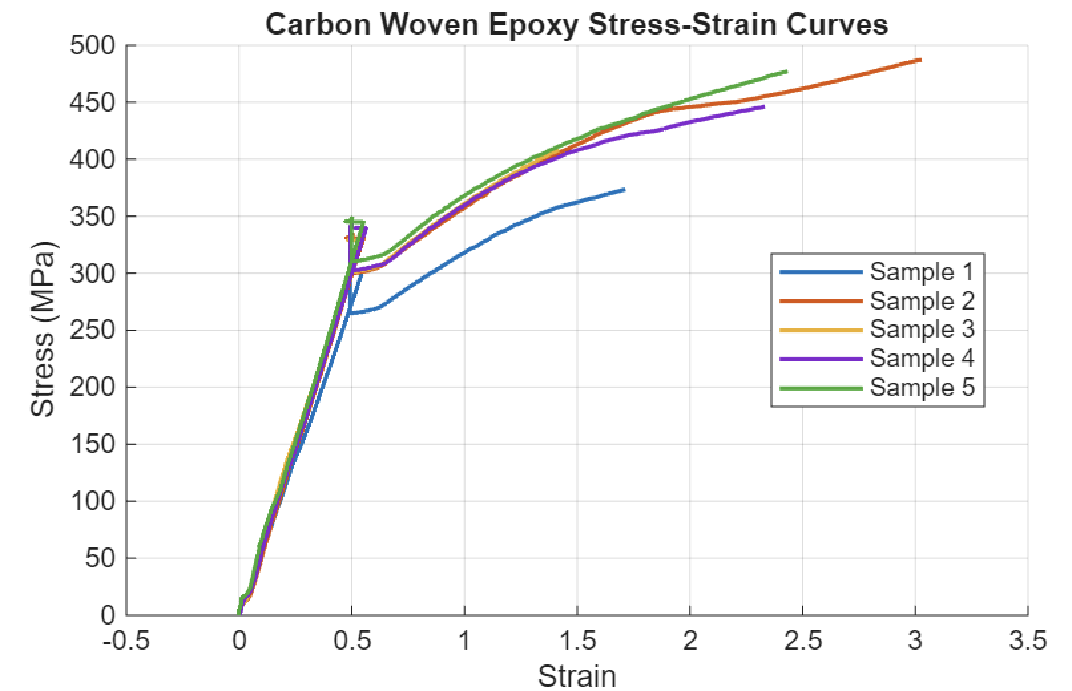
Figure 14- Stress and strain of Carbon Epoxy.

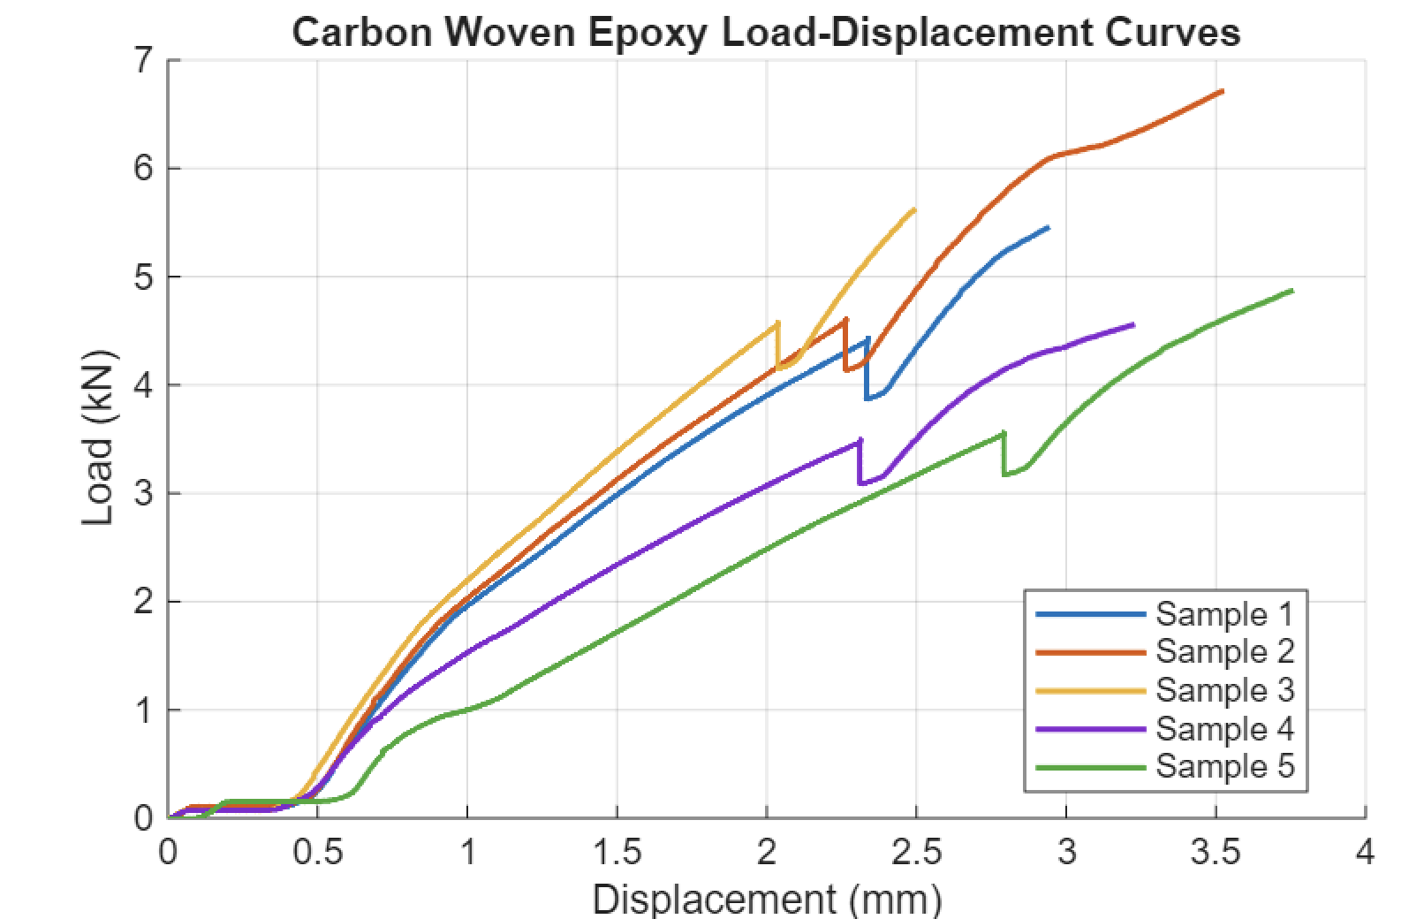

Figure 15- Load and displacement of Carbon Epoxy.

With an average tensile strength of about 450–480 MPa, the carbon woven epoxy composite exhibits great stiffness and strength, suggesting effective load transfer through aligned fibres inside the epoxy matrix. The comparatively low strain to failure in comparison to metals validates a primarily brittle nature, where failure is controlled more by matrix cracking and fibre fracture than by plastic deformation. The material's moderate hardness indicates that it absorbs some energy through progressive damage mechanisms including fibre pull-out and delamination.
This characteristic is typical of fibre-reinforced polymer composites, which prioritise strength and stiffness over ductility. Woven carbon/epoxy composites with tensile strengths ranging from 400 to 800 MPa, depending on fibre architecture and volume percentage, have been reported in the literature (Gibson, 2016), indicating that the experimental findings are within anticipated engineering. The comparatively low strain to failure in comparison to metals validates a primarily brittle nature, where failure is controlled more by matrix cracking and fibre fracture than by plastic deformation. The material’s moderate hardness indicates that it absorbs some energy through progressive damage mechanisms including fibre pull-out and delamination.

4.9 Comparison
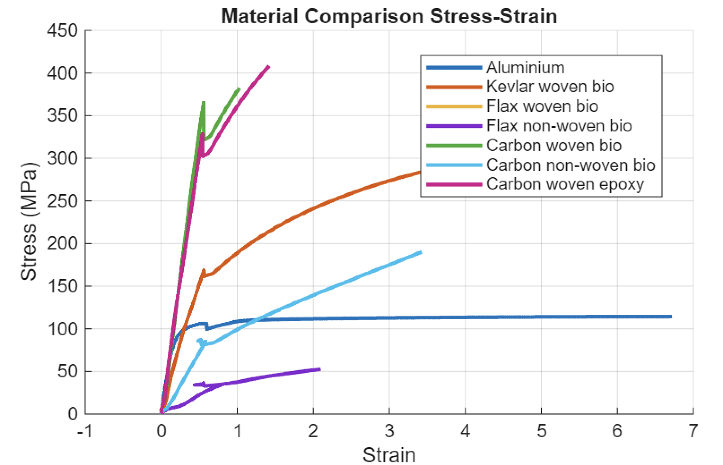
Figure 16- Comparison of all material' stress and strain.
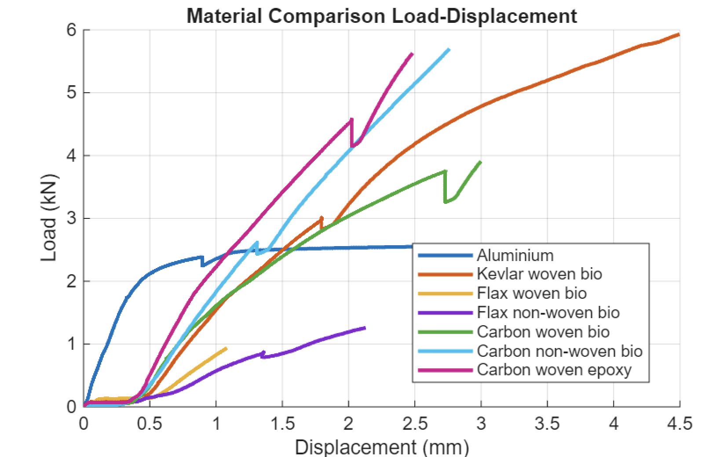

Figure 17- Comparison of all material' load and displacement.

The comparison findings show considerable differences in mechanical performance that are mostly caused by material composition and fibre architecture. The strongest and stiffest composites are made of carbon, especially woven carbon systems, which show effective load transfer along aligned fibres. A fibre-dominated, brittle failure process is confirmed by the carbon woven epoxy and carbon woven biomaterials' exceptional load-bearing capacity and comparatively low strain to failure. The carbon non-woven composite, on the other hand, shows improved deformation capability, indicating increased damage tolerance, but decreased stiffness and strength due to random fibre orientation.
Compared to carbon systems, Kevlar composites have a larger strain capacity, moderate stiffness, and a balance between strength and ductility. The toughness of aramid fibres is reflected in this characteristic, which makes them appropriate for impact-resistant applications. In contrast, aluminium has the maximum energy absorption and ductility but the lowest strength, which is indicative of metallic plastic deformation controlled by dislocation motion.
Overall, natural fibre composites especially those based on flax perform the least mechanically. However, because of better fibre alignment, the woven flax exhibits more strength and stiffness than its non-woven cousin. Overall, the findings support the notion that the primary determinants of mechanical performance are material structure and fibre alignment.

5 Recommendations and Future Developments

5.1 Material Recommendations
Carbon fibre composites, especially woven carbon systems continue to be at their best option for principal load-bearing structures in motorsport and automotive applications according to the experimental results. Although their low strain to failure indicates a brittle failure mode that needs to be taken into account in design, their high tensile strength and stiffness allow for effective load transmission and structural integrity under intense loading conditions (Marsh, 2003). Because of its exceptional toughness and capacity to absorb energy, Kevlar composites are advised for components that are having high impact presented. Because aramid fibres can deform though pull-out and stretching mechanisms, they are appropriate for reinforcing zones and protective constructions. A different mechanical reaction is provided by aluminium, which has a far more ductility and toughness but less strength. This makes it suitable for parts across structures that need to absorb energy and fail gradually. Flax fibre materials and other bio-based composite work well in non-critical applications like secondary structures and body panels. In situations when structural requirements, I’m in the mall, the environmental advantage makes them feasible, despite the poor mechanical performance (Pickering, et al., 2016).

5.2 Sustainability Strategy and Material Trade Off
The results show that this is presently not possible to directly replace conventional composite with sustainable alternatives for high performance applications. Because of the restricted recyclability and energy intensive manufacture, carbon fibre composite, have a high environmental impact, despite the better mechanical performance (Oliveux, et al., 2015). natural fibre composite, on the other hand have less of an environmental impact because they are renewable and need that energy during processing, but this comes at the cost of last stiffness and strength (Joshi, et al., 2004). Therefore, a hybrid material strategy is advised in which sustainable composite is included into non-structural components while higher performance materials are kept in crucial load-bearing areas. With this method, the overall environmental impact can be decreased without sacrificing mechanical performance.

5.3 Application in Motorsport and Automotive Industries
Because of the higher strength to weight ratio, carbon fibre composite should be employed for chassis and aerodynamic components in the motorsport. To increase to durability and safety in impact prone regions, Kevlar can be incorporated. Aluminium is still useful for structural elements that need to be ductile and absorb energy. The use of sustainable materials has more promise in automotive sectors where natural composite materials are used in non-structural parts, body, panels, and interior components, where performance requirements are low. Manufacturers can successfully balance, performance, safety, and environmental concerns by implementing hybrid material systems. The strategy maintains functional needs while moving forward towards more environmentally friendly engineering approaches (Mayyas, et al., 2012).

5.4 Future Research and Development
To enable broader structural application, future research should concentrate on enhancing the mechanical performance of sustainable composite materials. Improving fibre matrix bonding bio-composites to increase strength and load transfer efficiency in one of the key topics. Improvements in fibre alignment methods could greatly increase stiffness and strength while preserving sustainability advantages, especially for non-woven fabrics. Furthermore, a crucial step in lessening the influence on the environment is the creation of recyclable composites systems and bio-based polymers. A balance between performance and sustainability may be possible with more research into hybrid composites, which combine natural and synthetic fibres (Fiore, et al., 2016).

6 Conclusion
This study has shown that there is a definite trade-off between mechanical performance and sustainability when choosing materials for motorsport and automotive applications. According to the experimental findings, carbon composites especially woven and epoxy carbon had offered the best stiffness and tensile strength, which makes them ideal for high performance and primary load-bearing applications. However. Important sustainability issues are highlighted by their brittle failure behaviour and substantial environmental effect, which are caused by highly intensive production and restricted recyclability.
On the other hand, aluminium demonstrated less strength but far higher ductility and toughness, allowing for higher energy absorption and more gradual failure characteristics. Despite greater initial manufacturing impacts, it reinforces its value as a sustainable material.
Because of their renewable sources and reduced lifecycle effect, natural fibre composites such as flax showed the lowest mechanical performance but offered environmental benefits. They are a good choice for non-critical applications where sustainability is more important than performance, but they are not appropriate for heavily pressured structural components.
Overall, the results encourage the use of a hybrid material approach, in which sustainable materials are included into secondary components and high-performance composites are kept for important structures. To allow for wider application and lessen the environmental impact of sophisticated engineering systems, future development should concentrate on enhancing the mechanical dependability and recyclability of bio-composites.

References
Ajayi, N. et al., 2025. A comprehensive review of natural fiber reinforced Polymer composites as emerging materials for sustainable applications. Applied Material Today, Volume 43.
Al-Alimi, S. et al., 2024. Recycling aluminium for sustainable development: A review of different processing technologies in green manufacturing. Results in Engineering, Volume 23.
Alrehaili, E., Nurdiawati, A. & Al-Ghamdi, S., 2025. Sustainable composites for metal replacement: Environmental assessment and material selection of fiber-reinforced polymer across industries. Resources, Conservation & Recycling Advances, Volume 28.
Alrehaili, E., Nurdiawati, A. & Al-Ghamdi, S., 2025. Sustainable composites for metal replacement: Environmental assessment and material selection of fiber-reinforced polymer across industries. Resources, Conservation & Recycling Advances, Volume 28.
Anon., n.d. [Online]
Available at: https://www-materials.eng.cam.ac.uk/mpsite/interactive_charts/recycling-cost/basic.html?utm_source=chatgpt.com
Bandaru, A. K. et al., 2016. Ballistic impact response of Kevlar® reinforced thermoplastic composite armors. International Journal of Impact Engineering, Volume 89, pp. 1-13.
Callister, W. & Rethwisch, D., 2018. MATERIALS SCIENCE and ENGINEERING: An Introduction. s.l.:s.n.
De, B. et al., 2024. A comprehensive review on fiber-reinforced polymer composites: Raw materials to applications, recycling, and waste management. Progress in Materials Science, Volume 146.
Faruk, O., Bledzki, A. K., Fink, H. P. & Sain, M., 2012. Biocomposites reinforced with natural fibers: 2000–2010’. Progress in Polymer Science, 37(11), pp. 1552-1596.
Fiore, V. et al., 2016. A new eco-friendly chemical treatment of natural fibres. Composites Part B, Volume 85, pp. 150-160.
Gibson, R. F., 2016. A review of recent research on mechanics of multifunctional composite materials and structures. Composite Structures, 92(12), pp. 2793-2810.
Hirsch, J., 2011. Recent development in aluminium for automotive applications. Transactions of Nonferrous Metals Society of China, 21(11), pp. 2525-2532.
Joshi, S. V., Drzal, L. T., Mohanty, A. K. & Arora, S., 2004. Are natural fiber composites environmentally superior?. Composites Part A, 35(3), pp. 371-376.
Koronis, G., Silva, A. & Fontul, M., 2013. Green composites: A review of adequate materials for automotive applications. Composites Part B: Engineering, 44(1), pp. 120-127.
Lu, L. et al., 2024. A new strategy to develop simple and efficient monochrome and white organic light-emitting diodes. Material Today , Volume 74, pp. 109-120.
Majumdar, A., Butola, B. S. & Arivastava, A., 2013. An analysis of deformation and energy absorption modes of shear thickening fluid treated Kevlar fabrics as soft body armour materials. Materials & Design, Volume 51, pp. 148-153.
Mallick, P., 2007. Fiber-Reinforced Composites: Materials, Manufacturing, and Design. 3rd edn. Boca Raton: CRC Press..
Margoto, O. & Milani, A., 2025. Comparing flax fibre/biopolymer woven composites with carbon fibre-enhanced, partially green alternatives: Mechanical performance versus sustainability. Composites Part C: Open Access, Volume 16.
Marsh, G., 2003. Reinforced plastics: an industry overview’. Materials Today, 6(11), pp. 36-43.
Mayyas, A., Qattawi, A., Omar, M. & Shan D, 2012. Design for sustainability in automotive industry: A comprehensive review. Renewable and Sustainable Energy Reviews, 16(4), pp. 1845-1862.
Oliveux, G., Dandy , L. O. & Leeke, G. A., 2015. Current status of recycling of fibre reinforced polymers. Progress in Materials Science, Volume 72, pp. 61-99.
Oller, E. & Marí, A. R., 2013. Long-term bond stresses and debonding failure of FRP-strengthened RC cracked members. Composites Part B: Engineering, Volume 52, pp. 30-39.
Pakdel, E., Kashi, S., Varley, R. & Wang, X., 2021. Recent progress in recycling carbon fibre reinforced composites and dry carbon fibre wastes. Resources, Conservation and Recycling, Volume 166.
Pickering, K. L., Aruan Efendy, M. G. & Le, T. M., 2016. A review of recent developments in natural fibre composites and their mechanical performance. Composites Part A: Applied Science and Manufacturing, Volume 83, pp. 98-112.
Pickering, K. L., Efendy, M. G. & Le, T. M., 2016. A review of recent developments in natural fibre composites. Composites Part A: Applied Science and Manufacturing, Volume 83, pp. 98-112.
Polmear, I. J., 2005. Light Alloys. s.l.:s.n.
Soutis, C., 2005. Fibre reinforced composites in aircraft construction. Progress in Aerospace Sciences, 41(2), pp. 143-151.
Wodag, A. et al., 2025. A review of flax fiber reinforced polylactic acid composites as green polymeric materials: Ageing properties, sustainability, challenges and future perspectives. Materials Today Sustainability, Volume 31.
Yan, L., Chouw, N. & Jayaraman, K., 2014. Flax fibre and its composites – A review. Composites Part B: Engineering, Volume 56, pp. 296-317.
Zhang, J., Chevali, V., Wang, H. & Wang, C.-H., 2020. Current status of carbon fibre and carbon fibre composites recycling. Composites Part B: Engineering , Volume 193.
Zhang, X. et al., 2013. Interfacial microstructure and properties of Kevlar fiber composites: A review. Composites Part B: Engineering, Volume 55, pp. 499-506.

Table of Figures
Figure 1- Recyclability of materials (Anon., n.d.). 6
Figure 2- Stress and strain of aluminium. 8
Figure 3- Load and displacement of aluminium. 8
Figure 4- Stress and strain of Kevlar. 10
Figure 5- Load and displacement of Kevlar. 10
Figure 6- Stress and strain of Carbon Non-Woven. 12
Figure 7- Load and displacement of Carbon Non-Woven. 12
Figure 8- Stress and stain of Carbon Woven. 14
Figure 9- Load and Displacement of Carbon Woven. 14
Figure 10- Stress and stain of Flax Non-Woven. 16
Figure 11- Load and Displacement of Flax Non-Woven. 16
Figure 12- Stress and strain of Flax Woven. 18
Figure 13- Load and Displacement of Flax Woven. 18
Figure 14- Stress and strain of Carbon Epoxy. 20
Figure 15- Load and displacement of Carbon Epoxy. 20
Figure 16- Comparison of all material' stress and strain. 22
Figure 17- Comparison of all material' load and displacement. 22

