Junior Nduduzo Tshili
Student number: (1917482)
Module: BMSW4003 Digital Skills and Research Methods - Term 2 Resit
Word count: 1734

Virtual learning has become a major factor as to how students at UWTSD’s learn and greatly contributes to their overall learning experience. As technology continues to change the world and how we operate the implementation of virtual learning in to UWTSD student’s curriculum has brought about significant change such as allowing work allocation and completion to be done both inside and outside of the classroom. The virtual learning platform that UWTSD uses is called Moodle, through this platform there are multiple applications within it such as email, where students can access their student emails and stay notified on any information from the university and their Module leaders. The calendar application is where students can see a calendar that will depicts their academic schedule showing them what date and time, they have classes as well as when they have assignment deadlines.
The virtual learning Moodle library application is a useful tool which student of UWTSD can use within their studies to contribute to their work, this application allows for students to browse as well as read and cite from academic texts and academically supported literature. There is also an application within the virtual learning portal Moodle called my TSD which students can use to see their assessment results as well as keep track with their academic performance. Virtual learning is a digital tool that is intended to help students at UWTSD have access to more resources and learning material during their studying time as well as at home. There are many benefits to Virtual learning platforms, and they contribute to the students of UWTSD in beneficial ways such as, allowing students to keep track of deadlines as their assignment briefs and all relevant information is published on the virtual learning portal.
Students have the ease of access to all of their various module curriculum and due to this, reflecting on teachings from lectures can now be done in their spare time, if there is any work that the student might not be clear on, they can revise with notes and word documents as well as any power point presentations that the lecturer would have presented to them during the class. The creation and implementation of a virtual learning environment is a beneficial part to the UWTSD curriculum due to the point that it allows students to be independent in their learning experience and it brings to them all of the major resources that they might need to successfully study, and complete tasks allocated to them by their module leaders.
Although Virtual learning was designed to benefit the students of UWTSD it also comes with its disadvantages. Some of the disadvantages that are factored into the use and experience of virtual learning at UWTSD include the lack of instructions on how to use the virtual learning environment in practice from lecturers, as this platform is not like any other it may be confusing to some of the students at UWTSD who experience in might not have using such an application such as this one before. Another disadvantage is that the educational tools and services provided on Moodle are not allows reliable, there have been cases of program errors which have cause services such as the library feature not to work as intended as well as various links to external sites and programs such as Turnitin not functioning correctly or lagging. Due to the purpose that students are using Virtual learning more it is imperative that the most up to date information and forthcoming events are published for UWTSD students to view as this has not allows been the case and this has caused confusion on timetables as well as assignment scheduling.
In order to understand what the students of UWTSD are experiencing when using the Virtual learning environment Moodle and how they feel about the inclusion of this virtual learning environment into their curriculum data needs to be collected. Data collection is a reliable and effective way of assessing a situation and to clearly understand and define what data might be causing specific results. According to Questionpro “Data collection is defined as the procedure of collecting, measuring and analysing accurate insights for research using standard validated techniques. A researcher can evaluate their hypothesis on the basis of collected data”. By collecting data on how the students of UWTSD find the virtual learning environment Moodle will help me to get clear insight as to if Moodle is beneficial for the learning experience of the students at UWTSD or if it further complicates their learning experience or it does not change anything at all.
There are several ways to collect data for an analysis, such include mail surveys, online surveys, in-person interviews and phone surveys. The first step in collecting data is understanding what type of data to collect and what it has the aim of showing. I have decided to carry out a questionnaire with which I will ask 24 students at UWTSD a variety of questions that all intend on me collecting primary data on their personal experiences and opinions on the virtual learning environment (Moodle) at the UWTSD. As stated by Glen. S “Primary data is data that is collected by a researcher from first-hand sources, using methods like surveys, interviews, or experiments. It is collected with the research project in mind, directly from primary sources”. By collecting primary data from the students at UWTSD it will allow me to take the information that they have contributed, and I will turn it in to a survey which will give insight on the students of UWTSD’s opinion on the effectiveness and opinion on the virtual learning environment that they have available at their University. I will be collecting primary data through handing out my colleagues via email a questionnaire I have created that features 8 questions which are all based on the UWTSD students experience with the virtual learning environment (Moodle). I chose to create my questionnaire with a variety of different questions such as multiple choice, open ended questions and yes and no questions, by providing my survey participants with a variety of questions I increased the amount of data that I was able to collect and therefore allowing me to get better insight in to the experience and opinions of the UWTSD students who use the virtual learning environment Moodle.

After carrying out my survey by sending each of the 24 UWTSD students the survey that I created I am going to take the results and then put them up against other secondary data. According to questionpro “Secondary data is data that is already existing. Existing data is summarized and collated to increase the overall effectiveness of research”. that I have collected from online sources about how the impacts of virtual learning environment has had on students. After I have collected the primary data through my questionnaire, I will convert thins data into a survey which I will display as a survey result diagram which I will create on Excel and this will be the final format which I will present my findings which I can then further compare against other secondary data that I find through independent research on the web on the subject of virtual learning environment Moodle on the students of UWTSD.

When handling data it is necessary to follow data protection regulations and protocol as the data, I am collecting from the students of UWTSD and their experience on the virtual learning environment (Moodle). Therefore, as part of data protection I will be informing the participants on how and where their data will be used and that will be in my survey that I will be contributing to my assignment as well as not including the names and identities of the participating students, instead only their answers to my questionnaire will be used in my survey creation and overall data analysis. As stated by Rouse.M “Data protection is the process of safeguarding important information from corruption, compromise or loss”. The collection of data is as important as the protection of it and storing of it as it is clear and confidential between me and the people partaking in my questionnaire and survey that I am solely using their data for research purposes and that their data will not be used for other purposes and it will not be shared other than in my assignment. The results of my survey have shown although there is a close margin the majority of UWTSD students have found virtual learning environment moodle beneficial and a great tool alongside their studies at UWTSD. Carrying out this study has shown that it the use of VLE Moodle at UWTSD is having a positive impact on the learning experience of the students at the university as well as aiding in their academic performance. Such data can then become secondary data, with discloser to the survey participants in regard to their data being potentially used for this in the future by being compared against universities who might be thinking about implementing the use of a virtual learning environment and are in doubts at how beneficial it could be. Data analysis is crucial in helping resolve problems, finding solutions and areas of improvement as well as tracking progress and effectiveness of products and services.

The results that I collected from the individual questionnaires that each of the 24 UWTSD students that partook in my questionnaire where then counted up, I then created a survey which displays the over all results of all of the students and which responses they gave and for each question of the questionnaire it shows in my survey the cumulative students that marked each individual option. By formatting the questionnaire data into a survey, I am able to see what margin of students deem UWTSD’s virtual learning environment having a positive or negative effect on their learning experience as well as if they are understanding and utilising the feature.

Below are the cumulative results of each of my 8 Questionnaire questions on Virtual learning environment (Moodle) carried out by 24 students at UWTSD.

Survey Results
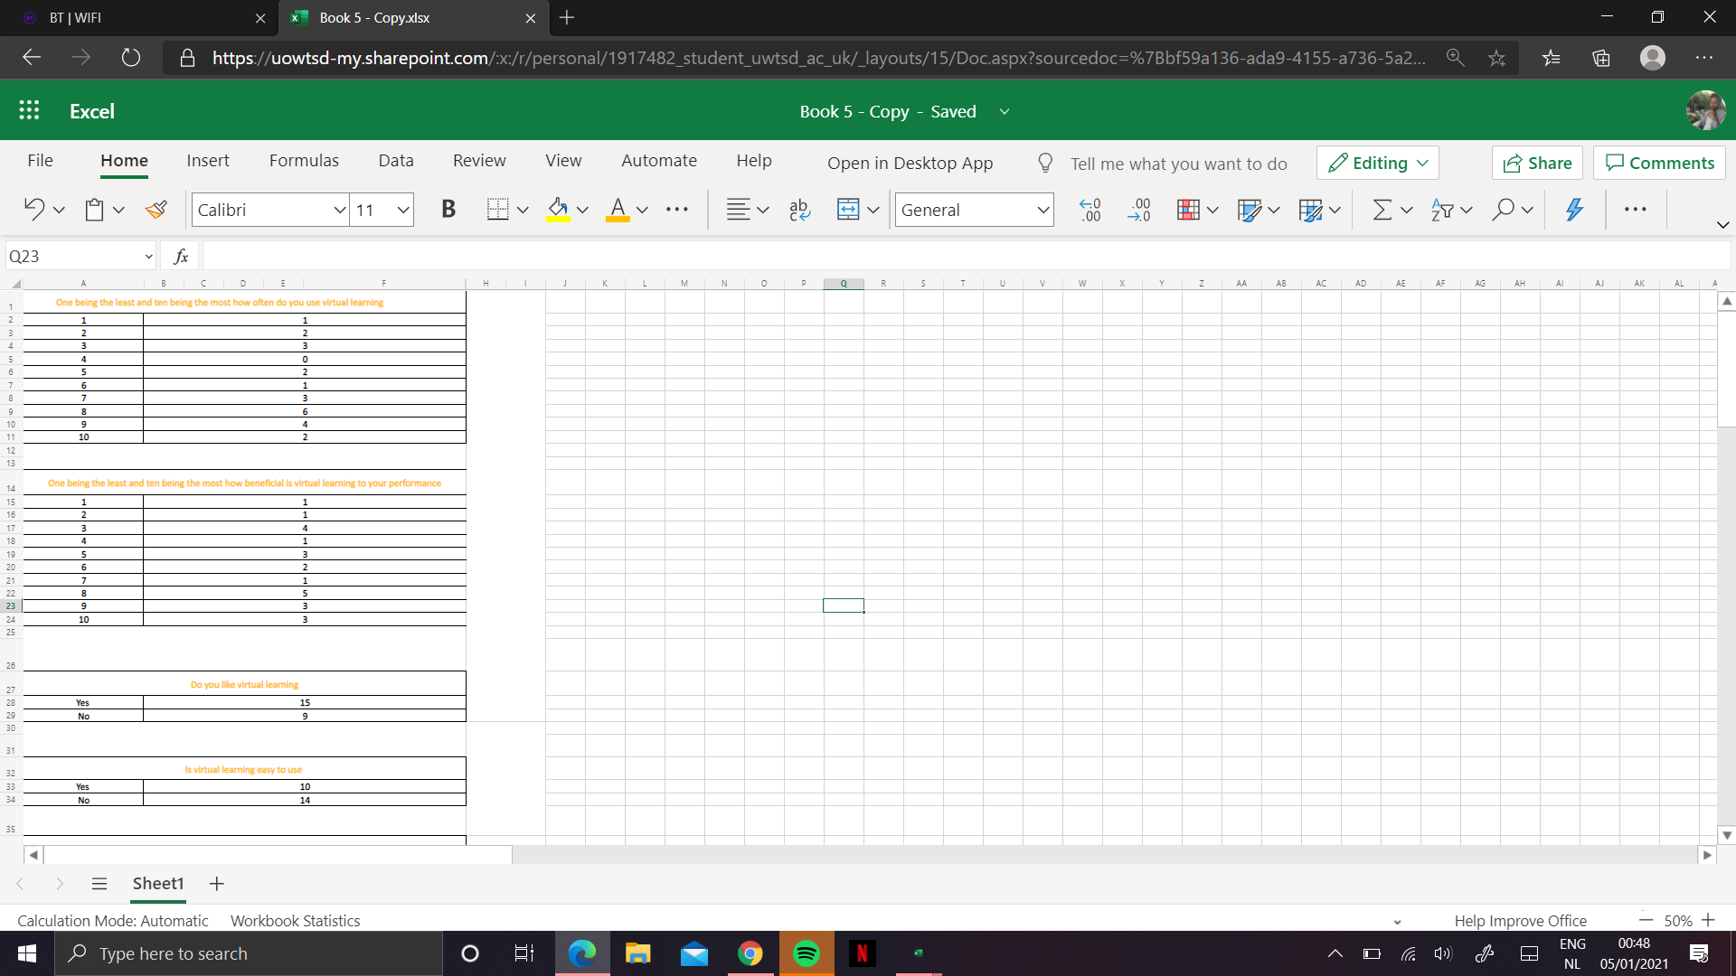
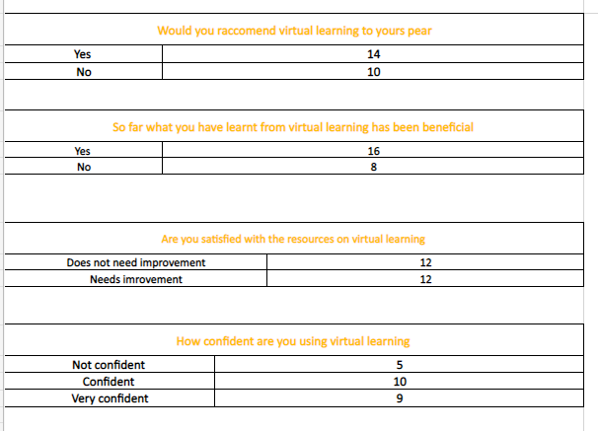

Reference List

Glen. S
Primary Data and Secondary Data definition and example
From www.statisticshowto.com
Accessed 12/12/2020

Rouse.M
Data Protection
www.searchdatabackup.techtarget.com
Accessed 15/12/202

By www.questionpro.com
Data Collection: Definition, Methods, Examples and Design
Accessed 14/12/2020

By www.questionpro.com
Secondary Research- Definition
Accessed 23/12/2020

