Rajab Ali Raja Learning in Digital Era- Component 1
ACCA4025

https://editor.wix.com/website/builder?storyId=bd7f5cec-078b-4b23-b69f-d5da5584c881#!/builder/story/bd7f5cec-078b-4b23-b69f-d5da5584c881:e0767e43-f64d-459c-a0b7-1d60ebe60bd2

Contents
Essential Skills for Study and Employment. 1
Create an online e-portfolio. 3
Mendeley User Guide 3
Life Is A Team Sport. 4

Q1 Computing Skills for the Workplace (CertHe)
Unit1 Task 1

Essential Skills for Study and Employment.
Depending on the precise skills they pick up and develop during their time at university, a student has to leave with a variety of attributes. Each student will develop personal and professional qualities along the way that people and employers will value and that will also set them apart. You'll probably be a strong candidate to apply for employment that fit you because of your training and habits. Employers value a specific set of behaviours known as employment skills.

Some of the skills are valued in employment that students will benefit from:

Communication.

a necessary ability where effective interpersonal communication is important.
Your verbal and written communication abilities will vary depending on the type of evaluation, including blogs, vlogs, reports, reports on assignments, and other formats. You must be able to speak verbally if you want to deliver presentations and reports to colleagues and clients within an organisation. It's crucial to listen to people in order to comprehend their perspectives.

Working to deadlines.

a talent necessary in circumstances where effective interpersonal communication is essential.
Your written and verbal communication abilities may vary depending on the type of the evaluation, such as blogs, vlogs, reports, reports on assignments, and other formats. You must be able to speak clearly if you wish to provide presentations and reports to clients and colleagues inside of a company. It's crucial to listen to people in order to comprehend their perspectives.

Team working and collaborating with fellow students.

Working with fellow students can assist put together various components of any project or group work because everyone has a variety of skills to contribute. having the capacity for effective communication, including the capacity to listen to and comprehend one another Along with verbal and writing talents, this is also useful. good teamwork skills, the capacity to maintain focus, and the ability to meet deadlines.

Critical thinking.

Thinking creatively, engaging in active learning, spotting issues, organising and classifying any knowledge gathered—evaluating what works and what doesn't. Advance and carry out justifications.
What can the situation be improved upon, and how can it be overcome?

Since part of the information is comparable because it is based on research, I would consider my similarity score to be fair. I might use different sources in the future to acquire a score that might be even lower. I might reread the document and try to improve the wording. In order to explore how I may earn a better grade; I would look into receiving assistance from my professor. I was able to have a general understanding of how the university's marking procedures operate thanks to this. I am happy with the overall outcome because the reference provided the majority of the marks.

References:

[1]K. (James K. Gallagher, Essential study and employment skills for business and management students, Fourth edition. Oxford: Oxford University Press, 2022. (accessed 12 Jul 2022

[2]Sheila Kloefkorn.(22 Nov 2016) 12 Essential Skills Every Employee Should Have(online) https://www.eskill.com/blog/essential-skills-employees/ (accessed 11 Jul 2022)

[3]ByMarissaCampbell(2022)top5skillsemployerslookforhttps://newmanu.edu/top-5-skills-employers-look-for(accessed 14 Jul 2022)

[4] Ariely, D. and Wertenbroch, K. (2002). 'Procrastination, Deadlines, and Performance: Self-Control by Precommitment,' Psychological Science, 13(3), 219-224. https://www.mindtools.com/pages/article/meet-deadline.htm(accessed 13 Jul 2022)

[5]S. Cameron, The business student’s handbook : skills for study and employment, Seventh edition. Harlow, England: Pearson Education, Limited, 2021.

Task 2a1.

Create an online e-portfolio.

I have created an online portfolio using Wix. Please find the URL below so that you can access my Wix website for my E portfolio.

https://editor.wix.com/website/builder?storyId=bd7f5cec-078b-4b23-b69f-d5da5584c881#!/builder/story/bd7f5cec-078b-4b23-b69f-d5da5584c881:e0767e43-f64d-459c-a0b7-1d60ebe60bd2

My Eportfolio was constructed on a web builder called Wix. The task was quite complicated it took time to get the hang of all the different sections to work through and the pages to add. I then chose the black and blue theme, and called it ‘MEET RAJAB’ each section has the slogan at the bottom which I felt was nice and easy on the eyes.
On some occasions adding my tasks as a link was quite challenging at times it would allow me to add it and other times, I would have to repeat it several times. Not sure whether that’s something that is a problem at the website and whether I was doing something wrong but in the end it all came together. I did get some help from online like watching videos to help me navigate around the Wix website builder.

Mendeley User Guide

The only drawback to this approach is that it only produces good results for journal articles.
Adding a certain file or folder from your computer is another method of populating your library.

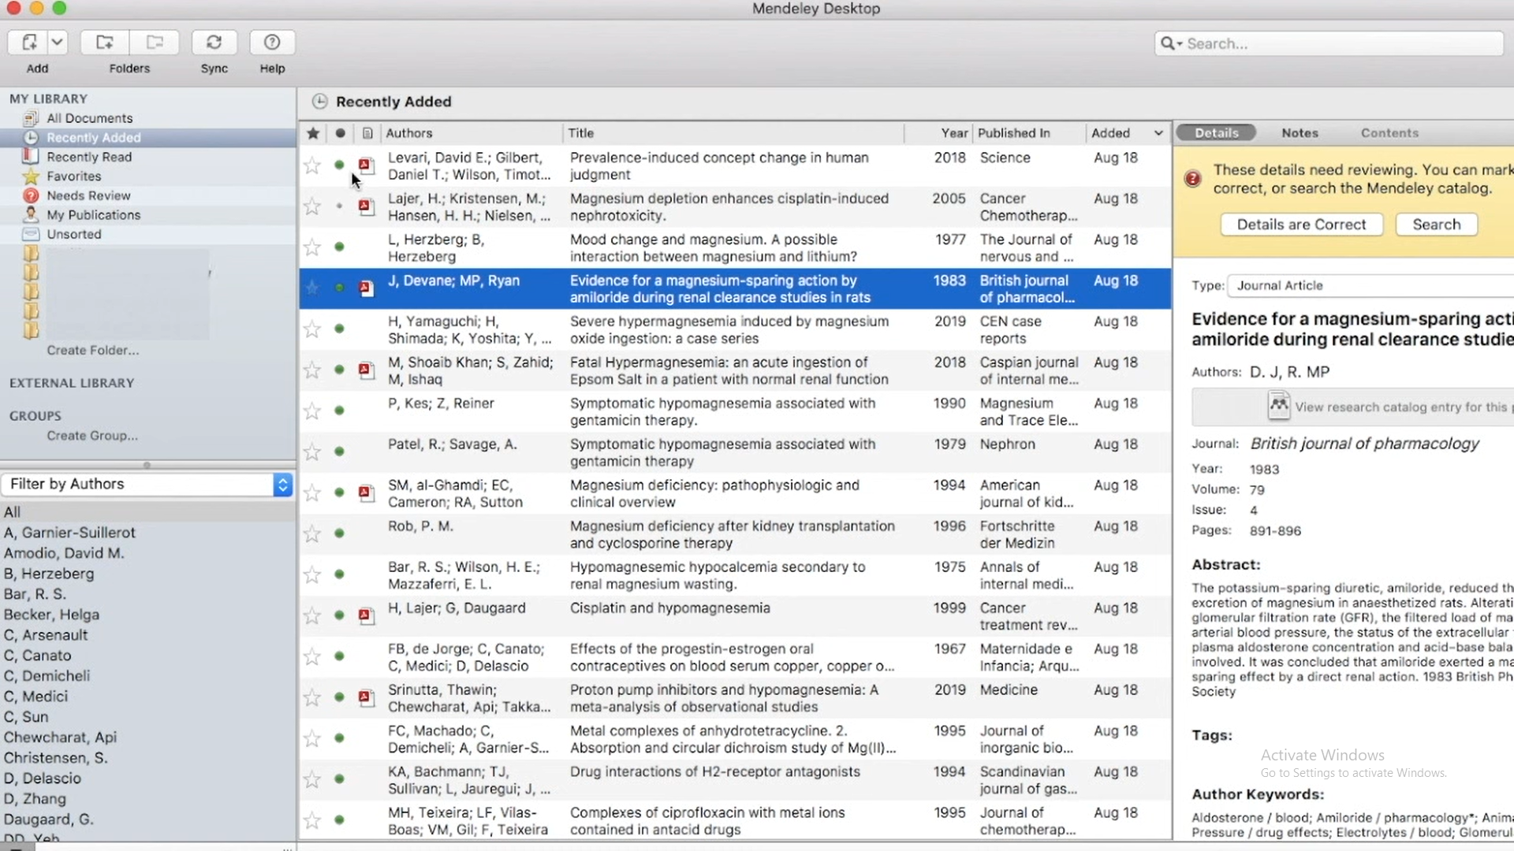
Manually creating an entry is another technique to fill your library; examples of this include
used to create entries for objects like books and articles that are not in pdf forms.
and once you've completed any other form on this screen, just press save.
have entered the necessary data.
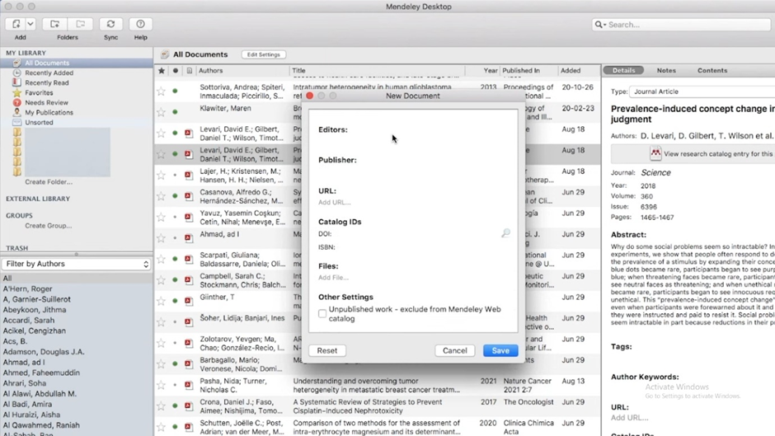

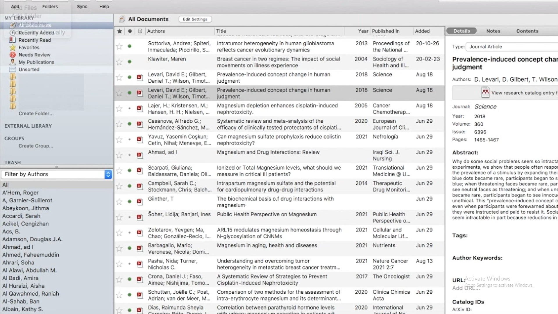

If you want to make a citation, you must first use the file menu to add files or add folders and find the document from a location on your computer rather than dragging and dropping. Mendeley library allows you to easily cite materials that you've added to your library in Microsoft Word. It can also easily generate a bibliography of the materials you've referenced in your paper once you've installed the plugin.
Mendeley's web importer, an extension for web browsers, is incredibly helpful if you need to cite a web page. Simply place your cursor where you want to input the citation and click the insert citation button on the toolbar under the references tab.

Task 4) Unit 2 on Moodle and Academic poster

Life Is A Team Sport.
Qualities Of A Good Team Member.

A competent team member needs to possess a certain set of abilities and traits. When the entire team works together toward the same objective, it is worthwhile.
As a result, your team will be successful and function well as a unit. For things to run well, there must be supportive cooperation. Being a good listener and respecting taking into account the views and viewpoints of others are key components of empathy. Being sensitive to others' emotions is what the heart is all about. A strategy must be in place so that everyone is aware of what has to be done, and time management is also necessary to stay to the schedule.
maintaining a positive outlook to remain committed, forceful, and focused. assisting one another when they require it. Being confident is more than simply bragging; it also involves knowing what to do, which includes being able to multitask and solve problems when working under pressure, as well as having the patience to plan with the rest of the team. A good team player consistently strives for success and perfection, which aids in the accomplishment of the team's objectives.

Reference:
[1]"Qualities That Make A Good Team Member," PaperAp.com, 21-Dec-2021. [Online]. Available: https://paperap.com/qualities-that-make-a-good-team-member/. [Accessed: 12-Jul-2022]

