Analysis of Starbucks,

Program : Master of Business Administration
Module : International Marketing: Principles and Practices
Module code : LCMB7026
Title: A Comparative Analysis of Starbucks’ International Marketing Strategies in the United Kingdom and Bulgaria
Lecturer : Tushara Balendran
Student Name : Daniela Ivanova Krasteva
Student No: 2124368


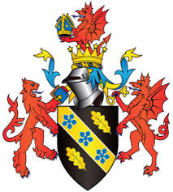

Table of Contents
Introduction 4
Brand Overview 4
1. Starbucks in the United Kingdom 5
2. Starbucks in Bulgaria 5
3. Strategic Comparison 6
Comparison of the Socio-Cultural Context (PESTLE Analysis): 6
1.Political Factor 7
2.Economic Factor 8
3.Social and Cultural Factors 8
4. Technological Factor: 10
5. Legal: 11
6. Environmental Factors: 11
7. Summary and Implications: 12
Comparison of Starbucks’ STP Strategies in the United Kingdom and Bulgaria 13
Comparison of Marketing Mix (7Ps) Strategies: 18
Evaluation of the Performance of Starbucks’ Marketing Strategies: 25
1. Performance in the United Kingdom 25
2. Performance in Bulgaria 26
3. Overall Performance Evaluation 27
Evaluation of Starbucks’ Marketing Ethics Practices 31
1. Pricing Ethics 31
2. Labour Ethics 31
3. Environmental Ethics 31
4. Social Responsibility and Community Engagement 32
5. Overall Ethical Evaluation 32
Recommendations & Conclusion: 34
Reference List: 35
Appendix 38
Appendix 1: PESTLE analysis 38
Appendix 2: Hofstede cultural comparison graph 39
Appendix 3: Profits and sales 40

Introduction
This report examines how Starbucks Corporation tailors its global marketing strategies for two different European markets: the United Kingdom and Bulgaria. It examines how the organization maintains global brand uniformity while adapting to local markets to address various cultural, economic, and consumer requirements. The evaluation starts with a summary of Starbucks’ activities in both nations, then proceeds to a detailed PESTLE comparison that explores how political, economic, social, technological, legal, and environmental elements affect the brand’s marketing choices in each market. It subsequently analyzes Starbucks' Segmentation, Targeting, and Positioning (STP) strategies and assesses variations in the marketing mix (7Ps). The report finishes with an evaluation of Starbucks’ marketing effectiveness, ethical standards, and offers strategic suggestions for maintaining growth and competitive edge in 2025 and the future

Brand Overview
The largest chain of coffee shops in the world, Starbucks Corporation, was established in 1971 in Seattle, Washington, by Gordon Bowker, Zev Siegl, and Jerry Baldwin. The business has expanded from a single location selling roasted coffee beans to a multinational corporation with operations in more than 80 countries and more than 400,000 employees. "To inspire and nurture the human spirit – one person, one cup, and one neighborhood at a time" is its stated objective (Britannica, 2024). Starbucks' emphasis on sustainability, ethical sourcing, premium quality, and customer experience gives it a competitive edge (Kotler and Keller, 2016). Standardization (maintaining a uniform worldwide identity) and localization (adjusting menus, retail layouts, and prices to suit regional customs) are balanced by the business (Solomon, 2018).
The Fiscal 2024 Annual Report states that Starbucks achieved USD 36.2 billion in net revenues and had more than 40,000 locations globally, with half being company-owned and half licensed (Starbucks Corporation, 2024). Despite inflationary challenges, the brand grew its footprint in Europe and Asia, bolstering its sustainability objectives with recyclable packaging, carbon-neutral aspirations, and responsible coffee sourcing (Starbucks Corporation, 2024b).
By 2025, the brand will maintain its commitment to innovation and ethical leadership, thanks to its worldwide digital loyalty network and commitment to environmental efforts (Martin Roll, 2023; Simplilearn, 2024)

1. Starbucks in the United Kingdom
Starbucks made its entry into the UK market in 1998 by acquiring Seattle Coffee Company (BBC News, 1998). By 2025, it will have approximately 1,250 stores, including both company-owned and licensed outlets. Starbucks' UK market is one of the most mature, competing with Costa Coffee, Caffè Nero, and Pre. Starbucks distinguishes itself with digital convenience, the Starbucks Rewards App, and sustainability-focused marketing that reflects British consumers' environmental ideals (Mintel, 2023; Starbucks UK, 2024).
In 2024 Starbucks acquired its largest UK licensee (23.5 Degrees) and announced plans to open 100 new stores, prioritising drive-thru and high-traffic locations (World Coffee Portal, 2024). Well-known seasonal drinks like the Pumpkin Spice Latte bolster its premium but accessible image and cultural significance (BluCactus, 2024). The 2025 strategy maintains a focus on digital integration, responsible sourcing, and community involvement.

2. Starbucks in Bulgaria
Starbucks began its operations in Bulgaria in 2008 through a franchise agreement with AmRest Holdings SE, a Polish company overseeing Starbucks locations in Central and Eastern Europe (AmRest Holdings SE, 2024).
Starting in 2024, Starbucks Bulgaria runs approximately 16 locations primarily in Sofia, Plovdiv, Varna, and Burgas (Statista, 2024). The brand is marketed as a high-end Western lifestyle experience, targeting young professionals, students, and travelers (World Coffee Portal, 2024).
In 2024, the SSP Group launched a new Starbucks at Sofia Airport, increasing the brand’s presence in travel centers (SSP Group, 2024). Starbuck`s menu in Bulgaria features espresso drinks, desserts, and cold beverages tailored to local tastes (AmRest Holdings SE, 2024).
Marketing is greatly dependent on social media interaction and the in-store experiences, with prices higher than local cafés to preserve its aspirational reputation.

3. Strategic Comparison
By 2025, Starbucks illustrates how an international brand can achieve consistency while embracing adaptation. In the UK, the strategy emphasizes sustaining leadership via digital advancements, customer loyalty initiatives, and sustainability efforts. In Bulgaria, it aims for growth by enhancing brand recognition, adapting to local conditions, and expanding through franchises. Collectively, they demonstrate Starbuck’s capacity to implement its international standards while customizing operations to various cultural and economic settings (Sciendo, 2015; Gireddy, 2019).

Comparison of the Socio-Cultural Context (PESTLE Analysis):
The UK, a developed Western European market, and Bulgaria, a developing Eastern European economy, have quite different external environments in which Starbucks works. This section examines the ways in which political, economic, social, technological, legal, and environmental factors impact Starbucks' marketing campaigns in both nations using the PESTLE paradigm.
PESTLE Table: Starbucks – UK vs Bulgaria
Table 1PESTLE Table: Starbucks – UK vs Bulgaria
PESTLE Factor | United Kingdom | Bulgaria
Political | Favourable – Predictable regulations, conducive investment policies, good post-Brexit transparency. | Favourable – EU stability, low 10% corporate tax, supportive franchise policies
Economic | Favourable – Good disposable income and premium pricing, as well as high frequency of consumption. | Moderately unfavourable – Frequency is constrained by low incomes, but selective growth is favoured by tourism.
Social | Favourable – Remote working, ethical products, the culture of a cafe third place. | Partially favourable – The youth, via Westernisation and social media, create the aspiration, but do not use it at a high daily frequency.
Technological | Favourable – Good digital penetration, mobile order & loyalty use. | Moderately unfavourable – Limited app adoption, reliance on social media marketing
Legal | Partially unfavourable – high labour and compliance expenses, even with clarity of the law. | Favorable- EU legal system, reduced wages, flexible franchising.
Environmental | Favourable – good sustainability awareness enhances the brand image. | Moderately unfavourable - Low awareness minimizes the effect, though it is on the increase.

1.Political Factor
The United Kingdom remains once of Starbuck’s most developed and steady markets. Following Brexit , the government has upheld a pro-investment climate by implementing policies that promote business growth and attract foreign investment. The Starbucks’s Fiscal Annual Report (2024) indicates that the UK is an essential strategic area where Starbuck’s keeps investing significantly, demonstrating confidence in its robust regulatory and economic landscape (Starbuck’s Corporation,2024b). A reliable political and legal framework bolsters Starbuck’s long term investment strategy, illustrated by its 2024 purchase of its largest UK licensee, 23.5 degrees, sanctioned by UK Competition and Markets Authority reflecting the nations favorable business regulatory position (World Coffee Portal, 2024).
Bulgaria, being a smaller EU member state, wields less political influence, maintains a stable democratic system, and benefits from favorable EU investment policies. Starbucks and various global firms offer appealing franchise regulations and maintain one of the lowest corporate tax rates in the EU at 10% (AmRest Holdings SE, 2024). Moreover, the company can import materials and equipment through EU trade agreements because of political stability within the EU. Consequently, the UK presents regulatory sophistication, while Bulgaria provides government receptiveness to foreign investment and affordable entry conditions (see Appendix A1).

2.Economic Factor
The two markets vary significantly in terms of their economies. The GDP per capita in the UK surpasses £43,000, while Bulgaria’s hovers around £12,000 (Statista, 2024). The difference directly influences pricing and positioning. In the UK, Starbucks effectively markets its products at higher prices since customers link the brand to comfort and quality (Mintel, 2023). In Bulgaria, Starbucks aims at the aspiring middle class, keeping prices a bit higher than local coffee shops, but utilizing smaller store sizes to control expenses (AmRest Holdings SE, 2024).
Inflation and energy prices during 2023-2024 influenced both markets, but Starbucks countered this by utilizing global supply chain efficiencies and local sourcing when feasible (Starbucks Corporation, 2024). The UK boasts a robust financial sector that facilitates seamless digital payments and customer credit usage, whereas Bulgaria’s expanding tourism sector particularly in Sofia and coastal areas generates seasonal spikes in coffee consumption. The UK offers steady revenue stability economically, Bulgaria provides growth opportunities with reduced operational costs (Appendix A2).

3.Social and Cultural Factors
Cultural practices regarding coffee consumption differ significantly. In the United Kingdom, consuming coffee has evolved into social and professional trends, with cafés functioning as “third places” for work, study, or leisure (Martin Roll, 2023). Starbucks UK advocates for diversity, convenience, and ethical sourcing, principles embraced by socially aware British consumers. Changing social trends like remote work, on-the-go lifestyles, and growing ethical consciousness are favourable to Starbucks because they drive more people to consume coffee, visitations, and loyalty at Starbucks in the UK market.
Traditional café culture in Bulgaria has been around for decades, although it has traditionally concentrated on espresso and social meetings in small local locations. Starbucks presented a Western lifestyle model, which appealed to younger Bulgarians looking for modern and foreign experiences. The brand's stores, which are commonly found in shopping malls and airports, represent prestige and cosmopolitanism (BluCactus, 2024). Changing trends such as youth westernisation, an increase in tourism, and the powerful social media factor are positive for brand image in Bulgaria, but coffee consumption is still infrequent and aspirational, and therefore, this social factor does not favour high-frequency sales.
Although both countries have ageing populations, youth groups drive growth. Students and urban professionals in the UK eat a lot of coffee (Mintel, 2023). In Bulgaria, Millennials and Generation Z are progressively embracing western consumption habits due to exposure from social media and tourism. Starbucks marketing on social media and collaborations with influencers significantly contribute to promoting aspirational consumption in Bulgaria (ResearchGate, 2024). Altogether, the social tendencies are positive in the UK and average positive in Bulgaria because of disparities in the level of income and regularity of consumption.
Cultural Factors (Hofstede Model Comparison)
The six dimensions of culture offered by Hofstede can be applied to Starbucks to further explain its performance in the two countries.
Table 2Cultural Factors (Hofstede Model Comparison)
Cultural Dimension | United Kingdom | Bulgaria | Impact on Starbucks
Power Distance | Low | High | It is favourable in the UK as an informal service, and mixed in Bulgaria because hierarchy and premium perception strengthen each other.
Individualism | Very high | Moderate | In the UK, it is favourable when it comes to personalisation and loyalty programmes.
Masculinity | Moderate | Higher | Status-sensitive consumption in Bulgaria is favourable.
Uncertainty Avoidance | Low | High | Unfavourable in Bulgaria because of price sensitivity and risk aversion.
Long-Term Orientation | High | Lower | Favorable in the UK regarding sustainability messaging.
Indulgence | High | Low | In the UK, it is preferable to consume on a daily basis.
Hence, the situation in the UK is more conducive to cultural considerations, as those are also congruent with the digital, ethical, and convenient strategy of Starbucks. Cultural issues in Bulgaria are somewhat favourable, with aspirational branding facilitated and restricted consumption.
The main merits of the Hofstede model are that it is easy to understand and compare, and that it can be used to analyse the international market. The drawbacks are that it overgeneralises, it uses national averages that are too old, and it has little regard for individual or regional variations.

4. Technological Factor:
Starbucks' competitive advantage in the global market is built on technology. In the United Kingdom, digital transformation is well underway: customers utilise the Starbucks Rewards App, mobile ordering, and contactless payments, and data analytics drive customised offers. Starbucks UK's engagement with Apple Pay and Uber Eats provides omnichannel ease (Appendix A3).
Bulgaria digitalization is advancing, albeit more slowly. ArmRest has implemented mobile payment options and Wi-fi access in all locations, however, the integration of Starbucks loyalty app remains restricted (AmRest Holdings SE, 2024). The main digital marketing channels for the brand are social media platforms, especially Instagram and TikTok, which aid in addressing low app adoption rates. The technology gap illustrates Starbucks flexible approach as sophisticated loyalty systems in advanced markets and affordable digital engagement in emerging ones.

5. Legal:
Starbucks is required to comply with regulations at both the national and EU levels. In the United Kingdom, regulations on food labelling, allergy details, and wage laws like the National Living wage (2024 rise to £11.44 per hour) all affect operating expenses. The UK enforces strict environmental and health and safety laws that require reporting on emissions and packaging (Starbucks UK, 2024).
Bulgaria adheres to EU standards, implementing uniform food and labor laws, but with reduced wage rates. As per franchising regulations, Starbucks (through Amrest) is allowed to license its operations based in agreed upon territorial contract. Legal stability encourages international investment. However, bureaucratic hurdles in business registration could result in delays in opening stores (Sciendo, 2015).
Overall, Starbucks shows a solid adherence to regulations in both regions, although the costs associated with compliance remain higher in the UK (Appendix A4).

6. Environmental Factors:
Environmental sustainability is a key foundation of the Starbucks brand. By 2030, Starbucks corporation aims to achieve a resource positive status, concentrating on reducing carbon emissions, promoting reusable packaging, and sourcing coffee ethically. In the UK, Starbucks has implemented programs like the reusable cup discount and waste recycling efforts in partnership with local councils (Starbucks UK, 2024). These aligns with the growing environmental consciousness among British consumers.
In Bulgaria, environmental expectations are minimal but increasing. AmRest follows global sustainability procedures, such as energy-efficient store designs and waste-reduction programs, although consumer engagement remains minimal due to low knowledge (AmRest Holdings SE, 2024). The brand conveys its environmental principles mostly through digital storytelling and in-store imagery, rather than large-scale national ads.
Both countries demonstrate advancement towards Starbucks global environmental goals, yet the speed of execution differs, indicative of economic capacity and consumer preferences (Appendix A5).

7. Summary and Implications:
The comparative PESTLE analysis shows that Starbucks benefits from political stability, compliance with EU regulations, and consumer trust in both countries, yet it must tailor its marketing strategies and operations to local conditions.
UK: A mature, innovation-focused market that seeks digital convenience and environmental excellence.
Bulgaria: A developing emerging market that prioritizes affordability, aspirational branding, and a slow progression in technological adoption.
PESTLE Similarities and Differences: UK vs Bulgaria
Table 3PESTLE Similarities and Differences: UK vs Bulgaria
Aspect | Similarities | Differences
Political | Stable governance, pro-investment climate | The UK is more sophisticated with regulations, and Bulgaria is cheaper with tax and less demanding in franchise entry.
Economic | Both affected by inflation and energy costs | UK has a high shopping power; Bulgaria has lower incomes and price sensitivity.
Social | Youth-driven demand and café culture | UK coffee is the habitual; Bulgarian coffee is the aspirational and occasional.
Technological | Use of digital and social media marketing | The UK has developed app use; Bulgaria is more dependent on social sites.
Legal | Compliance with EU food and labour standards | UK has increased wage and compliance expenses.
Environmental | Commitment to sustainability goals | UK consumers highly eco-conscious; Bulgaria awareness still developing

Comparison of Starbucks’ STP Strategies in the United Kingdom and Bulgaria
Starbuck’s international success is strongly backed by its ability for integrating effective segmentation, targeting and positioning methods throughout diverse markets. The core brand identity remains widely consistent, Starbucks uses its STP method for reflecting the social, economic, and cultural conditions of each country. Therefore a comparisons between the United Kingdom and Bulgaria will clearly showcases how Starbucks alters its market focus for aligning bought mature western economy, and the developing Eastern European market.
1. Segmentation
Starbucks uses a multivariable segmentations strategy in UK as well as Bulgaria which merges demographic, psychographic and behavioral factors for determining and serves its customers properly. For example, in the UK, Starbucks segment its market throughout a wider and economically consistent of individuals aged between 18 to 45 entailing students, young professionals and full-time working adults. With respect to the incomes. Starbucks mainly lures in the middle and upper middle class who owns sufficient disposable income for supporting regular premium coffee consumptions (Statista, 2024). On psychographic perspectives, UK customer is marked by urban lifestyles orientation, a robust interest in ethical consumptions and high expectations for speed, service efficiency. Further with respect to the behaviour level the customer showcases high consumptions frequency, robust engagement with the mobile ordering as well as loyalty apps and also consistent repeat purchasing patterns.
British consumer widely prioritizes Starbucks as not simply beverage provider rather as productive “third place” which is used for working remotely, studying or carrying out informal meetings. Therefore, as the result, coffee consumption within the UK is deeply integrated as part of the daily routines which positions Starbucks as the habitual purchase instead of discretionary luxury (Starbucks UK, 2024). In case of Bulgaria Starbucks’s segmentations method is critically distinct and more aspirational. The main demographic targeted by the business sis of consumer between the age of 18 to 35 who are mainly students and young adults. From a perspective of income, the brand mainly appeals to middle class and affluent consumer whereas its pricing remains high relative to the average national wages. With respect to the psychographic perspective, Bulgarians Starbucks customers are led by the western lifestyle aspirations, social status as well as brand visibility (World Coffee Portal, 2024). On behavior context, lifestyle aspirations, social status, and brand visibility with the visu8ts focused in shopping malls city centers and torusims locations.
Targeting
Starbucks relies on different plans for UK and Bulgaria. Therefore by looking at what people do and what kind of life they live, selected groups to serve. In case of UK, Starbucks targeted different types of people like daily commuters, remote workers, university students and people who care regarding environment, UK is selling a lot and keeping customer coming back often, further the business makes it easy with the use of rewards app, mobile ordering, food delivery partners and many drive thru stores (World Coffee Portal, 2024). All such tools offer business with the speed, reasons to return and convenience. Such also makes the business integrated in the daily life of the many groups.
In case of Bulgaria, Starbucks works well in diverse manner. However, it is mainly used as a special experience. The targeted groups of the business are university students, young professionals, tourists as well as people visiting shopping malls. They prefer Starbucks since it feels international, stylish as well as premium. More stores are in airports, malls as well as busty city spots (Statista, 2024). Such shows Starbucks as the place for the special occasions rather than daily coffee. With respect to the Bulgaria the focus is on the brand image, social value along with the prestige rather than selling vast amount every day.
Positioning
Starbucks strives for brand image recognized for premium coffee brand around the globe however the way people comprehend such “premium” notions which is vastly different in UK as well as Bulgaria. For example, in the UK, Starbucks is shown as a “convenient, ethical, and modern everyday coffee brand”. Such shows that Starbucks is not fancy rather stands for good quality, personal services, easy digital tools as well as care for the environment. Starbucks is open for many people as well as has become part of the many peoples’ daily life. it faces competition from other big coffee chains such as Costa Coffee as well as Caffe Nero. Here the focus is on simplicity, efficiency as well as reliability for everyday use (Starbucks Corporation, 2024). On the other hand, in Bulgaria, Starbucks has completely different image, where it is premium western lifestyle brand associated with the social status, and cosmopolitan identity”. To people it is special, stylish as well as connected to the western culture. Further due to the higher prices, mall locations as well as international image, makes the brand appear as exclusive. Further the customers tend to go for experience and prestige rather than daily coffee. Such clearly shows why people in Bulgaria drinks Starbucks, less and why business relies on promotions for promoting its brand and status rather than everyday convenience.
Perceptual Map Diagram (United Kingdom)
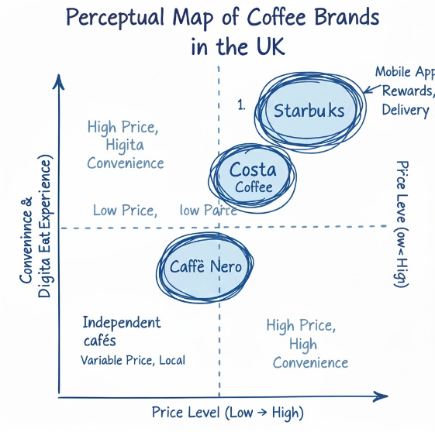
Figure 1Perceptual Map Diagram (United Kingdom)
Figure 2: Perceptual Map Diagram
The perceptual map reflects how Starbucks is positioned in the United Kingdom as a high-convenience and high-priced coffee brand. In comparison with other coffeehouse chains, like Costa Coffee and Caffe Nero, Starbucks is characterised by a well-developed digital ecosystem, i.e., mobile ordering, loyalty system, and integration of delivery. Although some independent cafes might be cheaper or more creative, they do not tend to be as convenient and large as Starbucks. This positioning would satisfy the UK consumer behaviour where coffee is not a luxury but a daily activity, and this serves to solidify the Starbucks brand as a trustworthy and affordable brand, as the third-place brand.
Summary
Similarities and Differences in Starbucks’ STP Strategies (UK vs Bulgaria)
Table 4/Similarities and Differences in Starbucks’ STP Strategies (UK vs Bulgaria)
Aspect | Similarities | Differences
Segmentation | Focus on youth, students, and middle-income groups | The UK is aimed at a broader age range and daily users, while Bulgaria is aimed at younger and aspirational users.
Psychographics | Brand-driven, urban-oriented consumers | The UK has the value of convenience and ethics; Bulgaria, status, and the Western lifestyle.
Behaviour | Preference for branded café experiences | In the UK, high-frequency daily usage is demonstrated; in Bulgaria, experience-based visits at intervals are demonstrated.
Targeting | Students and young professionals in both markets | The UK is aimed at ordinary consumption, Bulgaria at special events and tourism.
Positioning | Premium global coffee brand | UK positioned as everyday convenience; Bulgaria positioned as luxury lifestyle
Marketing Focus | Consistent global brand image | The UK is dedicated to loyalty and online convenience; Bulgaria is dedicated to image and status.
Starbucks implements a standardised high-end brand approach in either of the markets, although it adjusts STP implementation to the mature everyday consumption in the UK and high-aspirations, less frequent consumption in Bulgaria.

Table 5/STP Element: United Kingdom (UK)-Bulgaria
STP Element | United Kingdom (UK) | Bulgaria
Segmentation Demographic | People 18–45; students, young workers, adults | People 18–35; students, young adults
Segmentation Income | Middle to rich | Middle to rich
Segmentation Psychographic | City life, care about ethics, want easy choices | Want Western life, care about status, brands
Segmentation Behavioral | Drink coffee often, daily habit, order online, use app | Drink sometimes, go to malls, tourists drink
Consumer Role of Starbucks | Everyday coffee brand, part of daily life | Seen as modern and fancy
Targeting Strategy | Commuters, remote workers, students, families, eco-friendly people | Students, young workers, tourists, mall visitors
Targeting Focus | Many repeat buyers | Special occasions, nice experience
Positioning Statement | “Easy, ethical, modern daily coffee” | “Fancy Western brand, shows status”
Impact on Marketing Strategy | Many loyal users, visit often, strong online system | High prices, focus on image, not frequent

Comparison of Marketing Mix (7Ps) Strategies:
Product: The product depth in the UK is high, and there are various versions of the core drinks (e.g., latte style, milk options, and sizes) as well as the seasonal drinks like festive drinks and holiday cups. Product depth in Bulgaria is low, meaning the number of variations that products have and the type of diet available to people is less than that in other countries, because of the low demand for them on a daily basis. In the UK, the product is wide and is backed by brand extensions like Starbucks Reserve, ready-to-drink bottled products, and packaged coffee that is sold in cafes and retail stores. In Bulgaria, the product width is low, and primarily Starbucks deals with the brand cafe and a few extensions of the brand, which strengthen its position as a premium, experience-based product.
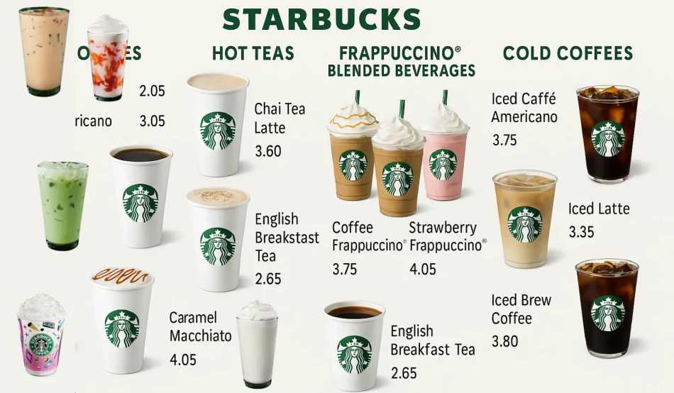
Figure 3/Variety of Starbucks beverages and food options available in the UK market

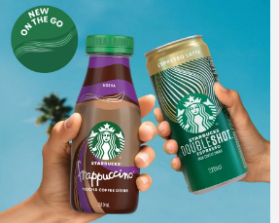
Figure 4/Selected Starbucks beverage in Bulgaria
in UK Starbucks sells around diverse items for the people who are regular. The menu offers hot drinks, cold brews, plant-based milk, seasonal specials, sandwiches, breakfast as well as snacks. There are also vegan, gluten free as well as low sugar choices for health needs. Moreover, the special drinks such as Pumpkin Spice Latte and holiday cups which is ideal for retaining loyal customer (Starbucks Corporation, 2024). On the other hand, Bulgaria, the brand sells only few items. Here menu mainly offer espresso drinks, frappes, and sweet desserts. There are also fewer food items and not many options for diet. This smaller menu aligns well with the local demand, further in Bulgaria Starbucks offer more special treats rather than daily use.
Price: Starbucks prices are also different in each market for example in UK its drinks costs around £3–£5, therefore many middle incomes people can afford such. Here the business also offers discounts on its app, loyalty rewards, free refills, along with the special deals. Such offers help the business retains customers. On the other hand, Bulgaria, prices tend to be much higher compare to income level (Starbucks Corporation, 2024). This is because Starbucks as positioned itself as premium brand rather than daily café, here discount is rare, with the focus on prestige therefore in the UK it feels mass premium and in Bulgaria it feels luxury.
Place: Starbucks has many more stores within UK market than in Bulgaria. It has around 1250 stores in UK, in the busty streets such as high streets, hospitals, universities, train stations drive thru spots. Starbucks also works with the delivery app such as Uber east, and Deliveroo which makes it much easier for people to get coffee anywhere. On the other hand, in Bulgaria there are only around 16 stores. Most are in Sofia, airports or shopping malls. Here delivery options are limited whereas stores are located in the fancy or torusims regions rather than in every neighborhood. (Starbucks UK, 2024) Therefore, UK focuses on easy access but Bulgaria focuses on the prestige of the locations.
Market Entry Methods
The UK market has numerous other Starbucks locations compared to Bulgaria. It operates approximately 1250 stores in busy places like high streets, hospitals, universities, train stations, and drive-through locations. Delivering via such apps as Uber Eats and Deliveroo is also available, which makes coffee readily available at Starbucks. Starbucks' entry mode in the UK market has primarily been that of company-owned stores, which has enabled it to have full control over its operation and brand experience. The advantages of such an approach are as follows: the reliability of quality and great brand presence, in contrast to such disadvantages as high costs of investment and operational risks.
In Bulgaria, the number of stores is only approximately 16, and they are primarily in Sofia, at Airports or shopping malls. There are a few options for delivery, and the stores target upscale areas in addition to convenience. In this case, Starbucks has adopted franchise and direct ownership to penetrate the market with the help of its local partners to expand and minimize risk.
Promotion: Starbucks encourages itself differently in the UK and Bulgaria. With respect to UK, promotion is mainly digital. The brand relies on mobile app offers, eco-friendly apps ads, influencer partnerships along with the student deals. It also encourages ethical sourcing, seasonal drinks as well as environment on social media. In case of Bulgaria the business is required to promote more regarding the looks and lifestyles (Statista, 2024). Starbucks emphasis on the posts made on Instagram, as well as TikTok, store designs, and brand style. here big national ads are not used as often rather the business uses on word of mouth, social sharing and in-store visuals. The messages are regarding status, western culture, and special experience rather than everyday convenience.
People: in the UK the business trains its workers significantly for keeping its services same everywhere. Baristas learns customer skills, as well as daily tasks more often. It works with the unions and knows importance of work rules. Wages are higher whereas costs are more band helps with keeping the services good (Royston, 2024). Starbucks UK has 520 stores and employs over 5,600 people. In Bulgaria however wages are low, ands services feels more personal; and friendly. Training is conducted with help of AmRest, local partner while also follows Starbucks’s global rules. Starbucks Bulgaria employs dozens to low hundreds, mainly Sofia/Varna.
Process: in the UK, Starbucks relies on many digital tools, where the customers can order by phone using drive-thru as well as tailored drinks fast. Such also helps in serving many people quickly. In case of Bulgaria, service is simpler whereas people order in persons, enjoy the ambience, and talk to staff. Here speed is less important than the experience.
Physical evidence: UK stores appear more modern, simple, as well as eco-friendly with digital menus. On the other hand, Bulgarians stores appear more stylish, premium and western reflecting comfort and prestige.
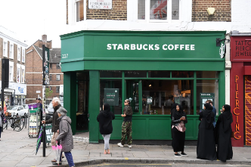
Figure 5/Starbuck store in UK
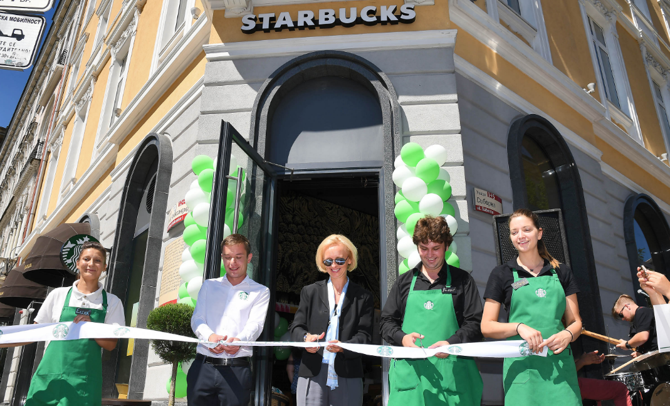
Figure 6/star buck store in Bulgaria
Websites
Starbucks UK: https://www.starbucks.co.uk/
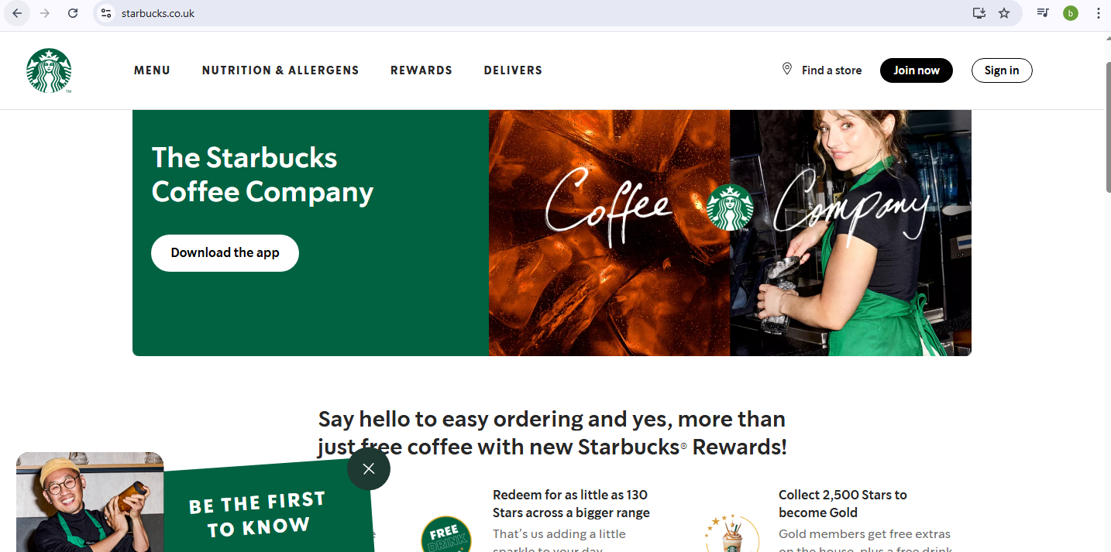
Figure 7/Starbucks UK:

Starbucks Bulgaria: https://www.starbucks.co.uk/

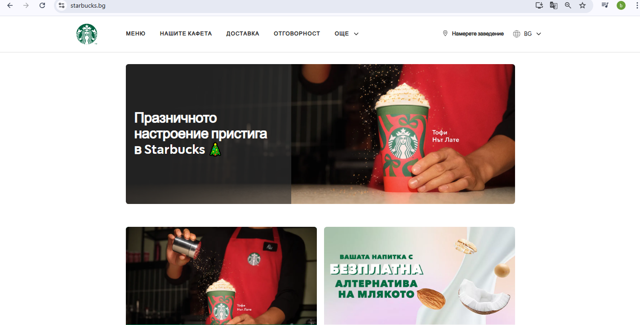
Figure 8/Starbucks Bulgaria:

Similarities and differences
Table 6/Similarities and differences
7Ps | UK | Bulgaria | Similarities / Differences
Product | Wide & deep menu: hot/cold drinks, plant-based, seasonal, snacks, vegan/gluten-free | Narrow menu: espresso, frappes, few desserts, limited diet options | Difference: UK focuses on variety & daily use; Bulgaria focuses on premium treats
Price | £3–£5, loyalty discounts, app deals, mass premium | Higher relative to income, rare discounts, luxury positioning | Difference: UK affordable/mass premium; Bulgaria premium/luxury
Place | 1,250 stores, busy streets, delivery apps, drive-thru | 16 stores, prestigious areas, limited delivery | Difference: UK focuses on accessibility; Bulgaria on prestige
Market Entry | Mainly company-owned stores | Mix of franchising & direct ownership | Similarity: Both maintain brand control; Difference: UK higher investment, Bulgaria lower risk via partners
Promotion | Digital marketing, app offers, social media, student deals, ethical campaigns | Social media focus (Instagram/TikTok), store visuals, lifestyle/status messaging | Difference: UK convenience/loyalty; Bulgaria status/experience
People | Extensive training, higher wages, 5,600+ staff, unions | Local partner training, lower wages, dozens–low hundreds staff | Similarity: Follows Starbucks global standards; Difference: UK more formalized & scaled
Process | Fast, digital orders, tailored drinks, efficient service | Simpler, in-person, slower, experience-focused | Difference: UK speed-focused; Bulgaria experience-focused
Physical Evidence | Modern, simple, eco-friendly stores | Stylish, premium, Western-style stores | Similarity: Reflects brand; Difference: UK functional/eco vs Bulgaria prestige/stylish

Evaluation of the Performance of Starbucks’ Marketing Strategies:
Evaluating the performance of Starbucks’ marketing strategies in the United Kingdom and Bulgaria shows how the brand adapts its global marketing mix to two different market conditions. Starbucks’ effectiveness can be assessed using indicators such as store network growth, brand positioning, customer loyalty, digital adoption, sustainability engagement, and financial stability.

1. Performance in the United Kingdom
The United Kingdom is one of the most advanced European markets for Starbucks. The brand has over 1,250 stores all over the country, and this means that it has good accessibility and high visibility. Geographic coverage under an extensive area supports the competitive status of Starbucks in the UK coffee shop business. Starbucks is constantly positioned in the top three of great coffee chain stores in the UK, in competition with Costa Coffee and Caffe Nero. This dominant market niche indicates the effectiveness of the Starbucks differentiation strategy that is based on personalisation, online convenience, and ethical branding (Dimitrakaki, 2023). The consumers in Britain tend to relate Starbucks to a current-day lifestyle, which promotes productivity and socialization within the comfortable store conditions. One of the contributors to performance success has been digital transformation. The Starbucks Rewards App allows pre-orders, offers, and payments without the use of money.
These online services make things easier for customers, reduce the waiting process, and foster a buying habit. The partnership with the food delivery mechanisms enhances the omnichannel business model and helps the brand engage with customers beyond the physical stores. The attention of consumers to seasonal beverages, including the Pumpkin Spice Latte and other themed drinks, boosts sales, especially in the case of promotions. These products promote the consumption patterns that are habitual, and they encourage brand loyalty. Starbucks manages to take advantage of students, commuters, and office workers by locating itself as a part of everyday life. The aspect of sustainability plays a major part in the Starbucks brand image in the UK.
The company advances ethically sourced products, the use of reusable cups as incentives, packaging that can be recycled, and support programmes for the community. This practice enhances the emotional trust and makes Starbucks respond to the consumers, who can cherish ethical consumption and environmental care. The UK financial performance is stable even when there is inflation and an increase in the cost of operation. Starbucks has shown the confidence to invest in the potential of the market in the long term by opting to acquire direct control of its largest licensee in the UK. This is a strategic step to enhance uniformity in the store operations and save the brand's quality (Musonera, 2021).

2. Performance in Bulgaria
Bulgaria is a smaller market than Starbucks has, with fewer partners and approximately 16 stores concentrated primarily in large cities such as Sofia, Plovdiv, Varna, and Burgas. The location of the stores is given importance in the high traffic areas like shopping malls, central areas, and airports. This is the selective growth that promotes brand awareness in the domestic and global consumer markets. Starbucks is highly branded in the minds of the younger Bulgarians and travellers. The brand is viewed as a modern, western, and world-renowned brand (Susilo and Mendoza, 2023). To a large group of consumers, Starbucks is aspirational and has social value, and not normal convenience. This image associated with the status of Starbucks drinking justifies the high prices despite the much lower purchasing power in Bulgaria, as compared to Western Europe. The performance of sales is high in high-end retailing facilities where the customer is less price-sensitive. Consumption of the product is often associated with social events, self-representations, and posts on social media.
This symbolic worth assists Starbucks in continuing to register a high level of profit, even though the target market is much smaller. The low amounts of disposable income among the general population, however, limit the quick growth. Starbucks is a luxury product that cannot be enjoyed by many of the residents. The growth is thus still tentative, and the brand is running under the franchise system. This strategy will reduce financial risk, but can slow down the effective development of the strategy and lessen direct control over employee welfare and CSR activities. Online involvement is evolving, though not as high as in the UK.
Customers have digital ordering systems and app-based loyalty programmes, which are not specifically popular. The marketing of social media is more significant compared to digital purchasing integration (Xu, 2023). The performance of Starbucks in Bulgaria relies more on the brand prestige and the in-store environment than on convenience based on technology. Overall performance evaluation: In this context, the company must assess its performance to identify the methods for enhancing it.

3. Overall Performance Evaluation
Starbucks exhibits both effective adjustments to the two markets through its glocalisation strategy. Starbucks in the UK is a mainstream, high-volume brand that is backed by the power of digital interaction, a sense of sustainability, and affordable prices. Starbucks operates in Bulgaria as a luxury lifestyle beverage brand that aims to provide aspirational and symbolic value to a smaller but committed group of customers (Zhang and He, 2024).
Profits and sales:
Table 7/Profits and sales
Metric (Latest Year Available) | United Kingdom | Bulgaria
Annual Revenue | £449 million (2023) (AmRest Holdings SE, 2024) | €17.2 million
Revenue Growth (YoY) | +21% (2022–2023) | +12% (2022–2023)
Operating Profit | £33.3 million (2023) | €1.8 million (approx.)
Net Profit Margin | 7.4% | 10.5%
Number of Stores | ≈1,250 stores (2024) | ≈16 stores (2024)
Average Transaction Value | £5.10 | €3.40
Customer Footfall Trend | Stable & growing | Seasonal, tourism-linked
Primary Growth Drivers | Digital loyalty, drive-thru, sustainability | Tourism, malls, airport locations
Cost Pressures | High labour + operational costs | Lower labour costs, but low purchasing power

AmRest Holdings SE (2024) Annual Report 2024. Available at: https://www.amrest.eu/
Social media engagement :
Table 8/Social media engagement
Platform / Metric | United Kingdom | Bulgaria
Main Platforms | Instagram, TikTok, Facebook, App | Instagram, TikTok only
Followers (Instagram) | ≈400K+ | ≈38K
Engagement Type | Seasonal campaigns, sustainability posts, app-based offers (Zhu, 2024) | Aesthetic posts, lifestyle imagery, influencer collaborations
Average Engagement Rate | 3–4% | 5–7%
Loyalty App Penetration | Very high (over 6M UK users) | Low–moderate
Digital Behavior | High use of rewards, mobile ordering, delivery apps | Social-media-driven visits; low mobile ordering
Core Digital Strategy | Personalisation through data | Aspirational branding through visuals

Zhu, Y. (2024). Leveraging Social Media Marketing: A Case Study of Starbucks Digital Success. Advances in Economics Management and Political Sciences, 102(1), 199–204. https://doi.org/10.54254/2754-1169/102/2024ed0108‌

Customer reviews :
Table 9/Customer reviews
Review Aspect | United Kingdom | Bulgaria
Average Google Rating | 4.1 / 5 | 4.4 / 5
Most Common Positive Feedback | Friendly staff, good seasonal drinks, fast service | Premium ambience, beautiful stores, Instagram-friendly
Most Common Negative Feedback | High prices, queues, inconsistent quality between locations (Ren et al., 2023) | Very high prices for local incomes, slow service in peak times
Customer Behavior | Daily/regular use | Occasional treat, social visits
Review Volume | Very high (thousands per store) | Moderate

Ren, Y., Choe, Y., and Song, H. (2023).
Antecedents and consequences of brand equity: Evidence from Starbucks coffee brand. International Journal of Hospitality Management, 108(1), 103351. https://doi.org/10.1016/j.ijhm.2022.103351
‌Similarities and differences
Table 10/Similarities and differences
Aspect | Similarities / Differences
Revenue & Profit | Difference: UK high volume, lower margin; Bulgaria smaller market, higher margin
Number of Stores | Difference: UK widespread; Bulgaria selective locations
Customer Footfall | Difference: UK regular use; Bulgaria seasonal/tourism-driven
Average Transaction Value | Difference: UK higher per transaction; Bulgaria lower
Growth Drivers | Difference: UK digital & volume-focused; Bulgaria prestige & location-focused
Social Media / Digital | Similarity: Active social presence; Difference: UK personalization & app use vs Bulgaria aspirational branding
Customer Reviews | Similarity: High satisfaction; Difference: UK service & speed vs Bulgaria ambience & prestige

Evaluation of Starbucks’ Marketing Ethics Practices
The ethics of marketing is a significant constituent of Starbucks on the international scene. Some of the areas that the company emphasizes include responsible sourcing, fair labour practices, environmental sustainability, and community impact. This evaluation focuses on the United Kingdom market to assess both ethical and unethical marketing practices (Dimitrakaki, 2023).

1. Pricing Ethics
Pricing in the UK is described as rather fair and affordable, even to middle-income consumers. Scholarships, student promotions, and incentives promote inclusivity and perceived low price barriers. This is ethical marketing because it is made available and accessible. Premium seasonal drinks can be an example of unethical marketing in the UK to price the products excessively and make the customers feel exploited (Musonera, 2021).

2. Labour Ethics
In the UK, Starbucks has legal obligations to observe good labour laws, such as fair remuneration and controlled working conditions. Diversity and inclusion are encouraged in the company. Ethical marketing is expressed through delivering just treatment and promoting employee well-being through campaigning. However, there has been some form of criticism of the workload of employees and against the expansion of the unions. Unethical marketing can also occur when the company boasts of being entirely employee-friendly but is actually working employees to death.

3. Environmental Ethics
Starbucks focuses on environmental conservation in its international business. Some of the sustainability initiatives in the UK are:
- Ethically sourced coffee
- Reusable cup discounts
- Recycling and waste-reduction goals
- Climate reporting and green energy use
These initiatives are examples of ethical marketing. The measures are in response to the sustainability consumer's high expectations (Susilo and Mendoza, 2023).

4. Social Responsibility and Community Engagement
The company strives to be a good citizen and is engaged in society through social activities, collaborating with other organizations worldwide to conserve the environment and promote the livelihoods of the host country. Starbucks donates to local communities in the UK through the support of youth employability programmes, collaboration with charities, and social inclusion. This is an ethical marketing as it highlights social responsibility. The activities enhance the social reputation and trust of the company among the stakeholders (Xu, 2023).

5. Overall Ethical Evaluation
The ethical performance of Starbucks in the UK is high based on good sustainability activities, labour protection, and community support.
Examples of Ethical Marketing in the UK:
Inclusive pricing policies with student discounts and promotional prices that will make products affordable to middle-income earners, showing fairness and being socially responsible.
Campaigns of sustainability to use reusable cups, ethical coffee, and programs on the environment, responding to consumer demands and showing true concern for the environment.
Examples of Unethical Marketing in the UK:
High prices of the high-end seasonal beverages capitalize on the loyalty of the customers to the specials of the season and result in a perceived injustice.
False statements concerning employee welfare, wherein the company portrays itself as entirely employee-friendly in advertisement campaigns, and in reality, they are accused of overworking workers and restricting further expansion of unions.
Ethical marketing :
STP framework
Table 11/STP framework
Ethical Dimension | Ethical Practice (UK) | Unethical Concern (UK)
Segmentation Ethics | Inclusive targeting (students, workers, families) | Prices still exclude some low-income groups
Targeting Ethics | Focus on sustainability-conscious consumers | Rewards system may promote over-consumption
Positioning Ethics | Ethical sourcing & environmental focus | Greenwashing concerns (critics argue impact is small vs claims)

Marketing mix
Table 12/Marketing mix
Product Ethics | Fairtrade & ethically sourced beans | High sugar content in seasonal drinks
Price Ethics | Transparent pricing, student discounts | Prices considered premium during inflation
Place Ethics | Safe, well-managed stores | Heavy reliance on urban areas; rural exclusion
Promotion Ethics | Promotes sustainability, charity, community work | Heavy marketing of high-calorie beverages
People Ethics | Good training, Living Wage commitments | Past criticism over tax structure (ethical perception issue)

Recommendations & Conclusion:
1.Strategic Recommendations for the UK market
In case of the UK market, Starbucks is required to solidify convenience as well as value via expanded drive-thru locations in regions like high traffic suburban regions, and targeted student discounts. Improving recycling measures and sustainability communications for supporting ethical expectations. Such practices enhance customer satisfactions, underscore loyalty, and sustain Starbucks’s competitive positions in the developed market.
2.Strategic Recommendations for Bulgarian market
In Bulgarian market, Starbucks is required to priorities certain initiatives like expanding the rewards app for boosting loyalty via tailored offers and mobile ordering. Launching affordable, locally inspired menu items, further solidifying sustainability awareness campaigns can be helpful for enhancing appeal. Selective drive-thru expansion in busy regions which can further enhance convenience and help in terms of appealing to the loyal customer in the developing market.
Conclusion
The following report has shown that a glocalisation strategy is used by Starbucks. Using this strategy, the company maintains a strong global brand along with making adjustments according to local needs in the UK as well as Bulgaria. In the UK, Starbucks has its operations in a stable market. In this market, it focuses on convenience and sustainability. In Bulgaria, the market is growing, where customers see Starbucks as a symbol of high status and Western identity. Starbucks has an effective positioning in both regions even when there are differences in economy and technology of these places. However, still it is essential for the company to improve ethics as well as digital access in Bulgaria in order to ensure its success in the long run.

Reference List:
- AmRest Holdings SE (2024) Annual Report 2024. Available at: https://www.amrest.eu/
- BBC News (1998) Starbucks to Acquire Seattle Coffee Company. Available at: https://news.bbc.co.uk/(Accessed: 21 Oct 2025).
- BluCactus (2024) Starbucks Marketing Strategy. Available at: https://www.blucactus.uk/starbucks-marketing-strategy/(Accessed: 21 Oct 2025).
- Britannica (2024) Starbucks: Sustainability and Community Development. Available at: https://www.britannica.com/money/Starbucks/Sustainability-and-community-development(Accessed: 21 Oct 2025).
- Dimitrakaki, I. (2023). Servant leadership. Case study-starbucks. International Journal of Management and Humanities, 9(6), 12-17.
- Gireddy, N. (2019) Starbucks Case Analysis. Harvard University. Available at: https://scholar.harvard.edu/files/nithingeereddy/files/starbucks_case_analysis.pdf
- Kotler, P. and Keller, K. L. (2016) Marketing Management. 15th edn. Harlow: Pearson Education.
- Martin Roll (2023) The Secret of Starbucks’ Brand Success. Available at: https://martinroll.com/resources/articles/strategy/secret-starbucks-brand-success/
- Mintel (2023) UK Coffee Shops Market Report. Available at: https://www.mintel.com/
- Musonera, E. (2021). Strategic marketing case analysis: Starbucks. Journal of Business and Social Science Review, 2(11), 12-22.
- Ren, Y., Choe, Y., and Song, H. (2023). Antecedents and consequences of brand equity: Evidence from Starbucks coffee brand. International Journal of Hospitality Management, 108(1), 103351. https://doi.org/10.1016/j.ijhm.2022.103351
- ResearchGate (2024) Analysis of the Successful Marketing Strategy of Starbucks Based on 4P Theory. Available at: https://www.researchgate.net/publication/380931199_Analysis_of_the_Successful_Marketing_Strategy_of_Starbucks_Based_on_4P_Theory(Accessed: 21 Oct 2025).
- Royston, C. (2024) What Is Marketing Management? An Introduction | Wrike Marketing Guide, Wrike. Available at: https://www.wrike.com/marketing-guide/marketing-management/.
- Sciendo (2015) Marketing Management and Brand Strategy: Starbucks Case. Available at: http://archive.sciendo.com/CRIS/cris.2015.2015.issue-1/cris-2015-0002/cris-2015-0002.pdf(Accessed: 21 Oct 2025).
- Simplilearn (2024) Starbucks Marketing Strategy Case Study. Available at: https://www.simplilearn.com/tutorials/marketing-case-studies-tutorial/starbucks-marketing-strategy(Accessed: 21 Oct 2025).
- Solomon, M. R. (2018) Consumer Behaviour: Buying, Having and Being. 12th edn. Harlow: Pearson Education.
- SSP Group (2024) SSP to Debut in Bulgaria with Starbucks and Camden Food Co Airport Stores. Available at: https://www.worldcoffeeportal.com/news/ssp-group-to-debut-in-bulgaria-with-starbucks-and-camden-food-co-airport-stores/(Accessed: 21 Oct 2025).
- Starbucks Corporation (2024) Fiscal 2024 Annual Report. Available at: https://s203.q4cdn.com/326826266/files/doc_financials/2024/ar/Starbucks-Fiscal-2024-Annual-Report.pdf(Accessed: 21 Oct 2025).
- Starbucks Corporation (2024b) Fiscal 2024 Global Impact Report. Available at: https://about.starbucks.com/uploads/2025/05/Starbucks-Fiscal-2024-Global-Impact-Report.pdf(Accessed: 21 Oct 2025).
- Starbucks UK (2024) Sustainability and Community Impact. Available at: https://www.starbucks.co.uk/(Accessed: 21 Oct 2025).
- Statista (2024) Number of Starbucks Stores Worldwide and in the UK and Bulgaria. Available at: https://www.statista.com/(Accessed: 21 Oct 2025).
- Susilo, D., & Mendoza, C. M. T. (2023). Marketing Model of Starbucks: A Sustainability Monetization. Jurnal Ekonomi, 12(02), 1182-1190.
- ‌Why is marketing management important to businesses? (no date) en. Available at: https://www.gisma.com/blog/why-is-marketing-management-important-to-businesses.
- World Coffee Portal (2024) Project Café Europe Report 2024 – Starbucks Expansion Plans. Available at: https://www.worldcoffeeportal.com/(Accessed: 21 Oct 2025).
- Xu, Z. (2023). The Marketing Strategy Analysis of Starbucks.
- Zhang, J., & He, Y. (2024, May). The Effectiveness of Starbucks’ Loyalty Program Across Different Culture (UK: Edinburgh; China: Kunming). In 9th International Conference on Financial Innovation and Economic Development (ICFIED 2024) (pp. 601-611). Atlantis Press.
- Zhu, Y. (2024). Leveraging Social Media Marketing: A Case Study of Starbucks Digital Success. Advances in Economics Management and Political Sciences, 102(1), 199–204. https://doi.org/10.54254/2754-1169/102/2024ed0108‌

Appendix

Appendix 1: PESTLE analysis
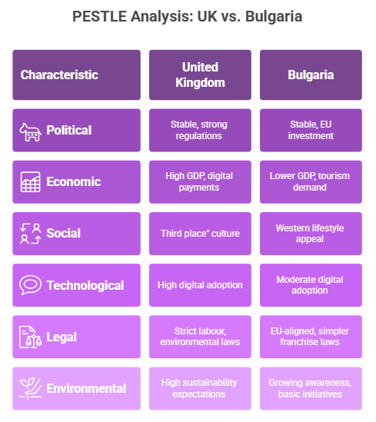
Figure 9/PESTLE analysis

Appendix 2: Hofstede cultural comparison graph
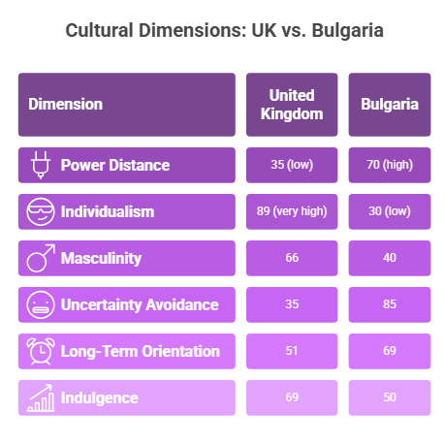
Figure 10/Hofstede cultural comparison graph

Appendix 3: Profits and sales
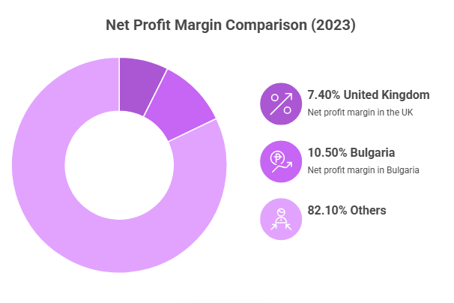
Figure 11/Profits and sales

