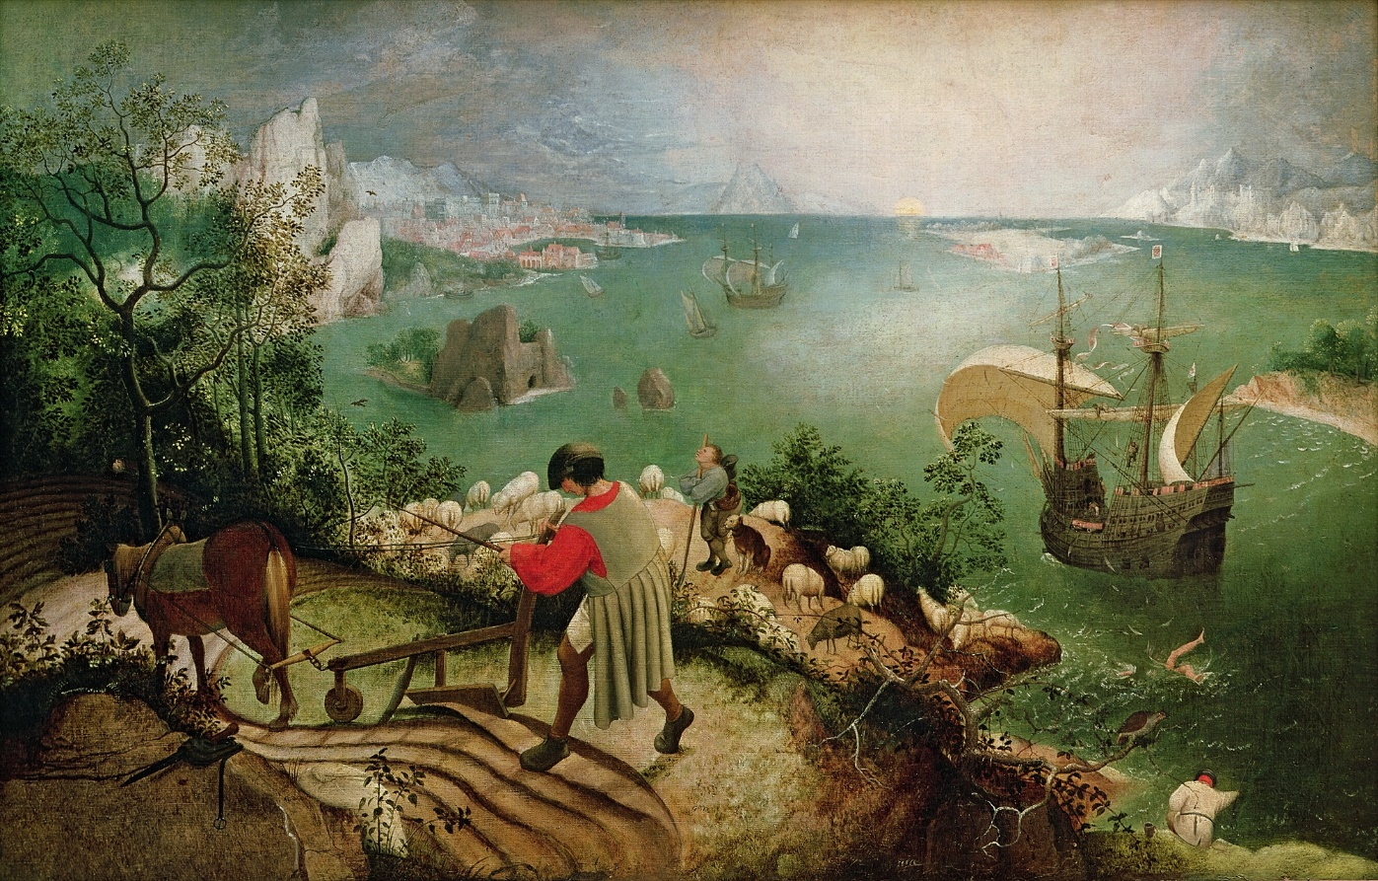

W.H Auden Musée des Beaux Arts
About suffering they were never wrong,
The Old Masters; how well they understood
Its human position; how it takes place
While someone else is eating or opening a window or just walking dully along;
How, when the aged are reverently, passionately waiting
For the miraculous birth, there always must be
Children who did not specially want it to happen, skating
On a pond at the edge of the wood:
They never forgot
That even the dreadful martyrdom must run its course
Anyhow in a corner, some untidy spot
Where the dogs go on with their doggy life and the torturer's horse
Scratches its innocent behind on a tree.
In Breughel's Icarus, for instance: how everything turns away
Quite leisurely from the disaster; the ploughman may
Have heard the splash, the forsaken cry,
But for him it was not an important failure; the sun shone
As it had to on the white legs disappearing into the green
Water; and the expensive delicate ship that must have seen
Something amazing, a boy falling out of the sky,
Had somewhere to get to and sailed calmly on.

William Carlos Williams Landscape with the Fall of Icarus

According to Brueghel
when Icarus fell
it was spring
a farmer was ploughing
his field
the whole pageantry
of the year was
awake tingling
near
the edge of the sea
concerned
with itself
sweating in the sun
that melted
the wings' wax
unsignificantly
off the coast
there was
a splash quite unnoticed
this was
Icarus drowning

Writing ekphrasis:

DESCRIBE:
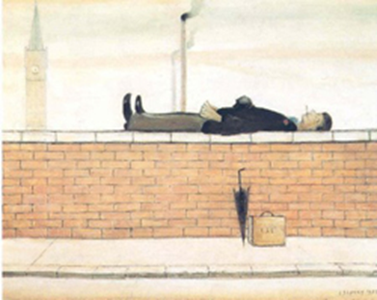

Michael Longley ‘Man Lying on a Wall’
You could draw a straight line from the heels,
Through the calves, buttocks and shoulderblades
To the back of the head: pressure points
That bear the enormous weight of the sky.
Should you take away the supporting structure
The result would be a miracle or
An extremely clever conjuring trick.
As it is, the man lying on the wall
Is wearing the serious expression
Of popes and kings in their final slumber,
His deportment not dissimilar to
Their stiff, reluctant exits from this world
Above the shoulders of the multitude.
It is difficult to judge whether or not
He is sleeping or merely disinclined
To arrive punctually at the office
Or to return home in time for his tea.
He is wearing a pinstripe suit, black shoes
And a bowler hat: on the pavement
Below him, like a relic or something
He is trying to forget, his briefcase
With everybody's initials on it.

Describe but imagine beyond the frame – SPATIALLY OR TEMPORALLY and ultimately make the the image a leaping off-point for something else

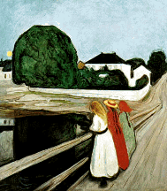

From Derek Mahon ‘Girls on the Bridge’
--Pykene na Brukken, Munch, 1900
Audible trout,
Notional midges. Beds,
Lamplight and crisp linen wait
In the house there for the sedate
Limbs and averted heads
Of the girls out
Late on the bridge.
The dusty road that slopes
Past is perhaps the high road south,
A symbol of world-wondering youth,
Of adolescent hopes
And privileges;
But stops to find
The girls content to gaze
At the unplumbed, reflective lake,
Their plangent conversational quack
Expressive of calm days
And peace of mind …
When the bad dreams
You scarcely know will scatter
The punctual increment of your lives.
The road resumes, and where it curves,
A mile from where you chatter,
Somebody screams….
The girls are dead,
The house and pond have gone.
Steel bridge and concrete highway gleam
And sing in the arctic dark; the scream
We started at is grown
The serenade
Of an insane
And monstrous age….
Describe but incorporate see above. [bring the research materials and ideas from elsewhere in the module to an object – e.g think about the differences between the monstrous mummy or the idea of the curse and the funeral paintings here]
Make Main/or secondary/or absent Figure Speak – ventriloquism [see the politics of Orientalism] Make the maker/artist speak
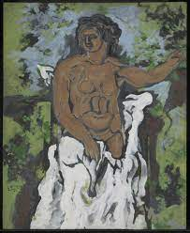
Carol Ann Duffy ‘Standing Female Nude’
Six hours like this for a few francs.
Belly nipple arse in the window light,
he drains the colour from me. Further to the right,
Madame. And do try to be still.
I shall be represented analytically and hung
in great museums. The bourgeoisie will coo
at such an image of a river-whore. They call it Art.
Maybe. He is concerned with volume, space.
I with the next meal. You're getting thin,
Madame, this is not good. My breasts hang
slightly low, the studio is cold. In the tea-leaves
I can see the Queen of England gazing
on my shape. Magnificent, she murmurs,
moving on. It makes me laugh. His name
is Georges. They tell me he's a genius.
There are times he does not concentrate
and stiffens for my warmth.
He possesses me on canvas as he dips the brush
repeatedly into the paint. Little man,
you've not the money for the arts I sell.
Both poor, we make our living how we can.
I ask him Why do you do this? Because
I have to. There's no choice. Don't talk.
My smile confuses him. These artists
take themselves too seriously. At night I fill myself
with wine and dance around the bars. When it's finished
he shows me proudly, lights a cigarette. I say
Twelve francs and get my shawl. It does not look like me.

incorporte the exerpeicne of the writer [you or an image]
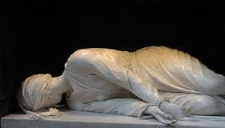

David Wright ‘By the Effigy of St Cecilia’
Having peculiar reverence for this creature
Of the numinous imagination, I am come
To visit her church and stand before the altar
Where her image, hewn in pathetic stone,
Exhibits the handiwork of her executioner.
There are the axemarks. Outside, in the courtyard,
In shabby habit, an Italian nun
Came up and spoke: I had to answer, ‘Sordo’.
She said she was a teacher of deaf children
And had experience of my disorder.
And I have had experience of her order,
Interpenetrating chords and marshalled sound;
Often I loved to listen to the organ’s
Harmonious and concordant interpretation
Of what is due to us from the creation.
But it was taken from me in my childhood
And those graduated pipes turned into stone.
Now, having travelled a long way through silence,
Within the church in Trastevere I stand
A pilgrim to the patron saint of music
And am abashed by the presence of this nun
Beside the embodiment of that legendary
Virgin whose music and whose martyrdom
Is special to this place: by her reality.
She is a reminder of practical kindness,
The care it takes to draw speech from the dumb
Or pierce with sense the carapace of deafness;
And so, of the plain humility of the ethos
That constructed, also, this elaborate room
To pray for bread in; they are not contradictory.

