
Intercultural Competence Report


Name: Andreea Serban
Student ID: 2212423
Module title: Cultural Awareness
Lecturer: Lisa-Marie Bassler
Word count: xxxx

Executive Summary

This report aims to provide insights into intercultural competence and leadership in Spain, with a focus on how the operations of Diversity Hotel & Spa is expanding into the Spanish market. It discusses Spain's culture and customs, highlighting key cultural differences between Spain and the UK. Additionally, it delves into employee management in Spain and potential challenges for the General Manager.
The main findings indicate that Spain is a diverse and complex country with a rich cultural and artistic heritage, which is influenced by its Catholic religious tradition. Spanish business culture is characterized by a mix of traditional and modern approaches, with a focus on relationships, hierarchy, and adaptability.
There are significant cultural differences between Spain and the UK, such as the different pace of business, communication, and punctuality.
The General Manager of the Diversity Hotel & Spa in London faces several challenges such as language barrier, cultural misunderstanding, and time management. The report recommends that the General Manager should develop intercultural competence and leadership skills, such as cultural awareness, sensitivity, empathy, flexibility, and communication.

Table of Contents
Executive Summary 1
Introduction 3
Main Body 3
Culture Overview 3
Customs 4
Cultural Differences 5
Potential Challenges 5
GLOVE Analysis 5
Conclusion 7
Recommendations 7
Reference List 8

Introduction
The Diversity Hotel & Spa is planning to expand its business to Spain and according to Statista (2023), Spain is the second most visited country in the Europe, with over 71.66 million tourists in 2022, and has a strong domestic demand for tourism and travel.
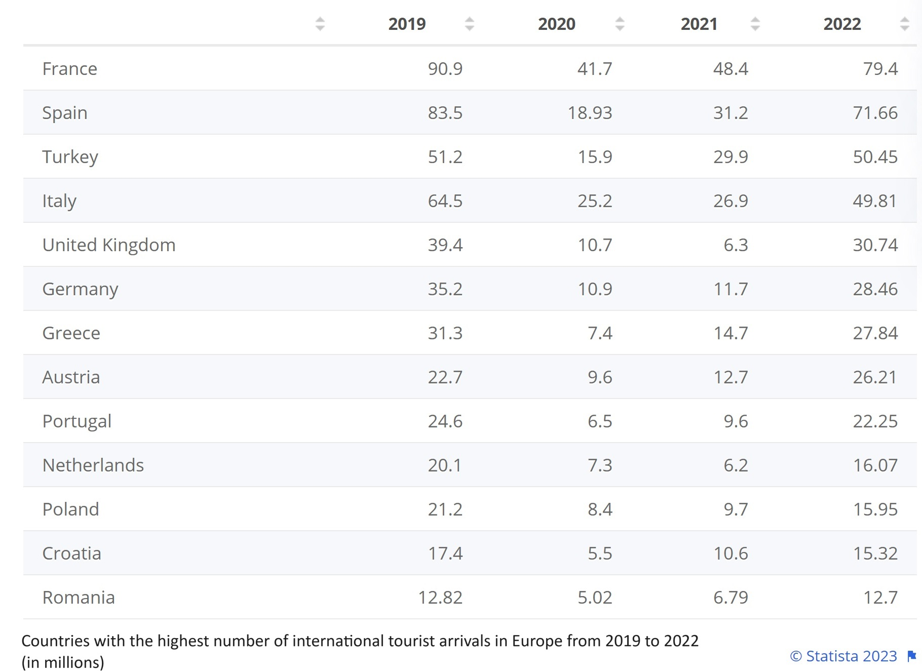
The Spanish hospitality industry is highly competitive and diverse, with a variety of players, from global chains to local independents, offering different segments, products, and services as per Lopez (2022).
The purpose of this report is to provide an overview of the culture, customs, and business practices of Spain, as well as the main challenges and opportunities for the General Manager.

Main Body

Culture Overview
According to La Moncloa (2023), the Spanish culture is rich and diverse, characterized by a deep-rooted history, a love for food, music, and art, and a strong emphasis on family and social connections.
“Spain consists of 17 autonomous communities (comunidades autónomas). Spanish regions have their own cultures and some even have their own official languages” (Janicke, 2023).
It is vital to understand the following aspects of Spanish culture:
- Language: According to Britannica (2023), Castilian is the official language of Spain. Also, there are other regional languages that are spoken throughout the nation as well, including Catalan, Basque, Valencian, and Galician.
- Religion: Catholicism is the predominant religion as per Statista (2023) and according to Kryukova and Davtiian (2019), “religion still plays an important role in people’s lives, and it continues to exert influence on the development of society”.
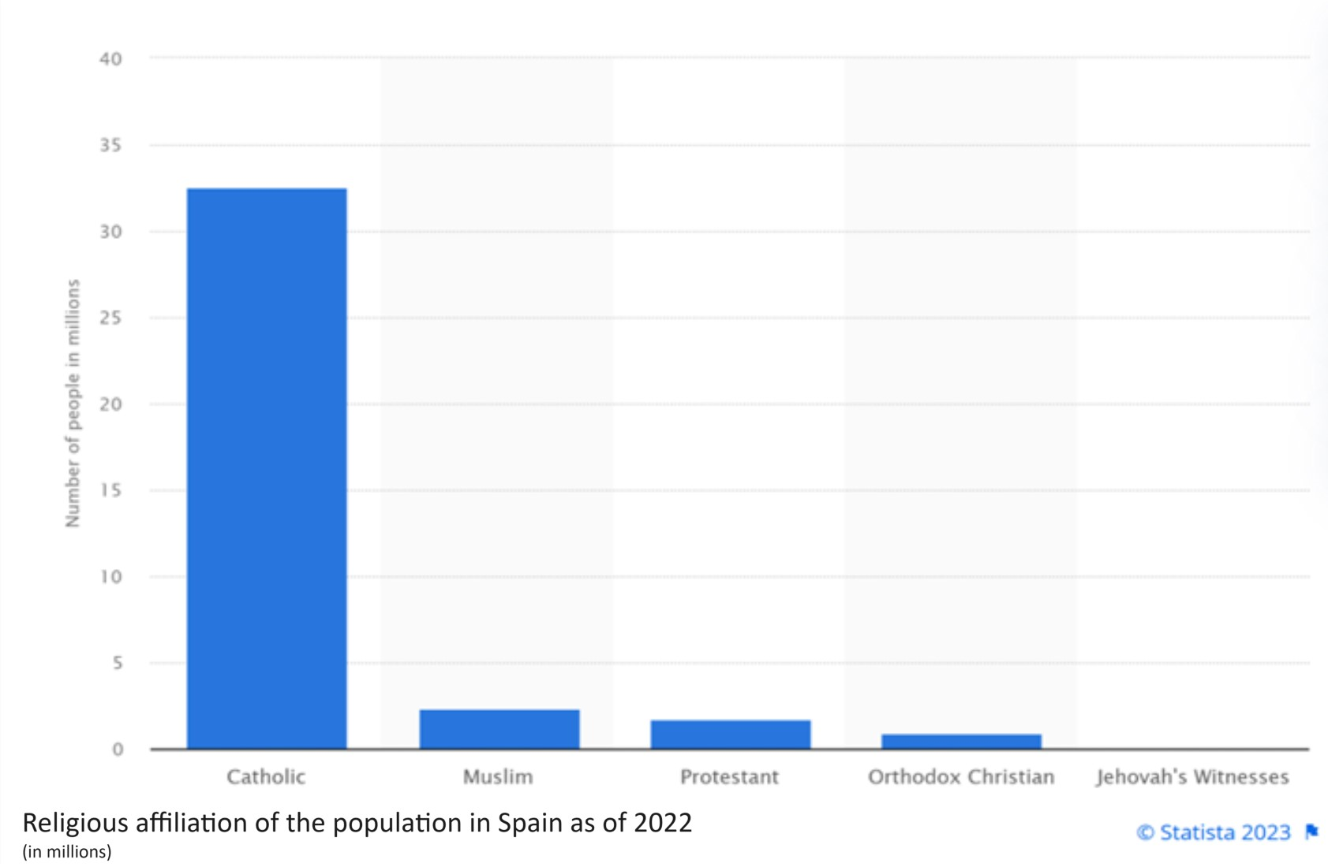

- Hierarchical Society: According to Santander (2023), in Spain, respect for seniors and rank are important aspects of the hierarchical business environment.
- Work-Life Balance: “Spaniards value their work-life balance, and it's essential to respect this. The workday may be long, but there is an emphasis on enjoying leisure time with family and friends” (Janicke, 2023).
- Communication Style: “Spanish communication is often warm and expressive. Spaniards tend to stand closer when speaking, maintain good eye contact and sometimes they can get carried away and speak loudly and gesticulate heavily” (Janicke, 2023).

Customs
- Greetings: In a professional context, it is customary to give a firm handshake and address someone as "Señor" or "Señora" before mentioning their name and last name. Although addressing new people formally with "Usted" is customary, they frequently request that you use the more casual "Tú" instead. according to Santander (2023).
- Siesta: According to Evason (2018) and Sophie (2021), the siesta is a traditional short break taken in the early afternoon, usually between 2:00 PM and 4:00 PM. Many businesses close during this time, particularly in smaller towns. However, in larger cities, the practice has become less common.
- Dining: According to Evason (2018) and Lexidy (2023), Spaniards enjoy their meals and often have a long lunch and dinner. Lunch is typically the largest meal of the day and can extend for several hours and it’s this special social ritual that sets the stage for building strong and meaningful connections.

Cultural Differences
- Pace of Business: “People generally report that Spanish business culture feels a bit slower than other professional settings of which they’ve been a part of previously” (Sophie N, 2023).
- Punctuality: According to Janicke (2023) and Santander (2023), Spaniards tend to have a more relaxed attitude towards punctuality than in UK, so it's common for meetings and events to start a bit later.
- Communication: According to Evason (2018) and Santander (2023), Spanish communication is often indirect, with a strong emphasis on non-verbal cues.

Potential Challenges
Language Barrier: According to Lexidy (2023) and Janicke (2023), effective communication is crucial, and it's important to be aware of the regional linguistic differences. While many Spaniards speak English, it is essential for leadership to have a basic understanding of Spanish.
Cultural Misunderstandings: As Janicke (2023) and Evason (2018) points out, the lack of cultural competence can result in misinterpretations.
Time Management: “Navigating the waters of Spanish punctuality and preparation involves finding that equilibrium between sticking to schedules and dancing to the nation’s rhythm” (Lexidy, 2023).

GLOBE analysis
Spain falls within the Latin Europe cultural cluster, which exhibits a unique set of cultural dimensions and leadership preferences. Here's a summary of the key findings of the GLOBE project for Spain:
- Performance orientation: Spaniards value achievement and excellence.
- Assertiveness: Spaniards tend to be direct and confrontational in their interactions with others.
- Future orientation: Spaniards plan and value long-term goals.
- Humane orientation: Spaniards value and care for others.
- Institutional collectivism: Spaniards value and identify with the institutions and organizations to which they belong.
- In-group collectivism: Spaniards value and identify with their close family and friends.
- Gender egalitarianism: Spain is a relatively egalitarian society, with men and women having equal rights and opportunities.
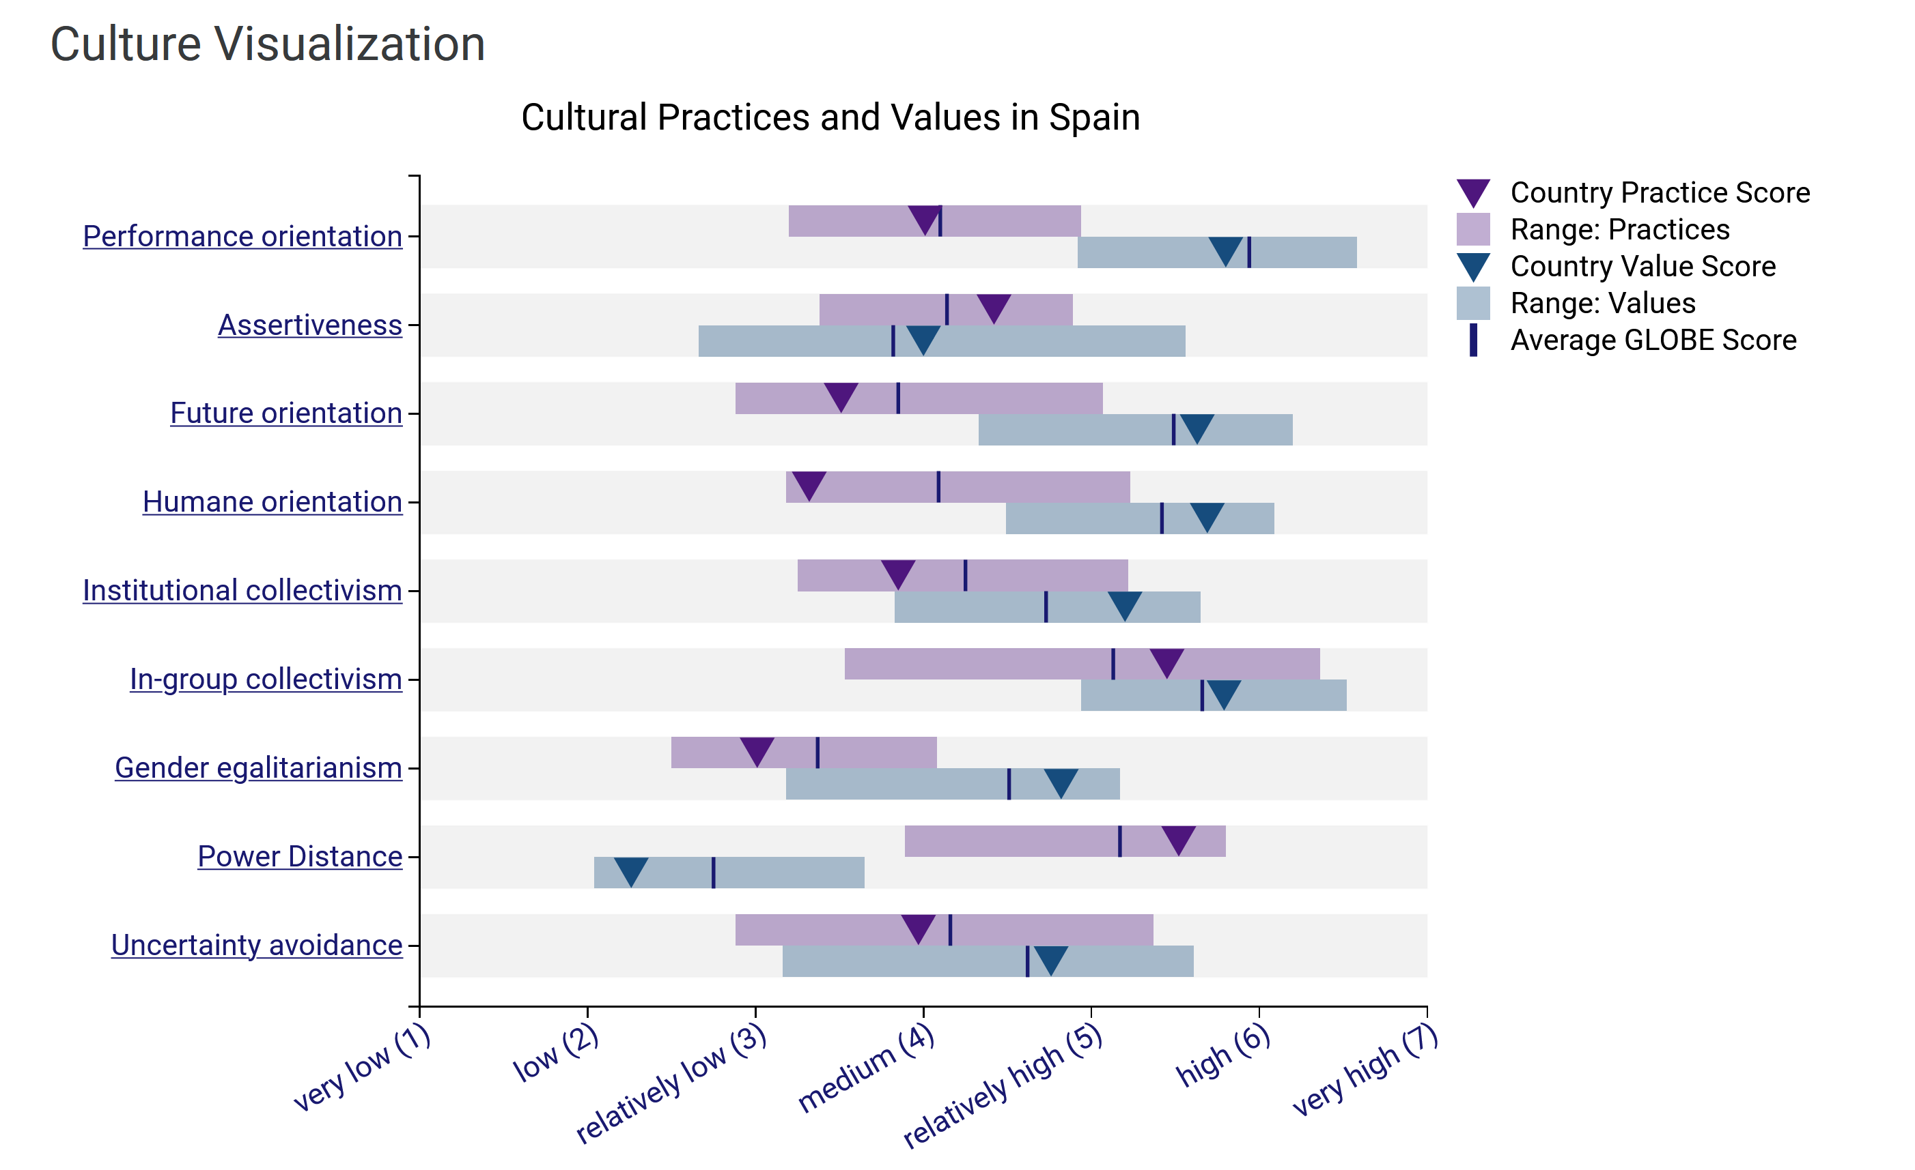
The GLOBE project also found that Spaniards prefer leaders who are:
- Visionary: Spaniards want leaders who can articulate a compelling vision for the future.
- Team-oriented: Spaniards want leaders who can build and lead effective teams.
- Participative: Spaniards want leaders who involve them in decision-making.
- Humane: Spaniards want leaders who care for and support them.
- Autonomous: Spaniards want leaders who empower them to make decisions and act.
- Integrative: Spaniards want leaders who are honest and trustworthy.
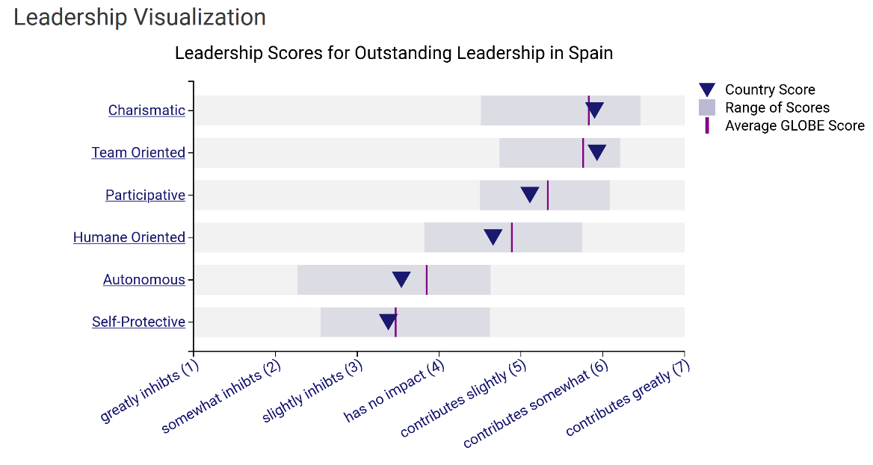

Conclusion
Expanding into Spain offers tremendous potential for Diversity Hotel & Spa, but it requires a deep understanding of Spain's unique culture and customs. Adapting to the differences between Spain and the UK is crucial for success.
Understanding the cultural aspects and customs will help the General Manager build rapport with the hotel personnel and guests in Spain. It's also crucial to incorporate the cultural insights into the staff training program to ensure that the hotel's operations and service standards align with the local culture and expectations.

Recommendations
A few suggestions can be made, considering the data and research included in this report:
- Cultural Sensitivity Training: Implement cultural sensitivity training for all hotel personnel to ensure they are aware of and respectful of the local customs and cultural norms in Spain.
- Employee retention & motivation: Acknowledge and reward hard work, as well as personal achievements, to motivate staff. Provide continuous training and respect employees' need for work-life balance and flexibility in working hours.
- Multilingual Staff: Ensure that the hotel has a staff proficient in both Spanish and English, as well as any regional languages spoken in the area. This will help facilitate effective communication with guests and ensure a seamless guest experience.
- Effective Communication: Effective leadership involves clear and respectful communication. Understanding the nuances of the Spanish language and communication style, including the use of formal and informal language, is essential.

Reference list

Britannica (2023) Spain. Available at: https://www.britannica.com/place/Spain (Accessed: 1 November 2023).
Evason, N. (2018) Spanish Business Culture. Available at: https://culturalatlas.sbs.com.au/spanish-culture/spanish-culture-business-culture (Accessed: 1 November 2023).
Globe Project (2004) GLOBE 2004 CEO Study. Available at: https://globeproject.com/results/countries/ESP?menu=country#country (Accessed: 1 November 2023).
Janicke, M (2023) The business culture in Spain. Available at: https://www.expatica.com/es/working/employment-basics/business-culture-in-spain-102512/ (Accessed: 1 November 2023).
Kryukova, E. & Davtiian, Y. (2019) Religion and Politics in Modern Spain. Available at: https://papers.ssrn.com/sol3/papers.cfm?abstract_id=3505476 (Accessed: 1 November 2023).
La Moncloa (2023) Culture of Spain. Available at: https://www.lamoncloa.gob.es/lang/en/espana/historyandculture/culture/Paginas (Accessed: 1 November 2023).
Lexidy (2023) Navigating Spanish Business Culture: 7 Key Characteristics. Available at: https://www.lexidy.com/blog/7-characteristics-of-the-spanish-business-culture/ (Accessed: 4 November 2023).
Lopez, A., M. (2022) Hotel industry in Spain - statistics & facts. Available at: https://www.statista.com/topics/7746/hotel-industry-in-spain/#topicOverview (Accessed: 1 November 2023).
Santander Trade Markets (2023) Spain: Business practices. Available at: https://santandertrade.com/en/portal/establish-overseas/spain/business-practices (Accessed: 1 November 2023).
Sophie N. (2021) Business culture in Spain: All you need to know in 2023. Available at: https://preply.com/en/blog/business-culture-in-spain/ (Accessed: 1 November 2023).
Statista Research Department (2023) Countries with the highest number of international tourist arrivals in Europe from 2019 to 2022. Available at: https://www.statista.com/statistics/261729/countries-in-europe-ranked-by-international-tourist-arrivals/ (Accessed: 4 November 2023).
Statista Research Department (2023) Number of adherents to the main religions in Spain 2022. Available at: https://www.statista.com/statistics/1338534/number-adherents-religions-spain/ (Accessed: 4 November 2023).

