
Assignment 2:
Operating Systems
CertHE Computing Skills for Workplace

Computer Architecture and Operating Systems. ACCA4022_LON
DR. Redhwan Al-Amri (Lecturer)
University of Wales Trinity Saint David
(London Campus)
Student Name: Edoard Buzga
Student Number: 2439674
Group: 02
Date: 14/12/25

Table of Contents
Introduction 1
1. Key functions of general Operating Systems 1
Systems 1
1.1 Process and Processor Management 1
1.2 Memory Management 3
1.3 File System Management 4
1.4 Security and Protection 5
2. Use of Windows OS CLI commands. 7
3. Use of Linux OS CLI commands. 15
4. Use of Windows OS scripts. 20
Script: System Health Check 20
Key Features Demonstrated 22
5. Use of Linux OS scripts. 23
Script: Log File Analyzer 23
Key Features Demonstrated 25
Conclusion 26
References 27
Appendices 29
Tutorial Activity on OS Types from OS Tutorial 1 29
1. LinkedIn Learning course: 29
2. Cisco Network Academy: 30
3. Cisco Network Academy : Operating Systems Basics 32

Introduction

1. Key functions of general Operating Systems

1.1 Process and Processor Management

System and processor management are a center feature of any present-day working gadget. A *system* is an example of a program this is presently going for walks on a laptop, together with a web browser, word processor, or media participant. The *processor* (CPU) is the hardware thing responsible for executing commands for these methods.
Due to the fact the CPU can best execute a constrained quantity of commands at a time, the working gadget must manipulate methods percentage processor time successfully to ensure the gadget stays responsive and stable. The working gadget achieves this through a system known as *CPU scheduling*. It swiftly switches the CPU between a couple of methods, giving every system a small slice of time to execute. This creates the illusion that many programs are going for walks simultaneously.
The OS also prioritizes critical gadget methods over much less crucial historical past responsibilities and might pause or terminate unresponsive methods to guard common gadget overall performance. powerful system and processor management prevents an unmarried utility from monopolizing CPU sources and causing gadget slowdowns or crashes. This functionality may be observed in Microsoft home windows using the challenge manager utility. *Parent 1* indicates the methods tab in challenge manager, which lists all active methods along with their CPU usage.
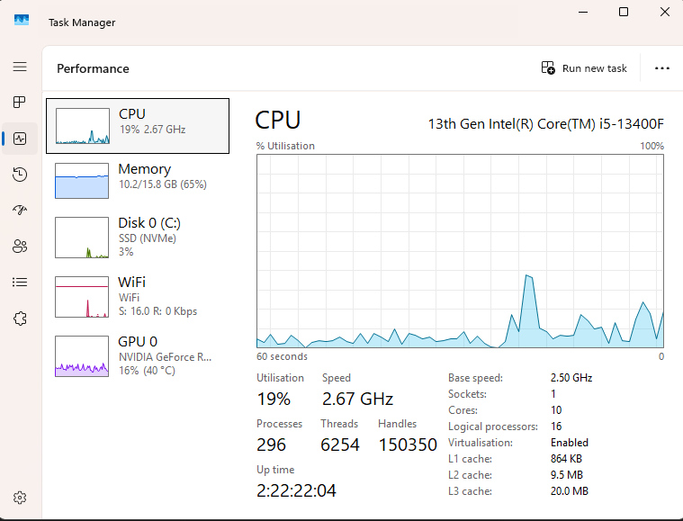
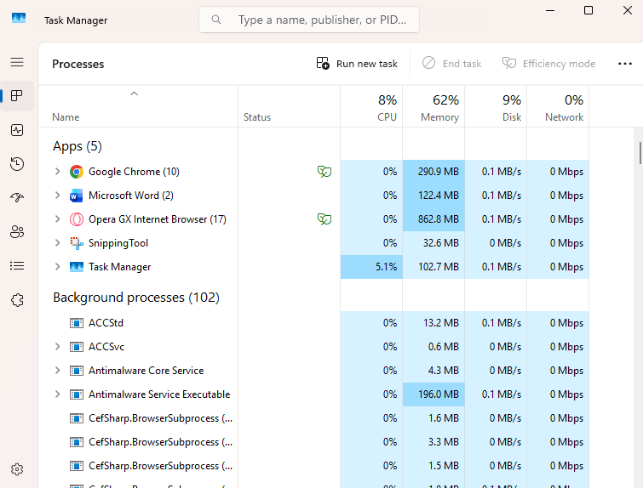
This demonstrates how home windows monitor and allocate processor sources across going for walks packages. *Parent 2* indicates the CPU segment under the overall performance tab, displaying real-time processor usage, center depend, and gadget load. Collectively, these perspectives provide clean evidence of how the working gadget manages methods and processor sources in exercise.

1.2 Memory Management
Memory control refers to how a running gadget controls and coordinates the usage of a computer’s primary memory (RAM). RAM is a limited aid that stores information and commands applications that are presently going for walks. The running gadget is responsible for allocating memory to approaches when they begin, dealing with memory utilization at the same time as they run, and liberating memory whilst approaches cease. powerful memory control guarantees that programs run smoothly without interfering with one another or laborious gadget sources.
Contemporary running systems use strategies consisting of virtual memory to increase the obvious length of bodily RAM. Virtual memory allows the OS to use disk space as transient memory, moving inactive information out of RAM to make space for energetic approaches. This facilitates save you gadget crashes whilst memory call for is high and permits more than one program to run simultaneously. The OS additionally isolates each procedure’s memory space to improve stability and safety, making sure that one software cannot access or corrupt every other software’s information. In home windows, memory control may be discovered using project supervisor. Parent three indicates the memory phase beneath the performance tab, which shows total mounted memory, memory in use, and available memory. This offers proof of ways the running gadget monitors and manage memory sources in real time.
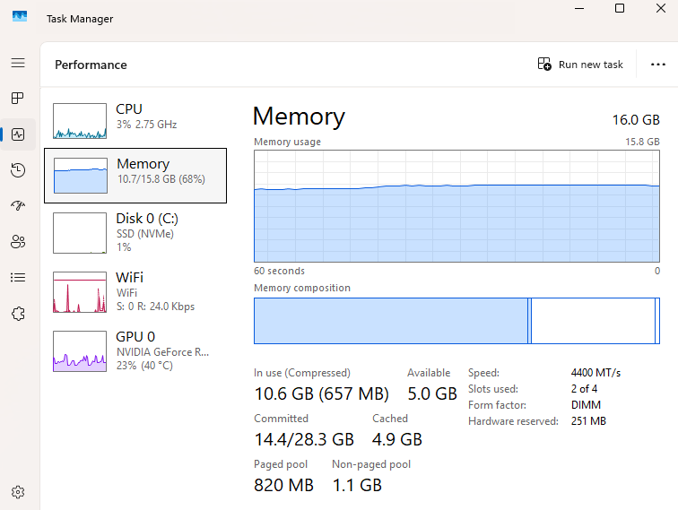

1.3 File System Management
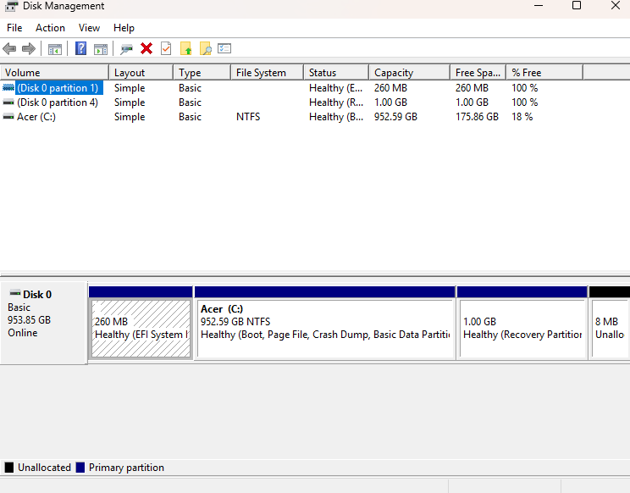
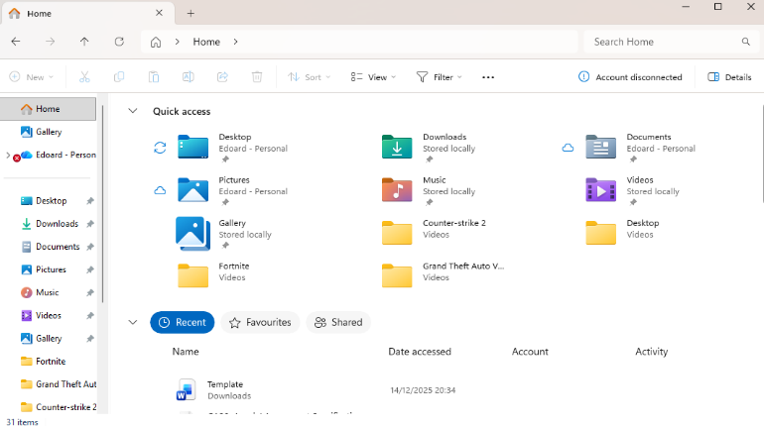
Report system control is the running system feature responsible for organizing, storing, retrieving, and protective statistics on storage devices such as difficult drives and stable-kingdom drives. The report system defines how files are named, saved, and accessed, and dependent on directories and folders. Without report system control, customers and applications could no longer be capable of reliably shopping or discovering statistics. The running system manages report permissions, tracks report places on disk, and guarantees statistics integrity during examine and write operations. It additionally handles tasks such as allocating disk space, coping with report metadata (such as length and advent date), and improving from errors wherein viable. In windows, the NTFS report system is commonly used because it helps big files, protection permissions, and fault tolerance capabilities. This feature can be located through windows report Explorer and Disk control gear. determine 4 indicates report Explorer showing folders and files organized in the report system, even as determine 5 may additionally show Disk control illustrating how storage is partitioned and formatted. Those gears display how the running system presents dependent and person-friendly get right of entry to save statistics.

1.4 Security and Protection
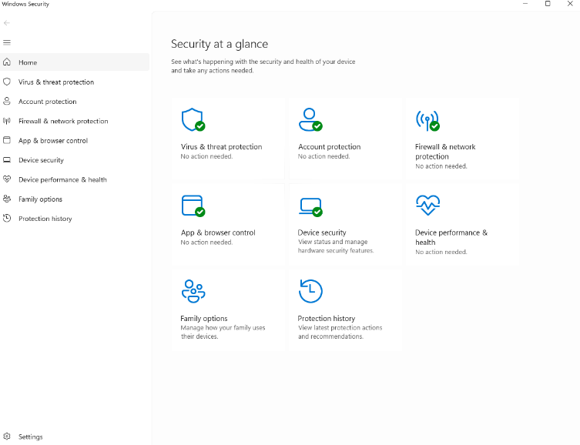
Safety and protection are crucial capabilities of current running systems, designed to protect information, users, and gadget sources from unauthorized get of entry to, misuse, and malicious software. The running gadget enforces safety policies that manage who can get right of entry to the gadget and what actions they're accredited to perform. This includes user authentication, getting right of entry to manage, and gadget-stage protection. Running systems use user accounts, passwords, and permissions to get right of entry to files and gadget sources. in addition, they include integrated safety tools along with firewalls, antivirus protection, and gadget updates to guard in opposition to threats. By means of keeping apart processes and implementing privilege tiers, the OS reduces the risk that malware or faulty packages can compromise the whole gadget. In windows, safety and protection functions can be managed through the windows safety application. Determination 6 indicates the windows safety dashboard, which provides entry to virus and risk protection, firewall settings, and device safety alternatives. This demonstrates how the running gadget centralizes safety management to protect users and gadget information.

2. Use of Windows OS CLI commands.
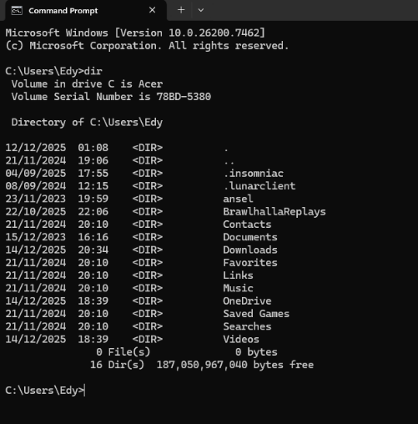
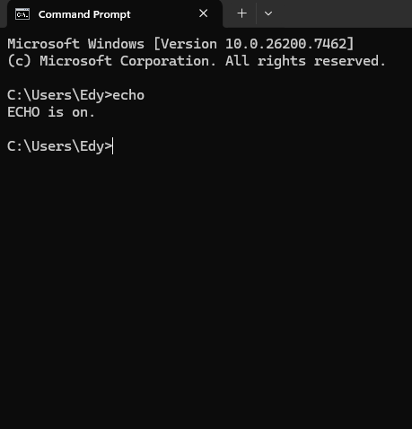
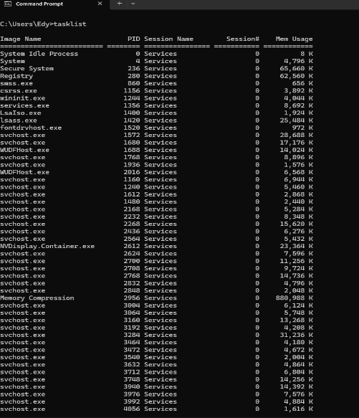
The Command Line Interface (CLI) in home windows presents a text-based method for interacting immediately with the running machine. Using the CLI allows customers and directors to carry out machine duties efficiently, access machine facts, and troubleshoot issues without relying on the graphical person interface. This section documents the realistic use of key home windows OS CLI commands and explains how they relate to center running machine functions. The (dir) command is used to show the contents of a listing, listing files and folders alongside information which includes length and date changed. This command demonstrates file machine management by means of allowing customers to view how statistics are organized on garage gadgets. The (echo) command outputs text or machine variables to the command window and is regularly used to show messages or assist with scripting and debugging duties. method and machine monitoring are supported through commands which includes (tasklist) and systeminfo. The tasklist command displays a list of all present walking procedures, showing how the running machine manages more than one program concurrently. The (systeminfo) command presents special facts about the running machine model, hardware configuration, reminiscence, and hooked up updates, helping machine administration and diagnostics. Several commands provide direct access to running machine facts and configuration. The (ver) command displays the present-day home windows model, confirming the OS surroundings in use. The (help) command lists to be had commands or presents steerage on how to use a particular command, acting as integrated documentation. The (mode) command displays or configures machine device settings which includes the console window length, illustrating low-level interaction with machine components. Networking and machine software commands further exhibit OS capability. The (ping) command checks community connectivity by sending packets to a far-flung host and measuring reaction time, that is vital for diagnosing community troubles. The (vol) command displays the extent label and serial number of a disk, linking the CLI to garage management. The (date) command displays or allows change of the machine date, demonstrating how the running machine manages extensive settings. Screenshots in this section display those commands being carried out inside the home windows Command activate alongside their outputs. collectively, those examples exhibit how home windows CLI commands provide direct access to file management, method manipulation, machine facts, and community diagnostics.

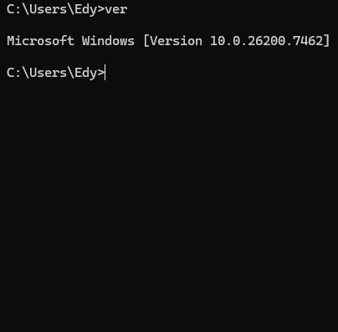
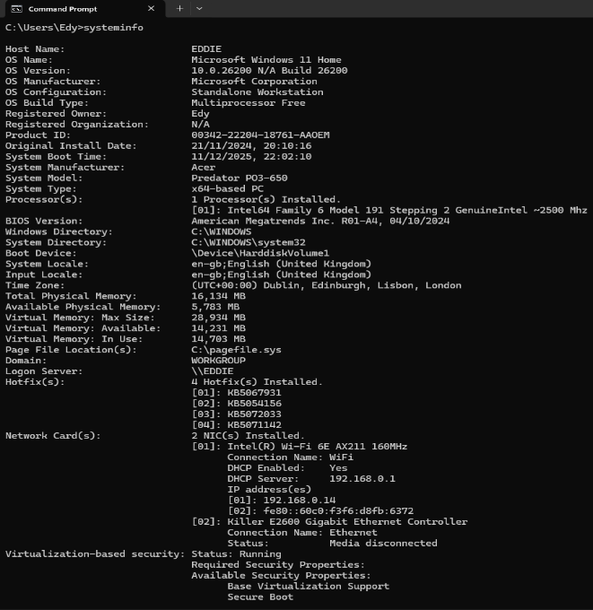

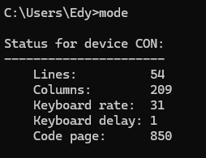
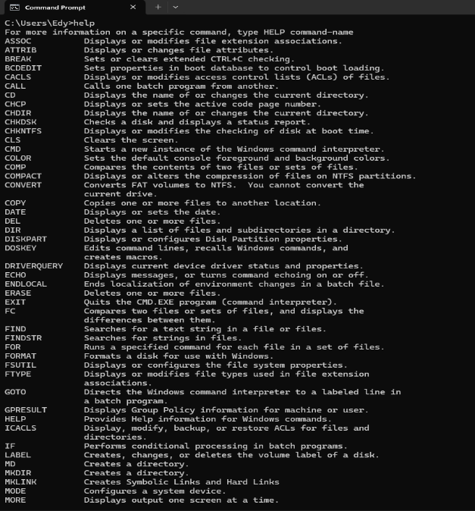

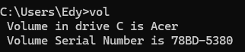
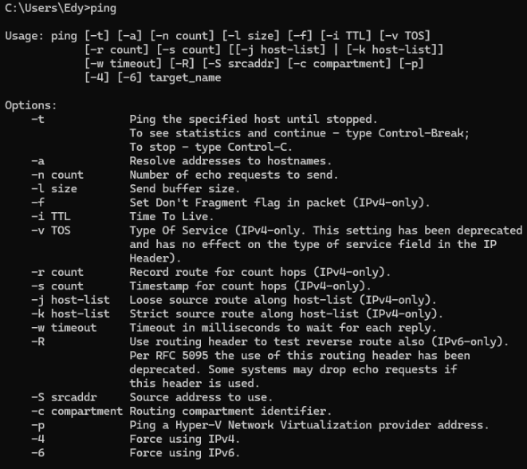
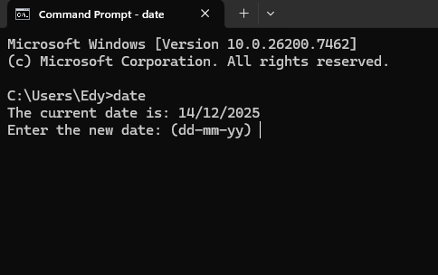

3. Use of Linux OS CLI commands.
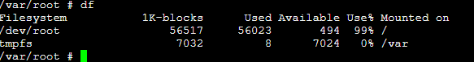
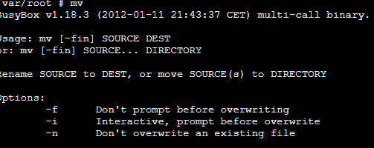
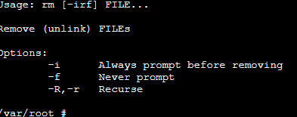
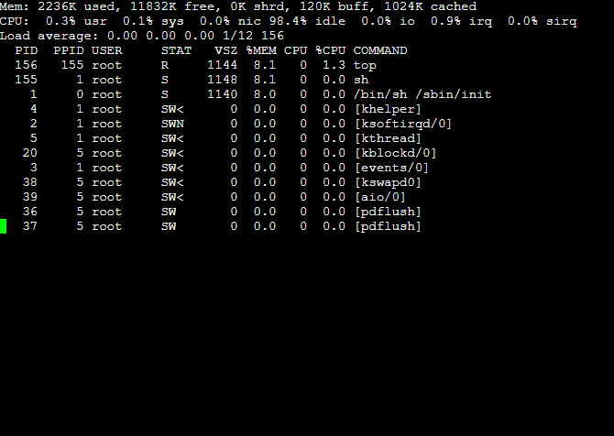
Linux working systems make huge use of the Command Line Interface (CLI), typically accessed through a Bash shell, to manipulate device resources and perform administrative responsibilities. Linux CLI gives effective tools for tracking processes, coping with files, controlling garage, and retrieving records from networks. This phase documents the usage of key Linux CLI commands and explains how they relate to center working device capabilities. system tracking is a fundamental obligation of the working device. The (top) command gives a real-time view of going for walks processes, showing CPU usage, reminiscence consumption, and device load. further, the (ps) command lists energetic processes at a particular point in time. collectively, those commands display how Linux permits customers to have a look at and manipulate multiple processes, helping efficient processors and resource control. document control is treated through numerous critical commands. The (touch) command creates a brand-new empty document or updates the timestamp of an existing document, even as the (mv) command actions or renames files and directories. The (rm) command eliminates files or directories, illustrating how Linux permits customers to manipulate stored records at once through the CLI. those commands spotlight the working device’s function in controlling document advent, amendment, and deletion. Garage and disk control are established in the use of the df and mount commands. The (df) command shows records about disk area usage on set up document systems, assisting customers monitor available garage. The (mount) command is used to connect document systems or garage gadgets to the directory tree, illustrating how Linux manages to get entry to physical and virtual garage resources. additional device utility and assessment tools in addition display Linux functionality. The (cal) command shows a calendar, showing how the device manages date-related records. The (wget) command retrieves files from the net, demonstrating network interaction thru the CLI. The (diff) command compares the contents of files and shows their differences, helping records verification and device management responsibilities. Screenshots in this phase display those commands being done in a Linux terminal environment at the side of their outputs. These examples display how Linux CLI commands offer direct management over processes, files, garage, and networking, reinforcing the significance of the command line in Linux working systems.
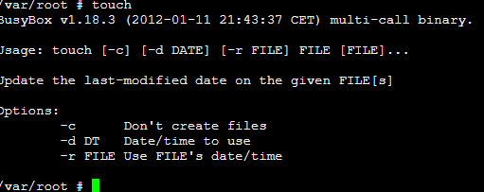
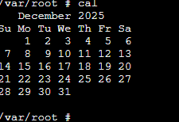
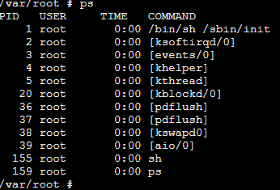
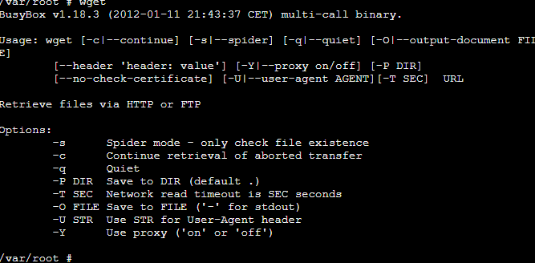

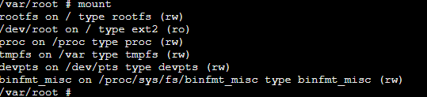
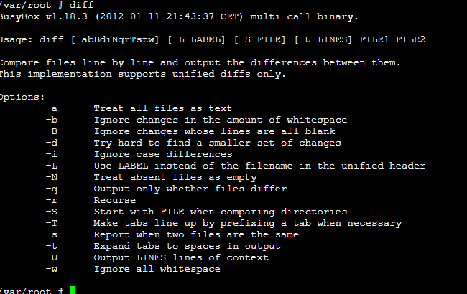

4. Use of Windows OS scripts.
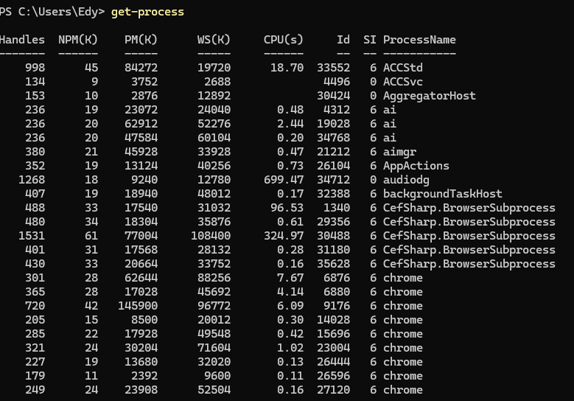
Home windows working systems encompass built-in scripting abilities that allow customers and directors to automate tasks, manage system sources, and engage immediately with working system additives. PowerShell is a cutting-edge home windows scripting language this is tightly integrated with the OS and makes use of item-based totally instructions referred to as cmdlets. This section demonstrates key features of home windows OS scripting the usage of PowerShell, focusing on using the brand new-item, Get-process, and Get-Variable cmdlets. One essential characteristic of home windows OS scripting is automation of document system tasks. The (new-item) cmdlet is used to create new documents or directories immediately from a script. As an example, PowerShell script can robotically create a folder shape and generate documents with no guide interplay. This demonstrates how scripting allows repetitive document management tasks to be completed fast, constantly, and with reduced danger of user blunders, highlighting the working system’s position in handling garage sources. PowerShell also permits system and system tracking through scripting. The (Get-process) cmdlet retrieves unique facts about currently strolling processes, consisting of CPU and reminiscence usage. When used within a script, this command allows directors to display system interest and identify aid-intensive or unresponsive programs. This demonstrates how home windows OS scripts can engage immediately with system management features which might be generally accessed through graphical tools such as task supervisor. Any other key scripting characteristic is using variables to keep and manage facts for the duration of script execution. The (Get-Variable) cmdlet presentations all variables currently defined in a PowerShell session, consisting of user-defined and system variables. This allows customers to look into saved values and apprehend how scripts tune facts for the duration of execution. using variables improves script flexibility, readability, and reusability, demonstrating how PowerShell supports based and logical automation. Screenshots on this section show PowerShell scripts being done and their output displayed within the PowerShell console. Examples exhibit how home windows OS scripting supports automation, system tracking, and variable management, reinforcing the significance of scripting for powerful administration of cutting-edge home windows working systems.
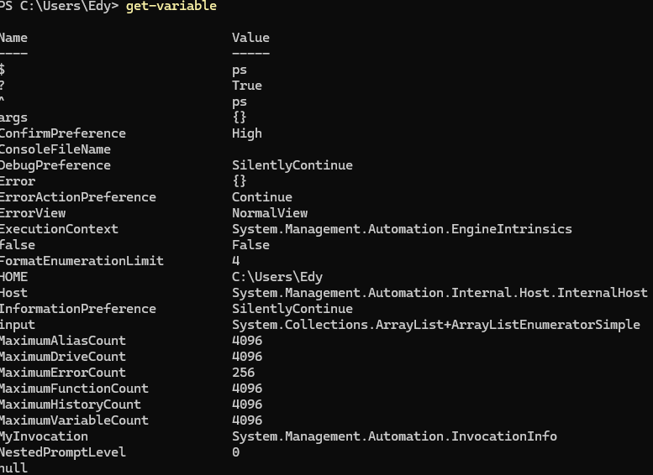
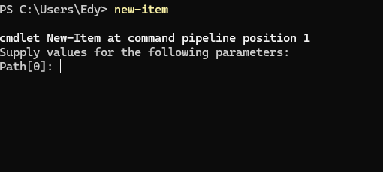

5. Use of Linux OS scripts.
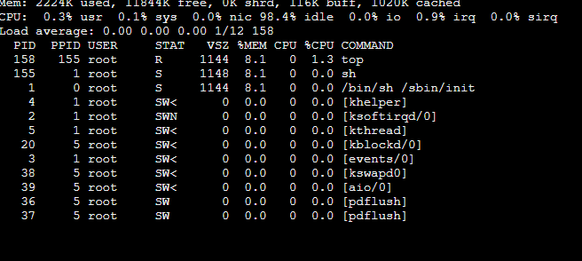
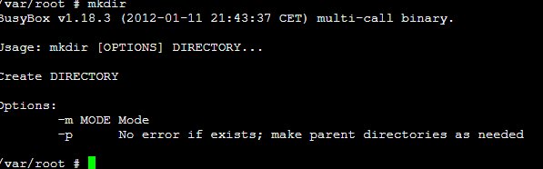
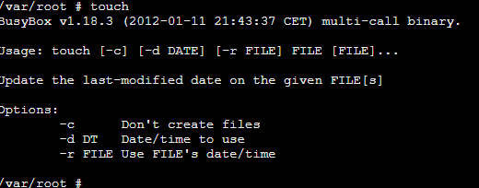
Linux running systems offer powerful scripting capabilities through the Bash (Bourne again Shell) scripting language. Bash scripting is widely used to automate duties, manipulate device resources, and perform administrative operations in Linux environments. This section demonstrates key functions of Linux OS scripting via documenting the use of Bash scripts that utilize the mkdir, contact, and top commands. One key characteristic of Bash scripting is automation of file and listing control. The (mkdir) command is used inside a script to mechanically create directories, while the contact command is used to create new empty files. for instance, and Bash script can be written to create a venture listing and generate more than one files in a single execution. This demonstrates how scripting allows repetitive file device duties to be finished correctly without guide input, highlighting the running device’s role in handling garage and listing structures. Bash scripts can also be used for device and procedure monitoring. The (top) command gives an actual-time view of jogging tactics, CPU utilization, and memory intake. When protected in a Bash script, top allows customers or administrators to speedy reveal device overall performance and identify tactics that are consuming immoderate resources. This indicates how Linux OS scripts engage directly with center procedure control and resource allocation features of the running device. Another essential characteristic of Bash scripting is sequential execution of commands. via combining mkdir, (touch), and top in a single script file (with an .sh extension), more than one running device duties can be performed so as with one command. This demonstrates how Bash scripting improves performance, consistency, and reliability when appearing administrative duties. Scripts can also include feedback to enhance readability and upkeep, that's vital for actual-world device administration. Screenshots on this section display a Bash script being performed in a Linux terminal environment and the output produced via each command. The examples reveal how Linux OS scripting supports automation, device monitoring, and green interplay with running device resources.

Conclusion
This challenge has explored the important thing standards and sensible use of present-day running systems through each theoretical evaluation and hands-on command-line and scripting activities. The important thing capabilities of running systems, consisting of method control, reminiscence control, report machine control, and protection, were tested to expose how running systems manipulate hardware and software program assets successfully. sensible obligations, the usage of home windows and Linux command-line interfaces established how running systems may be controlled and monitored through commands. Additionally, home windows PowerShell and Linux Bash scripting highlighted the significance of automation and machine management. Generally, the obligations supplied treasured perception into how running systems are characteristic in actual-global computing environments.

References
[1] A. Silberschatz, P. B. Galvin, and G. Gagne, Operating System Concepts, 10th ed. Hoboken, NJ, USA: Wiley, 2018.
[2] M. Russinovich, D. Solomon, and A. Ionescu, Windows Internals, Part 1, 7th ed. Redmond, WA, USA: Microsoft Press, 2021.
[3] Microsoft, “PowerShell Documentation,” Microsoft Learn, 2024. [Online]. Available: https://learn.microsoft.com/powershell
[4] Microsoft, “Windows Command-Line Reference,” Microsoft Learn, 2024. [Online].
[5] The Linux Foundation, “Linux Documentation,” Linux Foundation, 2024. [Online]. Available: https://www.kernel.org/doc/
[6] W. Shotts, The Linux Command Line, 2nd ed. San Francisco, CA, USA: No Starch Press, 2019.
[7] Tutorials Point, “Linux Shell Scripting Tutorial,” 2024. [Online]. Available: https://www.tutorialspoint.com/unix/shell_scripting.htm

Appendices
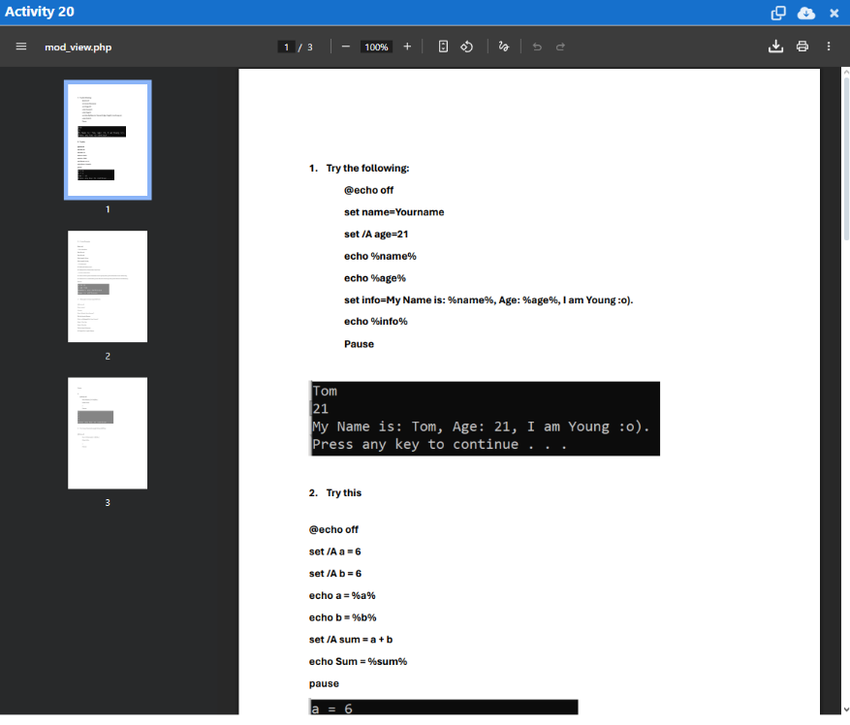
This appendix consists of evidence of engagement with the tutorial hobby on running gadget kinds from OS educational 1. The hobby blanketed distinctive classes of running structures, inclusive of batch running structures, time-sharing structures, disbursed running structures, real-time running structures, and embedded running structures. The tutorial helped broaden information of the way running structures are designed to satisfy distinctive users and gadget necessities.

