Report for Academic Skills Assignment 2 2018 – Academic Skills Brief



MARCH 2018

MODULE NAME: Academic skills (M4X01434)
Project Name: Down to Earth
Student Name: Phils muobike
Student Number: 1706873

Table of Contents

1. eXECUTIVE sUMMARY 1
2. Introduction 2
2.1 Report Remit 3
2.2 Background of the organisation .
2.3 models of reflection .
2.4 masterclass sessions .
2.5 influence of masterclasses on the project .
2.6 Influence of the Masterclasses on personal learning and development …………………
2.7 CONCLUSION………………………………………………………………………………………… 4
3. References 5

List of Figures
Figure 1.1 Kolb's Learning Cycle 4
Figure 2.2 Driscoll Reflective Cycle 4

APPENDICES

Appendix A – Notes from Masterclass
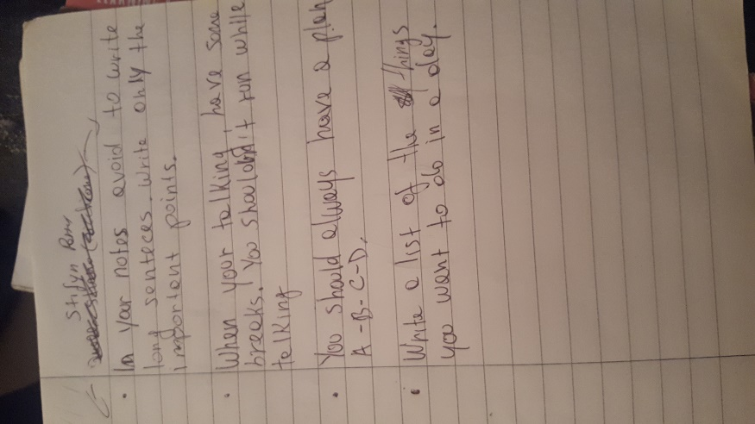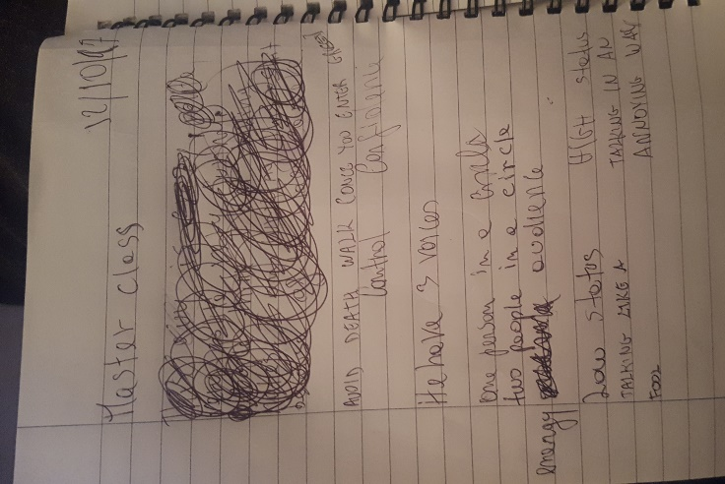

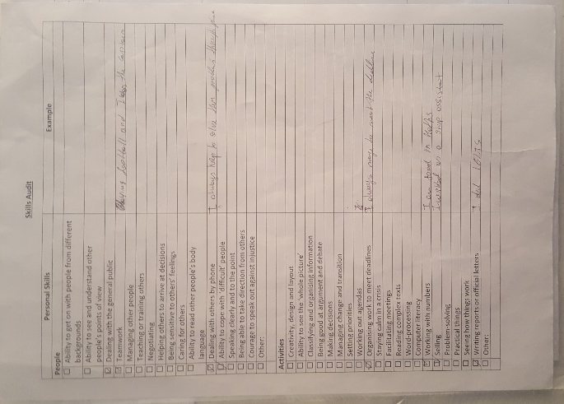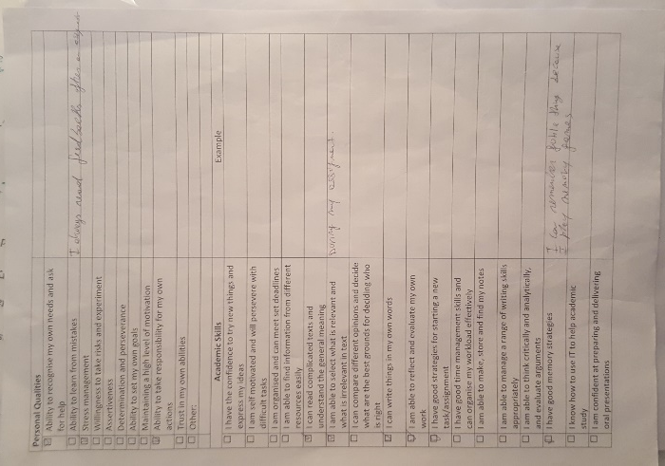

eXECUTIVE sUMMARY

The report will discuss how the group of students studying at the University of Wales Trinity Saint David worked with the social enterprise Down to Earth. Down to Earth uses sustainable materials for the construction of their building to remain eco-friendly with the environment. The report will also discuss about Kolb and Cottrell models of reflection. Kolb created his learning and developing skill model in 1984, where are represented four elements which are used to describe each part of the experience. The Concrete Experience is used to describe the new experience that is encountered. The Reflective Observation is used to understand the important aspect of the new activity. The Abstract Conceptualization is the stage which give someone a different prospective after experiencing the new activity. Finally, the Active Experimentation is the stage in which the someone applies all the things he learnt while practicing the activity and tries find out the results. In 1994, Driscoll used Kolb’s model of reflection to create his personal reflective cycle, there are three stages. ‘What?’ explains the experience someone had and the ‘So What?’ is the stage which explains how the new activity change someone in a positive way. Finally, the ‘Now What?’ stage is when someone has to put in practise what he learnt and find out the outcome. The Masterclasses are vital lectures held at the University of Wales Trinity Saint David, where special guests came to have a speech about their experience in their businesses and how they manage to succeed in their fields. The masterclasses also have a huge impact on Down to Earth project, where the lack of communication and confusing tasks set by the manager, made the experience very challenging. On the other hand, it helped me to enhance my skills and have a plan to improve them more in the future. In overall, the experience was a challenging and it was good for me to participate in new activities. If I would have another encounter with organisation Down to Earth, I will change my approach towards them. The short time available made things harder for me and my group, to achieve to objectives set by the manager. The manager requested to have an article in the newspaper, where should be discussed the activities made by organisation Down to Earth.

Introduction

Report Remit

In the first semester, the author was assigned a project with the other of group members of the University of Wales Trinity Saint David to raise awareness of social enterprise Down to Earth. This report aims to inform people what the author of the report learnt through the masterclasses and academic skills lectures and how the author applied them to his project with Down to Earth. This report will include necessary background information about the social enterprise which the author and his group worked with. In the report, there will also be a model reflection section where the author will describe the experience he had with a social enterprise using a valid model of reflection. A section about how the masterclasses influenced on my project will also be included as well as how the masterclasses had a significant impact on my personal learning and the development of his skills. In each section, there will be a detailed explanation and reliable sources to support the author's theories. At the end of the report, there will be a conclusion where all the contents of the report will be shortly summarised.

Brief background on the project

Down to Earth is an original social enterprise which bundles so many areas into one such as social care, education, construction of buildings and healthcare. The organisation Down to Earth summons up people with disabilities or physical limitations, drop out students, refugee and people with other difficult backgrounds giving them specialised training to acquire and develop new skills. Basically, Down to Earth gathers people with difficult backgrounds offering high-quality programmes to help them to build up a new life. The aim the organisation is to help people to learn new skills, develop their well-being, increase their self-confidence and start a new life (Down to Earth 2015)a. The social enterprise uses sustainable materials for the construction of their buildings to remain eco-friendly with the environment and the organisation also works with schools and community organisation to plan the development of outdoor spaces with local natural materials (Sustainable Swansea 2017). Initially, the task given to the group was to do some research about software for electric cars, the group of students decided to ask the manager of the organisation if they could raise awareness of the organisation. The group of students was asked to raise awareness of the organisation Down to Earth by getting an article in a national or local newspaper such as South Wales Evening Post or Western Mail (Down to Earth 2015)b.

Models of reflection

In this section, I will explain the experience I had with the organisation Down to Earth and my group; I will also include the Kolb model of reflection to describe my experience during the project. Models of reflection are mostly used to describe what someone has learnt from his experience, and there is not a right model of reflection, people could use the model that suits them. There are various models of reflection such as the Driscoll (1994), Gibbs (1988), Kolb (1984) and many others; I will focus on the Kolb's model of reflection to describe this report.
According to Wheatley (2002), without a deep reflection, people might act the way they want without thinking and create unforeseen consequences, failing to achieve anything (Bassott, 2016).
According to Bassot (2016), that there are two definitions of the word reflection, the first definition refers to the images reflected in a mirror, while, the second definition refers to the thick thinking made by someone. Basically, reflection is like looking into a mirror to see the result of our practice, finding out our weaknesses and it can give us critical thinking or consideration of ourselves.
In 1984, David Kolb published for the first time his learning styles model from which he developed his learning style inventory. Kolb's experiential learning model works on two different level, four separate learning method and four stage of the Experiential Learning Cycle. Kolb's theory is mostly concentrated on the learner's knowledge processes. Basically, Kolb's experiential learning theory is a comprehensive model that combines four different qualities such as experience, perception, cognition and behaviour.
"Learning is the process whereby knowledge is created through the transformation of experience. Knowledge results from the combination of grasping experience and transforming it" (Kolb, 1984, p.38-41).
Kolb's Experiential Learning Cycle is illustrated by four stages. The Concrete Experience is when someone has a new experience doing new activities or when existing expertise has been reinterpreted. I had a new and challenging experience with the social enterprise Down to Earth. Reflective Observation is when the unique experience is reviewed and understood by the person who had the experience. Abstract Conceptualization is where the learner tries to conceptualise a model or an existing theory of what the learner observed of the activity experienced. Active Experimentation is the final stage which involves the new learner to apply what he has learnt to the world and when the learner is trying to test a theory, a model or a plan for an upcoming experience (Kolb, 1984).

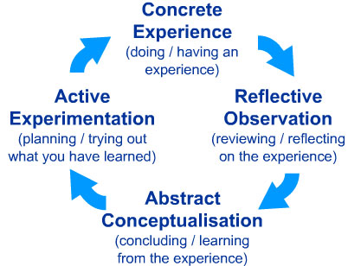

Figure 1.1 Kolb's Learning Cycle

In 1994, based on Kolb's (1984) model of reflection, Driscoll used the same model to create his personal model including three questions ‘What?', ‘So What?', ‘Now What?'. The ‘What?' question describes the new activity that someone experienced. ‘So what' describes the impact the experience had on someone, what difference did the experience make and why the experience was important. ‘Now What' is the hardest question among the two stated above, it is when someone has to plan to continue his personal learning and development for the future.

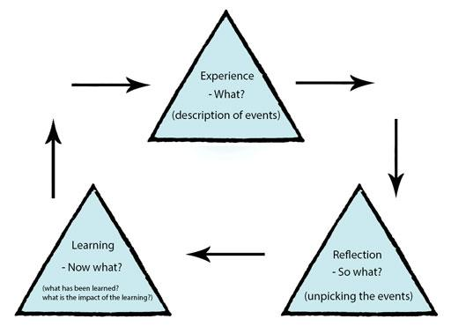
Figure 2.2 Driscoll Reflective Cycle
There are various models of reflection in the literature; each model has a different structure and layout. However, they have the same features. As stated above, I will use the Kolb's (1994) model of reflection to describe my experience with Down to Earth project in the following sections.

Masterclass Sessions

The masterclasses were hosted each Thursday by businessmen or businesswomen, who came to explain how they started their business activity, what was their aim and how to achieve their goals and objectives. Each of the guest speakers shared similar ideas in different fields, and they had a positive mindset, they believed that key to success was thinking positive and continue trying till they succeed. The speech in the first week of the masterclass of the managing director of Mr Producer, Stifyn Parry was inspiring and encouraging (MR Producer Stifyn Parry 2016). The special guest's key factor that made succeed was his high level of confidence and his flexibility to have different plans to overcome any difficulty. Parry's speech helped me to understand how to enhance my confidence and tackle the initial challenges I had with his project, my group and I had various problems during our project such as lack of communication, the limited time available and the lack of objectives with the organisation Down to Earth (Dubrin, 2015). I believe, the second guest speaker who had a remarkable presentation and speech was Andy Room, who is a teacher and has experience surfing, kiteboarding, skateboarding and other extreme activities, he had an impressive speech during the masterclasses at the University of Wales Trinity Saint David. Room's key factor to success was his bright idea and his numerous attempts to succeed in his skateboarding business activity (Kerzner and Kerz.er, 2017). During the masterclasses session, Mr Room gave me some tips to enhance my weak skills like the ability to keep on trying after a failure and learning how to plan to achieve the objectives set (Baker and Westrup, 2003). Last but not the least, Kate Jenkins, the owner of Gower Cottage Brownies, is a young businesswoman, who started her selling brownies in the local village, before becoming a multi-award winning brownie seller. In the masterclass, she had a speech that affected me positively (Theobald, 2016). In the proceeding sections, she always had a determined character and a positive mindset that made her turn a small shop of brownies into a big business, receives orders from all over the UK. I will now discuss how these masterclasses influenced both the implementation of the project and my personal development (Cottrell, 2015).

Influence of Masterclasses on the Project

Working with the social enterprise Down to Earth was quite challenging for us as a group due to poor communication The confusing objectives set by the manager of the organisation to me and my group of fellow students made the situation a little bit chaotic. In this section, I will discuss what I learnt in the masterclasses and how I applied them (Mullins, 2016). Firstly, I tried to develop my communication skill to communicate efficiently with my group members and the social enterprise in which I was involved in. I was particularly impressed when Kate was talking about her story that led her to succeed. During the masterclass, Kate shared her experience that she had to promote her business from a local shop to a national shop. She taught herself how to cook by experimenting how to perfect the brownies recipe in her kitchen, which took her two weeks to develop (Miller, 2016). She began selling her brownies in her little cottage, her business began to grow, where even tourists loved buying brownies in her cottage and the cottage did not have enough space. In 2007, she brought her brownies to the programme the True Taste Wales Food and Drink Awards, and on her most excellent surprise, she won the award. Due to the great achievement, she accomplished winning the award; she was able to raise awareness of her business activity. Basically, Kate gave me the idea and ability to know how to promote micro businesses (Gower Cottage Brownies). Her tenacity and ability to expand her business made me understand how to complete my task with my group, which is supporting Down to Earth on the local or regional newspaper. We as a team tried to have an article were Down to Earth was mentioned, the short available prevented us from completing our task. Finally, the manager of the organisation asked us to raise awareness of the organisation Down to Earth by promoting the development of the educational and residential centre in Gower for Valley's kids in the newspaper of the University of Wales Trinity Saint David (Miller, 2017). We found that there was an article where the residential and educational centre was mentioned, and we decided to abandon the idea of promoting the building in the University newspaper. However, as part of our marketing assignment, we had to create a blog where we had to raise awareness of the organisation that we were involved in. We posted the link to the blog on our Facebook pages, and we a had 4765 views from over ten countries. I personally posted the link of the blog on my Instagram page to increase the views from my Italian followers. We had a meeting to discuss how the initially set objectives were not achieved and how we performed during the project (Bovee and Thill, 2013).The showcase event held in unit 19 brought an end of the first semester and also the end of the project. Despite the challenges we had during our project, in overall we think that we tried as a group to achieve the objectives set by the social enterprise, even though it was not what we initially planned together with the organisation (Dubrin, 2015).

Influence of the masterclasses on personal learning & development

The masterclasses were essential for me during my first experience at the University; the special guests were very influential during their speech. The three guest speakers mentioned above grabbed my attention and caught my interest particularly, thanks to their experience and speaking skills (Denovan, John and Sinek, 2014). As mentioned in the previous section, I had some initial problems with my group and the organisation in which I was involved, the first challenge was the communication. I was born and brought up in Italy, so I had difficulties in communicating with my group project and understanding some tasks (Bovee and Thill, 2016). Stifyn Parry during his speech taught the students how to talk efficiently, and he showed some tricks how to be less stressed during a presentation with a large number of people. The methods given were based on confidence such as greeting the audience once you get in the classroom, without waiting to get in the middle of class tensed. The second trick is to have various plans, for example during a presentation you should make a powerpoint presentation, bullet points, personal laptop and phone, if one of the devices does not work, you could use another device without delaying what makes you flexible (Theobald, 2016). After the speech of the special guest, I had more confidence, and he enhanced my verbal communication skills, and this is proven through my performance with my assignments and the few presentations I had at University with my group. I also learnt and developed how to manage stress and timekeeping. These two skills are most essential skills that everyone should have, however, these skills are often ignored by people. According to Whetten and Cameron (2014), the reason why people neglect to develop the stress and timekeeping skills is due to lack of planning and the people not enjoying their working place. Basically, the two authors mentioned above believe that the significant things that are causing stress to people are their working place and their schools. Stress and time are two related elements, people are stressed because of the short time available they have, and these can lead them to get more stressed than usual. Thanks to the masterclasses and the lectures at the University, I improved my timekeeping and stress managing. Before I started my tertiary institution last year, I always had problems to control stress and manage my time to complete basic daily activities. According to Cottrell (2015), people demand a lot from students, and the students have to make some decision. Cottrell (2015) suggests that students should have a depth thought of their decision-making to know how it would affect their lives, their aims, their beliefs and values, and the quantity of time students can realistically give for each task. This would help the students to have a bright idea of what they are going to do and to enable them to have the strength to face the consequences of making difficult decisions. I could say that I was quiet satisfied with the development of my new skills through the masterclasses and lectures at the University. After the experience with special guests, who helped me to find out the skills that I have to develop, I will be taking part in special classes to enhance my self-confidence, I will use the student support and take advantage its benefits to start believing in myself. According to Bénabou and Tirole (2002), confidence is one of the essential abilities that improve someone’s motivation and it is also an effective weapon for people with a weak character and willpower. Once I become confident enough, I will also try to be more organised and spend time more maturely. From next week I will buy a diary where I could be writing my daily tasks and set deadlines to give a clear idea of what I will be doing during the day and complete the daily tasks effectively. Pedler, Burgoyne and Boydell (2013) stated that nowadays, time is very short for people and the opportunities of time spending are growing annually. The three authors mentioned above also claimed that most of the time people plan the way they will spend their time at work, with family, friends and for themselves.

Conclusion
The various models of learning and developing skills are useful for the description of someone that experienced a new activity. All these models have different layouts and structures but they have the same aim, which is finding out what someone learnt from the particular activity. I chose Kolb reflective model cycle because it looked more suitable for me to explain my experience with Down to Earth and the skills that I learnt and managed to develop, throughout the activities that we had as a group.
From my opinion, the masterclasses were the best lectures held at the University of Wales Trinity Saint David. During the masterclasses there have been invited businessmen and businesswomen, who shared their experience which led to success in their business activity. Their speech made me understand that in life nothing is easy, and I also learnt about many new skills which I would like to develop in the future.
Finally, to conclude this report it is vital to summarise the main structure of the report. This report begun with executive summary which had to present the main idea of the report, before moving on to the report remit. Then it discussed brief background of the organisation Down to Earth. Next the report described the models of reflection and masterclass sessions together with the influence of the masterclasses on the project and on the personal learning and development. As the last part of the report has been written the conclusion which summarised this report.

References
Bassot, B. (2016). The reflective practice guide: An interdisciplinary approach to critical reflection. Routledge.
Wheatley, M. J. (2002). Turning to one another: Simple conversations to restore hope to the future. Berrett-Koehler Publishers.
Down to Earth. (2015)a About us. [Online] Available from: https://www.downtoearthproject.org.uk/about/. [Accessed: 20 02 2018].
Down to Earth. (2015)b Eco Building. [Online] Available from: https://www.downtoearthproject.org.uk/eco-building/. [Accessed: 20 02 2018].
Whetten, D. and Cameron, K. (2014). Developing Management Skills: Global Edition. Pearson Higher Ed.
Kolb, D. A. (1984). Experiential learning: Experience as the source of learning and development. Englewood Cliffs, NJ: Prentice-Hall.
Cottrell, S. (2015). Skills for success: Personal development and employability. Palgrave Macmillan.
MR Producer Stifyn Parry. (2016). HOME. [Online] Available from: https://mrproducer.co.uk/homepage/. [Accessed: 9 03 2018].
DuBrin, A. J. (2015). Leadership: Research findings, practice, and skills. Nelson Education.
Baker, J. and Westrup, H. (2003). Essential speaking skills. A&C Black.
Kerzner, H., & Kerzner, H. R. (2017). Project management: a systems approach to planning, scheduling, and controlling. John Wiley & Sons.
Gower Cottage Brownies. (2016). Made in Wales. [Online] Available from: http://www.gowercottagebrownies.co.uk/. [Accessed: 9 03 2018]
Theobald, T. (2016). Develop your presentation skills. Kogan Page Publishers.
Donovan, J., John, R. S. and Sinek, S. (2014). How to deliver a TED talk. McGraw Hill.
Sustainable Swansea. (2017). Sustainable Swansea. [Online]
Available at: http://www.sustainableswansea.net/down-to-earth-project.html. [Accessed 16 02 2018].
Miller, J. (2017). Free Ways To Promote Charity Events. [Online]
Available at: http://www.admedia.com/free-ways-to-promote-charity-events.php
[Accessed 10 03 2018]
Mullins, L.J., 2016. Management and organisational behaviour. Pearson education.
Bovee, C. L., and Thill, J. V. (2013). Business communication essentials. 7th Ed. Pearson Higher Education.
Bénabou, R, and Tirole, J. (2002). Self-confidence and personal motivation. The Quarterly Journal of Economics, 117(3), 871-915.
Pedler, M, Burgoyne, J, and Boydell, T. (2013). A Manager's Guide to Self-development. McGraw-Hill Education (UK).

